ReactJS Hands-On Lab Exercises

# Exercise 1: Create “myfirstreact” Application

import React from 'react';  
  
function App() {  
 return (  
<div>  
<h1>Welcome to the first session of React</h1>  
</div>  
 );  
}  
  
export default App;

Running the app using:

npm start

Output: A heading saying 'Welcome to the first session of React' will be displayed.

# Exercise 2: StudentApp with Components (Home, About, Contact)

import React from 'react';  
  
function Home() {  
 return (  
<div>  
<h2>Welcome to the Home page of Student Management Portal</h2>  
</div>  
 );  
}  
  
export default Home;

About.js

import React from 'react';  
  
function About() {  
 return (  
<div>  
<h2>Welcome to the About page of the Student Management Portal</h2>  
</div>  
 );  
}  
  
export default About;

Contact.js

import React from 'react';  
  
function Contact() {  
 return (  
<div>  
<h2>Welcome to the Contact page of the Student Management Portal</h2>  
</div>  
 );  
}  
  
export default Contact;

App.js

import React from 'react';  
import Home from './Components/Home';  
import About from './Components/About';  
import Contact from './Components/Contact';  
  
function App() {  
 return (  
<div>  
<Home />  
<About />  
<Contact />  
</div>  
 );  
}  
  
export default App;

Run the app using:

npm start

Output:

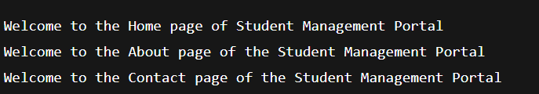

Exercise 3: scorecalculatorapp – CalculateScore Component

File: CalculateScore.js :

import React from 'react';

import './Stylesheets/mystyle.css';

function CalculateScore(props) {

const avg = props.total / props.goal;

return (

<div className="score-box">

<h2>Student Score Summary</h2>

<p>Name: {props.name}</p>

<p>School: {props.school}</p>

<p>Average Score: {avg.toFixed(2)}</p>

</div>

);

}

export default CalculateScore;

File: App.js

import React from 'react';

import CalculateScore from './Components/CalculateScore';

function App() {

return (

<div className="App">

<CalculateScore name="John" school="ABC High School" total={450} goal={5} />

</div>

);

}

export default App;

File: mystyle.css

.score-box {

padding: 20px;

background-color: lightyellow;

border: 1px solid #ccc;

border-radius: 5px;

margin: 20px;

}

Output :

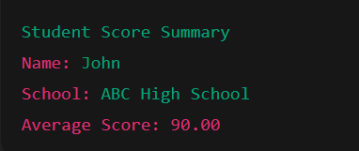

Exercise 4: blogapp – Posts Component Using Lifecycle

File: Posts.js

import React, { Component } from 'react';

class Posts extends Component {

constructor() {

super();

this.state = {

posts: [],

hasError: false

};

}

loadPosts = () => {

fetch("https://jsonplaceholder.typicode.com/posts")

.then(response => response.json())

.then(data => this.setState({ posts: data }))

.catch(error => this.setState({ hasError: true }));

}

componentDidMount() {

this.loadPosts();

}

componentDidCatch(error, info) {

alert('Error occurred: ' + error);

}

render() {

return (

<div>

<h2>Posts List</h2>

{this.state.posts.map(post => (

<div key={post.id}>

<h3>{post.title}</h3>

<p>{post.body}</p>

</div>

))}

</div>

);

}

}

export default Posts;

File: App.js

import React from 'react';

import Posts from './Posts';

function App() {

return (

<div className="App">

<Posts />

</div>

);

}

export default App;

Output:

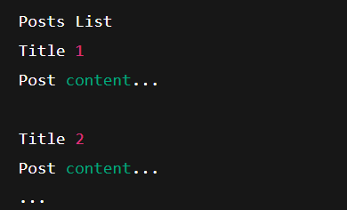

Exercise 5: Styling with CSS Module – CohortDetails

File: CohortDetails.js

import React from 'react';

import styles from './CohortDetails.module.css';

function CohortDetails({ name, status }) {

const titleStyle = { color: status === 'ongoing' ? 'green' : 'blue' };

return (

<div className={styles.box}>

<h3 style={titleStyle}>{name}</h3>

<dl>

<dt>Status:</dt>

<dd>{status}</dd>

</dl>

</div>

);

}

export default CohortDetails;

File: App.js

import React from 'react';

import CohortDetails from './Components/CohortDetails';

function App() {

return (

<div className="App">

<CohortDetails name="Cohort 2025" status="ongoing" />

<CohortDetails name="Cohort 2024" status="completed" />

</div>

);

}

export default App;

Output:

