WEEK6_Extra_Solutions

Exercise 1: Using React Hooks – useEffect with API Polling

Objective
Implement API polling using useEffect and setInterval to refresh data every few seconds.

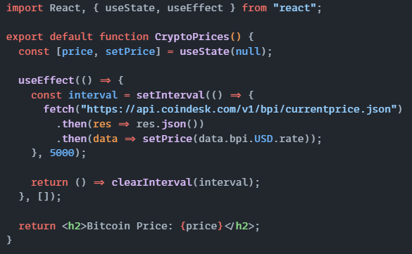Output
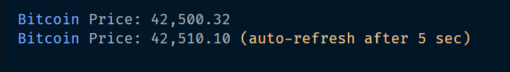

Exercise 2: Custom Hook for Form Handling

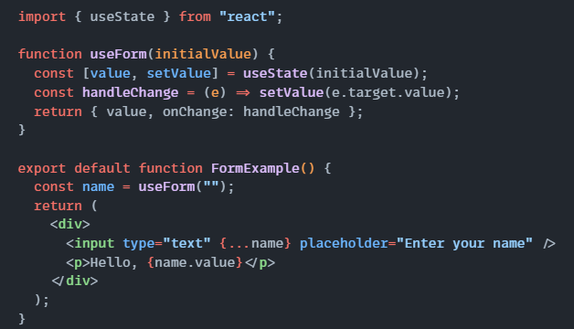

Output

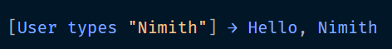

Exercise 3: Context API for Theme Switching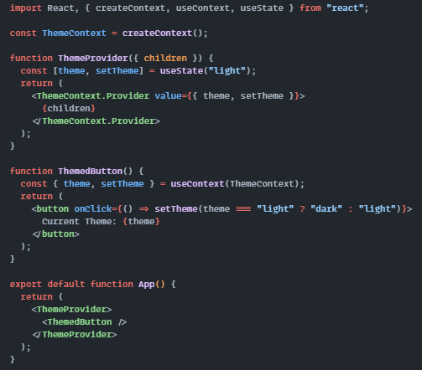

Output
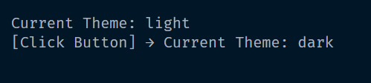

Exercise 4: React Router Navigation Example

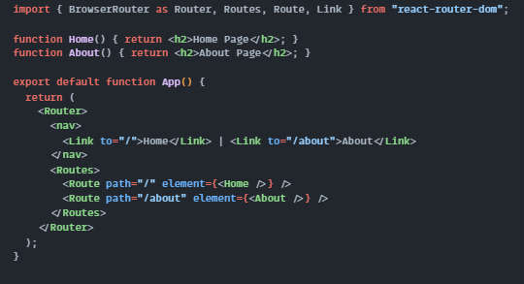

Output
