WEEK8_Mandatory_Solutions
Exercise 1: Initialize Git Repository and First Commit
Set up a Git repository and commit initial files.
Commands
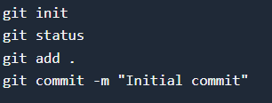

Output
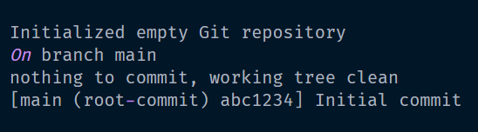✅ Exercise 2: Creating and Switching Branches
Create a new feature branch.
Commands
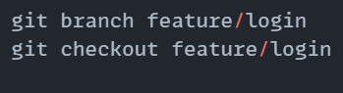
Output
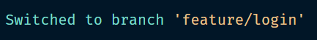

Exercise 3: Merging Branches and Resolving Conflicts
Merge a feature branch and resolve conflicts.
Commands
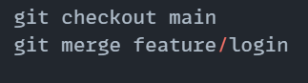
Output
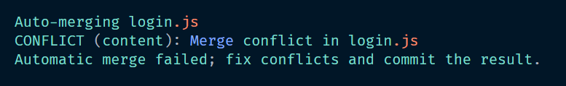
Fix the conflict manually and then:
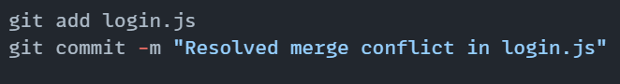

Exercise 4: Using Git Log, Blame, and Revert
🔹 Commands
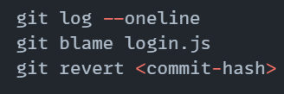
Output
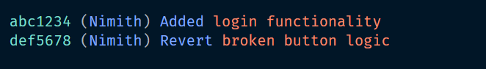
Exercise 5: Working with GitHub – Remote Push/Pull
🔹 Commands
💻 Output


