WEEK7_Extra_Solutions

Exercise 1: Using Context API for Global State

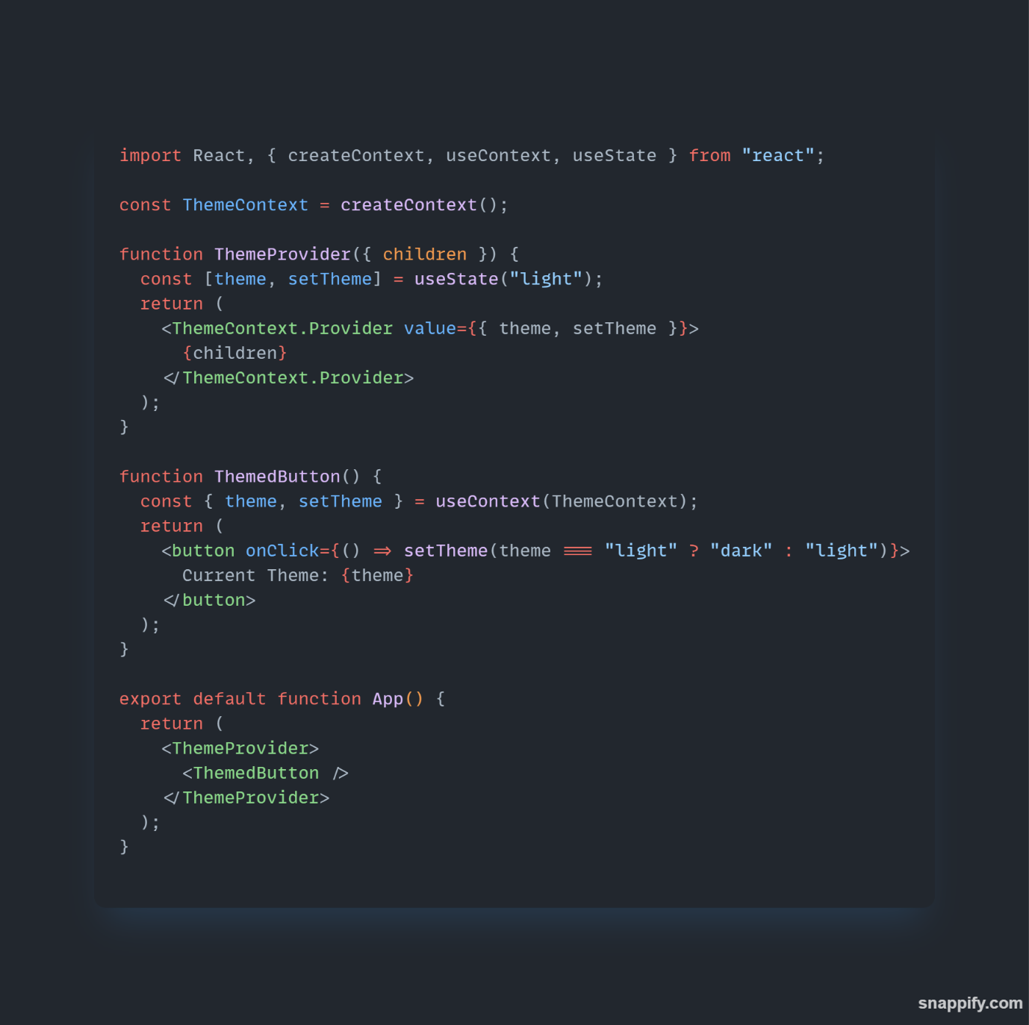

Output

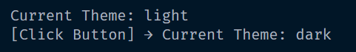

Exercise 2: Custom Hook for API Fetching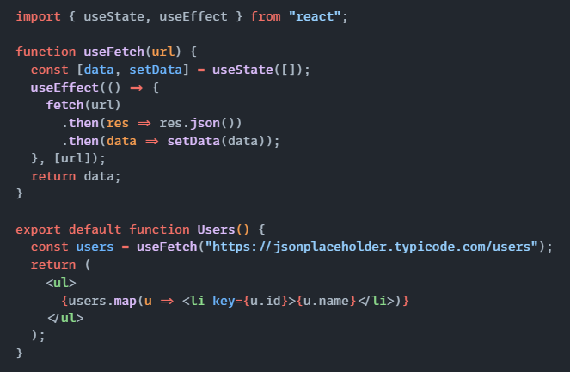Output

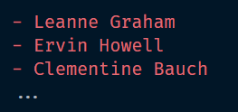

Exercise 3: React.memo for Performance Optimization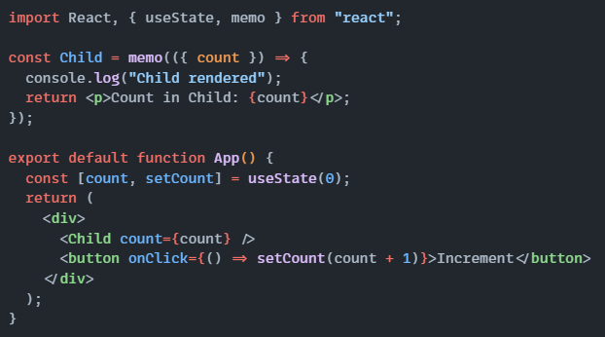Output

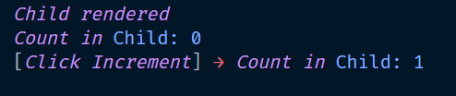

Exercise 4: React Suspense with Lazy Loading

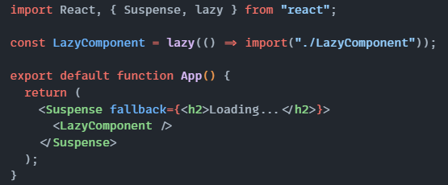Output
