WEEK8_Extra_Solutions
Exercise 1: Using Git Stash
Save temporary work without committing.
Commands
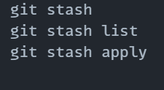
Output
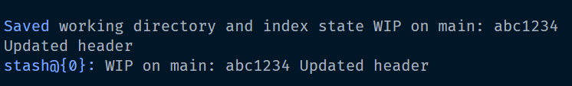
Exercise 2: Cherry-Picking a Commit
Apply a single commit from one branch to another.
Commands
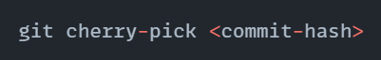
Output
Exercise 3: Rebasing a Feature Branch
Rebase feature branch with updated main branch.
Commands
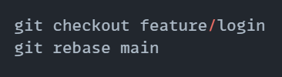
Output
Exercise 4: Tagging Releases
Create version tags for project milestones.
Commands
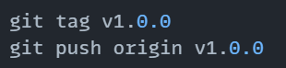
Output
