React Hands-On Exercises Part 2
9. Cricket app
// App.js
import ListofPlayers from './ListofPlayers';
import IndianPlayers from './IndianPlayers';

function App() {
const flag = true;
return (
<div>
{flag ? <ListofPlayers /> : <IndianPlayers />}
</div>
);
}

// ListofPlayers.js
const players = [
{ name: "Virat", score: 80 },
{ name: "Rohit", score: 65 },
...
];

const highScorers = players.filter(p => p.score >= 70);
return (
<ul>
{highScorers.map((p, index) => (
<li key={index}>{p.name} - {p.score}</li>
))}
</ul>
);

// IndianPlayers.js
const T20 = ["Virat", "Hardik"];
const Ranji = ["Jaiswal", "Ruturaj"];
const allPlayers = [...T20, ...Ranji];

return (
<ul>
{allPlayers.map((name, i) => <li key={i}>{name}</li>)}
</ul>
);

Output:
- If flag = true
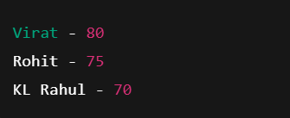
- If flag = false


10. Office Space Rental App
const offices = [
{ name: "WeWork", rent: 55000, address: "Indiranagar" },
{ name: "Innov8", rent: 70000, address: "HSR Layout" }
];

return (
<div>
<h1>Office Space Rental</h1>
{offices.map((office, index) => (
<div key={index}>
<h2>{office.name}</h2>
<p style={{ color: office.rent < 60000 ? 'red' : 'green' }}>
Rent: {office.rent}
</p>
<p>Address: {office.address}</p>
</div>
))}
</div>
);

Output:
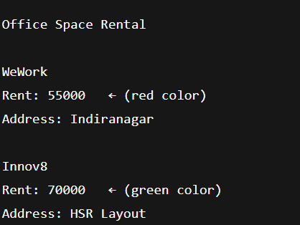

11. Event Examples App
class Counter extends React.Component {
state = { count: 0 };

increment = () => {
this.setState({ count: this.state.count + 1 });
this.sayHello();
};

sayHello = () => {
alert("Hello! Count incremented");
};

decrement = () => this.setState({ count: this.state.count - 1 });

welcome = msg => alert(msg);

handleClick = (e) => alert("I was clicked");

render() {
return (
<div>
<button onClick={this.increment}>Increase</button>
<button onClick={this.decrement}>Decrease</button>
<button onClick={() => this.welcome("Welcome")}>Say Welcome</button>
<button onClick={this.handleClick}>Synthetic Event</button>
<p>Count: {this.state.count}</p>
</div>
);
}
}

function CurrencyConvertor() {
const [amount, setAmount] = useState("");
const [converted, setConverted] = useState("");

const convert = () => {
setConverted((amount / 90).toFixed(2));
};

return (
<div>
<input onChange={e => setAmount(e.target.value)} />
<button onClick={convert}>Convert</button>
<p>Euros: {converted}</p>
</div>
);
}

Output:
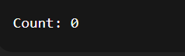
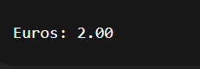

12. Ticket Booking App

function App() {
const [isLoggedIn, setIsLoggedIn] = useState(false);

const userPage = <h2>Welcome, User! Book your ticket here.</h2>;
const guestPage = <h2>Hello Guest! Please login to book tickets.</h2>;

return (
<div>
<button onClick={() => setIsLoggedIn(true)}>Login</button>
<button onClick={() => setIsLoggedIn(false)}>Logout</button>
{isLoggedIn ? userPage : guestPage}
</div>
);
}

Output :
