**Day-2 April 13 2018**

What I understood from day -1 ?

We are using only one programing language java script.

Gulp is build tool for java script and uses node.js as platform for build system.

To run we need to install node.js and using npm (nodejs package manager) install gulp

Gulp build’s for uc client will be public_deploy and client deploy.

Command ‘gulp’ builds public_deploy under folder uc_client/public/public_deploy.

Command ‘gulp fullBuild’ runs and builds under folder uc_client/client/client_deploy.

gulp looks for gulpfile.js when a build is triggered.

On demand , uc_client and uc_ae_client (assessment engine) has to be merged.

nvm installation

link https://github.com/coreybutler/nvm-windows/releases

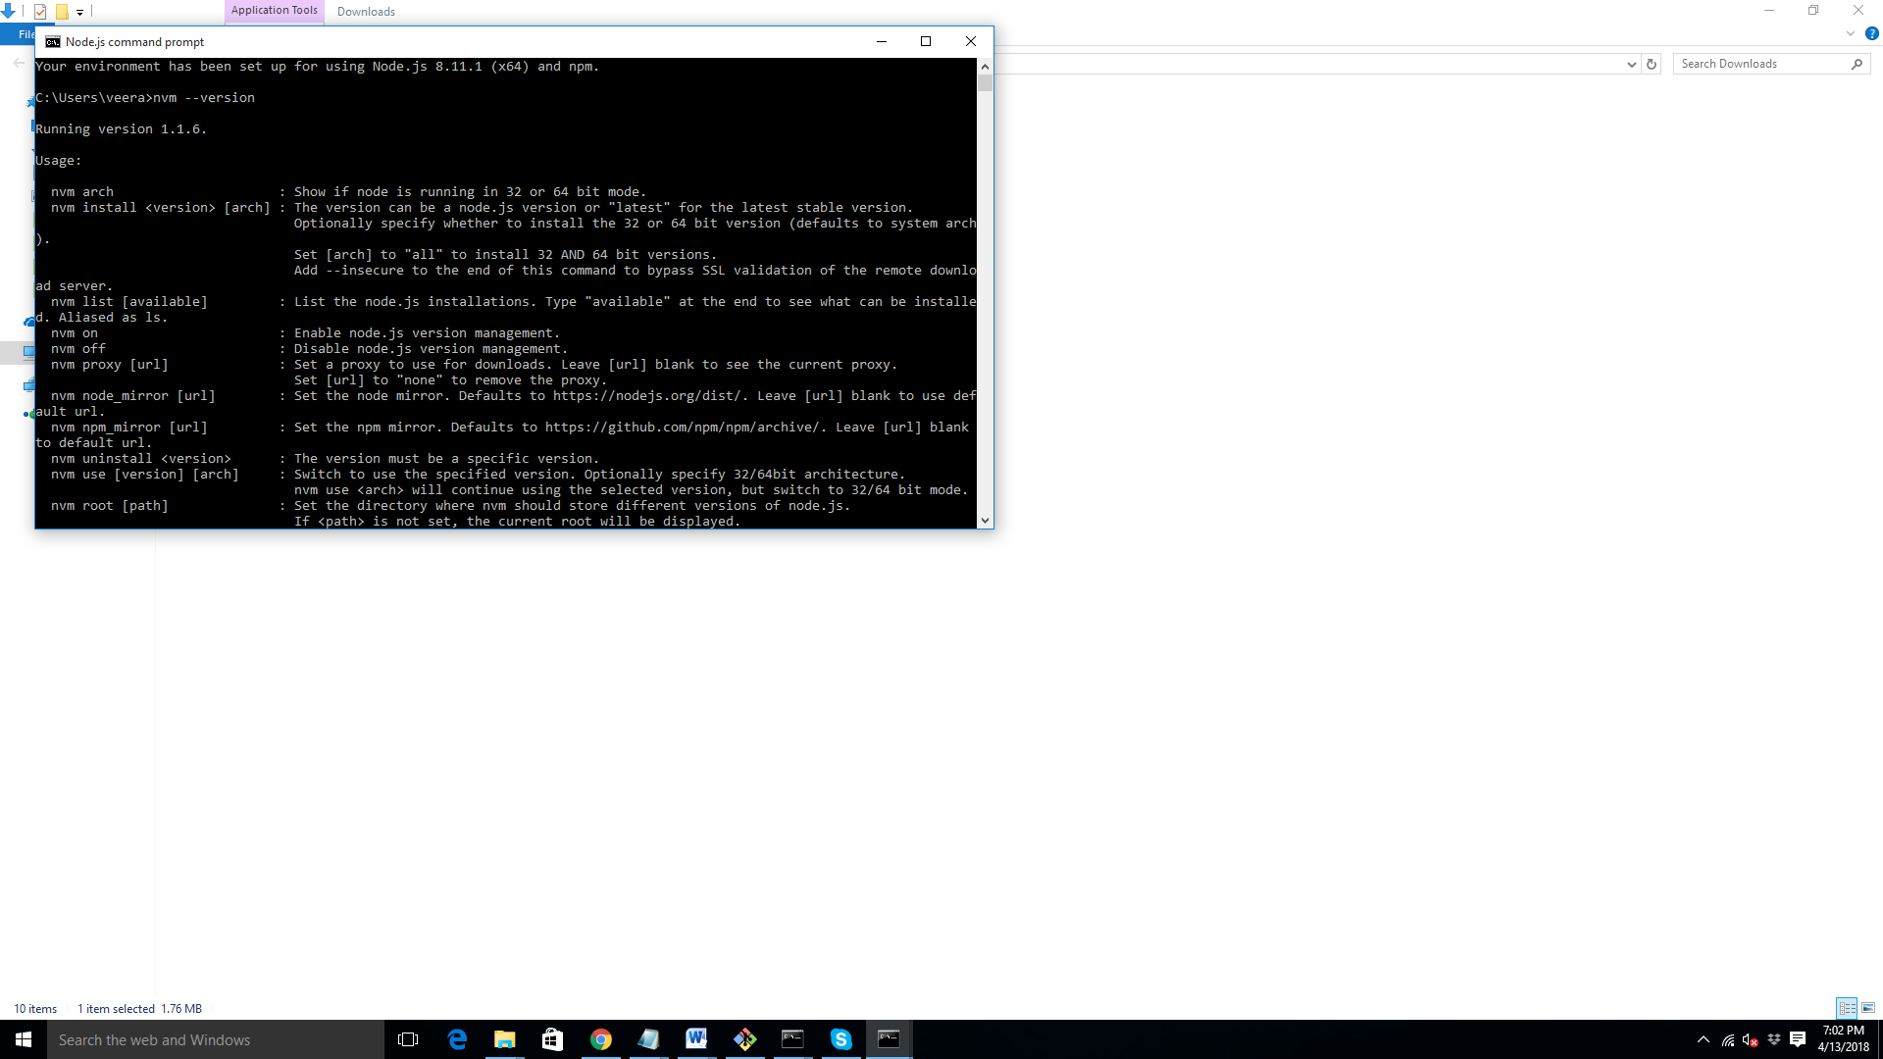

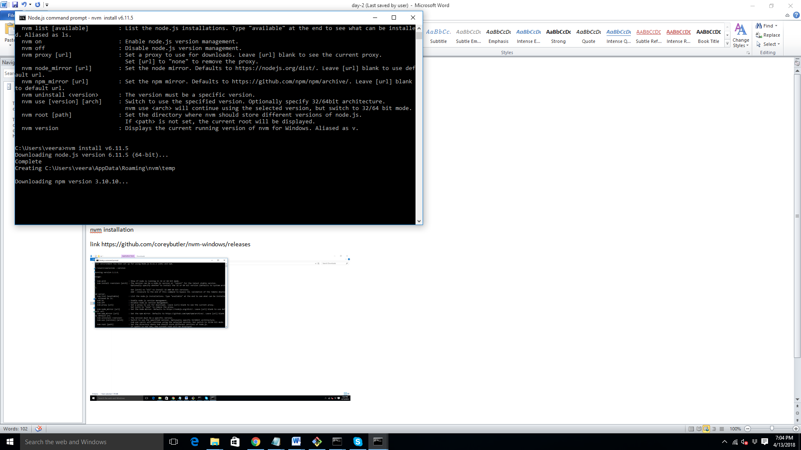

Source tree

