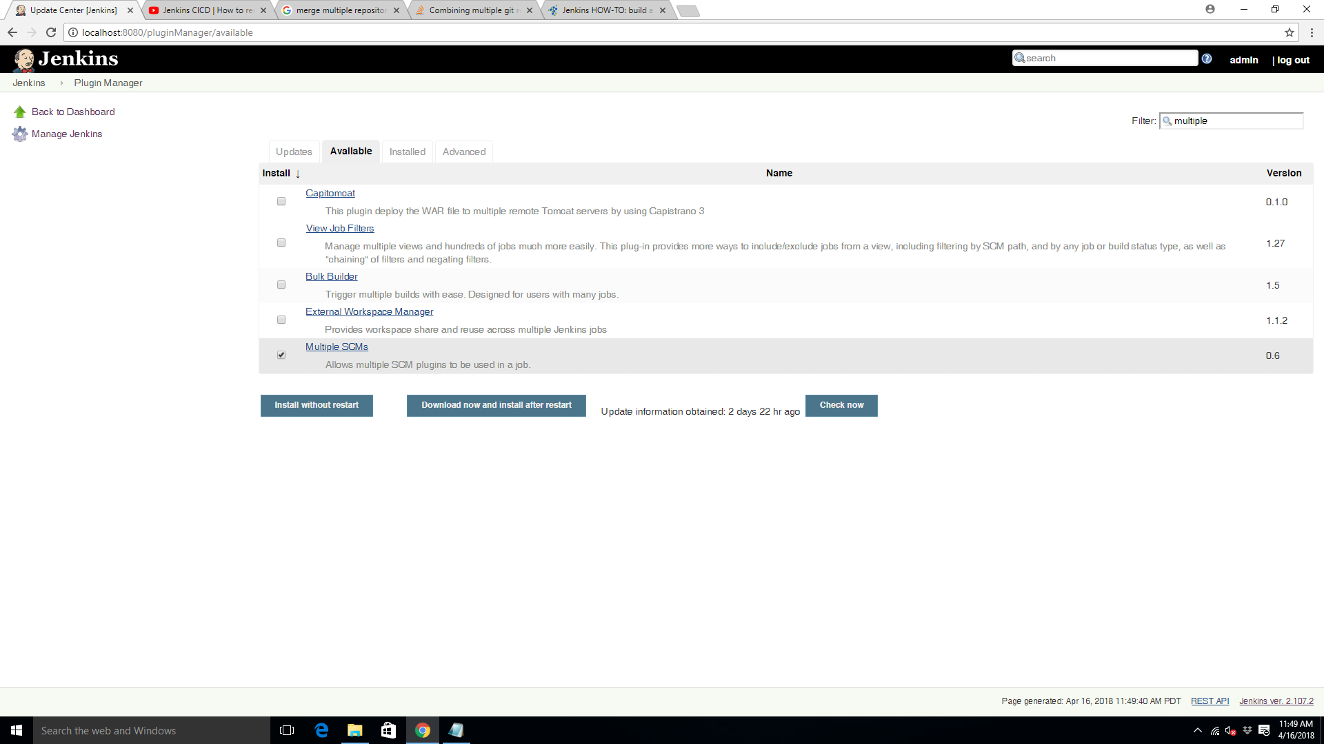

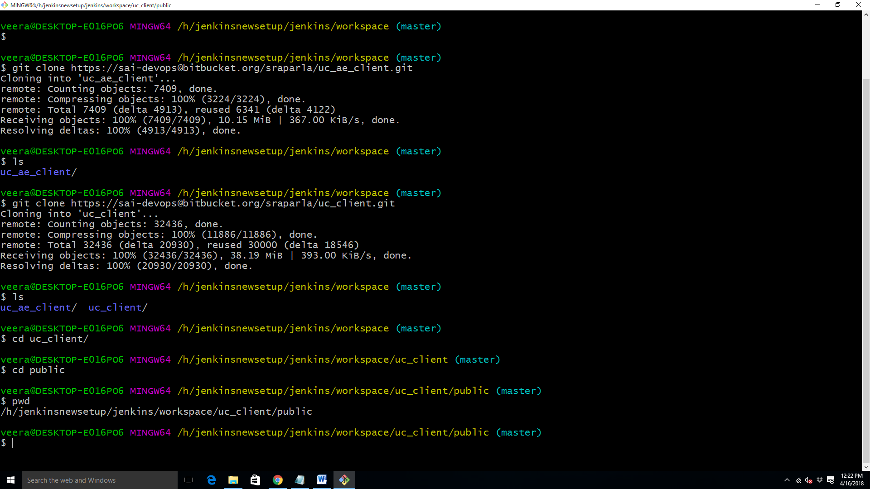

error

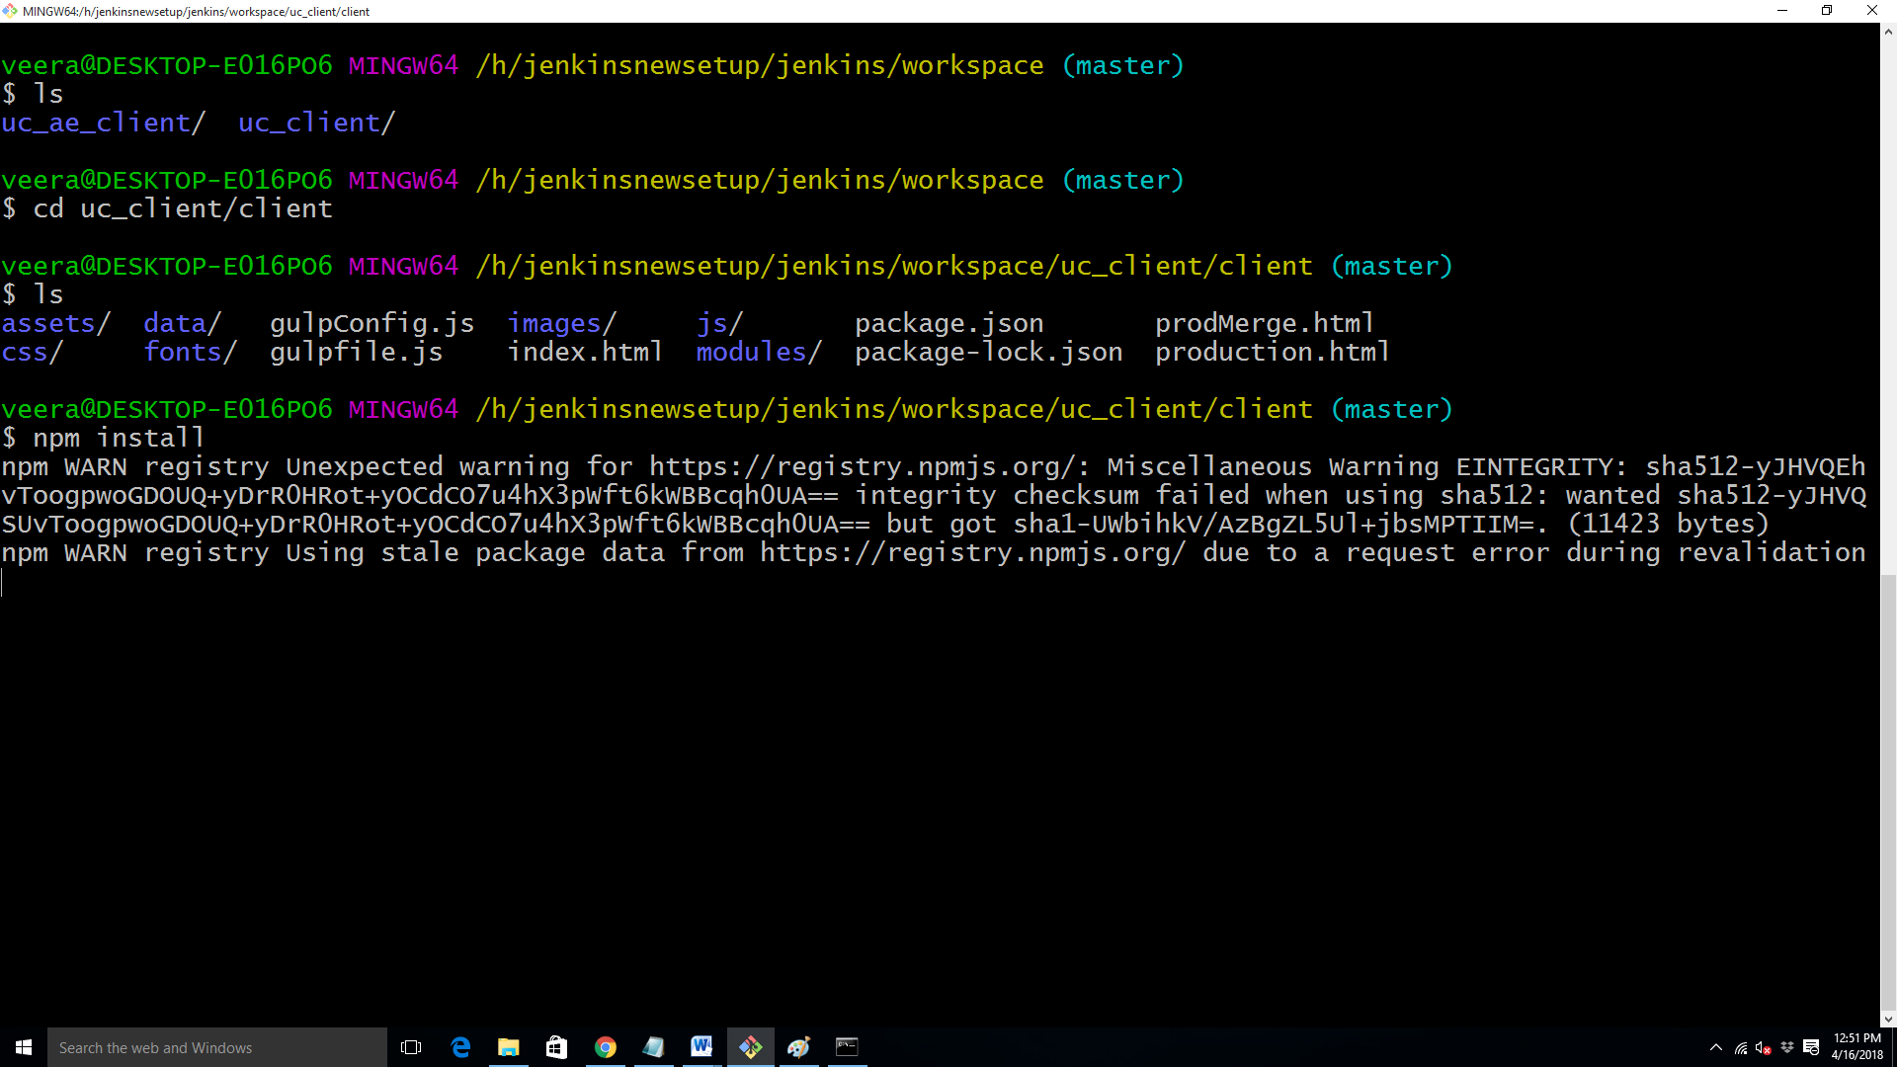

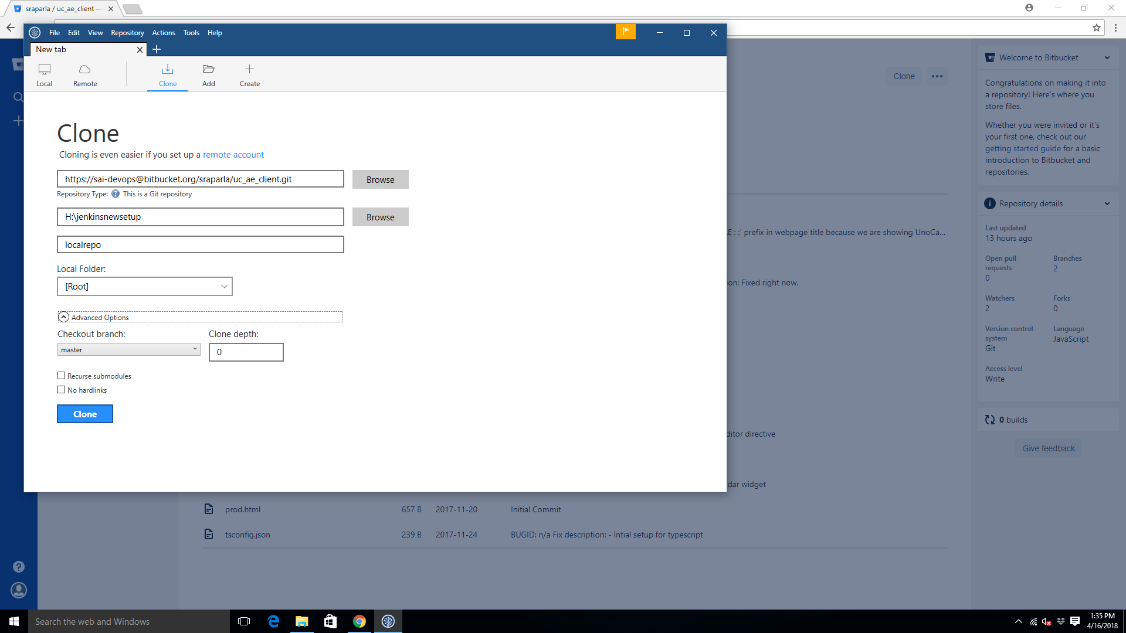

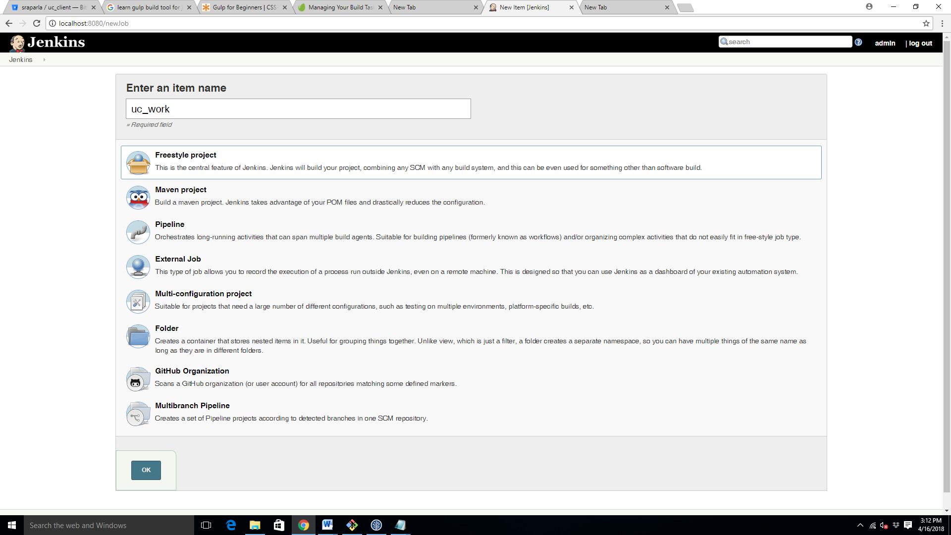

Monitoring the flow of batch commands, after npm install it is not running gulp commands as shown in this figure the reason is there might different version of gulp installed for production and development.

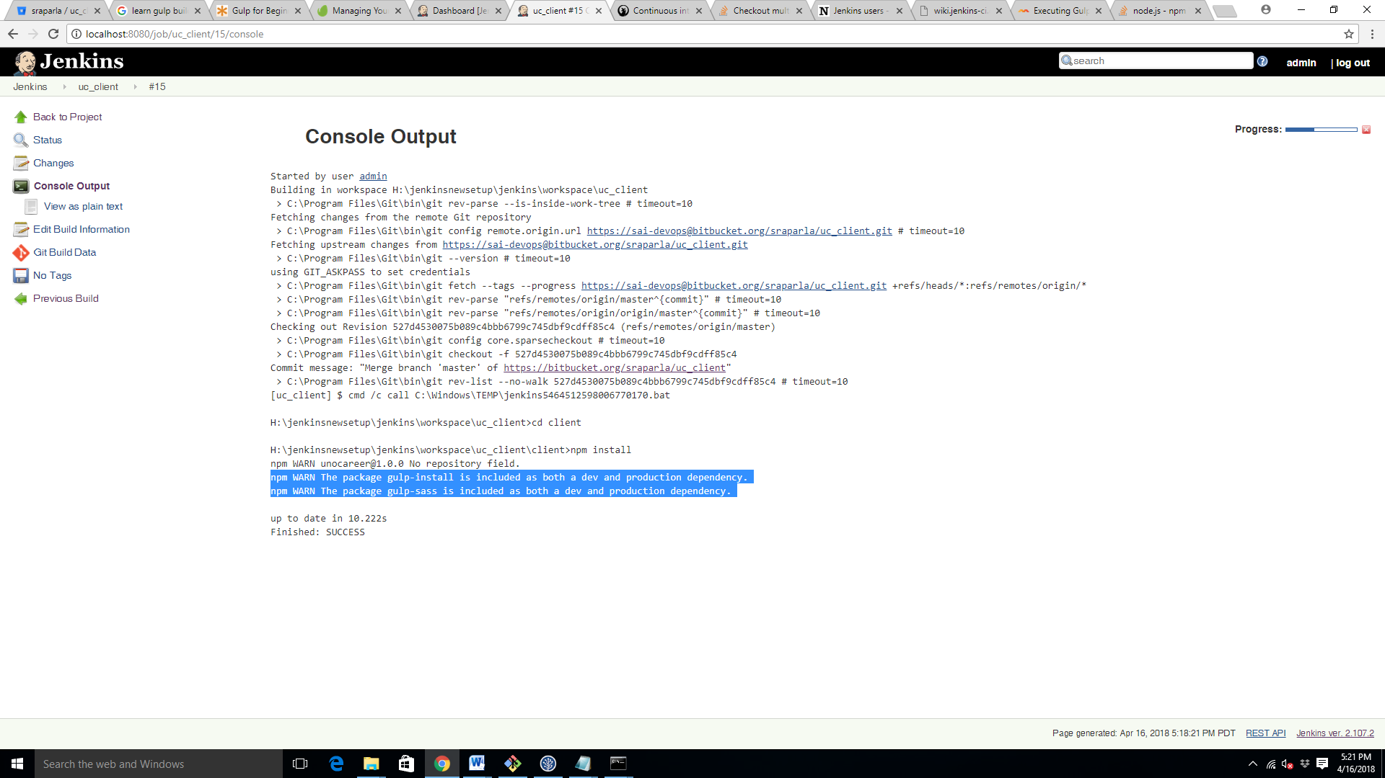

4/16/2018 5:27 pm

Steps I have followed to setup

1. Create a new project uc_ae_client add the repository in the scm section.

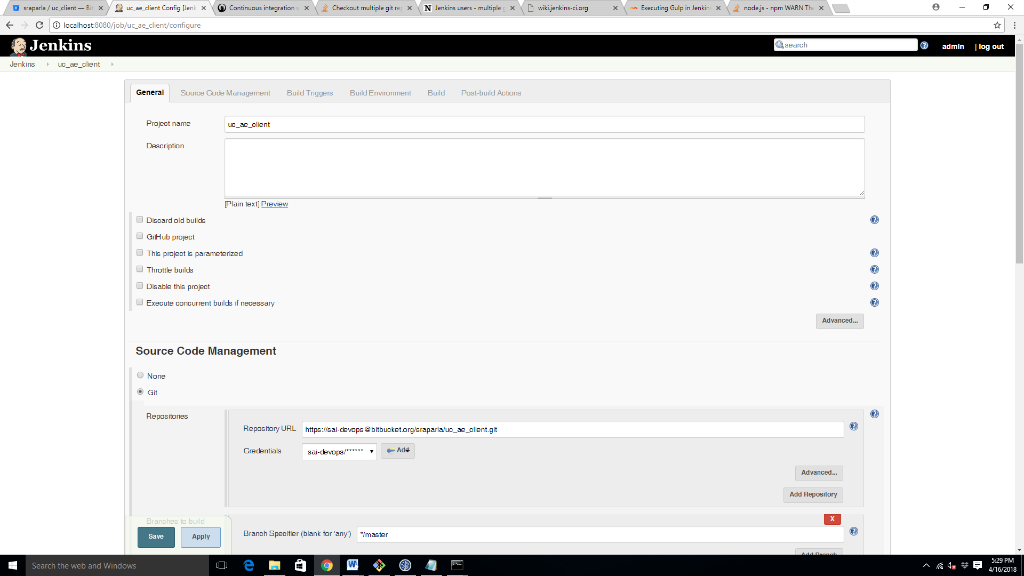

Set one more project uc_client and add the repository of uc_client in the scm section

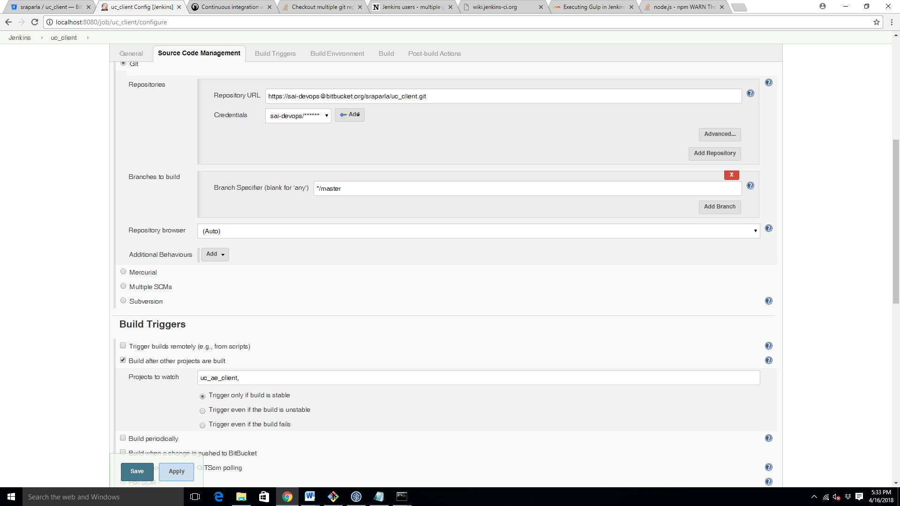

Under build triggers section select Build after other projects are built and give the name of the project uc_ae_client,

Select ‘trigger only if build is stable’, it means that if uc_ae_client is successfully executed then only uc_client project will be executed.

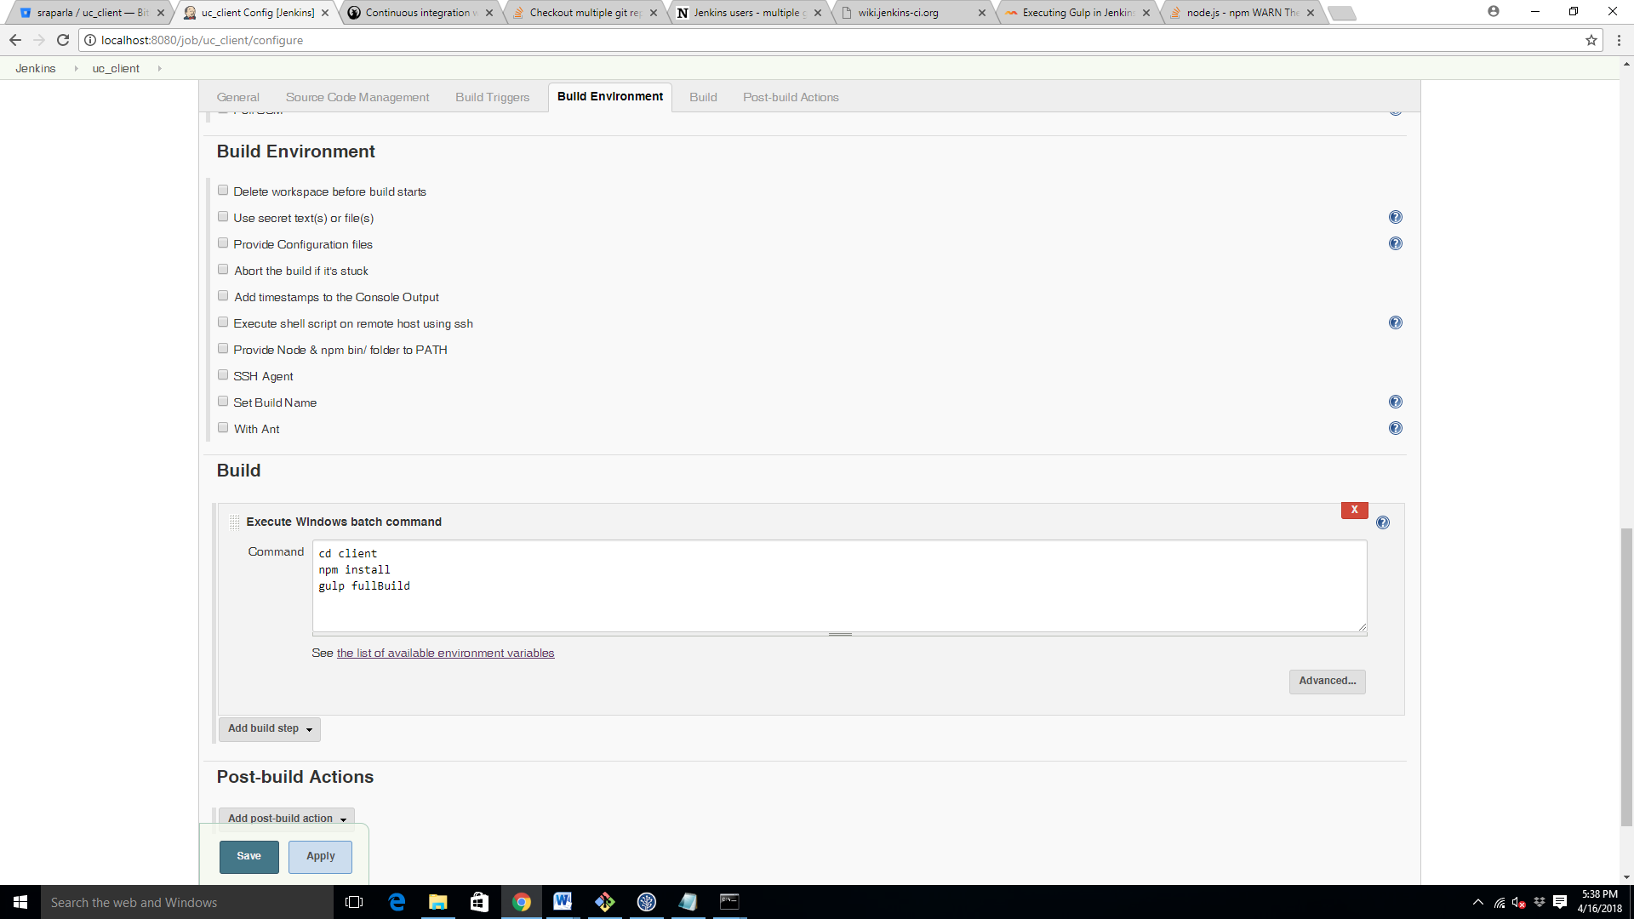

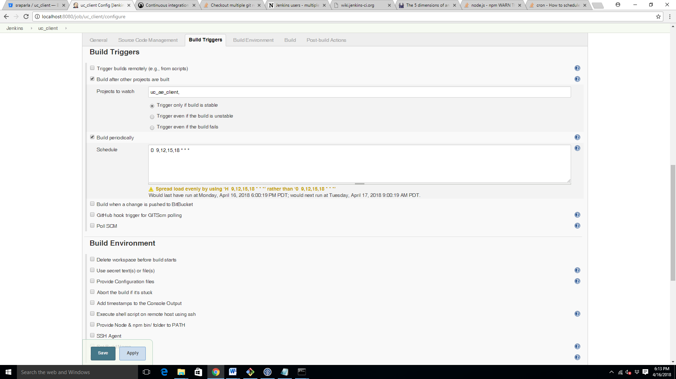

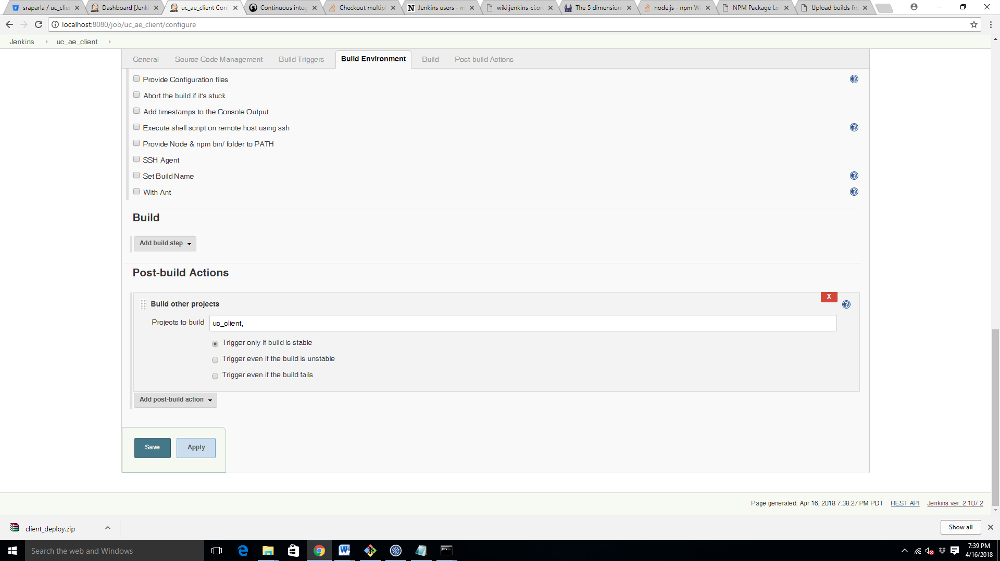

Creating uc_public deploy

