INTERNSHIP REPORT
[Task Sheduling Algorithms For Large
Language Model Inference]
Submitted To : Prof. Sanjaya Kumar Panda
Submitted By : Madana Sai Jahnavi
Ganta Padmasri Annapurna

[Due Date]

LARGE LANGUAGE MODELS

Introduction :
Large Language Models (LLM’s) it is a type of neural netwotrk that’s
trained on massive amounts of text and it’s generally trained on data that
can be found online everything from web scraping to books to transcriptions anything that is text based can be trained into a large language model.
(or)
A Large Language Model is a type of AI that can understand and generate human like text.Mainly the LLMs will try to predict the next word based on the context of the data.

Title : Task Scheduling Algorithms for Large Language Model Inference

- The rapid expansion of generative AI and its integration into daily workflows has magnified the demand for large language model (LLM)
inference services .

- The deployment of LLM models is often burdened by
- The high cost and
- Limited availability of GPU resources

- Decentralized Physical Infrastructure Network (DePIN ) Idle GPU resources globally to enable decentralized serving of LLMs

- Time per output token (TPOT) metric :
Measures the latency to generate each token after the first token.

- Shorter execution time

Scheduling Problem Definition

Given N machines in a decentralized network M1,. . ., MN , to run a
model with K layers L1,. . ., LK , we assume the following metrics are
measured in advance.

1. Layer computing latency, denoted as Tl(Mi , Lj), reflects the time
required for machine Mi to compute layer Lj .

- Network communication latency, denoted as Tn(Mi , Mj),
reflects the time required to send intermediate results from machine Mi
to machine Mj . Note that sequentially running two or more layers on
the same machine introduces nearly no latency, Tn(Mi , Mi) = 0.

- Remaining GPU memory, denoted as Rm(Mi), reflects the
available GPU memory on machine Mi for running the current
request.

- Layer memory requirement, denoted as Rl(Li), reflects how
much GPU memory the layer takes despite the differences in
machine GPU types.

We also assume these measurements are stable during the inference for a given inference request.

Now, we can define the problem more formally:

Problem 1: Find an assignment sequence A1,. . ., AK ∈ {M1,. . ., MN } to
Minimize.
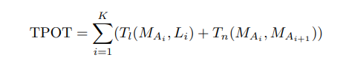(1)
where AK+1 is set to A1 for notation simplicity, such that

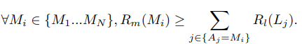(2)

With variable layer memory requirements and machines with finite memory availability, the problem of finding a valid assignment of the model layers is equivalent to the the bin packing problem, which is an
NP-hard combinatorial problem.

Algorithm Design :

There are possible approaches for solving the task scheduling problem
.
1.GHSPA (Greedy Heuristic Shortest Path Algorithm)
2.IGHSPA (Improved Greedy Heuristic Shortest Path Algorithm)
3.DPTSA (Dynamic Programming Task Scheduling Algorithm)

Table 1: Computational capacity constraints, and TPOT between
layers and GPUs

 | Rl | GPU1 | GPU2 | GPU3
L1 | 2 | 1 | 10 | 1
L2 | 4 | 10 | 1 | 10
L3 | 2 | 1 | 10 | 1
Rg |  | 5 | 6 | 5

Table 2 : Communication latency between GPUs
 | GPU1 | GPU2 | GPU3
GPU1 | 0 | 2 | 0
GPU2 | 2 | 0 | 2
GPU3 | 0 | 2 | 0

ALGORITHM 1 :

GREEDY HEURISTIC SHORTEST PATH ALGORITHM (GHSPA)
( For 3 layers and 3 GPU’S )

MATLAB Code :

clc;
clear;
close all;

tpot_values = [
1, 10, 1;
10, 1, 10;
1, 10, 1
];
layer_memory_requirements = [2; 4; 2];
initial_gpu_memory = [5, 6, 5];
comm_latency_matrix = [
0, 2, 0;
2, 0, 2;
0, 2, 0
];
path_to_analyze = [1, 1; 2, 2; 3, 2];
current_total_tpot = 0;
current_remaining_mem = initial_gpu_memory;
is_feasible = true;
for layer_idx = 1:size(path_to_analyze, 1)
layer = path_to_analyze(layer_idx, 1);
gpu = path_to_analyze(layer_idx, 2);

if layer_memory_requirements(layer) > current_remaining_mem(gpu)
is_feasible = false;
break;
end
current_remaining_mem(gpu) = current_remaining_mem(gpu) -layer_memory_requirements(layer);

layer_tpot = tpot_values(layer, gpu);
current_total_tpot = current_total_tpot + layer_tpot;

if layer_idx > 1
prev_gpu = path_to_analyze(layer_idx-1, 2);
comm_cost = comm_latency_matrix(prev_gpu, gpu);
current_total_tpot = current_total_tpot + comm_cost;
end
end

if is_feasible
final_tpot_value = current_total_tpot + 2;
fprintf('Optimal Path (GPU assignment for each layer): ');
for p_idx = 1:size(path_to_analyze, 1)
fprintf('GPU%d ', path_to_analyze(p_idx, 2));
end
fprintf('\n');
fprintf('GHSPA Value (Total Execution Time): %.2f ms\n', final_tpot_value);
else
fprintf('Path is not feasible due to memory constraints.\n');
end

OUTPUT :

ALGORITHM 2 :

IMPROVED GREEDY HEURISTIC SHORTEST PATH
ALGORITHM (IGHSPA)
( For 3 layers and 3 GPU’S )

MATLAB Code :

clc;
clear;
close all;

tpot_values = [
1, 10, 1;
10, 1, 10;
1, 10, 1
];

layer_memory_requirements = [2; 4; 2];

initial_gpu_memory = [5, 6, 5];

comm_latency_matrix = [
0, 2, 0;
2, 0, 2;
0, 2, 0
];

path_to_analyze = [1, 1; 2, 2; 3, 2];

current_total_tpot = 0;
current_remaining_mem = initial_gpu_memory;
is_feasible = true;

for layer_idx = 1:size(path_to_analyze, 1)
layer = path_to_analyze(layer_idx, 1);
gpu = path_to_analyze(layer_idx, 2);
if layer_memory_requirements(layer) > current_remaining_mem(gpu)
is_feasible = false;
break;
end
layer_tpot = tpot_values(layer, gpu);
current_total_tpot = current_total_tpot + layer_tpot;

if layer_idx > 1
prev_gpu = path_to_analyze(layer_idx-1, 2);
comm_cost = comm_latency_matrix(prev_gpu, gpu);
current_total_tpot = current_total_tpot + comm_cost;
end
end

if is_feasible
final_tpot_value = current_total_tpot;
fprintf('Optimal Path (GPU assignment for each layer): ');
for p_idx = 1:size(path_to_analyze, 1)
fprintf('GPU%d ', path_to_analyze(p_idx, 2));
end
fprintf('\n');
fprintf('IGHSPA Value : %.2f ms\n', final_tpot_value);
else
fprintf('Path is not feasible due to memory constraints.\n');
end

OUTPUT :

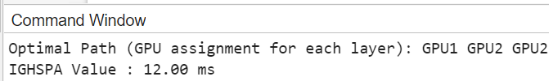

ALGORITHM 3 :

DYNAMIC PROGRAMMING TASK SCHEDULING
ALGORITHM (DPTSA)
( For 3 layers and 3 GPU’S )

MATLAB Code :

clc;
clear;
close all;

tpot = [
1, 10, 1;
10, 1, 10;
1, 10, 1
];

layer_mem = [2; 4; 2];

gpu_mem_initial = [5, 6, 5];

comm = [
0, 2, 0;
2, 0, 2;
0, 2, 0
];

num_layers = size(tpot, 1);
num_gpus = size(tpot, 2);

dp_cost = inf(num_layers, num_gpus);
dp_path = cell(num_layers, num_gpus);
dp_rem_mem = cell(num_layers, num_gpus);

for g = 1:num_gpus
if layer_mem(1) <= gpu_mem_initial(g)
dp_cost(1, g) = tpot(1, g);
dp_path{1, g} = g;
dp_rem_mem{1, g} = gpu_mem_initial;
dp_rem_mem{1, g}(g) = dp_rem_mem{1, g}(g) - layer_mem(1);
end
end

for l = 2:num_layers
current_layer_mem = layer_mem(l);
for current_gpu = 1:num_gpus
if current_layer_mem > gpu_mem_initial(current_gpu)
continue;
end

for prev_gpu = 1:num_gpus
if dp_cost(l-1, prev_gpu) ~= inf
prev_rem_mem = dp_rem_mem{l-1, prev_gpu};
if current_layer_mem <= prev_rem_mem(current_gpu)
transition_cost = tpot(l, current_gpu);
if current_gpu ~= prev_gpu
transition_cost = transition_cost + comm(prev_gpu, current_gpu);
end
total_current_cost = dp_cost(l-1, prev_gpu) + transition_cost;
if total_current_cost < dp_cost(l, current_gpu)
dp_cost(l, current_gpu) = total_current_cost;
dp_path{l, current_gpu} = [dp_path{l-1, prev_gpu}, current_gpu];
new_rem_mem = prev_rem_mem;
new_rem_mem(current_gpu) = new_rem_mem(current_gpu)- current_layer_mem;
dp_rem_mem{l, current_gpu} = new_rem_mem;
end
end
end
end
end
end

[min_total_cost, last_gpu_idx] = min(dp_cost(num_layers, :));

if min_total_cost == inf
fprintf('No feasible path found under given constraints.\n');
else
optimal_path = dp_path{num_layers, last_gpu_idx};
fprintf('Optimal Path : ');
fprintf('GPU%d ', optimal_path);
fprintf('\n');
fprintf('DPTSA Value: %.2f ms\n', min_total_cost);
final_mem_check = gpu_mem_initial;
for l_idx = 1:num_layers
assigned_gpu = optimal_path(l_idx);
final_mem_check(assigned_gpu) = final_mem_check(assigned_gpu) -
layer_mem(l_idx);
end
end

OUTPUT :

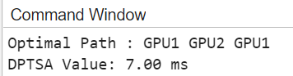

Conclusion From 3 Algorithms :
DPTSA > IGHSPA > GHSPA

ALGORITHM 4 :

IMPROVED DYNAMIC PROGRAMMING TASK SCHEDULING
ALGORITHM (IDPTSA)
( For 3 layers and 3 GPU’S [IDPTSA =GHSPA(Logic) + DPTSA])

MATLAB Code :

clc;
clear;
close all;
tpot = [
1, 10, 1;
10, 1, 10;
1, 10, 1
];
layer_mem = [2; 4; 2];
gpu_mem_initial = [5, 6, 5];
comm = [
0, 2, 0;
2, 0, 2;
0, 2, 0
];
num_layers = size(tpot, 1);
num_gpus = size(tpot, 2);
dp_cost = inf(num_layers, num_gpus);
dp_path = cell(num_layers, num_gpus);
dp_rem_mem = cell(num_layers, num_gpus);
if layer_mem(1) <= gpu_mem_initial(1)
dp_cost(1, 1) = tpot(1, 1);
dp_path{1, 1} = [1]; % Path starts with GPU 1
dp_rem_mem{1, 1} = gpu_mem_initial;
dp_rem_mem{1, 1}(1) = dp_rem_mem{1, 1}(1) - layer_mem(1);
end
for l = 2:num_layers-1
current_layer_mem = layer_mem(l);
for current_gpu = 1:num_gpus
for prev_gpu = 1:num_gpus
if dp_cost(l-1, prev_gpu) ~= inf
prev_rem_mem = dp_rem_mem{l-1, prev_gpu};
if current_layer_mem <= prev_rem_mem(current_gpu)
transition_cost = tpot(l, current_gpu);
if current_gpus ~= prev_gpu
transition_cost = transition_cost +
comm(prev_gpu, current_gpu);
end
total_current_cost = dp_cost(l-1, prev_gpu) +
transition_cost;
if total_current_cost < dp_cost(l, current_gpu)
dp_cost(l, current_gpu) = total_current_cost;
dp_path{l, current_gpu} = [dp_path{l-1,
prev_gpu}, current_gpu];
new_rem_mem = prev_rem_mem;
new_rem_mem(current_gpu) =
new_rem_mem(current_gpu) -
current_layer_mem;
dp_rem_mem{l, current_gpu} =
new_rem_mem;
end
end
end
end
end
end

min_cost_to_final_gpu1 = inf;
optimal_final_path = [];

for prev_gpu = 1:num_gpus
if dp_cost(num_layers-1, prev_gpu) ~= inf

prev_rem_mem = dp_rem_mem{num_layers-1, prev_gpu};

if layer_mem(num_layers) <= prev_rem_mem(1)

transition_cost = tpot(num_layers, 1);

if 1 ~= prev_gpu
transition_cost = transition_cost + comm(prev_gpu, 1);
end

current_final_cost = dp_cost(num_layers-1, prev_gpu) +
transition_cost;

if current_final_cost < min_cost_to_final_gpu1
min_cost_to_final_gpu1 = current_final_cost;
optimal_final_path = [dp_path{num_layers-1, prev_gpu},
1];
end
end
end
end

fprintf('--- Modified DPTSA (Dynamic Programming with GHSPA
Constraints) ---\n');
if min_cost_to_final_gpu1 == inf
fprintf('No feasible path found under given constraints.\n');
else
fprintf('Optimal Path : ');
fprintf('GPU%d ', optimal_final_path);
fprintf('\n');
fprintf('Modified DPTSA: %.2f ms\n', min_cost_to_final_gpu1);
end

OUTPUT :

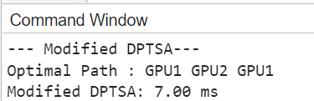

ALGORITHM FOR N LAYERS :

GHSPA & IGHSPA & DPTSA ( For N layers and 5 GPU’s )

MATLAB Code :

function gpu_tpot_analyzer()
clc;
fprintf('=== GPU TPOT Analyzer ===\n');

input_file = input('Enter input filename (e.g., layer10.txt): ', 's');

if isempty(input_file)
input_file = 'layer10.txt'; % Default filename
end

[tpot_matrix, success, num_layers] = process_input_file(input_file);
if ~success, return; end

fprintf('Detected %d layers in input file\n', num_layers);

[optimal_paths, tpot_values] = calculate_tpot_and_paths(tpot_matrix,
num_layers);

output_file = sprintf('gpu_tpot_results_%dlayers.xlsx', num_layers);
export_to_excel(tpot_matrix, optimal_paths, tpot_values,
ghspa_tpot,ghspa_path, output_file, num_layers);

fprintf('\n=== GHSPA Results ===\n');
fprintf('Minimum TPOT: %d\nPath: %s\n', ghspa_tpot,
path_to_string(ghspa_path));
fprintf('\nResults saved to: %s\n', output_file);
winopen(output_file);
end
function [tpot_matrix, success, num_layers] = process_input_file(input_file)
success = false;
num_layers = 0;
try
if ~exist(input_file, 'file')
error('File not found: %s', input_file);
end
fid = fopen(input_file, 'r');
raw_data = textscan(fid, '%s', 'Delimiter', '\n');
fclose(fid);

num_layers = numel(raw_data{1});
tpot_matrix = zeros(num_layers, 5); % 5 GPUs

for i = 1:num_layers
line = strrep(raw_data{1}{i}, 'o', '0'); % Handle 'o' as zero
nums = sscanf(line, '%f')';
if length(nums) ~= 5
error('Line %d must contain exactly 5 values', i);
end
tpot_matrix(i,:) = nums;
end
success = true;
catch ME
fprintf('Error: %s\n', ME.message);
tpot_matrix = [];
end
end
function [optimal_paths, tpot_values] =
calculate_tpot_and_paths(tpot_matrix, num_layers)
comm_latency = 2; % Communication cost
tpot_values = zeros(1, 5);
optimal_paths = cell(1, 5);

for start_gpu = 1:5
path = start_gpu;
total_tpot = tpot_matrix(1, start_gpu);

for layer = 2:num_layers
current_gpu = path(end);
costs = tpot_matrix(layer,:) + (comm_latency*(1:5 ~=
current_gpu));
[~, next_gpu] = min(costs);
path = [path, next_gpu];
total_tpot = total_tpot + costs(next_gpu);
end

optimal_paths{start_gpu} = path;
tpot_values(start_gpu) = total_tpot;
end
end

function export_to_excel(tpot_matrix, optimal_paths, tpot_values,
ghspa_tpot, ghspa_path, output_file, num_layers)

headers = {'Layer', 'GPU1', 'GPU2', 'GPU3', 'GPU4', 'GPU5'};
layer_labels = arrayfun(@(x) sprintf('Layer %d', x), 1:num_layers,
'UniformOutput', false)';
raw_data = [headers; [layer_labels, num2cell(tpot_matrix)]];
writecell(raw_data, output_file, 'Sheet', 'Raw Data');

results = {'GPU', 'Total TPOT', 'Optimal Path'};
for gpu = 1:5
path_str = path_to_string(optimal_paths{gpu});
results = [results; {sprintf('GPU%d',gpu), tpot_values(gpu),
path_str}];
end

results = [results; {'GHSPA', ghspa_tpot, path_to_string(ghspa_path)}];

writecell(results, output_file, 'Sheet', 'Results');
end
function str = path_to_string(path)
str = strjoin(arrayfun(@(x) sprintf('GPU%d',x), path, 'UniformOutput',
false), ' → ');
End

NOTE:
( First you create the files in one folder and then output also saves to that
folder. )

OUTPUT :
(The output is saved in excel sheet.) 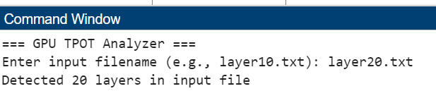

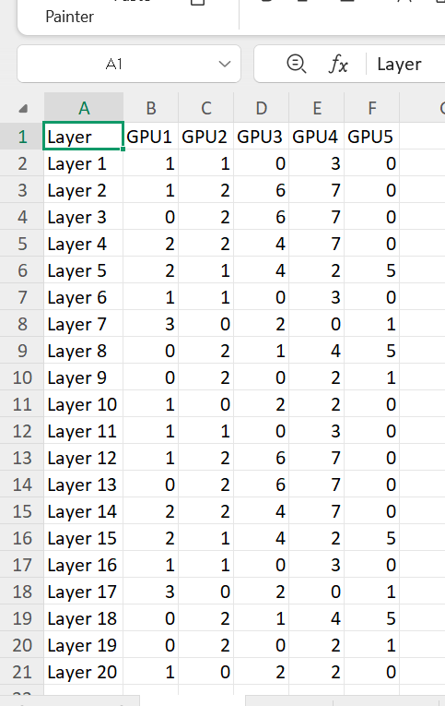

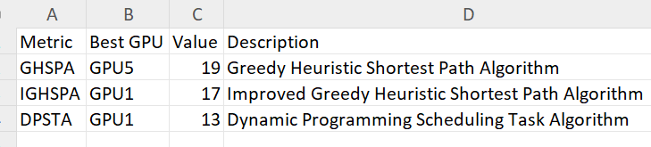

- CONCEPT ON TRADE OFF TASK ASSIGNMENT WRT TIME &
COST
“Each task is assigned to the machine that minimizes the trade-off , defined as a weighted combination of time and cost, using the formula :
F(x) = λ . T(x) + ( 1-λ) . C(x)

Where F(x) = Trade Off ,
T(x) = Time,
C(x)= Cost,
λ = parameter values(0.25 - Low Time and High cost ;
0.5 - Equilibrium Constant ;
0.75 - High time and Low Cost)

“ This Algorithm allocates that best machine (GPU) to the layers “.

For Example,

We can take the 5 GPUs and 5 layers with Time matrix and Cost
Matrix. By this it can allocate the best gpu’s to the layers :

MATLAB Code :

time_matrix = [
1 8 2 5 1;
6 1 7 1 6;
2 5 1 4 1;
1 3 6 1 5;
4 1 3 5 1
];
cost_matrix = [
5 7 3 2 4;
6 4 3 5 1;
2 6 7 5 1;
3 2 4 6 5;
5 4 3 1 6
];
lambda = 0.5;
[num_layers, num_machines] = size(time_matrix);
assignments = zeros(1, num_layers);
assigned_times = zeros(1, num_layers);
assigned_costs = zeros(1, num_layers);
assigned_m_values = zeros(1, num_layers);

for i = 1:num_layers
fprintf('Layer %d:\n', i);

for j = 1:num_machines
fprintf(' Machine %d: Time = %d, Cost = %d\n', j, time_matrix(i,j),
cost_matrix(i,j));
end
m_values = lambda * time_matrix(i,:) + (1 - lambda) * cost_matrix(i,:);

fprintf(' Combined m values: ');
fprintf('%.2f ', m_values);
fprintf('\n');

[min_m_value, best_machine] = min(m_values);
assignments(i) = best_machine;
assigned_times(i) = time_matrix(i, best_machine);
assigned_costs(i) = cost_matrix(i, best_machine);
assigned_m_values(i) = min_m_value;

fprintf(' ==> Best Machine: %d with Time = %d, Cost = %d, m-value
= %.2f\n\n', ...
best_machine, assigned_times(i), assigned_costs(i), min_m_value);
end
TPOT = sum(assigned_times);
total_cost = sum(assigned_costs);
total_m = sum(assigned_m_values);

fprintf('Summary:\n');
fprintf('Total Processing Time (TPOT): %d\n', TPOT);
fprintf('Total Cost: %d\n', total_cost);

fprintf('Layer assignments (Layer -> Best Machine):\n');
for i = 1:num_layers
fprintf(' Layer %d -> Machine %d\n', i, assignments(i));
end

OUTPUT :

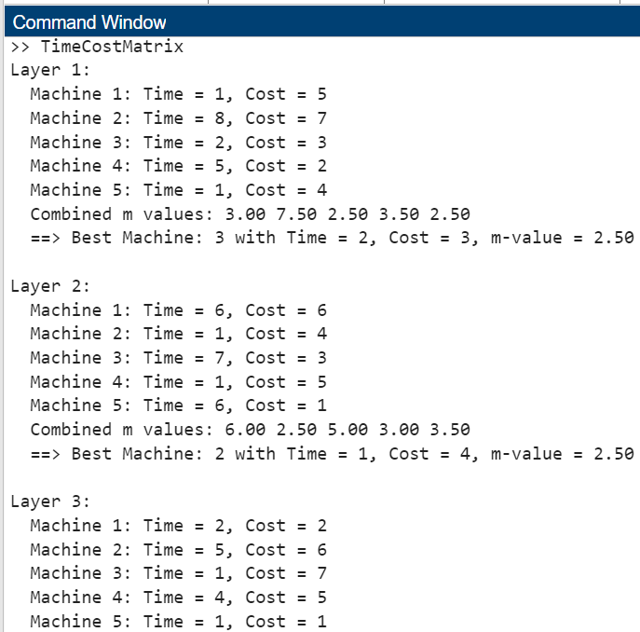
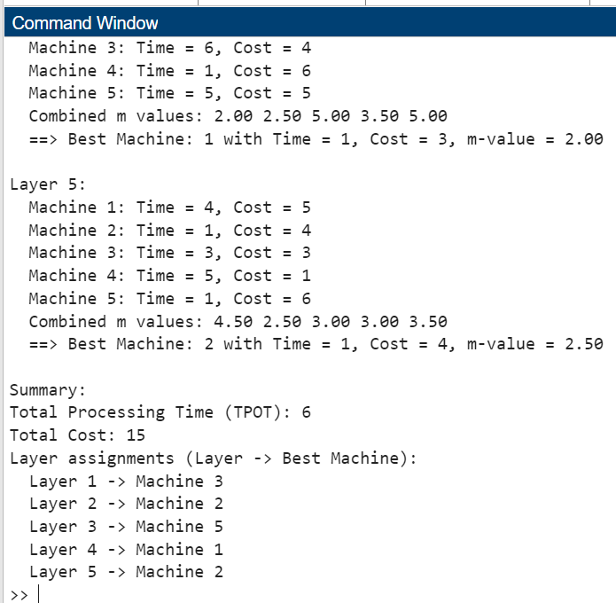

ALGORITHM 5:

GREEDY HEURISTIC SHORTEST PATH ALGORITHM WRT TIME
& COST (GHSPA 1)
( For N layers and 5 gpu’s )

MATLAB Code :

function greedy_ghspa_scheduler()
time_matrix = dlmread('time100gpu5.txt');
cost_matrix = dlmread('cost100gpu5.txt');

comm_matrix = [
0, 3, 2, 4, 1;
4, 0, 1, 2, 3;
3, 2, 0, 5, 2;
5, 1, 4, 0, 3;
2, 4, 3, 2, 0
];

layer_mem = 3 * ones(1, size(time_matrix, 1));
gpu_mem = [7, 8, 6, 7, 10];
lambda = 0.25;

num_layers = size(time_matrix, 1);
num_gpus = size(time_matrix, 2);
path = zeros(1, num_layers);
total_time = 0;
total_cost = 0;
total_comm = 0;

for layer = 1:num_layers
best_gpu = 0;
min_cost = Inf;
current_comm = 0;

for gpu = 1:num_gpus
if gpu_mem(gpu) >= layer_mem(layer)
if layer == 1
comm = 0;
else
if path(layer-1) > 0 && path(layer-1) <=
size(comm_matrix, 1) && ...
gpu > 0 && gpu <= size(comm_matrix, 2)
comm = comm_matrix(path(layer-1), gpu);
else
warning('Invalid GPU index for communication
matrix at layer %d: prev_gpu=%d,
current_gpu=%d', layer, path(layer-1), gpu);
comm = Inf;
end
end

cost = lambda * (time_matrix(layer, gpu) + comm) + ...
(1 - lambda) * cost_matrix(layer, gpu);

if cost < min_cost
min_cost = cost;
best_gpu = gpu;
current_comm = comm;
end
end
end

if best_gpu == 0
error('No GPU has sufficient memory for layer %d
(required: %gGB)', layer, layer_mem(layer));
end

path(layer) = best_gpu;

total_time = total_time + time_matrix(layer, best_gpu);
total_cost = total_cost + cost_matrix(layer, best_gpu);
total_comm = total_comm + current_comm;
end

ghspa_value = lambda*(total_time + total_comm) + (1-lambda)*total_cost;

path_str_cells = cell(1, num_layers);
for i = 1:num_layers
path_str_cells{i} = sprintf('gpu%d', path(i));
end
optimal_path_display = strjoin(path_str_cells, '->');

output_data = {'Optimal Path', optimal_path_display; ...
'GHSPA Value', ghspa_value};

fprintf('Optimal Path: %s\n', optimal_path_display);
fprintf('GHSPA Value: %.2f\n', ghspa_value);
end

OUTPUT :

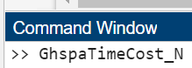
Optimal Path: gpu3->gpu3->gpu1->gpu1->gpu1->gpu3->gpu1->gpu2->gpu3->gpu3->gpu3->gpu3->gpu1->gpu1->gpu1->gpu3->gpu1->gpu2->gpu3->gpu3->gpu3->gpu3->gpu1->gpu1->gpu1->gpu3->gpu1->gpu2->gpu3->gpu3->gpu3->gpu3->gpu1->gpu1->gpu1->gpu3->gpu1->gpu2->gpu3->gpu3->gpu3->gpu3->gpu1->gpu1->gpu1->gpu3->gpu1->gpu2->gpu3->gpu3->gpu3->gpu3->gpu1->gpu1->gpu1->gpu3->gpu1->gpu2->gpu3->gpu3->gpu3->gpu3->gpu1->gpu1->gpu1->gpu3->gpu1->gpu2->gpu3->gpu3->gpu3->gpu3->gpu1->gpu1->gpu1->gpu3->gpu1->gpu2->gpu3->gpu3->gpu3->gpu3->gpu1->gpu1->gpu1->gpu3->gpu1->gpu2->gpu3->gpu3->gpu3->gpu3->gpu1->gpu1->gpu1->gpu3->gpu1->gpu2->gpu3->gpu3
GHSPA Value: 365.00

Note :

[ First you have to Create the input files for time and cost as shown below ]

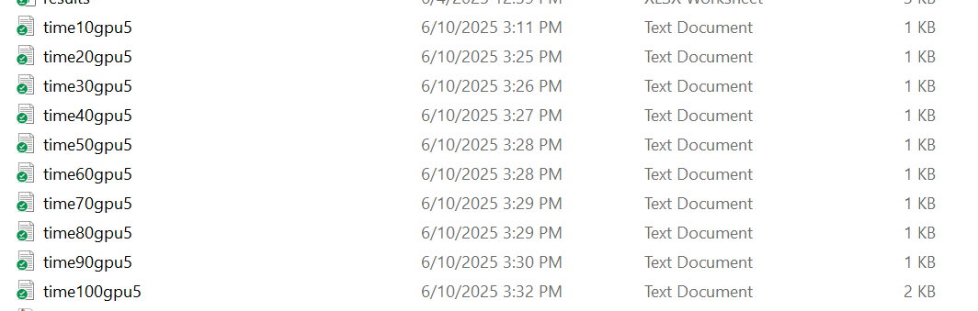

[ I have created the TIME MATRIX files as shown in the above picture ]

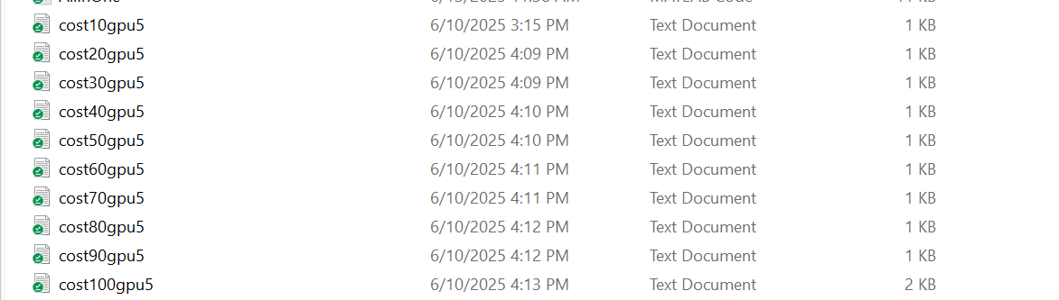

[ I have created the COST MATRIX files as shown in the above picture ]

ALGORITHM 6 :

IMPROVED GREEDY HEURISTIC SHORTEST PATH
ALGORITHM WRT TIME & COST (IGHSPA 1)
( For N layers and 5 gpu’s )

MATLAB Code :

function [best_path, ighspa_value] = IghspaTimeCost()
try
time_matrix = dlmread('time100gpu5.txt');
cost_matrix = dlmread('cost100gpu5.txt');

layer_mem = ones(1, 100);
gpu_mem = [16, 24, 32, 16, 24];
lambda = 0.25;

[best_path, ighspa_value] = calculate_ighspa(time_matrix, cost_matrix,
lambda, layer_mem, gpu_mem);

fprintf('IGHSPA Value: %.2f\n', ighspa_value);
fprintf('Optimal Path: ');
fprintf('gpu%d->', best_path(1:end-1));
fprintf('gpu%d\n', best_path(end));

if nargout == 0
clear best_path ighspa_value;
end

catch ME
error('Error in IGHSPA calculation: %s', ME.message);
end
end
function [best_path, ighspa_value] = calculate_ighspa(time_mat, cost_mat,
lambda, layer_mem, gpu_mem)
num_layers = length(layer_mem);
num_gpus = length(gpu_mem);

best_path = ones(1, num_layers);
ighspa_value = Inf;

remaining_mem = gpu_mem;
for layer = 1:num_layers
valid_gpus = find(remaining_mem >= layer_mem(layer));
if isempty(valid_gpus)
error('No valid allocation for layer %d', layer);
end

m_values = lambda * time_mat(layer, valid_gpus) + (1-lambda) *
cost_mat(layer, valid_gpus);
[~, idx] = min(m_values);
best_path(layer) = valid_gpus(idx);
remaining_mem(best_path(layer)) = remaining_mem(best_path(layer))
- layer_mem(layer);
end

total_time = sum(time_mat(sub2ind(size(time_mat), 1:num_layers,
best_path)));
total_cost = sum(cost_mat(sub2ind(size(cost_mat), 1:num_layers,
best_path)));
ighspa_value = lambda * total_time + (1-lambda) * total_cost;
end

OUTPUT :

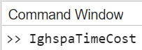
IGHSPA Value: 372.50
Optimal Path: gpu3->gpu3->gpu1->gpu2->gpu1->gpu3-
>gpu1->gpu2->gpu3->gpu3->gpu3->gpu3->gpu1->gpu2->gpu1->gpu3->gpu1->gpu2->gpu3->gpu3->gpu3->gpu3->gpu1->gpu2->gpu1->gpu3->gpu1->gpu2->gpu3->gpu3->gpu3->gpu3->gpu1->gpu2->gpu1->gpu3->gpu1->gpu2->gpu3->gpu3->gpu3->gpu3->gpu1->gpu2->gpu1->gpu3->gpu1->gpu2->gpu3->gpu3->gpu3->gpu3->gpu1->gpu2->gpu3->gpu3->gpu4->gpu2->gpu3->gpu3->gpu3->gpu2->gpu4->gpu2->gpu2->gpu2->gpu4->gpu2->gpu4->gpu4->gpu4->gpu2->gpu4->gpu2->gpu2->gpu2->gpu4->gpu2->gpu4->gpu4->gpu4->gpu2->gpu4->gpu2->gpu4->gpu4->gpu4->gpu5->gpu4->gpu5->gpu5->gpu5->gpu5->gpu5->gpu5->gpu5->gpu5->gpu5->gpu5->gpu5

ALGORITHM 7 :

DYNAMIC PROGRAMMING TASK SCHEDULING
ALGORITHM WRT TIME & COST (DPTSA 1)
( For N layers and 5 GPU’S )

MATLAB Code :

function dptsa()
clc;
clear;
close all;

time_matrix = dlmread('time10gpu5.txt');
cost_matrix = dlmread('cost10gpu5.txt');
comm_matrix = [
0, 3, 2, 4, 1;
4, 0, 1, 2, 3;
3, 2, 0, 5, 2;
5, 1, 4, 0, 3;
2, 4, 3, 2, 0
];
layer_mem = ones(1, 10);
gpu_mem = [16, 24, 32, 16, 24];
lambda = 0.25;

tpot = time_matrix;
comm = comm_matrix;
gpu_mem_initial = gpu_mem;

num_layers = size(tpot, 1);
num_gpus = size(tpot, 2);

dp_cost = inf(num_layers, num_gpus);
dp_path = cell(num_layers, num_gpus);
dp_rem_mem = cell(num_layers, num_gpus);

for g = 1:num_gpus
if layer_mem(1) <= gpu_mem_initial(g)
dp_cost(1, g) = tpot(1, g);
dp_path{1, g} = g;
dp_rem_mem{1, g} = gpu_mem_initial;
dp_rem_mem{1, g}(g) = dp_rem_mem{1, g}(g) -
layer_mem(1);
end
end

for l = 2:num_layers
current_layer_mem = layer_mem(l);
for current_gpu = 1:num_gpus
if current_layer_mem > gpu_mem_initial(current_gpu)
continue;
end
for prev_gpu = 1:num_gpus
if dp_cost(l-1, prev_gpu) ~= inf
prev_rem_mem = dp_rem_mem{l-1, prev_gpu};
if current_layer_mem <=
prev_rem_mem(current_gpu)
transition_cost = tpot(l, current_gpu);
if current_gpu ~= prev_gpu
transition_cost = transition_cost +
comm(prev_gpu, current_gpu);
end

total_current_cost = dp_cost(l-1, prev_gpu) +
transition_cost;

if total_current_cost < dp_cost(l, current_gpu)
dp_cost(l, current_gpu) =
total_current_cost;
dp_path{l, current_gpu} = [dp_path{l-1,
prev_gpu}, current_gpu];
new_rem_mem = prev_rem_mem;
new_rem_mem(current_gpu) =
new_rem_mem(current_gpu) -
current_layer_mem;
dp_rem_mem{l, current_gpu} =
new_rem_mem;
end
end
end
end
end
end

[min_total_cost, last_gpu_idx] = min(dp_cost(num_layers, :));

if min_total_cost == inf
fprintf('No feasible path found under given constraints.\n');
else
optimal_path = dp_path{num_layers, last_gpu_idx};

fprintf('Optimal Path : ');
fprintf('GPU%d ', optimal_path);
fprintf('\n');
fprintf('DPTSA Value: %.2f ms\n', min_total_cost);

final_mem_check = gpu_mem_initial;
for l_idx = 1:num_layers
assigned_gpu = optimal_path(l_idx);
final_mem_check(assigned_gpu) =
final_mem_check(assigned_gpu) - layer_mem(l_idx);
end
end
end

OUTPUT :


Optimal Path : GPU5 GPU5 GPU5 GPU5 GPU5 GPU5 GPU5 GPU5
GPU5 GPU5 GPU5 GPU5 GPU5 GPU5 GPU5 GPU5 GPU5 GPU5 GPU5
GPU5 GPU5 GPU5 GPU5 GPU5 GPU4 GPU4 GPU4 GPU2 GPU2 GPU2
GPU2 GPU2 GPU2 GPU2 GPU2 GPU2 GPU2 GPU2 GPU2 GPU2 GPU2
GPU2 GPU2 GPU2 GPU2 GPU2 GPU2 GPU2 GPU2 GPU2 GPU2 GPU4
GPU4 GPU4 GPU4 GPU4 GPU4 GPU4 GPU4 GPU4 GPU4 GPU4 GPU4
GPU1 GPU1 GPU1 GPU1 GPU1 GPU1 GPU1 GPU1 GPU1 GPU1 GPU1
GPU1 GPU1 GPU1 GPU1 GPU1 GPU3 GPU3 GPU3 GPU3 GPU3 GPU3
GPU3 GPU3 GPU3 GPU3 GPU3 GPU3 GPU3 GPU3 GPU3 GPU3 GPU3
GPU3 GPU3 GPU3 GPU3
DPTSA Value: 339.50 ms

ALGORITHM 8 :

IMPROVED DYNAMIC PROGRAMMING TASK SCHEDULING
ALGORITHM WRT TIME & COST (IDPTSA 1)
( For N layers and 5 GPU’S [IDPTSA =GHSPA(Logic) + DPTSA])

MATLAB Code :

function dptsa()
clc;
clear;
close all;

time_matrix = dlmread('time100gpu5.txt');
cost_matrix = dlmread('cost100gpu5.txt');
comm_matrix = [
0, 3, 2, 4, 1;
4, 0, 1, 2, 3;
3, 2, 0, 5, 2;
5, 1, 4, 0, 3;
2, 4, 3, 2, 0
];
layer_mem = ones(1, 100);
gpu_mem = [16, 24, 32, 16, 24];
lambda = 0.25;

tpot = time_matrix;
comm = comm_matrix;
gpu_mem_initial = gpu_mem;

num_layers = size(tpot, 1);
num_gpus = size(tpot, 2);

dp_cost = inf(num_layers, num_gpus);
dp_path = cell(num_layers, num_gpus);
dp_rem_mem = cell(num_layers, num_gpus);

for g = 1:num_gpus
dp_cost(1, g) = lambda * time_matrix(1, g) + (1 - lambda) *
cost_matrix(1, g);

dp_path{1, g} = g;
dp_rem_mem{1, g} = gpu_mem_initial;
dp_rem_mem{1, g}(g) = dp_rem_mem{1, g}(g) - layer_mem(1);
end

for l = 2:num_layers
current_layer_mem = layer_mem(l);
for current_gpu = 1:num_gpus
if current_layer_mem > gpu_mem_initial(current_gpu)
continue;
end
for prev_gpu = 1:num_gpus
if dp_cost(l-1, prev_gpu) ~= inf
prev_rem_mem = dp_rem_mem{l-1, prev_gpu};
if current_layer_mem <= prev_rem_mem(current_gpu)

exec_time_current = time_matrix(l, current_gpu);

resource_cost_current = cost_matrix(l,
current_gpu);

comm_cost = 0;
if current_gpu ~= prev_gpu
comm_cost = comm_matrix(prev_gpu,
current_gpu);
end

weighted_transition_cost = lambda *
(exec_time_current + comm_cost) + (1 -
lambda) *
resource_cost_current;

total_current_cost = dp_cost(l-1, prev_gpu) +
weighted_transition_cost;

if total_current_cost < dp_cost(l, current_gpu)
dp_cost(l, current_gpu) = total_current_cost;
dp_path{l, current_gpu} = [dp_path{l-1,
prev_gpu}, current_gpu];
new_rem_mem = prev_rem_mem;
new_rem_mem(current_gpu) =
new_rem_mem(current_gpu) -
current_layer_mem;
dp_rem_mem{l, current_gpu} =
new_rem_mem;
end
end
end
end
end
end

[min_total_cost, last_gpu_idx] = min(dp_cost(num_layers, :));

if min_total_cost == inf
fprintf('No feasible path found under given constraints.\n');
else
optimal_path = dp_path{num_layers, last_gpu_idx};

fprintf('Optimal Path : ');
fprintf('GPU%d ', optimal_path);
fprintf('\n');
fprintf('IDPTSA Value : %.2f\n', min_total_cost);

final_mem_check = gpu_mem_initial;
for l_idx = 1:num_layers
assigned_gpu = optimal_path(l_idx);
final_mem_check(assigned_gpu) =
final_mem_check(assigned_gpu) - layer_mem(l_idx);
end
end
end
OUTPUT :


Optimal Path : GPU3 GPU3 GPU1 GPU1 GPU1 GPU1 GPU1 GPU2
GPU3 GPU3 GPU3 GPU3 GPU1 GPU1 GPU1 GPU1 GPU1 GPU2 GPU3
GPU3 GPU3 GPU3 GPU1 GPU1 GPU1 GPU1 GPU1 GPU2 GPU3 GPU3
GPU3 GPU3 GPU1 GPU2 GPU3 GPU3 GPU4 GPU2 GPU3 GPU3 GPU3
GPU3 GPU3 GPU2 GPU3 GPU3 GPU4 GPU2 GPU3 GPU3 GPU3 GPU3
GPU3 GPU2 GPU3 GPU3 GPU4 GPU2 GPU3 GPU3 GPU4 GPU4 GPU4
GPU2 GPU2 GPU2 GPU4 GPU2 GPU4 GPU4 GPU4 GPU4 GPU4 GPU2
GPU2 GPU2 GPU4 GPU2 GPU4 GPU4 GPU4 GPU2 GPU2 GPU2 GPU2 GPU2 GPU2 GPU2 GPU5 GPU5 GPU5 GPU5 GPU5 GPU5 GPU5 GPU5 GPU5
GPU5 GPU5 GPU5
IDPTSA Value : 345.50

ALL IN ONE CODE ( For 5 layers and 5 gpu’s )

ALGORITHM (I) :

GREEDY HEURISTIC SHORTEST PATH ALGORITHM WRT
TIME & COST (GHSPA_T & W)
( For 5 layers and 5 GPU’S )

ALGORITHM (II) :

IMPROVED GREEDY HEURISTIC SHORTEST PATH
ALGORITHM WRT TIME & COST (GHSPA_T & W)
( For 5 layers and 5 GPU’S )

ALGORITHM (III) :

DYNAMIC PROGRAMMING TASK SCHEDULING ALGORITHM
WRT TIME & COST (DPTSA_T & W)
( For 5 layers and 5 GPU’S )

EXAMPLE :

I am taking the input time_matrix and cost_matrix as some values and
For that I used to find the best way for assigning the machines to the layers.

AIM :
To Write the code to Find the best Algorithm which gives the minimum Tpot value .

DESCRIPTION :
This code compares three GPU scheduling algorithms for assigning
computational layers: GHSPA, a greedy heuristic selecting the best
immediate GPU per layer while managing memory and communication;
IGHSPA, a simpler greedy approach that seeks a single GPU for all layers
to eliminate communication, if feasible; and DPTSA, an exact dynamic
programming solution guaranteeing the globally optimal allocation
considering all time, cost, memory, and communication factors and it
gives the best algorithm for assinging the machines to the layers.

MATLAB Code :

clc;
clear;
close all;

--- Common Input Data ---
time_matrix = [ 1 8 2 5 1;
6 1 7 1 6;
2 5 1 4 1;
1 3 6 1 5;
4 1 3 5 1];

cost_matrix = [ 5 7 3 2 4;
6 4 3 5 1;
2 6 7 5 1;
3 2 4 6 5;
5 4 3 1 6];

comm_matrix = [ 0 3 1 2 1;
3 0 2 1 3;
1 2 0 2 1;
2 1 2 0 3;
1 3 1 3 0];

lambda = 0.5;

layer_mem = [3, 5, 2, 4, 3];
gpu_mem = [7, 8, 6, 7, 10];

--- Run GHSPA Algorithm ---
disp('--- Running GHSPA (Greedy Heuristic - Layer-by-Layer Assignment) ---
');
[ghspa_value, ghspa_path, ghspa_total_time, ghspa_total_cost] = ...
ghspa_scheduler(time_matrix, cost_matrix, layer_mem, gpu_mem,
comm_matrix, lambda);
fprintf('Greedy Optimal Path (GHSPA): ');
fprintf('GPU%d ', ghspa_path(1:end-1));
fprintf('GPU%d\n', ghspa_path(end));
fprintf('GHSPA Value (λ=%.1f): %.2f\n', lambda, ghspa_value);

--- Run IGHSPA Algorithm ---
disp('--- Running IGHSPA (Improved Greedy Heuristic - Single GPU
Assignment) ---');
[ighspa_value, ighspa_path, ighspa_total_time, ighspa_total_cost] = ...
ighspa_scheduler(time_matrix, cost_matrix, layer_mem, gpu_mem,
comm_matrix, lambda);
fprintf('Optimal GPU Path (IGHSPA - Single GPU): ');
fprintf('GPU%d ', ighspa_path(1:end-1));
fprintf('GPU%d\n', ighspa_path(end));
fprintf('IGHSPA Value (λ=%.1f): %.2f\n', lambda, ighspa_value);

--- Run DPTSA Algorithm ---
disp('--- Running DPTSA (Dynamic Programming - Exact) ---');
[dptsa_value, dptsa_path, dptsa_total_time, dptsa_total_cost] = ...
dptsa_time_cost_single_comm(time_matrix, cost_matrix, layer_mem,
gpu_mem, comm_matrix, lambda);
if isnan(dptsa_value)
disp('DPTSA: No feasible path found considering memory constraints.');
else
disp(['Optimal GPU Path (DPTSA): ', sprintf('GPU%d ', dptsa_path)]);
disp(['DPTSA Value (lambda=', num2str(lambda), '): ',
num2str(dptsa_value)]);
end
fprintf('\n');
function [ghspa_value, path, total_time_actual, total_cost_actual] =
ghspa_scheduler(time_matrix, cost_matrix, layer_mem, gpu_mem,
comm_matrix, lambda)
num_layers = size(time_matrix, 1);
num_gpus = size(time_matrix, 2);
path = zeros(1, num_layers);
remaining_mem = gpu_mem;
total_time_actual = 0;
total_cost_actual = 0;

for layer = 1:num_layers
best_gpu = 0;
min_immediate_weighted_cost = Inf;
current_layer_proc_time_chosen = 0;
current_layer_proc_cost_chosen = 0;
current_layer_comm_cost_chosen = 0;

for gpu = 1:num_gpus
if layer_mem(layer) <= remaining_mem(gpu)
comm_cost_candidate = 0;
if layer > 1
if gpu ~= path(layer-1)
comm_cost_candidate =
comm_matrix(path(layer-1), gpu);
end
end

immediate_weighted_cost_candidate = ...
lambda * (time_matrix(layer, gpu) +
comm_cost_candidate) + ...
(1 - lambda) * (cost_matrix(layer, gpu) +
comm_cost_candidate);

if immediate_weighted_cost_candidate <
min_immediate_weighted_cost
min_immediate_weighted_cost =
immediate_weighted_cost_candidate;
best_gpu = gpu;
current_layer_proc_time_chosen = time_matrix(layer,
gpu);
current_layer_proc_cost_chosen = cost_matrix(layer,
gpu);
current_layer_comm_cost_chosen =
comm_cost_candidate;
end
end
end

if best_gpu == 0
error('No feasible GPU found for layer %d (memory constraints
or all paths too costly)', layer);
end

path(layer) = best_gpu;
remaining_mem(best_gpu) = remaining_mem(best_gpu) -
layer_mem(layer);
total_time_actual = total_time_actual +
current_layer_proc_time_chosen +
current_layer_comm_cost_chosen;
total_cost_actual = total_cost_actual +
current_layer_proc_cost_chosen +
current_layer_comm_cost_chosen;
end
ghspa_value = lambda * total_time_actual + (1 - lambda) *
total_cost_actual;
end

function [weighted_value, path, total_time, total_cost] =
ighspa_scheduler(time_matrix, cost_matrix, layer_mem, gpu_mem,
comm_matrix, lambda)
num_layers = size(time_matrix, 1);
num_gpus = size(time_matrix, 2);

candidate_total_times = zeros(1, num_gpus);
candidate_total_costs = zeros(1, num_gpus);

candidate_total_times(:) = Inf;
candidate_total_costs(:) = Inf;

for gpu = 1:num_gpus
if all(layer_mem <= gpu_mem(gpu))
candidate_total_times(gpu) = sum(time_matrix(:, gpu));
candidate_total_costs(gpu) = sum(cost_matrix(:, gpu));
end
end

[min_total_time, best_gpu_idx] = min(candidate_total_times);

if isinf(min_total_time)
weighted_value = NaN;
path = NaN(1, num_layers);
total_time = NaN;
total_cost = NaN;
error('IGHSPA: No single GPU can fit all layers for calculation.
Consider relaxing memory constraints or using a different
scheduler.');
end

total_time = min_total_time;
total_cost = candidate_total_costs(best_gpu_idx);

path = ones(1, num_layers) * best_gpu_idx;

weighted_value = lambda * total_time + (1 - lambda) * total_cost;
end

function [min_weighted_value, optimal_path, total_time, total_cost] =
dptsa_time_cost_single_comm(time_matrix, cost_matrix, layer_mem,
gpu_mem, comm_matrix, lambda)
[num_layers, num_gpus] = size(time_matrix);
dp_weighted_value = inf(num_layers, num_gpus);
dp_prev_gpu = zeros(num_layers, num_gpus);
dp_actual_time = zeros(num_layers, num_gpus);
dp_actual_cost = zeros(num_layers, num_gpus);
for g = 1:num_gpus
if layer_mem(1) <= gpu_mem(g)
dp_weighted_value(1, g) = lambda * time_matrix(1, g) + (1 -
lambda) * cost_matrix(1, g);
dp_actual_time(1, g) = time_matrix(1, g);
dp_actual_cost(1, g) = cost_matrix(1, g);
dp_prev_gpu(1, g) = -1;
end
end
for l = 2:num_layers
for g = 1:num_gpus
if layer_mem(l) > gpu_mem(g)
continue;
end
min_prev_weighted_val = inf;
best_prev_gpu_for_this_state = 0;
actual_time_for_this_state = inf;
actual_cost_for_this_state = inf;
for prev_g = 1:num_gpus
if isinf(dp_weighted_value(l-1, prev_g))
continue;
end
current_layer_proc_time = time_matrix(l, g);
current_layer_proc_cost = cost_matrix(l, g);
comm_val = 0;
if prev_g ~= g
comm_val = comm_matrix(prev_g, g);
end
path_time = dp_actual_time(l-1, prev_g) +
current_layer_proc_time + comm_val;
path_cost = dp_actual_cost(l-1, prev_g) +
current_layer_proc_cost + comm_val;
current_weighted_value_candidate = lambda * path_time
+ (1 - lambda) * path_cost;
if current_weighted_value_candidate <
min_prev_weighted_val
min_prev_weighted_val =
current_weighted_value_candidate;
best_prev_gpu_for_this_state = prev_g;
actual_time_for_this_state = path_time;
actual_cost_for_this_state = path_cost;
end
end
dp_weighted_value(l, g) = min_prev_weighted_val;
dp_prev_gpu(l, g) = best_prev_gpu_for_this_state;
dp_actual_time(l, g) = actual_time_for_this_state;
dp_actual_cost(l, g) = actual_cost_for_this_state;
end
end
[min_weighted_value, last_gpu_idx] = min(dp_weighted_value(end, :));
if isinf(min_weighted_value)
optimal_path = NaN(1, num_layers);
total_time = NaN;
total_cost = NaN;
return;
end
optimal_path = zeros(1, num_layers);
optimal_path(end) = last_gpu_idx;
for l = num_layers:-1:2
optimal_path(l-1) = dp_prev_gpu(l, optimal_path(l));
end
total_time = dp_actual_time(num_layers, last_gpu_idx);
total_cost = dp_actual_cost(num_layers, last_gpu_idx);
end

OUTPUT :

λ = 0.5

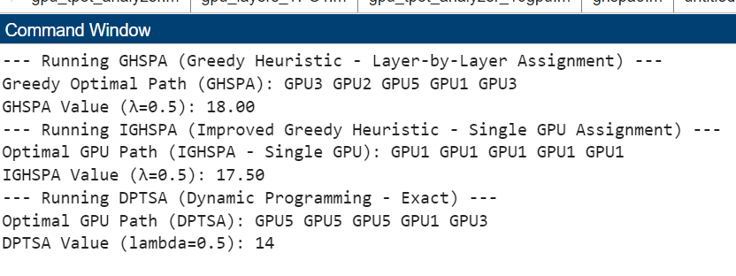

λ = 0.25

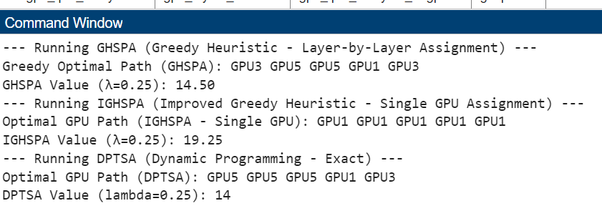

λ = 0.75

