SMART PAGE REPLACEMENT
ALGORITHM
PROJECT DOCUMENTATION

A Project Report Submitted in Partial Fulfilment of the Requirements
for the Academic Project

By
TEAM MEMBER | STUDENT ID
K Sai Joshna | 2520030293
A Bhavana Sri | 2520030232
J Charvi | 2520030294

Department of Computer Science and Engineering
[Institution / University Name]
Academic Year 2026–2027
Project theme: Operating Systems • Virtual Memory • Page Replacement

DECLARATION
We hereby declare that the project report entitled “Smart Page Replacement Algorithm” is prepared by our team as part of our academic project work. The report describes the problem, design, proposed algorithm, implementation approach, testing plan and learning outcomes associated with page replacement in virtual memory.
We confirm that the submitted work is intended for educational purposes and that any external concepts, documentation or references used in preparing this report are acknowledged in the References chapter.

Name | Student ID | Signature
K Sai Joshna | 2520030293 | ________________
A Bhavana Sri | 2520030232 | ________________
J Charvi | 2520030294 | ________________

Date: ____________________
Place: ___________________

CERTIFICATE
This is to certify that the project report entitled “Smart Page Replacement Algorithm” has been prepared by K Sai Joshna (2520030293), A Bhavana Sri (2520030232), and J Charvi (2520030294) as an academic project in the area of Operating Systems.
The project studies virtual-memory page replacement and presents an adaptive, score-based strategy for selecting a page to evict when a page fault occurs and all available frames are occupied. The report is submitted for academic review.

Project Guide | Course Coordinator | Head of Department
Signature: __________  Name: ______________ | Signature: __________  Name: ______________ | Signature: __________  Name: ______________

ACKNOWLEDGEMENT
We would like to express our sincere gratitude to our faculty and project guide for their guidance, encouragement and feedback during the preparation of this project documentation. Their suggestions helped us organize the concepts of virtual memory, page faults and replacement policies into a structured design.
We also thank our department and institution for providing an environment in which we could study operating-system concepts and apply them through a practical algorithmic project.
Finally, we thank our teammates for their cooperation in discussing the design, preparing the documentation and reviewing the proposed workflow.
K Sai Joshna • A Bhavana Sri • J Charvi

ABSTRACT
The Smart Page Replacement Algorithm is an educational operating-systems project that explores how a system chooses a memory page to remove when a process requests a page that is not currently resident and all physical-memory frames are occupied. Page replacement is an important part of virtual memory because a poor choice can cause repeated page faults and reduce system performance.
The proposed design uses an adaptive score to rank the pages currently held in memory. The score combines recency of use and frequency of use, with optional reference and dirty-page information when those attributes are available in the simulator. Recently used and frequently used pages receive stronger protection, while pages that have been inactive for longer are more likely to be selected as victims. If the project implementation does not track dirty pages or reference bits, those factors should be omitted from the score rather than assumed.
The simulator accepts a page-reference string and a frame capacity, processes each reference, identifies hits and page faults, updates page metadata, and replaces a victim when no empty frame remains. It can report the frame state after every reference, total page faults, hits, replacements and hit ratio. Comparing the proposed policy with FIFO, LRU and LFU on the same input provides a way to evaluate its behavior.
This report presents the background, problem statement, objectives, requirements, system architecture, algorithm, pseudocode, sample demonstration, testing strategy, limitations and possible extensions. The project is intended to make page replacement decisions observable and understandable; performance claims should be established through repeatable experiments rather than assumed in advance.

TABLE OF CONTENTS
Section | Contents
Preliminary Pages | Declaration, Certificate, Acknowledgement, Abstract
Chapter 1 | Introduction
Chapter 2 | Operating-System Concepts and Background Study
Chapter 3 | System Requirements
Chapter 4 | Technology and Tools
Chapter 5 | System Architecture and Design
Chapter 6 | Algorithm and Implementation
Chapter 7 | Execution, Demonstration and Testing
Chapter 8 | Results, Conclusion and Future Scope
Chapter 9 | References

Note: Page numbers may change when the document is edited or opened in a different word processor. Update the table of contents after final formatting if an automatic TOC is inserted.

CHAPTER 1 — INTRODUCTION

1.1 Background of the Project
Modern operating systems use virtual memory to give processes the impression that they have a large, continuous address space. Physical memory is divided into frames, while a process’s virtual address space is divided into pages. The operating system maps pages to frames and brings pages into memory when they are needed.
When a requested page is not in physical memory, a page fault occurs. If an empty frame is available, the page can be loaded into it. If every frame is occupied, the operating system must choose a resident page to evict. The replacement decision affects how often pages must be fetched again, which can affect execution time and system responsiveness.
Traditional policies such as First-In, First-Out (FIFO), Least Recently Used (LRU) and Least Frequently Used (LFU) make decisions using different signals. FIFO uses arrival order, LRU uses recent access, and LFU uses access counts. Each policy has strengths and weaknesses for different reference patterns. This project explores a simple adaptive policy that considers more than one signal.

1.2 Problem Statement
A page replacement policy must select a victim using limited information about past and current memory access. A policy based only on arrival order may evict a page that is still used often, while a policy based only on frequency may retain a page that was popular long ago but is no longer active. The project problem is to design and simulate a transparent, adaptive replacement strategy that combines recency and frequency and evaluates its results against familiar baseline policies.

1.3 Aim
To design and document a Smart Page Replacement Algorithm simulator that demonstrates page hits, page faults, frame allocation, victim selection and performance measurement using a configurable page-reference string and frame count.

1.4 Objectives
- Explain virtual memory, pages, frames and page faults through a step-by-step simulation.
- Maintain metadata for pages currently resident in memory, including last-used position and access frequency.
- Use a combined score to select a replacement candidate when all frames are full.
- Display the frame contents and decision for each page reference.
- Calculate page faults, hits, replacements and hit ratio.
- Compare the proposed policy with FIFO, LRU and LFU under identical test inputs.
- Document the design so that the algorithm can be implemented or extended in a programming language.

1.5 Scope of the Project
The project focuses on an algorithm simulator rather than changing the page-replacement policy of a real operating-system kernel. It works on a finite sequence of page references and a user-selected number of frames. The simulator can be implemented as a command-line program or a small graphical interface.
- In scope: parsing page references, initializing frames, hit/miss detection, score calculation, victim selection, trace output and metric calculation.
- In scope: baseline comparisons using the same reference sequence and frame capacity.
- Out of scope for the basic version: kernel integration, actual disk I/O, multi-process scheduling, hardware page tables and production memory management.
- Optional extension: dirty-bit cost, reference bits, aging counters, visual charts and generated reference workloads.

1.6 Importance and Target Users
The simulator is useful for students learning Operating Systems, computer architecture and algorithm design. It provides a concrete way to observe why page replacement matters, how a victim is chosen, and why no single policy is guaranteed to be best for every workload. It may also serve as a teaching aid for comparing algorithmic trade-offs.

CHAPTER 2 — OS CONCEPTS AND BACKGROUND STUDY

2.1 Virtual Memory, Pages and Frames
Virtual memory separates the addresses used by a process from the physical locations in RAM. The operating system and memory-management hardware translate virtual addresses to physical addresses. A page is a fixed-size block of virtual memory; a frame is a fixed-size block of physical memory of the same size. A page can be resident in a frame or absent from physical memory.

2.2 Page Fault
A page fault occurs when a process references a page that is not currently mapped as resident. The operating system validates the reference, locates or creates the required page contents, selects a free frame or replacement victim, updates mappings and resumes the process. In a simulator, the page-fault handling is represented logically; the program does not perform real disk transfers.

2.3 Page Replacement Policies
Policy | Decision basis | Strength | Limitation
FIFO | Evict the page loaded earliest. | Simple to implement and explain. | May evict a heavily used page; can show Belady’s anomaly.
LRU | Evict the page least recently used. | Uses locality of reference. | Needs recency tracking; exact LRU can be costly in real systems.
LFU | Evict the page with the lowest access count. | Protects frequently used pages. | Old counts can dominate even after workload behavior changes.
Optimal (OPT) | Evict the page whose next use is farthest in the future. | Minimum possible faults for a known reference string. | Requires future knowledge; mainly a benchmark.
Smart (proposed) | Rank resident pages using a combined adaptive score. | Combines recent activity and accumulated usage. | Needs clear scoring rules and empirical evaluation.

2.4 Locality of Reference
Programs commonly show temporal locality (recently used items are likely to be used again) and spatial locality (nearby addresses may be accessed together). Page replacement policies try to exploit these patterns. Recency is a practical signal for temporal locality, while frequency can indicate repeated use.

2.5 Proposed Smart Replacement Idea
For the basic documented design, each resident page maintains a last-used index and an access count. The simulator computes a normalized score at each replacement point. A higher score means the page is more valuable to keep; the page with the lowest score becomes the victim. One example score is:
KeepScore(page) = α × RecencyScore + β × FrequencyScore
RecencyScore can be defined as 1 / (1 + current_index − last_used_index), and FrequencyScore can be defined as access_count / maximum_access_count among resident pages. The weights α and β are non-negative and should sum to 1. A sample starting point is α = 0.6 and β = 0.4, but these values are tunable parameters, not a claim of universal optimality.
To avoid ambiguous tie handling, the simulator should define a deterministic rule: if two pages have equal scores, evict the page with the oldest last-used index; if still tied, choose the lowest frame index. Dirty-page information can be added later as an eviction-cost adjustment, but only if dirty status is tracked consistently.

2.6 Advantages and Trade-offs
- Combines two common indicators rather than relying on only arrival order or access count.
- Makes victim decisions explainable because the score components can be displayed.
- Supports parameter experiments by changing α and β.
- May perform differently across workloads; evaluation is required before claiming fewer faults than existing algorithms.
- Requires additional metadata and score calculation compared with FIFO.

CHAPTER 3 — SYSTEM REQUIREMENTS

3.1 Hardware Requirements
Component | Minimum / Recommended
Processor | Any modern dual-core processor or equivalent
RAM | 4 GB minimum recommended for the development environment
Storage | Approximately 500 MB for source files, tools and outputs
Display | Standard laptop/desktop display
Input devices | Keyboard and mouse

3.2 Software Requirements
Software | Purpose
Operating system | Windows, Linux or macOS
Programming language | C, C++, Java or Python (select the language actually used by the team)
Compiler / runtime | GCC/G++, JDK or Python runtime, according to implementation
Editor / IDE | Visual Studio Code, IntelliJ IDEA, Code::Blocks or equivalent
Version control | Git (optional but recommended)

3.3 Functional Requirements
- The program shall accept a page-reference sequence and a positive frame count.
- The program shall validate empty input, invalid page values and invalid frame counts.
- For each reference, the program shall determine whether the page is already resident.
- On a hit, the program shall update the page’s metadata and hit counter.
- On a fault, the program shall use an empty frame if available; otherwise it shall select and replace a victim.
- The program shall display a trace showing each reference, frame contents and hit/fault status.
- The program shall calculate total hits, page faults, replacements and hit ratio.
- If comparison mode is implemented, all policies shall receive the same reference sequence and frame count.

3.4 Non-Functional Requirements
- Correctness: results should be reproducible for the same input and settings.
- Usability: trace labels and final metrics should be easy to read.
- Maintainability: separate input, simulation, scoring and reporting logic.
- Portability: avoid unnecessary platform-specific dependencies.
- Performance: the simulator should process ordinary classroom-sized reference strings quickly.

3.5 Assumptions and Constraints
The reference string is treated as a sequence of page identifiers, not raw byte addresses. The number of frames remains fixed during a run. The basic score uses metadata available inside the simulator. Results depend on the scoring formula, tie-breaking rule and input workload; therefore, those details must be reported alongside experimental results.

CHAPTER 4 — TECHNOLOGY AND TOOLS

4.1 Programming Language
The algorithm can be implemented in C/C++, Java or Python. An implementation language should be selected based on course requirements and team familiarity. C/C++ provides explicit data structures and is commonly used in Operating Systems coursework; Java offers structured classes and collections; Python is convenient for rapid prototyping and visualization.

4.2 Data Structures
Data structure | Purpose
Array / list of frames | Stores the page identifier in each physical frame.
Page metadata record | Stores page ID, last-used index, access frequency and optional flags.
Reference sequence | Stores the ordered page requests for one simulation run.
Counters | Track hits, faults and replacements.
Result table | Stores the frame trace and decision for each reference.

4.3 Development and Testing Tools
- A source-code editor or IDE for implementation.
- Compiler or language runtime appropriate to the chosen language.
- Terminal for running test cases and saving outputs.
- Spreadsheet or plotting library (optional) for visualizing policy comparisons.
- Git (optional) for source control and collaboration.

4.4 Input and Output Format
Example input: reference string 7, 0, 1, 2, 0, 3, 0, 4, 2, 3, 0, 3, 2 and frame count 3. Example output fields include reference index, requested page, frame 1..N, HIT/FAULT, victim page (if any), and running totals.

CHAPTER 5 — SYSTEM ARCHITECTURE AND DESIGN

5.1 Overall Architecture
The simulator is organized into input validation, simulation control, frame management, smart victim selection and result reporting. The controller processes references in order. The frame manager checks membership and updates metadata. When memory is full and a page fault occurs, the victim selector scores each resident page and returns the lowest-ranked candidate.
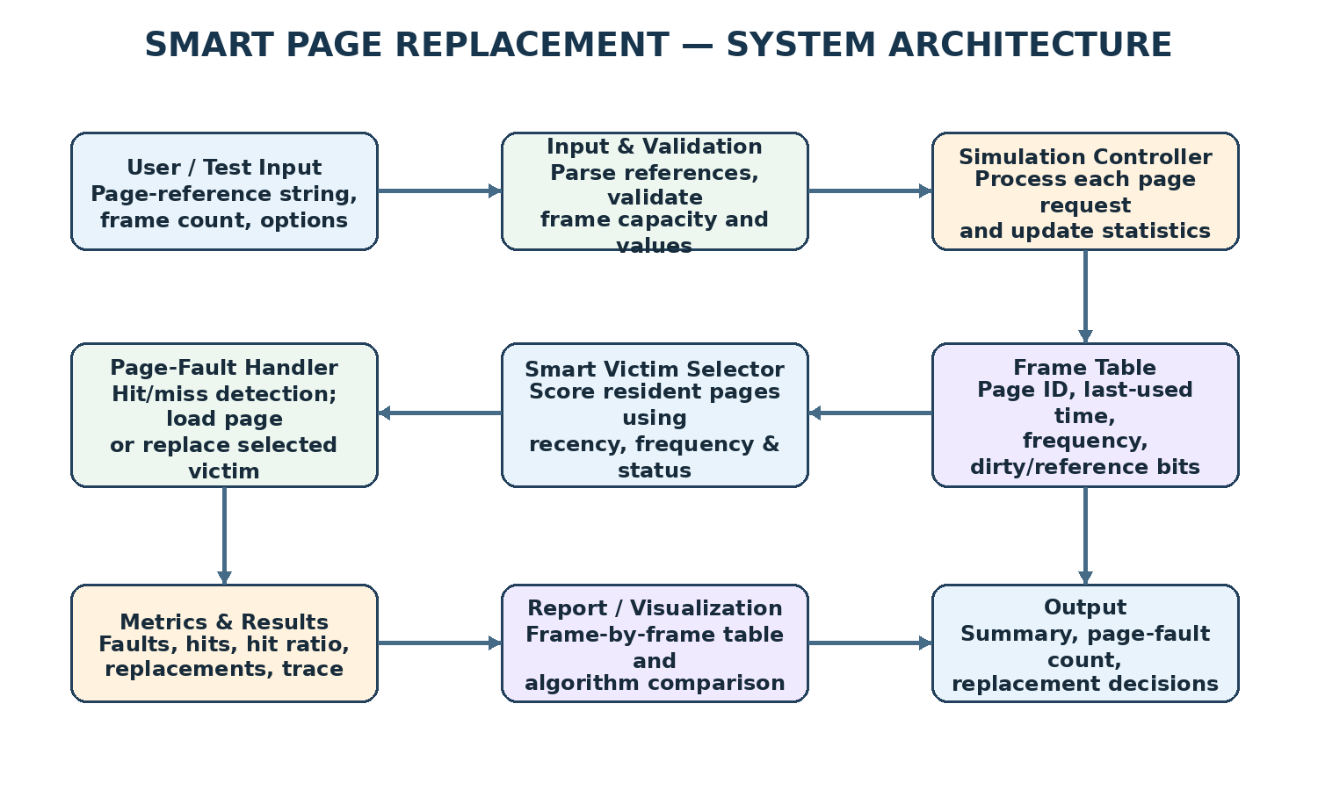
Figure 5.1: Logical architecture of the proposed simulator.

5.2 Module Description
Module | Responsibility
Input module | Reads the reference string, frame count and optional score weights; validates values.
Simulation controller | Iterates through page requests and coordinates each decision.
Frame manager | Stores resident pages and reports hits, free frames and replacement needs.
Metadata updater | Updates last-used index and access frequency after every hit or load.
Smart victim selector | Calculates keep scores and selects the lowest-scoring resident page.
Metrics module | Calculates hits, faults, replacements and hit ratio.
Output module | Displays a frame-by-frame trace and summary.

5.3 Data Flow
- User supplies the page-reference string and frame count.
- The input module validates the data and initializes counters and empty frames.
- The controller reads the next page reference.
- The frame manager checks whether the page is already resident.
- For a hit, metadata and hit counters are updated.
- For a fault, the page is loaded into a free frame or the selector chooses a victim.
- The frame trace and running metrics are recorded.
- After the final reference, the metrics module calculates the summary and displays the results.

5.4 Flowchart
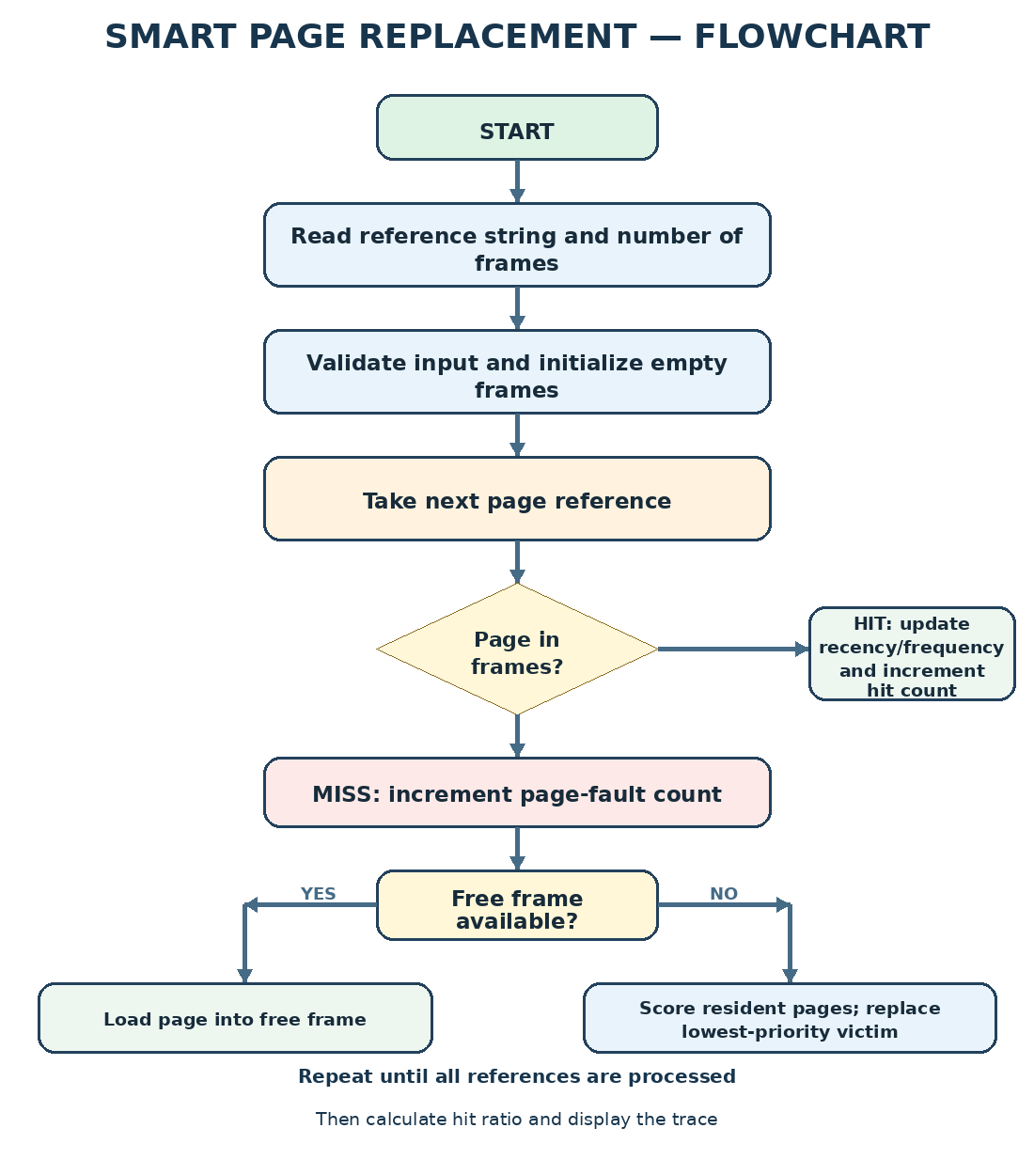
Figure 5.2: Main simulation and replacement flow. The implementation should loop back to the next reference until the sequence is exhausted.

5.5 Core Data Model
Field | Meaning
page_id | Identifier of the page held in a frame.
last_used_index | Position of the most recent reference to this page.
access_count | Number of references observed for the page during the run.
frame_index | Position of the frame containing the page.
keep_score | Combined normalized recency and frequency score.
hit_count / fault_count | Counts used to calculate the final statistics.

5.6 Input and Output Design
Input validation should reject a frame count less than one and should report malformed page identifiers clearly. Duplicate references are valid. The trace should show the page requested at each step, the current contents of all frames, and whether the request caused a hit or fault. When a replacement occurs, the output should identify the victim and ideally display its score.

CHAPTER 6 — ALGORITHM AND IMPLEMENTATION

6.1 Algorithm Overview
The proposed Smart Page Replacement Algorithm uses a combined recency-frequency score. It is intentionally specified so that each decision can be inspected. A page with a recent access obtains a higher recency score. A page with more observed accesses obtains a higher frequency score. The lowest combined keep score is selected for eviction when all frames are occupied.

6.2 Score Definition
Let t be the index of the current reference, L(p) the most recent index at which page p was used, C(p) the access count of page p, and Cmax the largest access count among resident pages.
Recency(p) = 1 / (1 + t − L(p))
Frequency(p) = C(p) / Cmax
KeepScore(p) = α · Recency(p) + β · Frequency(p)
Use α ≥ 0 and β ≥ 0 with α + β = 1. In this report, α = 0.6 and β = 0.4 are example default weights. Since the recency term uses the current reference index, the exact implementation must update timestamps consistently before scoring. The proposed rule is to update the requested page on a hit; for a missing page, score existing resident pages before loading the new page, then initialize the newly loaded page’s metadata.

6.3 Pseudocode
INPUT reference_sequence, frame_count, alpha, beta
IF frame_count <= 0: report invalid frame count and stop
frames = empty
hits = 0; faults = 0; replacements = 0
initialize metadata for each resident page
FOR each page p at reference index t:
IF p is already in frames:
hits = hits + 1
update last_used_index[p] = t
access_count[p] = access_count[p] + 1
record HIT and current frame state
ELSE:
faults = faults + 1
IF an empty frame exists:
load p into an empty frame
ELSE:
Cmax = maximum access_count among resident pages
FOR each resident page q:
recency = 1 / (1 + t - last_used_index[q])
frequency = access_count[q] / max(1, Cmax)
score[q] = alpha * recency + beta * frequency
victim = resident page with minimum score
break ties by oldest last_used_index, then lowest frame index
replace victim with p
replacements = replacements + 1
initialize/update metadata for p
record FAULT, victim (if any), and current frame state
hit_ratio = hits / length(reference_sequence)
display trace, hits, faults, replacements, hit_ratio

6.4 Complexity Analysis
Let n be the number of page references and f the number of frames. A straightforward implementation that scans all frames to find a hit and scans all resident pages to select a victim takes O(n × f) time. Since f is usually small in a classroom simulator, this approach is simple and transparent. The frame table and per-page metadata require O(f) space, excluding storage for the reference sequence and trace.

6.5 Important Implementation Details
- Use the same reference index convention throughout the program.
- Increment access_count on every reference to a page, including its first load, if that is the chosen convention.
- Initialize last_used_index to the current reference index when a page is loaded.
- Normalize frequency to avoid making the frequency term dominate solely because counts are numerically large.
- Define tie-breaking deterministically to make output reproducible.
- If a page is evicted and later loaded again, decide whether its frequency history resets. The simplest implementation resets metadata on eviction and reload.
- Keep the baseline implementations independent so that their metadata rules do not accidentally affect the proposed algorithm.

6.6 Metrics and Formulae
Metric | Formula / meaning
Page faults | Number of references not found in the current frames.
Hits | Number of references already present in a frame.
Replacements | Number of times a resident page is evicted; usually faults minus initial free-frame loads.
Hit ratio | Hits / total references.
Fault ratio | Page faults / total references.
Replacement rate | Replacements / total references.

Hit ratio and fault ratio sum to 1 when every reference is classified as exactly one hit or one fault. Replacement count is not necessarily equal to page-fault count because the first pages may use empty frames.

CHAPTER 7 — EXECUTION, DEMONSTRATION AND TESTING

7.1 General Execution Procedure
- Create the project source file(s) in the selected programming language.
- Implement the frame table, metadata updates, score calculation and trace output.
- Compile or run the program using the toolchain required by the chosen language.
- Enter a reference string and frame count.
- Inspect each HIT/FAULT decision and victim selection.
- Run FIFO, LRU and LFU on the same input if comparison mode is available.
- Record the final metrics and repeat the test with additional reference patterns.

7.2 Illustrative Input
Parameter | Example value
Reference string | 7, 0, 1, 2, 0, 3, 0, 4, 2, 3, 0, 3, 2
Frame count | 3
Recency weight (α) | 0.6
Frequency weight (β) | 0.4
Tie-breaking | Oldest last-used index, then lowest frame index

This input is an illustrative test case for the simulator. Exact Smart-policy results depend on the metadata convention and score update order used in the final implementation. The team should run its actual code and insert verified output screenshots before submission.

7.3 Test Cases
Test ID | Input / condition | Expected behavior
TC-01 | One frame; sequence 1, 1, 1 | First reference faults; later references hit.
TC-02 | Frames greater than or equal to distinct pages | No replacement should occur after pages are loaded.
TC-03 | Repeated page, e.g. 2, 2, 2 | First access faults; subsequent accesses hit while resident.
TC-04 | All frames full and new page arrives | A victim is selected and replacement count increases.
TC-05 | Frame count is zero or negative | Input is rejected with a clear error.
TC-06 | Empty reference string | Program reports invalid/empty input or a zero-reference summary without division by zero.
TC-07 | Equal victim scores | Deterministic tie-breaking chooses the same victim each run.
TC-08 | Same input across policies | Each policy receives the same sequence and frame capacity.

7.4 Sample Trace Format
Step | Page | Frame 1 | Frame 2 | Frame 3 | Result | Victim
1 | 7 | 7 | – | – | FAULT | –
2 | 0 | 7 | 0 | – | FAULT | –
3 | 1 | 7 | 0 | 1 | FAULT | –
4 | 2 | 2 | 0 | 1 | FAULT | 7
5 | 0 | 2 | 0 | 1 | HIT | –

The trace above illustrates the output format and early frame filling; the victim shown for later steps must be generated by the actual Smart score implementation. Do not treat the partial example as a complete verified benchmark.

7.5 Demonstration of Operating-System Concepts
- Demand paging: a requested page may be absent from the simulated frames.
- Page fault: a miss causes the simulator to load the page.
- Frame allocation: pages occupy a limited number of frame slots.
- Replacement policy: when frames are full, a victim is selected.
- Locality: repeated and clustered references can influence recency and frequency.
- Performance evaluation: hit ratio and page-fault count summarize the run.

7.6 Screenshots to Include in Final Submission
- Source code showing the frame data structure and score formula.
- Program input showing the page-reference string and frame count.
- Frame-by-frame trace showing hits, faults and at least one replacement.
- Final metrics summary.
- Comparison table or chart for Smart, FIFO, LRU and LFU, if implemented.

CHAPTER 8 — RESULTS, CONCLUSION AND FUTURE SCOPE

8.1 Result Evaluation Plan
The algorithm should be evaluated using several reference patterns: repeated access to a small working set, sequential scans, alternating references, and mixed random sequences. For each workload and frame count, run Smart, FIFO, LRU and LFU with identical inputs. Record page faults, hit ratio and replacement count. Repeat experiments if randomized workloads are used and report the random seed.
A fair evaluation should not assume that the Smart policy always wins. Its value is whether the combined score behaves as designed and whether the measured results are useful for the target workload. If the score weights are tuned, separate the tuning workload from the evaluation workload to reduce overfitting.

8.2 Expected Outcomes
- A clear trace of page references and frame contents.
- Correct distinction between hits, page faults and replacements.
- An explainable victim decision based on recency and frequency.
- Metrics that allow repeatable comparisons between policies.
- Improved understanding of virtual memory and replacement trade-offs.

8.3 Limitations
- The proposed score is a heuristic and does not guarantee the minimum possible number of page faults.
- Access frequency can retain pages that were popular earlier but are no longer useful.
- Recency and frequency weights may need tuning for different workloads.
- The simulator does not model disk latency, asynchronous I/O, page-table overhead or concurrent processes unless those features are explicitly added.
- Dirty-page write-back cost is not included in the basic score.

8.4 Future Enhancements
- Add an aging or decaying frequency counter so old accesses gradually lose influence.
- Include dirty-page status and estimated write-back cost in victim ranking.
- Provide an interactive visualization of frames and replacement decisions.
- Generate synthetic workloads and graph fault counts across multiple frame sizes.
- Add OPT as a lower-bound benchmark for known reference strings.
- Support CSV export of traces and summary metrics.
- Allow weight selection and compare results across multiple α/β combinations.

8.5 Conclusion
The Smart Page Replacement Algorithm project provides a structured way to study how an operating system manages a limited number of memory frames. By combining recency and frequency in a transparent score, the proposed policy demonstrates how multiple signals can influence a replacement decision. The simulator’s trace and metrics make the behavior observable and allow comparison with established policies such as FIFO, LRU and LFU.
The key outcome is not a claim that one heuristic is universally superior, but a repeatable framework for implementing, explaining and testing a page replacement strategy. With verified test runs and optional visualization, the project can serve as a practical learning resource for Operating Systems.

8.6 Team Contribution Record
Team member | Suggested contribution area
K Sai Joshna — 2520030293 | Algorithm design, score formula and documentation coordination.
A Bhavana Sri — 2520030232 | Implementation support, test-case design and result collection.
J Charvi — 2520030294 | Architecture/flowchart preparation, validation and report review.

Note: The contribution areas above are suggested placeholders. Edit them to reflect the actual work completed by each team member.

CHAPTER 9 — REFERENCES

9.1 Books
- Silberschatz, A., Galvin, P. B., and Gagne, G. Operating System Concepts. Wiley.
- Tanenbaum, A. S., and Bos, H. Modern Operating Systems. Pearson.
- Stallings, W. Operating Systems: Internals and Design Principles. Pearson.

9.2 Online Documentation and Learning Resources
- Operating-system course notes and academic materials on virtual memory, demand paging and page replacement.
- Linux man-pages project, for general operating-system interfaces and system concepts: https://man7.org/linux/man-pages/
- GeeksforGeeks, educational explanations of FIFO, LRU, LFU and Optimal page replacement: https://www.geeksforgeeks.org/
- Computer science and operating-systems textbooks available through the institution’s library.

9.3 Reference Note
The Smart score in this report is a proposed educational heuristic defined for this project. It should be cited as the team’s design, not as an established operating-system standard. If the final implementation uses a different formula, update Sections 2.5 and 6.2 and ensure the pseudocode, results and screenshots match the actual code.

APPENDIX A — VIVA / REVIEW QUESTIONS
- What is virtual memory, and why is it used?
- What is the difference between a page and a frame?
- What causes a page fault?
- How do FIFO, LRU and LFU choose a victim?
- Why can a frequency-only policy make a poor decision?
- How are recency and frequency combined in the proposed Smart score?
- What do α and β represent, and why should their sum be 1?
- How is hit ratio calculated?
- Why is OPT useful for comparison but difficult to implement online?
- What are the limitations of a score-based heuristic?

APPENDIX B — FINAL SUBMISSION CHECKLIST
- Replace [Institution / University Name] with the correct institution name.
- Add the actual guide, course coordinator and department details if required.
- Confirm that the implementation’s score formula matches this report.
- Insert real screenshots from the team’s program.
- Run the test cases and replace illustrative values with verified outputs.
- Update the table of contents and page numbers after final edits.
- Review spelling, formatting, team details and institutional submission rules.

