Asymptotic Notation

# Source:

1. **Asymptotic Notation**

# Khan Academy: [Asymptotic Notation](https://www.khanacademy.org/computing/computer-science/algorithms#asymptotic-notation) learn here nice theory with examples practice here quiz’s

# 

## **Fig: - 1.1** Common Asymptotic Notations

Source: tutorials point

# Introduction to Logarithms:

# [logarithms](https://www.mathsisfun.com/algebra/logarithms.html) refer this very nice introduction about logs.

# 

## **Fig: - 1.2** Basic Log Example

Source: maths is fun

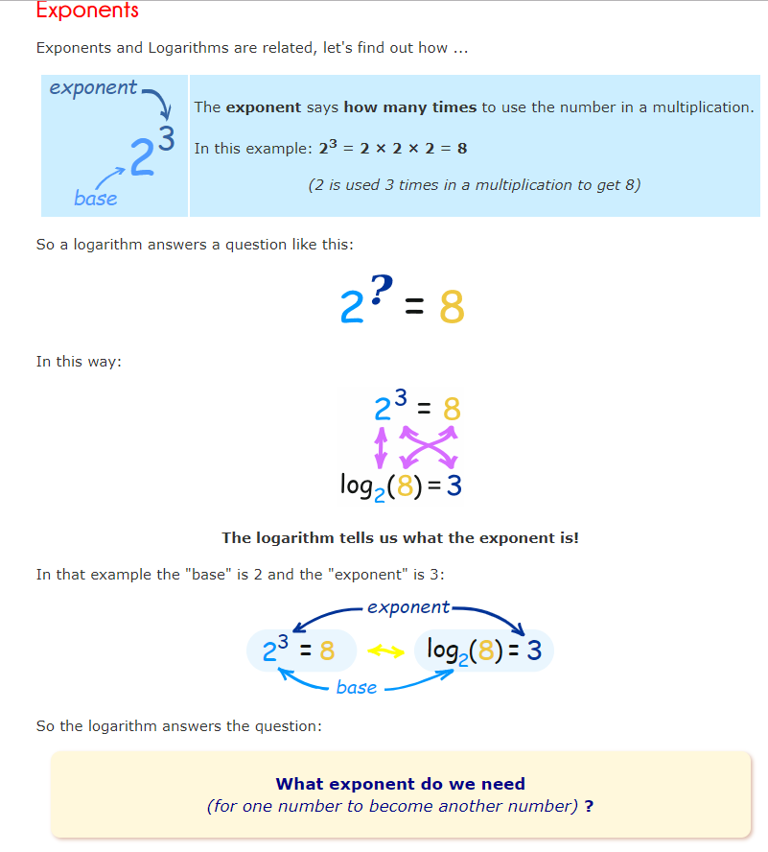

## **Fig: - 1.3** Exponent Log Example

Source: maths is fun

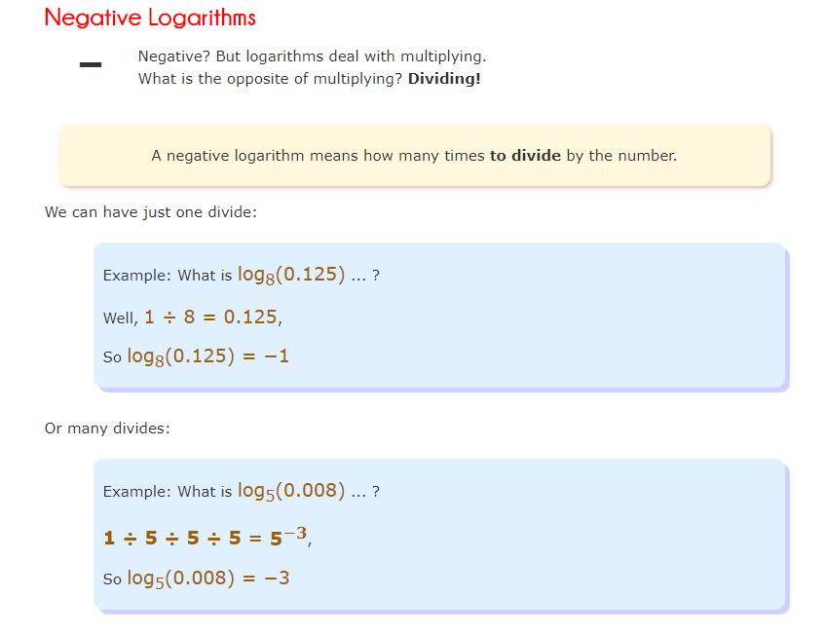

## **Fig: - 1.4** Negative Logs

Source: maths is fun

Quiz source **Khan Academy**

1. Question

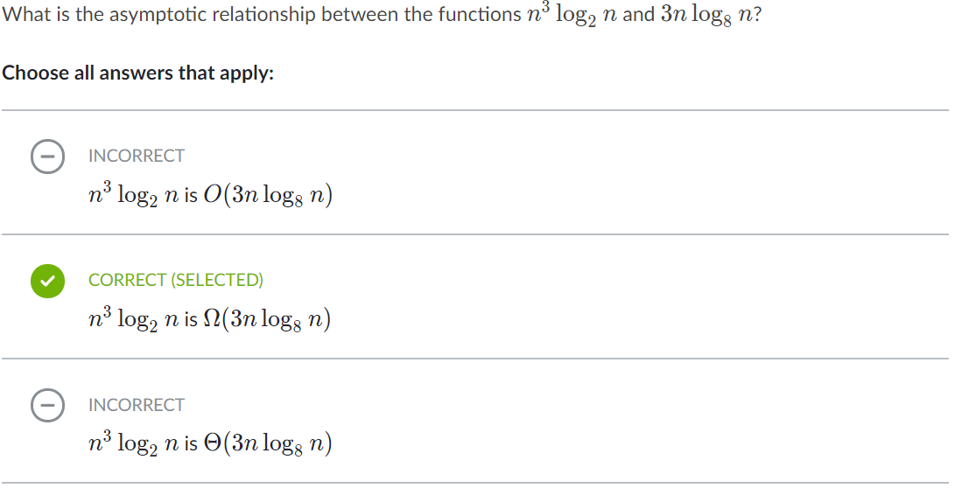

Explanation: -

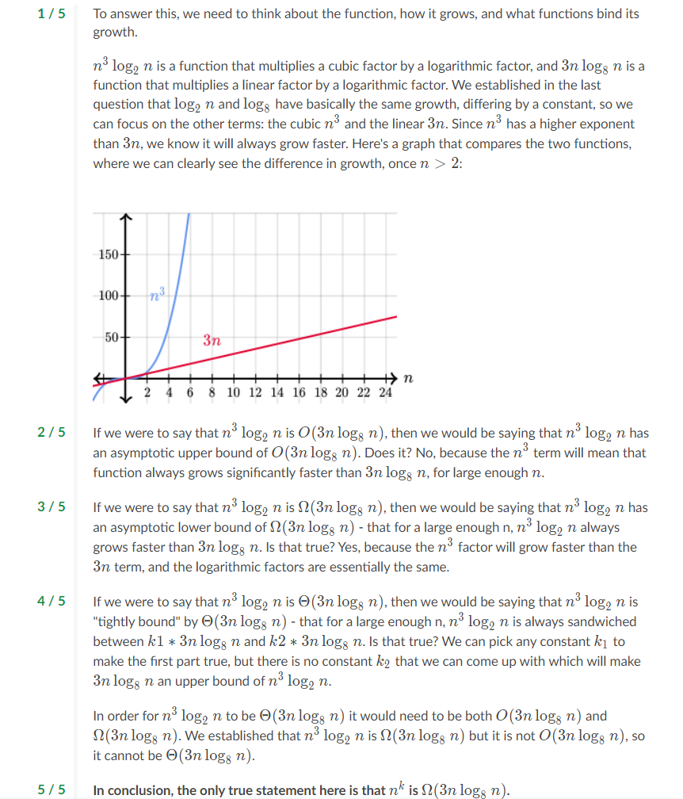

1. Question

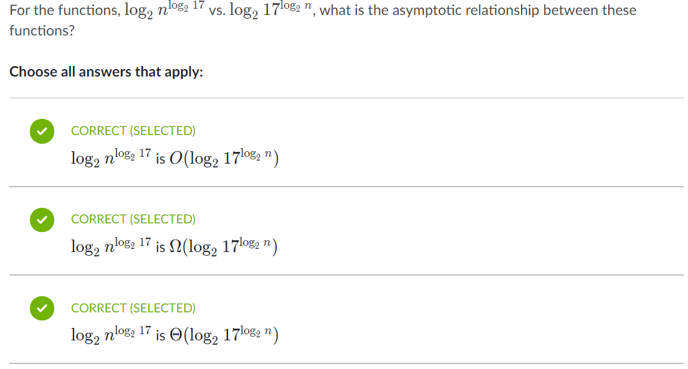

Explanation: -

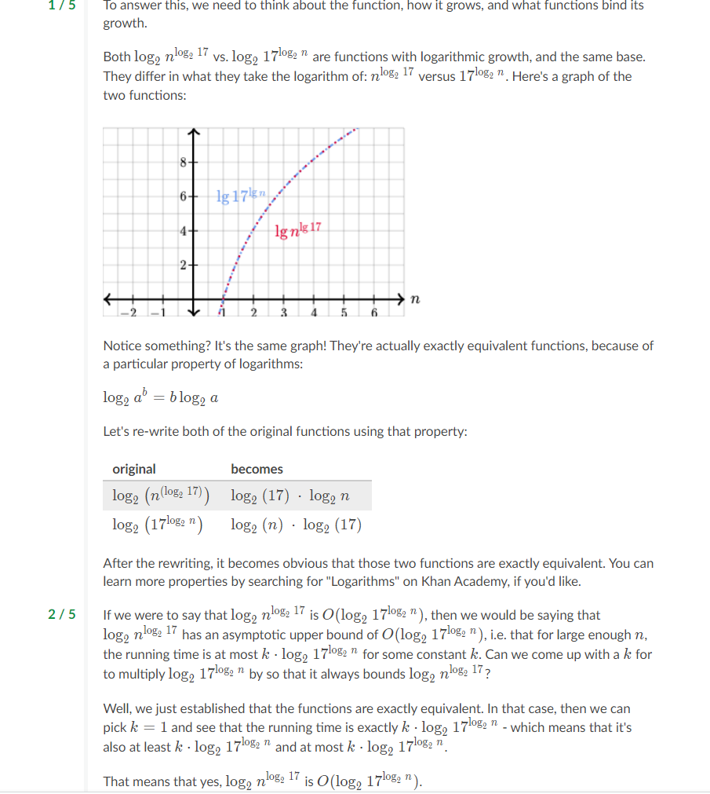

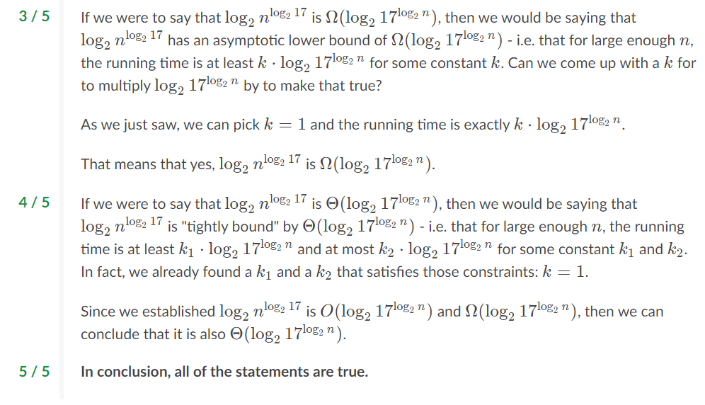

1. Question: -

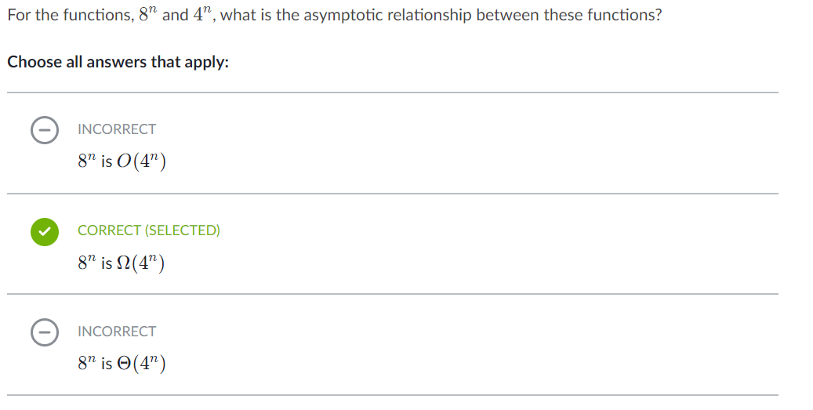

Explanation: -

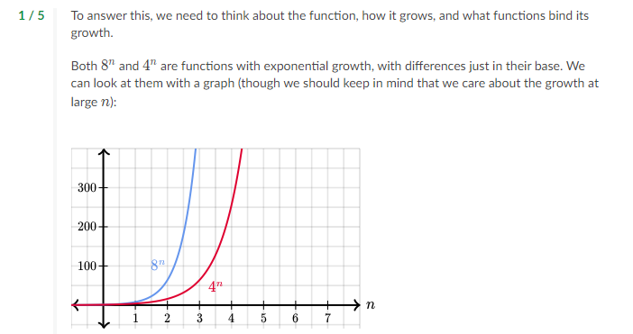

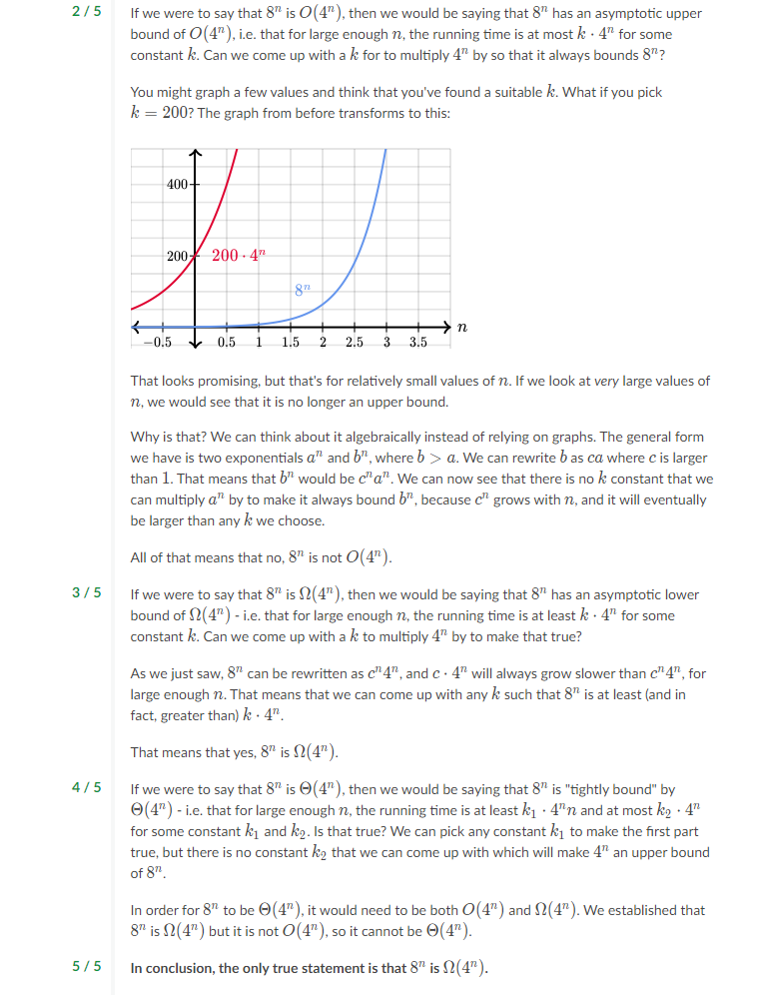

Algorithms from Abdul Bari channel.

1. Intro about course

# 1.1 Priori Analysis and Posteriori Testing

