**Worksheet for Prog2 Warmup**

**Task: simulate the described algorithm to populate the P[] lists with resulting**

**option lists / tradeoff curves. (Source vertex: 0).**

**On a separate sheet, maintain and update the priority queue entries. Submit both**

**this page and your sheet maintaining the priority queue (granted, the separate**

**sheet is kind of scratch work, but submit it anyhow).**

**A short video will be posted to get you started.**

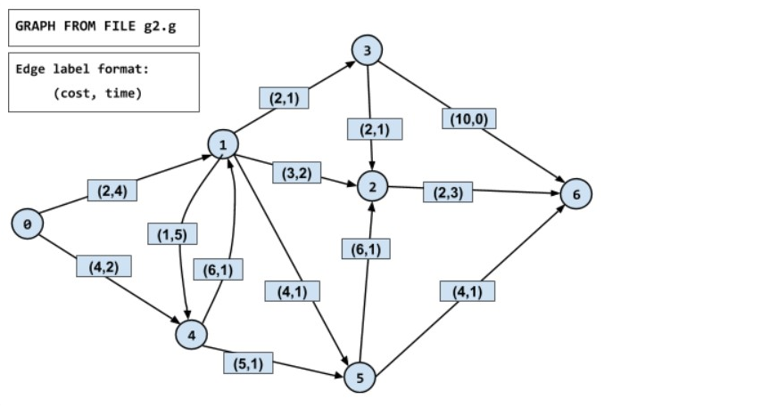

|  |  |
| --- | --- |
| P[0] | (0, 0) |
| P[1] | (2, 4) |
| P[2] | (5, 6), (15, 4) |
| P[3] | (4, 5) |
| P[4] | (3, 9), (4, 2) |
| P[5] | (6, 5), (9, 3) |
| P[6] | (7, 9), (10, 6), (13, 4) |

