**Assignment 5**

**Tasks 1: Database Design:**

1. Create the database named "TicketBookingSystem"

CREATE DATABASE IF NOT EXISTS TicketBookingSystem;

Screenshot 2024-04-08 at 3.02.42 PM

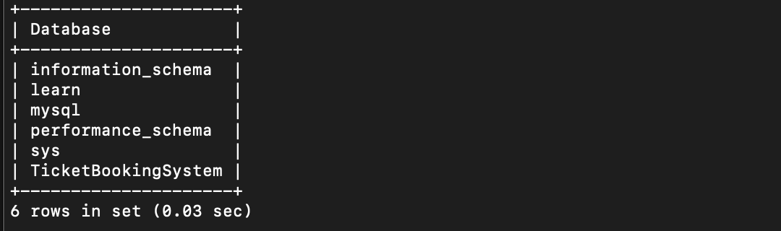

**2.** Write SQL scripts to create the mentioned tables with appropriate data types, constraints, and

relationships.

• Venue

• Event

• Customers

• Booking

**1. Venue Table**

• **venue_id (Primary Key)**

• venue_name,

• address

CREATE TABLE IF NOT EXISTS Venue (

venue_id INT PRIMARY KEY,

venue_name VARCHAR(255) NOT NULL,

address VARCHAR(255) NOT NULL

);

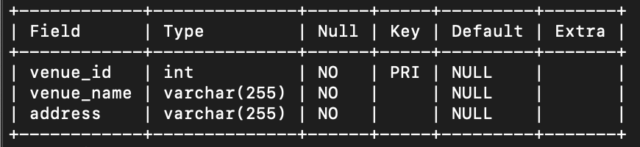

**2. Event Table**

• **event_id (Primary Key)**

• event_name,

• event_date DATE,

• event_time TIME,

• venue_id **(Foreign Key)**,

• total_seats,

• available_seats,

• ticket_price DECIMAL,

• event_type ('Movie', 'Sports', 'Concert')

• booking_id **(Foreign Key)**

CREATE TABLE IF NOT EXISTS Event (

event_id INT PRIMARY KEY,

event_name VARCHAR(255) NOT NULL,

event_date DATE NOT NULL,

event_time TIME NOT NULL,

venue_id INT,

total_seats INT NOT NULL,

available_seats INT NOT NULL,

ticket_price DECIMAL(10, 2) NOT NULL,

event_type ENUM('Movie', 'Sports', 'Concert') NOT NULL,

booking_id INT

);

**Screenshot 2024-04-08 at 3.23.15 PM**

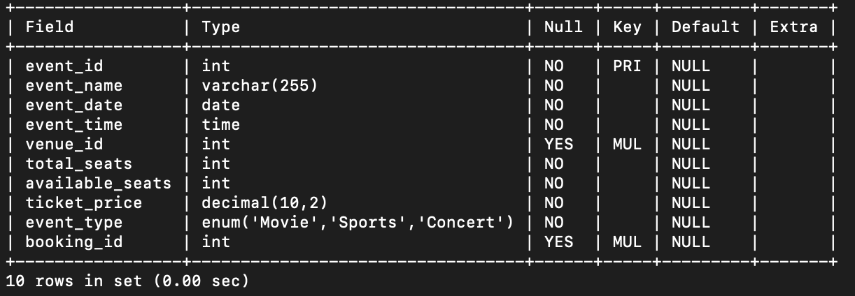

**3. Customer Table**

• **customer_id (Primary key)**

• customer_name,

• email,

• phone_number,

• booking_id **(Foreign Key)**

CREATE TABLE IF NOT EXISTS Customer (

customer_id INT PRIMARY KEY,

customer_name VARCHAR(255) NOT NULL,

email VARCHAR(255) NOT NULL,

phone_number VARCHAR(20) NOT NULL,

booking_id INT

);

**Screenshot 2024-04-08 at 3.24.08 PM**

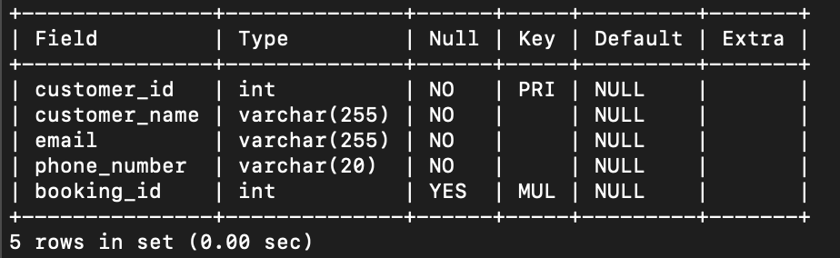

**4. Booking Table**

• booking_id **(Primary Key)**,

• customer_id **(Foreign Key)**,

• event_id **(Foreign Key)**,

• num_tickets,

• total_cost,

• booking_date,

CREATE TABLE IF NOT EXISTS Booking (

booking_id INT PRIMARY KEY,

customer_id INT,

event_id INT,

num_tickets INT NOT NULL,

total_cost DECIMAL(10, 2) NOT NULL,

booking_date TIMESTAMP DEFAULT CURRENT_TIMESTAMP

);

Screenshot 2024-04-08 at 3.24.23 PM

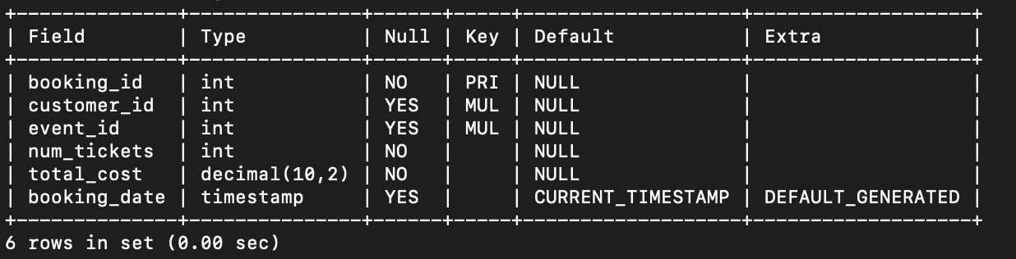

**3.** Create an ERD (Entity Relationship Diagram) for the database.

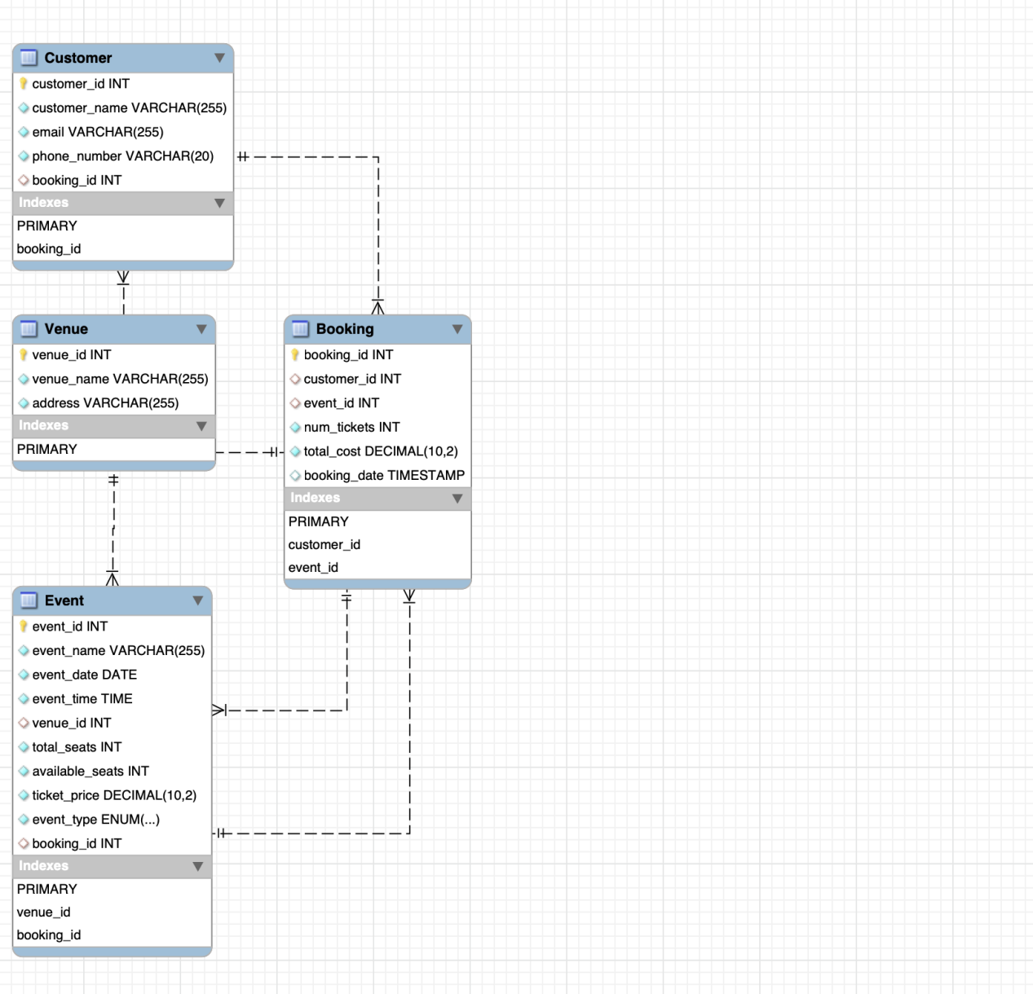

**4.** Create appropriate Primary Key and Foreign Key constraints for referential integrity.

ALTER TABLE Event ADD FOREIGN KEY (venue_id) REFERENCES Venue(venue_id);

ALTER TABLE Event ADD FOREIGN KEY (booking_id) REFERENCES Booking(booking_id);

ALTER TABLE Customer ADD FOREIGN KEY (booking_id) REFERENCES Booking(booking_id);

ALTER TABLE Booking ADD FOREIGN KEY (customer_id) REFERENCES Customer(customer_id);

ALTER TABLE Booking ADD FOREIGN KEY (event_id) REFERENCES Event(event_id);



**Tasks 2: Select, Where, Between, AND, LIKE:**

1. Write a SQL query to insert at least 10 sample records into each table.

INSERT INTO Venue (venue_id, venue_name, address) VALUES

(1, 'Venue 1', 'Address 1'),

(2, 'Venue 2', 'Address 2'),

(3, 'Venue 3', 'Address 3'),

(4, 'Venue 4', 'Address 4'),

(5, 'Venue 5', 'Address 5'),

(6, 'Venue 6', 'Address 6'),

(7, 'Venue 7', 'Address 7'),

(8, 'Venue 8', 'Address 8'),

(9, 'Venue 9', 'Address 9'),

(10, 'Venue 10', 'Address 10');



INSERT INTO Event (event_id, event_name, event_date, event_time, venue_id, total_seats, available_seats, ticket_price, event_type, booking_id) VALUES

(1, 'Event 1', '2024-04-10', '12:00:00', 1, 200, 200, 1500.00, 'Concert', NULL),

(2, 'Event 2', '2024-04-11', '14:00:00', 2, 150, 100, 2000.00, 'Movie', NULL),

(3, 'Event 3', '2024-04-12', '15:00:00', 3, 300, 250, 1800.00, 'Sports', NULL),

(4, 'Event 4', '2024-04-13', '18:00:00', 4, 250, 150, 2200.00, 'Concert', NULL),

(5, 'Event 5', '2024-04-14', '20:00:00', 5, 400, 350, 1200.00, 'Concert', NULL),

(6, 'Event 6', '2024-04-15', '19:00:00', 6, 350, 300, 1600.00, 'Sports', NULL),

(7, 'Event 7', '2024-04-16', '17:00:00', 7, 200, 100, 2500.00, 'Movie', NULL),

(8, 'Event 8', '2024-04-17', '16:00:00', 8, 300, 200, 1700.00, 'Concert', NULL),

(9, 'Event 9', '2024-04-18', '21:00:00', 9, 500, 450, 1900.00, 'Sports', NULL),

(10, 'Event 10', '2024-04-19', '13:00:00', 10, 450, 400, 2100.00, 'Movie', NULL);



INSERT INTO Customer (customer_id, customer_name, email, phone_number, booking_id) VALUES

(1, 'John Doe', 'john@example.com', '1234567890', NULL),

(2, 'Jane Smith', 'jane@example.com', '9876543210', NULL),

(3, 'Alice Johnson', 'alice@example.com', '4567890123', NULL),

(4, 'Bob Brown', 'bob@example.com', '3216549870', NULL),

(5, 'Charlie Davis', 'charlie@example.com', '7891234560', NULL),

(6, 'Emma Wilson', 'emma@example.com', '6549873210', NULL),

(7, 'David Lee', 'david@example.com', '1472583690', NULL),

(8, 'Olivia Clark', 'olivia@example.com', '2583691470', NULL),

(9, 'James Miller', 'james@example.com', '3698521470', NULL),

(10, 'Sophia Martinez', 'sophia@example.com', '8527419630', NULL);

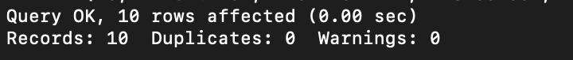

INSERT INTO Booking (booking_id, customer_id, event_id, num_tickets, total_cost, booking_date) VALUES

(1, 1, 1, 2, 3000.00, '2024-04-03 09:30:00'),

(2, 2, 2, 3, 6000.00, '2024-04-02 10:45:00'),

(3, 3, 3, 1, 1800.00, '2024-04-01 11:20:00'),

(4, 4, 4, 4, 8800.00, '2024-03-05 12:15:00'),

(5, 5, 5, 2, 2400.00, '2024-04-02 13:00:00'),

(6, 6, 6, 3, 4800.00, '2024-04-06 14:30:00'),

(7, 7, 7, 1, 2500.00, '2024-04-07 15:10:00'),

(8, 8, 8, 2, 3400.00, '2024-04-07 16:00:00'),

(9, 9, 9, 4, 7600.00, '2024-04-02 17:45:00'),

(10, 10, 10, 3, 6300.00, '2024-03-01 18:20:00');



1. Write a SQL query to list all Events.

SELECT * FROM Event;

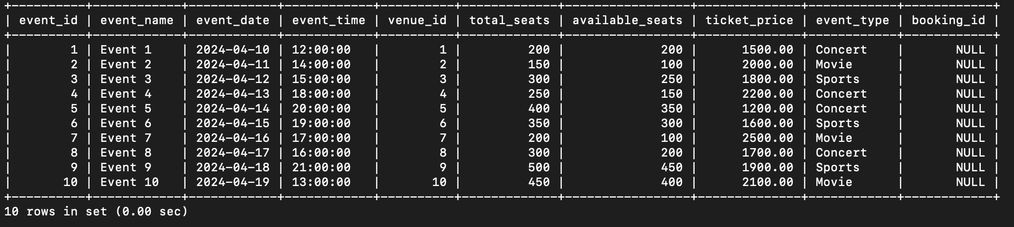

3. Write a SQL query to select events with available tickets.

SELECT * FROM Event WHERE available_seats > 0;



4. Write a SQL query to select events name partial match with ‘cup’.

SELECT * FROM Event WHERE event_name LIKE '%cup%';

Screenshot 2024-04-09 at 3.19.04 PM

1. Write a SQL query to select events with ticket price range is between 1000 to 2500.

SELECT * FROM Event WHERE ticket_price BETWEEN 1000 AND 2500;



1. Write a SQL query to retrieve events with dates falling within a specific range.

SELECT * FROM Event WHERE event_date BETWEEN '2024-04-10' AND '2024-04-15';

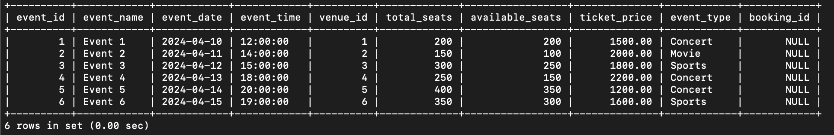

1. Write a SQL query to retrieve events with available tickets that also have "Concert" in their name.

SELECT * FROM Event WHERE available_seats > 0 AND event_type = 'Concert';

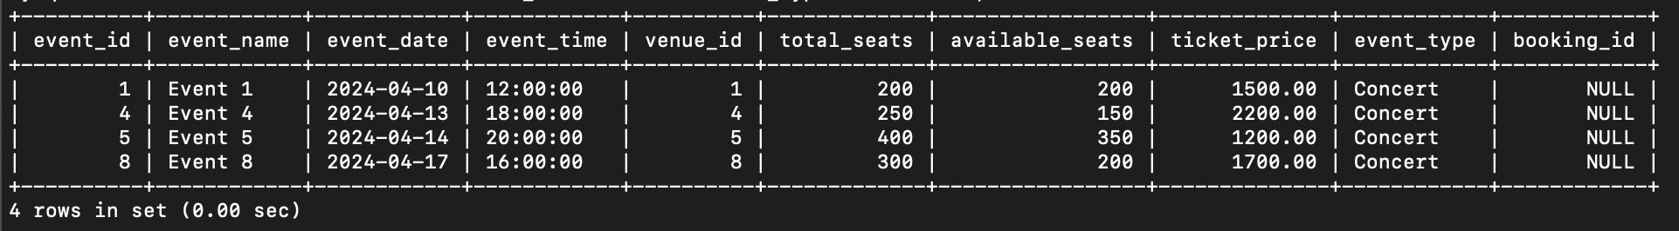

1. Write a SQL query to retrieve users in batches of 5, starting from the 6th user.

SELECT * FROM Customer LIMIT 5 OFFSET 5;

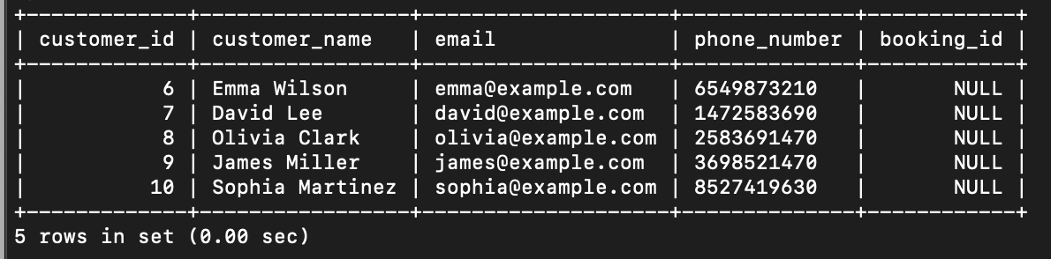

1. Write a SQL query to retrieve bookings details contains booked no of ticket more than 3.

SELECT * FROM Booking WHERE num_tickets > 3;

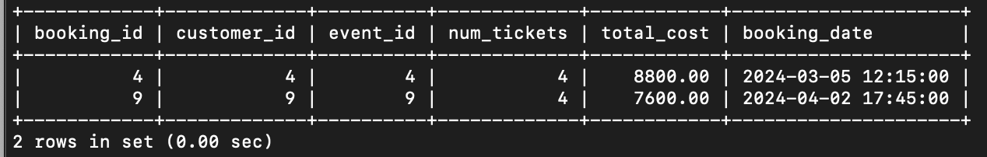

10. Write a SQL query to retrieve customer information whose phone number end with ‘000’

SELECT * FROM Customer WHERE phone_number LIKE '%000';

Screenshot 2024-04-09 at 3.38.48 PM

11. Write a SQL query to retrieve the events in order whose seat capacity more than 15000.

SELECT * FROM Event WHERE total_seats > 250;

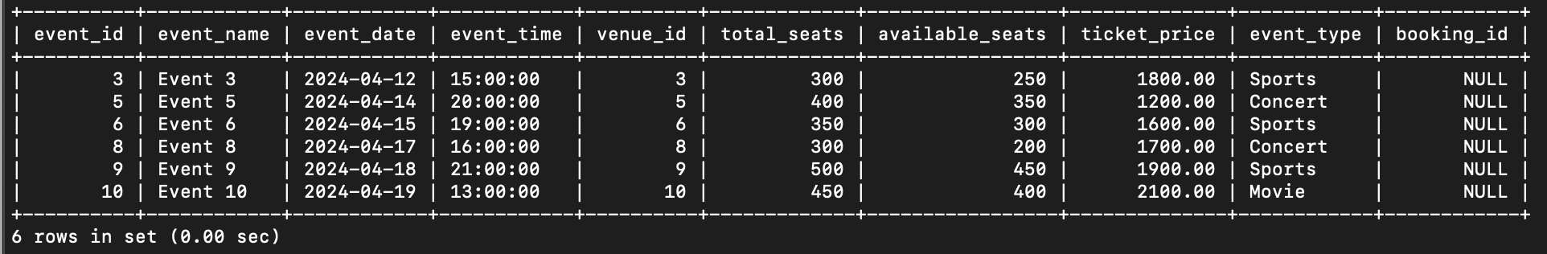

12. Write a SQL query to select events name not start with ‘x’, ‘y’, ‘z’

SELECT * FROM Event WHERE event_name NOT LIKE 'x%' AND event_name NOT LIKE 'y%' AND event_name NOT LIKE 'z%';



**Tasks 3: Aggregate functions, Having, Order By, GroupBy and Joins:**

1. Write a SQL query to List Events and Their Average Ticket Prices.

SELECT event_type, AVG(ticket_price) AS avg_ticket_price FROM Event GROUP BY event_type;

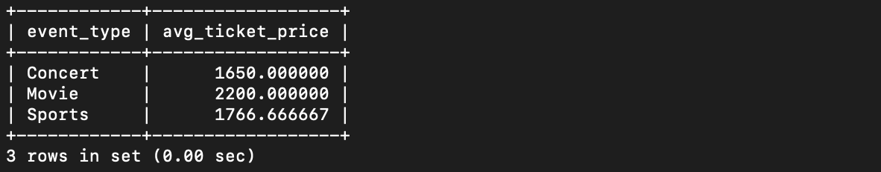

2. Write a SQL query to Calculate the Total Revenue Generated by Events.

SELECT SUM(total_cost) AS total_revenue FROM Booking;

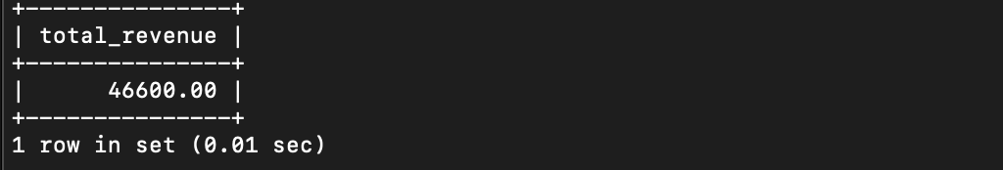

3. Write a SQL query to find the event with the highest ticket sales.

SELECT event_id, SUM(num_tickets) AS total_tickets_sold, SUM(total_cost) AS total_revenue FROM Booking GROUP BY event_id ORDER BY total_tickets_sold DESC, total_revenue DESC LIMIT 1;

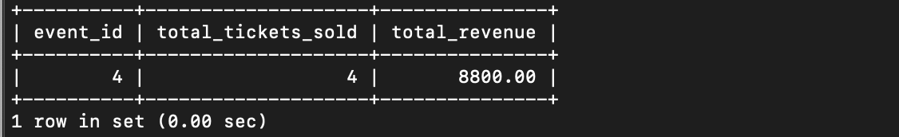

4. Write a SQL query to Calculate the Total Number of Tickets Sold for

Each Event.

SELECT event_id, SUM(num_tickets) AS total_tickets_sold FROM Booking GROUP BY event_id;

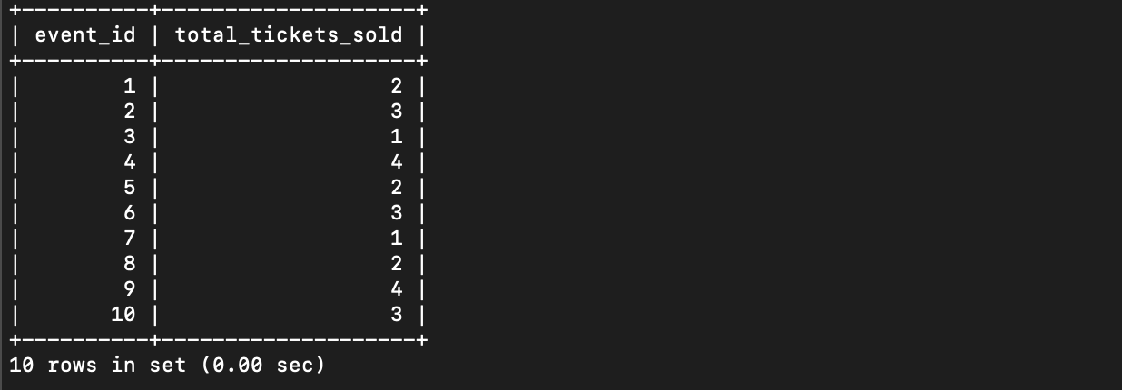

5. Write a SQL query to Find Events with No Ticket Sales.

SELECT event_id, event_name FROM Event WHERE event_id NOT IN (SELECT event_id FROM Booking);

Screenshot 2024-04-10 at 2.51.53 PM

6. Write a SQL query to Find the User Who Has Booked the Most Tickets.

SELECT customer_id, SUM(num_tickets) AS total_tickets_booked

FROM Booking

GROUP BY customer_id

HAVING SUM(num_tickets) = (

SELECT MAX(total_tickets)

FROM (

SELECT SUM(num_tickets) AS total_tickets

FROM Booking

GROUP BY customer_id

) AS subquery

);

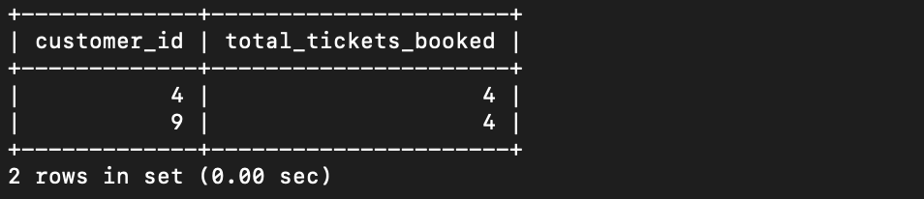

7. Write a SQL query to List Events and the total number of tickets sold for each month.

SELECT event_id,MONTH(booking_date) AS month, COUNT(*) AS total_tickets_sold FROM Booking GROUP BY event_id,MONTH(booking_date);

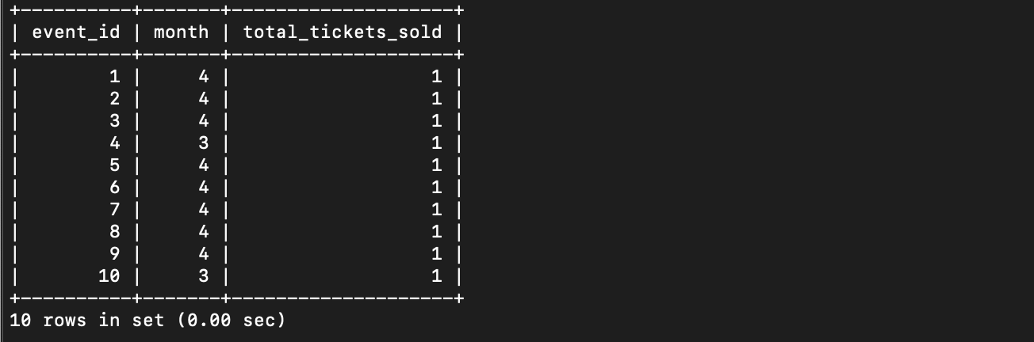

1. Write a SQL query to calculate the average Ticket Price for Events in

Each Venue.

SELECT venue_id, AVG(ticket_price) AS avg_ticket_price FROM Event GROUP BY venue_id;

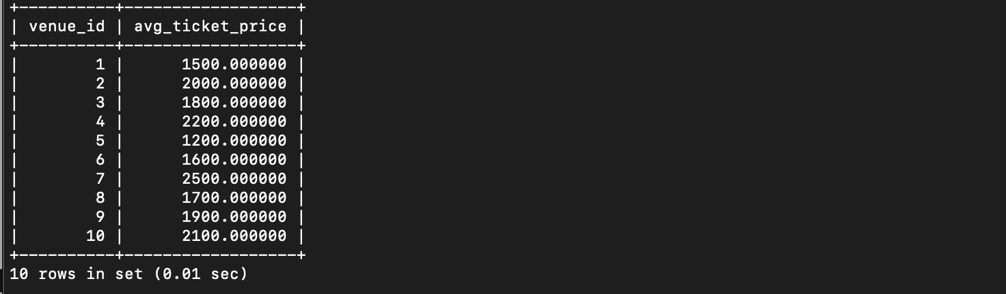

9. Write a SQL query to calculate the total Number of Tickets Sold for Each Event Type.

SELECT event_type, SUM(num_tickets) AS total_tickets_sold

FROM Event JOIN Booking ON Event.event_id = Booking.event_id GROUP BY event_type;

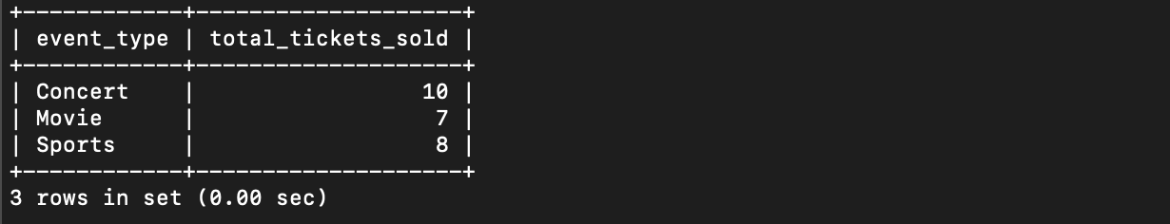

10. Write a SQL query to calculate the total Revenue Generated by Events in Each Year.

SELECT YEAR(booking_date) AS year, SUM(total_cost) AS total_revenue FROM Booking GROUP BY YEAR(booking_date);

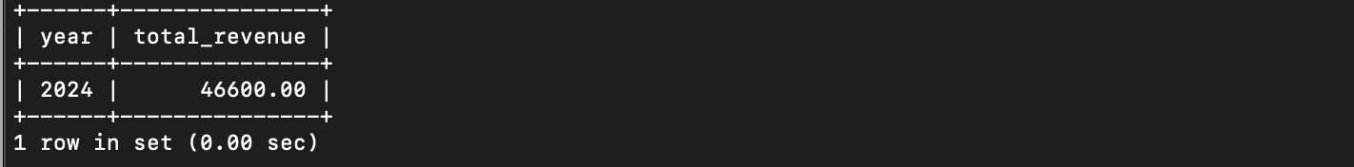

11. Write a SQL query to list users who have booked tickets for multiple events.

SELECT customer_id FROM Booking GROUP BY customer_id HAVING COUNT(DISTINCT event_id) > 1;

Screenshot 2024-04-10 at 2.51.53 PM

12. Write a SQL query to calculate the Total Revenue Generated by Events for Each User.

SELECT customer_id, SUM(total_cost) AS total_revenue_generated FROM Booking

GROUP BY customer_id;

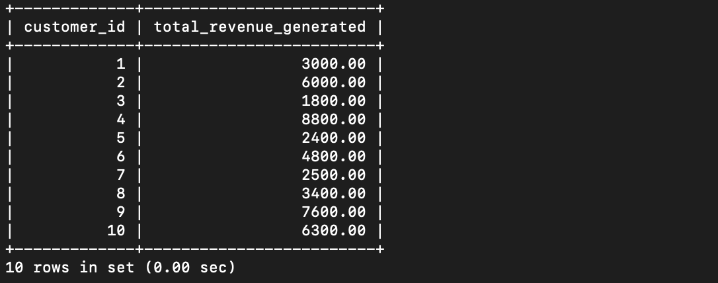

13. Write a SQL query to calculate the Average Ticket Price for Events in Each Category and Venue.

SELECT event_type, venue_id, AVG(ticket_price) AS avg_ticket_price

FROM Event GROUP BY event_type, venue_id;

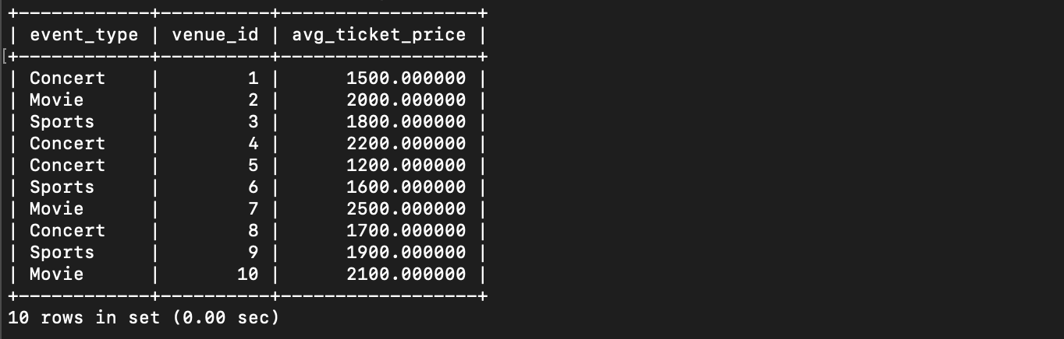

1. Write a SQL query to list Users and the Total Number of Tickets

They've Purchased in the Last 30 Days.

SELECT customer_id, COUNT(*) AS total_tickets_purchased_last_30_days FROM Booking

WHERE booking_date >= DATE_SUB(CURRENT_DATE(), INTERVAL 30 DAY)

GROUP BY customer_id;

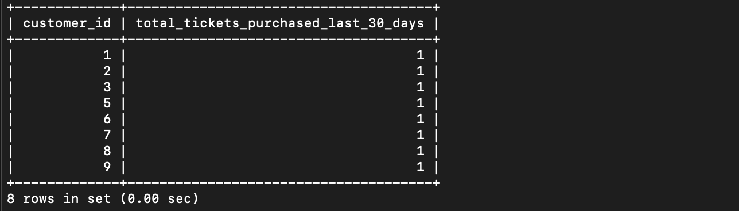

**Tasks 4: Subquery and its types**

1. Calculate the Average Ticket Price for Events in Each Venue Using a Subquery.

SELECT v.venue_id, v.venue_name,

(SELECT AVG(ticket_price)

FROM Event

WHERE venue_id = v.venue_id) AS avg_ticket_price

FROM Venue v;

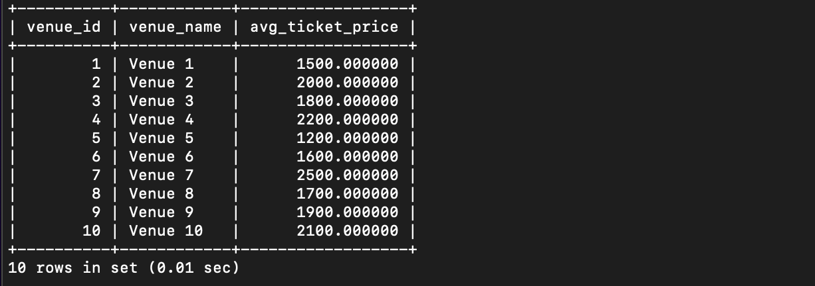

2. Find Events with More Than 50% of Tickets Sold using subquery.

SELECT event_id, event_name

FROM Event

WHERE (SELECT SUM(num_tickets)

FROM Booking

WHERE Booking.event_id = Event.event_id) > (total_seats / 2);

Screenshot 2024-04-10 at 2.51.53 PM

3. Calculate the Total Number of Tickets Sold for Each Event.

SELECT event_id, event_name,

(SELECT SUM(num_tickets)

FROM Booking

WHERE Booking.event_id = Event.event_id) AS total_tickets_sold

FROM Event;

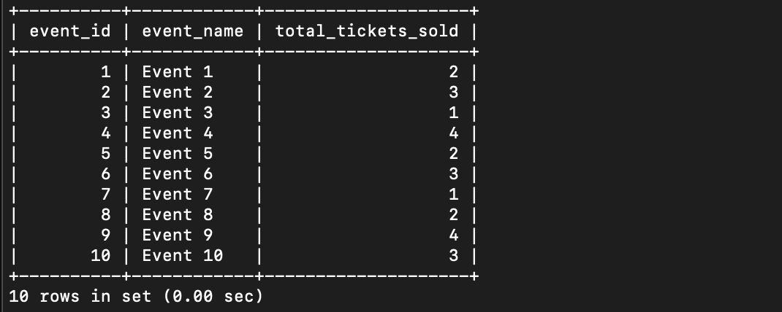

4. Find Users Who Have Not Booked Any Tickets Using a NOT EXISTS Subquery.

SELECT customer_id, customer_name

FROM Customer c

WHERE NOT EXISTS (

SELECT *

FROM Booking

WHERE Booking.customer_id = c.customer_id

);

Screenshot 2024-04-10 at 2.51.53 PM

5. List Events with No Ticket Sales Using a NOT IN Subquery.

SELECT event_id, event_name

FROM Event

WHERE event_id NOT IN (

SELECT event_id

FROM Booking

);

Screenshot 2024-04-10 at 2.51.53 PM

6. Calculate the Total Number of Tickets Sold for Each Event Type Using a Subquery in the FROM Clause.

SELECT event_type, SUM(total_tickets_sold) AS total_tickets_sold

FROM (

SELECT event_id, event_type,

(SELECT SUM(num_tickets)

FROM Booking

WHERE Booking.event_id = Event.event_id) AS total_tickets_sold

FROM Event

) AS subquery

GROUP BY event_type;

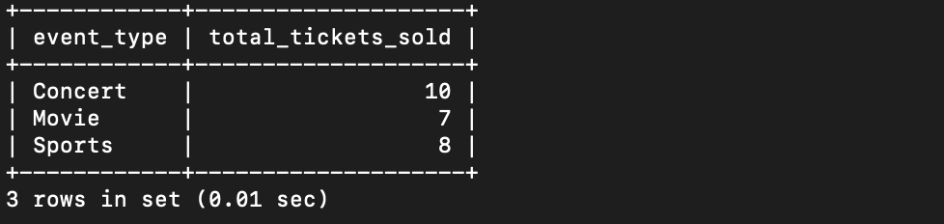

7. Find Events with Ticket Prices Higher Than the Average Ticket Price Using a Subquery in the WHERE Clause.

SELECT event_id, event_name, ticket_price

FROM Event

WHERE ticket_price > (

SELECT AVG(ticket_price)

FROM Event

);

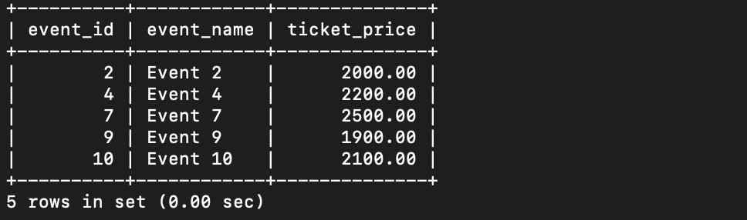

8. Calculate the Total Revenue Generated by Events for Each User Using a Correlated Subquery.

SELECT customer_id, customer_name,

(SELECT SUM(total_cost)

FROM Booking

WHERE Booking.customer_id = Customer.customer_id) AS total_revenue_generated

FROM Customer;

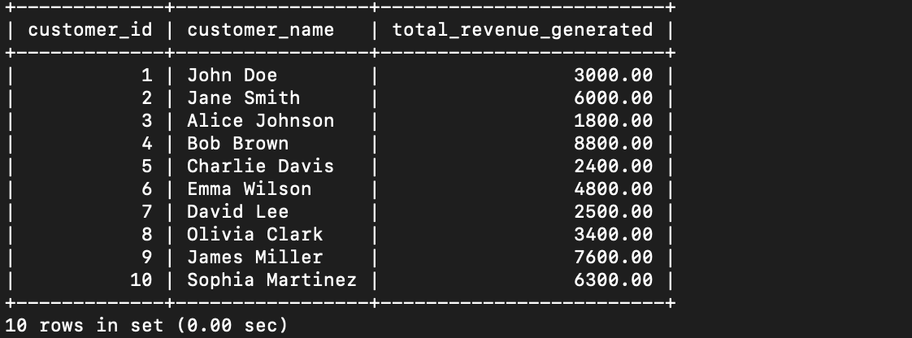

9. List Users Who Have Booked Tickets for Events in a Given Venue Using a Subquery in the WHERE Clause.

SELECT customer_id, customer_name

FROM Customer

WHERE customer_id IN (

SELECT DISTINCT customer_id

FROM Booking

WHERE event_id IN (

SELECT event_id

FROM Event

WHERE venue_id = 2

)

);

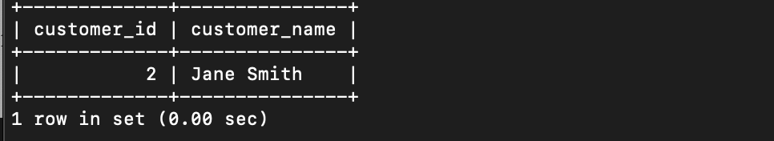

10. Calculate the Total Number of Tickets Sold for Each Event Category Using a Subquery with GROUP BY.

SELECT event_type, SUM(total_tickets_sold) AS total_tickets_sold

FROM (

SELECT event_id, event_type,

(SELECT SUM(num_tickets)

FROM Booking

WHERE Booking.event_id = Event.event_id) AS total_tickets_sold

FROM Event

) AS subquery

GROUP BY event_type;



11. Find Users Who Have Booked Tickets for Events in each Month Using a Subquery with DATE_FORMAT.

--

12. Calculate the Average Ticket Price for Events in Each Venue Using a Subquery

SELECT venue_id, venue_name,

(SELECT AVG(ticket_price)

FROM Event

WHERE Event.venue_id = Venue.venue_id) AS avg_ticket_price

FROM Venue;

