Requirement Specification Document
AI-Powered Restaurant Reservation Platform
This document serves as the formal requirements specification for the AI-Powered Restaurant Reservation Platform, outlining the problem statement, core modules, structural database schemas, user experiences, and future roadmap.

1. Problem Statement
Traditional restaurant reservation systems suffer from operational inefficiencies:

For Customers: Booking tables is often static (cannot select a specific table location like "Window" or "Patio"), waitlists are manual, and recommendations are generic rather than tailored.
For Restaurant Owners: Predictable demand planning is non-existent (leading to staffing over/under-allocation), table utilization is unoptimized, and no-shows cause massive revenue leaks.
The Solution: An AI-powered reservation platform that offers real-time WebSocket availability, automated queue promotions, NLP-driven chatbot booking, hybrid content/collaborative restaurant recommendations, and predictive ML models for demand forecasting and no-show risk classification.
2. Objectives
Optimize Seat Utilization: Implement real-time WebSocket tables grid configurations to reduce empty seating margins.
Automate Queue Management: Achieve zero-delay waitlist promotions using an automated cancellation-triggered queue matcher.
Improve Operational Efficiency: Provide restaurant owners with 7-day demand forecasts to optimize staff levels and reduce food waste.
Reduce Revenue Loss: Classify reservation no-show probabilities to allow proactive warnings for high-risk bookings.
Provide Smart Search: Implement an NLP chatbot parsing engine to translate natural queries into bookings.
3. Target Users
Customer: Everyday diners looking to search restaurants, receive personalized recommendations, choose specific tables live, monitor waitlists, and check in via QR code tickets.
Restaurant Owner: Staff and owners who manage restaurant profiles, menus, table configurations, handle active reservations, and view predictive staffing graphs.
Administrator: System moderators tracking user registries, restaurant configurations, and review feedback queues.
4. Modules
Login / Authentication Module:
Secure registration and role selection (Customer, Owner, Admin).
Custom JWT claims authentication attaching user profile context directly to simple tokens.
Discovery & Search Module:
Keyword filters (Cuisine, Price Range, Location).
NLP Assistant search translating conversational queries into search inputs.
Personalized hybrid recommendations (TF-IDF cosine similarity + reservation history).
Interactive Booking Module:
Live grid selection rendering active table states (Free vs Occupied) via WebSockets.
AI Table Suggestion matrix matching occasions and group size to specific tables.
Automated Waitlist Module:
FIFO waitlist queueing when dining slots are full.
cancellation-triggered promoter bumping waitlisted users to confirmed status with live socket alerts.
Owner Analytics Hub:
Recharts analytics dashboard rendering Random Forest staffing demand forecasts.
No-show risk scoring on incoming bookings.
Admin Control Module:
User registries audit grid.
Review feedback moderator logs with AI category-level sentiment breakdown.
5. User Flow
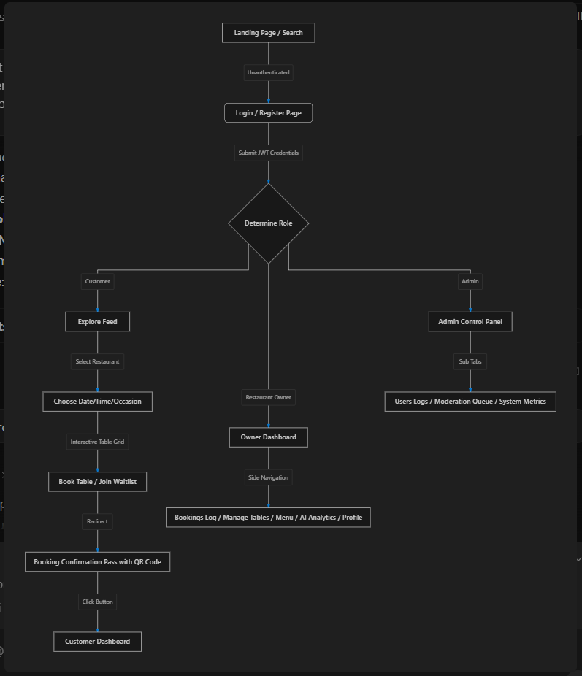
6. Database Tables
accounts_user (Custom User Model)
Column | Type | Description
id | Integer (PK) | Unique user identification
email | CharVar (Unique) | User email used for login
name | CharVar | Full name
phone | CharVar | Telephone number
role | CharVar | customer, owner, or admin
is_active | Boolean | Account status

restaurants_restaurant
Column | Type | Description
id | Integer (PK) | Unique restaurant profile ID
owner_id | Integer (FK) | Reference to accounts_user
name | CharVar | Restaurant name
location | CharVar | Address details
cuisine | CharVar | Comma-separated tag list
description | Text | Profile introduction
operating_hours | CharVar | Operating intervals
price_range | CharVar | Budget tag ($, $$, $$$)
rating | Float | Average score (0.0 to 5.0)
cover_image | Image | Cover banner upload

restaurants_table
Column | Type | Description
id | Integer (PK) | Unique table ID
restaurant_id | Integer (FK) | Reference to restaurants_restaurant
table_number | CharVar | Table identifier code (e.g. T1)
capacity | Integer | Seat count
location_tag | CharVar | Position (e.g., Window, Patio)
is_active | Boolean | active configuration status

reservations_reservation
Column | Type | Description
id | Integer (PK) | Unique reservation identifier
user_id | Integer (FK) | Reference to customer account
restaurant_id | Integer (FK) | Reference to restaurant profile
table_id | Integer (FK) | Reference to selected table
date | Date | Reservation date
time_slot | CharVar | Booking time (e.g. 20:00)
guests_count | Integer | Party count
status | CharVar | pending, confirmed, completed, cancelled
qr_code | Image | Check-in verification QR ticket

7. Wireframes Layout & Styling Specs
The application is styled with a premium, glassmorphism theme defined in src/styles/index.css:

Color System: Curated dark background (#0b0f19) with bright primary gradient glows (#2563eb to #8b5cf6), border accents (rgba(255,255,255,0.08)), and white text fields.
Typography: Sleek Sans-Serif fonts (Outfit or Inter) with clean sizes and weights.
Animations: Soft fades (animate-fade) and micro-hover translations on cards.
Home/Landing Page Wireframe
text

+------------------------------------------------------------------------+
| DiningIn AI (Logo) [Search Bar (NLP input)] [Login / Reg] |
+------------------------------------------------------------------------+
| |
| [ Banner: Find & Book tables with AI Suggestions ] |
| |
| +---------------------------+ +----------------------------------+ |
| | Filters: Cuisine, Price | | Hybrid Recommendations | |
| +---------------------------+ | | |
| | [Rest Card 1] [Rest Card 2] | |
| +----------------------------------+ |
+------------------------------------------------------------------------+
Restaurant Detail Page Wireframe
text

+------------------------------------------------------------------------+
| <- Back to home [Restaurant Cover Image] |
+------------------------------------------------------------------------+
| About & Description | Reserve Your Table |
| [Menu Highlights] | - Date Selector |
| | - Time Slot / Party Size |
| AI Sentiment reviews breakdown | - [X] Enable AI Suggestions |
| - Food: 4.8 | - [Table Grid Layout (Live States)] |
| - Service: 4.2 | [T1-Free] [T2-Occ] [T3-Suggest] |
| - Ambience: 4.7 | - [ Book Selected Table Button ] |
+------------------------------------------------------------------------+
Booking Confirmation Ticket Wireframe
text

+------------------------------------------------------------------------+
| [ Checkmark: Confirmed ] |
| |
| +------------------------------+ |
| | Maisammaguda Biryani | |
| | - Date: 2026-08-10 | |
| | - Time: 20:00 | |
| | - Table: M2 (4 Pax) | |
| | .................... | |
| | [ QR Code Block ] | |
| | Pass ID: #2 | |
| +------------------------------+ |
| |
| [ Home Button ] [ My Bookings ] |
+------------------------------------------------------------------------+
8. Future Scope
Real-Time Map View Integration: Live visual map layouts of tables (drag & drop restaurant floor planners).
Integrated Payments & Deposit System: Escrowed dining deposits for high-capacity bookings to mitigate no-show losses further.
RAG-based AI Agent Voice Reservations: Support for phone-based voice reservation agents interacting directly with the API.
Mobile Companion Apps: Native iOS/Android apps with location-based proximity alerts for waitlist queues.

