|  |  |  |  |
| --- | --- | --- | --- |
| *Course:* | **Maschinelles Lernen und künstliche Intelligenz/**  **Machine Learning and Artificial Intelligence** | | |
| *(Group) Member:* | *Nr.* | *Name* | *Matrikel* |
| *1* | **Singa Sai Rohit Gupta** | **5164448** |
| *2* | **Jayant Subhash Kendole** | **5159172** |
| *3* | **Nikhil Mukesh Sadafule** | **5163582** |

1. Definition
   1. Introduction and Explanations

The task aims to make us understand the step one of creating an ml model. That include.

* Data collection
* Feature Extraction
* Cleaning of data & Preprocessing of data
  1. Tools Used

The below tolls are used to achieve the resultant output

* Python
* vs code
* pip

1. Preparation & Concept
   1. Implementation & Explaination
      1. Task 6.1 Adding Kitchenware images to the provided database

After checking the resources provided there was no image sets that were found. We have collected photos of cups, bowls and plates from the team mates and friends’ dorms. Also student lounge and when we felt some data is lesser we have taken images from online platforms like kleinanzeigan, amazon etc. In each category that is cups bowls plates more than 25 +images are been collected.

The structure in which the data set is stored

**Data**

| --- **cups**

| ------1.1.jpg

| ------ ..

| ------ 1.n.jpg

| --- **bowls**

| ------ 2.1.jpg

| ------ ..

| ------ 2.n.jpg

| --- **plates**

| ------ 3.1.jpg

| ------ ..

| ------ 3.n.jpg

* + 1. Task 6.2 Exploring and applying Image processing methods for feature extraction

A given code has been adapted for the data that has been collected, Various image thresholding have been checked.

After executing the code given the below resultant outputs have been produced for cups, bowls and plates. Some of the notable records are being presented below.

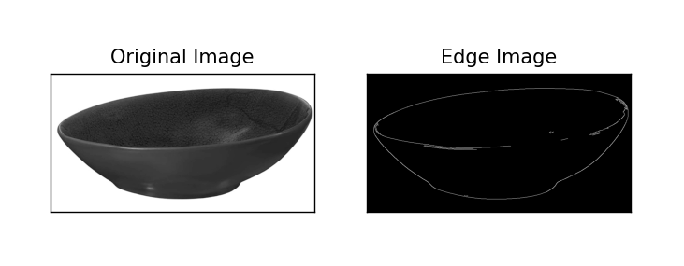

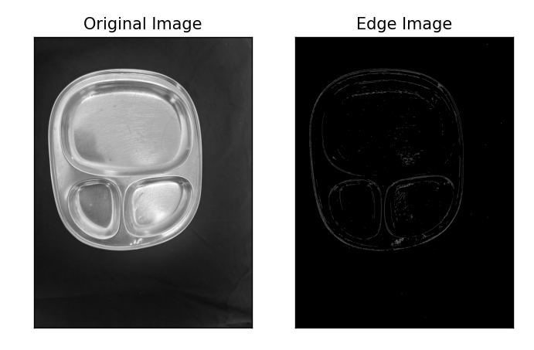

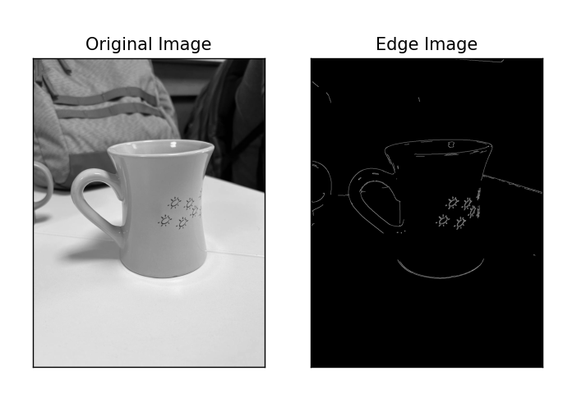

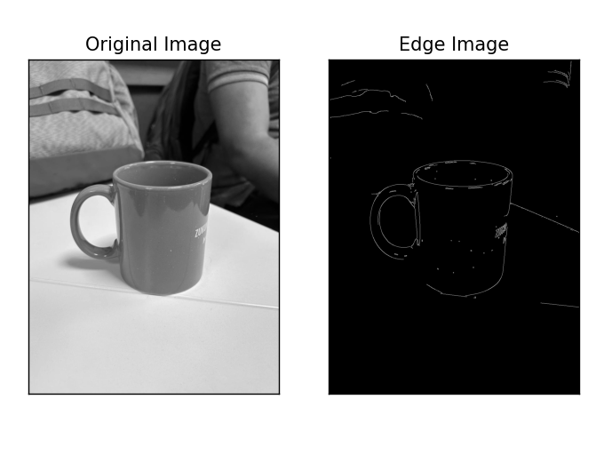

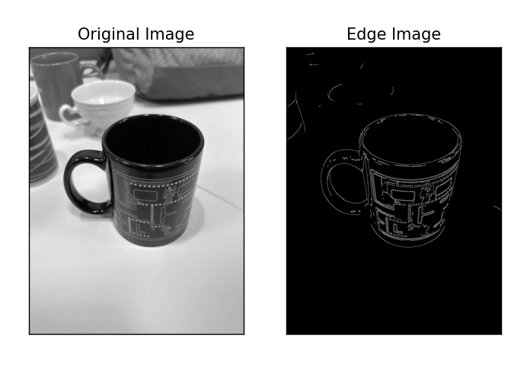

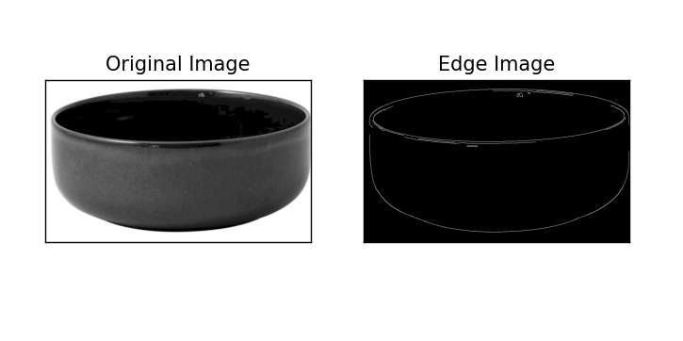

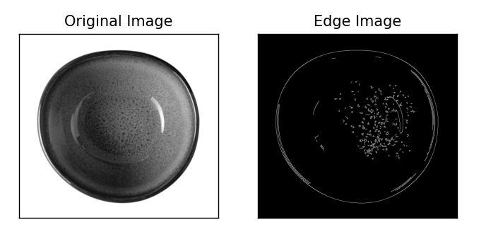

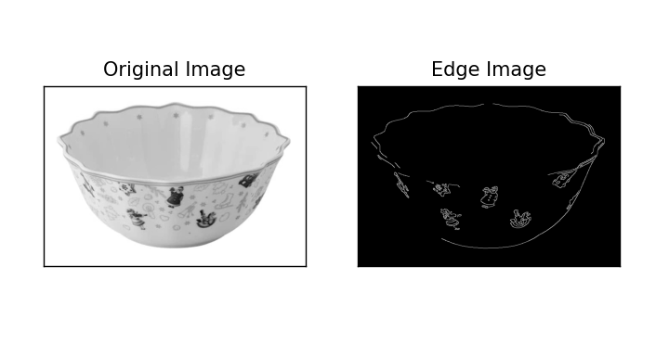

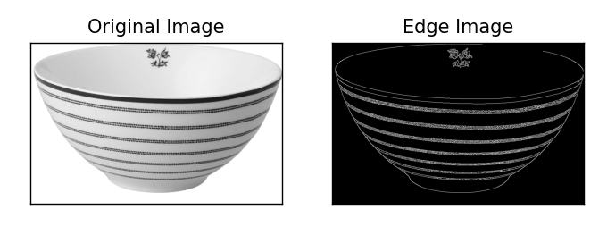

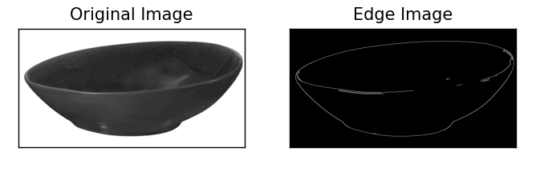

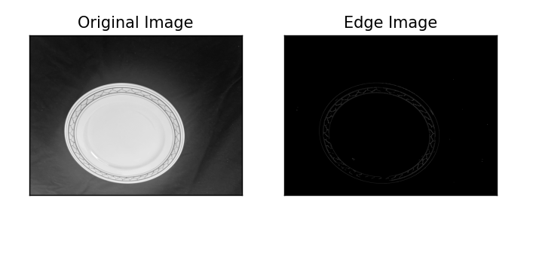

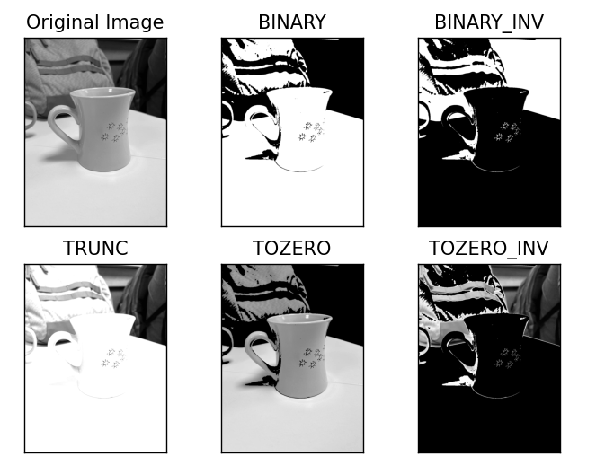

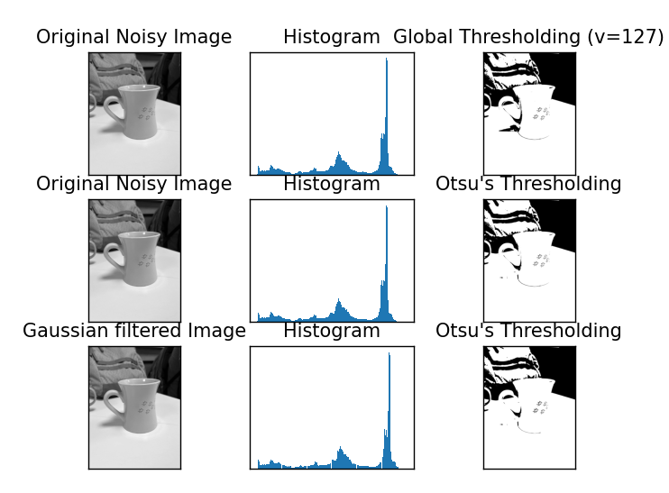

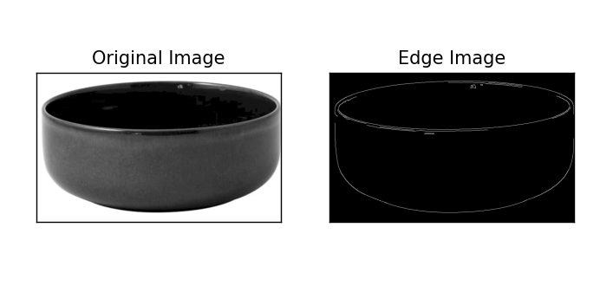

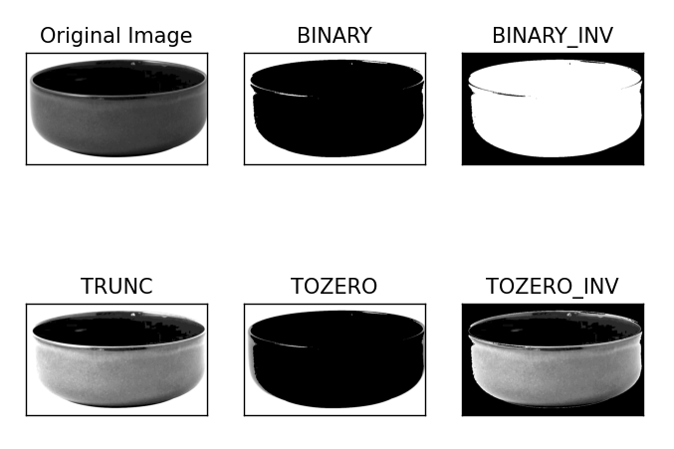

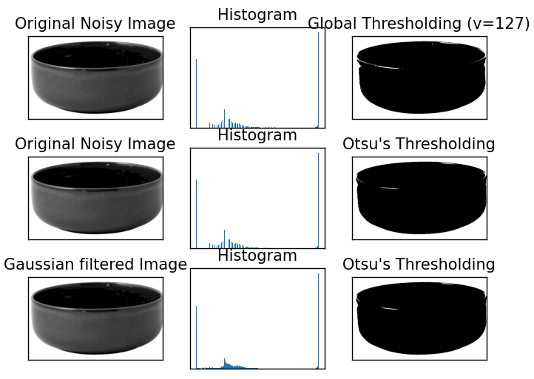

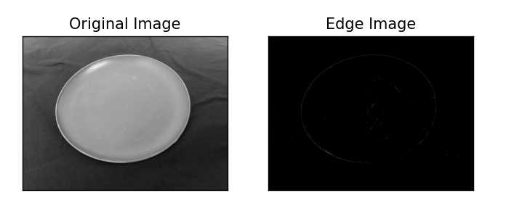

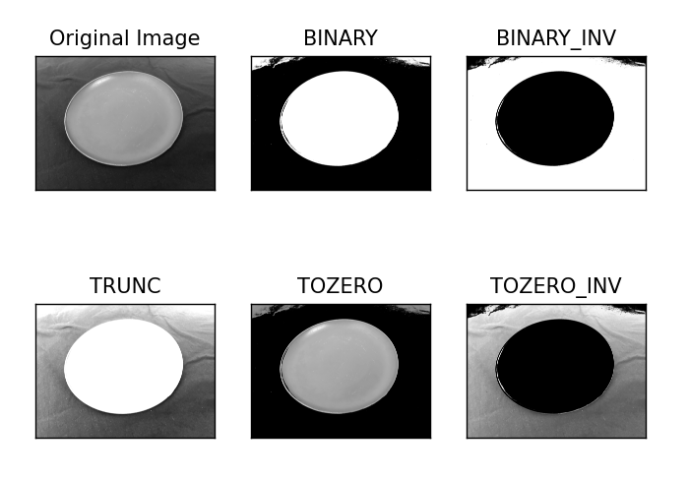

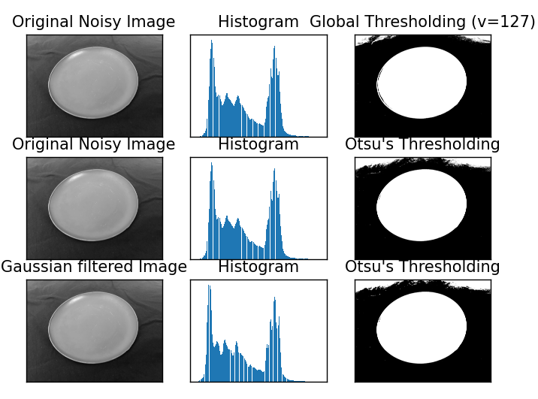

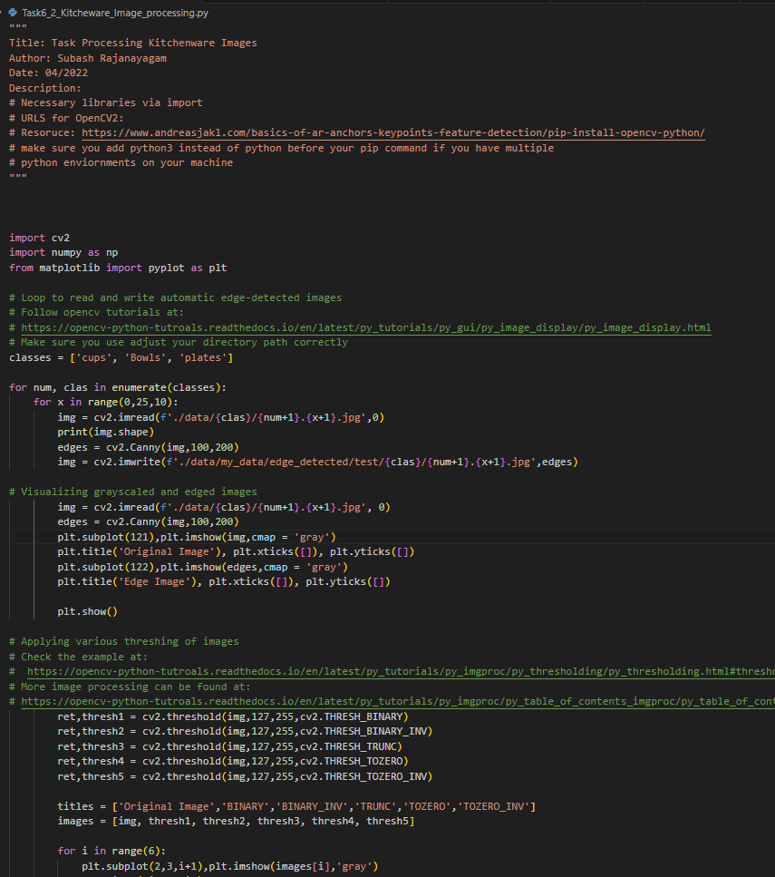

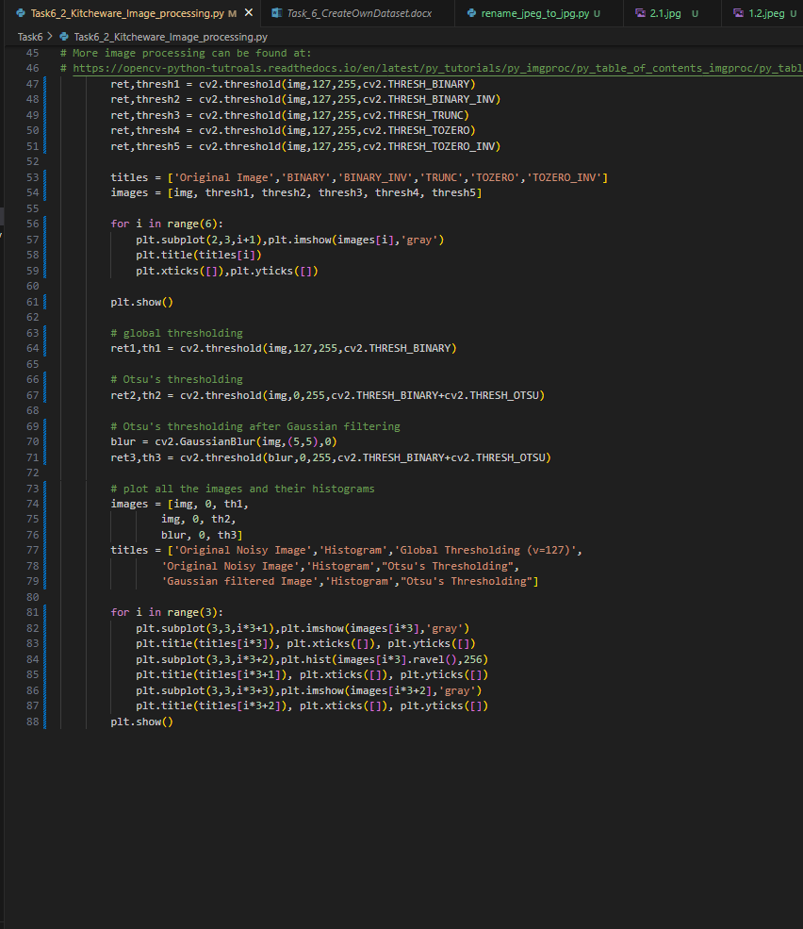

* + 1. Preparing the feature extracted images for an ANN

The data is been split into train and test data. A small python code is used to split the data between train and test. Code snippet attached as below.

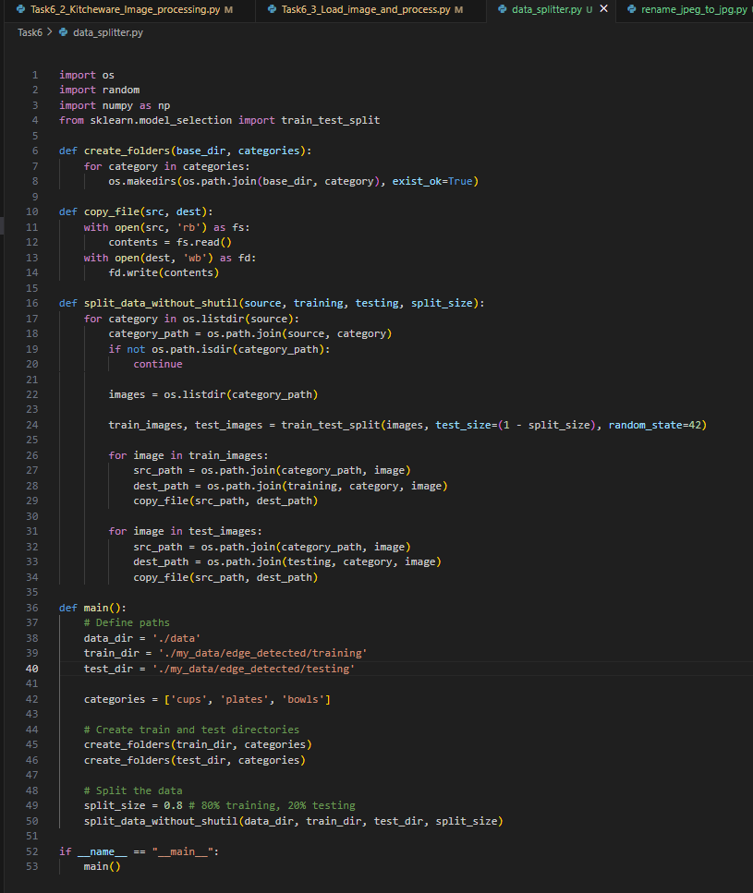

Executing the Task6_3_Load_image_and_process.py below results are been observed.  
There are 119 pictures in the training data set. The testing data consists of 31 pictures.

Some of these are been plotted as below.

