**Task 7: Improve the Supervised Kitchenware ML model**

Please read the given Task carefully.

Resources

**Session7_Example_fashion_mnist.py** in Moodle

Task 7 Definition

We have created a Supervised classification ML model, now your team needs, understand,implement, and improve it!

The aim of this task is to familiarize how to:

* 1. Initializing a Supervised ANN model to classify your own data with the help of TensorFlow + Kera
  2. Train and test the model on your own dataset
  3. Explored methods to improve the accuracy of the model with combined datasets.

We make use of our own pre-processed image database. The objects of interest for classifications are still cups, bowls, and plates.

Allowed Tools

Tools that can be used:

* Python 3.9/ 2.7
* VS-Code
* TensorFlow + Keras, NumPy, Matplotlib, and OpenCV2.

Task 7.1 Adding Kitchenware images to the provided database

**Create “Task7_Train_test_classify.py”**

This is the continuation of from Task 6, for Task 7.1

1. Implement your ML-Model based on the provided code – “Task7_Train_test_classify.py”
2. Icon

   Description automatically generated with medium confidenceTrain and test the Kitchenware ML Model on the previously provided data + your data

Figure 1: Screenshots of provided dataset after preprocessing .

Expected Outcomes of Task 7.1

The expected outcome of the above is a functioning python application and documentation showing the result from training and testing the Kitchenware ML model on provided + your dataset. So highlight with accuracy and loss what you have achieved.

Task 7.2 Improve accuracy by adding the data created by the other groups

**Resource = Add data from next group number (e.g. Group 1 exchanges with group 2; Gr3+Gr4, etc.)**

Combine your dataset with those of one or more of the other groups, implement and review the improvement of the accuracy and loss results.

**Expected results after adding more data**

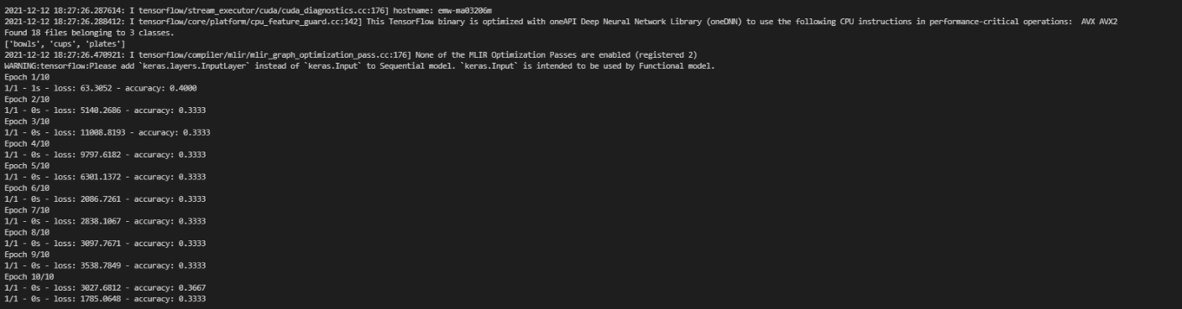

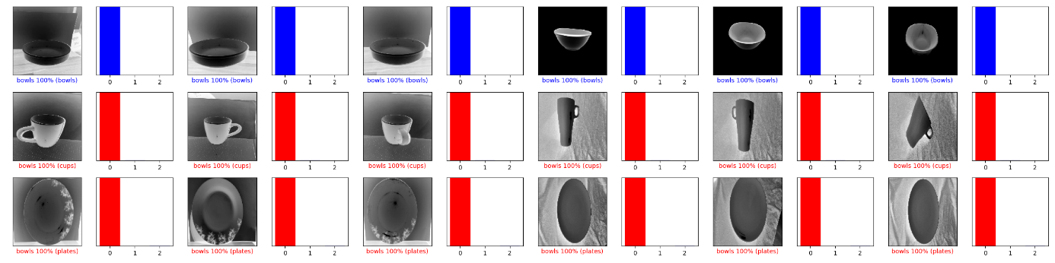

Figure 2: Accuracy after adding more data

Expected Outcomes of Task 7.2

The expected outcome of the above is a functioning python application and documentation showing the result from investigating the option of adding more data for improving classification accuracy.

Is the accuracy better? If yes, great, if no – why?

Task 7.3 Explore different methods to improve the accuracy

**Hint:** Try different data processing options as well as different features from TensorFlow + Keras.

**Try one different ML-Modell design and one different feature set (e.g. grayscale and edge) and explore the impact.**

**Useful links:**

[1] <https://www.tensorflow.org/guide>

[2] <https://www.tensorflow.org/tutorials/keras/classification>

[3] <https://keras.io/api/preprocessing/image/>

[4] <https://keras.io/api/models/sequential/>

[5] <https://machinelearningmastery.com/tensorflow-tutorial-deep-learning-with-tf-keras/>

Expected Outcomes of Task 7.3

The expected outcome of the above is a functioning python application and documentation showing the result from investigating the option of using different methods for improving classification accuracy. With each method explored…