|  |  |
| --- | --- |
| Developer | Sai Sarangam |
| Document | Unit testing document for AW Code Challenge |
| Date | 07/11/2021 |

**Bug #1: -** Movies are sorting properly after fix the issue

Sort with title (Excludes leading articles (a/an/the))

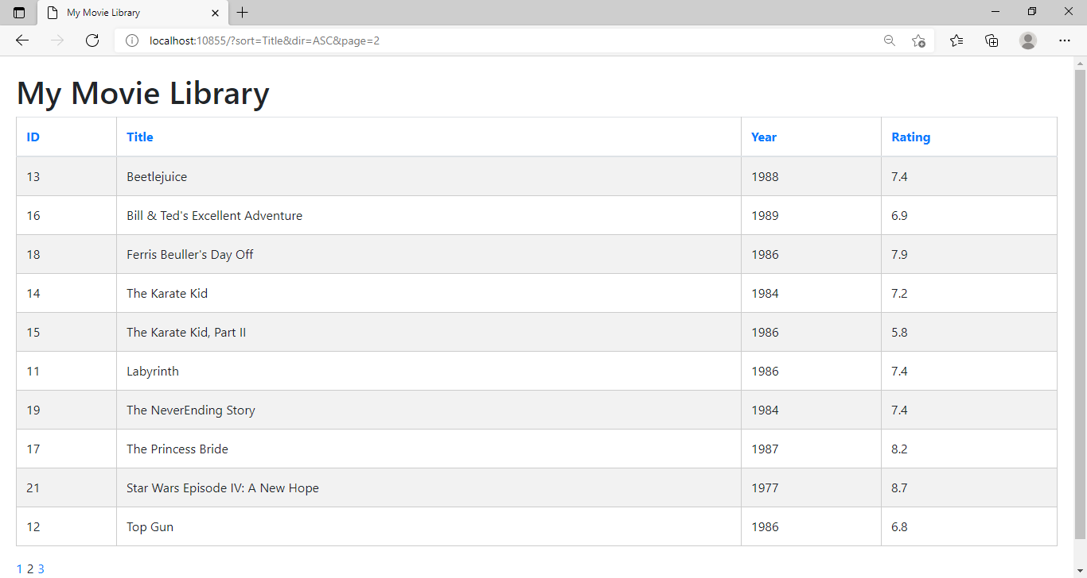

Sort With Rating: -

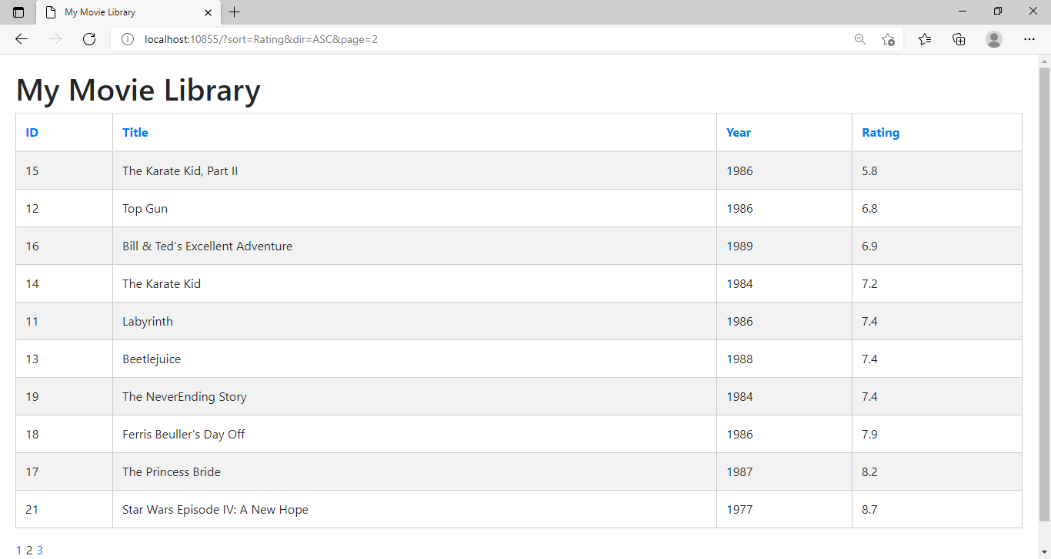

Sort with Year: -

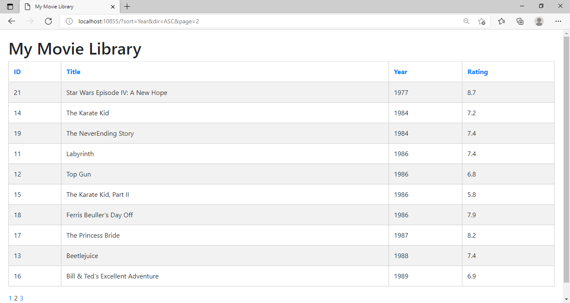

**Bug #2: -** Duplicate names are not displaying after fix the issue. Before fixing the issue 30 records were displaying, now only 28 records are displaying

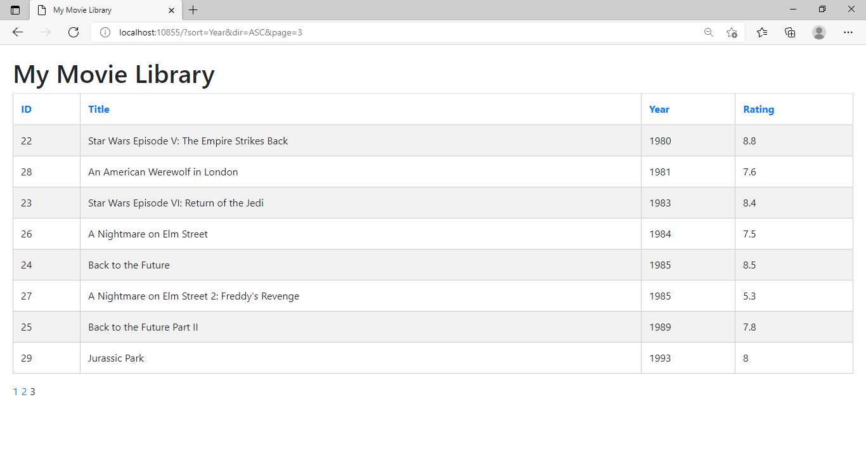

Unit Test Cases for CodeChallenge Project :-

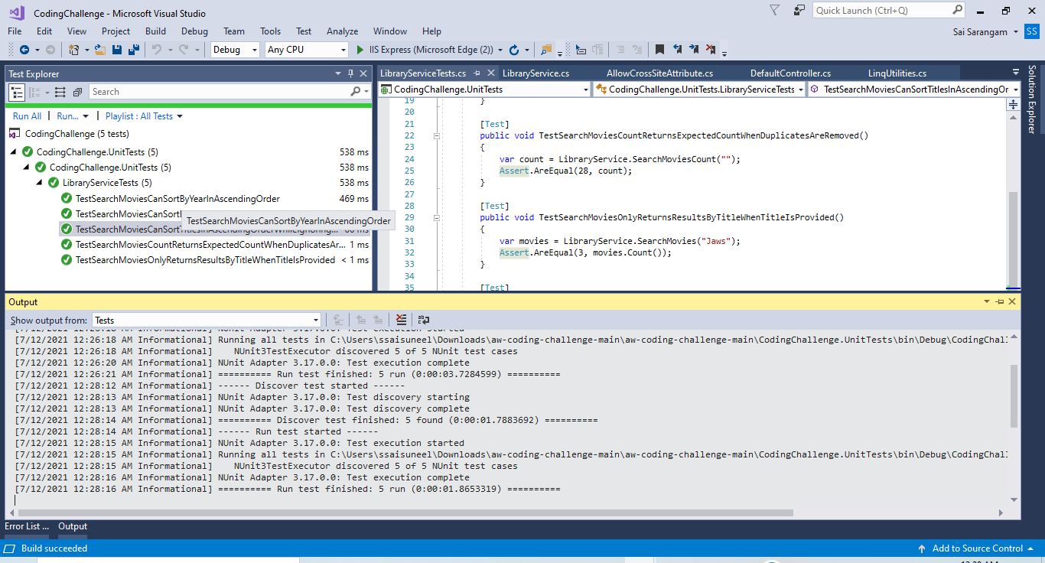

**Request #3: -** MovieLibraryAPI [.NET Core 2.1 - Rest Web API for getting movie library details.]

Get Method Testing from Swagger: -

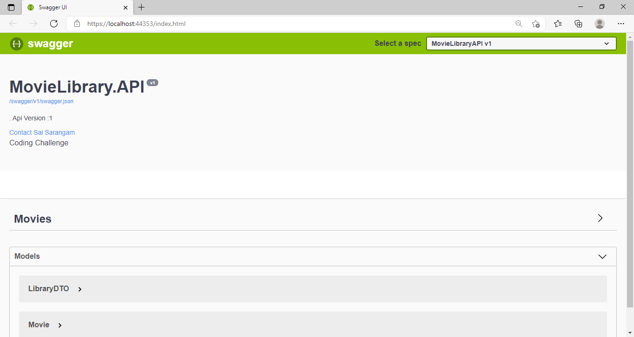

3.a) Search with Empty Title (Expected Output: Return all records)

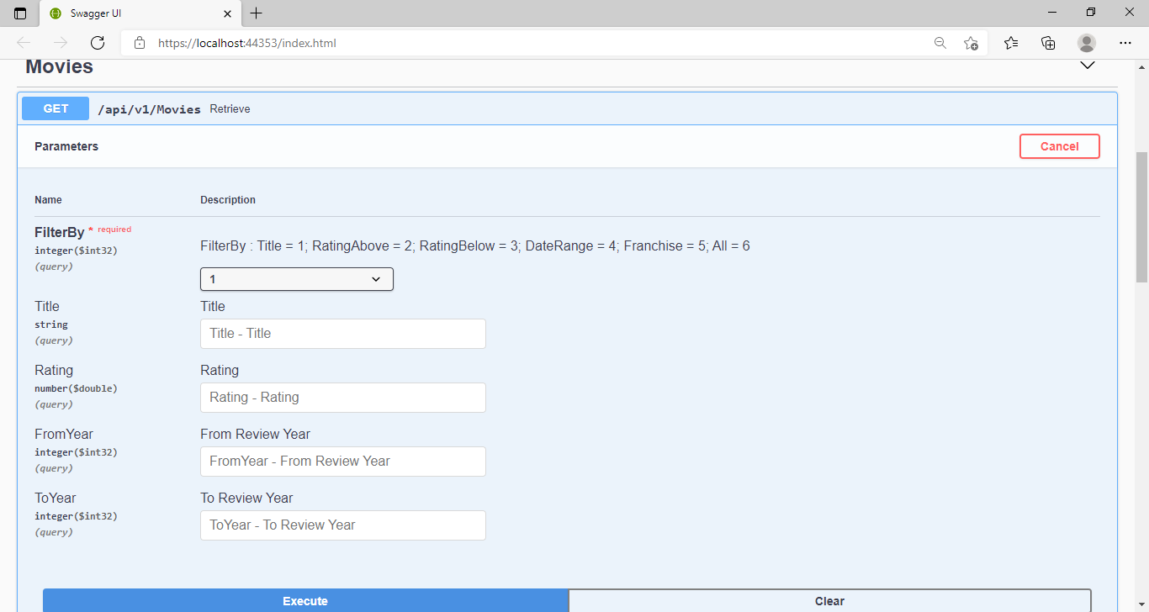

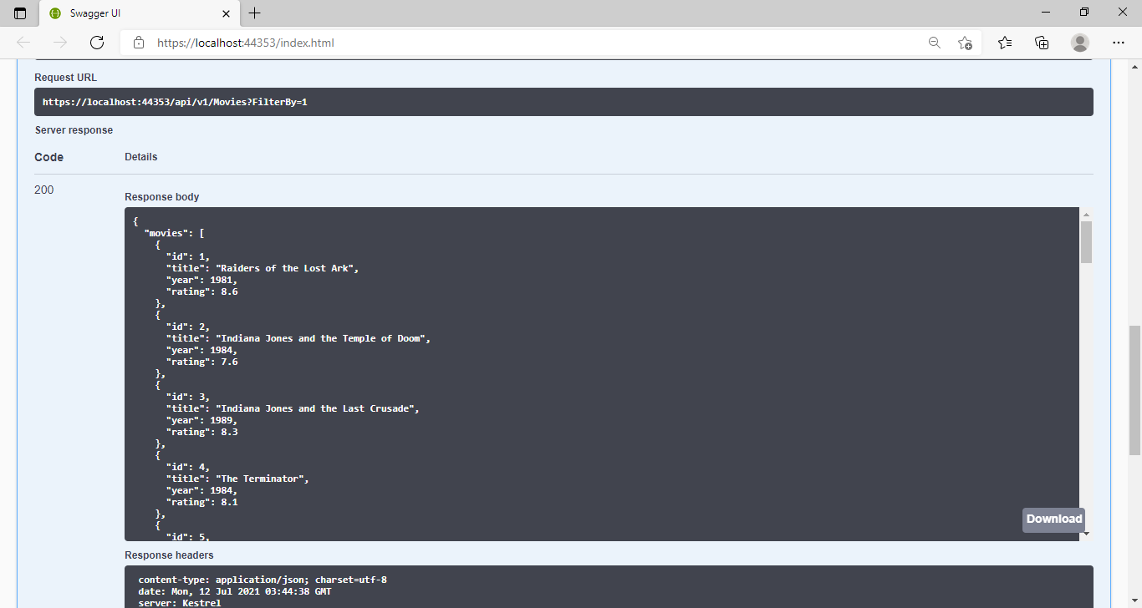

3.b) Search with some text in Title (Expected Output: Return if the title contains the search content)

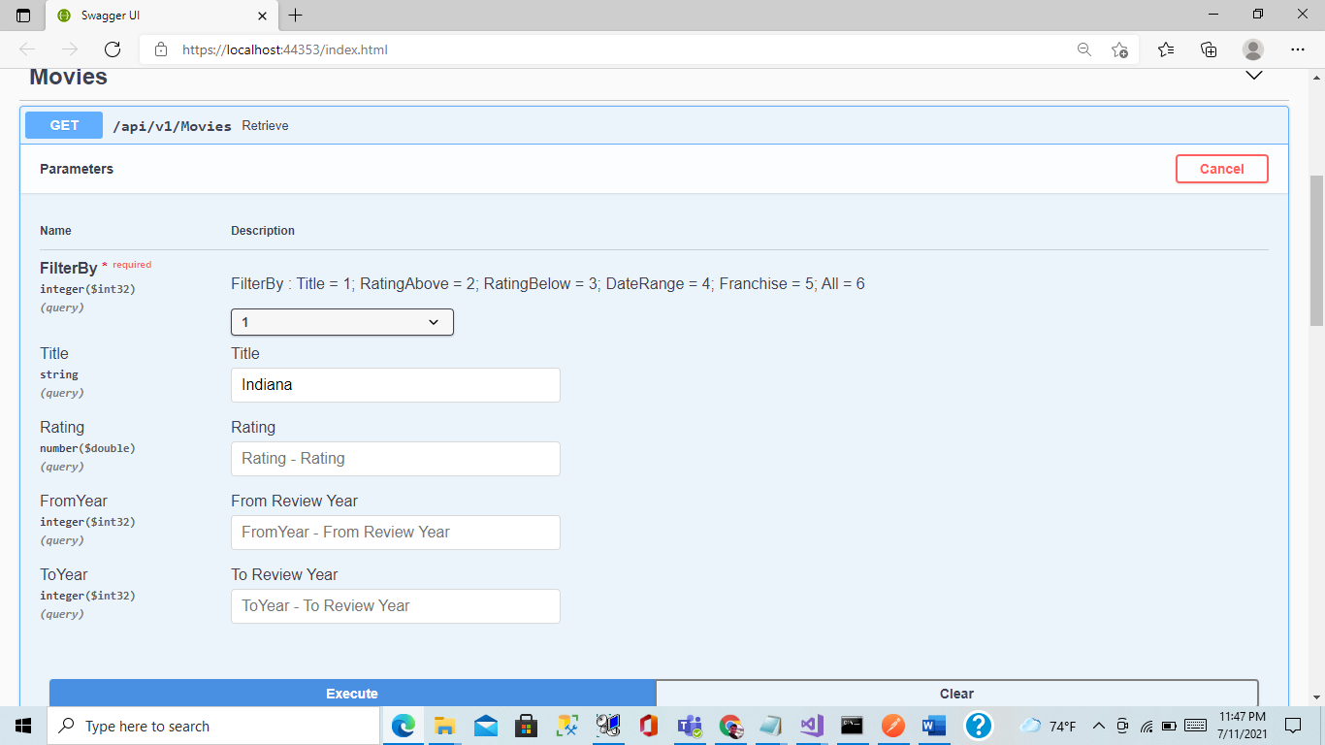

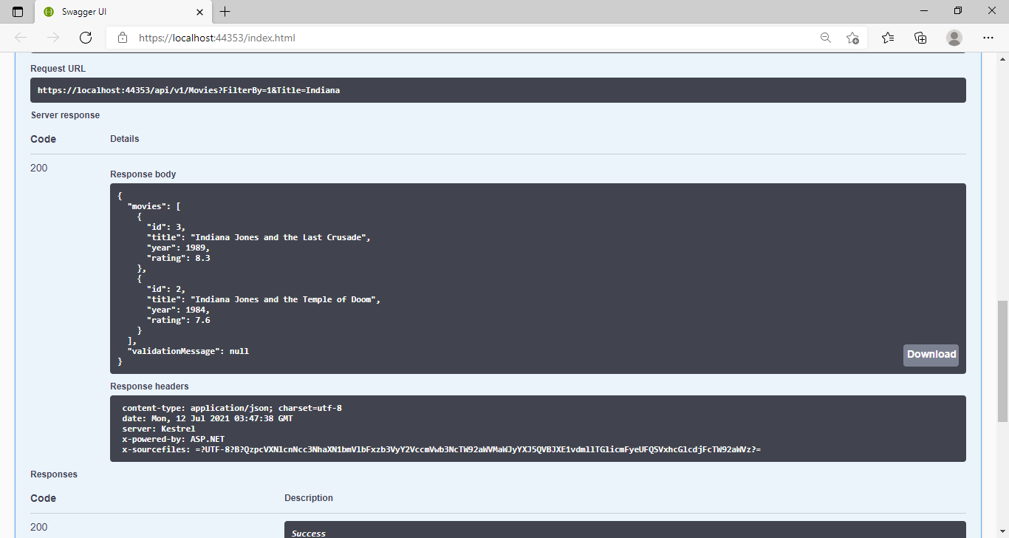

3.c) Movies that are above Rating

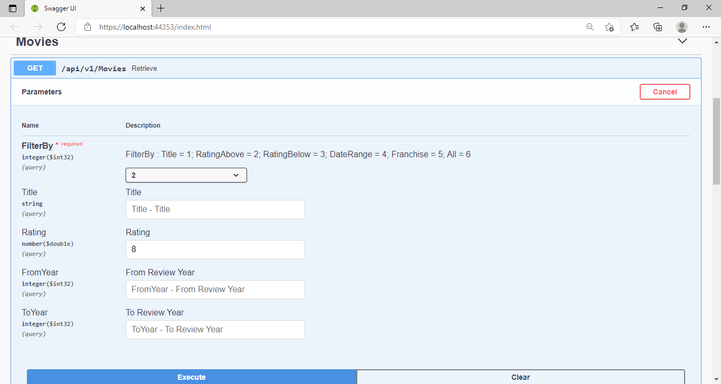



3.d) Movies that are below Rating

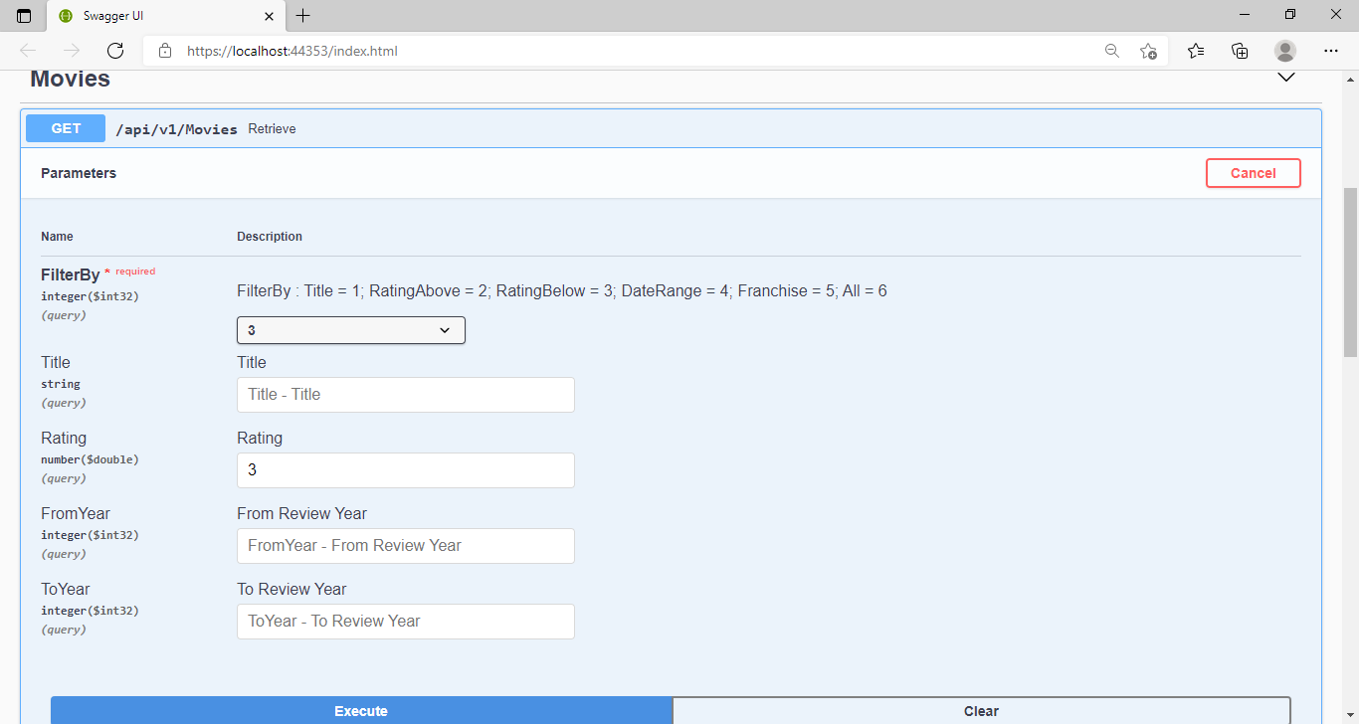

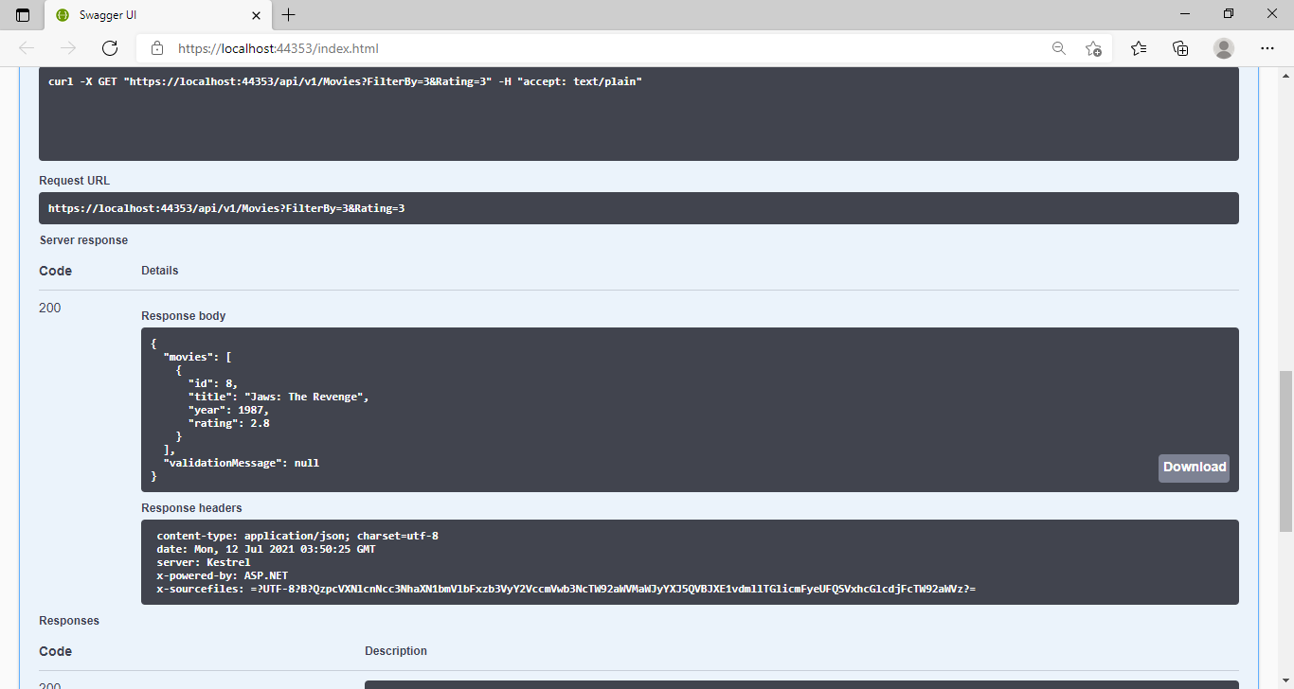

3.e) Movies between a date range

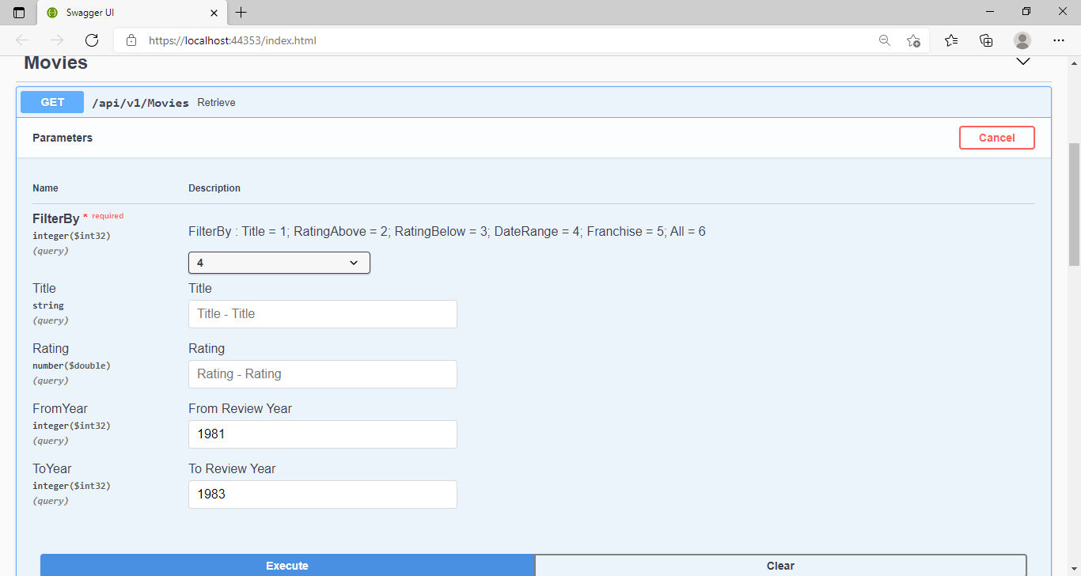

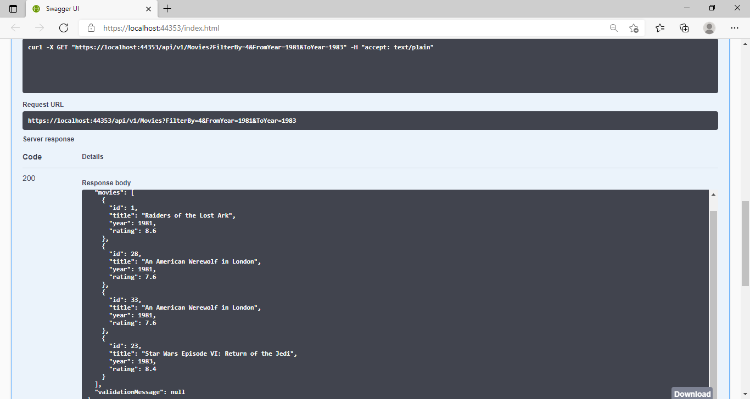

3.f) All the Unit Test Cases are success

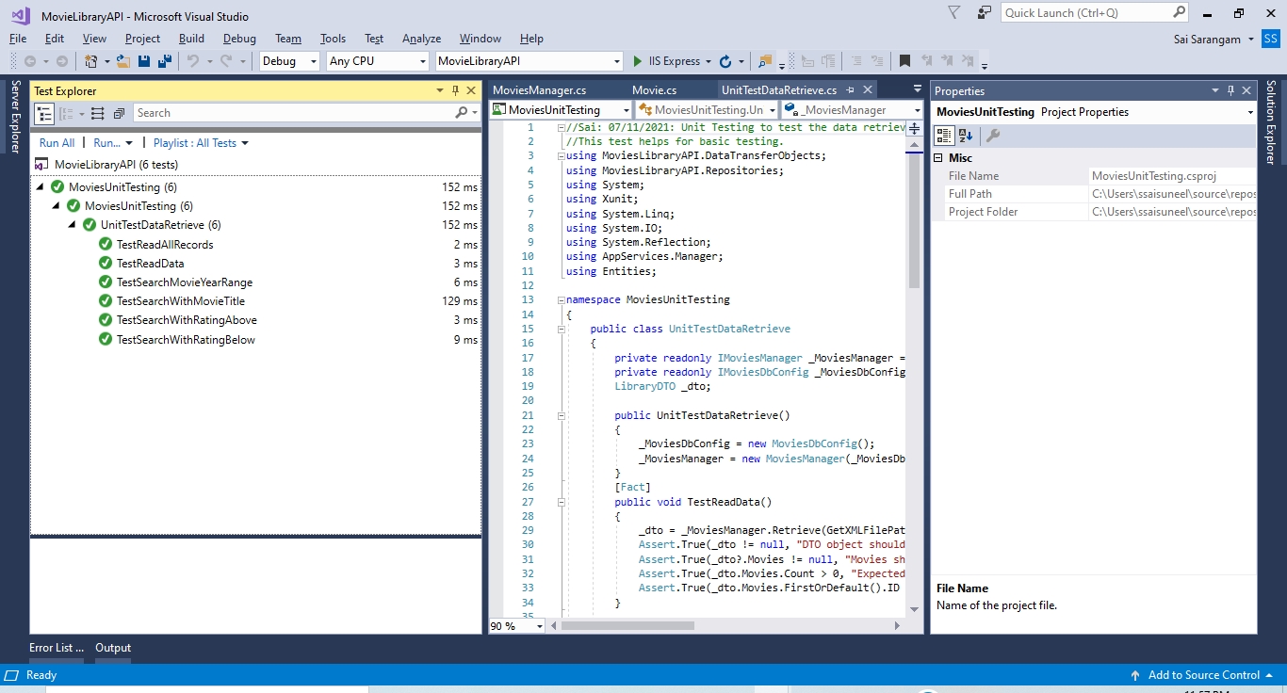

**Request #4: -** Created UI in Angular (12.1.1) for improving the performance to avoid server calls for sorting/paging and to add search functionality. We still call the existing MVC Controller to get the data and bind them in Angular Page.

**Home Screen: -**

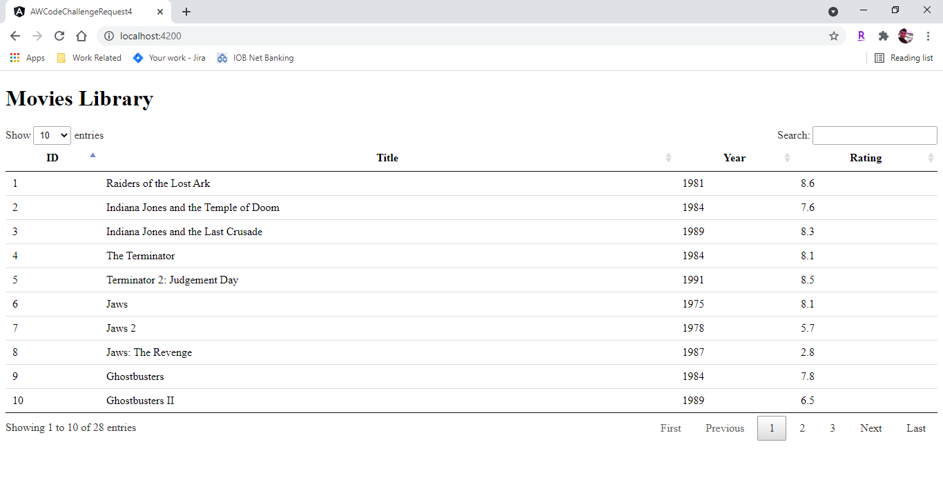

**Sort with Title:**



**Search:**

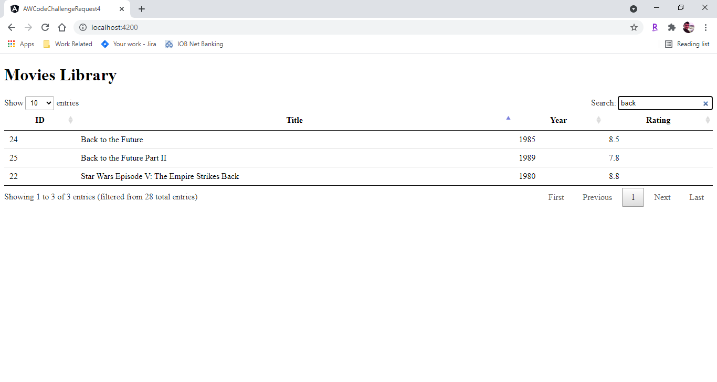

**Paging:**

