What is Fault-Tolerant Microservice?
- Fault Tolerant Microservice is a service, which continues to work even when downstream system fails.
- Instead of crashing or Cascading failures, it handles the failure gracefully.

What its required?
- As in microservices, different services communicate over the network.
- And its possible that 1 service unavailability could bring down the whole system.

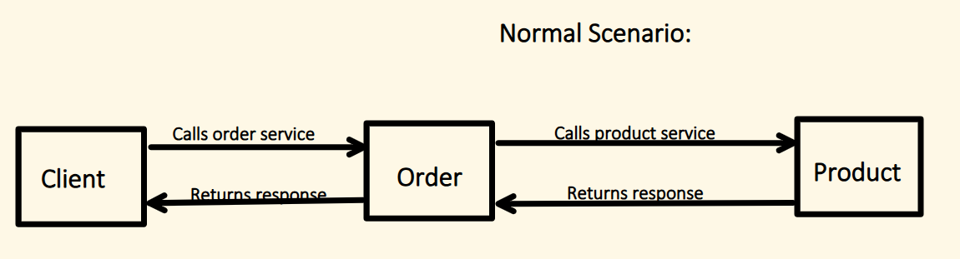
Lets say because of either buggy code or Infrastructure issue "Product" service becomes too slow:
- Say, product service become slow and taking 60 seconds to respond.
- If proper fault tolerant is not applied, then a call from Order service will hang for 60sec.
- Thus, a thread is blocked for that period.
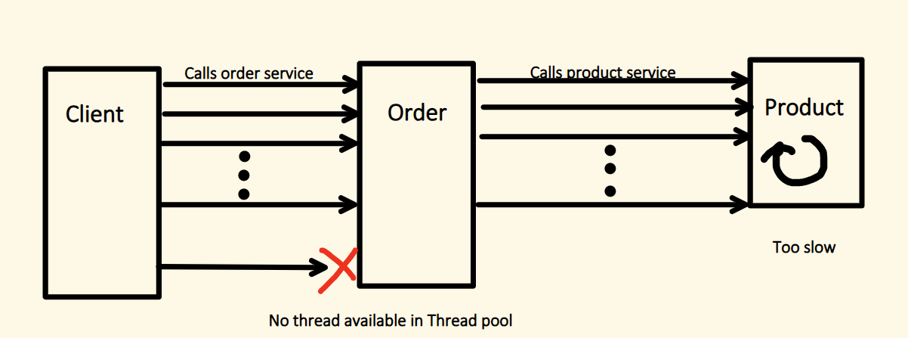
- if sudden burst of request comes from Order to Product service, all threads will now get blocked (waiting for response).
- And because of this, clients of Order service also get blocked.
- Eventually, services will run out of threads and start rejecting the request.
This is know as CASCADING FAILURE.

means, issue is at Product service, but now propagated to other services too.

To avoid this, we need to build Fault tolerant microservice.
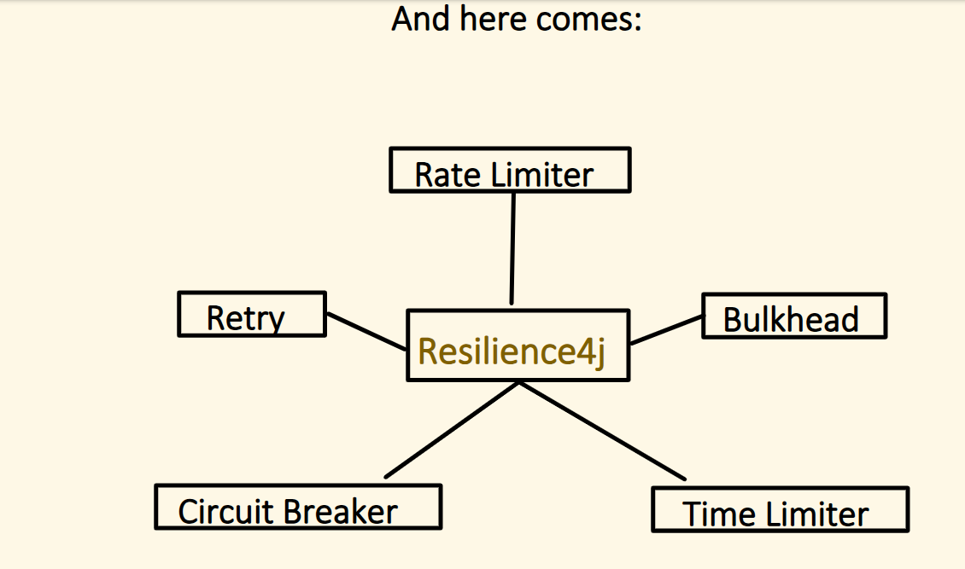
Lets go in depth one by one in recommended logical ordering:
RateLimiter → Bulkhead → TimeLimiter → CircuitBreaker → Retry
Why Ordering required?
For example: Always apply RateLimiter before Retry, so that retry logic doesn't overwhelm the system with already limited traffic.
Else we end up in retry the traffic, which will get blocked by RateLimiter later.

RateLimiter:
It controls the number of requests allowed to a microservice in a given time window.
So in other words, it protect our system from sudden traffic spike (like in DDOS attack).
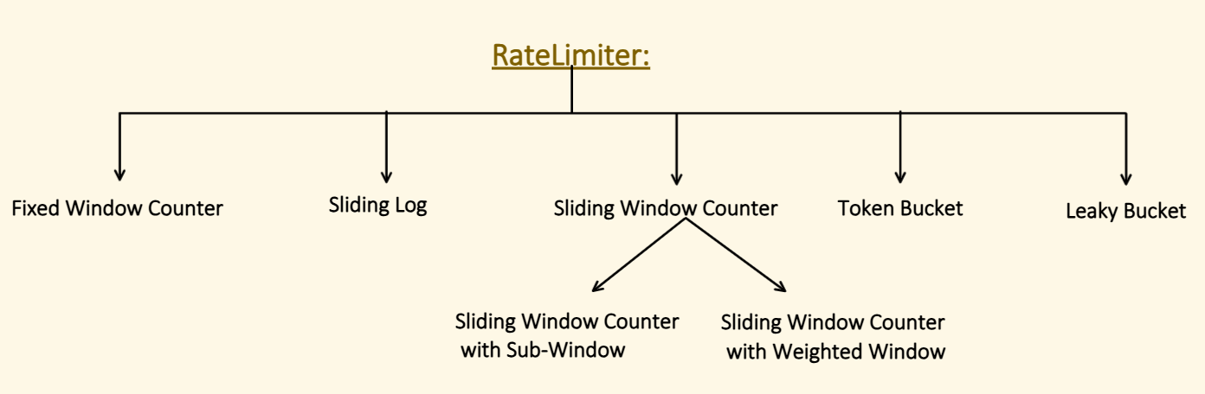
Fixed Window Counter:
- Counts how many request happens in a fixed window.
- If the count crossed the Limit, then reject the request.
- For example:
- Limit = 5
- Fixed Window Size = 10 second
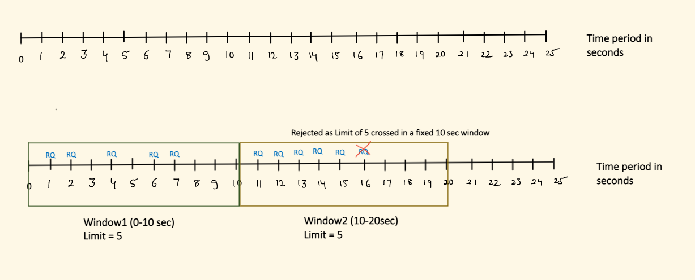
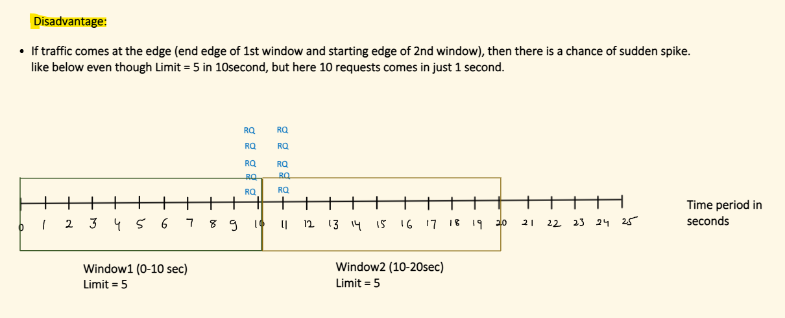

Sliding Log:
- For each accepted request, it stores the exact timestamp.
- For each request comes in, it first check, how many request happened in last X seconds (Window size).
- If no of requests reach the LIMIT, it will reject the request.
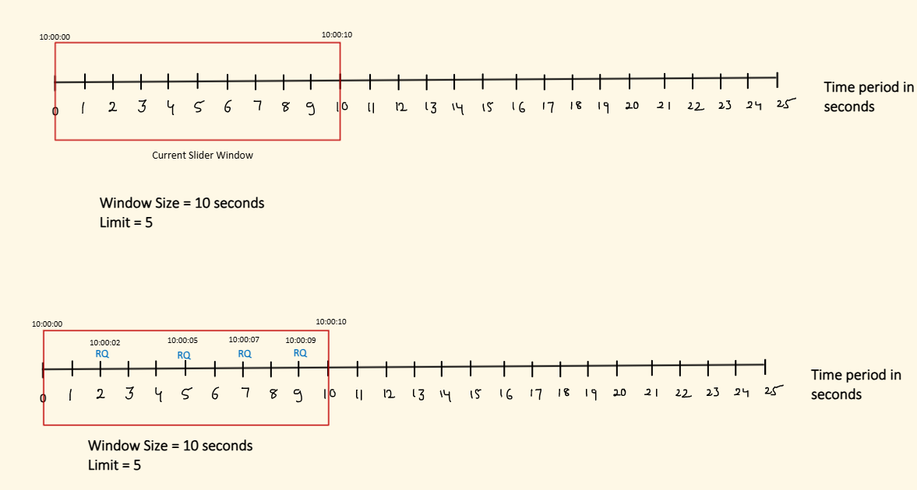
Now, when window size crossed, slider moves on.
So it consider only those request in count, which are in slider window only.
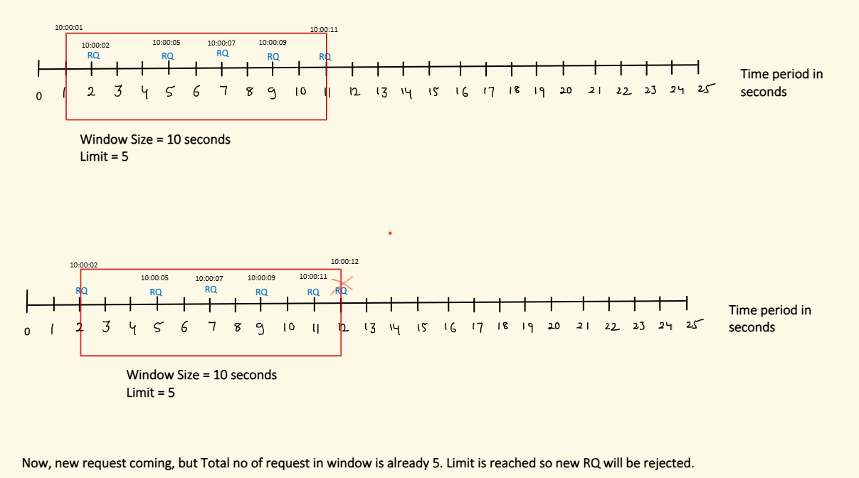
Disadvantage:
- Need to maintain timeframe info for each accepted request. Which needs more memory.
- Extra overhead of clean up of expired timestamps.
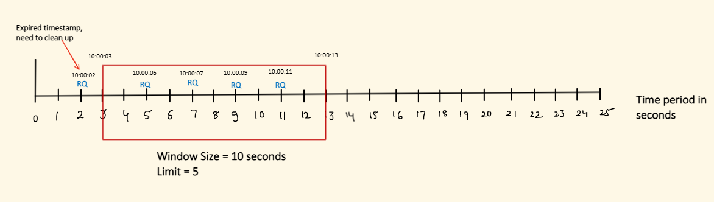
Sliding Window Counter:
Sliding Window Counter with Sub-Window:
- Main window is divided into equal sized sub-windows.
- Keep Tracks of the number of request in each sub-window.
- To decide if request need to be rejected or not, it consider only active sub-windows.
- Main window slides(by sub-window size) over time.
- Window Size = 10 seconds
- Sub-Window = 2 seconds
- Limit = 5
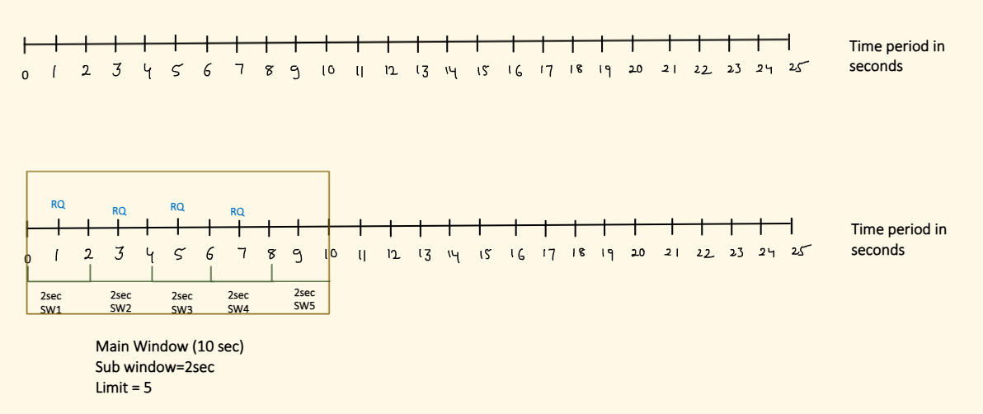

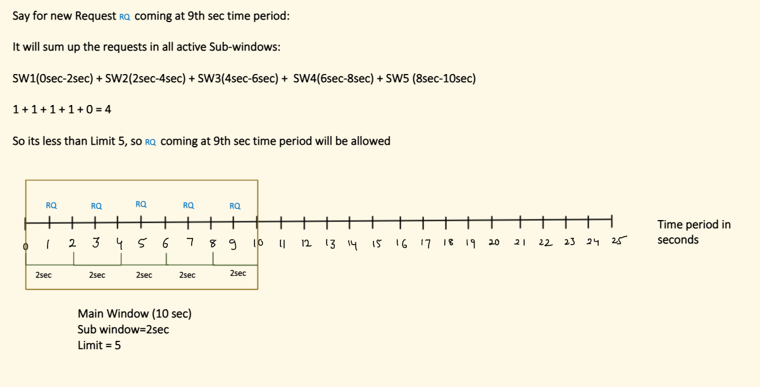
Disadvantage:
- More complex than Fixed window logic.
- Need to maintain Sub window info and request count per sub window. Which needs more memory.
Sliding Window Counter with Weighted Window:
- It tries to simplify the logic by removing Sub-window granularity and bringing some approximation.
- It combined Fixed Window + Sliding Log Concept.
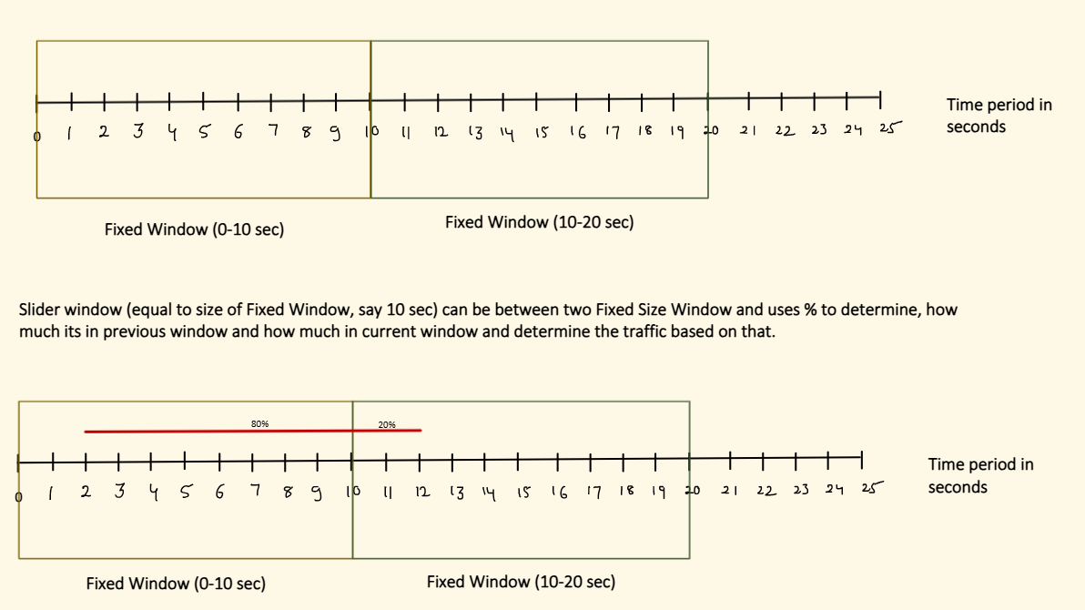
Let’s Say, Limit = 5 in a slide window.
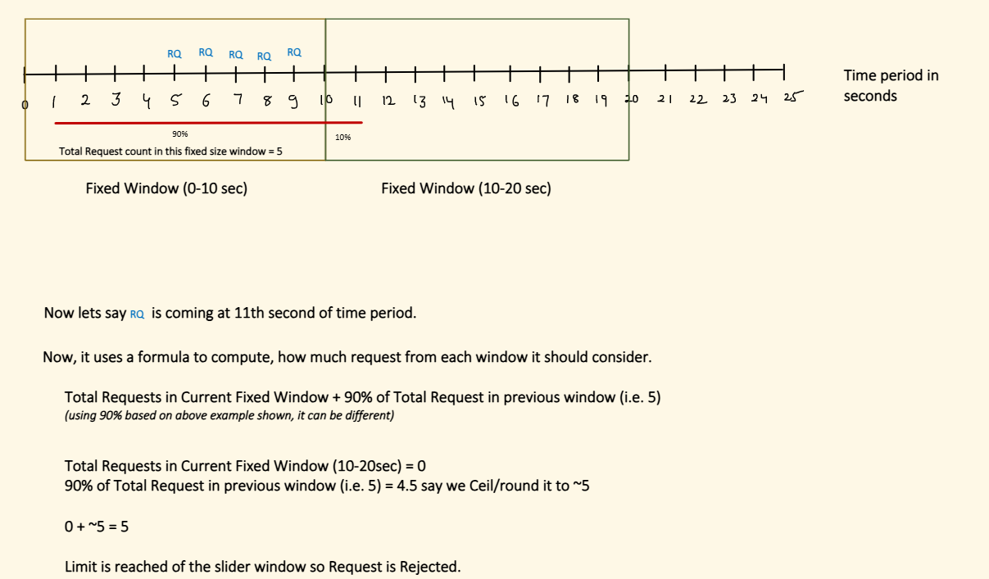

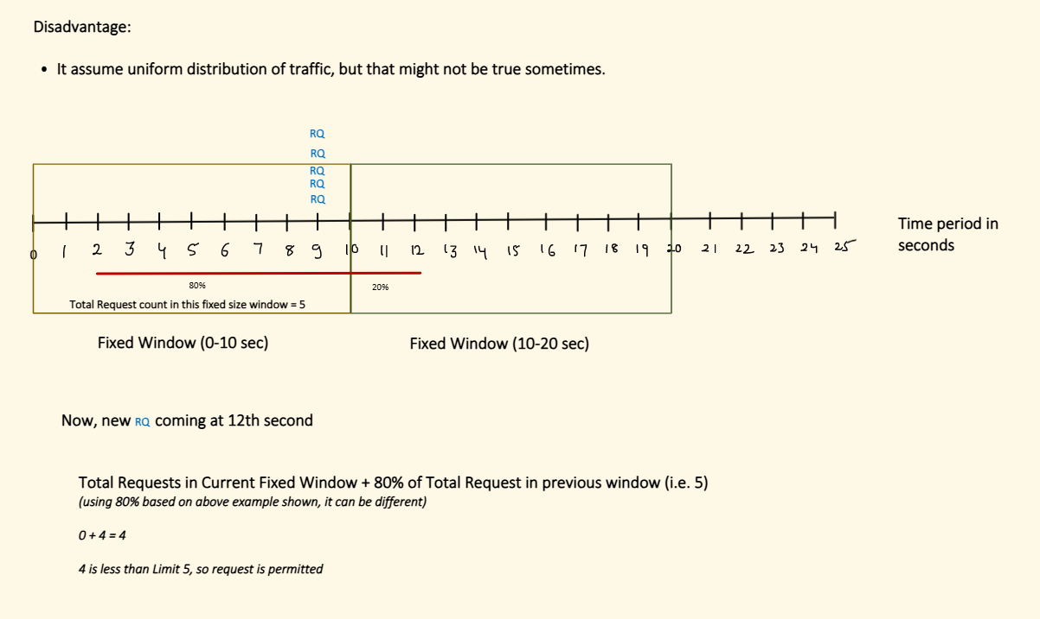
Token Bucket:
- Limited Tokens are placed in a bucket.
- Each request consume one token.
- If there is no token left, request is denied.
- There is a re-filler, which adds the token in bucket at regular time interval.
- If Bucket capacity is full and can not hold more token, token overflow will happen and token will be rejected.
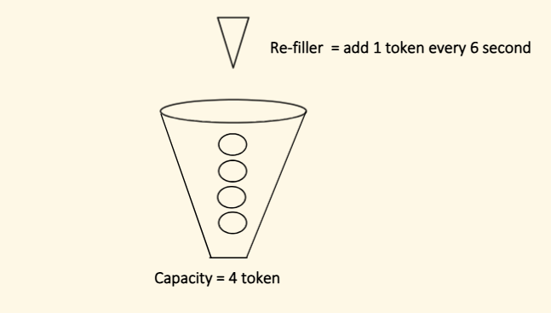
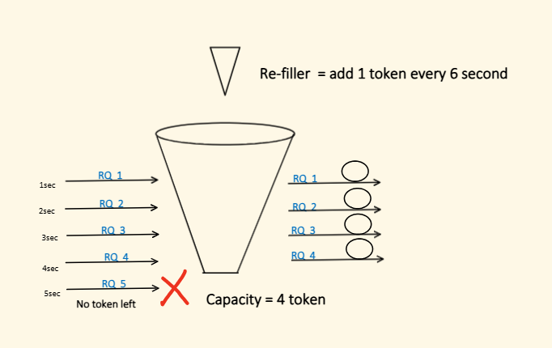
Disadvantage:
- A quick burst is possible if token capacity is not set properly.
Let’s say system remains idle for some time and token keep on accumulating, and when sudden burst comes, it will be allowed as token is present.
Leaky Bucket:
- Requests are Queued and accepted at fixed rate.
- If queue is full, incoming request will overflow
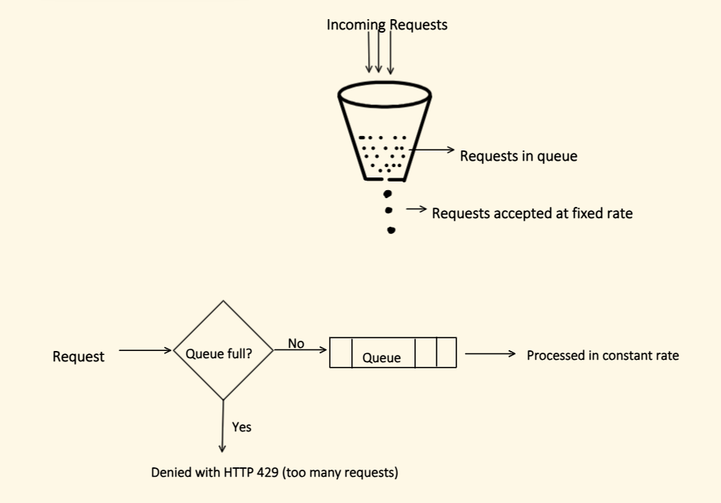Disadvantage:
- Latency increases, as request might have to wait in queue for its turn.
- Queue size is a bottle neck. So size should be properly set.
Implementation in Spring boot:
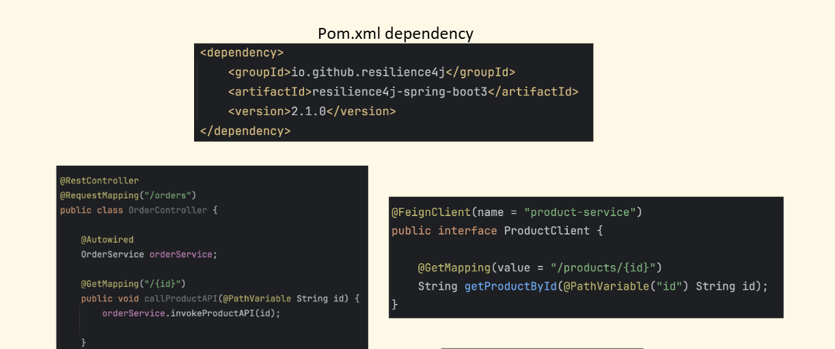
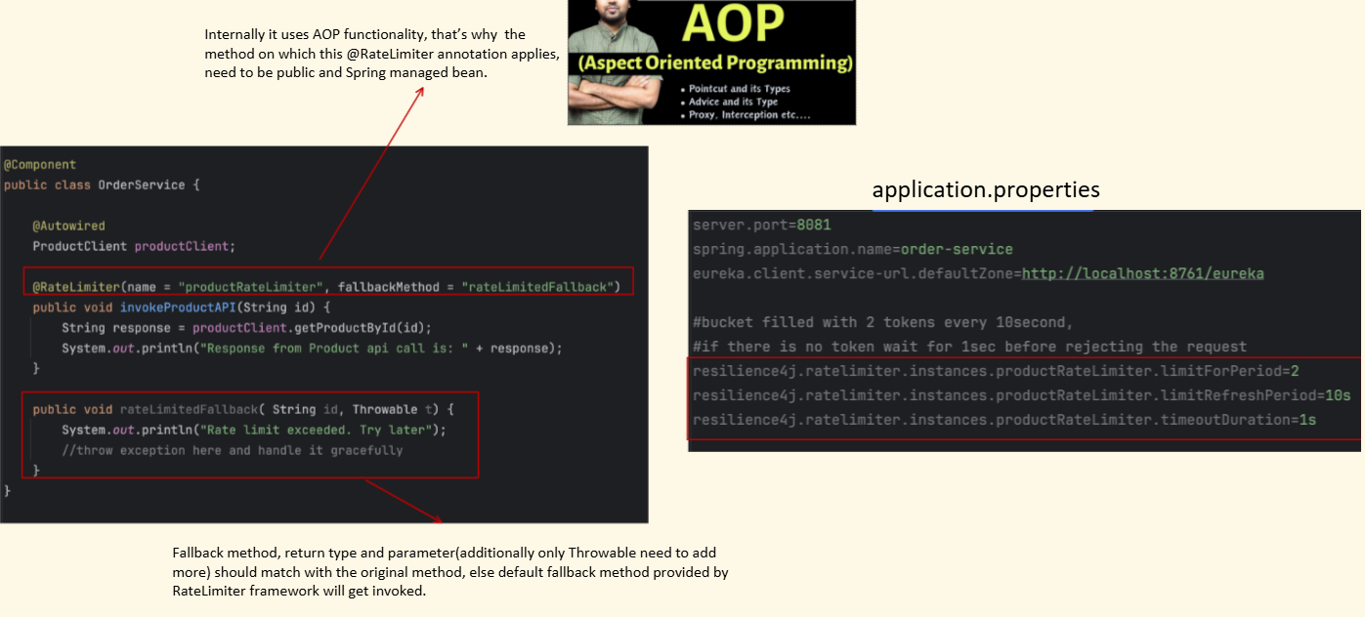

Property | Meaning
limitForPeriod | Number of requests allowed
limitRefreshPeriod | Time window
timeoutDuration | How long request waits for permission
This means:
Allow only 2 calls every 10 seconds
After 2 requests: Request gets rejected
because: timeoutDuration = 1( Wait up to 1 second for permission)
After waiting: Timeout exceeded
Then: Fallback will be called.

Resilience4j Internally, its RateLimiter uses a: Atomic Cycle-Based Rate Limiting Algorithm
which behaves very similar to a: Fixed Window Rate Limiter

Bulkhead: Fault-Tolerant Microservice (Part-2)
It helps to control how many concurrent requests can go to downstream service.

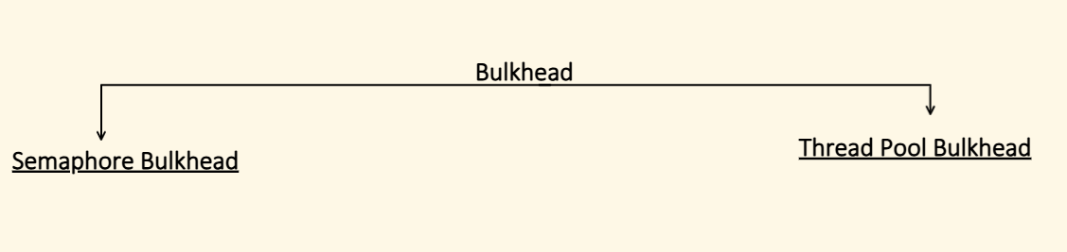
1. Semaphore Bulkhead
Limits concurrent calls using semaphores.
No separate thread pool.
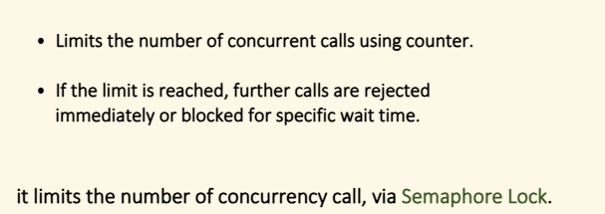

Example
Allow only 3 concurrent requests
4th request:
- rejected immediately
- or waits (configurable)
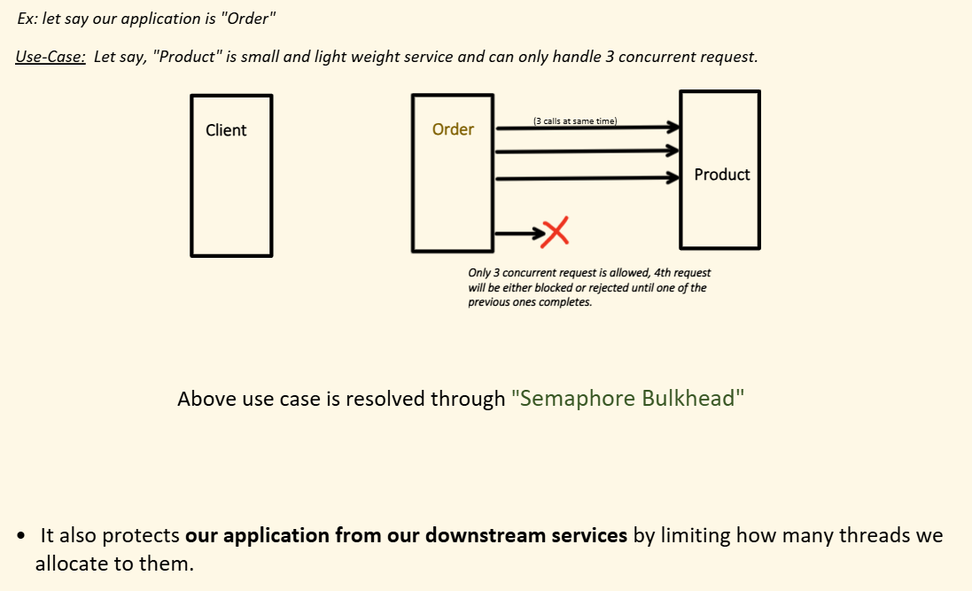
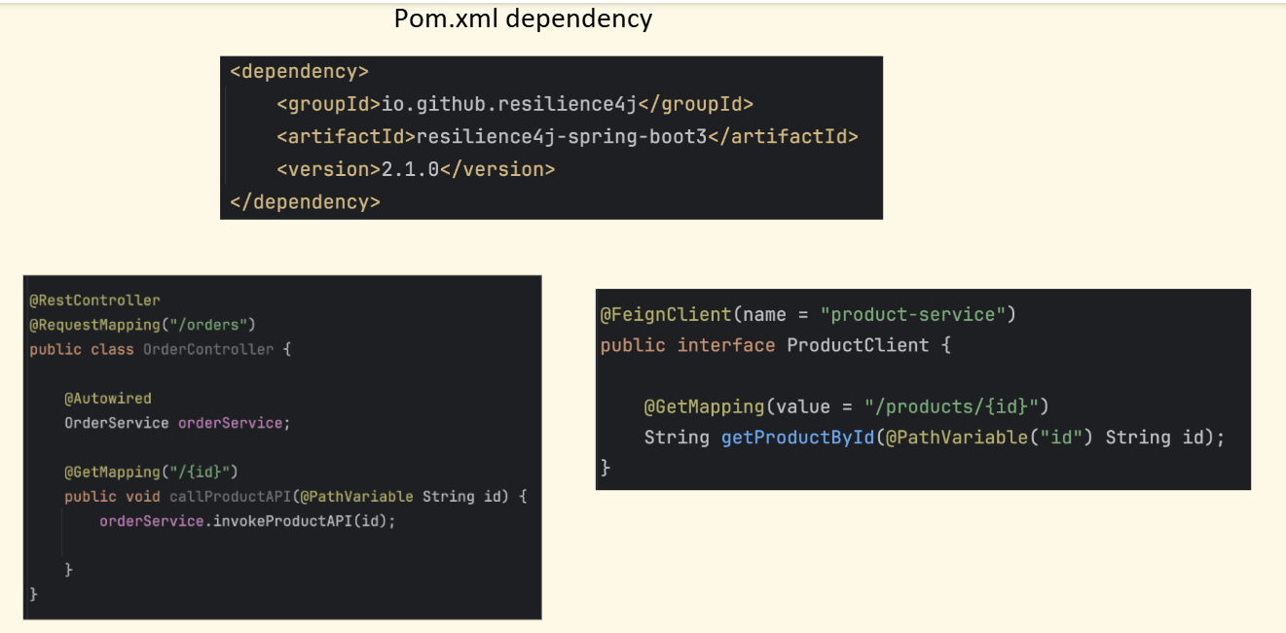

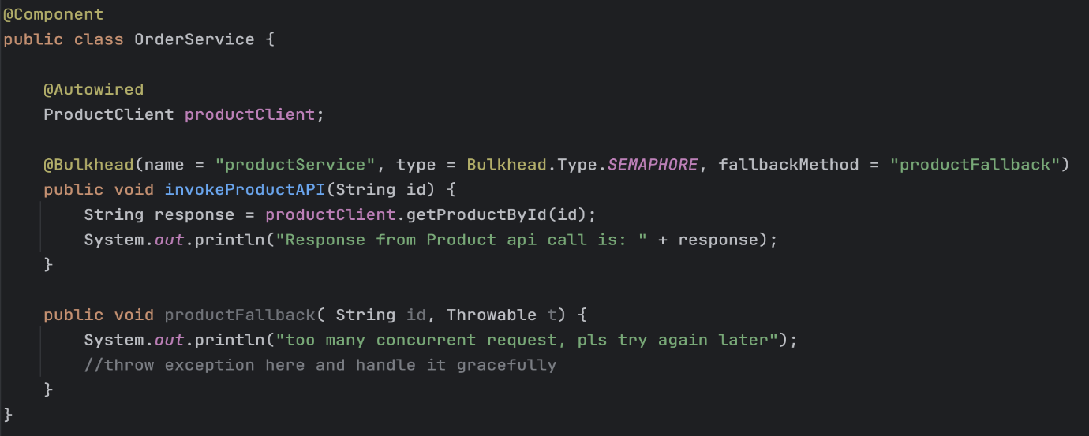
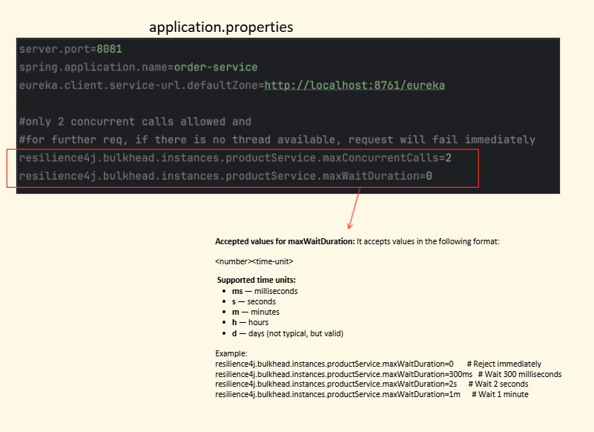
2. Thread Pool Bulkhead
Uses separate thread pool + queue.
- Assign a dedicated thread pool for each service.
- Only that pool is used to call the downstream.
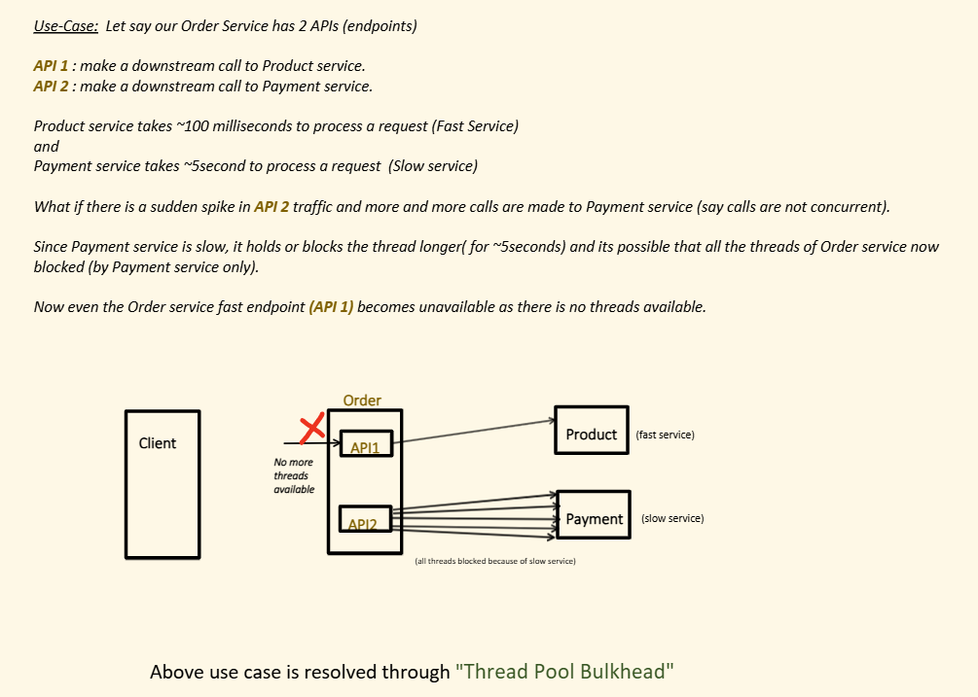
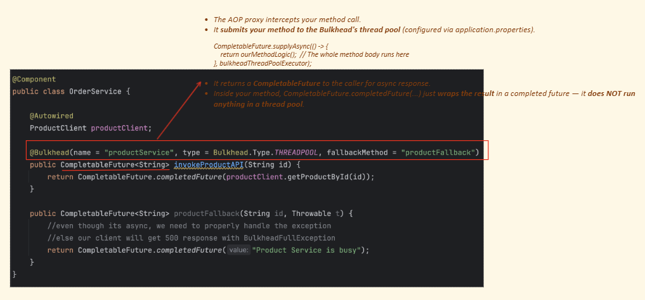
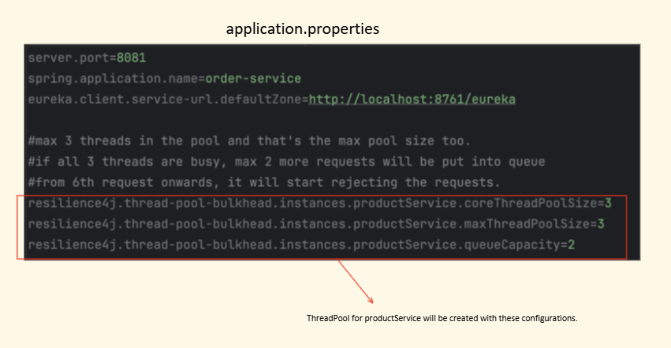
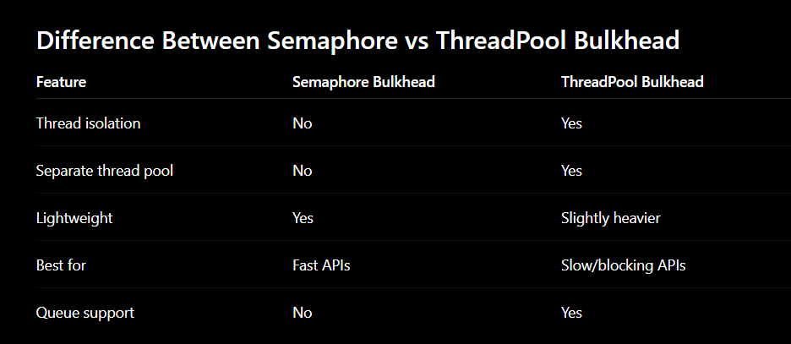
TimeLimiter : Fault-Tolerant Microservice (Part-3)
- A TimeLimiter is used to limit how long an operation is allowed to run.
- If the operation takes longer than the configured timeout:
- Request is cancelled/timed out
- and fallback can be executed.
Why TimeLimiter is Needed
In distributed systems, external services may become:
- slow
- unresponsive
- partially down
Without timeout handling:
Threads keep waiting
This causes:
- thread pool exhaustion
- increased latency
- cascading failures
Important Point
TimeLimiter is mainly used for:
Asynchronous calls
like:
- CompletableFuture
- async APIs
- non-blocking operations
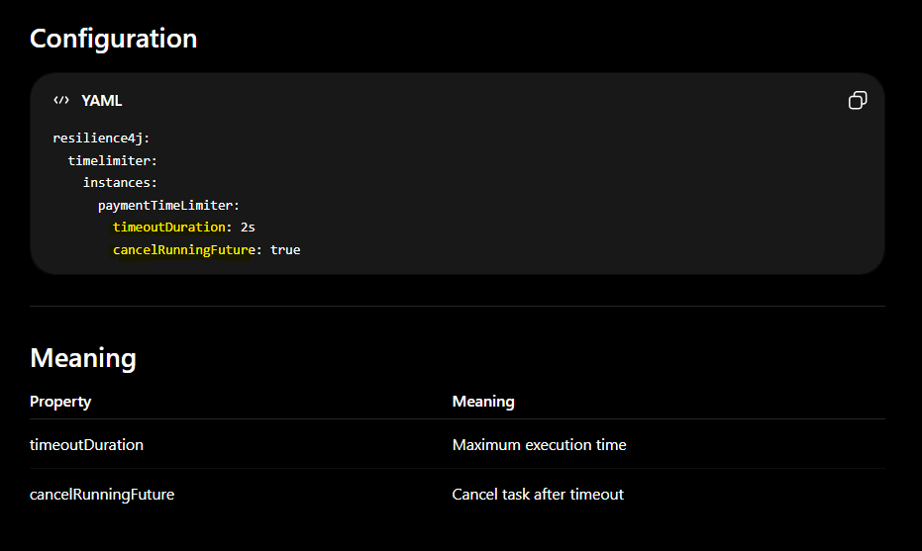
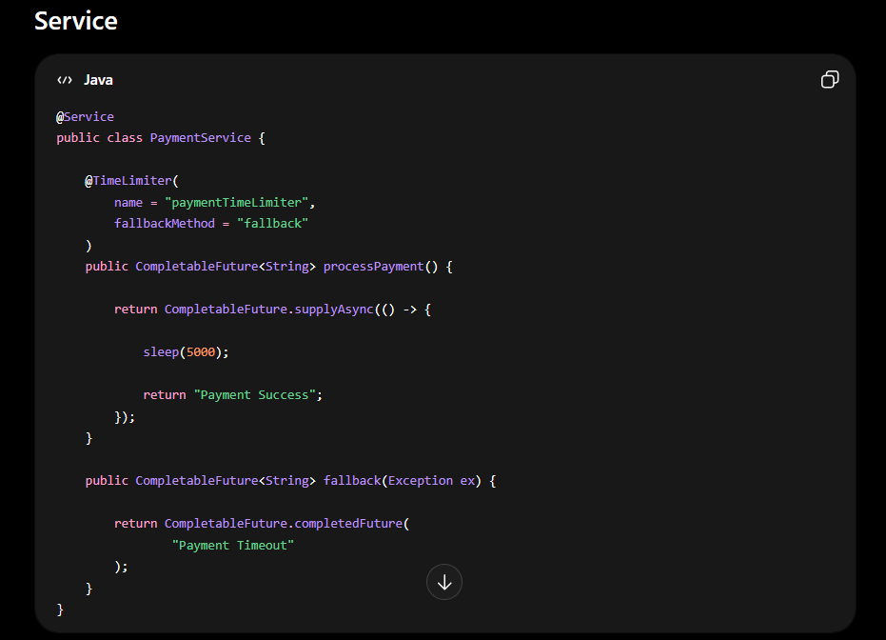
Short Definition
“TimeLimiter in Resilience4j is used to limit how long an asynchronous operation can run. If execution exceeds the configured timeout, the operation is cancelled and fallback logic can be executed.”
Retry : Fault-Tolerant Microservice (Part-4)
- In distributed system, call to downstream service might fail because of Transient issues.
- Transient issues means short temporary issues like network issue, timeouts etc.
- And retry of same request after a short delay can get succeed
When to retry?
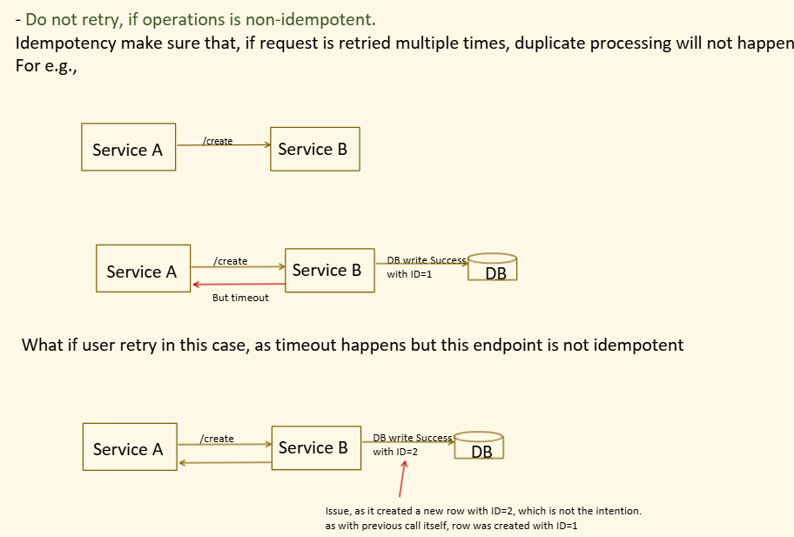

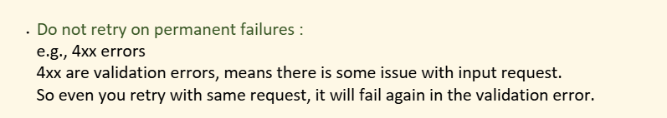
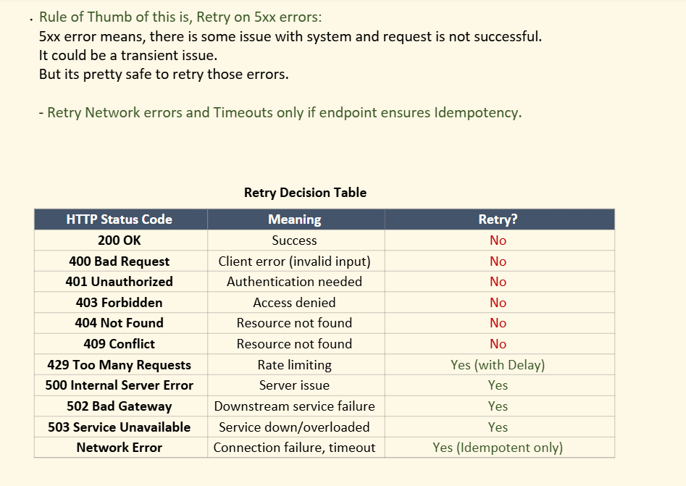
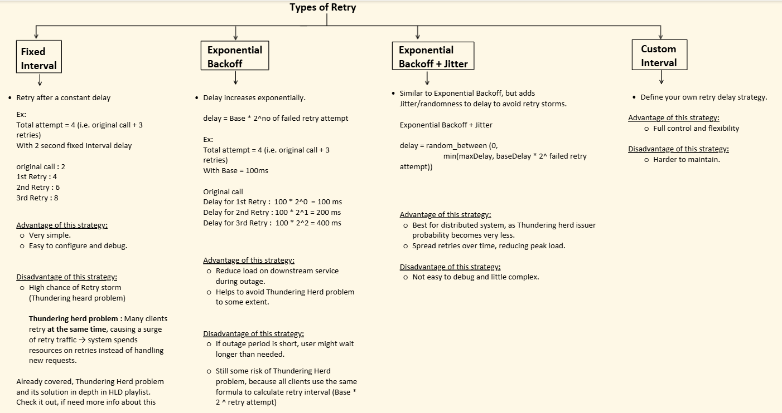

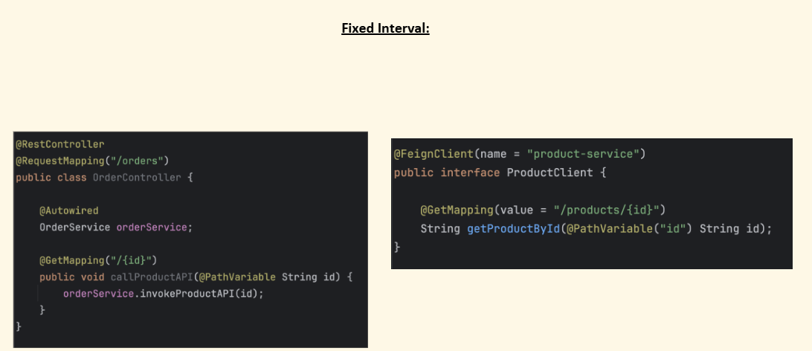
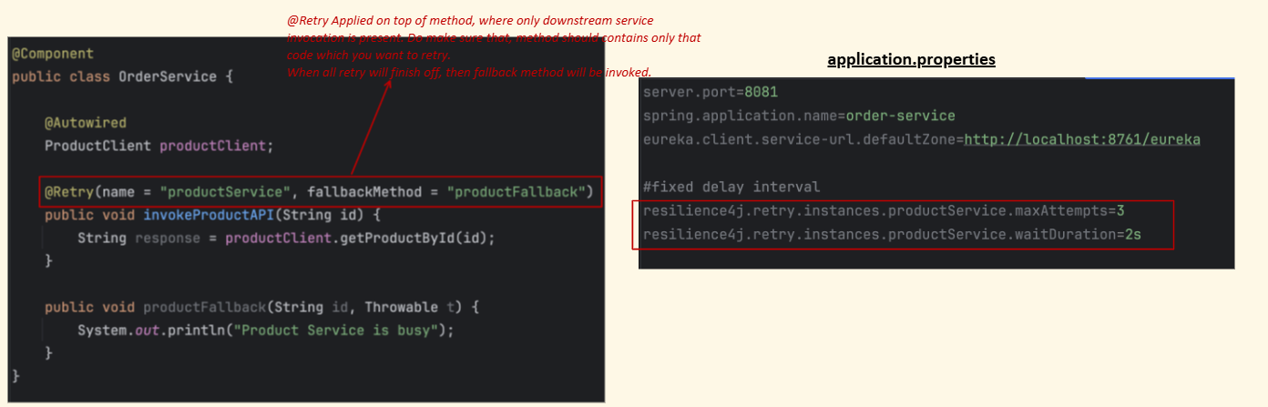
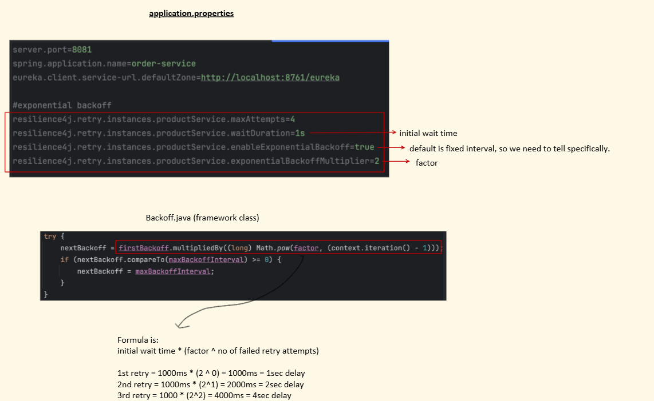

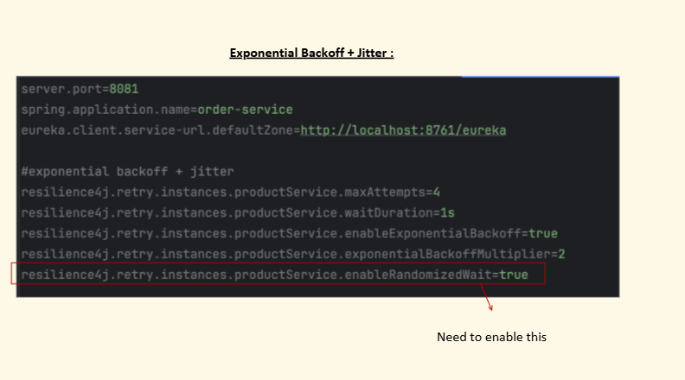

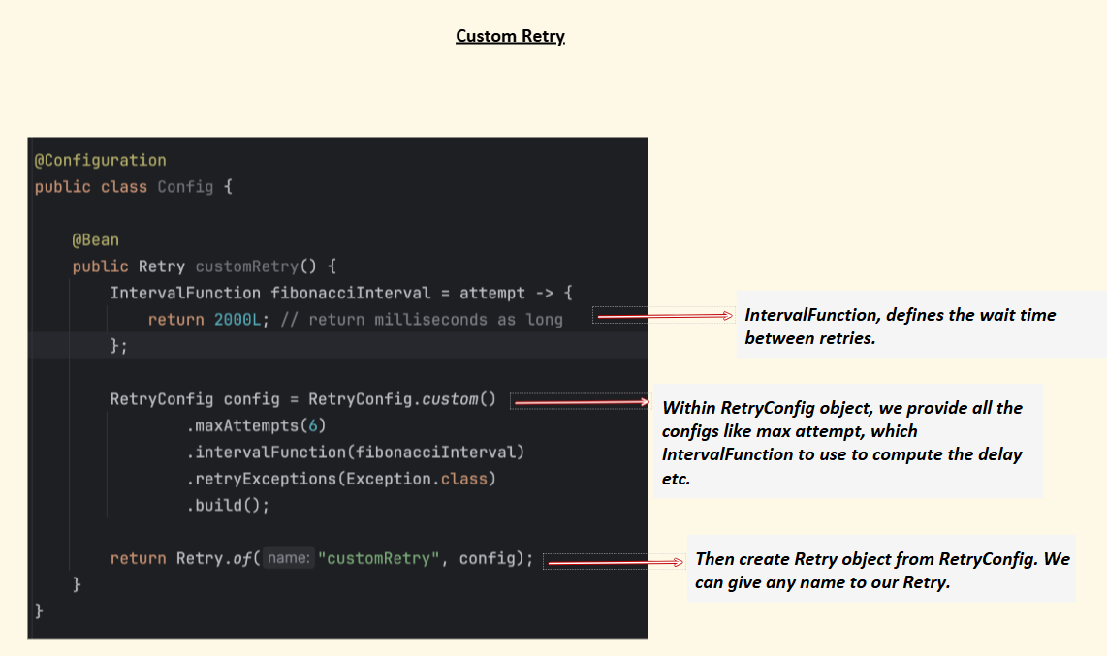
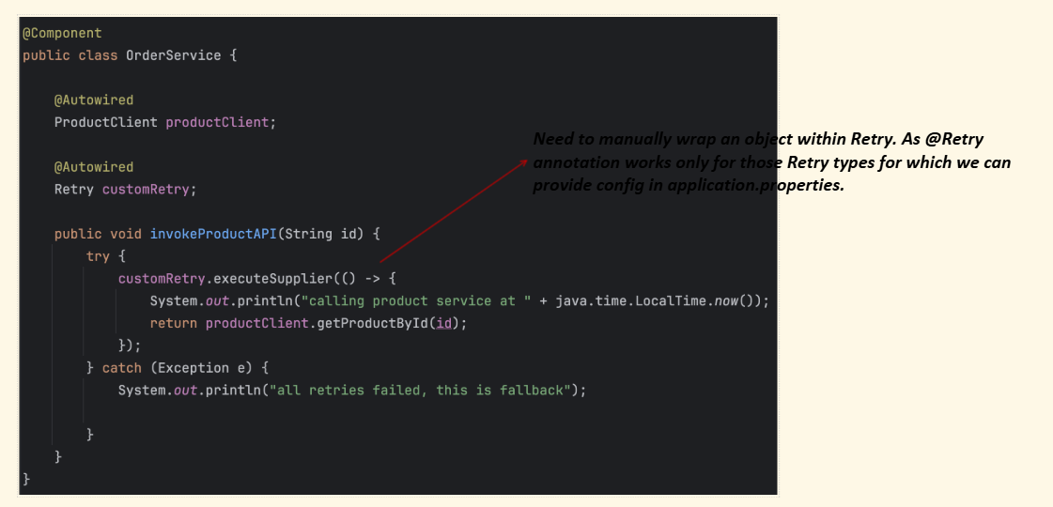

Circuit Breaker: Fault-Tolerant Microservice (Part-5)
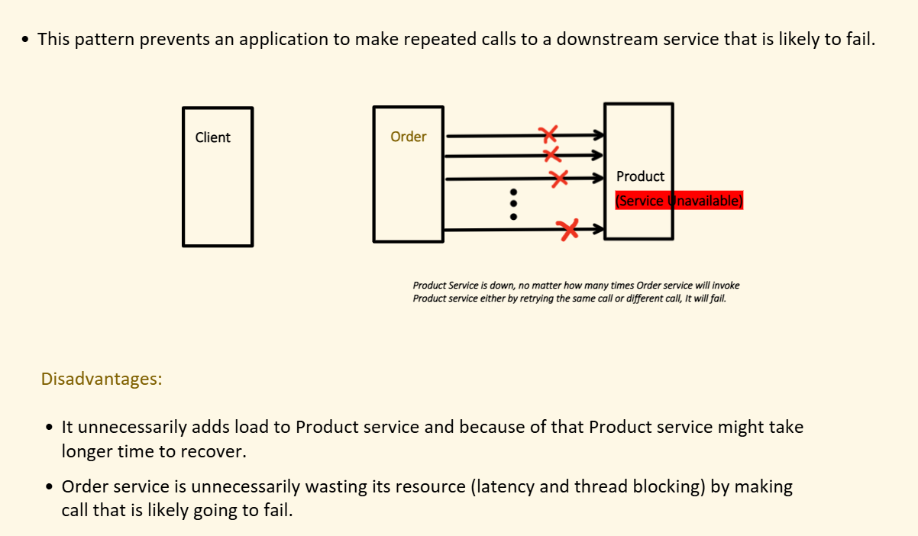
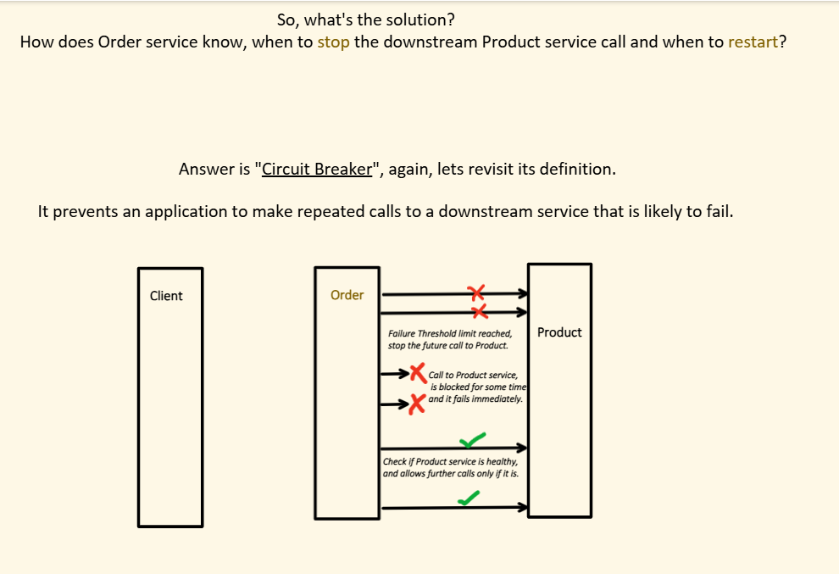
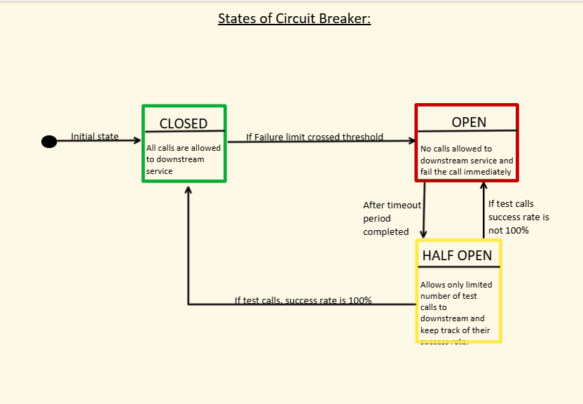
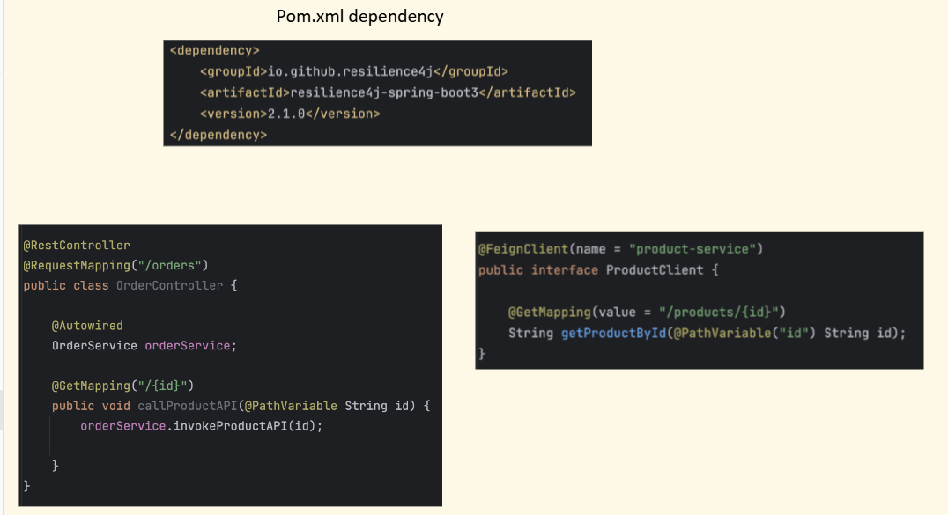
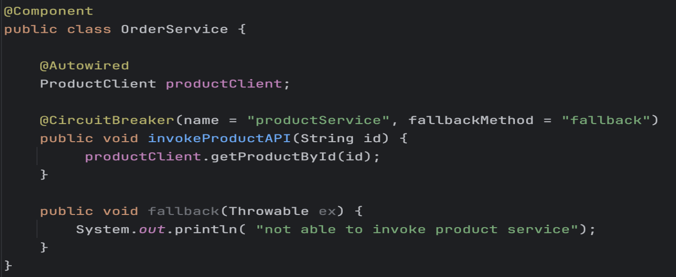
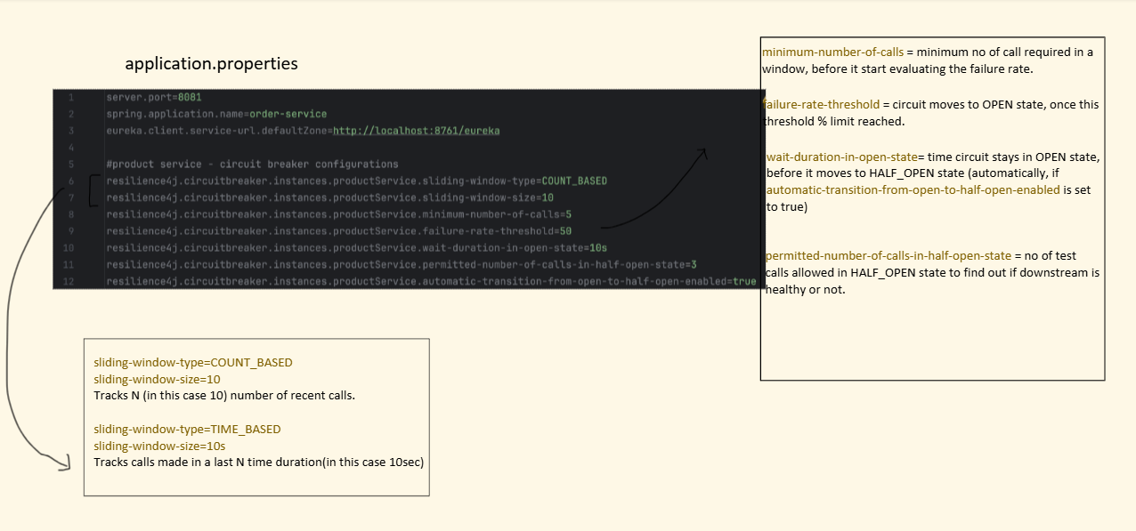
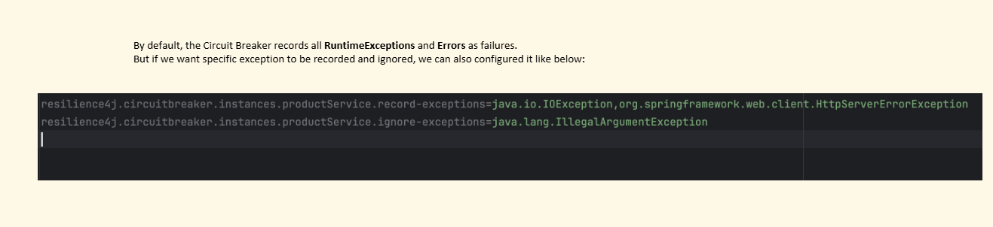

Concurrency Control in Distributed Systems

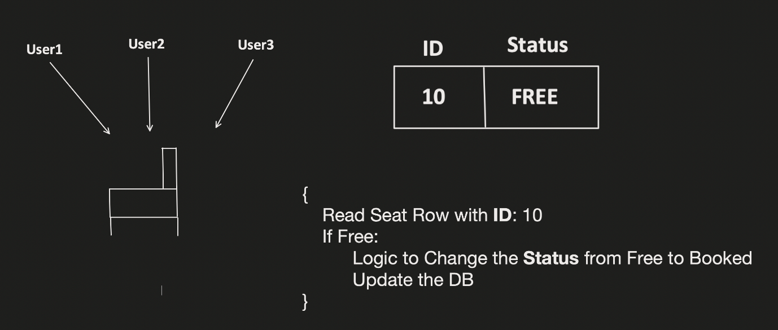

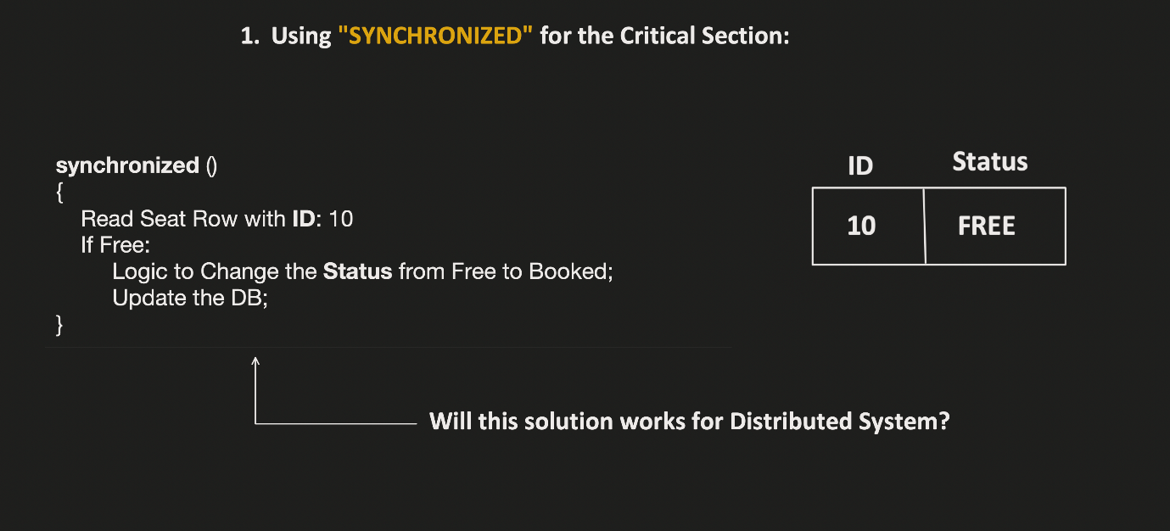

Process vs Thread =>
Process:- It’s like a one request.
A process is an independent program in execution.
Thread :- Each request we can process it using multiple threads.
A thread is a smaller unit of execution within a process.

When you run multiple instances of the same service in a distributed system and those instances handle transactions, the main challenge is data consistency and race conditions.

🔹 What Happens with Multiple Service Instances?
Suppose you have:
- 3 instances of PaymentService
- All connected to the same database
- Multiple users making transactions simultaneously
Example:
PaymentService-1
PaymentService-2
PaymentService-3
Now imagine two requests arrive at the same time:
User A withdraws ₹500
User B withdraws ₹700
Both access the same account balance.
🔥 Problem: Race Condition
Assume account balance = ₹1000
Without proper transaction handling:
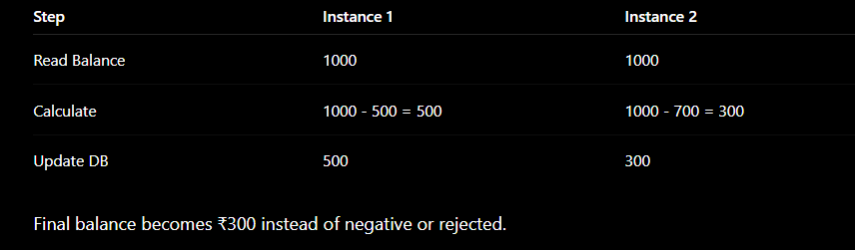
This is called a race condition or lost update problem.
🔹 Why Multiple Instances Increase the Problem
With one instance:
- Requests are easier to control
With multiple instances:
- Requests run truly in parallel
- Each instance has its own memory
- synchronized keyword works only inside one JVM
- One instance cannot control another instance directly
So application-level locking becomes insufficient.

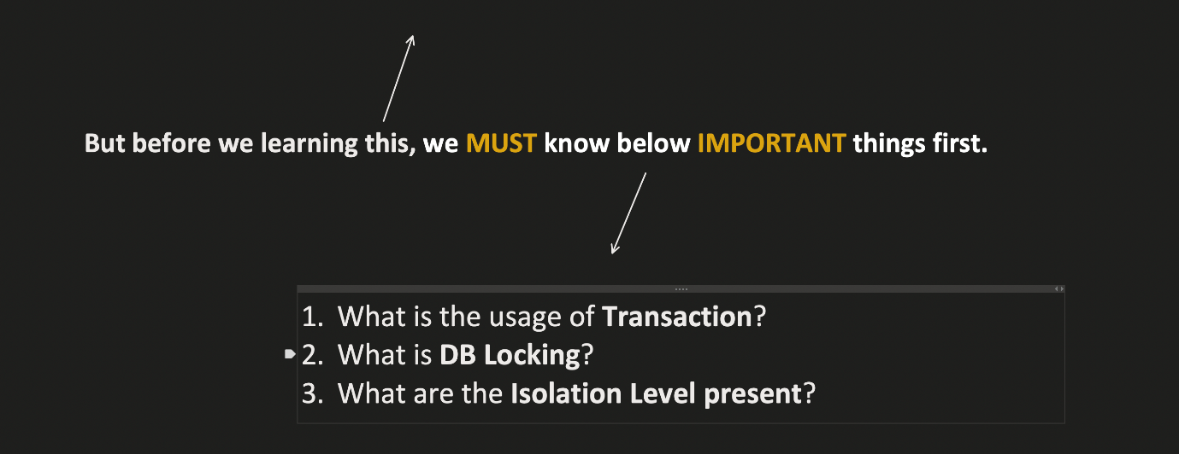
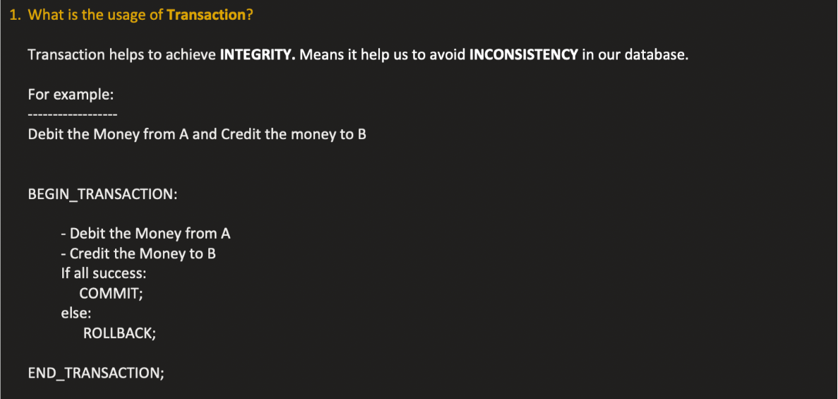
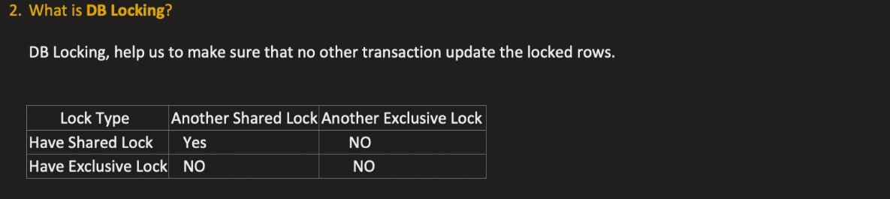
In databases, shared locks and exclusive locks are used to control concurrent access to data and maintain consistency during transactions.
They are part of database concurrency control in Database Management Systems.
🔹 Shared Lock (S Lock)
A shared lock allows:
- Multiple transactions to read the same data simultaneously
- But prevents any transaction from modifying that data while the lock exists (We can’t apply Exclusive lock while having Shared lock)
👉 Used mainly for READ operations
Example
Transaction T1:
SELECT * FROM account WHERE id = 1;
Database places a shared lock on that row.
Now:
✅ Other transactions can also read it
❌ No transaction can update/delete it
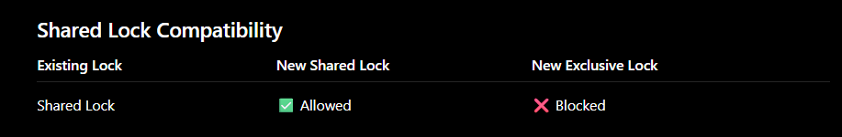
🔹 Exclusive Lock (X Lock)
An exclusive lock allows:
- Only one transaction to access and modify the data
- Prevents both:
  - Other reads (in some DB/isolation levels)
  - Other writes
👉 Used for INSERT / UPDATE / DELETE

Example
Transaction T1:
UPDATE account
SET balance = balance - 500
WHERE id = 1;
Database places an exclusive lock.
Now:
❌ Other transactions cannot read/write that row (depending on isolation level)
until transaction completes.



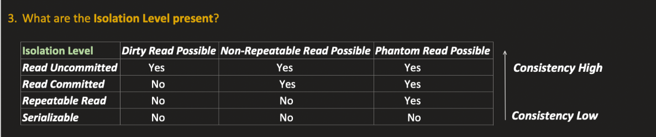
Dirty Read =>
A dirty read happens when one transaction reads data that was modified by another transaction but not yet committed.
If the first transaction later rolls back, the second transaction has read invalid or “dirty” data.
Problem Here ❌[In below given example ]
At T3, Transaction B read data (Booked) that was not committed by Transaction A.
Later at T5, Transaction A rolled back.
So Transaction B worked with invalid data.
This is called a Dirty Read.

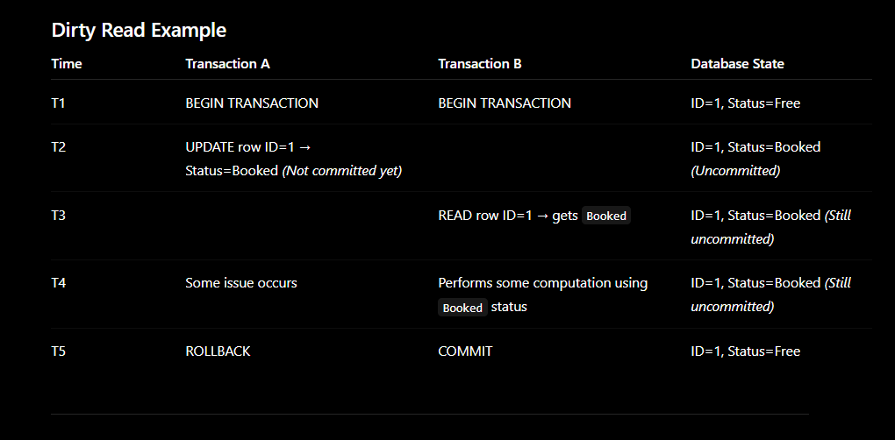
Non-Repeatable Read =>
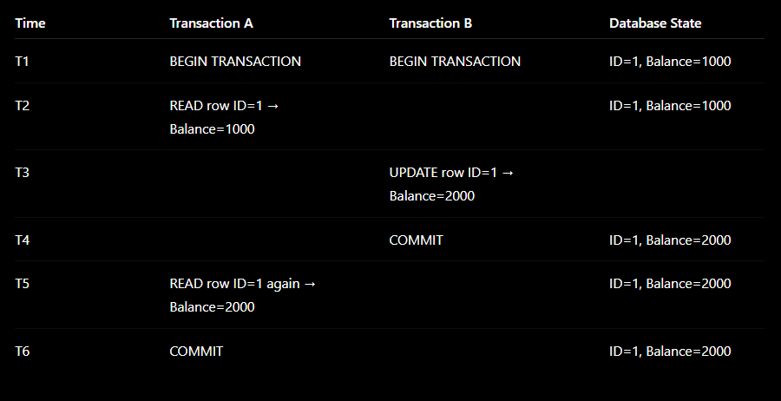
Problem Here ❌
Transaction A read the same row twice:
- First read → 1000
- Second read → 2000
The row value changed during the same transaction because Transaction B updated and committed the data in between.
This is called a Non-Repeatable Read.

Phantom Read =>
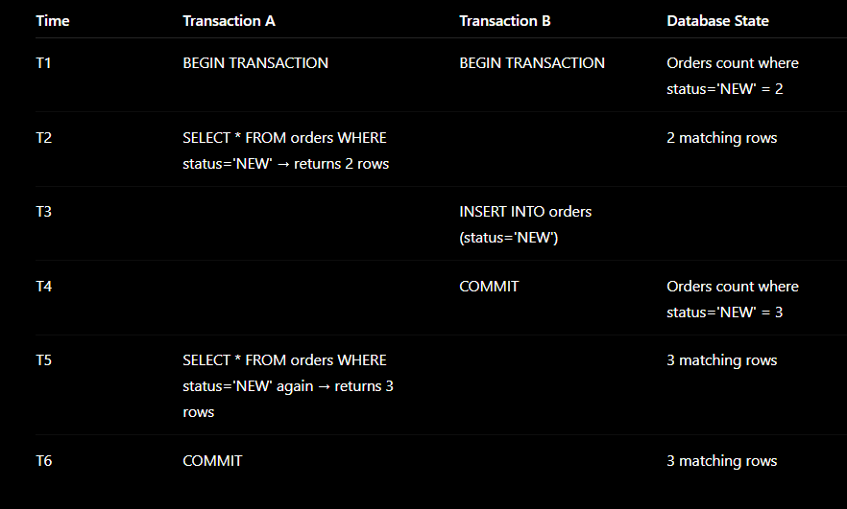
Problem Here ❌
Transaction A executed the same query twice:
SELECT * FROM orders WHERE status='NEW';
Results changed:
- First query → 2 rows
- Second query → 3 rows
A new row appeared during the transaction.
This extra row is called a Phantom Row. So this issue is called a Phantom Read.
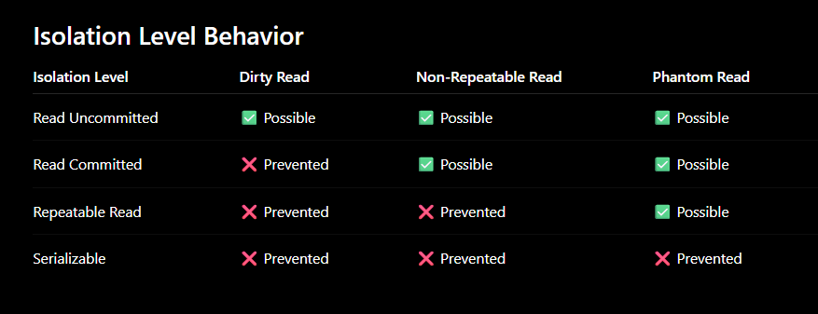

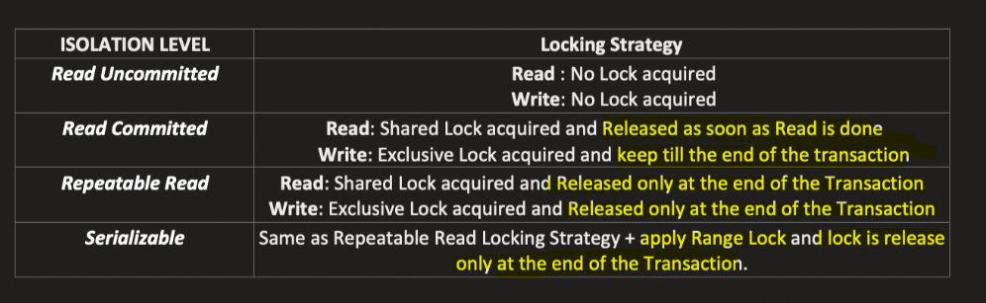

You can set the transaction isolation level either:
- Directly in SQL (database level)
- In application code (like Spring Framework using @Transactional)
🔹 1. Using SQL
Syntax
SET TRANSACTION ISOLATION LEVEL <LEVEL>;

Example: Read Committed
SET TRANSACTION ISOLATION LEVEL READ COMMITTED;
BEGIN TRANSACTION;
SELECT * FROM account;
COMMIT;

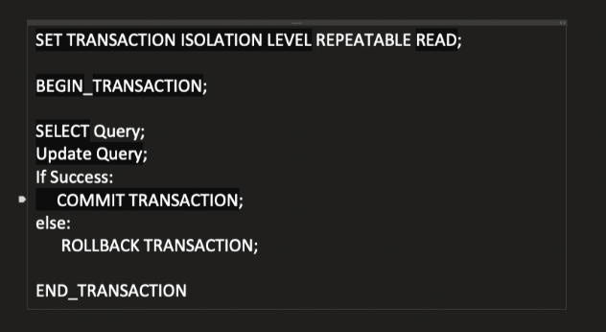
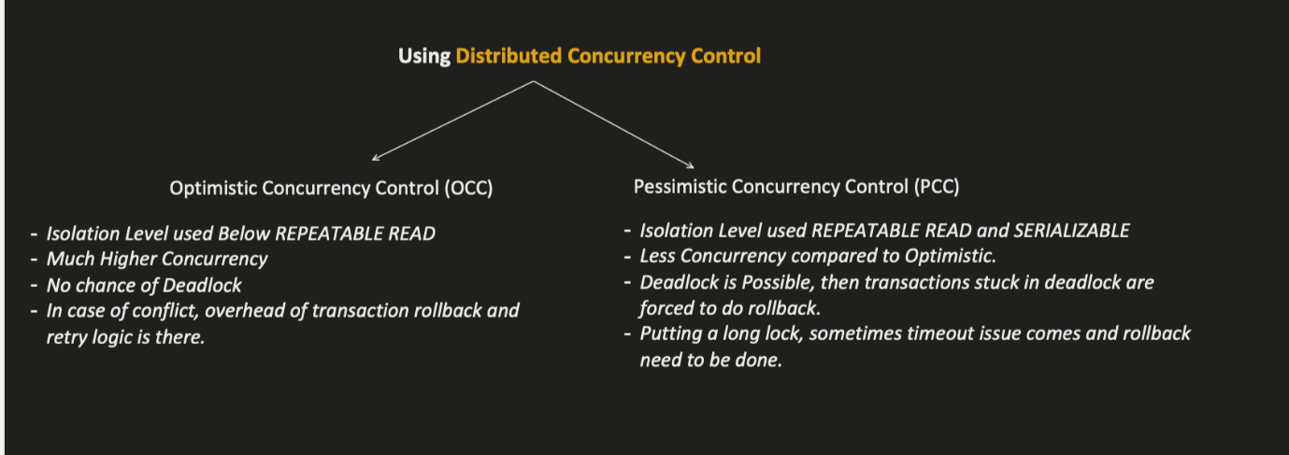

Optimistic Concurrency Control (OCC)
Optimistic Concurrency Control assumes:
Conflicts between transactions are rare, so transactions can proceed without locking initially.
Instead of locking rows early, OCC checks for conflicts at the time of update/commit using a version number or timestamp.
Isolation levels used READ UNCOMMITTED and READ COMMITED
Used heavily in:
- High-concurrency systems
- Microservices
- Distributed systems
- Web applications
🔹 Main Idea
Each row contains a version field.
Example:
ID | Status | Version
1 | Free | 1
When updating:
- Transaction validates version before commit
- If version changed → another transaction already modified the row
- Current transaction fails and retries/rolls back
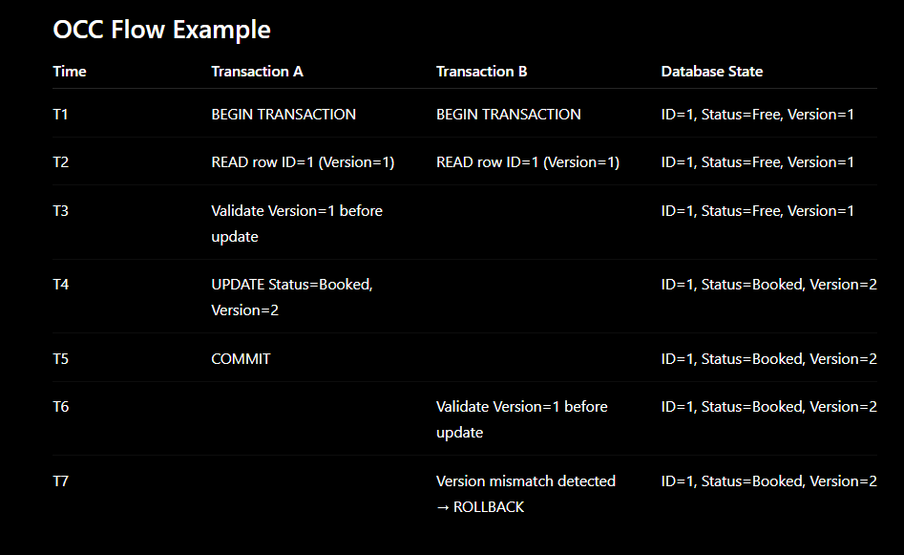
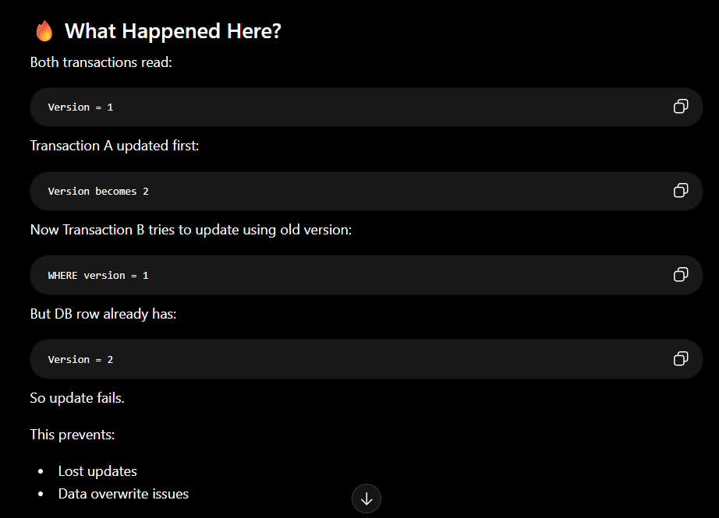
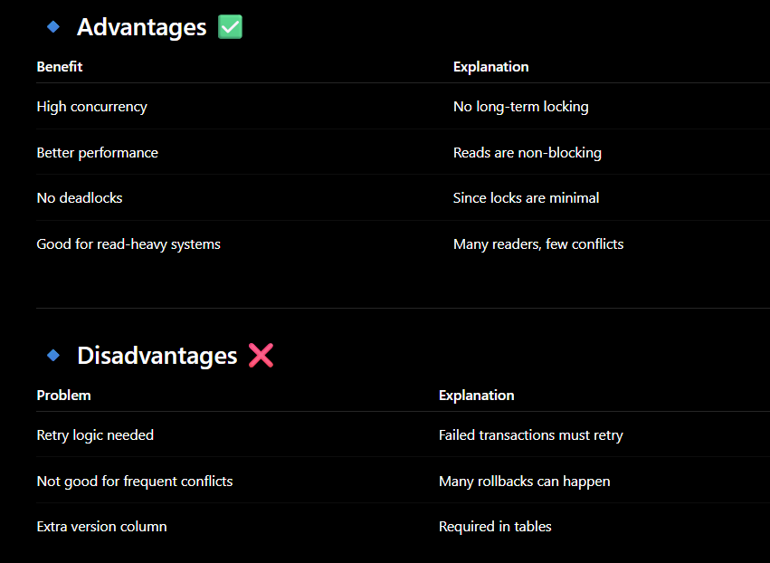

Pessimistic Concurrency Control (PCC)
Pessimistic Concurrency Control assumes:
Conflicts between transactions are likely, so data should be locked immediately before modification.
Instead of allowing parallel updates and checking later, PCC locks the row early so other transactions must wait.
Used in:
- Banking systems
- Payment systems
- Ticket booking
- Inventory management
where strong consistency is critical.
🔹 Main Idea
When a transaction wants to update data:
- Database places an Exclusive Lock
- Other transactions cannot modify the same row until lock is released
This prevents:
- Lost updates
- Dirty writes
- Concurrent modification issues
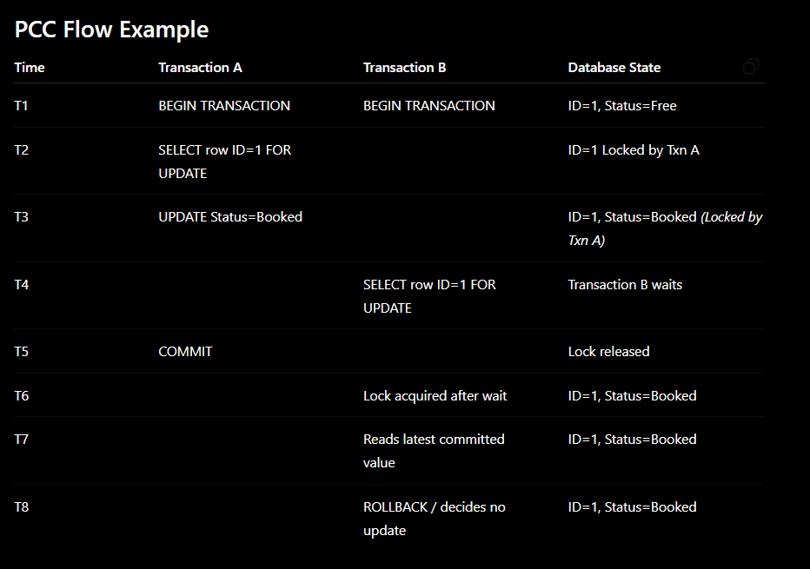
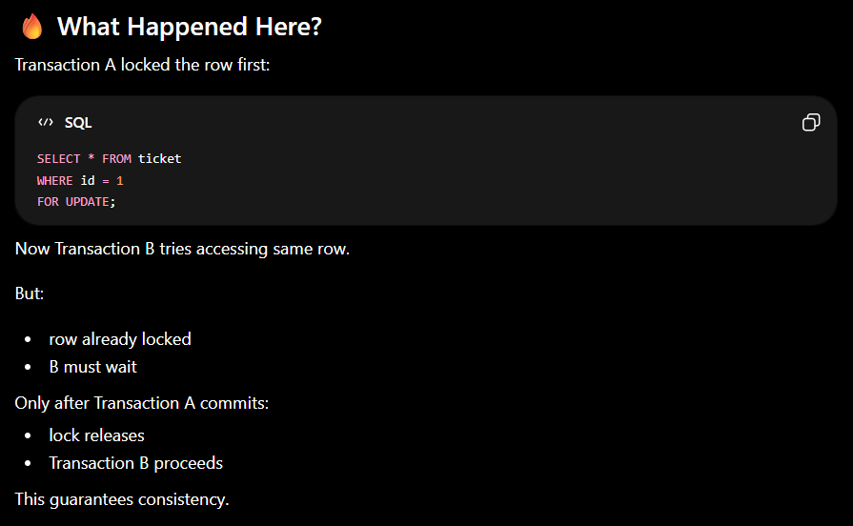

🔹 SQL Example
Lock Row for Update
SELECT *
FROM ticket
WHERE id = 1
FOR UPDATE;
This creates:
- Exclusive lock
- Prevents concurrent updates
🔹 In Spring Boot / JPA
Using pessimistic lock mode:
@Lock(LockModeType.PESSIMISTIC_WRITE)
@Query("SELECT t FROM Ticket t WHERE t.id = :id")
Ticket findTicketForUpdate(Long id);
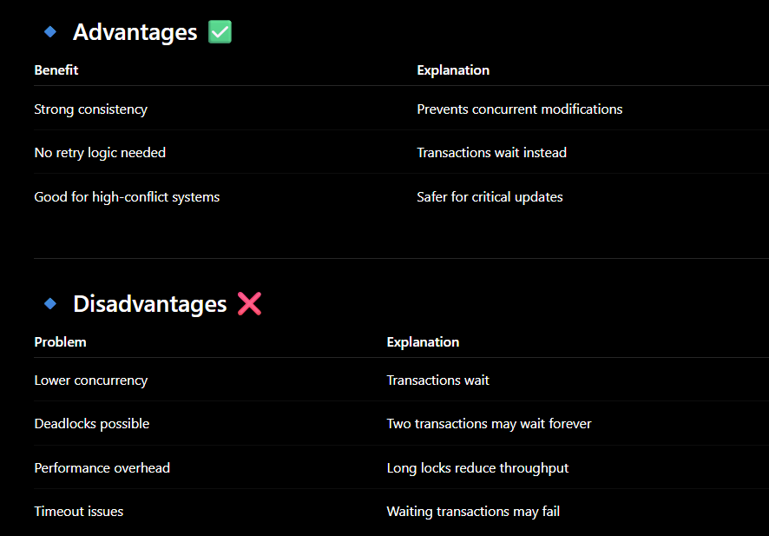
🔹 Deadlock Example
Transaction A locks Row1
Transaction B locks Row2
Now:
- A waits for Row2
- B waits for Row1
Both stuck forever → deadlock.
Database detects this and rolls back one transaction.
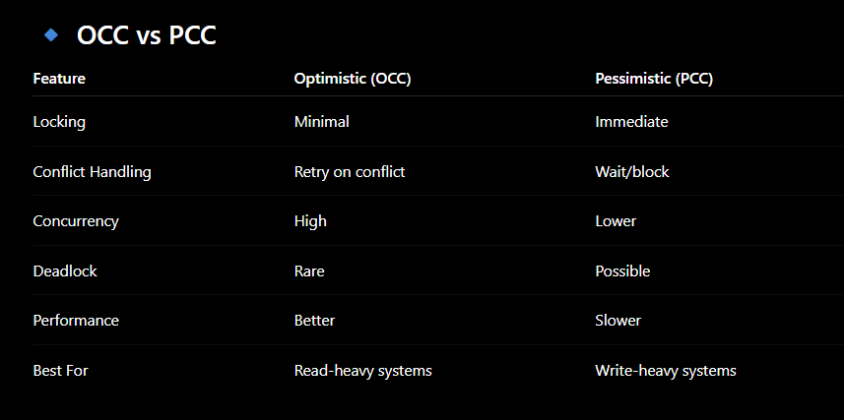

Two-Phase Locking (2PL) is one of the mechanisms used to implement pessimistic locking in databases.

