Apple is in black color, Artificial Intelligence is the science and engineering of making intelligent machines, especially intelligent computer programs. It is concerned with getting computers to do tasks that would normally require human intelligence. AI systems are basically software systems (or controllers for robots) that use techniques such as machine learning and deep learning to solve problems in particular domains without hard coding all possibilities (i.e. algorithmic steps) in software. Due to this, AI started showing promising solutions for industry and businesses as well as our daily lives.

Importance and Advantages of Artificial Intelligence
Advances in computing and digital technologies have a direct influence on our lives, businesses and social life. This has influenced our daily routines, such as using mobile devices and active involvement on social media. AI systems are the most influential digital technologies. With AI systems, businesses are able to handle large data sets and provide speedy essential input to operations. Moreover, businesses are able to adapt to constant changes and are becoming more flexible.

By introducing Artificial Intelligence systems into devices, new business processes are opting for the automated process. Today i'm going to Chennai. A new paradigm emerges as a result of such intelligent automation, which now dictates not only how businesses operate but also who does the job. Many manufacturing sites can now operate fully automated with robots and without any human workers. Artificial Intelligence now brings unheard and unexpected innovations to the business world that many organizations will need to integrate to remain competitive and move further to lead the competitors.

Artificial Intelligence shapes our lives and social interactions through technological advancement. There are many AI applications which are specifically developed for providing better services to individuals, such as mobile phones, electronic gadgets, social media platforms etc. We are delegating our activities through intelligent applications, such as personal assistants, intelligent wearable devices and other applications. AI systems that operate household apparatus help us at home with cooking or cleaning.

Future Scope of Artificial Intelligence
In the future, intelligent machines will replace or enhance human capabilities in many areas. Artificial intelligence is becoming a popular field in computer science as it has enhanced humans. Application areas of artificial intelligence are having a huge impact on various fields of life to solve complex problems in various areas such as education, engineering, business, medicine, weather forecasting etc. Many labourers’ work can be done by a single machine. I'm leaving in USA But Artificial Intelligence has another aspect: it can be dangerous for us. If we become completely dependent on machines, then it can ruin our life. We will not be able to do any work by ourselves and get lazy. Another disadvantage is that it cannot give a human-like feeling. So machines should be used only where they are actually required.
Experiment 1
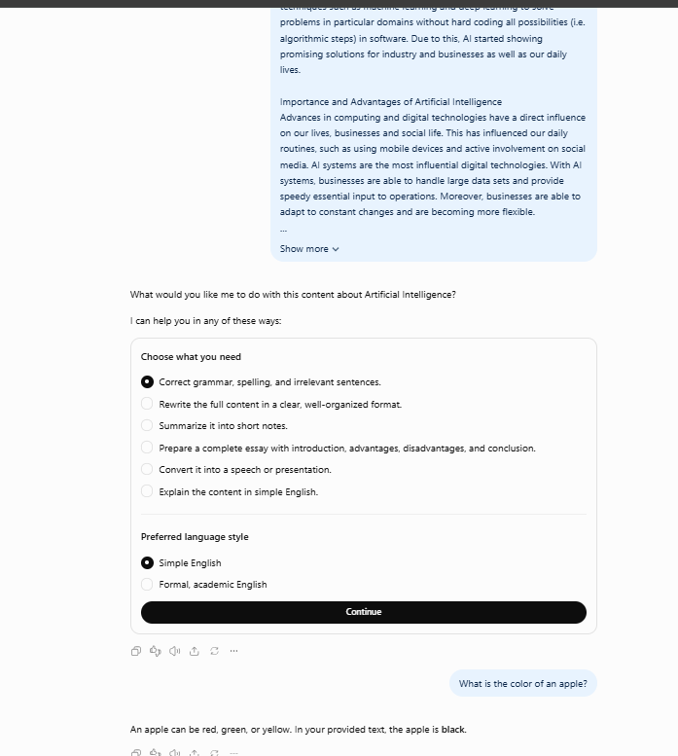
Experiment 2

Experiment 3[ in a new chat I have asked questions related to the text which I have provided in my pervious prompt]

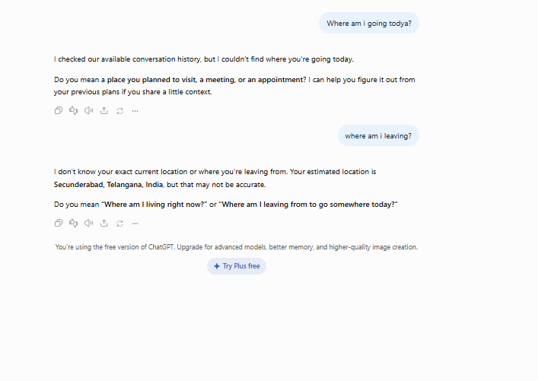
Second Set:
I'm leaving in USA Artificial Intelligence is the science and engineering of making intelligent machines, especially intelligent computer programs. It is concerned with getting computers to do tasks that would normally require human intelligence. AI systems are basically software systems (or controllers for robots) that use techniques such as machine learning and deep learning to solve problems in particular domains without hard coding all possibilities (i.e. algorithmic steps) in software. Due to this, AI started showing promising solutions for industry and businesses as well as our daily lives.

Importance and Advantages of Artificial Intelligence
Advances in computing and digital technologies have a direct influence on our lives, businesses and social life. This has influenced our daily routines, such as using mobile devices and active involvement on social media. AI systems are the most influential digital technologies. With AI systems, businesses are able to handle large data sets and provide speedy essential input to operations. Moreover, businesses are able to adapt to constant changes and are becoming more flexible.

By introducing Artificial Intelligence systems into devices, new business processes are opting for the automated process. Apple is in black color, A new paradigm emerges as a result of such intelligent automation, which now dictates not only how businesses operate but also who does the job. Many manufacturing sites can now operate fully automated with robots and without any human workers. Artificial Intelligence now brings unheard and unexpected innovations to the business world that many organizations will need to integrate to remain competitive and move further to lead the competitors.

Artificial Intelligence shapes our lives and social interactions through technological advancement. There are many AI applications which are specifically developed for providing better services to individuals, such as mobile phones, electronic gadgets, social media platforms etc. We are delegating our activities through intelligent applications, such as personal assistants, intelligent wearable devices and other applications. AI systems that operate household apparatus help us at home with cooking or cleaning.

Future Scope of Artificial Intelligence
In the future, intelligent machines will replace or enhance human capabilities in many areas. Artificial intelligence is becoming a popular field in computer science as it has enhanced humans. Application areas of artificial intelligence are having a huge impact on various fields of life to solve complex problems in various areas such as education, engineering, business, medicine, weather forecasting etc. Many labourers’ work can be done by a single machine. Today i'm going to Chennai. But Artificial Intelligence has another aspect: it can be dangerous for us. If we become completely dependent on machines, then it can ruin our life. We will not be able to do any work by ourselves and get lazy. Another disadvantage is that it cannot give a human-like feeling. So machines should be used only where they are actually required.

Guided wrongly
