SMAI-Assignment 1

Algorithm Implementation:

- Decision tree structure used is
subtree={question:[max_count,{yes_subtree,no_subtree}]}
- Impurity Function used is ‘Entropy’
- Entropy of provided data is calculated in cal_entropy() function and uses the formula
E=-p *log(p) - ( 1-p )*log(1-p )
- Then the information gain for all the attributes is calculated in cal_gain() function using formula : Gain= E - I
where I is the weighted entropy of all values of an attribute
- Choose the attribute having maximum gain
- Repeat the process to build tree until we get pure attributes
- For numerical attributes,the split value is found by calculating entropy for all possible values and choosing the min value.This is done in cal_split_num()
- Decision Tree is built using the above steps recursively in build_tree()
- Prediction is done on validation data using the tree built in precision() function
- We traverse the tree from top using the questions and comparing values for numerical attributes
- To handle the case where key present in test data is missing in tree, we are stroing ‘max_count’ in the tree structure which stores the prediction label by storing the maximum label by counting 1s and 0s until that questions.Whenever key is not present,we return the prediction as this label in tree
- Then we calculate all the measures like accuracy,precision,recall,F1 score based on the predictions.

Results

- Using Entropy
Accuracy- 0.9346085409252669
Precision- 0.8571428571428571
Recall- 0.9156193895870736
F1 score- 0.8854166666666666
- Using Gini
Accuracy- 0.9150355871886121
Precision- 0.7879256965944272
Recall- 0.9040852575488455
F1 score- 0.8420181968569065

Graphs:

- Part-4
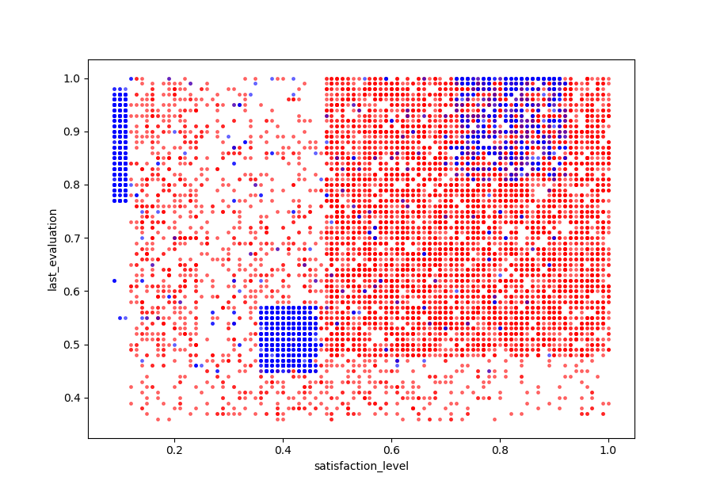

- Part-5:

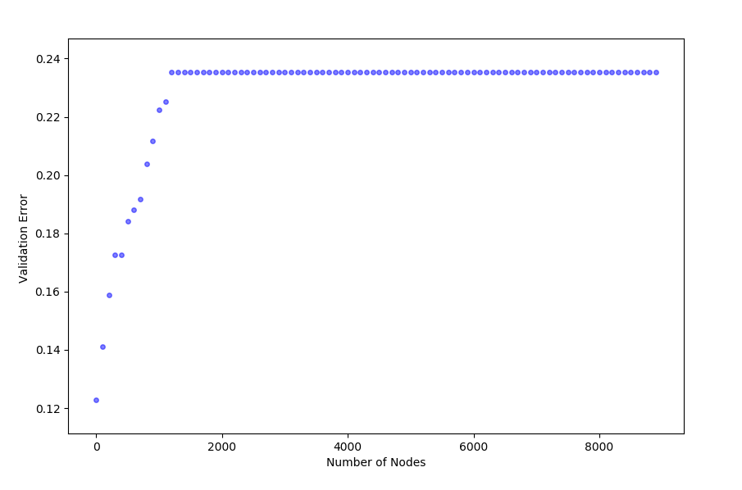

q6) Explain how decision tree is suitable handle missing values(few attributes missing in test samples) in data.
If the missing attribute is not part of the tree structure,then it is not needed for Decision Making.
In this way, decision trees also help in Feature Extraction
If the missing attribute is part of Decision tree ,then it is a problem because we cannot proceed further in the tree without the value of that attribute.
To handle such cases,we have stored the label(1,0) having maximum count until that level in the structure of tree.
Structure of tree is:
subtree={question:[max_count,{yes_part,no_part}]}
If the attribute is missing in test data ,we consider the maximum count label at that level as our prediction.

Observations:
- Decision Tree is not stable.
When we randomly change training data,the structure of tree changes and hence also the accuracy,precision values changes.
- Part 4 :
The two attributes chosen is ‘last_evaluation’,’satisfaction_level’
Decision Boundaries mostly parallel to axes are observable
- Part 5:
Graph is drawn between number of nodes and validation error
Validation error = 1-accuracy

