PAGERANK ALGORITHM

Team Members:
- C.Sai Sukrutha 2018201054
- Sarvat Ali 2018201009

Objective:
Study and Implementation of PageRank Algorithm and improvement of execution time.
Implementation of PageRank in real time application where ranks of team/individuals playing sports is calculated.

Repository:
https://github.com/sarvatgit/apsprojectPageRank.git

PageRank:
PageRank is a algorithm for rating the importance of web pages effectively using the link structure of the web.
It is invented by Google founders Larry Page and Sergey Brin.
In other words,PageRank is a probability distribution used to represent the likelihood that a person randomly clicking on links will arrive at any particular page.

PageRank Calculation:

PageRank is a numerical weighting assigned to each page in a hyperlinked set of documents, such as the World Wide Web based on number of incoming links and their importance.
Each link’s vote is proportional to the ‘importance’ of its source page.If page P with importance x has n outgoing links, each link gets x/n votes.Page P’s own importance is the sum of the votes on its incoming links.

Formula: PR(A) = (1-d)/N + d (PR(T1)/C(T1) + ... + +PR(Tn)/C(Tn))
where

N – Total no of Pages
PR(Ti) – PageRank of ith Page having incoming link to A
C(Ti) - No of outgoing links from Ti
d- damping factor
- probability that the surfer will continue clicking links from the current page is damping factor.
-various studies have tested different damping factors, but it is generally assumed that the damping factor will be set around 0.85.

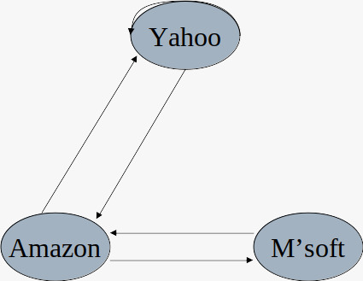

Fig1. Example-Link Structure of World Wide Web

Calculation of PageRanks from Fig1:

PageRank (Yahoo) = d* PageRank(Amazon) / 2 + (1-d)/3
PageRank(Amazon) =d* [ PageRank(Yahoo) / 1 + PageRank(M’soft) / 1 ] + (1-d )/3
PageRank(M’soft) = d* PageRank(Amazon) / 2 + (1-d)/3

- Initially at t=0,PageRank of all pages is assigned to 1/N.

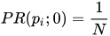

- At time t+1,
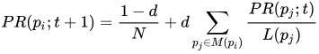

PageRank Calculation using Power Method:

- Define a Matrix M which has one row and one column for each web page.
- Suppose page j has n outlinks
If j != i, then Mij=1/n
Else Mij=0
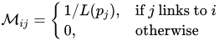

- M is a column stochastic matrix i.e., Columns sum to 1.
- Suppose R is a vector with one entry per web page , Ri is the Rank of page i

- Rank Vector , R =[ 1/ N 1/N ..... 1/N ] for all N pages
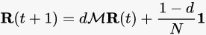

Power Iteration :
- Initialize: R₀ = [1/N,….,1/N]T
- Iterate: R_{k+1} = M ^{k} * R₀
- Stop when | R_{k+1} – R_{k} |1 < Convergence Value (0.001)

Example
Considering previous example of Fig1,
- Calculating matrix M

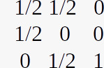
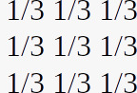
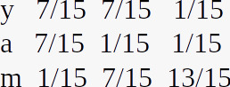

=

- Initial Rank Vector R₀= [ 1/3 1/3 1/3 ]
- Apply formula R_{k+1} = M ^{k} * R₀ until convergence value is acheived between R_{k} and R_{k+1}

OpenMP:
- OpenMP stands for Open specification for Multi-Processing.
- OpenMP is an Application Program Interface (API) that may be used to explicitly direct multi-threaded, shared memory parallelism.
- API components: Compiler Directives, Runtime Library Routines. Environment Variables.
- OpenMP is a directive-based method to invoke parallel computations on share-memory multiprocessors
- OpenMP API is specified for C/C++ and Fortran. OpenMP is not intrusive to the original serial code: instructions appear in comment statements for fortran and pragmas for C/C++.
- OpenMP uses the Fork-Join model of parallel execution.
All OpenMP programs begin with a single master thread.The master thread executes sequentially until a parallel region is encountered, when it creates a team of parallel threads (FORK).When the team threads complete the parallel region, they synchronize and terminate, leaving only the master thread that executes sequentially (JOIN)
- OpenMP API core syntax:
-> Include the header file : #include <omp.h>
-> General Syntax : #pragma omp construct [clause [clause]...]
-> We are using :
--> #pragma omp parallel for
-- #pragma omp parallel spawns a group of threads, while #pragma omp for divides loop iterations between the spawned threads. You can do both things at once with the fused #pragma omp parallel for directive.
--> #pragma
- Compiling OpenMP Programs (Linux):
g++ -fopenmp <filename.cpp>

Deliverables:
- To make Page Rank Algorithm efficient by doing parallel computation.
- Application of Page Rank to calculate performance of competitors playing a tournament based on previous matches history data and current ongoing matches.

Project Delivery Plan:
- Module 1 – Reasearch of Page Rank Algorithm and its sequencial implementation using Vanilla Page Rank.
- Module 2 – Page Rank calculation using matrix Power Method.
- Module 3 – Parallel Computation of Ranks using OpenMP.
- Module 4 – Application of PageRank to calculate ranks of team participating in tournament on the basis of loose and win.
- Module 5 – Application of Page rank Algorithm to calculate rank of participants in Race or Swimming on the basis of their order(who finishes before).
- Module 6 – Rank Calculation after configuring match/race data after every competetion.
- Module 7 – Comparision of Execution Time for Sequential and Parallel Computation of Page Rank.

