**Class Work-2**

**Svalicherla1**

Exercise to create the tables

Tab_ex1.html:

**Codd Server link**

<https://codd.cs.gsu.edu/~svalicherla1/WP/CW/CW2/tab_ex1.html>

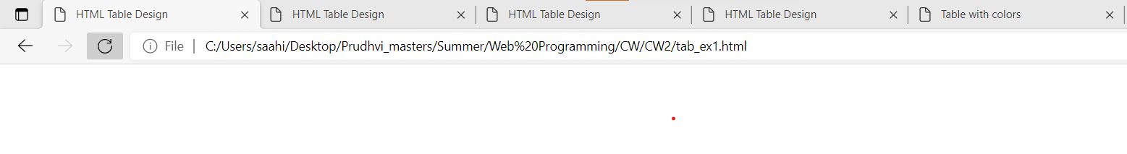

Code snippet:

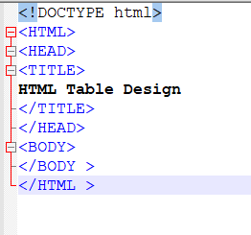

Tab_ex2.html:

**Codd Server link**

https://codd.cs.gsu.edu/~svalicherla1/WP/CW/CW2/tab_ex2.html

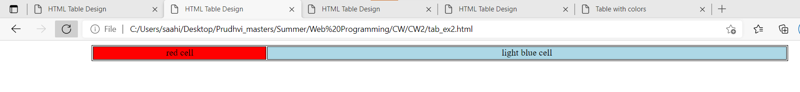

Code Snippet:

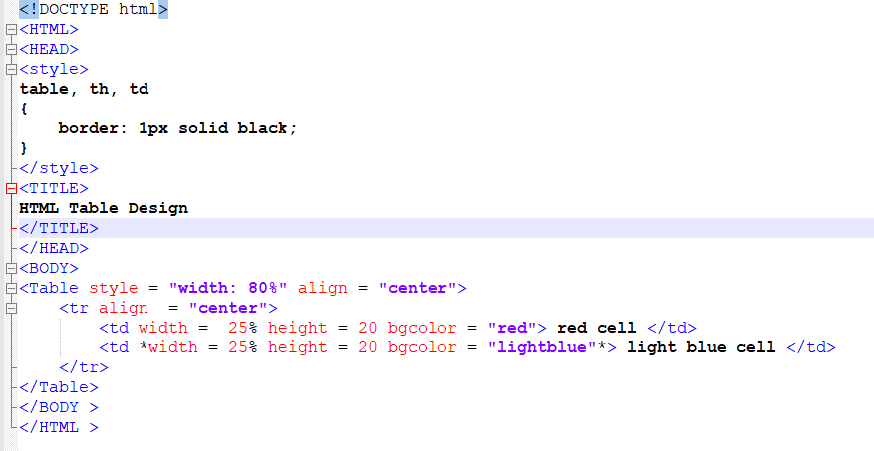

Tab_ex3.html:

**Codd Server link**

https://codd.cs.gsu.edu/~svalicherla1/WP/CW/CW2/tab_ex3.html

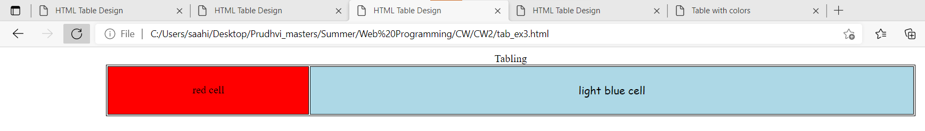

Code Snippet:

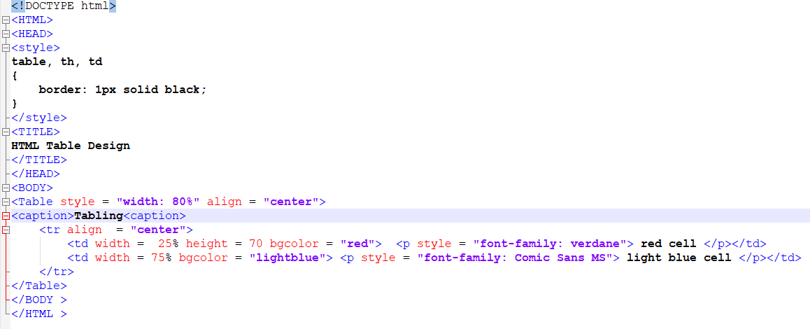

Tab_ex4.html:

**Codd Server link**

https://codd.cs.gsu.edu/~svalicherla1/WP/CW/CW2/tab_ex4.html

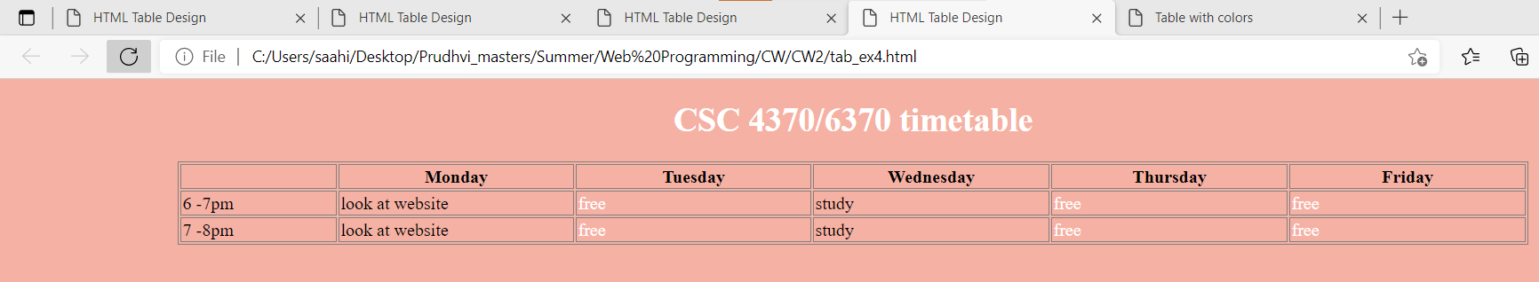

Code Snippet:

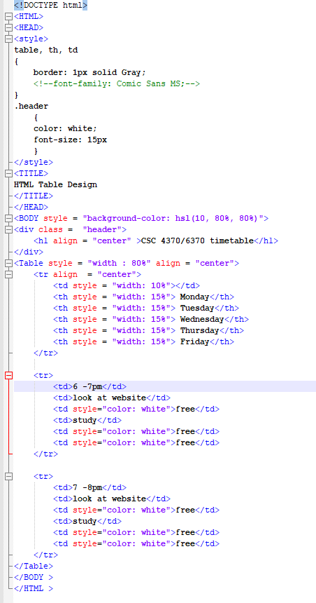

Activity-2:

**Codd Server link**

https://codd.cs.gsu.edu/~svalicherla1/WP/CW/CW2/activity_2.html

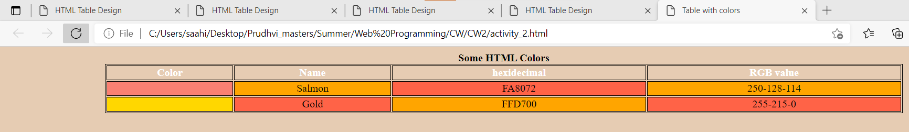

Code Snippet:

