**Class Work-3**

**Svalicherla1**

Exercise to create the tables

**Tab_ex4.html:**

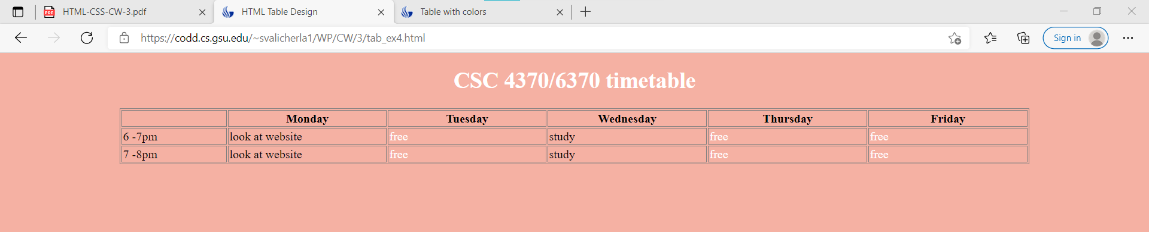

**Codd Server link**

<https://codd.cs.gsu.edu/~svalicherla1/WP/CW/3/tab_ex4.html>

**Code snippet:**

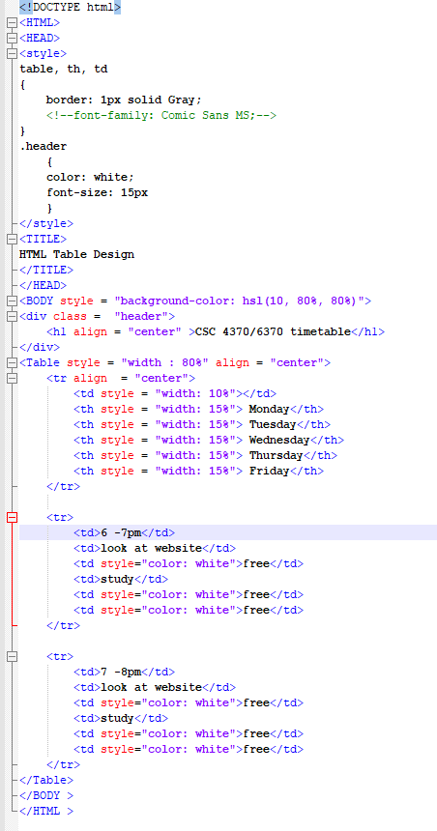

**Activity-2:**

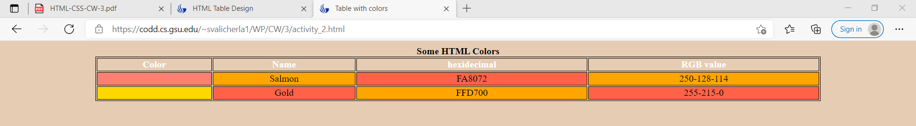

**Codd Server link**

<https://codd.cs.gsu.edu/~svalicherla1/WP/CW/3/activity_2.html>

Code Snippet:

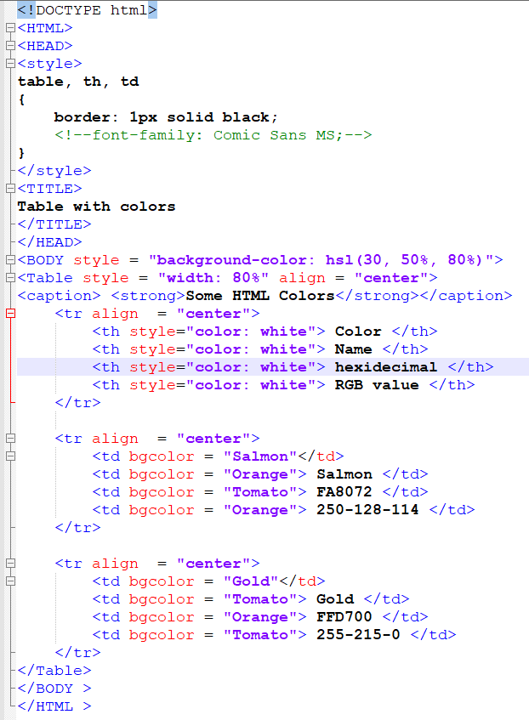

**adv_tab1.html:**

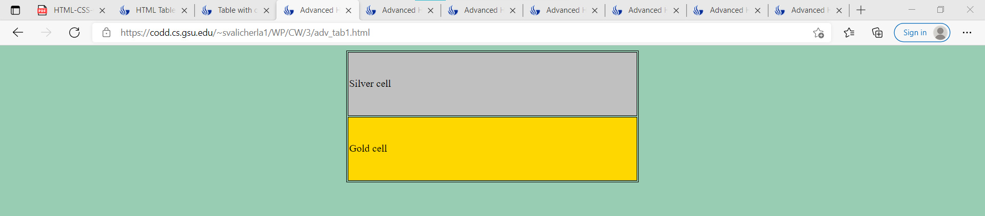

**Codd Server link**

<https://codd.cs.gsu.edu/~svalicherla1/WP/CW/3/adv_tab1.html>

**Code Snippet:**

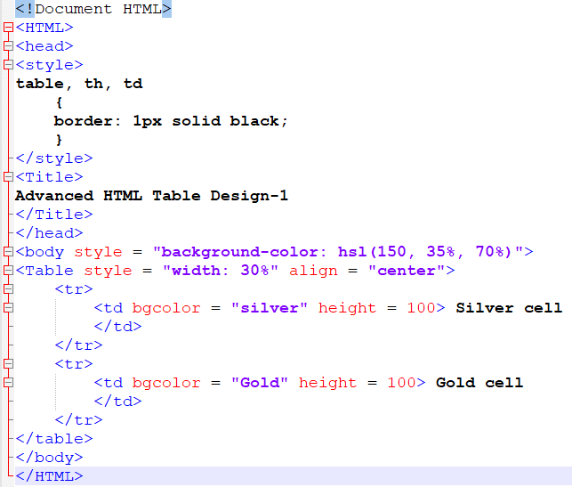

**adv_tab2.html:**

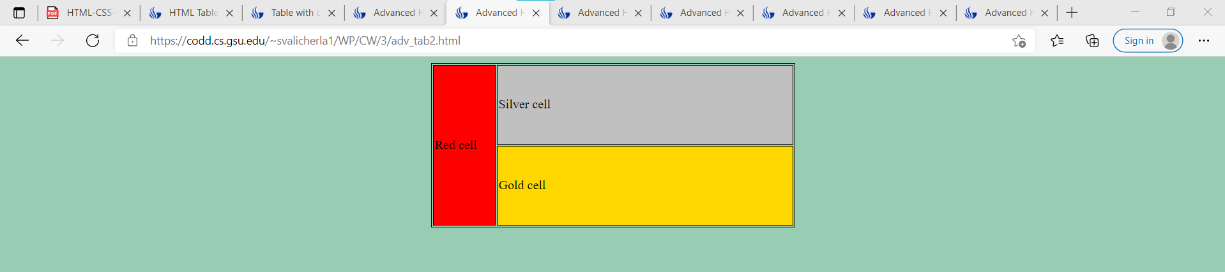

**Codd Server link**

<https://codd.cs.gsu.edu/~svalicherla1/WP/CW/3/adv_tab2.html>

**Code Snippet:**

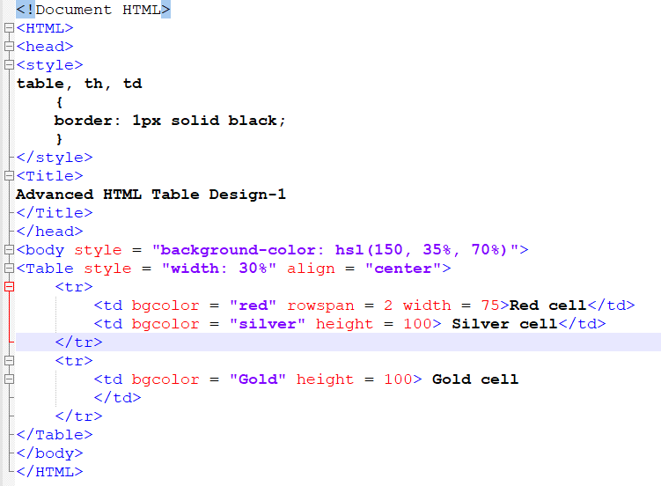

**adv_tab3.html:**

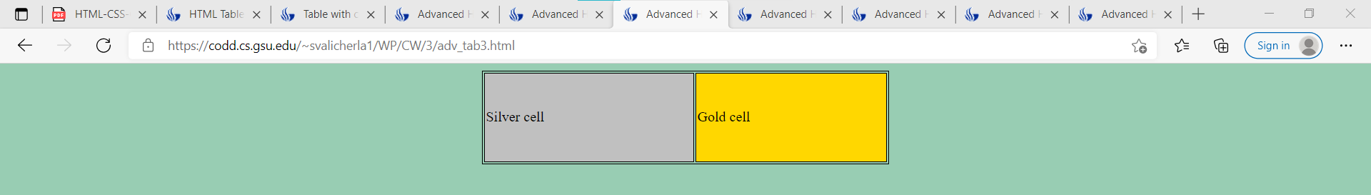

**Codd Server link**

<https://codd.cs.gsu.edu/~svalicherla1/WP/CW/3/adv_tab3.html>

**Code Snippet:**

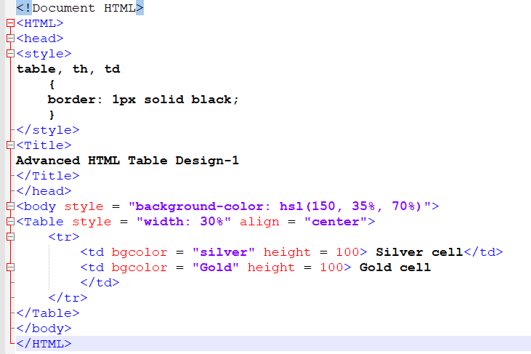

**adv_tab4.html:**

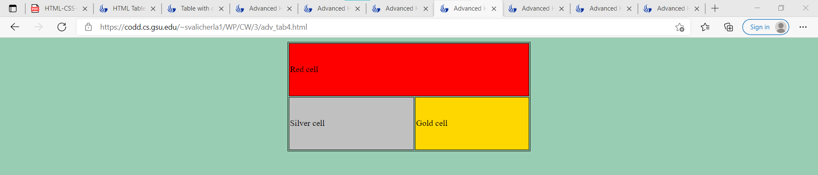

**Codd server:**

<https://codd.cs.gsu.edu/~svalicherla1/WP/CW/3/adv_tab4.html>

**Code Snippet:**

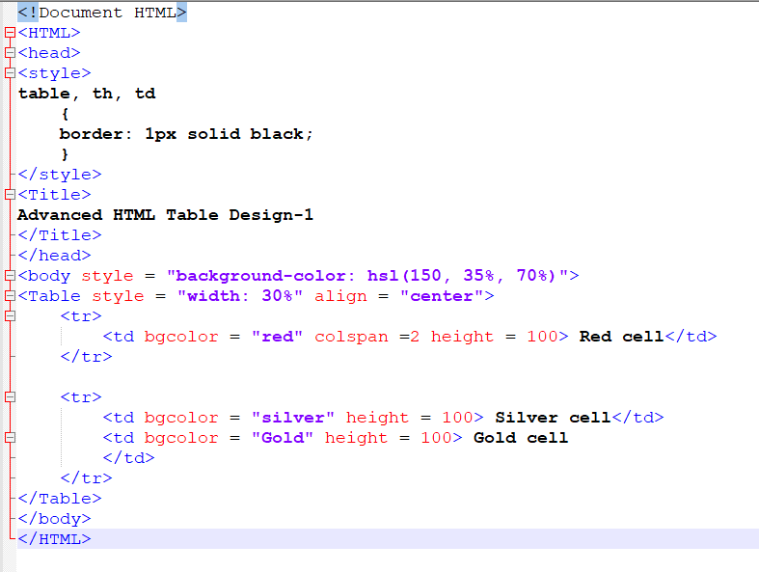

**adv_tab5.html:**

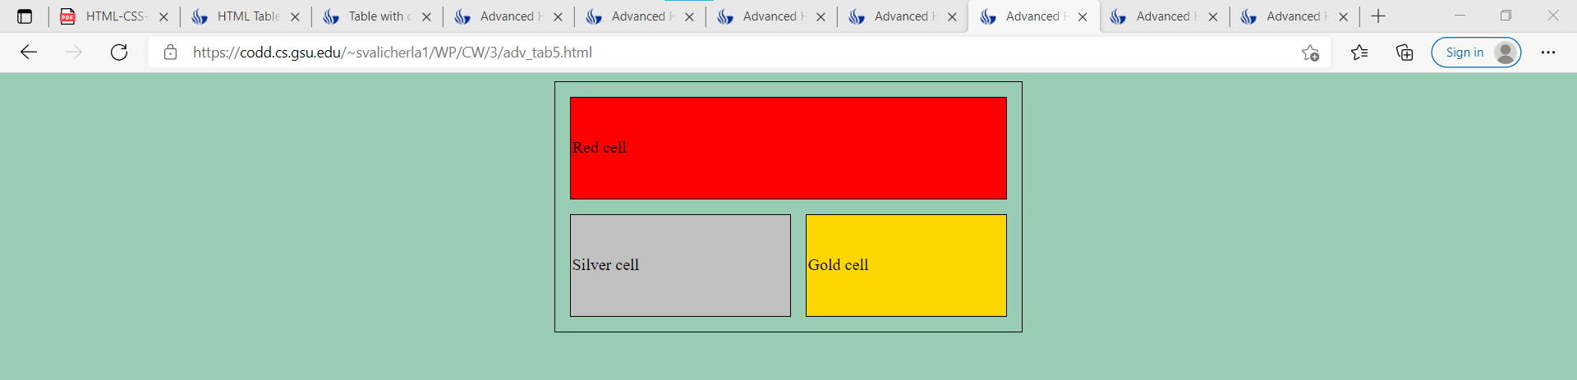

**Codd Server:**

<https://codd.cs.gsu.edu/~svalicherla1/WP/CW/3/adv_tab5.html>

**Code Snippet:**

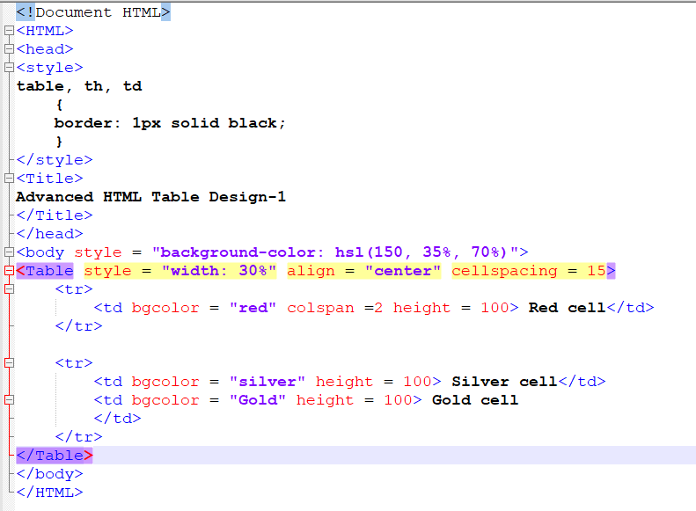

**adv_tab6.html:**

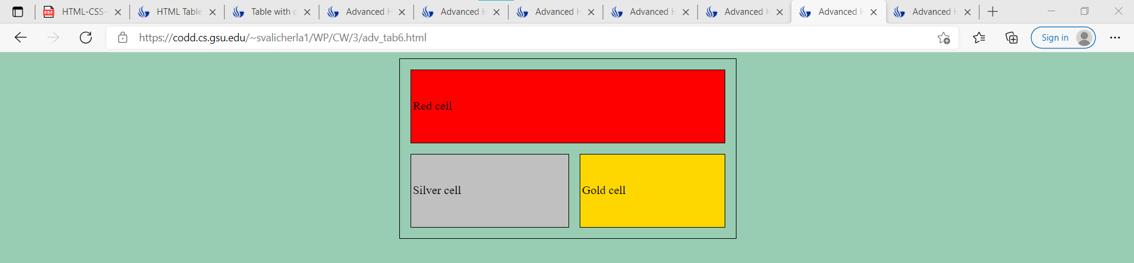

**Codd Server:**

<https://codd.cs.gsu.edu/~svalicherla1/WP/CW/3/adv_tab6.html>

**Code Snippet:**

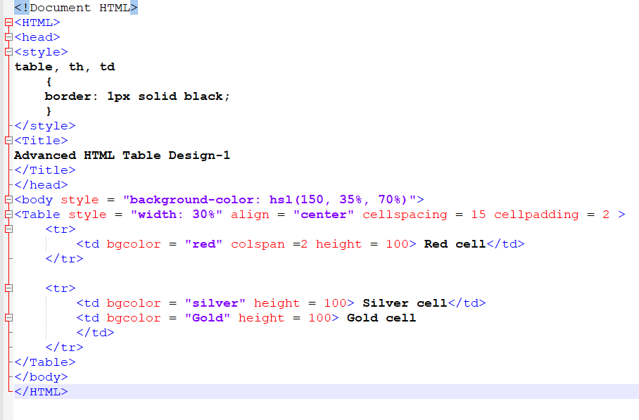

**Activity-5:**

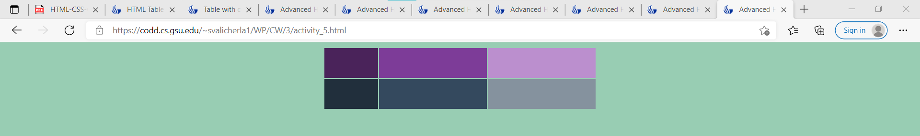

**Codd Server:**   
<https://codd.cs.gsu.edu/~svalicherla1/WP/CW/3/activity_5.html>

**Code Snippet:**

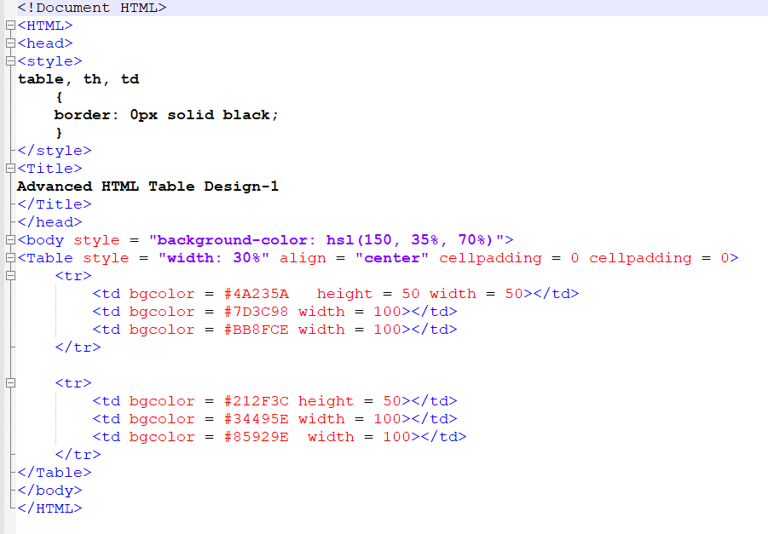

**Activity-6:**

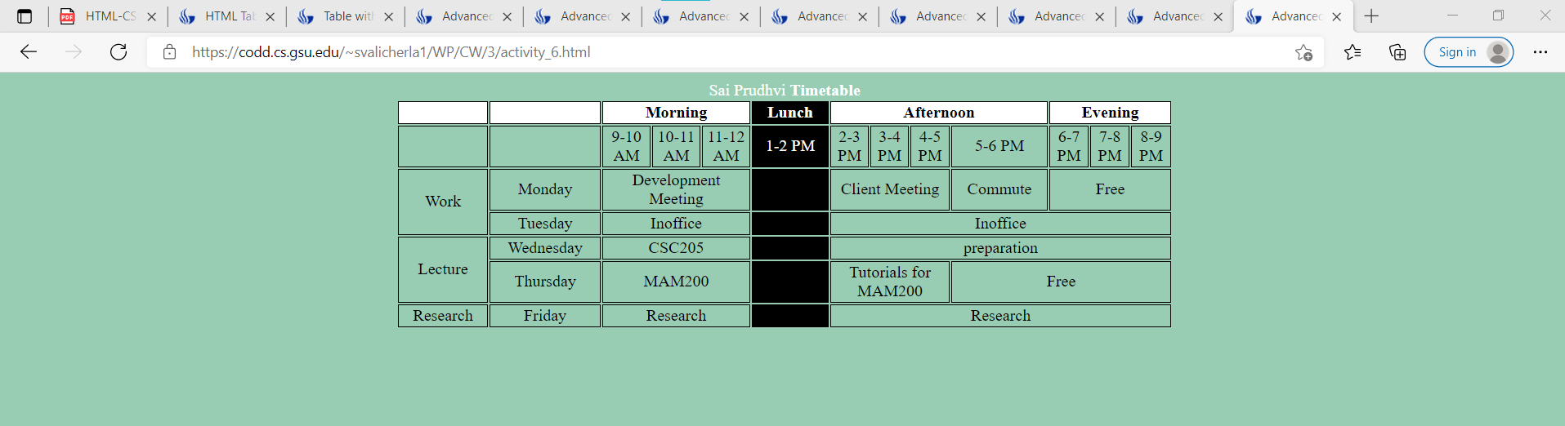

Codd Server:

[Advanced HTML Table Design-1 (gsu.edu)](https://codd.cs.gsu.edu/~svalicherla1/WP/CW/3/activity_6.html)

<https://codd.cs.gsu.edu/~svalicherla1/WP/CW/3/activity_6.html>

Code Snippet:

