|  |  |  |  |  |  |  |  |  |  |
| --- | --- | --- | --- | --- | --- | --- | --- | --- | --- |
| **SCHOOL OF COMPUTER SCIENCE AND ARTIFICIAL INTELLIGENCE** | | | | | **DEPARTMENT OF COMPUTER SCIENCE ENGINEERING** | | | | |
| **ProgramName:**B. Tech | | | | **Assignment Type: Lab** | | | **AcademicYear:**2025-2026 | | |
| **CourseCoordinatorName** | | | | Venkataramana Veeramsetty | | | | | |
| **Instructor(s)Name** | | | | 1. Dr. Mohammed Ali Shaik 2. Dr. T Sampath Kumar 3. Mr. S Naresh Kumar 4. Dr. V. Rajesh 5. Dr. Brij Kishore 6. Dr Pramoda Patro 7. Dr. Venkataramana 8. Dr. Ravi Chander 9. Dr. Jagjeeth Singh | | | | | |
| **CourseCode** | | | 24CS002PC215 | **CourseTitle** | | AI Assisted Coding | | | |
| **Year/Sem** | | | II/I | **Regulation** | | R24 | | | |
| **Date and Day of Assignment** | | |  | **Time(s)** | |  | | | |
| **Duration** | | | 2 Hours | **Applicableto Batches** | |  | | | |
| **AssignmentNumber:3.3**(Present assignment number)/**24**(Total number of assignments) | | | | | | | | | |
|  | | | | | | | | | |
|  | **Q.No.** | **Question** | | | | | | ***Expected Time***  ***to***  ***complete*** |  |
|  | 1 | Lab 3: Prompt Engineering – Improving Prompts and Context Management  **Lab Objectives:**   * To understand how prompt structure and wording influence AI-generated code. * To explore how context (like comments and function names) helps AI generate relevant output. * To evaluate the quality and accuracy of code based on prompt clarity. * To develop effective prompting strategies for AI-assisted programming.   **Lab Outcomes (LOs):**  After completing this lab, students will be able to:   * Generate Python code using Google Gemini in Google Colab. * Analyze the effectiveness of code explanations and suggestions by Gemini. * Set up and use Cursor AI for AI-powered coding assistance. * Evaluate and refactor code using Cursor AI features. * Compare AI tool behavior and code quality across different platforms. | | | | | | 03.08.2025  EOD |  |

|  |  |  |  |  |
| --- | --- | --- | --- | --- |
|  | **Task Description#1**   * Try 3 different prompts to generate a factorial function.   **Expected Output#1**   * Comparison of AI-generated code styles   **Task Description#2**   * Provide a clear example input-output prompt to generate a sorting function.   **Expected Output#2**   * Functional sorting code from AI   **Task Description#3**   * Start with the vague prompt “Generate python code to calculate power bill” and   improve it step-by-step  **Expected Output#3**   * Enhanced AI output with clearer prompts   **Task Description#4**   * Write structured comments to help AI generate two linked functions (e.g., login_user() and register_user()).   **Expected Output#4**   * Consistent functions with shared logic   **Task Description#5**   * Analyzing Prompt Specificity: Improving Temperature Conversion Function with Clear Instructions   **Expected Output#5**   * Code quality difference analysis for various prompts   **Note: Report should be submitted a word document for all tasks in a single document with prompts, comments & code explanation, and output and if required, screenshots**  **Evaluation Criteria:** | | |  |
| **Criteria** | **Max Marks** |  |
| Factorial Function (Task#1) | 0.5 |
| Sorting Function (Task#2) | 0.5 |
| Vogue Vs. Specific Prompting (Task #3) | 0.5 |
| Linked Functions (Task #4) | 0.5 |
| Temperature Conversion Function (Task #5) | 0.5 |
| **Total** | **2.5 Marks** |

# Task Description#1

* Try 3 different prompts to generate a factorial function.

# Expected Output#1

* Comparison of AI-generated code styles

Prompt-1:

Generate a function that prints factorial of a given number

Code:

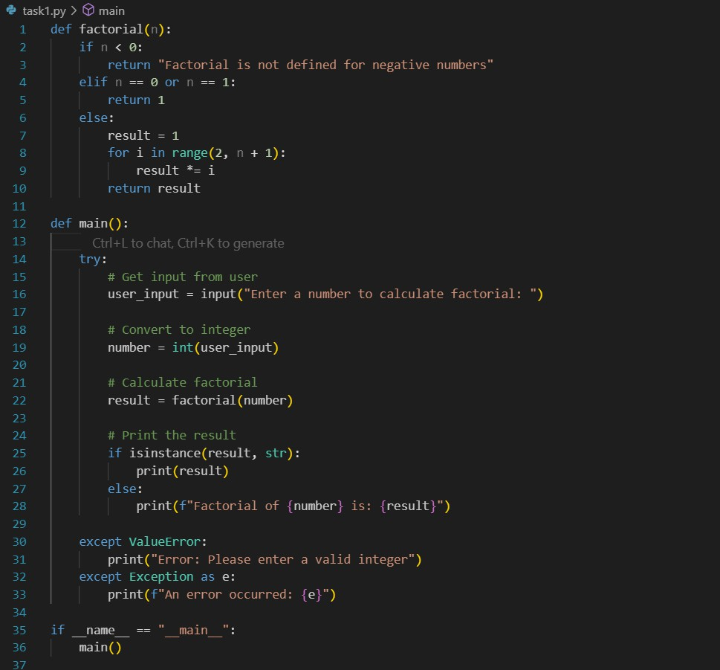

Output:

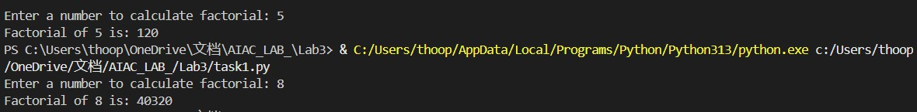

Prompt 2:

Write a simple python function to find factorial of a number ,collect input from the console

Code:

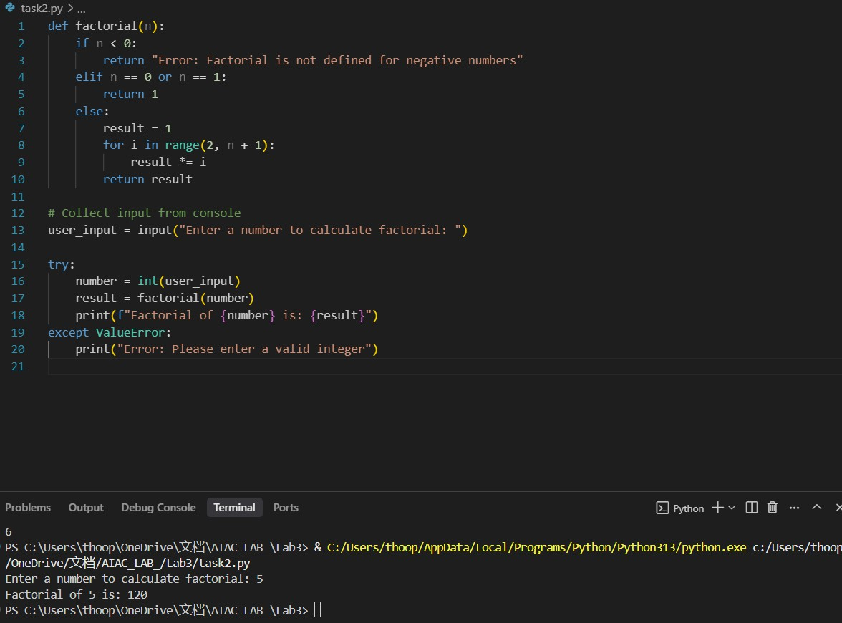

Prompt-3:

Create a simple python function that gives factorial of a number,use input from the programmer

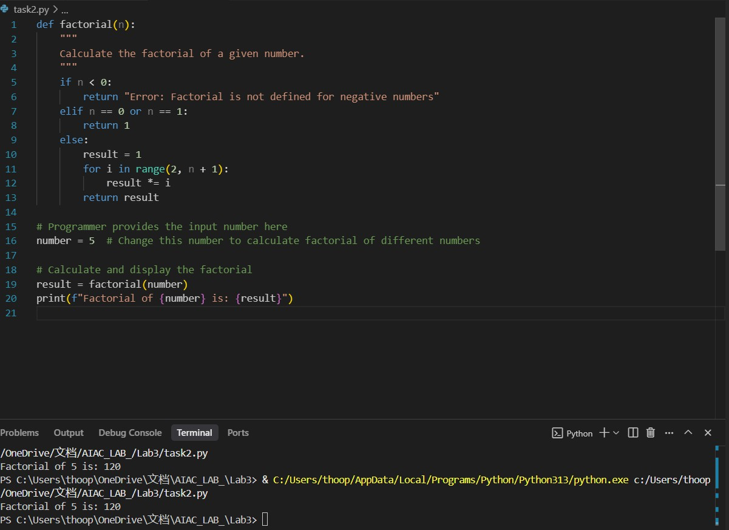

# Task Description#2

* Provide a clear example input-output prompt to generate a sorting function.

# Expected Output#2

* Functional sorting code from AI

Prompt:

Generate a python code that takes a input list from the user and sort the list Ascending order

Code along with output:

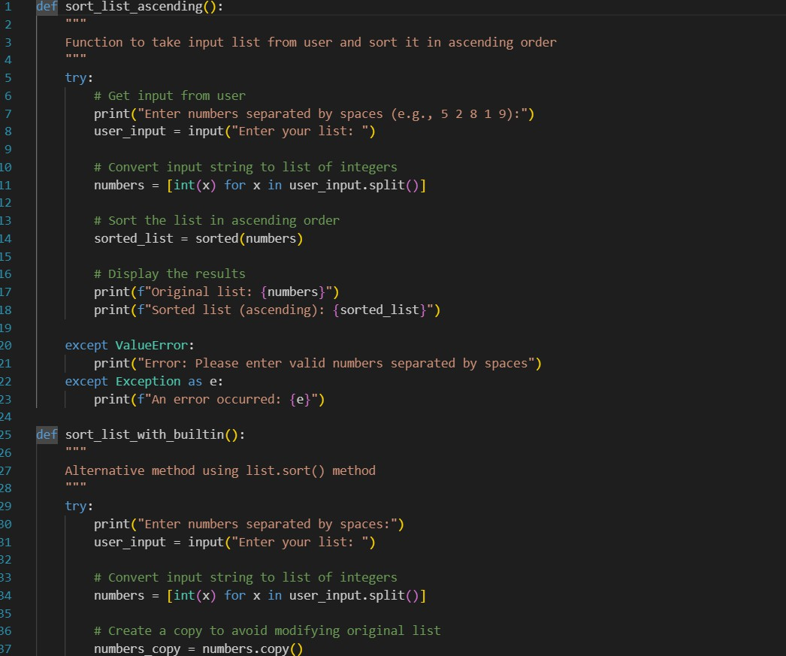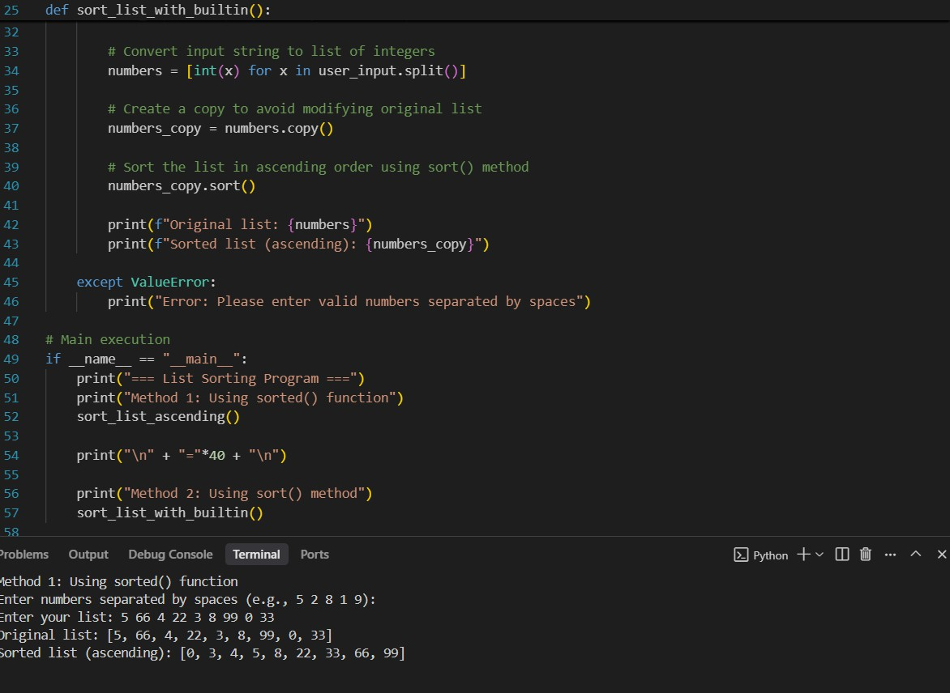

# Task Description#3

* Start with the vague prompt “Generate python code to
* calculate power bill” and improve it step-by-step

# prompt:

**generate a python code to calculate powerbill containing previous units**

**,present units ,read input units from the console**

code:

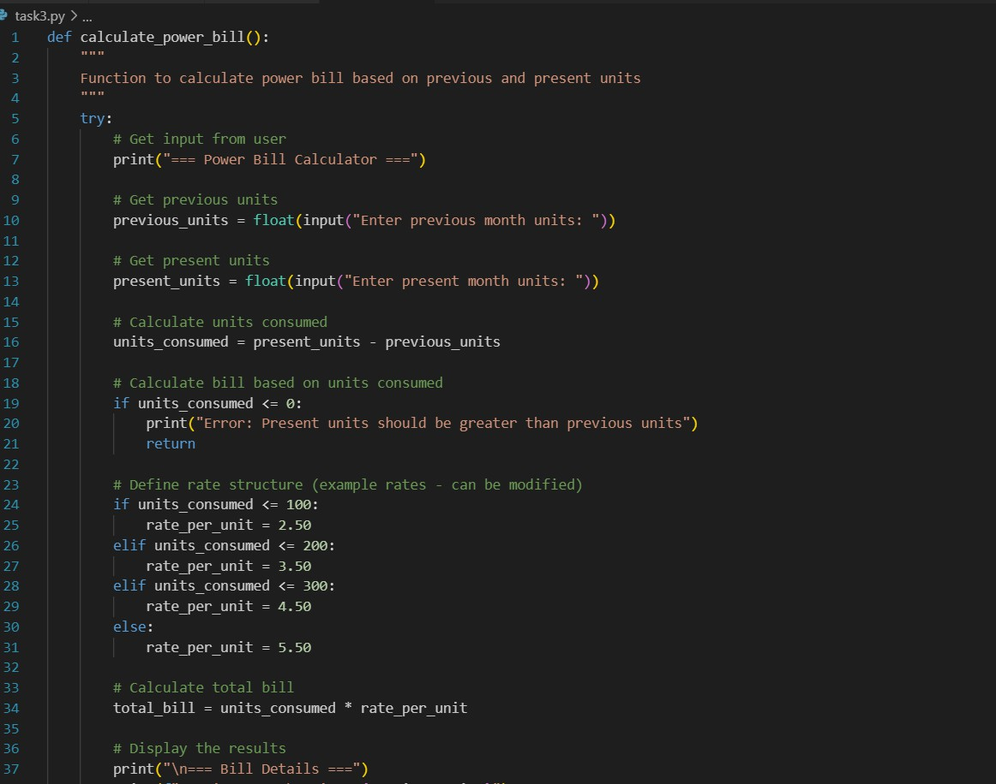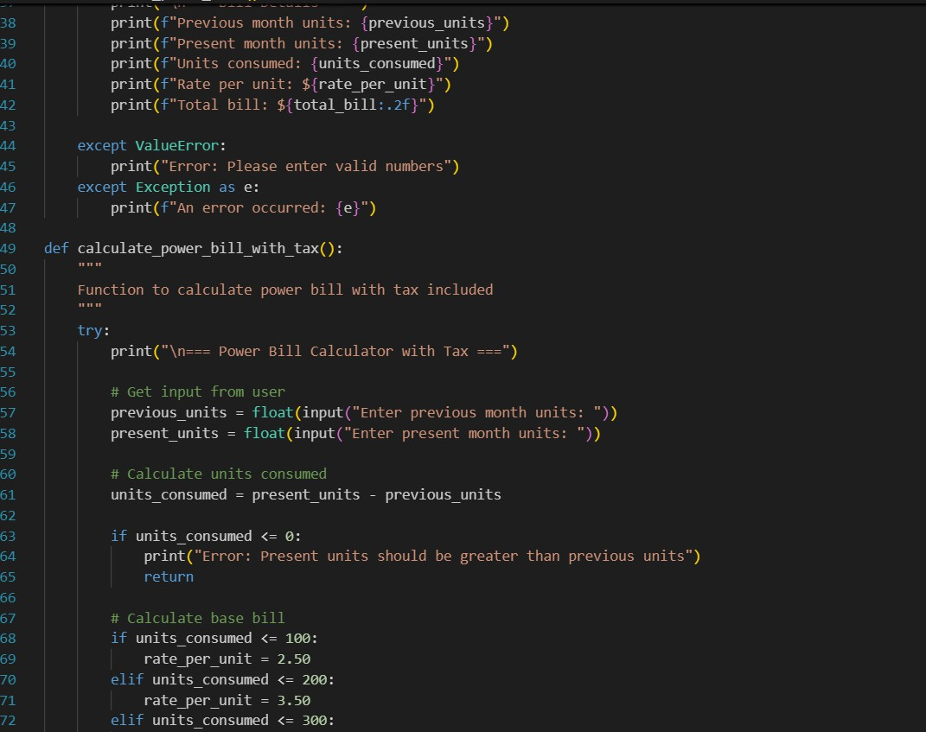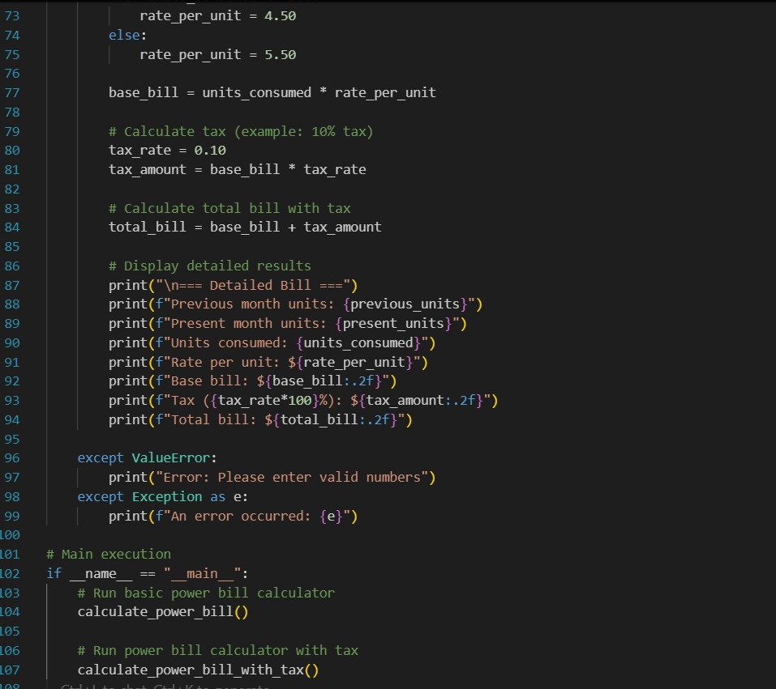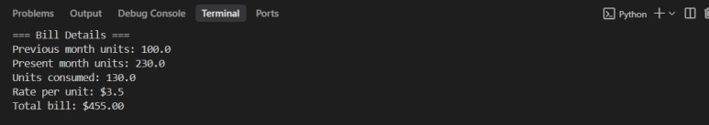

# Task Description#4

* Write structured comments to help AI generate two linked functions (e.g., login_user() and register_user()).

Prompt:

Generate simple two python linked functions one is for register user and login user for account creation

Code:

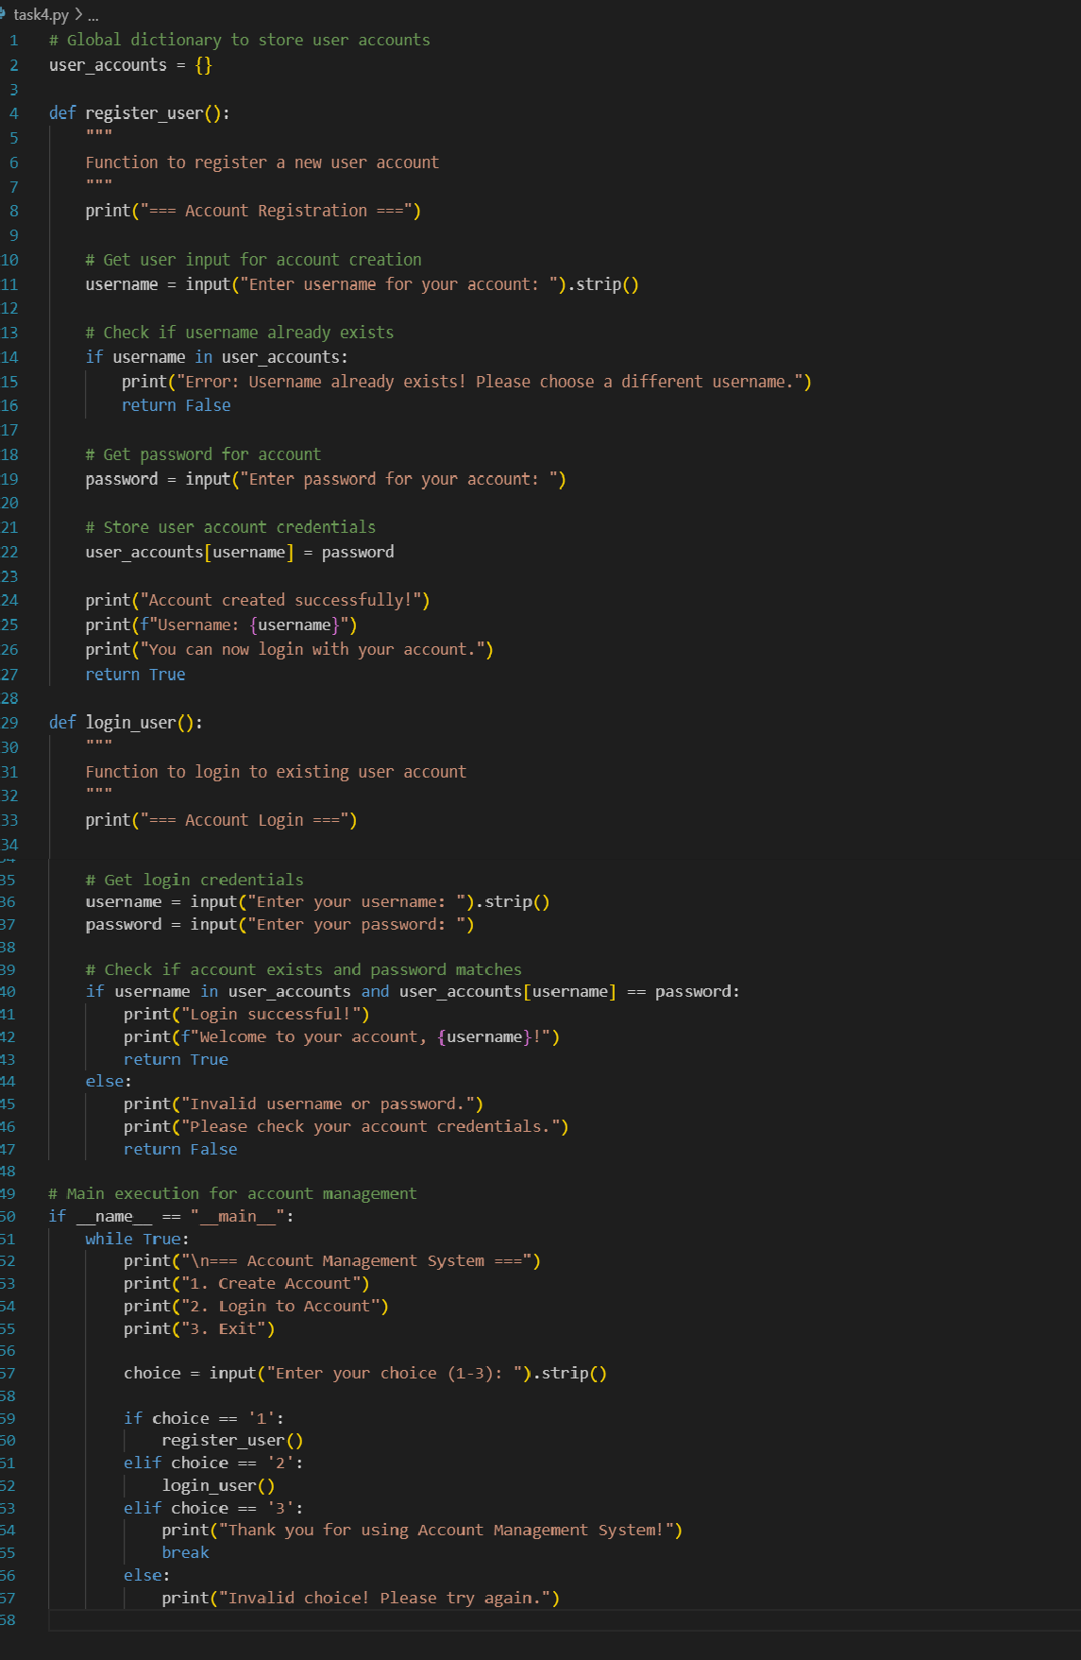

Output:

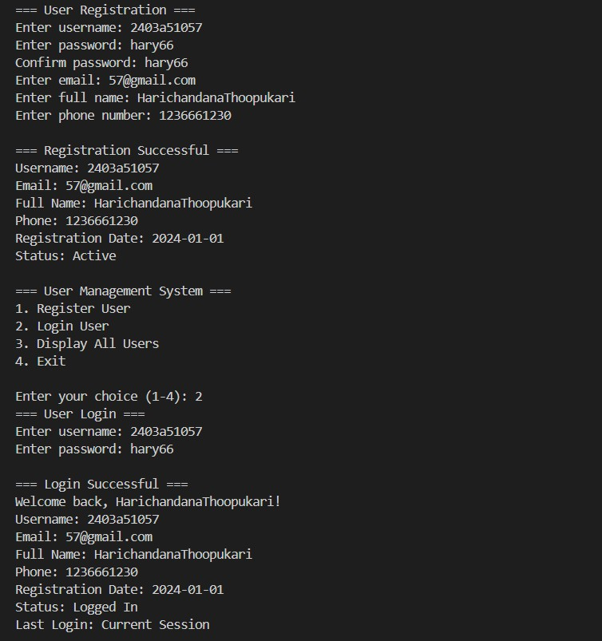

**Task Description#5**

* Analyzing Prompt Specificity: Improving Temperature Conversion Function with Clear Instructions

Prompt1:

Write a Python function to convert temperature from Celsius to Fahrenheit or vice-versa as for the user`s selection

Code:

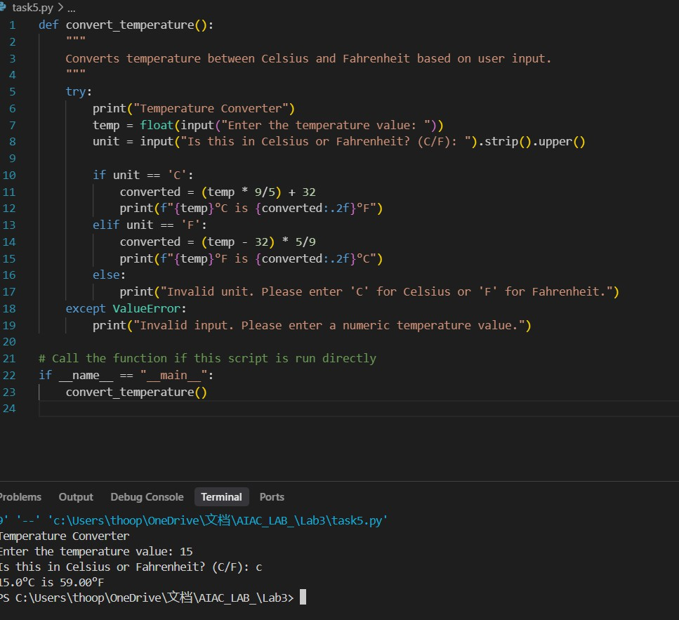

Prompt2:

Write a Python function to convert temperature from Celsius to Fahrenheit or vice-versa as for the user`s selection.

Code along with output:

