LAB ASSIGNMENT:01

NAME: T. SAI VARUN

ROLL NO: 2403A510C0

BATCH: 05

BRANCH: CSE

SUB: AI ASSISTED CODING

TASK - 01

Screen shot-1

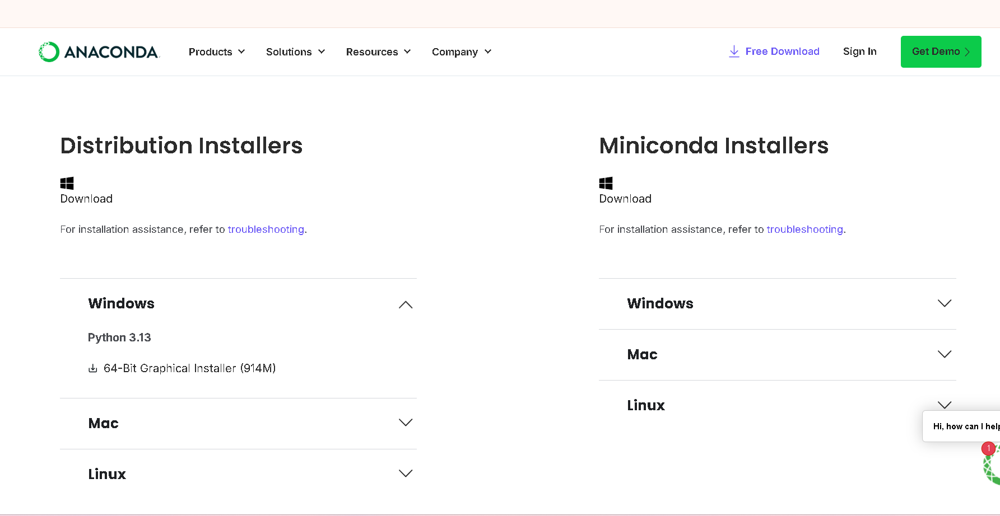

Screen shot-2

Screen shot-3

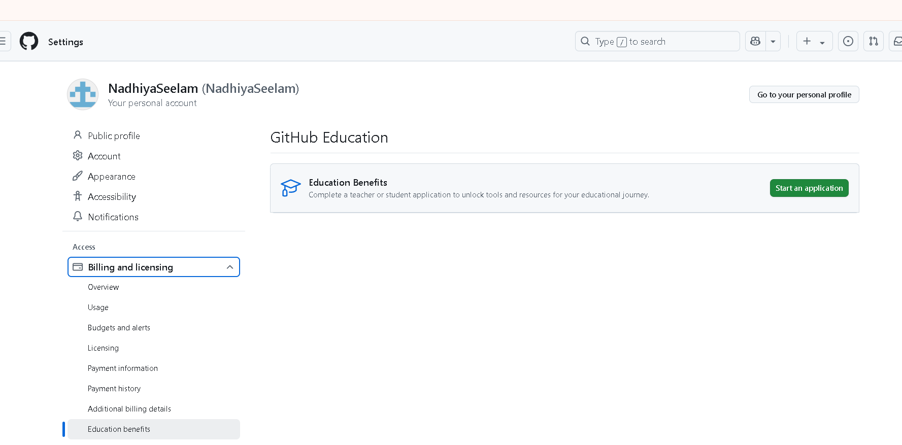

Screen shot-4

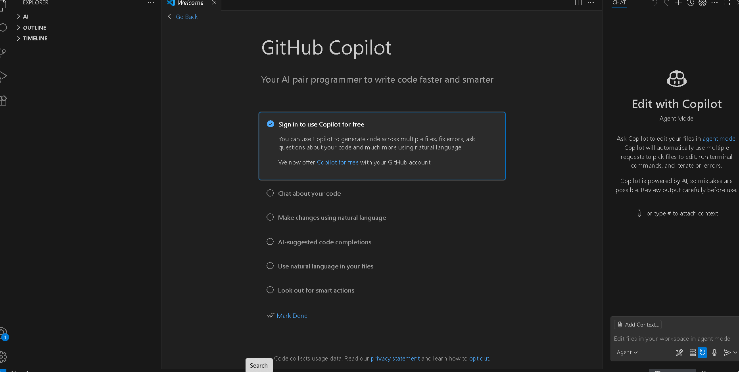

Screen shot-5

Screen shot-6

Screen shot-7

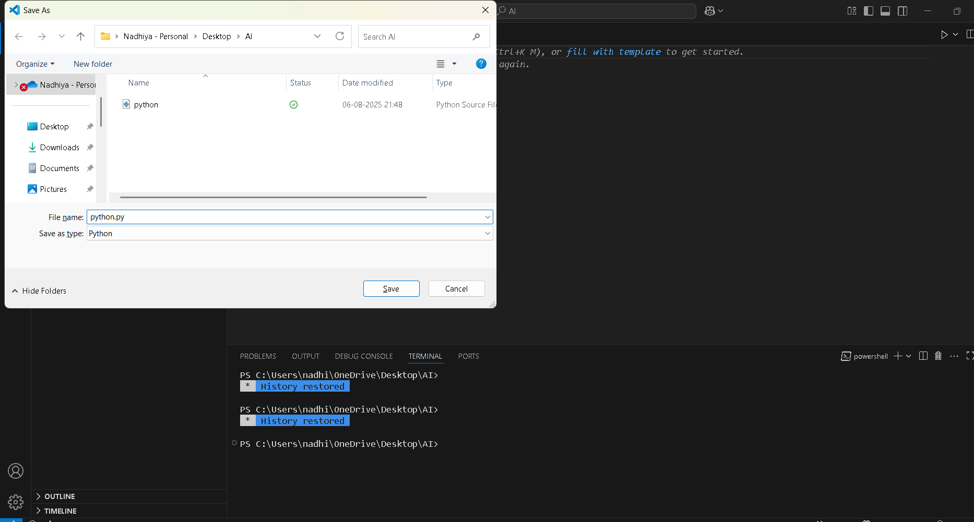

Screen shot-8

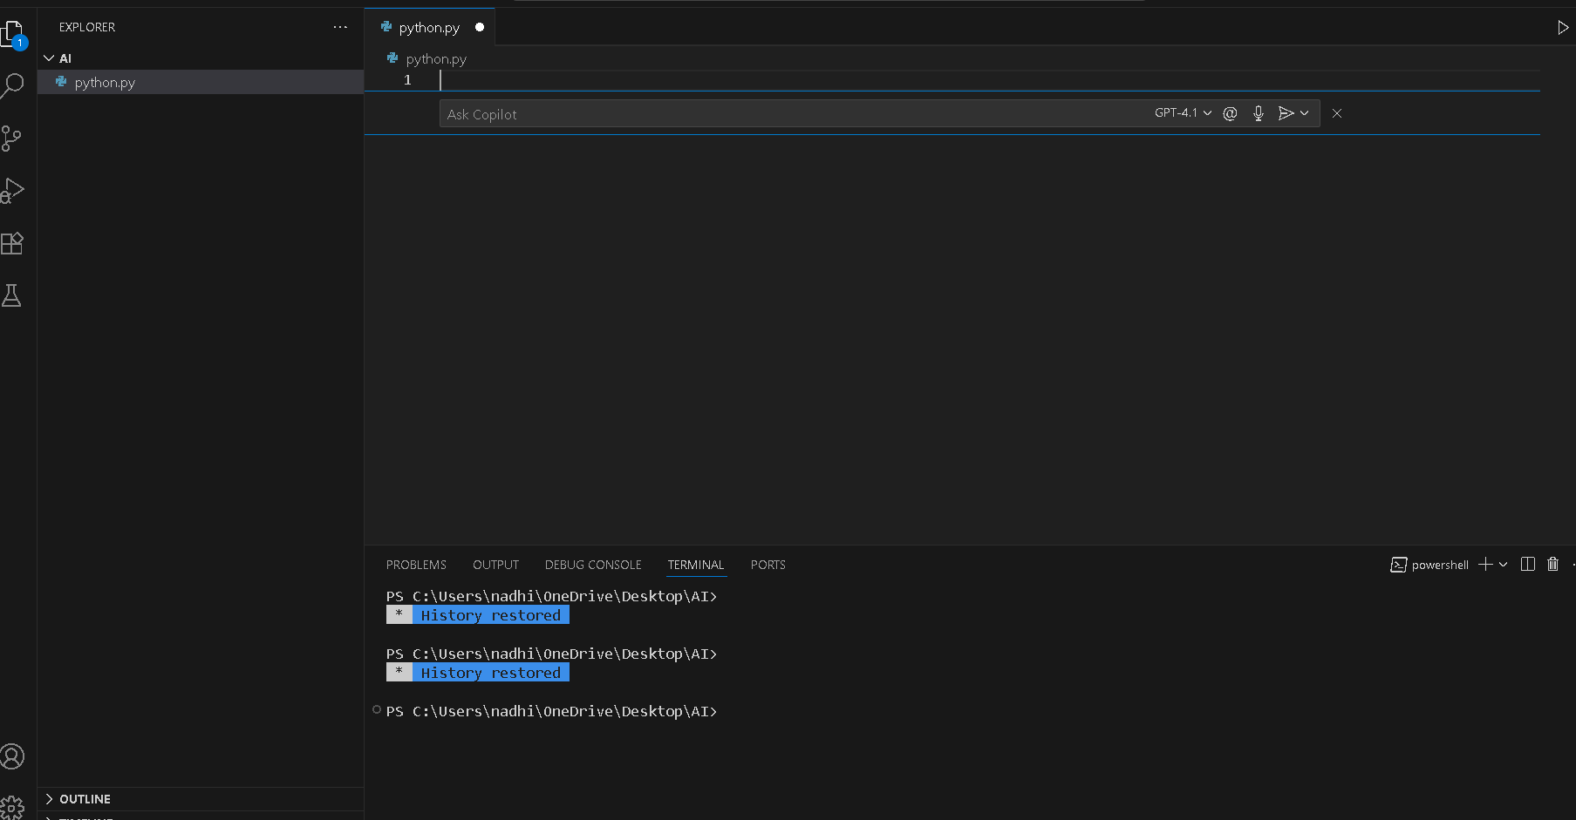

Screen shot-9

Screen shot-9

TASK – 02

Prompt : Write a python code to check whether a number is prime or not.

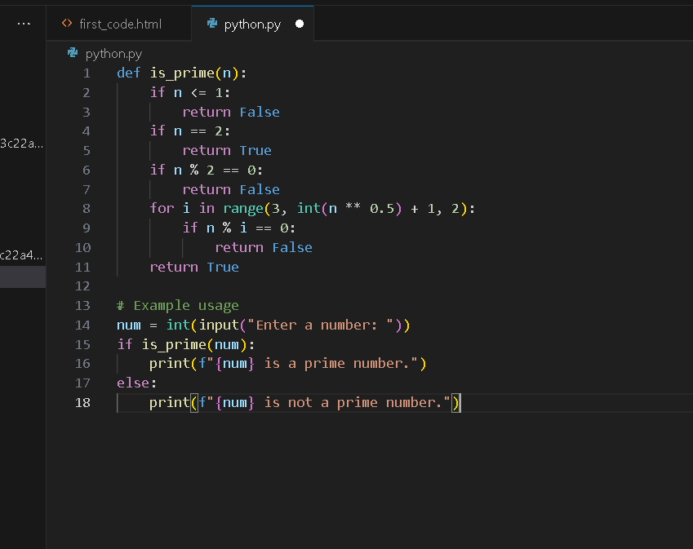

Output: 2 is prime number

Explanation:

* he code checks if a given number is prime.
* A prime number is a number greater than 1 that has no divisors other than 1 and itself.
* The code usually:
  + Returns False if the number is less than or equal to 1.
  + Loops from 2 up to the square root of the number.
  + If the number is divisible by any of these, it returns False.
  + If no divisors are found, it returns True.

Task-3:

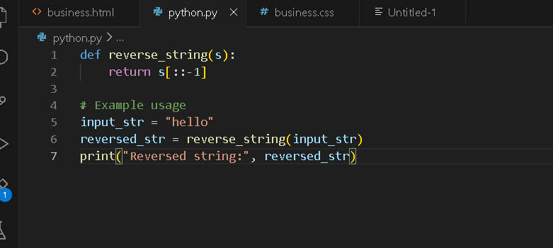

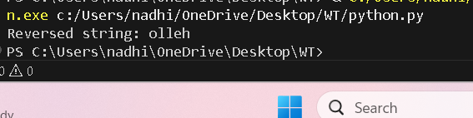

Explanation:

* The function [reverse_string(s)](vscode-file://vscode-app/c:/Users/nadhi/AppData/Local/Programs/Microsoft%20VS%20Code/resources/app/out/vs/code/electron-browser/workbench/workbench.html) takes a string [s](vscode-file://vscode-app/c:/Users/nadhi/AppData/Local/Programs/Microsoft%20VS%20Code/resources/app/out/vs/code/electron-browser/workbench/workbench.html) as input and returns its reverse using slicing ([s[::-1]](vscode-file://vscode-app/c:/Users/nadhi/AppData/Local/Programs/Microsoft%20VS%20Code/resources/app/out/vs/code/electron-browser/workbench/workbench.html)).
* The example usage sets [input_str](vscode-file://vscode-app/c:/Users/nadhi/AppData/Local/Programs/Microsoft%20VS%20Code/resources/app/out/vs/code/electron-browser/workbench/workbench.html) to "hello".
* It calls [reverse_string(input_str)](vscode-file://vscode-app/c:/Users/nadhi/AppData/Local/Programs/Microsoft%20VS%20Code/resources/app/out/vs/code/electron-browser/workbench/workbench.html), which returns "olleh", and stores it in [reversed_str](vscode-file://vscode-app/c:/Users/nadhi/AppData/Local/Programs/Microsoft%20VS%20Code/resources/app/out/vs/code/electron-browser/workbench/workbench.html).
* Finally, it prints Reversed string: olleh to the console

Task-04:



Explanation:

* This function calculates the factorial of [n](vscode-file://vscode-app/c:/Users/nadhi/AppData/Local/Programs/Microsoft%20VS%20Code/resources/app/out/vs/code/electron-browser/workbench/workbench.html) using recursion.
  + If [n](vscode-file://vscode-app/c:/Users/nadhi/AppData/Local/Programs/Microsoft%20VS%20Code/resources/app/out/vs/code/electron-browser/workbench/workbench.html) is 0 or 1, it returns 1 (base case).
  + Otherwise, it returns [n * factorial_recursive(n - 1)](vscode-file://vscode-app/c:/Users/nadhi/AppData/Local/Programs/Microsoft%20VS%20Code/resources/app/out/vs/code/electron-browser/workbench/workbench.html).
* **factorial_iterative(n):**  
  This function calculates the factorial of [n](vscode-file://vscode-app/c:/Users/nadhi/AppData/Local/Programs/Microsoft%20VS%20Code/resources/app/out/vs/code/electron-browser/workbench/workbench.html) using a loop.
  + It initializes [result](vscode-file://vscode-app/c:/Users/nadhi/AppData/Local/Programs/Microsoft%20VS%20Code/resources/app/out/vs/code/electron-browser/workbench/workbench.html) to 1.
  + Then multiplies [result](vscode-file://vscode-app/c:/Users/nadhi/AppData/Local/Programs/Microsoft%20VS%20Code/resources/app/out/vs/code/electron-browser/workbench/workbench.html) by each number from 2 up to [n](vscode-file://vscode-app/c:/Users/nadhi/AppData/Local/Programs/Microsoft%20VS%20Code/resources/app/out/vs/code/electron-browser/workbench/workbench.html).
* **Example usage:**
  + If the script is run directly, it sets [num = 5](vscode-file://vscode-app/c:/Users/nadhi/AppData/Local/Programs/Microsoft%20VS%20Code/resources/app/out/vs/code/electron-browser/workbench/workbench.html).
  + It prints the factorial of 5 using both the recursive and iterative functions.
  + Both methods output 120.

Task-05:

Explanation:

* **find_largest(numbers):**  
  This function takes a list of numbers and returns the largest value.
  + If the list is empty, it returns None.
  + It starts by assuming the first number is the largest.
  + It then loops through the rest of the list, updating [largest](vscode-file://vscode-app/c:/Users/nadhi/AppData/Local/Programs/Microsoft%20VS%20Code/resources/app/out/vs/code/electron-browser/workbench/workbench.html) if it finds a bigger number.
  + Finally, it returns the largest number found.
* **Example usage:**
  + A list [nums = [3, 7, 2, 9, 4]](vscode-file://vscode-app/c:/Users/nadhi/AppData/Local/Programs/Microsoft%20VS%20Code/resources/app/out/vs/code/electron-browser/workbench/workbench.html) is defined.
  + The function is called with this list, and the result is printed.
  + Output: Largest number: 9