Infosys Springboard Virtual Internship 7.0 Completion Report

Team Details <Do not mention any personally identifiable information like email ID, institute details, mobile phone number etc.>
Batch Number
Start date
Names: Thota Sai Venkat
Internship Duration: 8 Weeks

1. Project Title
Infosys _Healthcare Management Platform for Clinical Operations.

2. Project Objective
The key goal of Medisphere project is to develop an advanced full-stack healthcare platform which helps in making appointment scheduling easier for patients and doctors and gives administrators full control on system management. Some of the main aspects include onboarding of patients, appointment management, creation of digital receipt for payments, inclusion of AI functionalities and analysis of system logs.

3. Project description in detail
The project was built on the basis of a decoupled architecture with a dynamic React front-end for smooth interactions and scalable Java back-end. Data consistency and relational mapping were defined through the use of a well-defined database schema.

Tools Used:
Front-end: React, HTML5, CSS3, JavaScript
Back-end: Java, Core Spring Framework
Database: MySQL
AI & Utilities: Artificial Intelligence Model integration, REST APIs,, Git

Impact of Application: Medisphere decreases patient waiting time, makes scheduling of doctors easier, provides digital receipt of payments, and utilizes artificial intelligence capabilities.

4. Timeline Overview
Week | Activities Planned | Activities Completed
Week 1 | Requirement analysis, project setup, and UI wireframing. | Defined project requirements and designed user interface layouts for login/signup portals.
Week 2 | Frontend UI development for core user roles. | Created UI for Admin login, Patient login/signup, and doctor selection for booking appointments.
Week 3 | Database schema architecture and relational modeling. | Designed and deployed complete database schema covering Admins, Doctors, Patients, and Bookings.
Week 4 | Backend API development and Spring framework integration. | Developed core backend RESTful services mapped to the database architecture.
Week 5 | Feature integration: Payments and Doctor management. | Implemented payment receipt download feature and doctor appointment acceptance functionality.
Week 6 | Administrative dashboard and system log analysis. | Developed Admin management features and integrated system log analysis for monitoring.
Week 7 | AI feature development and integration. | Integrated live AI functionality into the application and verified full operational execution.
Week 8 | End-to-end testing, documentation, and final report. | Conducted system testing, finalized project documentation, and prepared submission report.

5a. Key Milestones
Milestone | Description | Date Achieved
Project Kickoff | Finalized scope, tools, and UI wireframes for Medisphere. | July 08, 2026
Prototype/First Draft | Developed Admin and Patient login/signup portals and appointment booking interface. | July 08, 2026
Mid-Term Review | Designed database architecture and integrated backend APIs with React for payments and doctor portal. | July 21, 2026
Final Submission
Presentation

5b. Project execution details
The project followed an Agile development lifecycle divided into clear iterative sprints across 8 weeks:
- Architecture & Database Setup: Established a decoupled application architecture. Standardized backend entities (Admins, Doctors, Patients, Bookings) using MySQL relational mapping to handle scalable database transactions.
- Frontend Development: Built a responsive single-page frontend using React, custom CSS styling, and component modularity. Specialized views were created for Public Landing, Doctor Management, and Patient Portals.
- Backend API Layer: Implemented RESTful APIs leveraging Core Spring Framework. Integrated controllers, repositories, and data handling workflows for appointment booking, status updates, and dynamic bill generation.
- AI & Administrative Features: Integrated an AI model for intelligent triage support. Developed system log tracking and custom reporting panels within the Admin dashboard for system-wide auditing.
- Verification & Testing: Performed end-to-end integration testing across frontend components and backend REST API endpoints to confirm complete data flow stability.

6. Snapshots / Screenshots
Include relevant visuals such as screenshots of work done, dashboards, code snippets, or designs. 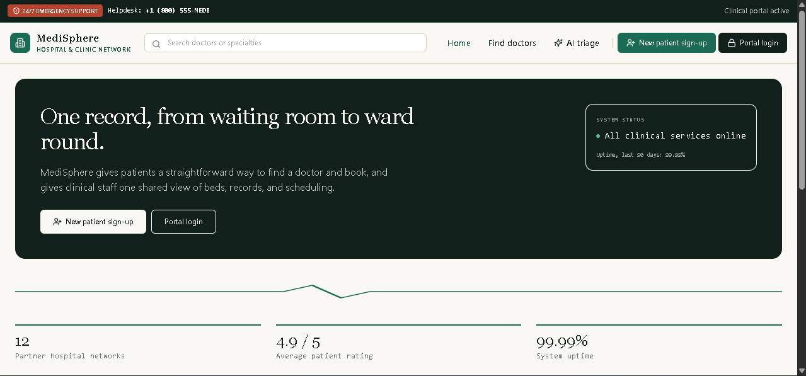
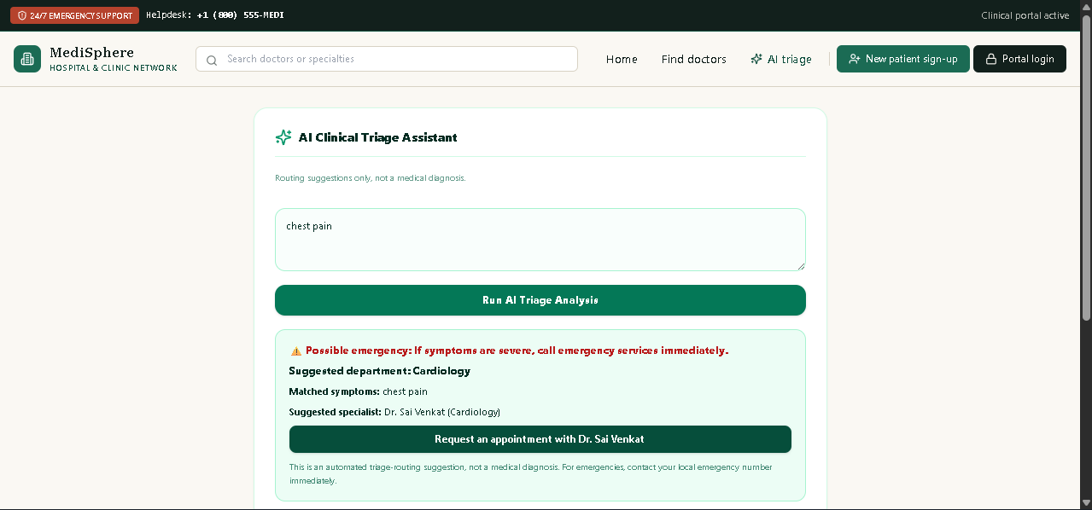
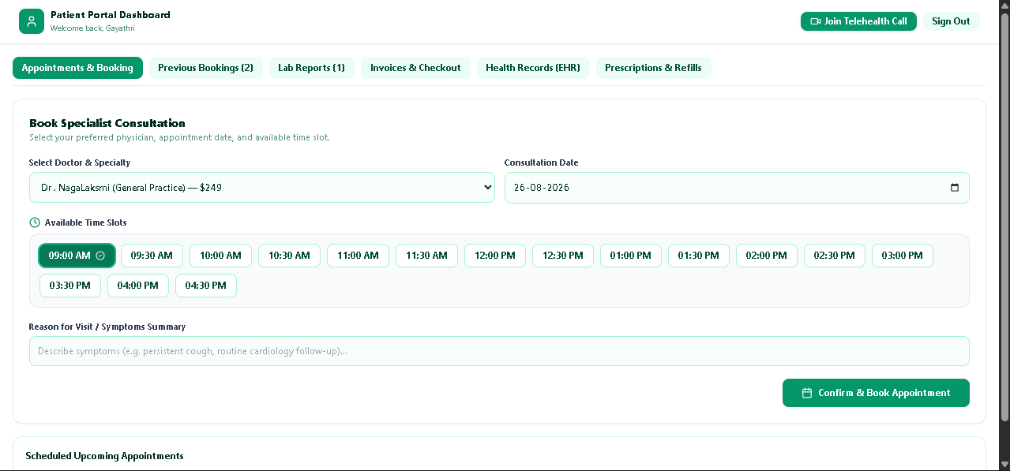
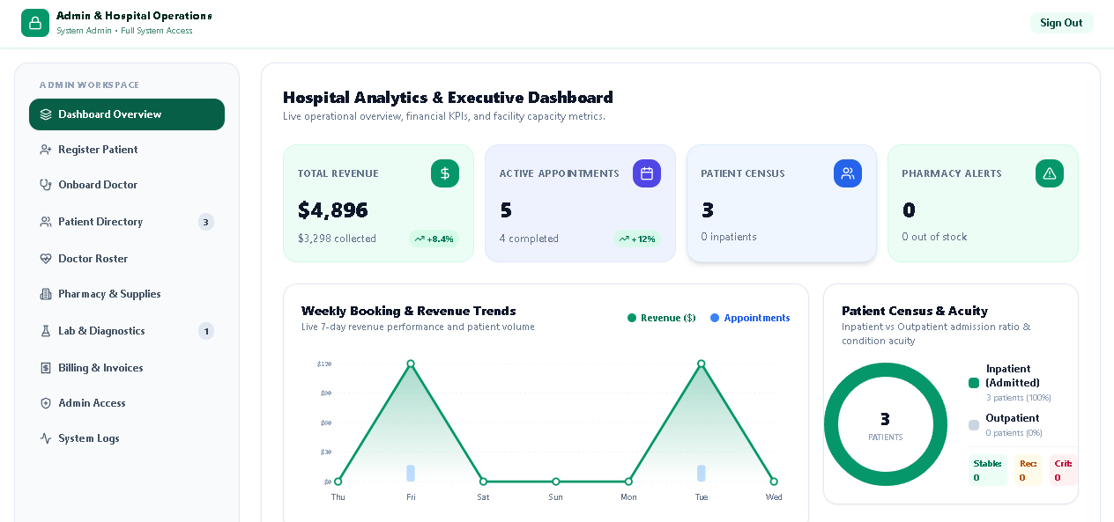
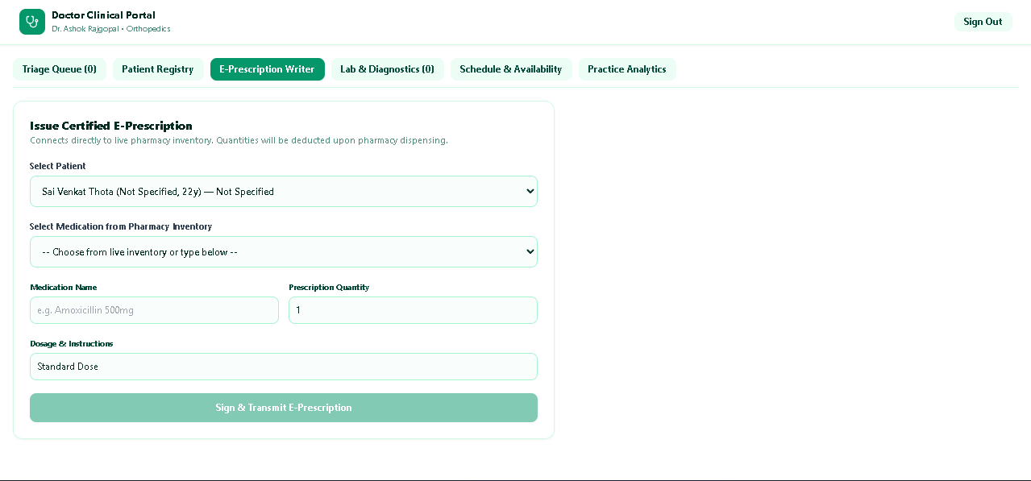

7. Challenges Faced
• Managing State Across Decoupled Architecture:
- Challenge: Synchronizing UI state updates dynamically when doctors update appointment statuses or room assignments.
- Resolution: Implemented centralized state management contexts in React to handle asynchronous API response updates gracefully.
• AI Model API Integration:
- Challenge: Structuring real-time responses from the AI integration without blocking primary application workflows.
- Resolution: Applied async REST handling to parse model responses smoothly without UI degradation.
• Complex Data Formatting for Digital Receipts:
- Challenge: Formatting dynamic patient billing data into structured, downloadable receipts across diverse patient interactions.
- Resolution: Developed specialized billing helper utilities to format transactional attributes consistently.

8. Learnings & Skills Acquired
- Technical Technologies: Full-stack development utilizing Java and Core Spring Framework for back-end APIs, alongside modern React, JavaScript, HTML5, and CSS3 for interactive interfaces.
- Database & Architecture Management: Relational database design in MySQL, RESTful web service architecture, and Git version control workflows.
- Domain Knowledge: Operational healthcare IT processes including IPD/OPD patient workflows, digital billing, appointment triage, and clinical scheduling rules.
- Professional Skills: Project execution planning, system testing, software documentation, and analytical problem-solving.

9. Testimonials from team
Working on Medisphere during the Infosys Springboard Virtual Internship provided hands-on experience in building a real-world enterprise application. Translating clinical workflows into code and integrating intelligent features like AI triage was an incredible technical journey that strengthened my confidence in full-stack Java development.

10. Conclusion
The Infosys Springboard Virtual Internship 7.0 provided an exceptional platform to build Medisphere, a robust full-stack healthcare management application. By seamlessly bridging core backend Java architecture with modern React interfaces, the project addresses key bottlenecks in hospital management such as patient scheduling and administrative log monitoring. This experience significantly bolstered full-stack software development competencies and directly aligned with career goals in backend engineering and complex system integration.

11. Acknowledgements
I express my sincere gratitude to Infosys Springboard for offering this virtual internship opportunity. Special thanks to our project mentors and advisors for their guidance, domain insights, and continuous feedback throughout the 8-week journey. I also appreciate the collaborative efforts of fellow interns and team members who supported the successful completion of this project.

