Heapsort code input
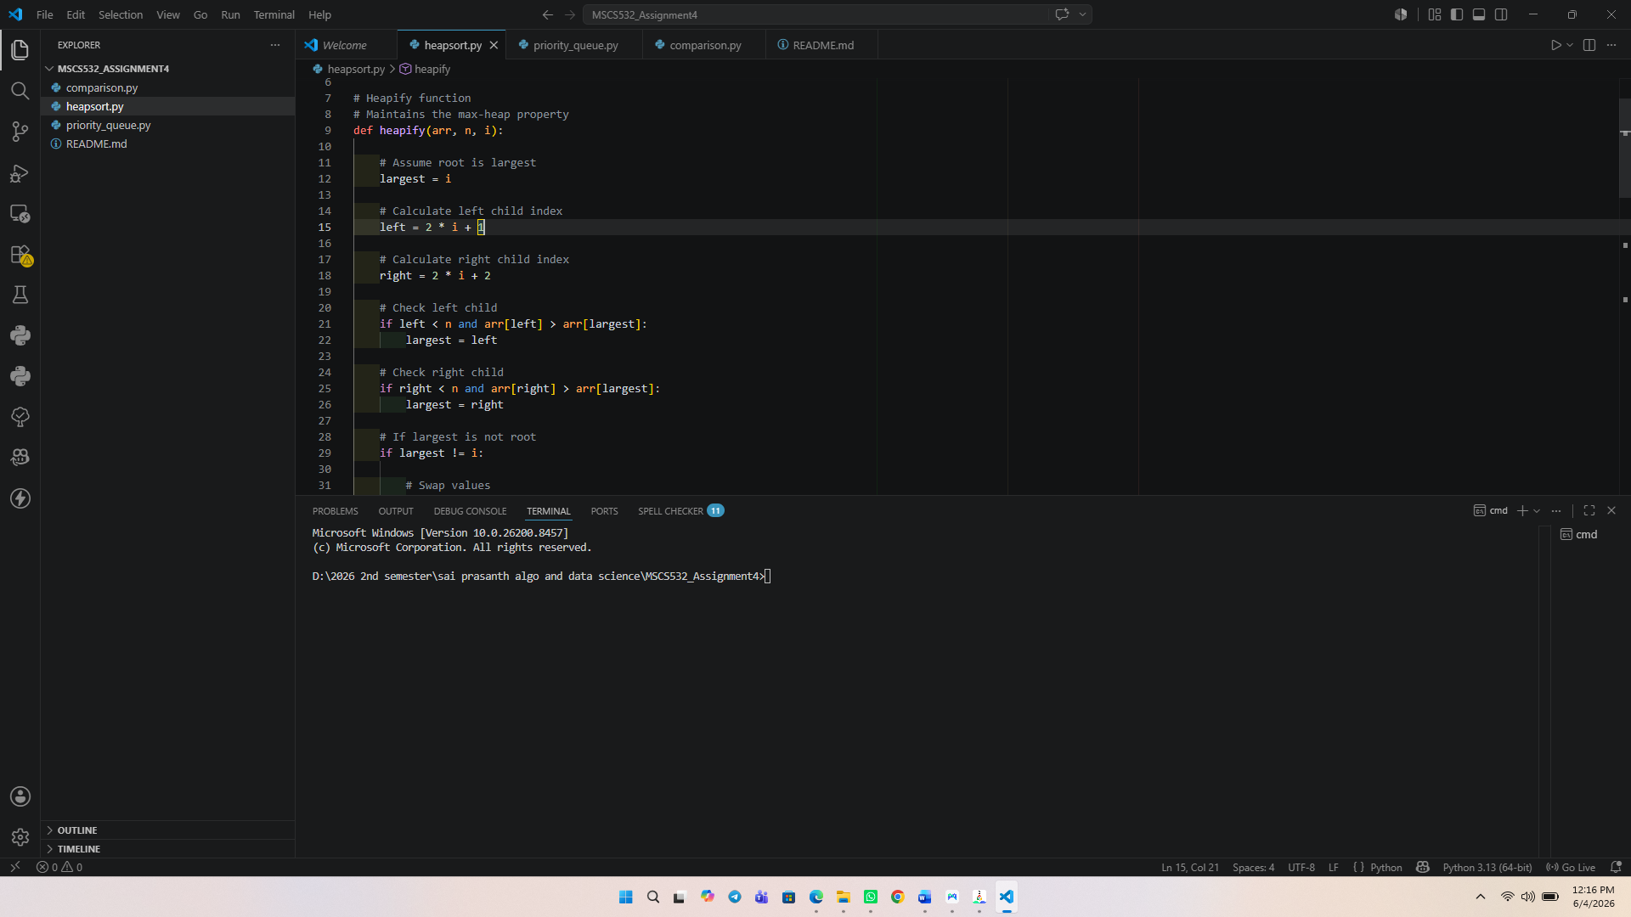
Heapsort code output
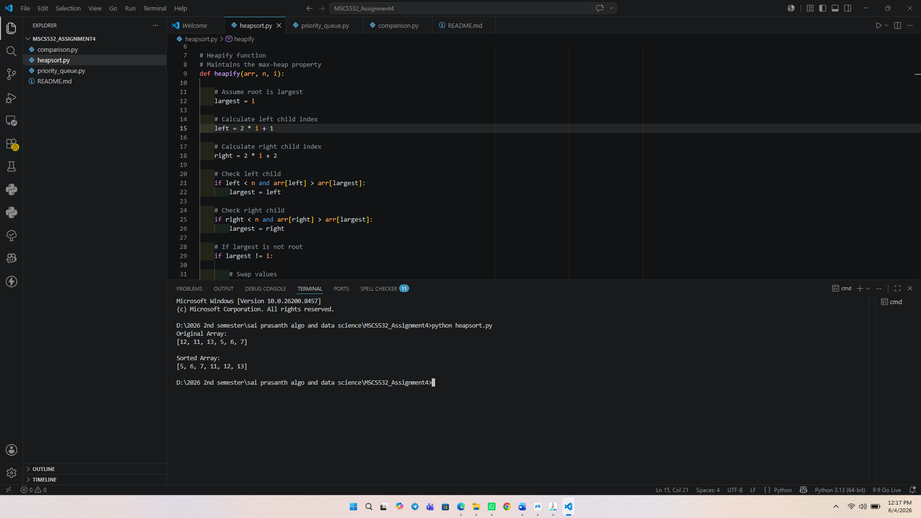

Priority_queue code input
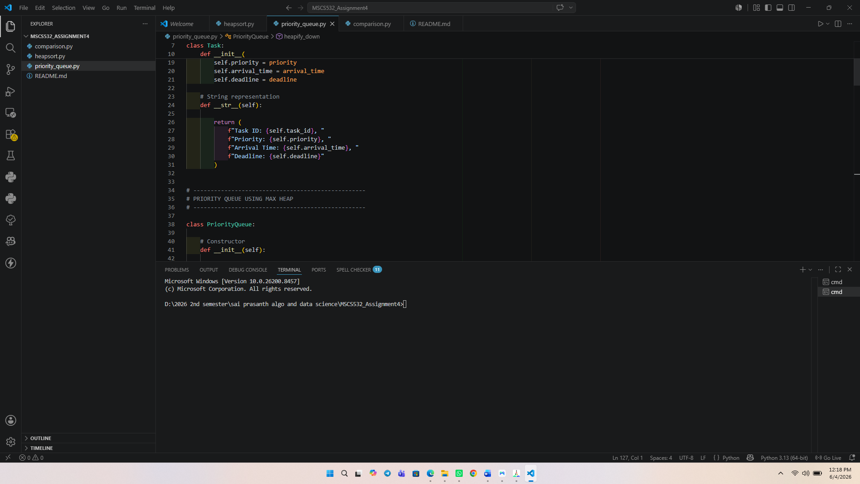
Priority_queue code output
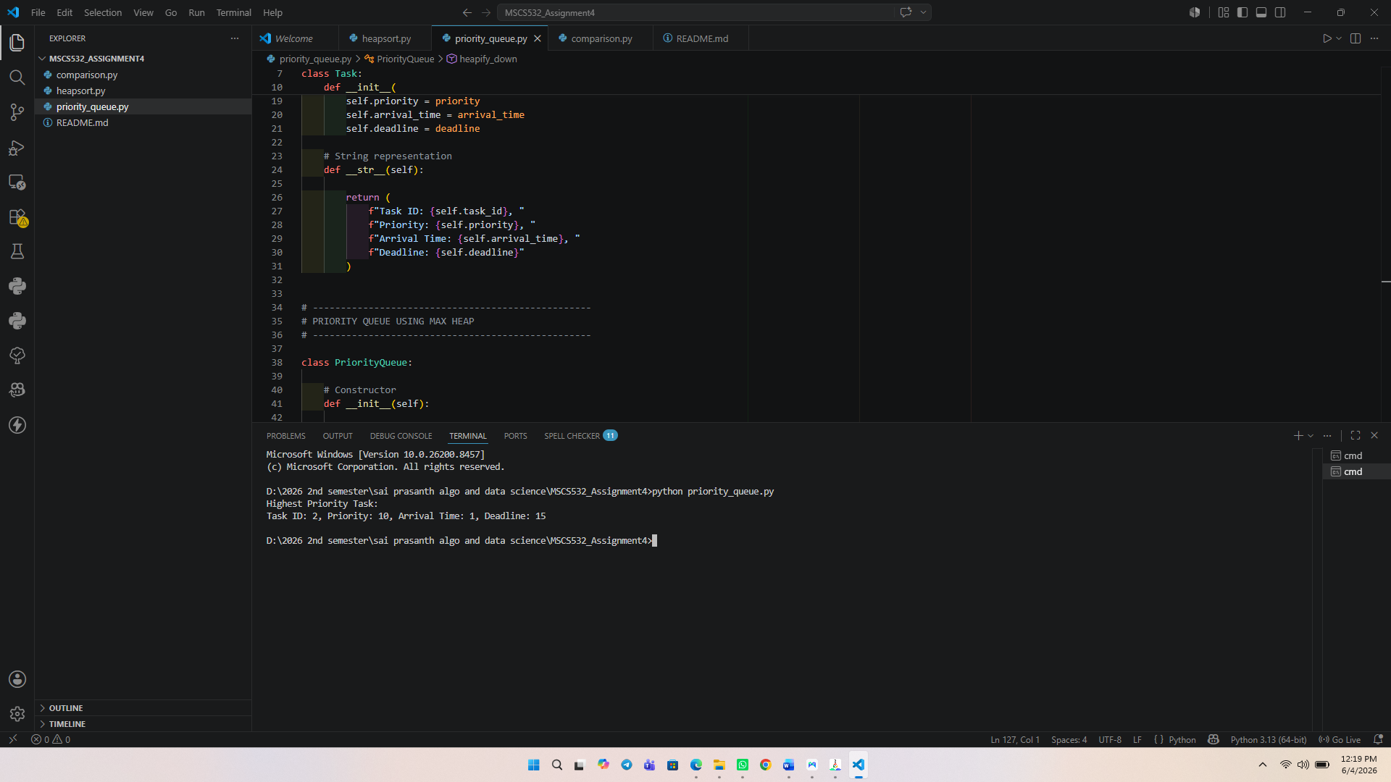

Comparison code input
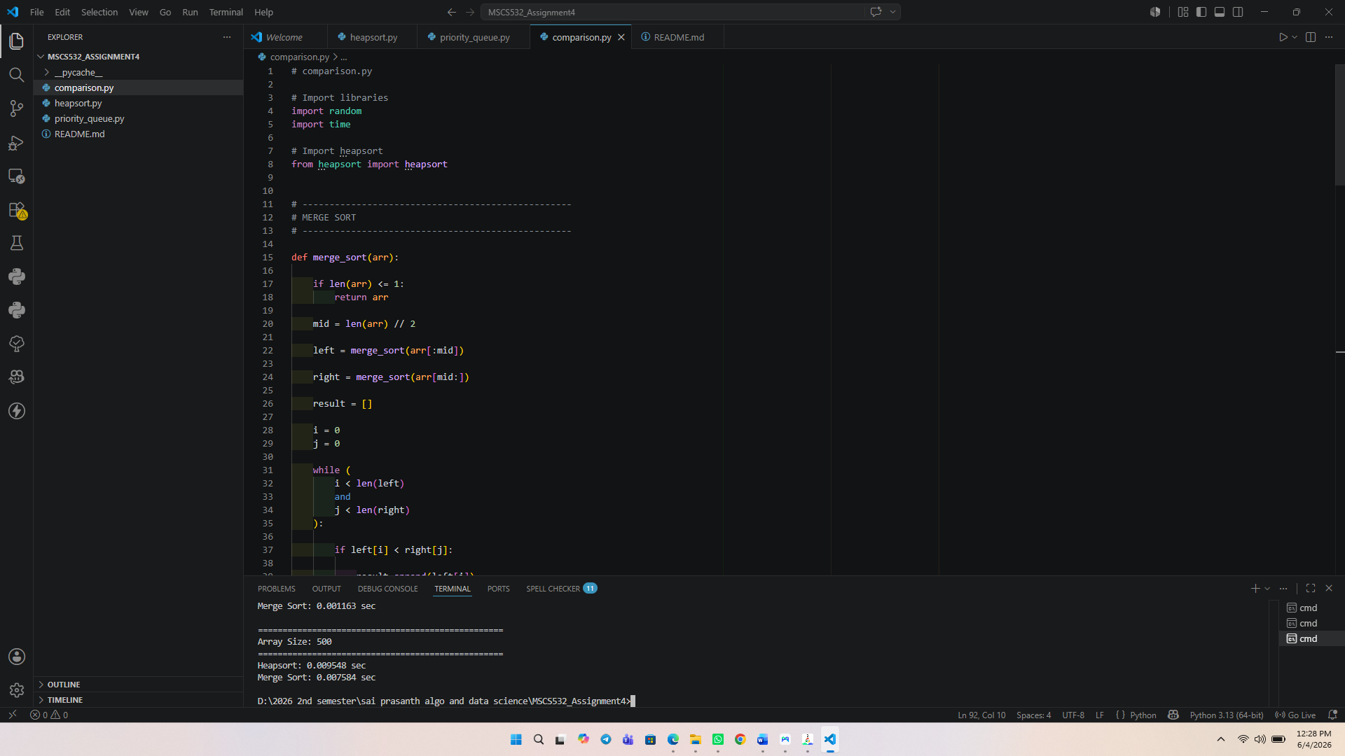
Comparison code output
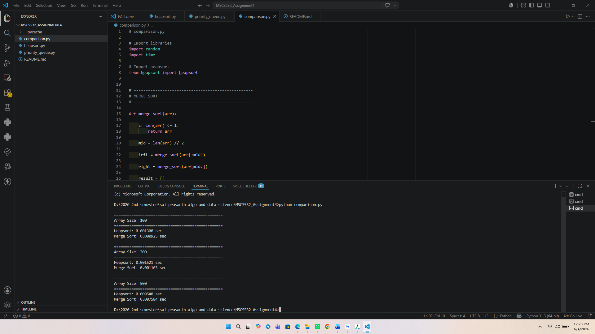

The experimental results and comparison
Empirical tests were carried out to assess the performance of Heapsort by generating random arrays of size 100, 300, and 500. The execution times of Heapsort were compared with Merge Sort. The results are presented below.
Time taken by Heapsort for an array size of 100 is 0.001308 seconds and time taken by Merge Sort in an array size of 100 is 0.000925 seconds. The Heapsort took 0.001521 seconds and Merge Sort took 0.001163 seconds for an array size of 300. Finally, the array size was 500 and Heapsort took 0.009548 seconds whereas Merge Sort took 0.007584 seconds.
Based on the results of the experiments, Merge sort was a little faster than Heapsort for all sizes of input. This is normal as Merge Sort is highly efficient in partitioning and merging. Heapsort is guaranteed to have the complexity of O (n log n) in all cases, however there are extra overheads because of the repeated heap construction, and heap maintenance operations during the sorting process.
The runtimes of both algorithms increased as the number of inputs increased from 100 to 500 elements. This is in line with the theoretical time complexity of O (n log n) for both sorting algorithms. The execution time for both algorithms increased moderately, which shows that both are efficient in their growth with the increase of data size.
Heapsort is resistant to the worst-case scenario of Quicksort, which is O(n²) time. Heapsort doesn't have the same worst-case scenario as Quicksort, which is O(n²) time, it is always O (n log n). This property is very useful in situations where the performance can be guaranteed. In these experiments, Merge Sort got slightly faster execution time, but Heapsort has the advantage of only using O (1) space when implemented in-place.
To implement and test a priority queue.
A binary max-heap is implemented as a Python list and used to make a priority queue. The choice of the array-based representation was made due to the implementation of heap operations is efficient, straightforward and low in memory overhead. This parent-child relationship in the heap can be readily computed by array indices without the need for explicit pointers.
A Task class was created to represent individual tasks. Every task carries a task identifier, priority value, arrival time and deadline. The priority queue will process the tasks based on the priority values; wherein higher priority tasks will be processed before lower priority tasks.
The implemented priority queue allows to add tasks, remove the highest priority task, raise the priority of a task, and determine if the queue is empty. In the test, three tasks were added to the queue with priority 5, priority 10, and priority 7. The task with the highest priority 10 was returned first when the extract () operation was used. This is to be expected, and shows that the heap property was upheld during insertions and removals.
The complexity of the insert operation is O (log n) since the newly inserted task can end up moving up the heap to maintain the heap property. Also, the extract () operation takes O (log n) because the last element is moved to the root and adjusted down the heap. The increase key () operation takes O (log n) time because if a task's priority has been increased, the heap must be adjusted upwards. The is empty () operation runs in O (1) time since it simply tests whether the heap is empty.
The implementation of a priority queue is shown to illustrate how heaps can be used efficiently in scheduling and prioritizing tasks. They are common in operating systems, job scheduling systems, event simulations, network routing algorithms and other systems that need to manage prioritized data efficiently.

