MARWADI UNIVERSITY
Faculty of Computer Applications
Bachelor of Computer Applications (BCA)

A PROJECT REPORT ON
ONLINE QUIZ PORTAL
(QuizMaster: A Java Swing and MySQL Based Quiz Application)
Subject: Java Programming
Class: BCA 3C
Academic Year: 2026-27
Submitted By | Roll No.
V. Sai Pratap Reddy | 92500527150
M. Nikhil Kumar | 92500527152

Under the Guidance of
Prof. Tirth Bhadeshiya
CERTIFICATE
This is to certify that the project report entitled "Online Quiz Portal" is a bonafide work carried out by V. Sai Pratap Reddy (Roll No. 92500527150) and M. Nikhil Kumar (Roll No. 92500527152), students of BCA 3C, Marwadi University, in partial fulfilment of the requirements of the Java Programming subject during the academic year 2026-27.
The work embodied in this report was carried out under my guidance and supervision. To the best of my knowledge, the project is original and has not been submitted elsewhere for any other purpose.

Date: ____________________
Project Guide: Prof. Tirth Bhadeshiya
Signature: ____________________
ACKNOWLEDGEMENT
We would like to express our sincere gratitude to our project guide, Prof. Tirth Bhadeshiya, for his valuable guidance, constant encouragement and support throughout the development of this project. His suggestions helped us to understand the concepts of Java programming and apply them in a practical application.
We are also thankful to Marwadi University and the Department of Computer Applications for providing us the opportunity and the resources needed to complete this project.
Finally, we thank our friends and family for their motivation and support during the project work.

V. Sai Pratap Reddy (92500527150)
M. Nikhil Kumar (92500527152)

Abstract
The Online Quiz Portal, named QuizMaster, is a desktop application developed using Java Swing for the user interface and MySQL as the database, connected through JDBC. The purpose of the project is to let students test their knowledge of Java through a timed multiple choice quiz and to track their performance over time.
The application allows a user to register and log in, view a dashboard, and attempt a quiz of 25 questions within 15 minutes. During the quiz, a countdown timer, a progress bar and a question palette help the user manage time and navigate between questions. After submission, the user sees a result screen with score, percentage, rank badge and a Java fact. Users scoring 70 percent or more are greeted with a confetti celebration.
The portal also maintains a score history for every user, with an option to delete a selected attempt, and a leaderboard showing the top ten users by best score percentage. The system uses a modern dark theme across all screens for a consistent look and feel.

1. Introduction

1.1 About the Project
Quizzes are one of the most common ways to practise and evaluate knowledge. Traditional paper based tests need manual checking and take time to produce results. An online quiz system removes this effort by evaluating answers instantly and storing the results for future reference.
QuizMaster is a Java based online quiz portal in which registered users can attempt a Java quiz, get their result immediately, and compare their performance with other users. All data such as users, questions and results is stored in a MySQL database.

1.2 Problem Statement
Manual quizzes are slow to conduct and check, it is hard to maintain records of previous attempts, and students get no instant feedback. There is a need for a simple application that conducts a quiz, calculates the result automatically, and keeps the history of every attempt.

1.3 Scope
- Registration and login for students.
- Timed quiz with randomly shuffled questions.
- Automatic evaluation and instant result.
- Score history and leaderboard for performance tracking.

2. Objectives
- To develop a user friendly desktop application for conducting online quizzes.
- To provide secure registration and login using database stored accounts.
- To evaluate answers automatically and display the result instantly.
- To store every attempt in the database and show it as score history.
- To motivate users with a leaderboard, rank badges and a celebration for high scores.
- To apply Java Swing, JDBC and MySQL concepts in a real project.

3. Technologies and Requirements

3.1 Technologies Used
Component | Details
Programming Language | Java
User Interface | Java Swing and AWT
Database | MySQL 8
Connectivity | JDBC (MySQL Connector/J)
Code Editor / IDE | Any Java IDE (for example IntelliJ IDEA, Eclipse or NetBeans)
Version Control | Git and GitHub

3.2 Software Requirements
- Operating System: Windows, macOS or Linux.
- Java Development Kit (JDK) installed.
- MySQL Server installed and running.
- MySQL Connector/J jar added to the project.

3.3 Hardware Requirements
- Processor: dual core or higher.
- RAM: 4 GB or more.
- Free disk space: 500 MB or more.

4. System Design

4.1 Modules of the System
- Login and Registration (LoginFrame, RegisterFrame): creates new accounts and verifies existing users from the users table.
- Dashboard (DashboardFrame): shows the welcome message, the number of available questions, and buttons for Start Quiz, Score History and Leaderboard.
- Quiz (QuizFrame): loads questions from the database, shuffles them, runs the timer and evaluates the answers.
- Result (ResultFrame): saves the score, shows percentage, rank badge, correct and wrong summary, a Java fact and the confetti celebration.
- Score History (ScoreHistoryFrame): lists all attempts of the user and allows deleting a selected attempt.
- Leaderboard (LeaderboardFrame): shows the top 10 users by best score percentage and highlights the current user.
- Database Connection (DBConnection): provides the JDBC connection used by all modules.

4.2 Working Flow
The user opens the application and reaches the Login screen. A new user creates an account from the Register screen. After a successful login the Dashboard opens. From the Dashboard the user can start the quiz, view score history or open the leaderboard. When the quiz is submitted (manually or when time ends), the score is saved to the database and the Result screen is shown. From the Result screen the user can try again or go back to the Dashboard.

4.3 Database Design
The database is named online_quiz_db and contains three tables.
Table: users
Column | Type | Description
id | INT (PK, auto increment) | Unique user id
name | VARCHAR(100) | Full name of the user
email | VARCHAR(100), unique | Email used for login
password | VARCHAR(100) | Login password

Table: questions
Column | Type | Description
id | INT (PK, auto increment) | Unique question id
question | VARCHAR(500) | Question text
option_a to option_d | VARCHAR(200) | The four answer options
correct_answer | CHAR(1) | Correct option (A, B, C or D)

Table: quiz_results
Column | Type | Description
id | INT (PK, auto increment) | Unique attempt id
user_id | INT (FK) | Refers to users.id
score | INT | Number of correct answers
total_questions | INT | Total questions in the quiz
quiz_date | TIMESTAMP | Date and time of the attempt (default current time)

5. Features
- User registration and login with email and password.
- Dashboard with the user name and the live question count from the database.
- Quiz of 25 questions with a 15 minute countdown timer that turns red in the last minute.
- Progress bar showing the current question number.
- Question palette that shows skipped, attempted and current questions and allows jumping to any question.
- Back, Next, Clear and Finish options, with a warning if some questions are not attempted.
- Questions are shuffled in every attempt, and the quiz is auto submitted when time is over.
- Highlighted selection of the chosen option.
- Result screen with score, percentage, rank badge (Java Legend, Master, Pro, Learner or Beginner) and correct and wrong summary.
- Confetti celebration for a score of 70 percent or more.
- Random Java fact displayed on the result screen.
- Score history with a Delete Selected option to remove an attempt.
- Leaderboard with the top 10 users and medals for the top three.
- Consistent modern dark navy and purple theme on all screens.

6. Screenshots
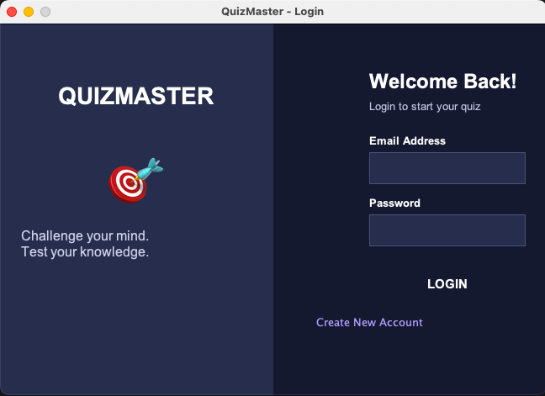
Figure 6.1: Login Screen
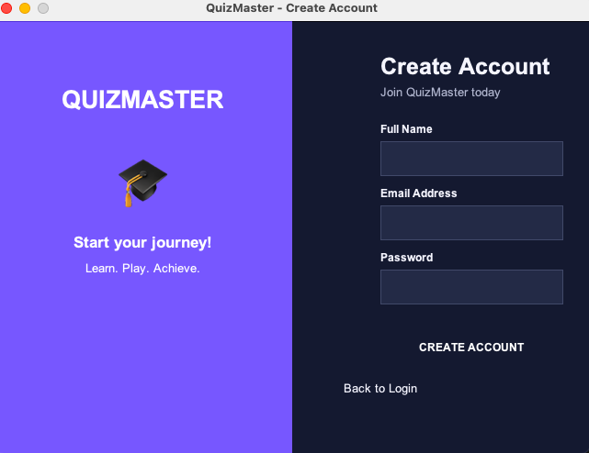
Figure 6.2: Create Account Screen
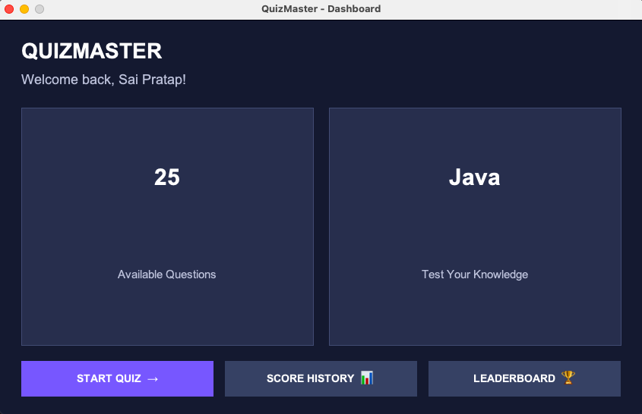
Figure 6.3: Dashboard
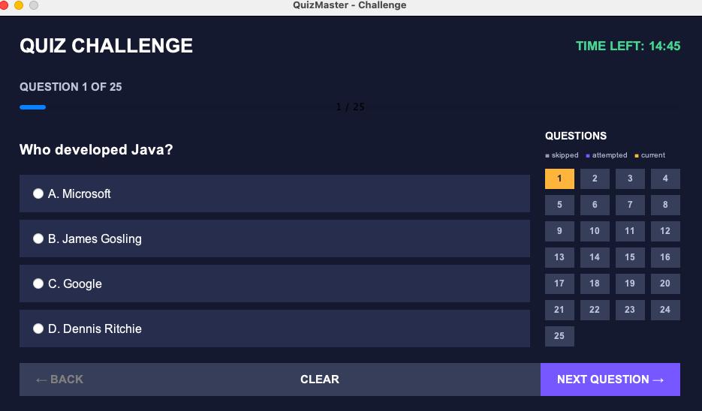
Figure 6.4: Quiz Screen with Timer, Progress Bar and Question Palette
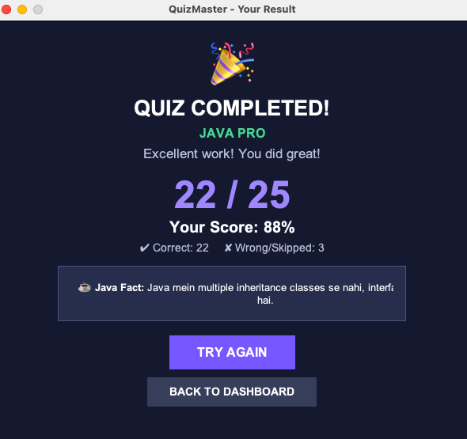
Figure 6.5: Result Screen
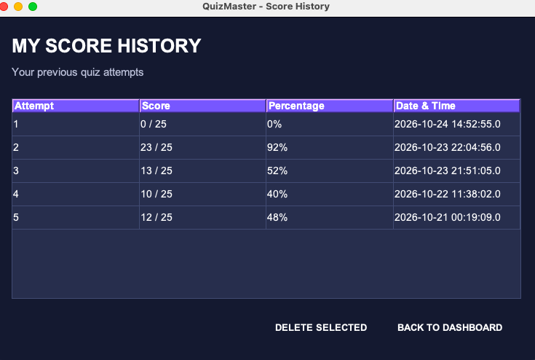
Figure 6.6: Score History with Delete Option
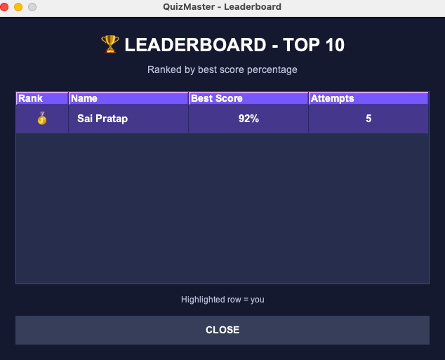
Figure 6.7: Leaderboard

7. Future Scope
- Admin panel to add, edit and delete questions from the application.
- Multiple quiz categories such as Java, DBMS and C, with difficulty levels.
- Answer review screen that shows correct and wrong answers after the quiz.
- Password encryption (hashing) for better security.
- Web or mobile version of the portal.
- Time limit and number of questions that can be set by the admin.

8. Conclusion
The Online Quiz Portal successfully meets the objective of providing an easy way to conduct quizzes and track performance. The application evaluates answers automatically, stores every attempt in the database, and motivates users with a leaderboard, rank badges and a celebration for high scores.
While developing this project we gained practical experience in Java Swing, event handling, JDBC database connectivity, SQL queries and user interface design. The project can be extended further with an admin panel, more categories and stronger security.

Bibliography
- Oracle Java Documentation: https://docs.oracle.com/javase
- MySQL Reference Manual: https://dev.mysql.com/doc
- Java Swing Tutorial: https://docs.oracle.com/javase/tutorial/uiswing

