ARCHITECTURE DOCUMENTATION
DIAGRAM:
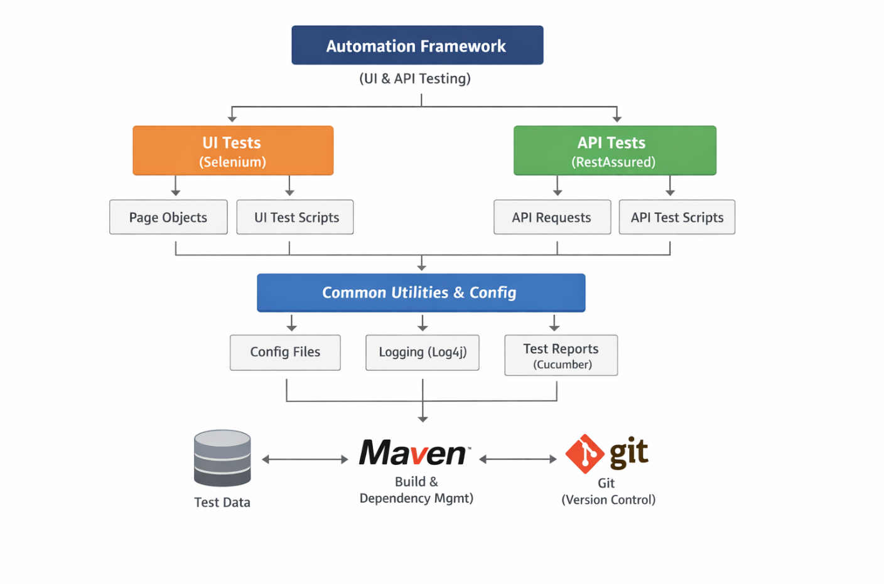
1. UI Tests (Selenium)
This layer handles frontend testing (what user sees)
Components:
- Page Objects
  - Implements Page Object Model (POM)
  - Contains locators (id, xpath) and methods (click, sendKeys)
  - Example: LoginPage.java
- UI Test Scripts
  - Actual test cases written using TestNG.
  - Calls Page Object methods.
  - Example: login test, form submission test.

2. API Tests (RestAssured)
This layer handles backend validation
Components:
- API Requests
  - Builds HTTP requests (GET, POST, PUT, DELETE)
  - Uses reusable request builder methods
  - Example: createUser(), updateUser()
- API Test Scripts
  - Contains test cases validating API responses
  - Validates:
    - Status codes
    - Response body
    - Headers
3. Common Utilities & Config
Core shared layer used by both UI & API
Components:
- Config Files
  - Stores environment data (URLs, credentials)
  - Avoids hardcoding
  - Example: config.properties
- Logging (Log4j)
  - Captures execution logs
  - Helps in debugging failures
- Test Reports (Cucumber)
- Generates readable HTML reports
- Shows pass/fail status with steps
4. Test Data
Stores input data for testing
- Can be:
  - JSON files
  - Excel
  - Hardcoded maps (initial stage)
Purpose:
- Data-driven testing
- Reusability
5. Maven (Build Tool)
Manages project lifecycle
- Handles:
  - Dependencies (Selenium, RestAssured)
  - Build process
  - Test execution
6. Git (Version Control)
Tracks code changes
- Features:
  - Version history
  - Collaboration
  - Branching

