**To-Do List App**

**Overview**

This Android application is a simple To-Do list app that allows users to add tasks, set due dates, choose priorities, and track the status of their tasks.

**Features**

- Add tasks with names and descriptions.

- Set due dates for tasks.

- Choose task priorities (Low, Medium, High).

- Track task status (New, In Progress, Completed).

- View and manage tasks in a list format.

**Screenshots**

View of the task list with due dates, priorities, and statuses.

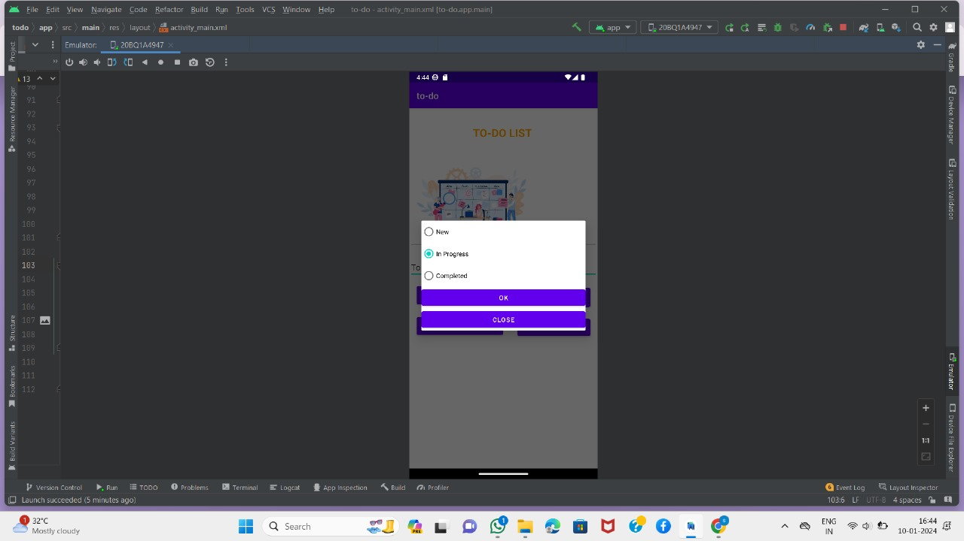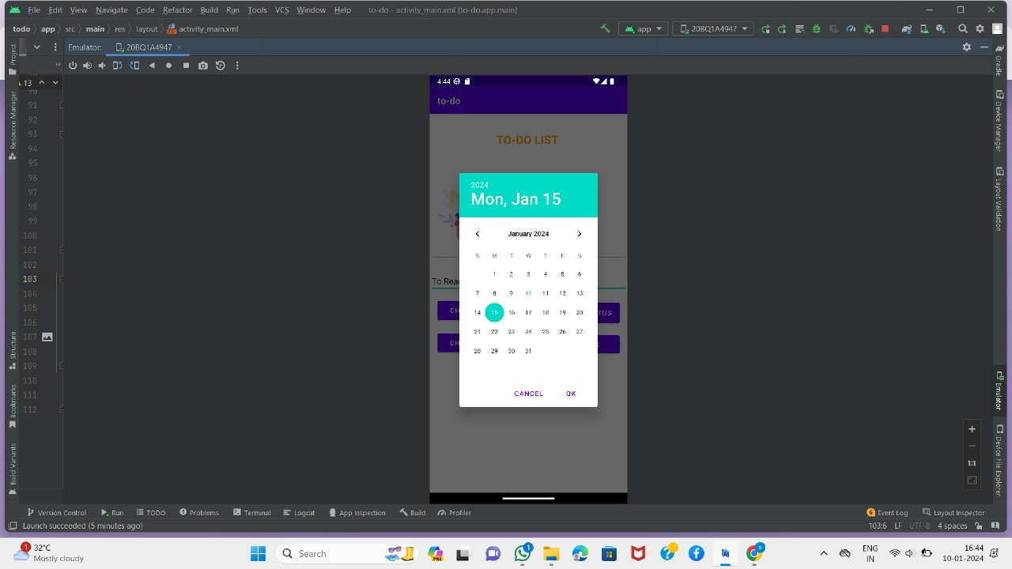

Adding a new task with due date, priority, and status selection.

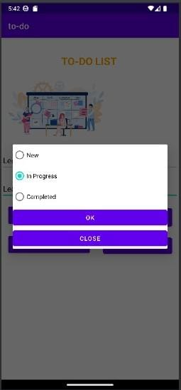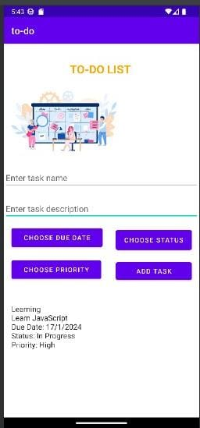

**Usage**

1. Add Task: Enter a task name and description, choose a due date, priority, and status. Click the "Add Task" button.

2. Choose Due Date: Click the "Choose Due Date" button to set the due date using the date picker.

3. Choose Priority: Click the "Choose Priority" button to set the priority using a radio button selection dialog.

4. Choose Status: Click the "Choose Status" button to set the task status using a radio button selection dialog.

**Dependencies**

- [AndroidX ConstraintLayout](https://developer.android.com/jetpack/androidx/releases/constraintlayout)

- [AppCompat](https://developer.android.com/jetpack/androidx/releases/appcompat)

**Development Environment**

- IDE: Android Studio

- Programming Language: Java,Xml

- Database: SQLite (not implemented yet)

**How to Run**

1. Clone the repository: `git clone https://github.com/your-username/todo-list-app.git`

2. Open the project in Android Studio.

3. Run the app on an Android emulator or a physical device.

**License**

This project is licensed under the [MIT License](LICENSE).