PROJECT TITLE
PHARMAFLOW - A SMART MEDICAL CARE SYSTEM
A course project report submitted in partial fulfillment of the requirement
of
DEVOPS AND FULLSTACK
by

G.SAI (2303A52255)
A.VAMSHI KRISHNA (2303A52249)

Under the guidance of
Dr. N.VENKATESH
Asst. Professor, Department of CS & AI


SR University, Warangal
APRIL-2026
ABSTRACT
PharmaFlow is a Smart Medical Care System that aims at simplifying the management of medical store operations in the form of a digital platform. The system offers an efficient solution when handling the inventory of medicines, attendance of the staff, the billing and the tracking of medicines in a pharmacy environment. Traditional medical store management is frequently based on handyman records, which can result in errors, inefficiency and difficulty in tracking the availability of medicines. The PharmaFlow system brings in an interactive Staff Dashboard that enables the users to control the medicines and keep track of the stock levels and critical data of operation in real-time. The feature of the Medicine Locator enables the staff to quickly find the place and availability of medicines in the inventory that helps the customers for faster service. The Attendance module is used to record staff attendance and keep records of employees. Billing module helps in creating and managing customer bills efficiently. The system also gives statistical information such as total medicines available and total stock units to control and take better decisions about inventory. By consolidation of these functionalities in a centralized platform called PharmaFlow, one can reduce the amount of work, improve accuracy, and enhance overall pharmacy management. The system is implemented by the use of modern web technologies with a backend server and database for storage and management of the information regarding medicine and staff. This digital solution is used by pharmacies to be able to provide better and faster service as well as have an organized medical record.

CONTENTS

ABSTRACT ii

Chapter No. Title Page No.

1 INTRODUCTION
1.1 About the project 01
1.2 Objectives 02

2 LITERATURE REVIEW
2.1 Overview 03
2.2 Related Studies and Existing Solutions 05
2.3 Tools and Technologies Used 07

3. METHODOLOGY
3.1 Data Collection and Description 08
3.2 Data Preprocessing and Cleaning 10
3.3 Analytical and Visualization Techniques 12

4 RESULTS AND DISCUSSION
4.1 Data Analysis and Key Findings 14
4.2 Visualization and Interpretation of Results 16
4.3 Insights and Discussion 18

5 CONCLUSION AND FUTURE WORK
5.1 Summary of Findings 19
5.2 Conclusions Drawn 20
5.3 Recommendations and Future Scope 20

CHAPTER 1: INTRODUCTION
  - About the Project:
PharmaFlow is a Smart Medical Care System built in order to enhance the efficiency and management of pharmacy operations using the digital platform. In traditional medical stores, many processes such as inventory, billing, attendance of store staff are done manually. These manual methods are often error prone, delaying the clock, and having a hard tracking of medicines availability.
The PharmaFlow system is a centralized web-based solution which assists pharmacy staff with their day-to-day business efficiently. The system features such as medicine inventory management, medicine locator, staff attendance tracking, and billing management are some facilities. Through the Staff Dashboard, it is possible to see real-time stock levels of medicines, to manage medicines and to see operational data.
One of the main pictures in the system is the Medicine Locator, which allows staff to quickly determine the location and availability of medicines within the store inventory. This cuts down the time needed for the search of the medicines and improves customer services. The billing module helps in generating and maintaining the bills of customers, and the attendance module is used for recording staff attendance and handling the data of the employees.
The system also gives statistical kind of information like the number of medicines and stock units available in all together. This helps in pharmacy owners to maintain proper inventory management and make informed decisions about the procurement and control of medicines.
PharmaFlow is developed in modern web technologies with backend server and database to store and manage medicine and staff information. The system's purpose is to ease the manual workload, improve accuracy and also enhance the overall efficiency of the pharmacy operations.

  - 1.2 Objectives:
The general goals of PharmaFlow system are: Objective:
- To create a website for the smooth functioning of pharmacy operations. In financing operations this means: "to keep correct records of medicine stock and of medicines used" (Oakes, 1969, 81). The objectives of the elective were:
- To facilitate and provide a medicine locator system for medicines to be identified quickly. Point Out:
- To automate the process of tracking staff attendance and managing the employees records.
- To ease the procedure of bill payable and keep transaction records of customers. Role of management information systems
- Marketing information systems: Product management
- To attain statistical insights for improved decision-making and inventory management.
Finally, I find this a little relevant at the conclusion, as I think these two points are relevance to the study.

CHAPTER 2: LITERATURE REVIEW
DevOps and Full-Stack Application Development
2.1 Overview :
Medical store management systems have gained significance in the contemporary healthcare environments. Pharmacies handle volumes of medicines, updating of inventory, payment transactions or even staff management. Manual method of record-keeping is inefficient and subject to human error.
With the development of information technology, digital pharmacy management systems that automate these tasks have also been created. These systems help pharmacies to maintain accurate inventory records and reduce shortages of medicines and improve operational efficiency.
Web-based pharmacy systems enable the on-demand access to medicine information, inventory management and billing services. They also help pharmacy staff to find medicines quickly, track the sales data and generate reports for analysis.
The PharmaFlow system is part of this digital transformation by offering an integrated solution to the management of pharmacy operations through a centralized web-based application.
2.2 Studies and Solutions:
Related to the Problem Several pharmacy management systems and research studies have been prepared to overcome the challenges related to the management of pharmacy operations.
Traditional pharmacy management software is based primarily on the billing and inventory systems. But a lot of systems do not include the capabilities like real-time tracking of medicine location, integrated staff management etc.
Studies about healthcare information systems achieve a high importance on the digitization of pharmacy operations to improve accuracy, efficiency and patient service. Automated systems decrease human error when it comes to stock management and the overall workflow in pharmacies.
Existing pharmacy systems also come with functionality options such as the scanning of barcodes, prescriptions, and stock alerts. However, many small pharmacies are still running on manual systems because of the complexity or cost of existing solutions.
PharmaFlow wants to offer a simple and efficient web-based solution that allows inventory management, staff attendance, billing, and medicine location tracking to be integrated on one platform.

2.3 Tools and Technologies Used:
The development of PharmaFlow comes with several modern web technologies:
Frontend Technologies:
- HTML - This is used to structure web pages
- CSS - Used for designing and styling of interface
- JavaScript - Used to implement the functionalities of interactivity
Backend Technologies:
- Node.js / Backend server - The backend server deals with the server computer end operations
- Express.js - Framework to build Web Applications
Database:
- MongoDB / Database - Holds information about medicines, staff & bills
Deployment Platform:
- Render - Used to deploy and host the web application in the web

These technologies facilitate building a scalable, efficient and easy to use pharmacy management system.

CHAPTER 3: METHODOLOGY
3.1 Data Collection and Description:
The data used in the PharmaFlow system is the data of medicines, stock of inventory, attendance of staff, bills, etc.
Medicine data includes:
- Medicine name
- Medicine category
- Quantity available
- Location of medicine in the store
- Price details
Staff data includes:
- Staff name
- Employee ID
- Attendance records
- Work schedules
Billing data includes:
- Customer purchases
- Medicine quantities
- Total bill amount
- Date of transaction
This information is stored in the system database and is live updated via the dashboard interface.
3.2 Data Preprocessing and Cleaning:
Before storing data in the system, a number of preprocessing steps are followed to ensure the accuracy and consistency of data.
These steps include:
- Removing duplicate entries in medicine records
- Validating input fields such as the name and quantity of medicines
- Providing for the proper formatting of dates and numeric values
- Verifying of staff records before storing the attendance record
- Guide Principles for Data Storage Guide Principles for Data Storage
Data validation is the record-keeping method to ensure that the system contains accurate and reliable records in the pharmacy management system.
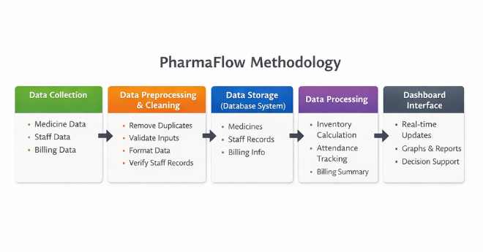
3.3 Analytical/ visualization Techniques
The PharmaFlow system applies basic analytical methods to give meaningful information about the pharmacy operations.
The dashboard shows the following statistical information:
Total number of medicines available In this case, the amount of goods held in inventory could be represented by:
- Total amount of goods (units) in inventory
- Staff attendance records
- Billing of transaction summaries
These visual representations help the staff in the pharmacy get a rapid picture of the current status of the inventory and the implementation of the operational activities. The dashboard interface gives a good overview of the key metrics which can be used to make better decisions.
CHAPTER 4: RESULTS AND DISCUSSION
Website Link: https://devops-project-and-depolyment.onrender.com
4.1 Analysis of the Data and Important Findings
After the implementation of the PharmaFlow system, a number of improvements were noticed on the pharmacy operations.
The system's functionality gives instant information about the medicine stock, so it becomes easier for staff to keep track of stock levels. The medicine locator feature helps staff to quickly determine the location of medicines and lowers the searches time.
The billing system makes the process of generating customer bills and keeping records of transactions simple. Accurate employee management is provided by keeping track of staff attendance.
Overall, the system helps to improve the efficiency and accuracy of the pharmacy management process.
4.2 Visualization/ Interpretation of Result
The system dashboard presents visual summaries of important operation data. These involve the total number of medicines that exist in inventory and the total numbers of stock units existing in the pharmacy.
These visual indicators for pharmacy staff make the inventory status easily understood and which medicines are needed to be restocked. The dashboard also allows easy maneuvering to different modules like medicine management, billing, attendance tracking and more.
This structured interface is good from a usability perspective and allows a user to perform tasks effectively.

Website Link: https://devops-project-and-depolyment.onrender.com
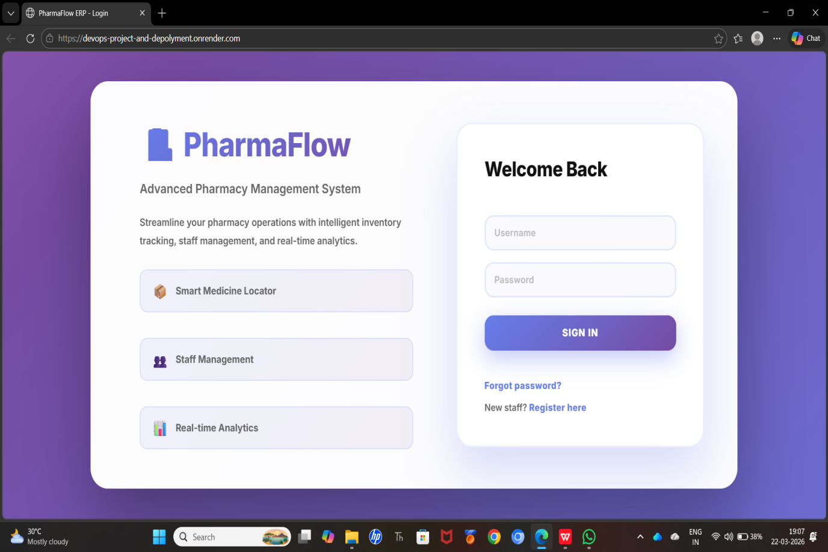

4.3 Insights and Discussion
The implementation of the PharmaFlow system is the proof of the benefit of digital solutions in managing pharmacy.
By combining several functionalities into one platform, the system helps in cutting down on manual work and making operations more efficient. Staff members can access information in a quick manner, lessening delays in serving customers.
The system also ensures accurate recording and provides useful information about inventory management and decision-making. All in all, PharmaFlow makes for more reliable and productive pharmacy operations.

CHAPTER 5: CONCLUSION AND FUTURE WORK
5.1 Summary of Findings
The PharmaFlow Smart Medical Care System offers an efficient solution to managing the operations of a pharmacy system in a digital manner. The system integrates medicine inventory management, staff attendance tracking, billing, and medicine location tracking into one.
By automating these processes, the system is used to reduce manual errors, increase efficiency and offer better control over the pharmacy operations.
5.2 Conclusions Drawn
The implementation of PharmaFlow proves that web-based pharmacy management systems can offer an opportune chance to enhancing the efficiency and accuracy of pharmacy operations to a great extent.
The system offers a user-friendly interface for the management of medicines, inventory tracking, and billing transactions. It also helps in faster services as it helps staff to find out medicines quickly.
Overall, PharmaFlow is a dependable digital solution for managing modern pharmacies.
5.3 Recommendations and Further Scope
In the future, the PharmaFlow system can be supplemented with more features such as:
- Scanning of barcode for the quicker identification of the medicines
- Auto tracking of expiry date, automatic alerts of expiry date in case of medicines
- Integration for online prescription systems zynosophy
- Advanced analytics and reporting dashboards
- Easier accessibility through: Mobile application support
- Auto alerts through stock control to warn you of low stock levels
These enhancements can further boost the functionality and usability of the system, which can make it more appropriate for pharmacy operations on a large scale.

REFERENCES
[1] Y. Qardawi and A. S. Hastuti, “Inventory Management Optimization and Its Impact on Service Quality in Pharmacy Chains,” Maroon Journal of Management, 2025.
[2] A. B. Ayalew, A. G. Alemu, and A. M. Worku, “ABC-VED with Multi-Criteria Analysis for Drug Inventory Management,” Scientific Reports, 2026.
[3] “Evaluation and Optimization of Pharmaceutical Inventory in Tertiary Hospitals,” PMC Healthcare Study, 2025.
[4] V. K. Jaiswal, “Building a Robust Pharmaceutical Inventory and Supply Chain Management System,” IJARET, 2025.

[5] “Multi-Product Multi-Period Inventory Planning Model for Pharmacies,” MDPI Journal, 2025.
[6] A. Sari, “Implementation of Pharmacy Management Information Systems in Hospitals,” Scientific Journal of Pharmacy & Clinical Research, 2025.
[7] “Enhancing Pharmacy Warehouse Management Using Faster R-CNN,” Wiley Online Library, 2025.
[8] “Analytical Framework for Improving Healthcare Data Management,” ScienceDirect, 2025.
[9] A. Desai, “Enhancing Inventory Management with Progressive Web Applications,” arXiv, 2025.
[10] Y. P. Lee, P. Wong, and T. C. Han, “Data-Driven Methods for Inventory Optimization,” arXiv, 2025.
[11] S. Maitra, “System-Dynamic Simulation and Bayesian Optimization for Inventory Management,” arXiv, 2025.
[12] “AI-Based Supply Chain Optimization in Pharmaceutical Systems,” IJARET Study, 2025.
[13] “Digital Transformation in Healthcare Data Systems,” ScienceDirect, 2025.
[14] “Pharmacy Inventory Control Using ABC and VED Analysis,” PMC Healthcare Study, 2025.

[15] “Multi-Criteria Decision Models in Healthcare Inventory Systems,” Scientific Reports, 2026.

