Project Report - Phase 2

Name: P Sai Lalith

Project Title: Student Registration Portal – Salesforce CRM Implementation for Universities

# Phase 2: Org Setup & Configuration

## 1. Salesforce Edition & Org Setup

A Salesforce Developer Edition org was created and configured to serve as the development and testing environment for the Student Registration Portal project. Lightning Experience was enabled for ease of use.

## 2. Company Profile Setup

The company profile was updated with the following information:  
- Company Name: University XYZ  
- Default Currency: INR  
- Default Time Zone: Asia/Kolkata  
- Fiscal Year: Standard (January–December)

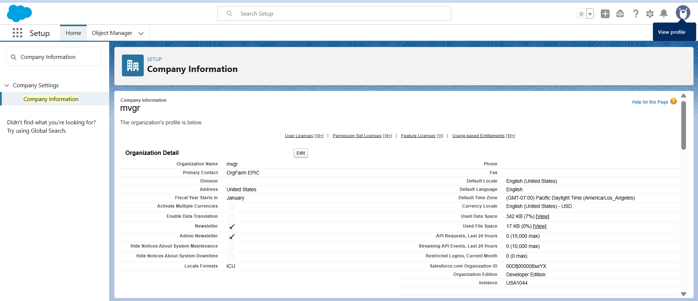

## 3. Business Hours & Holidays

Business hours were configured to represent academic working timings:  
- University Hours: Monday to Friday, 9 AM to 6 PM  
Additionally, academic holidays such as Independence Day, Republic Day, and semester breaks were added.

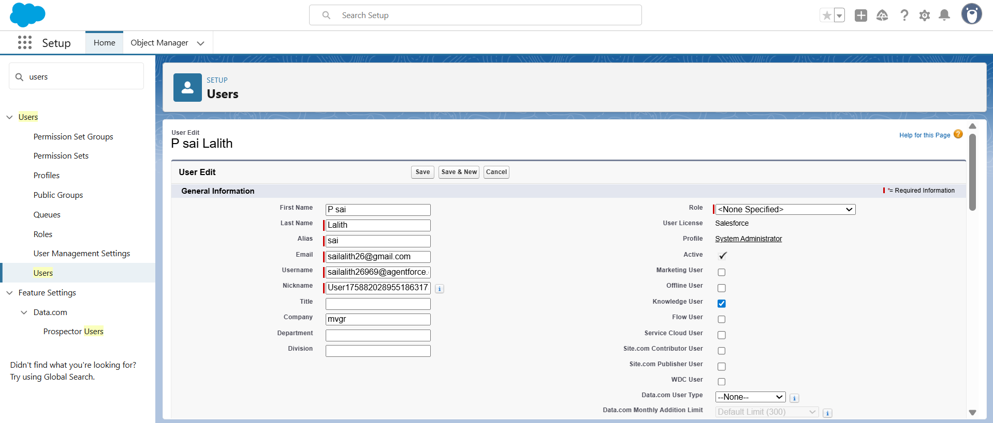

## 4. Users & Licenses

Test users were created to represent different roles in the university:  
- Admin (System Administrator)  
- Faculty (assigned to a custom Faculty Profile)  
- Student (assigned to a custom Student Profile)

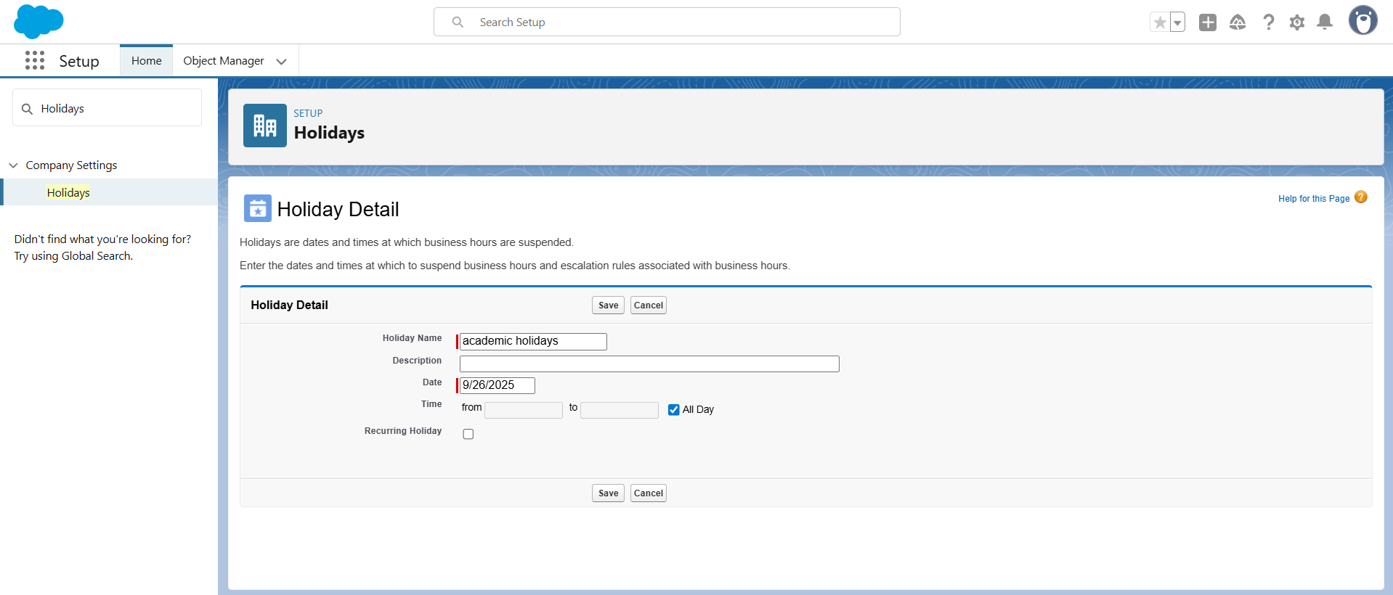

## 5. Profiles & Roles

Custom profiles and roles were created to enforce security and access controls:  
- Student Profile: Limited access to own records, no setup rights.  
- Faculty Profile: Access to Courses and Enrollment.  
- Role Hierarchy: University Admin > Faculty > Students.  
Users were assigned to appropriate roles based on their responsibilities.

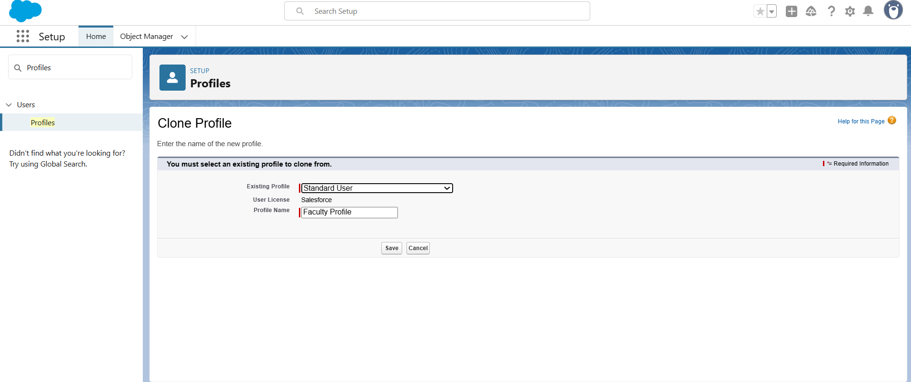

## 6. Permission Sets

Permission sets were used to grant additional rights beyond profiles:  
- Faculty Reports Permission Set: Granted faculty the ability to create and run reports.  
This ensured flexibility without modifying the base profile.

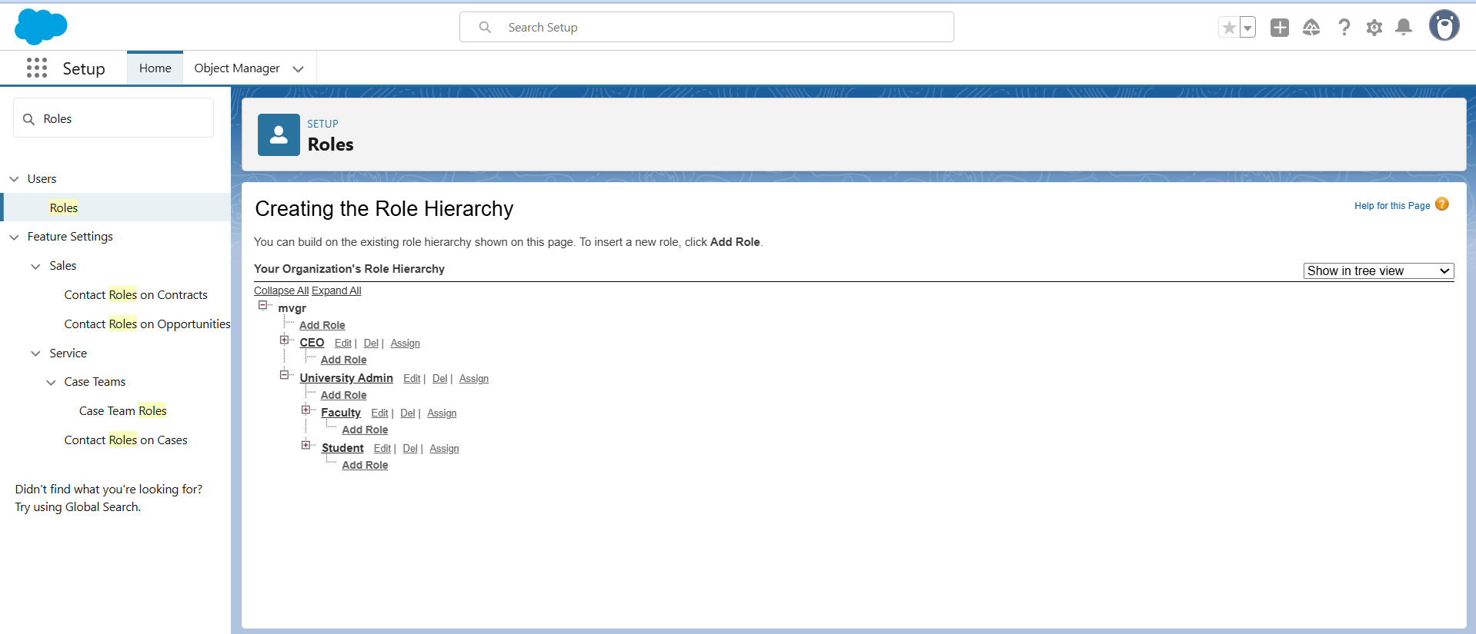

## 7. Org-Wide Defaults (OWD) & Sharing Rules

Org-Wide Defaults and Sharing Rules were defined to protect sensitive student data while ensuring necessary access to faculty and admins:  
- Student Records: Private  
- Course Records: Public Read Only  
- Enrollment Records: Controlled by Parent  
A sharing rule was created to automatically share student records with their assigned faculty.

## 8. Login Access Policies & Security

Login policies were configured to enhance security:  
- Trusted IP ranges were added for secure login.  
- Login Hours: Students (6 AM – 11 PM), Faculty/Admin (24x7).  
- Administrators were given the ability to log in as any user for testing purposes.

## 9. Org-Wide Email Address

An organization-wide email address was configured for official communications:  
- Email Address: admissions@universityxyz.edu  
Deliverability settings were enabled to allow sending and receiving of test emails.

## 10. Dev Org / Sandbox & Deployment Basics

Development and testing are being carried out in the Salesforce Developer Edition org. Deployment strategies such as Change Sets and Salesforce DX (SFDX) were noted for future use when moving configurations to different environments.