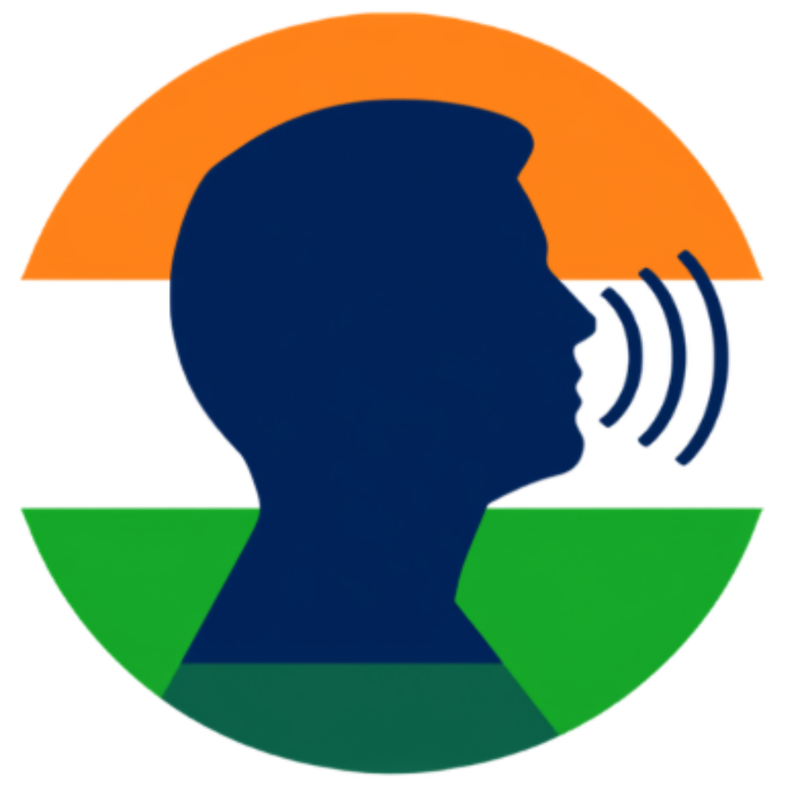
PRAJADHWANI
Voice of the People
AI-Powered Citizen Voice & Grievance Routing Platform
with a fine-tuned Gemma 4 Responsible-Officer Router

CONCEPT DOCUMENT
Submitted to the Seva First Innovation Challenge 2026 · Ministry of Education, Government of India
Theme | Swachh & Sustainable Bharat (Clean and Sustainable Bharat)
Innovation track | Track B — Business Model & Governance (with technology core)
Technology Readiness Level | TRL 5 — validated in a relevant environment
Team name | [Team name]
Team members | [Member 1 (Lead)], [Member 2], [Member 3], [Member 4]
Institution | [Institution name, City]
SFIC participation level | [Open — UG/PG/Research] / [Technical — ITI/Polytechnic]
Institution coordinator | [Coordinator name, designation]
Contact | [email@institution.edu.in] · [+91 XXXXX XXXXX]
Date | 22 October 2026

Document Control
Item | Details
Document title | Prajadhwani — Concept Document
Version | 1.0
Date of issue | 22 October 2026
Classification | For evaluation — Seva First Innovation Challenge 2026
Prepared by | [Team name], [Institution name, City]
Status of components | Implemented and running: Sections 3–5. Proposed (Phase 2): Section 6 (Gemma 4 router).

All statistics are cited in Annexure C. Figures for the prototype (Section 4.4) are read live from the project's Cloud Firestore database and include seeded test data; they demonstrate that the pipeline works, not real-world adoption.

Contents
Document Control 2
Contents 2
1. Executive Summary 4
2. Problem Statement and Demographic Context 5
2.1 Scale of the challenge 5
2.2 The grievance-redress gap 5
3. Proposed Solution: Prajadhwani 8
3.1 Users and what each gets 8
3.2 What makes Prajadhwani different 8
4. The Working Prototype — App Walkthrough 10
4.1 Inclusive onboarding 10
4.2 Reporting a problem in one screen 11
4.3 Every jurisdiction mapped 12
4.4 Prototype data snapshot 13
5. Technology Architecture 14
5.1 The AI pipeline for every report 14
5.2 Security and privacy by design 15
6. Fine-tuned Gemma 4 Responsible-Officer Router (Proposed Core Innovation) 16
6.1 Why a specialised model 16
6.2 Model design 17
6.3 Training data and fine-tuning 17
6.4 Evaluation targets 18
6.5 Responsible AI safeguards 18
7. Business Model and Sustainability 19
7.1 Revenue model (indicative, for discussion) 19
7.2 Cost structure and unit economics (indicative) 20
7.3 Go-to-market 20
8. Impact and Alignment with National Priorities 20
9. Technology Readiness and Implementation Roadmap 22
9.1 Pilot plan (TRL 5 → TRL 6) 22
9.2 Risks and mitigation 23
10. Legal, Privacy and Compliance 23
11. Team 24
Annexure A — Current Prototype Inventory 25
Annexure B — Glossary 25
Annexure C — References 26

1. Executive Summary
Every day, citizens of Karnataka encounter civic problems — a broken streetlight, an open drain, a pothole that injures two-wheeler riders. Bengaluru alone logged more than 1.27 lakh civic grievances in the first five and a half months of 2025, over 750 every day. Yet the citizen rarely knows which of a dozen agencies is responsible, complaint channels are fragmented, and tickets are sometimes closed without the problem being fixed.
Prajadhwani (“voice of the people”) is a working mobile platform that lets any citizen report a problem in 20 seconds — by voice, text or photo, in 10 Indian languages, without Aadhaar, phone number or email — and gives them an instant receipt. Artificial intelligence then understands the report, places it precisely on the map of wards, assembly seats, taluks and districts, groups it with similar reports into hotspots, and presents it on the dashboard of the official responsible for that area, together with AI-generated briefings and downloadable reports. The citizen tracks every status change live.
At a glance
Problem: fragmented, slow and opaque civic grievance redress; citizens cannot tell who is accountable.
Solution: a multilingual citizen app + AI triage + jurisdiction-aware dashboards for MPs, MLAs and officers.
Core innovation (proposed): a fine-tuned, open-weight Gemma 4 model that names the responsible office and officer for every report, with an automatic District Collector fallback.
Status: TRL 5 — live cloud backend in India (Mumbai region), Android app distributed to testers, AI pipeline verified end-to-end.
Business model: free for citizens; sustained through per-ward / per-district licences for government, plus public-programme funding.
Ask: pilot support in one GBA ward (TRL 6), mentorship, and cloud/GPU credits to fine-tune the Gemma 4 router.

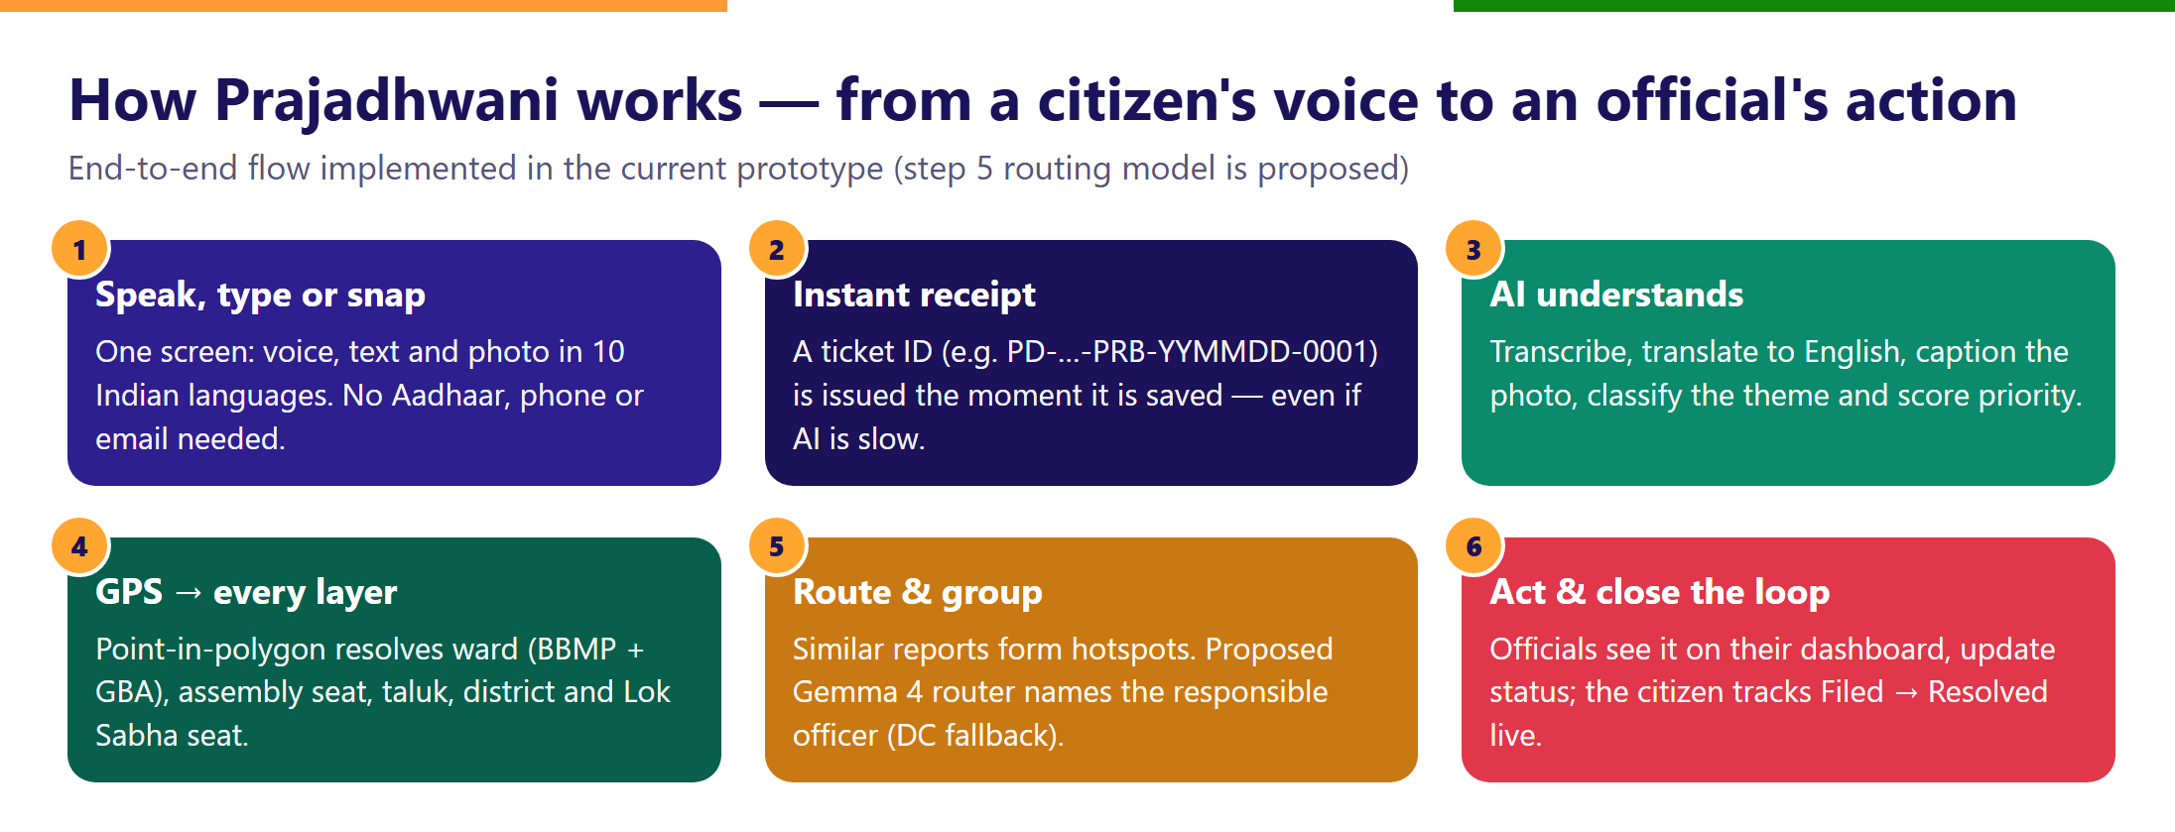
Figure 1: How Prajadhwani works — six steps from a citizen's report to official action

2. Problem Statement and Demographic Context

2.1 Scale of the challenge
Karnataka had 6.11 crore residents at the 2011 Census and is projected to reach about 6.9 crore in 2026. Bengaluru has grown into a metropolis of roughly 1.16 crore people within the new Greater Bengaluru Authority (GBA) area. Civic administration spans several overlapping layers: 31 districts, 224 assembly constituencies, 28 Lok Sabha constituencies, and — in Bengaluru — five new city corporations with 369 wards that replaced the 198-ward BBMP in 2025.
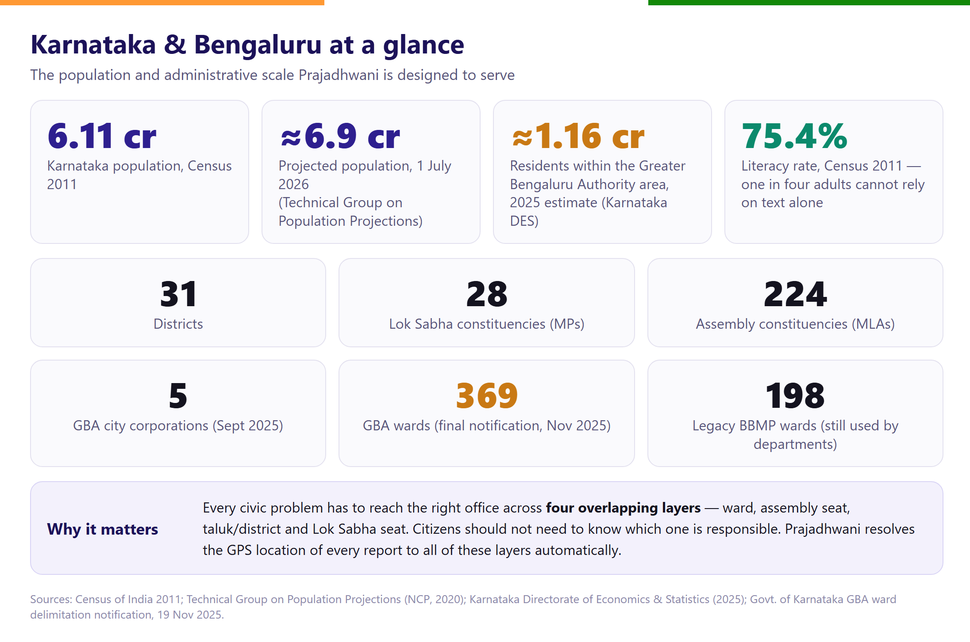
Figure 2: Demographic and administrative context of Karnataka and Bengaluru

2.2 The grievance-redress gap
High volume is only part of the problem. Responsibility is split between municipal bodies and parastatals (electricity, water, public works, health, education), so the same pothole may belong to the city corporation or to the Public Works Department depending on the road. Citizens must know the right portal and the right office; many give up. Even national systems that perform well on averages carry large pending volumes.
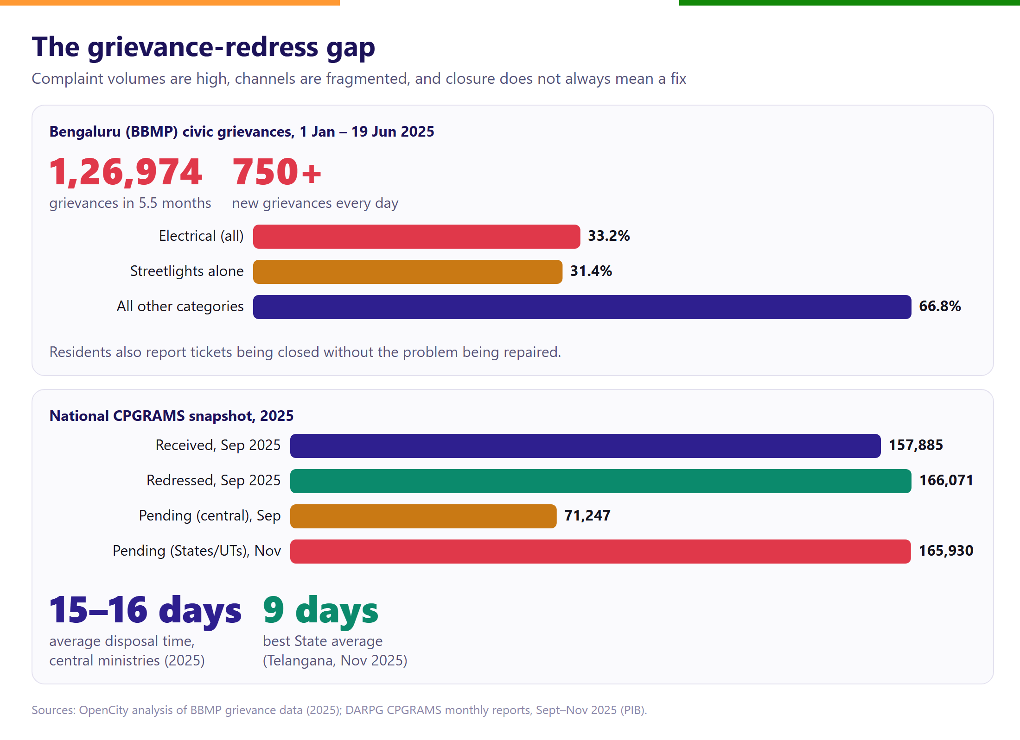
Figure 3: Grievance volumes in Bengaluru and the national CPGRAMS system
Gap | What citizens experience | Consequence for government
Who is responsible? | Does not know whether BESCOM, BWSSB, GBA or PWD owns the issue | Mis-routed tickets, transfers, delay
Language & literacy | Forms are text-heavy and mostly in English/Kannada; ~1 in 4 adults (2011) not literate | Under-reporting from the most affected groups
No feedback loop | No receipt, no visible status, tickets closed without repair | Loss of trust; duplicate complaints
No aggregate view | Each complaint is treated in isolation | Officials and legislators cannot see hotspots or plan budgets
Fragmented boundaries | New GBA wards vs old BBMP wards vs assembly seats | Data cannot be compared across jurisdictions

Table 1: Root causes of the grievance-redress gap
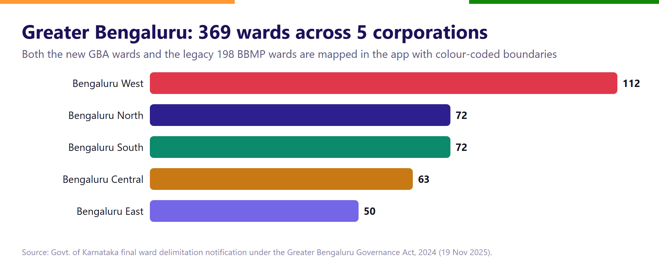
Figure 4: Ward distribution across the five Greater Bengaluru corporations

3. Proposed Solution: Prajadhwani
Prajadhwani is a civic-intelligence platform with three connected faces — one for citizens, one for government officials and elected representatives, and one public, anonymised view for everyone. It is built to be inclusive by default and accountable by design.

3.1 Users and what each gets
User | Access | Key capabilities
Citizen | Username + password; no Aadhaar, phone or email | Report by voice / text / photo in 10 languages; instant ticket receipt; live status tracker; civic profile with levels and badges; Google Maps directions to the reported spot
MP / MLA | Verified government sign-in | Constituency dashboard, hotspot map, AI briefing on top problems, downloadable PDF report, status updates
Ward officer / Tahsildar / District officer | Self-registration, approved by Prajadhwani Admin | Queue of tickets inside their own jurisdiction only; bulk status updates; performance statistics
Prajadhwani Admin | Restricted admin console | Approves official registrations, oversees the platform
Public / media / researchers | No sign-in | Anonymised public dashboard and maps — no names, addresses or exact locations

Table 2: User groups and capabilities

3.2 What makes Prajadhwani different
Capability | Conventional grievance portals | Prajadhwani
Input | Typed forms, category menus | Voice, text and photo on one screen; AI fills the category
Languages | One or two | 10 Indian languages with automatic translation
Identity | Phone / email / ID often required | Username only — lowers barriers and protects privacy
Location | Citizen selects ward or office | GPS automatically resolved to ward, assembly seat, taluk, district and Lok Sabha seat
Routing | Manual, by category | AI department routing today; fine-tuned Gemma 4 officer routing proposed
Aggregation | Individual tickets | AI hotspots, root-cause analysis and solution cards
Transparency | Limited | Live citizen tracker + public anonymised dashboard
Representatives | Not connected | MP and MLA dashboards with AI briefings and reports

Table 3: Comparison with conventional grievance systems

4. The Working Prototype — App Walkthrough
The screens below are real screenshots captured from the current Android build running against the live cloud backend on 22 October 2026, using a temporary demonstration account (since deleted).

4.1 Inclusive onboarding
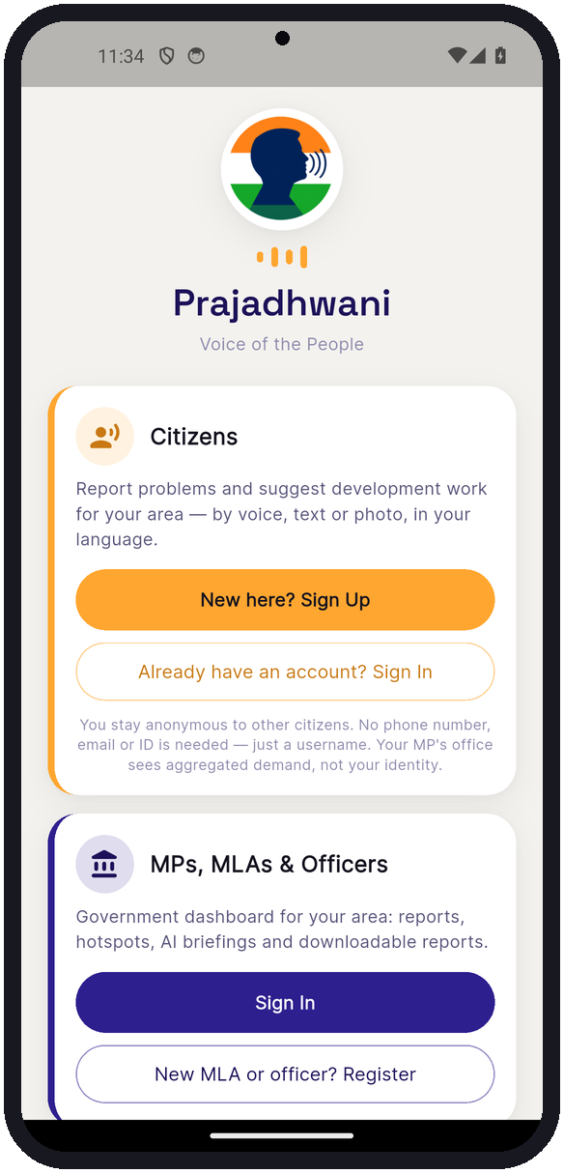 | 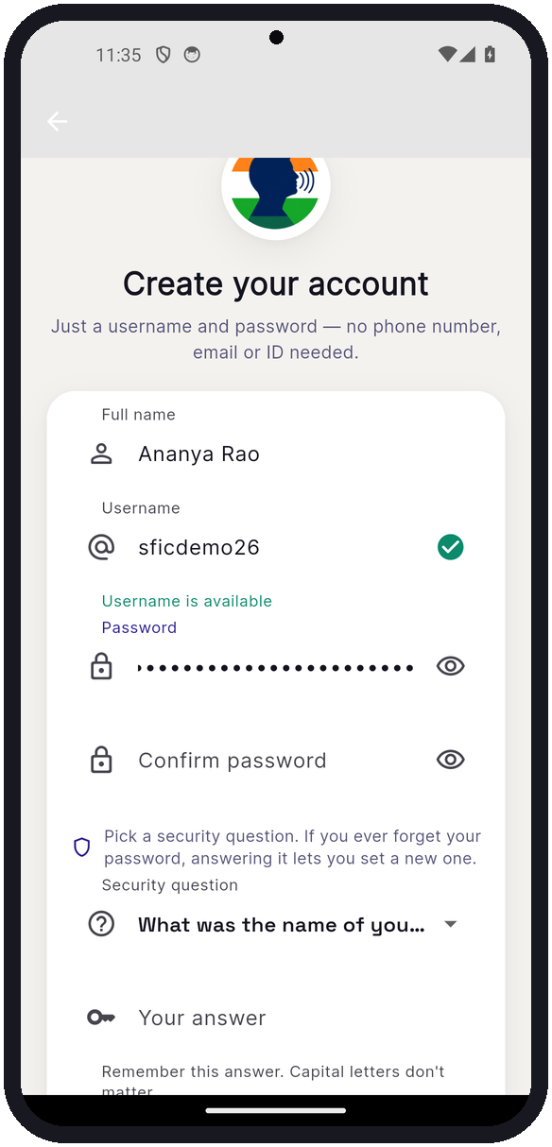 | 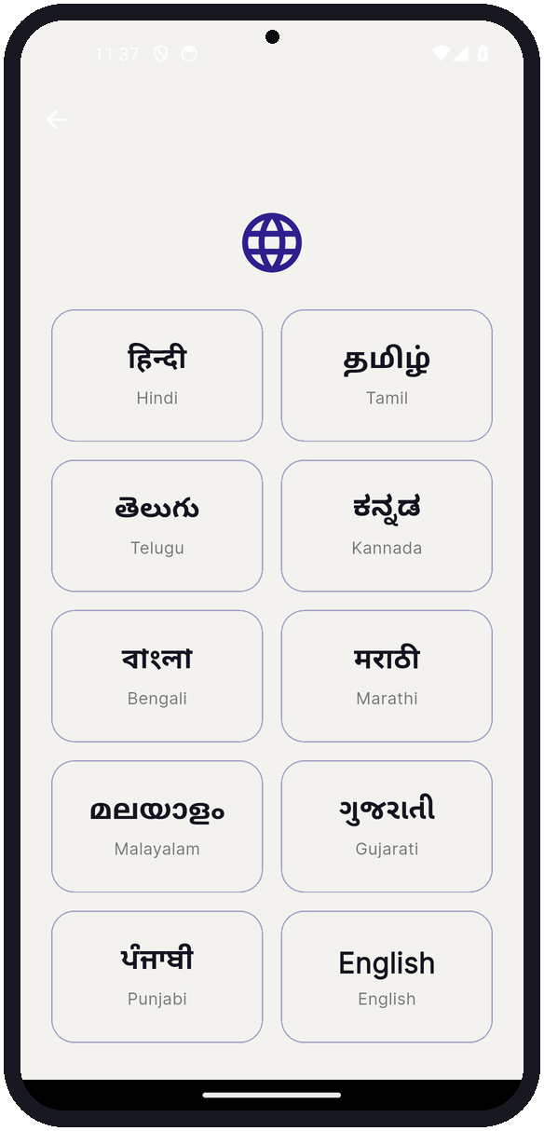
Figure 5: Welcome screen with separate entry for citizens and for MPs, MLAs & officers | Figure 6: Sign-up with only a username and password; a security question replaces phone/email recovery | Figure 7: Choice of 10 Indian languages; the whole app switches instantly
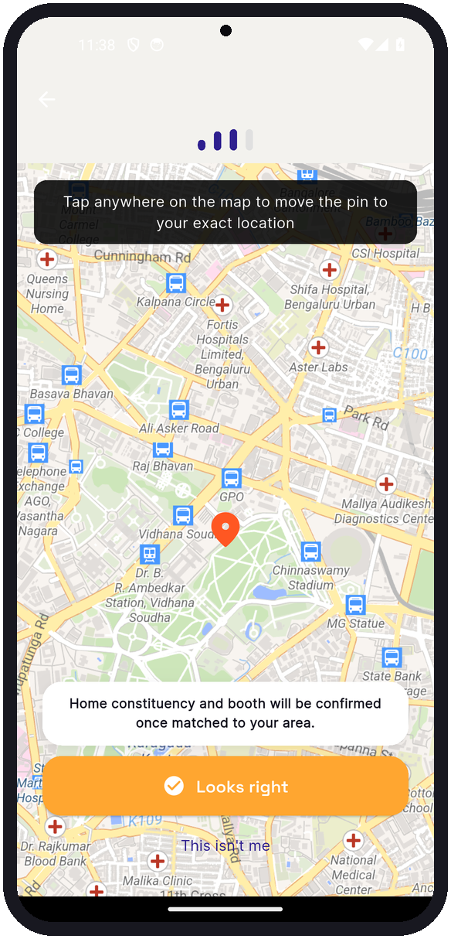 | 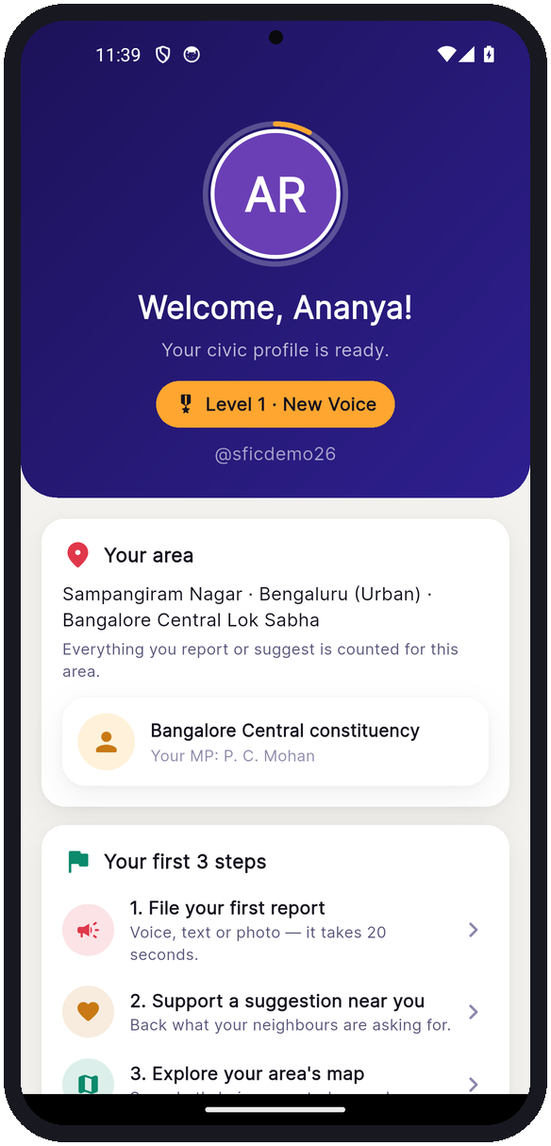 | 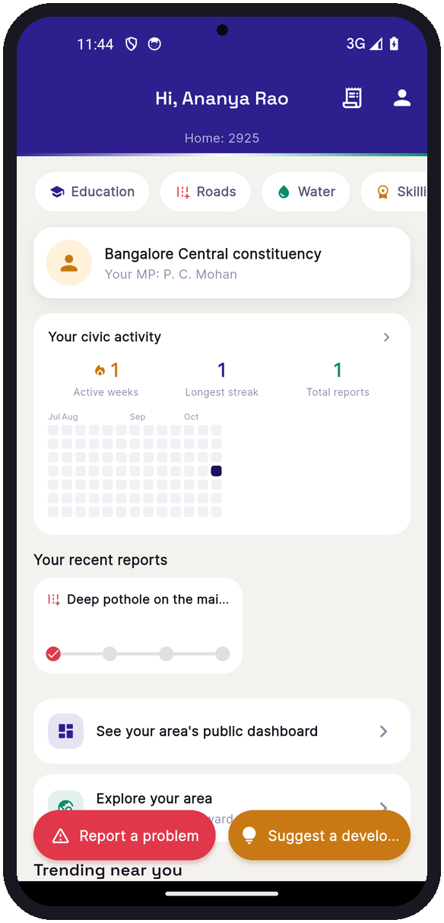
Figure 8: Home location on a free OpenStreetMap-based map (no paid licence) | Figure 9: First-time civic profile: ward, constituency, MP and three first steps | Figure 10: Citizen home: constituency, civic-activity streak and one-tap reporting

4.2 Reporting a problem in one screen
The redesigned report screen brings voice, text and photo together. The citizen can type or tap the microphone (speech is converted to editable text), attach a photo, optionally pick a category, and confirm where the problem is. A ticket number is issued the instant it is saved. On the confirmation screen an animated officer salutes and stamps the ticket, reassuring the citizen that the problem has been registered.
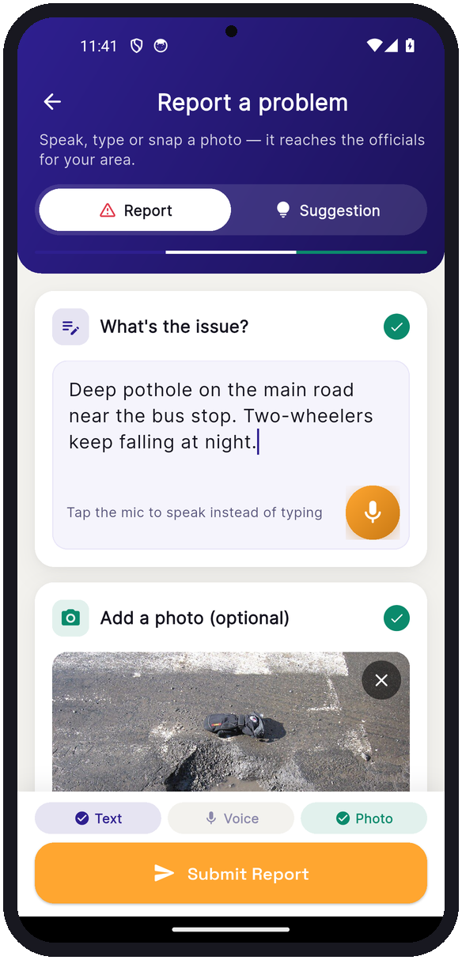 | 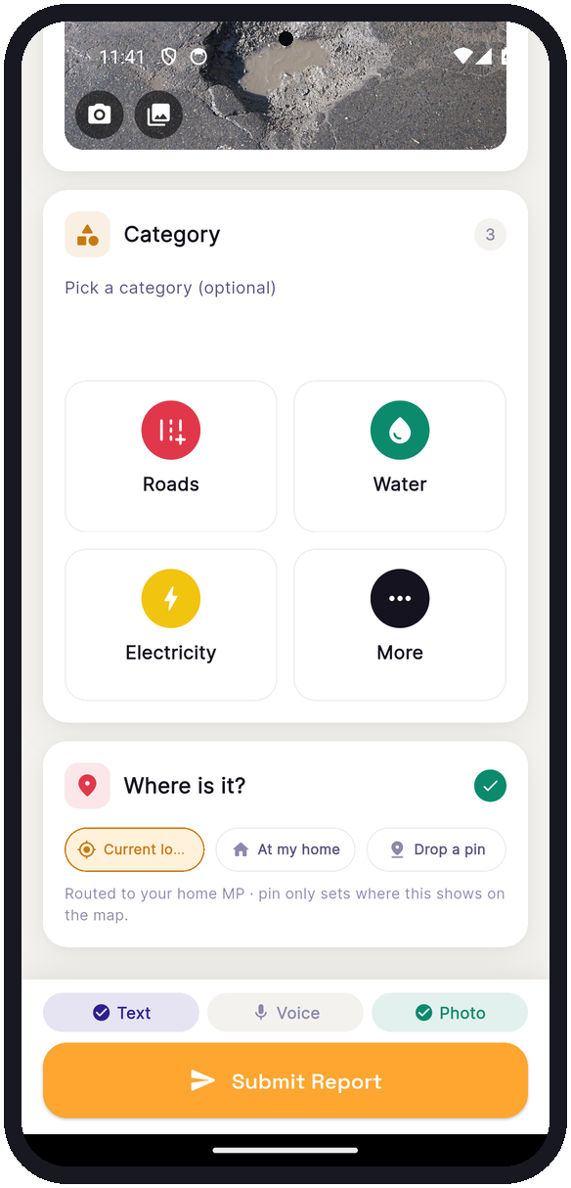 | 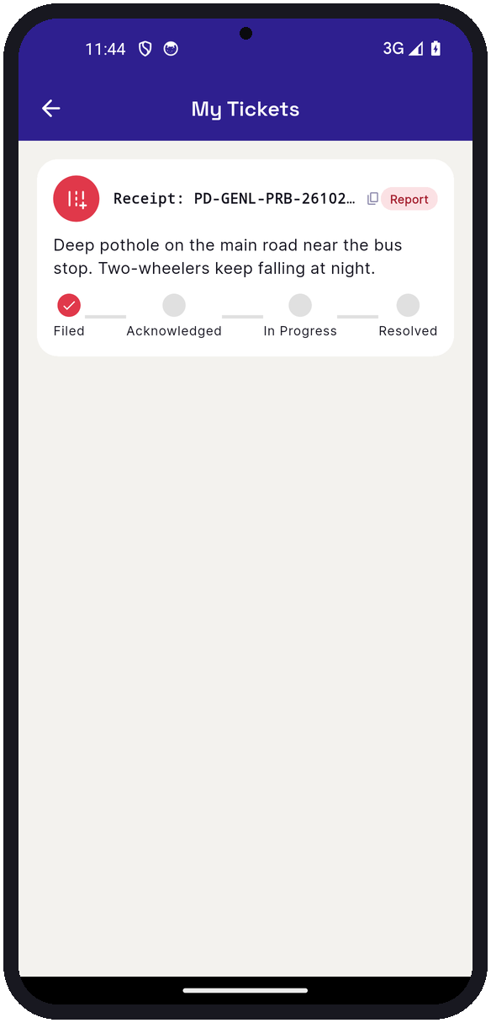
Figure 11: Unified report screen: text and photo added; microphone for voice | Figure 12: Category and location (current location, home, or drop a pin) | Figure 13: My Tickets: every report with its receipt ID
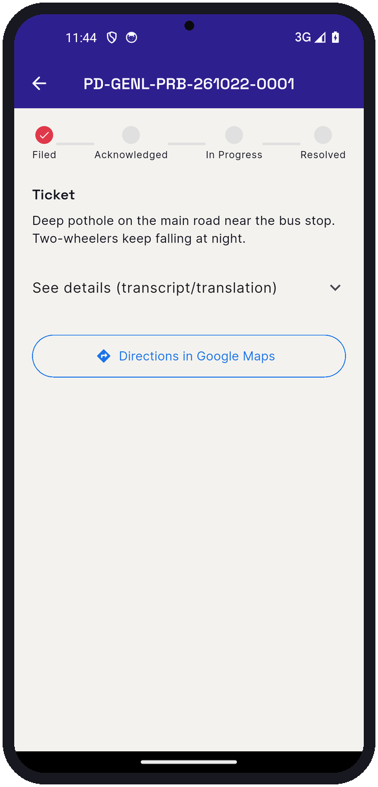 | 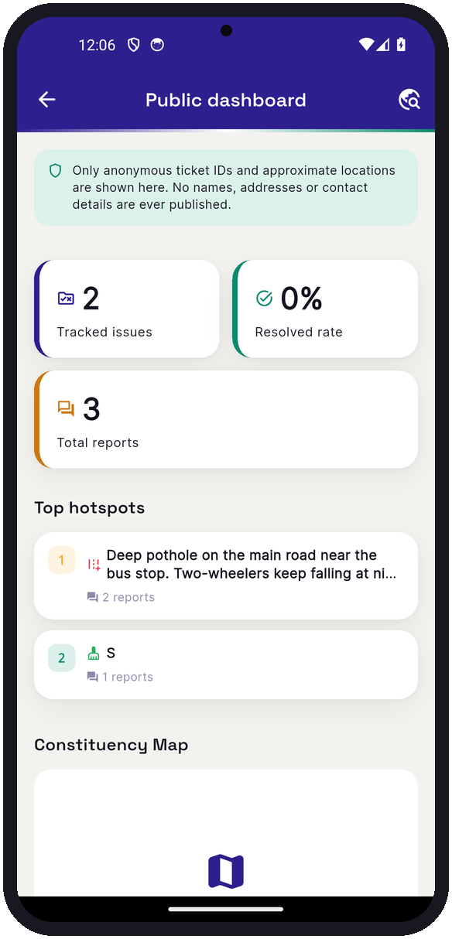 | 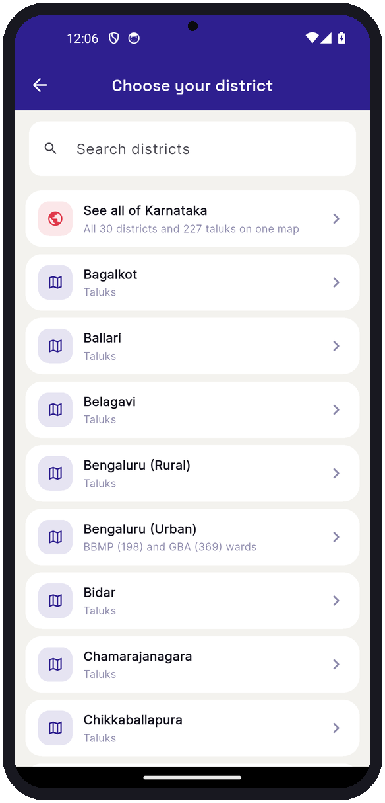
Figure 14: Live status tracker Filed → Acknowledged → In Progress → Resolved, with Google Maps directions | Figure 15: Public dashboard: anonymised totals, resolution rate and top hotspots | Figure 16: Explore Karnataka: all districts and taluks on one map

4.3 Every jurisdiction mapped
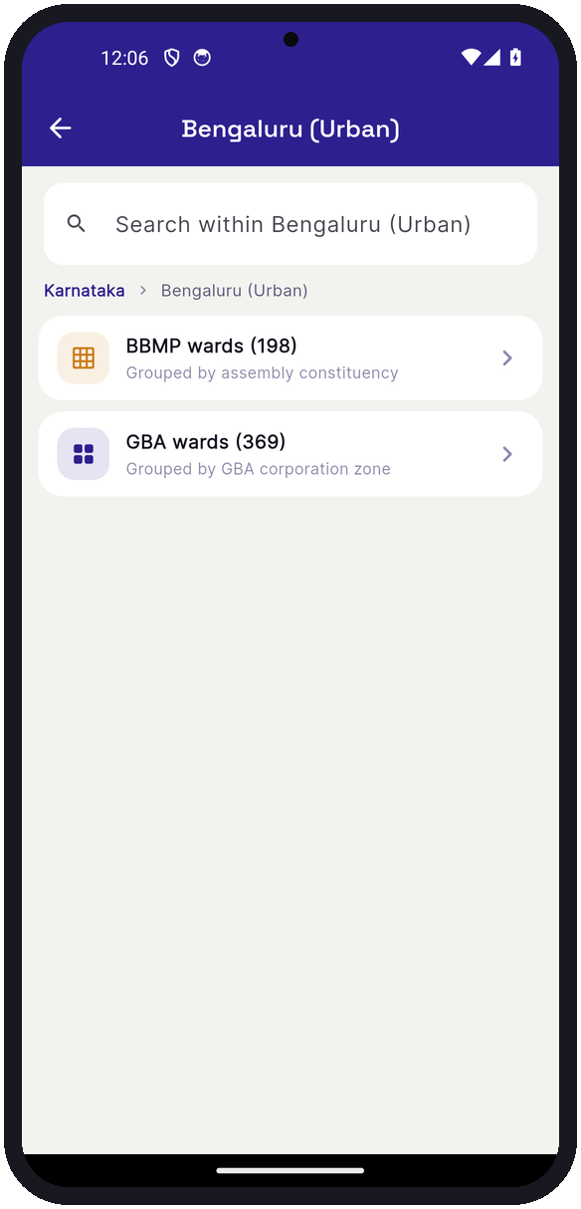 | 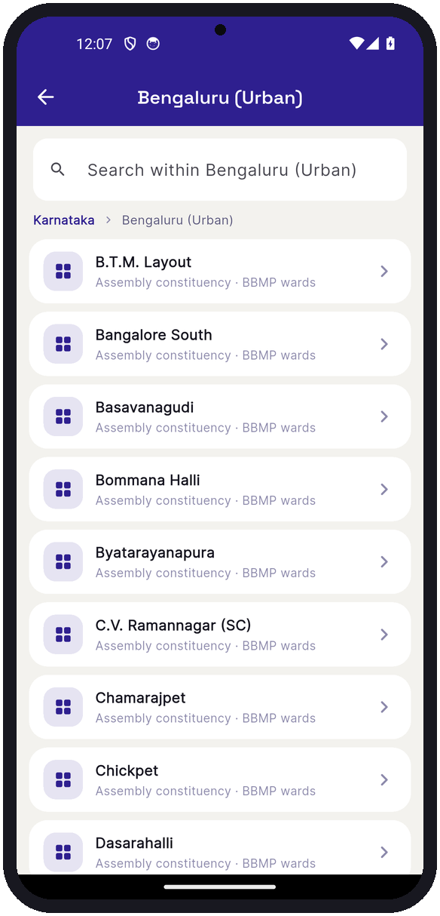
Figure 17: Bengaluru: both the 198 BBMP wards and the 369 GBA wards | Figure 18: BBMP wards grouped by assembly constituency

Officials sign in to a separate government dashboard scoped to their own jurisdiction, with a hotspot map, an AI briefing card summarising the most pressing problems, ticket management with bulk status updates, and a downloadable PDF report for their constituency or area.

4.4 Prototype data snapshot
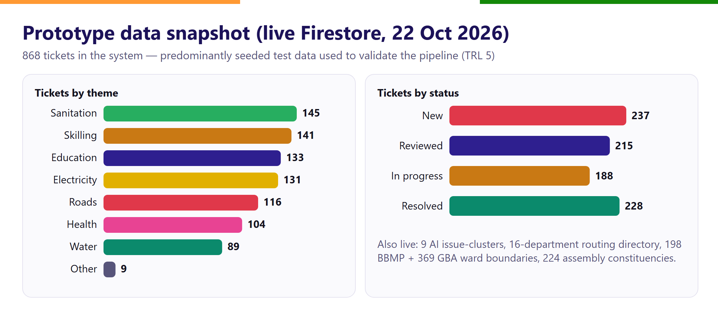
Figure 19: Tickets in the prototype database by theme and by status (includes seeded test data)

5. Technology Architecture
Prajadhwani is serverless and hosted in Google Cloud's Mumbai region (asia-south1), so citizen data stays in India. The mobile app is built in Flutter; Firebase provides authentication, the Cloud Firestore database and file storage; Cloud Functions run the AI pipeline; and Gemini 2.5 Flash on Vertex AI provides language understanding.
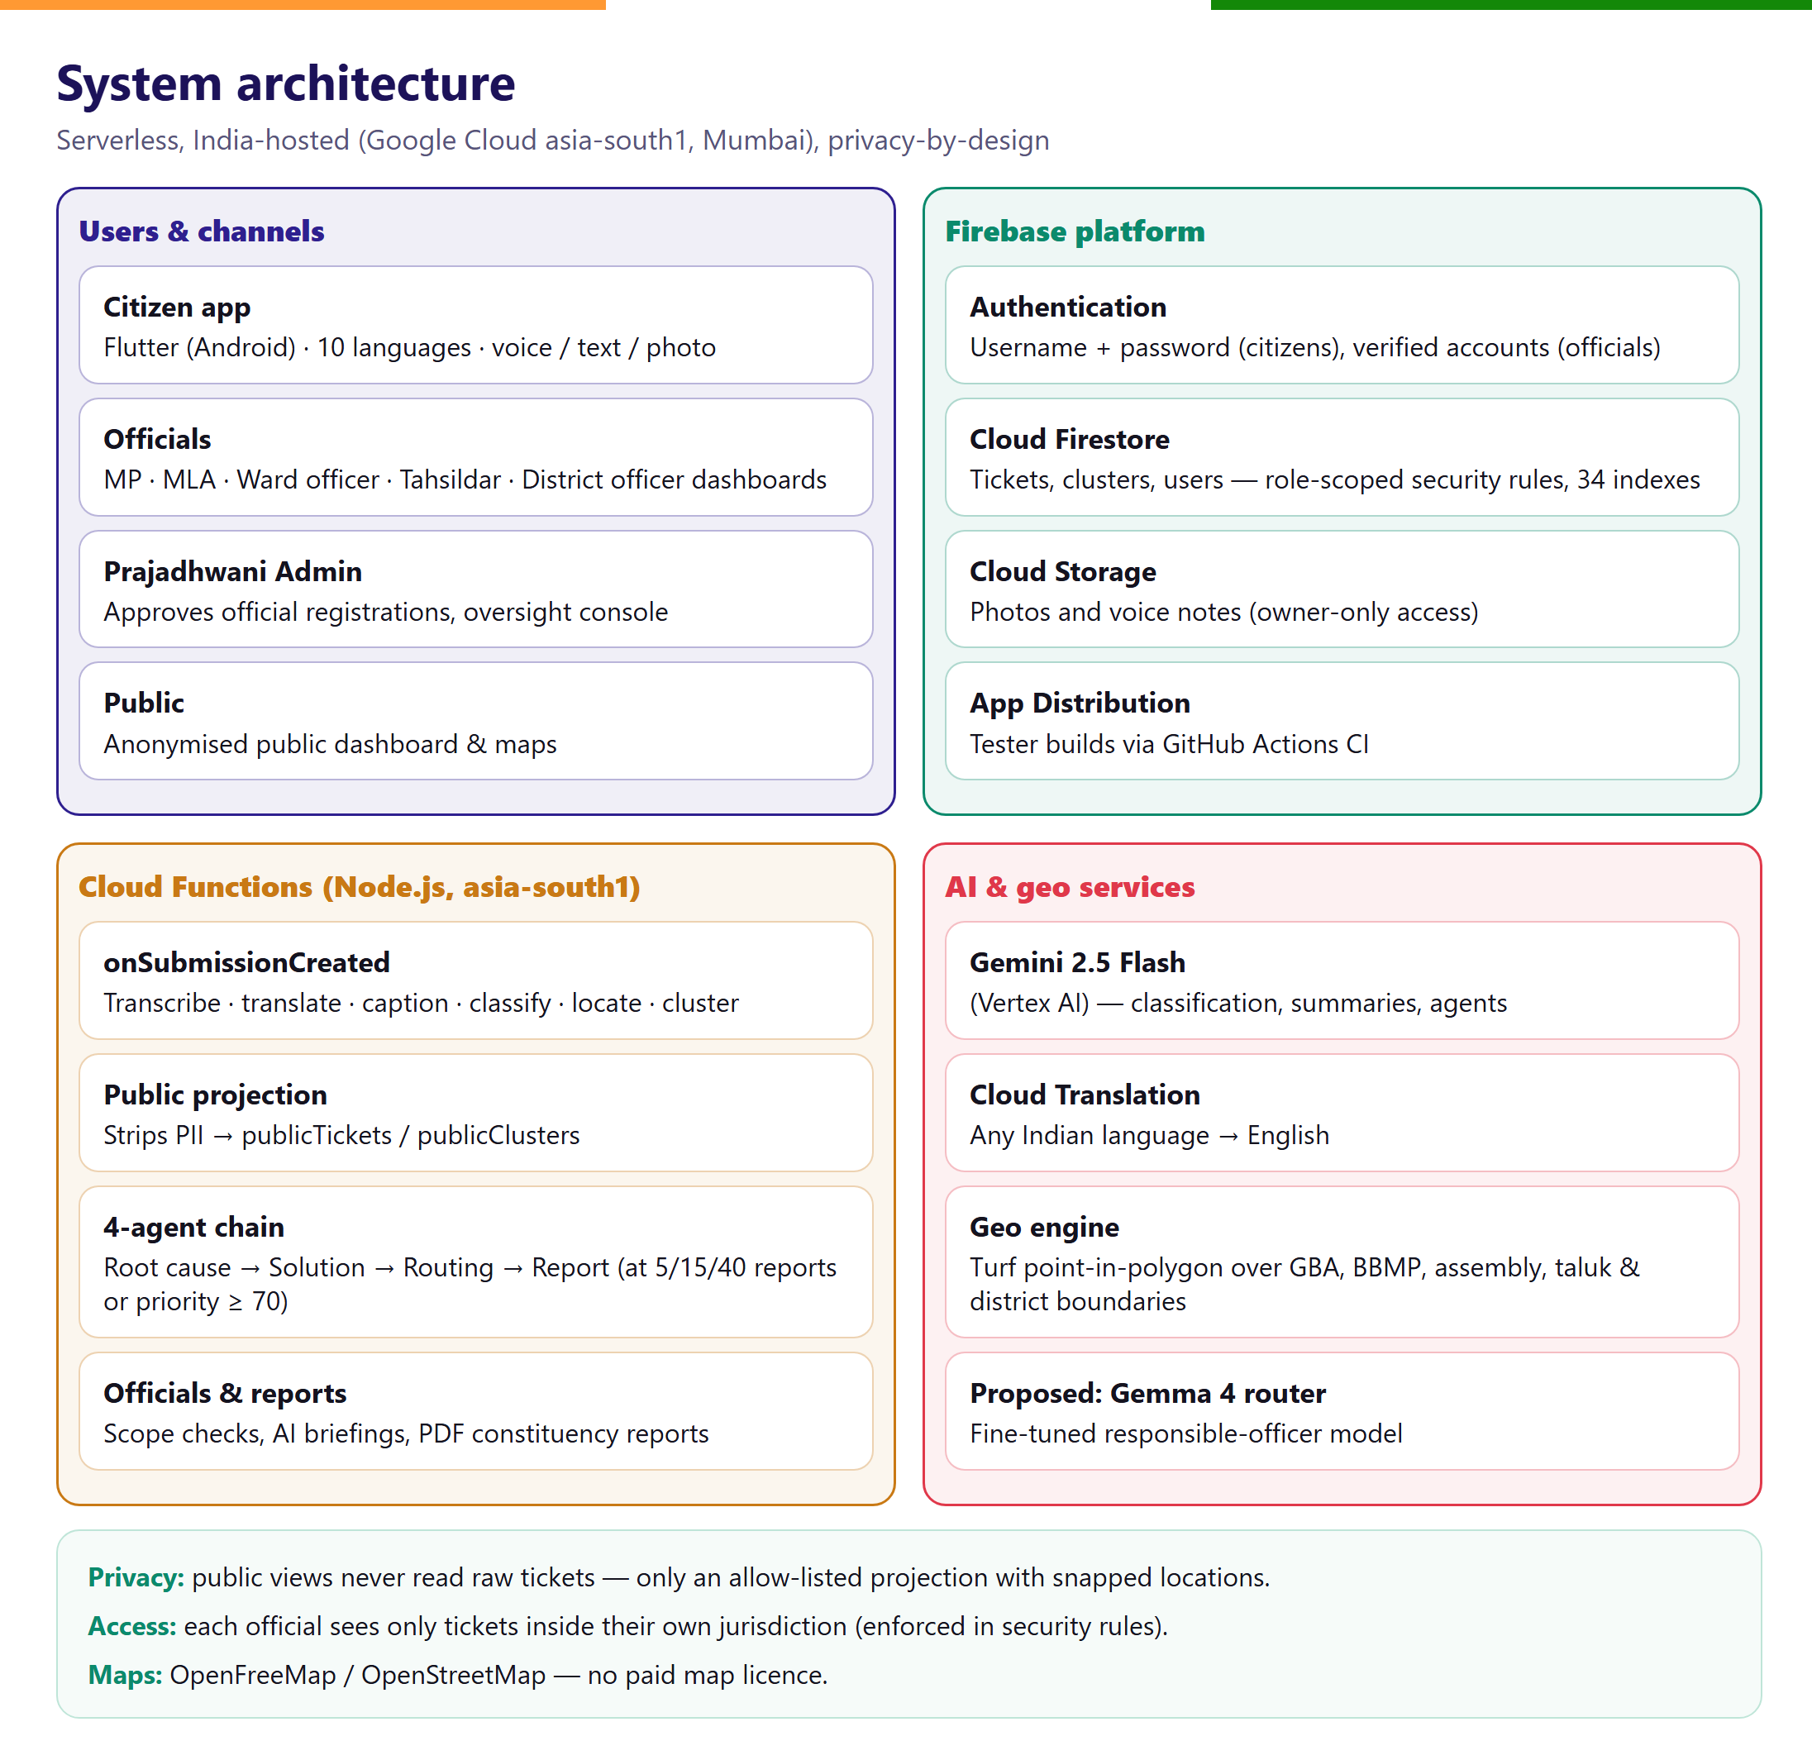
Figure 20: System architecture

5.1 The AI pipeline for every report
Stage | What happens | Technology
1. Receipt | Ticket ID generated in a database transaction before any AI runs, so the citizen never loses a report | Firestore transaction
2. Understand | Voice transcribed (on device first, server fallback); text translated to English; photo captioned | Gemini 2.5 Flash, Cloud Translation
3. Classify | Theme (if not chosen), priority, demand, demographic and infrastructure-gap scores, and a privacy-safe one-line public summary | Gemini 2.5 Flash
4. Locate | GPS point resolved to Lok Sabha seat, assembly seat, district, taluk, BBMP ward and GBA ward | Turf point-in-polygon over official boundary data
5. Group | Ticket joins or starts an issue cluster (same area and theme); aggregates updated | Cloud Functions
6. Publish | Anonymised copy with snapped location written for the public dashboard | Allow-listed projection
7. Analyse hotspots | At 5 / 15 / 40 reports or priority ≥ 70, four AI agents produce a solution card | Multi-agent chain (Figure below)

Table 4: Processing stages applied to every report
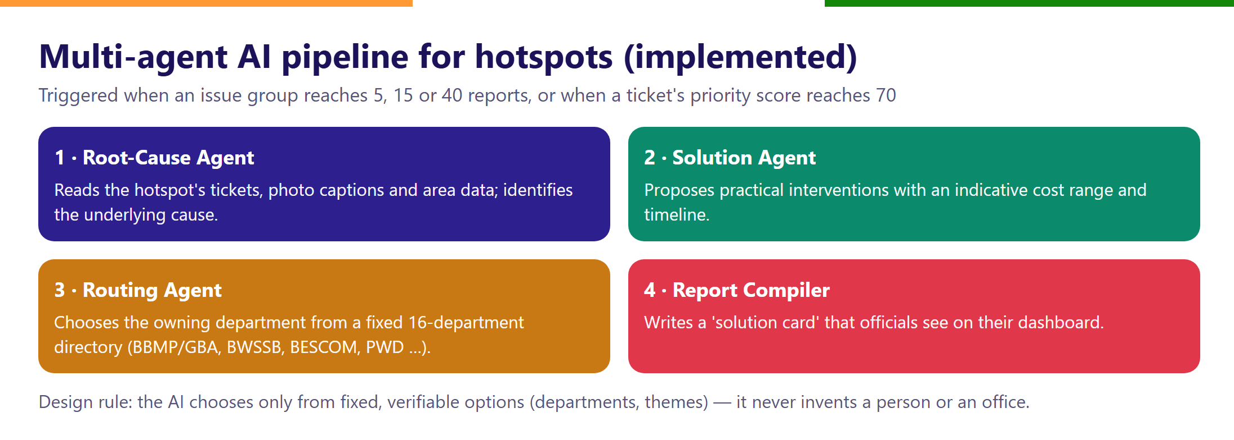
Figure 21: Multi-agent AI pipeline for hotspots

5.2 Security and privacy by design
- Data minimisation: no Aadhaar, phone number or email is collected from citizens.
- Role-scoped access: database security rules let an official read only tickets inside their own jurisdiction; officials cannot change their own jurisdiction or role.
- Public data isolation: the public dashboard reads only a separate, allow-listed projection with approximate locations — the raw tickets are never publicly readable.
- Data residency: all services run in the asia-south1 (Mumbai) region.
- Verified officials: MLAs and officers self-register and are approved by an administrator before gaining access.

6. Fine-tuned Gemma 4 Responsible-Officer Router (Proposed Core Innovation)
Status
This component is proposed for Phase 2 (months 2–5 of the roadmap). Today, department routing is performed per hotspot by a general-purpose model choosing from a fixed 16-department directory. The router below extends this to every individual report and to a named officer.

6.1 Why a specialised model
Deciding who must act on a civic problem requires local institutional knowledge: a pothole on a GBA road belongs to the ward engineer, on a state highway to the Public Works Department; a dark street may be a BESCOM supply fault or a municipal streetlight contract. General-purpose language models do not reliably know Karnataka's allocation of business, and sending every report to a large proprietary model is costly and raises data-sovereignty concerns.
Gemma 4 is Google's family of open-weight models, released in 2026 in sizes from E2B and E4B (built for on-device and edge use) to a 26B mixture-of-experts model with about 3.8B active parameters and a 31B dense model. Open weights mean the State can host, audit and own the fine-tuned model.
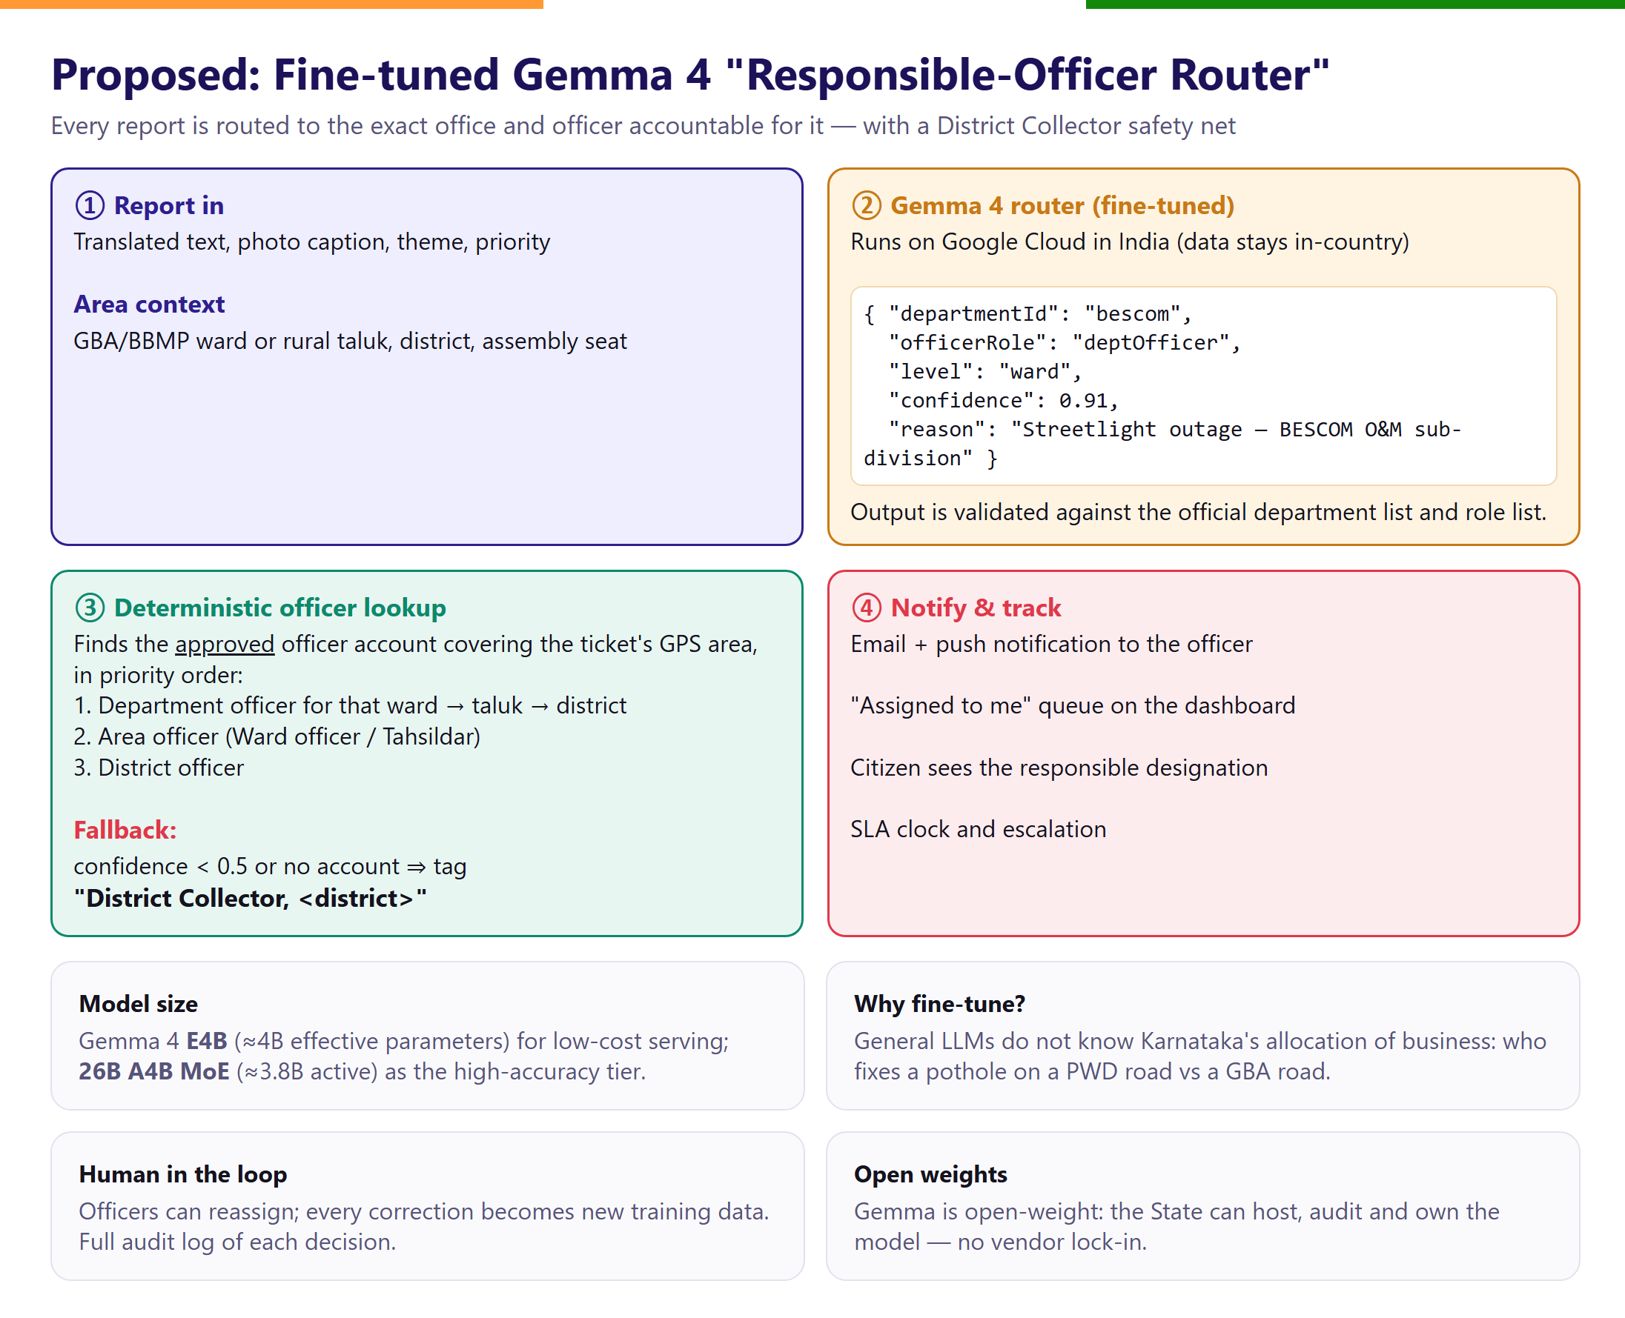
Figure 22: Proposed inference flow of the Responsible-Officer Router

6.2 Model design
Aspect | Design decision
Base model | Gemma 4 E4B (≈4B effective parameters) — low serving cost; 26B A4B MoE as the high-accuracy tier if E4B misses targets
Task | Structured classification: {departmentId, officerRole, jurisdictionLevel, confidence, reason}
Input | PII-free public summary + English translation, photo caption, theme, priority, area context (urban ward or rural taluk, district)
Constrained output | Department and role must come from the official enumerated lists; any other output is treated as a failure → fallback
Officer resolution | Deterministic lookup of the approved officer account covering the ticket's ward → taluk → district; the model never invents a person
Fallback | Confidence < 0.5 or no matching account → assigned to the post “District Collector, <district>” for re-assignment
Notification | Email and push notification to the assigned officer; “Assigned to me” queue; citizen sees the responsible designation
Hosting | Vertex AI / Cloud Run with GPU in asia-south1; batch or near-real-time

Table 5: Design of the Gemma 4 router

6.3 Training data and fine-tuning
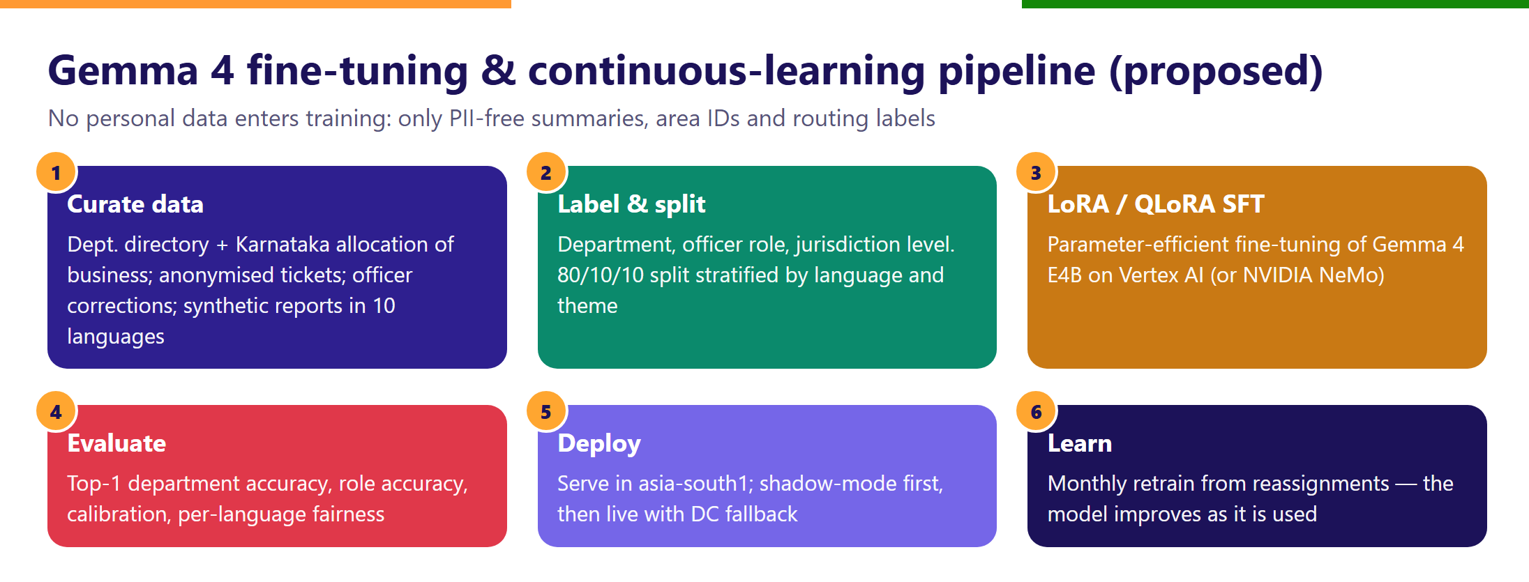
Figure 23: Fine-tuning and continuous-learning pipeline
Data source | Volume (target) | Purpose
Department directory & allocation-of-business rules | 16+ departments, all officer roles | Ground truth for labels
Synthetic multilingual reports | ≈20,000 examples across 10 languages and 8 themes | Coverage of rare categories and languages
Anonymised real tickets from the pilot | ≈5,000 examples | Real-world phrasing and noise
Officer re-assignments | Continuous | Corrections become new labels each month

Table 6: Training data plan
Fine-tuning uses parameter-efficient LoRA / QLoRA supervised fine-tuning (for example rank 16, 3 epochs) on Vertex AI or NVIDIA NeMo, which fits on a single data-centre GPU. The model first runs in shadow mode beside the current system; it goes live only after meeting the targets below.

6.4 Evaluation targets
Metric | Target before go-live
Top-1 department accuracy (held-out test set) | ≥ 90%
Officer-role accuracy | ≥ 85%
Share of tickets falling back to the District Collector | ≤ 15%
Re-assignment rate after go-live | ≤ 10%
Accuracy gap between best and worst language | ≤ 5 percentage points
Median time from report to officer acknowledgement | < 48 hours in the pilot ward

Table 7: Acceptance criteria for the router

6.5 Responsible AI safeguards
- Human in the loop: officers and District Collectors can re-assign; the system learns from every correction.
- Explainability: each assignment stores the model's short reason and confidence, visible to officials.
- Auditability: an immutable assignment log supports grievance appeals and RTI queries.
- Privacy: no names, phone numbers or exact addresses are used in training or inference.
- Fairness: accuracy is monitored per language and per district to avoid systematically worse service for any group.

7. Business Model and Sustainability
Prajadhwani will always be free for citizens. Its customers are the institutions that must resolve grievances and plan local development; its value to them is faster redress, lower duplication, and evidence for budgeting.
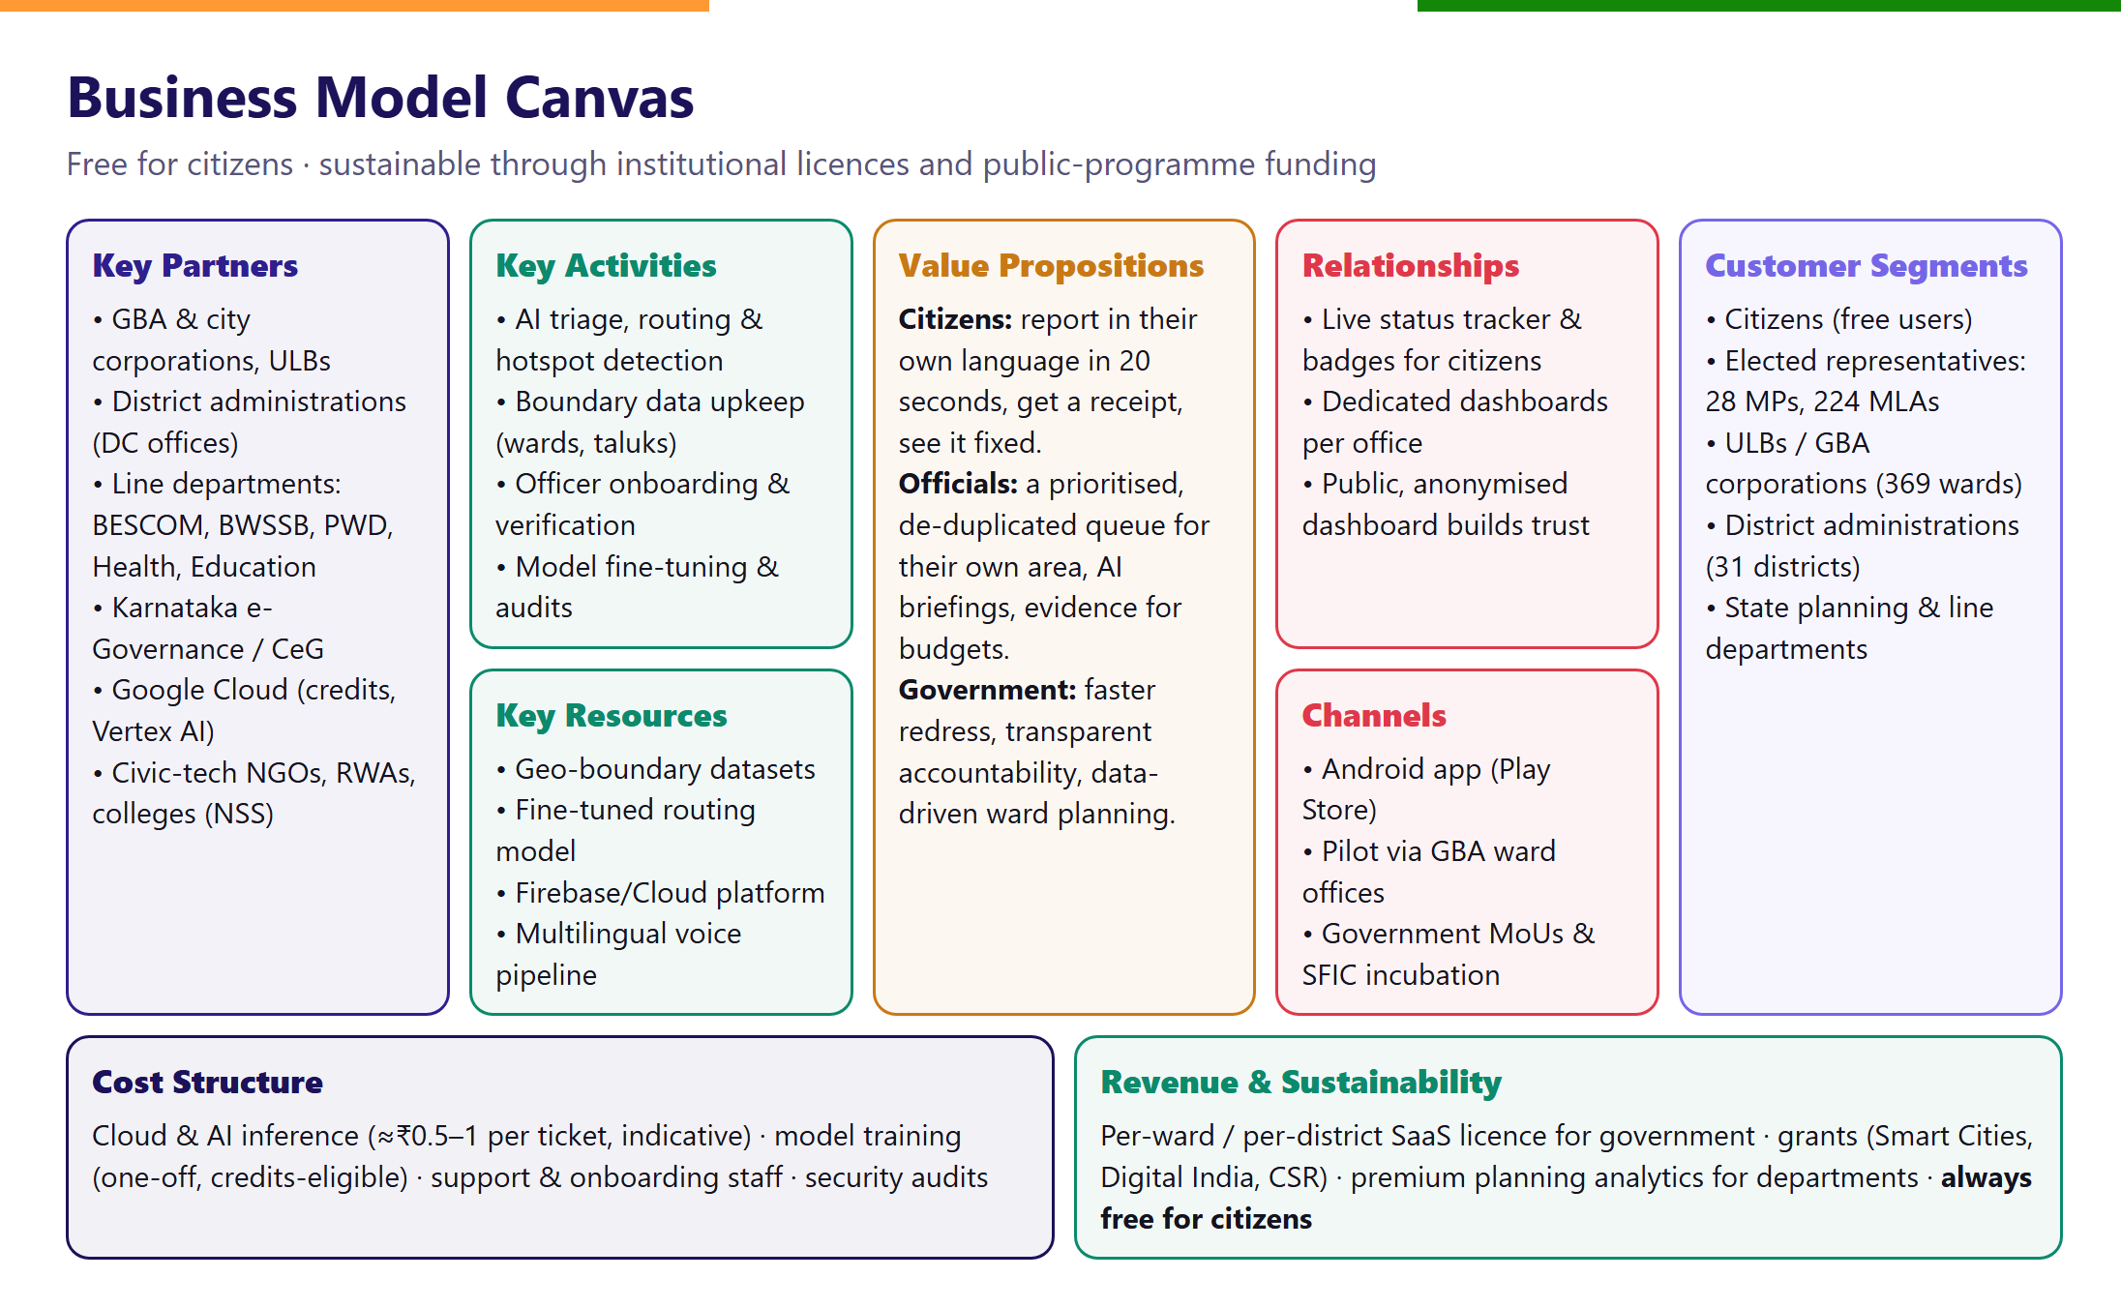
Figure 24: Business Model Canvas

7.1 Revenue model (indicative, for discussion)
Stream | Unit price (indicative) | Illustrative annual potential
Urban local body licence | ₹12,000 per ward per year | ₹44 lakh for all 369 GBA wards
District administration licence | ₹6 lakh per district per year | ₹1.86 crore for 31 districts
Legislator dashboards | ₹60,000 per constituency per year | ₹1.5 crore for 224 assembly + 28 Lok Sabha seats
Planning analytics for departments | Custom | Project-based
Grants and CSR | — | Smart Cities Mission, Digital India, Google Cloud credits, CSR

Table 8: Indicative revenue streams (prices are proposals, not quotations)

7.2 Cost structure and unit economics (indicative)
Cost item | Indicative cost | Notes
AI processing per ticket (Gemini 2.5 Flash + translation) | ≈ ₹0.5 – 1.0 | Depends on text length and photo
Gemma 4 router inference per ticket (self-hosted, batched) | ≈ ₹0.05 – 0.2 | Replaces repeated calls to a larger model
Cloud infrastructure at 1 lakh tickets/month | ≈ ₹40,000 – 60,000 per month | Firestore, Functions, Storage
One-time router fine-tuning | ≈ ₹1 – 2 lakh | Eligible for cloud research credits
Support, onboarding and maintenance team | ≈ ₹6 lakh per month | 4–5 people at state scale

Table 9: Indicative operating costs
At the scale of one city (≈1 lakh tickets per month) the platform costs about ₹90 lakh – 1 crore a year to run; licences from one city corporation group and a handful of districts cover this, making the model self-sustaining within about two years.

7.3 Go-to-market
- Phase 1 — Pilot (0–3 months): one GBA ward with the ward office, a resident welfare association and a college NSS unit.
- Phase 2 — Corporation (3–8 months): scale to one GBA corporation (≈70 wards) with the Gemma 4 router live.
- Phase 3 — Districts (8–12 months): rural taluks via District Collector offices; State-level MoU and integration with existing redress portals.

8. Impact and Alignment with National Priorities
Outcome | Indicator | Pilot target
Faster redress | Median time to resolution | 30% lower than ward baseline
Correct routing | Tickets reaching the right office first time | ≥ 90%
Inclusion | Share of reports in voice or non-English languages | ≥ 40%
Transparency | Tickets with a visible status update within 72 hours | ≥ 80%
Better planning | Hotspots with an AI solution card reviewed by officials | 100% of hotspots ≥ 5 reports

Table 10: Impact indicators
Programme / goal | How Prajadhwani contributes
Swachh Bharat Mission | Sanitation, garbage and drainage reports routed and tracked to closure
Smart Cities Mission | Ward-level civic data and hotspot analytics for planning
Digital India | Inclusive, voice-first, multilingual digital public service
CPGRAMS / good governance | Accountability, time-bound redress, citizen feedback loop
SDG 6, 9, 11, 16 | Clean water & sanitation; infrastructure; sustainable cities; effective, accountable institutions

Table 11: Alignment with national programmes and the Sustainable Development Goals

9. Technology Readiness and Implementation Roadmap
The platform is at TRL 5: all components run on the production cloud and have been verified end-to-end, the Android app is distributed to testers, and the AI pipeline has processed hundreds of test tickets. Reaching TRL 6 requires a pilot with real citizens and a real officer.
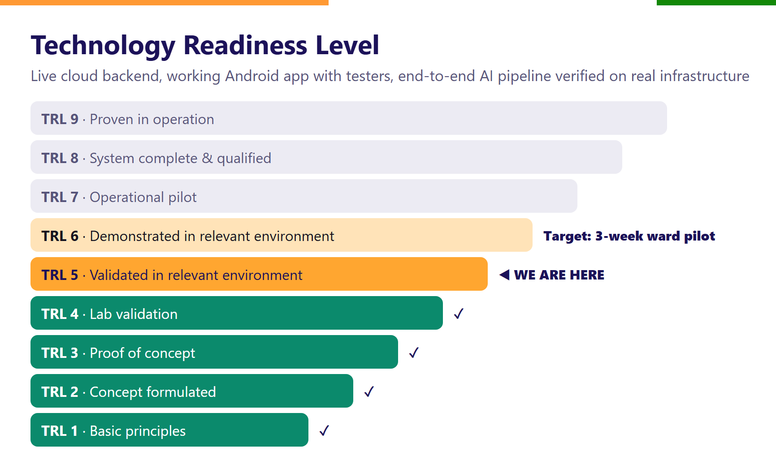
Figure 25: Technology Readiness Level of Prajadhwani

9.1 Pilot plan (TRL 5 → TRL 6)
Element | Plan
Location | One GBA ward in Bengaluru, selected with the ward office
Participants | 50+ citizens (via RWA and college volunteers), 1 ward officer, the area MLA's office
Duration | 3 weeks of live use + 1 week of evaluation
Success criteria | ≥ 100 real reports; ≥ 80% acknowledged within 72 hours; officer and citizen satisfaction surveys
Data collected | Routing correctness, time to acknowledge / resolve, language mix — feeds the Gemma 4 training set

Table 12: Pilot plan
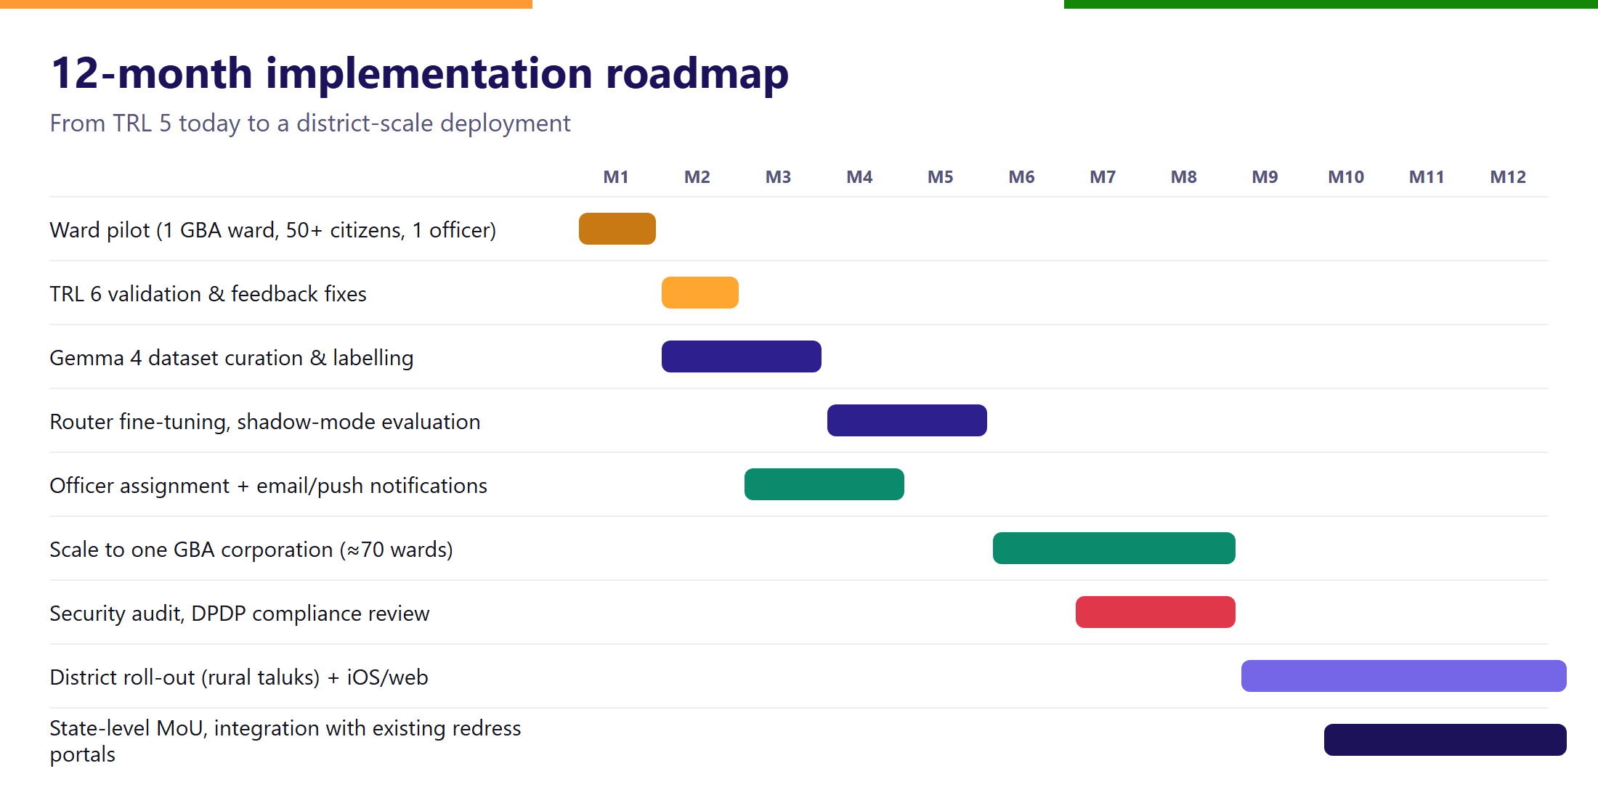
Figure 26: 12-month implementation roadmap

9.2 Risks and mitigation
Risk | Likelihood | Mitigation
Low adoption by officials | Medium | Co-design in the pilot; dashboards save officials time; MLA/MP sponsorship
Mis-routing by AI | Medium | Confidence threshold, District Collector fallback, human re-assignment, monthly retraining
Misuse / fake reports | Medium | Username accounts with rate limits, duplicate clustering, officer flagging
Privacy breach | Low | No sensitive identifiers collected; role-scoped rules; anonymised public data; security audit
Boundary changes (e.g. GBA delimitation) | High | Boundary data is versioned and both BBMP and GBA wards are supported
Cloud cost growth | Low | Small self-hosted Gemma model, batching, cloud credits

Table 13: Risk register

10. Legal, Privacy and Compliance
- Digital Personal Data Protection Act, 2023: minimal personal data, clear purpose, consent at sign-up, and the ability to delete one's account.
- Data localisation: processing and storage in the Mumbai cloud region.
- Accessibility: voice input and 10 languages for low-literacy users; large touch targets.
- Open standards: OpenStreetMap-based mapping, open-weight AI model, exportable data for government systems.

11. Team
Name | Role | Responsibility
[Member 1] | Team lead | Product, government liaison
[Member 2] | Mobile & cloud | Flutter app, Firebase, Cloud Functions
[Member 3] | AI / ML | Gemma 4 fine-tuning, evaluation
[Member 4] | Research & outreach | Pilot coordination, surveys, impact measurement
[Faculty mentor] | Mentor | Guidance and institutional coordination

Table 14: Team composition (to be completed)

Annexure A — Current Prototype Inventory
Component | Status
Android app (Flutter), 10 languages | Implemented; distributed via Firebase App Distribution
Username + password sign-in with security-question recovery | Implemented
Unified voice + text + photo report screen | Implemented
Instant ticket receipt and live status tracker | Implemented
AI transcription, translation, captioning, classification | Implemented (Gemini 2.5 Flash, Cloud Translation)
Geo-resolution: GBA 369 + BBMP 198 wards, 224 assemblies, taluks, districts | Implemented
Issue clustering and 4-agent hotspot analysis | Implemented
Official dashboards (MP, MLA, ward officer, Tahsildar, district officer) | Implemented
AI briefings and downloadable PDF reports | Implemented
Admin console and official approval workflow | Implemented
Public anonymised dashboard and maps | Implemented
Gemma 4 responsible-officer router with DC fallback | Proposed — Phase 2
Email and push notifications to assigned officers | Proposed — Phase 2

Annexure B — Glossary
Term | Meaning
BBMP | Bruhat Bengaluru Mahanagara Palike — Bengaluru's former municipal corporation (198 wards)
GBA | Greater Bengaluru Authority — constituted 2025, with five city corporations and 369 wards
CPGRAMS | Centralised Public Grievance Redress and Monitoring System, Government of India
DC | Deputy Commissioner / District Collector — head of a district administration
Gemma 4 | Google's open-weight model family (2026); E4B is a small edge-optimised variant
LoRA / QLoRA | Parameter-efficient fine-tuning methods that adapt a model with small trainable matrices
TRL | Technology Readiness Level, a 1–9 scale of technology maturity
PII | Personally identifiable information

Annexure C — References
[1] Census of India 2011 — Karnataka population and literacy tables, Office of the Registrar General & Census Commissioner, India.
[2] National Commission on Population (2020). Report of the Technical Group on Population Projections 2011–2036.
[3] Karnataka Directorate of Economics and Statistics (2025). Population estimate for the Greater Bengaluru Authority area (as reported by Deccan Herald).
[4] Government of Karnataka (19 Nov 2025). Final ward delimitation notification for the five city corporations under the Greater Bengaluru Governance Act, 2024 (as reported by Deccan Herald / The South First).
[5] OpenCity (2025). “Decoding Bengaluru's Civic Complaints: A Deep Dive into BBMP Grievances Data 2025.” opencity.in.
[6] Department of Administrative Reforms and Public Grievances. CPGRAMS monthly reports, September–November 2025. Press Information Bureau.
[7] Google AI for Developers (2026). Gemma releases and model overview — Gemma 4. ai.google.dev/gemma.
[8] NVIDIA NeMo AutoModel documentation — Gemma model coverage and LoRA fine-tuning guides.
[9] Ministry of Education (2026). Seva First Innovation Challenge 2026 — sevafirst.mic.gov.in.
[10] Digital Personal Data Protection Act, 2023, Government of India.

