SEVA FIRST INNOVATION CHALLENGE | BUSINESS AND GOVERNANCE
Prajadhwani
India's public rail for civic voice
A business and governance concept report for the whole administrative ecosystem: citizens, field workers, officials, departments, MLAs, MPs and the state and central governments
Report details
Prepared by | [Team name], [Team lead name], [Email], [Phone]
Date | November 2026 (version 4)
What is new in this version | A worked example of population-slab pricing; governance shown as five stages from paper to proactive, with lessons from Estonia, the European Union and China; and an ask reduced to ₹10 lakh for a six-month proof, with a stage gate before any growth funding.
Status | Concept report. The product is built and tested; the pilot has not yet run. Every number carries an evidence tag [S = public source, P = product evidence, A = team assumption with a validation plan]. The Evidence Register (Appendix C) lists the source or test for each tag.
Live product | https://code-for-community-e2cf2.web.app [P1]

The answer in three lines
The problem. Civic problems cross many offices, but each office works from its own papers, letters and phone calls. The citizen is lost, the officer is blind, and the elected representative is not informed.
The answer. Prajadhwani is one shared digital record for every civic problem, used by citizens, field workers, officers, departments, MLAs, MPs and administrators. It is free for citizens and paid for by government on population-based slabs.
The ask. A pilot partner in government and ₹10 lakh to prove the model in one area in six months. If the proof holds, the growth plan reaches operating break-even in year 3 and covers about 18.7 crore residents by year 5.

Executive summary
Civic voice is the missing rail in India's digital public infrastructure, and the whole administration, not only the citizen, needs it.

Situation
India has built shared digital rails for money, identity, documents and language: UPI processed 24.07 billion transactions in September 2026 [S12], DigiLocker has 72.43 crore registered users [S13] and 142.76 crore Aadhaar numbers have been generated [S14]. With about 109 crore internet subscribers [S15], the citizen is online. The administration behind the service is not yet on one record.

Complication
A single civic problem touches a field worker, a ward officer or Tahsildar, a District Commissioner, one or more line departments, an MLA, an MP and sometimes a state or central ministry. Grievances already travel across these levels: in 2022 the national grievance system recorded 18.19 lakh grievances, with central ministries and states and Union Territories disposing of them [S7]. But each hand-off is still a letter, a file or a call, so ownership is unclear and the citizen is rarely asked whether the problem is really fixed. Even in the Central Secretariat, only 94 percent of files are e-files [S9]; offices below it are still being brought onto e-Office [S9].

Resolution
Prajadhwani gives every actor one shared digital record. The citizen reports by voice, text or photo in 10 languages [P2]. The area's officials assign a named field worker; the worker fixes; the citizen confirms, with a fair 48-hour rule [P3]. Officials see only their own area; administrators see similar issues grouped across the state [P3]. A planned Department Hub lets state and central departments transfer and resolve problems together on the same record. Citizens are never charged. The report also shows where this leads: from today's paper and portals to a connected and then proactive administration, with lessons from Estonia, the European Union and China.
Exhibit 1 Prajadhwani at a glance (base case)
Dimension | Headline and evidence
Who uses it | Citizens, field workers, ward officers and Tahsildars, District Commissioners, MLAs, MPs, line departments, state and central bodies, and administrators. Built today for all but the Department Hub [P6].
Business model | Free for every citizen, always. Governments pay by the population slab of the jurisdiction (₹1 lakh to ₹4 crore a year), plus Department Hub licences, one-time implementation fees, civic-insight subscriptions, assisted-filing fees and CSR grants [A2, A3].
Market | A bottom-up pool of about ₹370 crore a year in software revenue: state and Union Territory licences, urban local bodies and department hubs [S5, S6, S21, A2, A3].
Financials | Revenue of ₹1.3 crore in year 2 and ₹25.7 crore in year 5. Operating surplus turns positive in year 3 and reaches ₹7.1 crore (27 percent) in year 5 [A1 to A10].
Funding need | ₹10 lakh now, for a six-month proof in one taluk or ward cluster [A17]. The full growth plan would need about ₹2.3 crore (base) to ₹2.5 crore (conservative) at its peak, driven by a 120-day government payment cycle [A8]. We seek that only after the pilot passes its gate.
Impact | Measured time-saving value of about ₹49.0 crore a year in year 5: about ₹2.3 for every ₹1 governments pay, before counting faster repairs [A4, A5].
Digital India fit | Built on Bhashini [S11], designed for the DPDP Act [S16], sold through GeM with startup relaxations [S18], and shaped as an open rail aligned with Digital India's three vision areas [S10].
Evidence of the product | Live on web and Android [P1]; 10 of 10 languages verified [P2]; 32 workflow checks and a 20 of 20 live run passed [P3]; 16 photo-privacy checks and an 18 of 18 live run passed [P4]; 64 automated app tests [P5]. No real-citizen pilot yet.

So what
The product risk is largely retired. The remaining risks are institutional: winning a first government partner, and managing government payment cycles. This report is built around those two risks.

Contents
1. The case for change: the whole ecosystem, not only the citizen
2. The solution and what makes it different
3. Market: every actor who uses it and every buyer who pays
4. Business model and pricing by population slab
5. Go-to-market
6. Financial outlook and funding need
7. Impact
8. How governance changes: from paper to digital to proactive
9. Digital India alignment and the public-rail strategy
10. Expansion roadmap
11. Operating model, platform governance and team
12. Risks and how we manage them
13. The next 24 months and the 100-day plan
14. The ask: ₹10 lakh and what it delivers
Appendix A: Assumptions | B: Scenario detail | C: Evidence register | D: Glossary

How to read the evidence tags
[S#] Public source: a published government, regulator or press source, with its link in Appendix C.
[P#] Product evidence: something we built or tested, with the command, test or file that shows it.
[A#] Team assumption: a planning input we cannot yet prove. Each carries the way we will validate it in the pilot.

1. The case for change
A civic problem is never solved by one office. It crosses a field worker, an officer, a department, an MLA, an MP and the state. The failure is in the hand-offs.

The ecosystem around one problem
Consider a leaking water main, a pothole or a dead streetlight. The citizen sees one problem. The administration sees several: a ward officer, a Tahsildar or a municipal engineer; the District Commissioner who coordinates departments; the water, roads or power department that owns the asset; the MLA and MP who are asked about it; and, for schemes and policy, the state secretariat and central ministries.
Exhibit 2 The ecosystem that touches a single civic problem
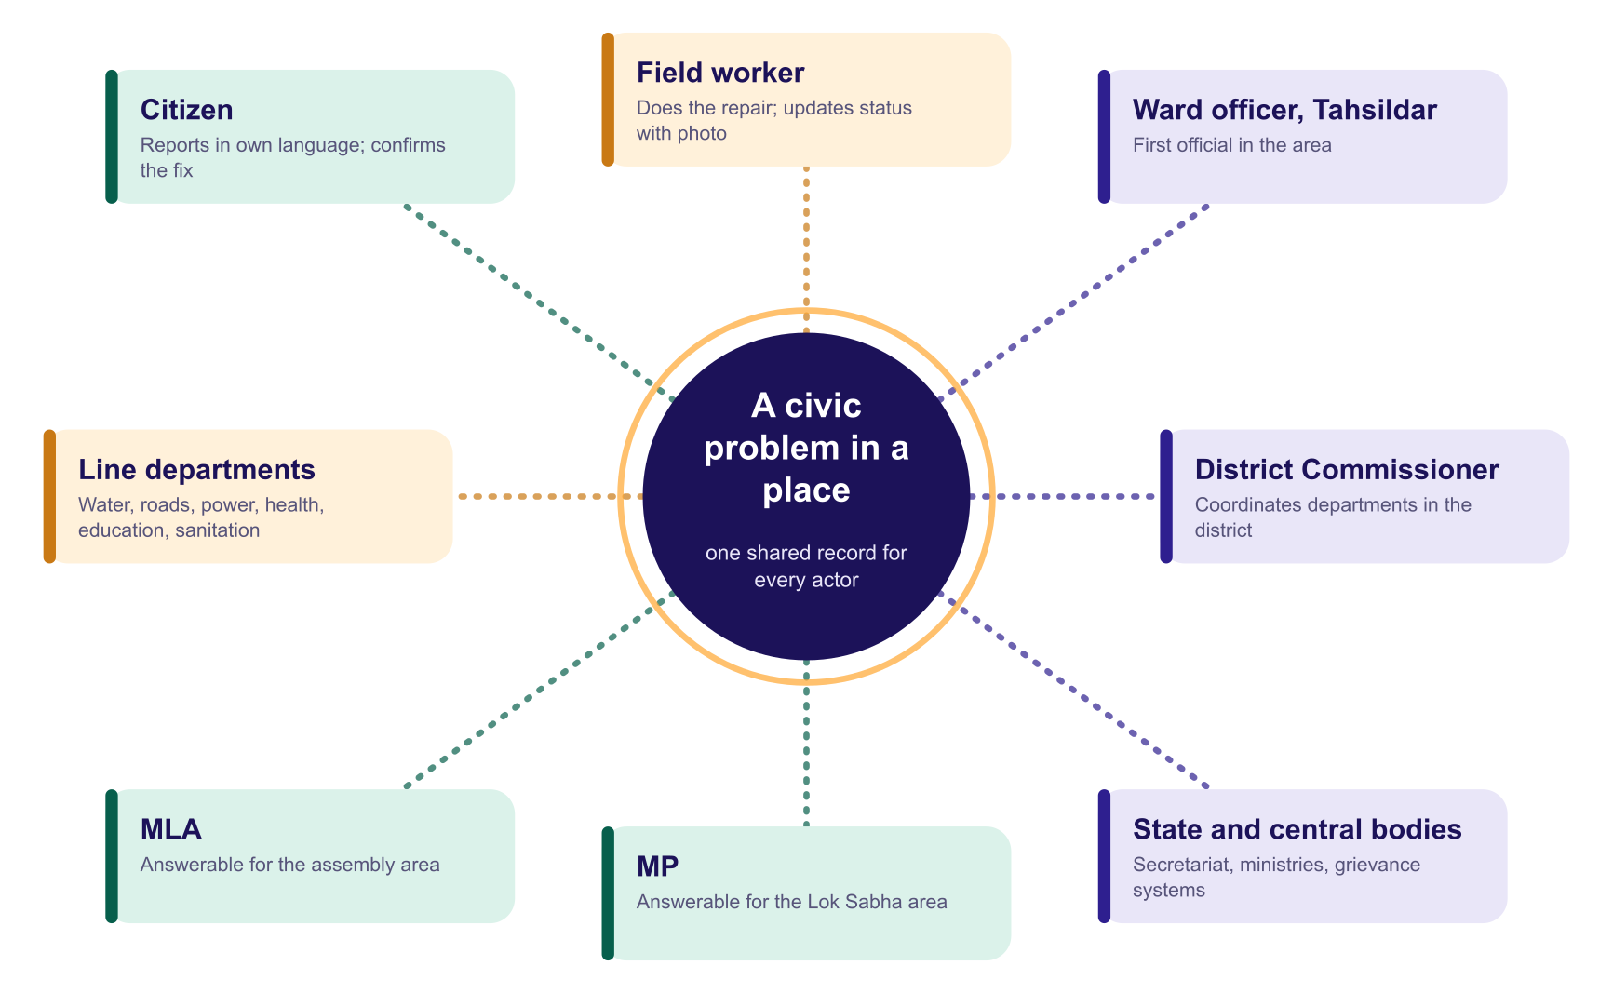
Source: team analysis of how a civic problem is handled, drawn from the roles built into the product [P6].

Everyone in the ecosystem faces the problem
Exhibit 3 Who is affected, and what breaks for each
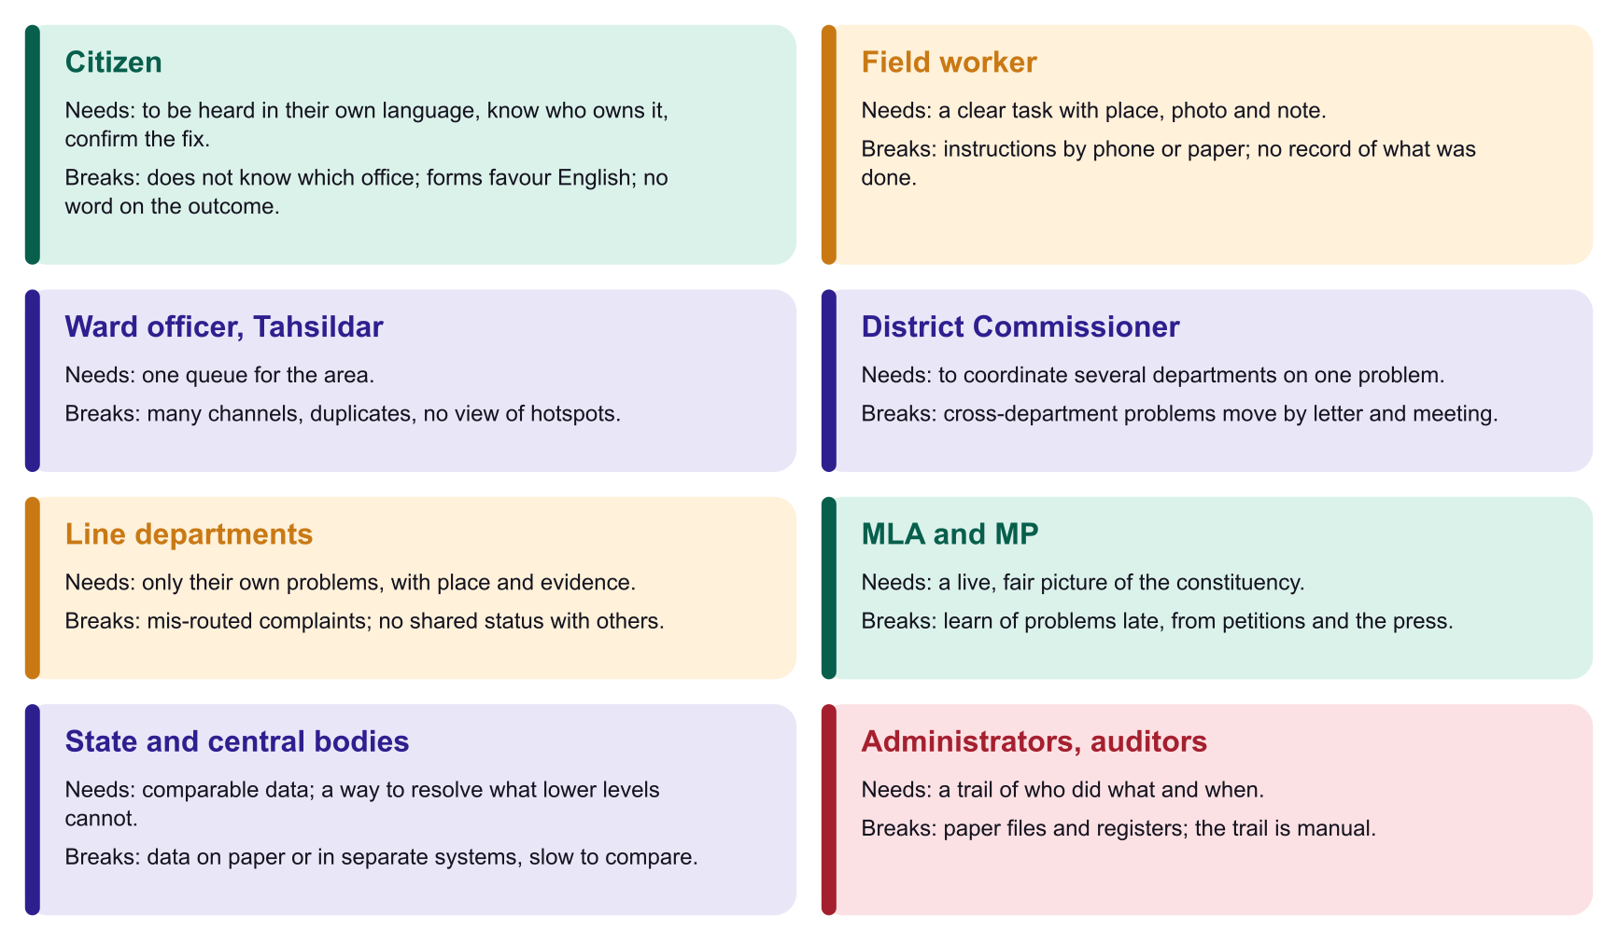
Source: team analysis; role scopes are built into the product [P6]. To be validated through interviews with each role in the pilot [A14].

The evidence that hand-offs, not effort, are the problem
Exhibit 4 Public evidence on grievance handling and paperwork
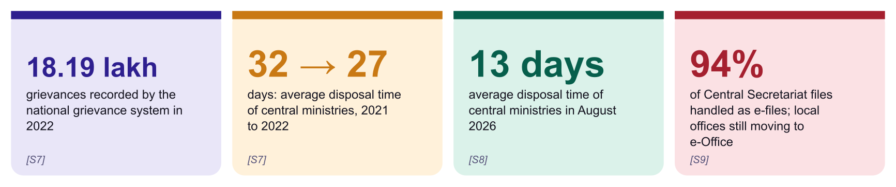
Sources: CPGRAMS annual report 2022 [S7]; DARPG monthly reports [S8]; DoPT and PIB on e-Office [S9]. These show that digital systems are already shortening disposal times at the centre, and that the paper-to-digital job is incomplete below it.
- Grievances already cross levels. Central ministries and states and Union Territories each disposed of part of the 2022 load [S7]. Karnataka's own system escalates a grievance to a higher officer if the citizen is not satisfied [S17]. The flow exists; a shared civic record across departments does not.
- Paper persists. The Central Secretariat reached 94 percent e-files [S9]. In 2024 the government identified 133 attached, subordinate and autonomous offices for e-Office, and 55 had started by July 2024 [S9]. Local offices, where civic problems are actually fixed, are further behind.

Why this is a governance problem
- Trust. A complaint that disappears teaches citizens that the system does not listen.
- Accountability. Without a named owner and a public record, no one can be held to a standard, and good officials get no credit.
- Coordination. Departments cannot fix what they cannot see together.
- Planning. Governments plan blind when problems are not captured in a structured, geotagged and comparable form.
- Inclusion. The people with most to gain from public services are least able to use English-first, form-heavy channels.

Why now
Exhibit 5 Five forces that did not exist together five years ago
Enabler | Why it matters for Prajadhwani
Bhashini | Government-built speech, translation and language tools: about 20 languages and 350-plus AI models reported [S11]. This removes the biggest barrier, language.
Connected citizens | About 109 crore internet subscribers in March 2026 [S15].
Shared digital rails | UPI, DigiLocker and Aadhaar operate at national scale [S12 to S14], so departments are used to buying shared rails.
Data protection law | The Digital Personal Data Protection Rules were notified in November 2025 and phase in over 18 months [S16]. A privacy-by-design product is timely.
Practical AI | Classification, clustering and routing run cheaply. The model picks from a verified shortlist; contacts are never generated [P6].

So what
The need is universal across the administration, the technology is affordable, and policy favours shared rails. What is missing is one record that every actor in the ecosystem can use.

2. The solution and what makes it different
Prajadhwani is a shared platform with a role for every actor: citizens report, field workers fix, officials coordinate, departments resolve, and the public can see.

What is built today
Exhibit 6 The product, by user
User | What they do today | Status
Citizen | Reports by voice, text or photo in 10 languages; sees the suggested office; gets a token and a public report card; browses a feed; says 'Me too'; chooses whether the photo is private or public (blurred) after accepting privacy terms; confirms the fix. | Built [P6]
Field worker | Task list with place, note and photo; marks in progress or fixed; closes after the 48-hour window. | Built [P3]
Ward officer, Tahsildar, District Commissioner | Six-tab dashboard for their own area; assigns workers singly or in bulk; opens the original photo; AI briefing and PDF report. | Built [P6]
MLA and MP | The same area dashboard for their own constituency; public report cards name them; leaderboard of share fixed. | Built [P6]
Administrator | Approves officials; groups similar issues by district, taluk, constituency, type, status and assignee; bulk assign and close. | Built [P3]
Line departments, state and central bodies | Receive, transfer and jointly resolve problems on one shared record with a service-level clock; connectors to existing grievance systems. | Planned (Department Hub)
The public | Open anonymised map and feed; report cards; leaderboard. | Built [P6]
Source: product as deployed and tested [P1, P3, P6]. The Department Hub is on the roadmap and is not claimed as built.

Competitive landscape
Prajadhwani does not compete with the idea of grievance redress. It improves how each existing option handles the loop. Options are grouped by type; examples include national and state grievance portals, city civic apps, single-issue apps, social media and telephone helplines.
Exhibit 7 How the alternatives compare (team assessment, a hypothesis to test in the pilot) [A15]
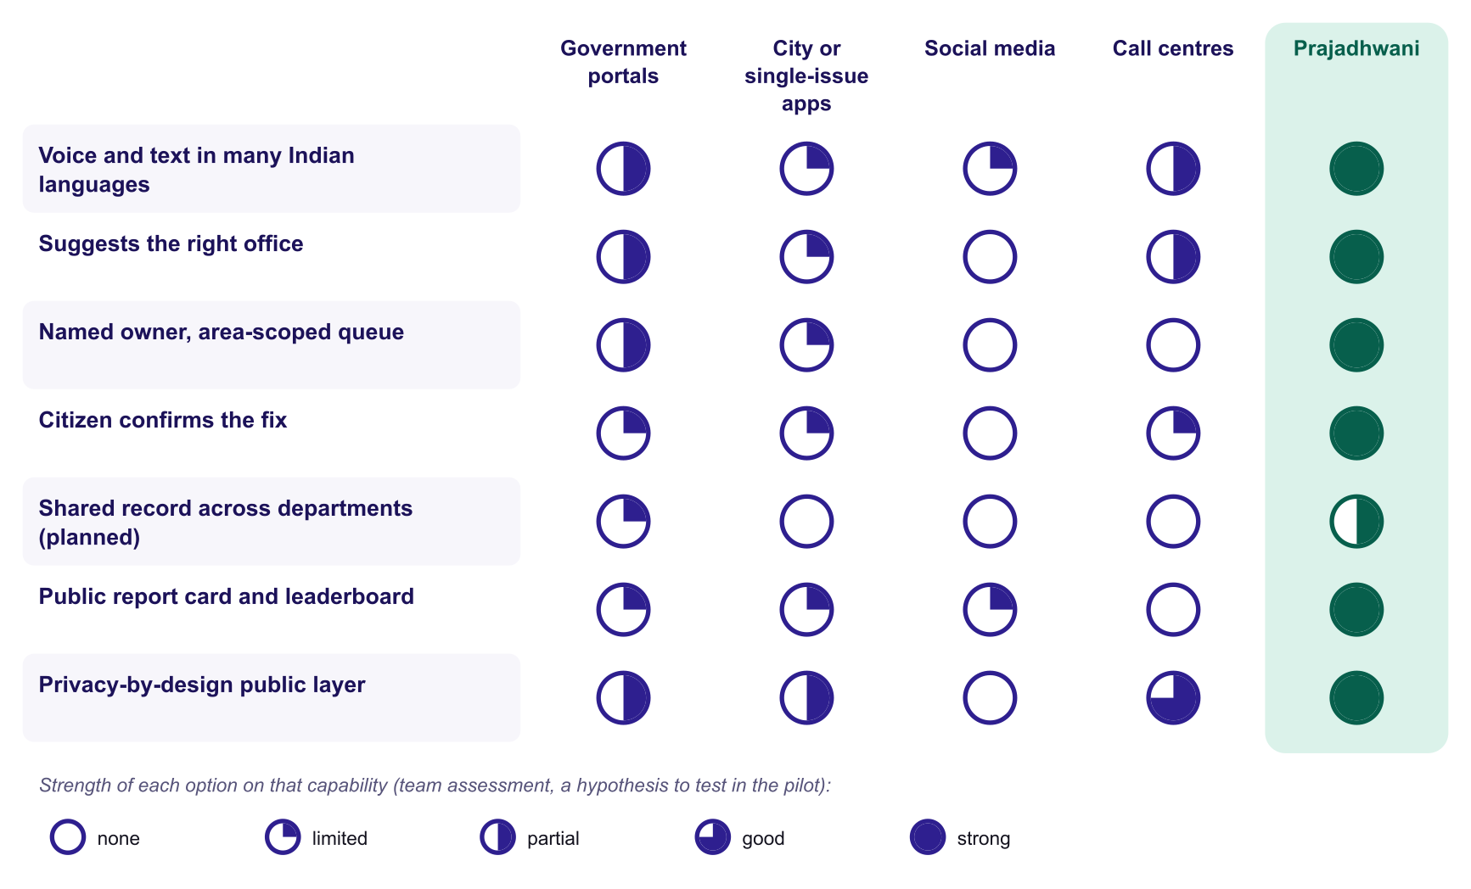
Source: team assessment of publicly known characteristics, by category and not by named product. Karnataka's Janaspandana system, for example, offers a portal, app and 1902 helpline with escalation [S17].

Five sources of difference
- One record for the whole administration. Citizens, workers, officers, departments, MLAs and MPs work from the same ticket.
- Language stays language. The citizen's words are never forced into English on their own screen [P2].
- Citizen-confirmed closure. The person who reported decides whether it is fixed, with a fair 48-hour rule [P3].
- Deterministic routing. AI ranks a shortlist; official contacts come only from a verified directory of 26 offices [P6].
- A privacy firewall. Officials and the public work from an anonymised copy; photos are private by default [P4].

3. Market: every actor who uses it and every buyer who pays
The users are the whole administration; the buyers are governments at every level. Citizens are never charged.

Who uses it, and who pays
Exhibit 8 Users and buyers
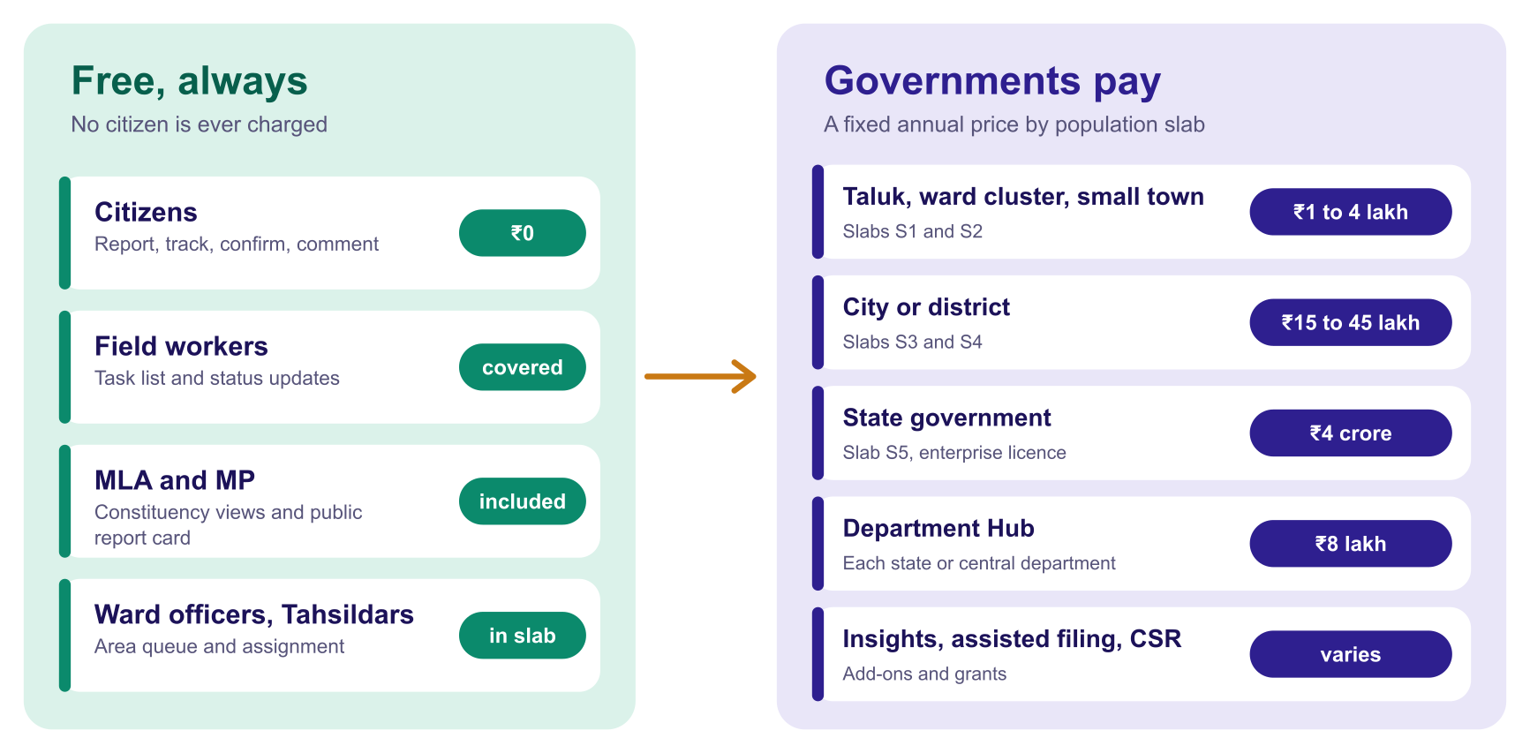
Source: team business design [A2, A3]. Citizens are never charged: this is a design rule of the platform.

How departments communicate and resolve problems together (Department Hub, planned)
Many civic problems need more than one department: a road dug up for a water pipe, a drain blocked by a power cable trench. Today these move by letter or by a meeting. The Department Hub puts them on one shared ticket:
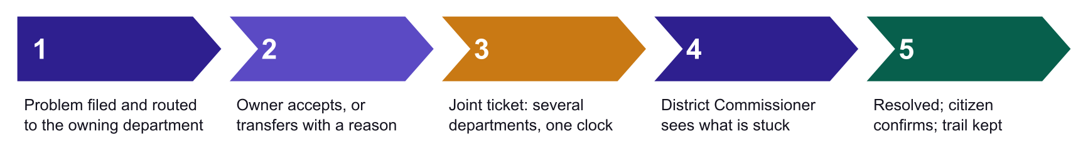
Source: product roadmap. Area-scoped assignment, suggested-office routing and the audit trail are built [P3, P6]; inter-department transfer and the joint ticket are planned and priced as an add-on [A3].

Sizing the revenue pool bottom-up
Exhibit 9 Annual software revenue pool in India (₹ crore), built from counted jurisdictions
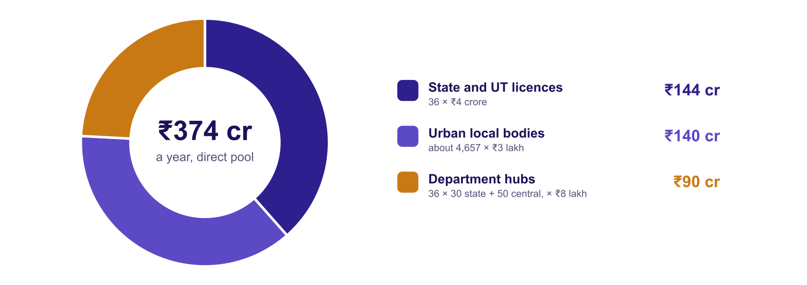
Sources: 28 states and 8 Union Territories [S21]; about 4,657 urban local bodies in 2017, a dated figure [S6]; prices from the slab card [A2]; 30 departments per state and 50 central departments are assumptions to verify [A3, A12]. The 2,68,603 gram panchayats [S5] are served inside district and state subscriptions, so they are not counted separately.

Reading the numbers honestly
- The direct software pool, a few hundred crore rupees a year, is real but not enormous. We do not hide this.
- The larger prizes are different. The value created for citizens and officials, the adjacent pools (analytics, assisted filing, integration) and the strategic position of the default civic-voice rail.
- Our own plan is a small share. Year-5 subscription revenue of ₹18.8 crore is about 5 percent of the pool, so the plan does not depend on winning the market.
So what
We should be judged as public infrastructure with a sustainable business model, not as a venture-scale consumer app.

4. Business model and pricing by population slab
Citizens pay nothing. Governments pay a fixed annual price set by the population slab of the jurisdiction, with a separate Department Hub licence.

Five revenue streams
Exhibit 10 Revenue streams
Stream | What it is | Role
1. Jurisdiction subscription | A fixed annual price by population slab (Exhibit below). Covers all officials, workers, MLA and MP views in the jurisdiction. | Core and recurring.
2. Department Hub licence | A licence per department (state or central) for inter-department transfer, joint tickets and service-level tracking. ₹8 lakh a year. | Starts in year 3, once built [A3].
3. Implementation and integration | One-time fee: onboarding, data set-up, training, integration with existing grievance systems. 25 percent of new annual contract value. | Funds delivery [A9].
4. Civic insights | Subscriptions to anonymised, aggregated analytics. | High margin; from year 3 [A10].
5. Assisted filing and CSR | A small per-filing fee at Common Service Centres; CSR and philanthropic grants for outreach. | Keeps the citizen side free [A10].

Exhibit 11 Year-5 revenue by stream (base case)
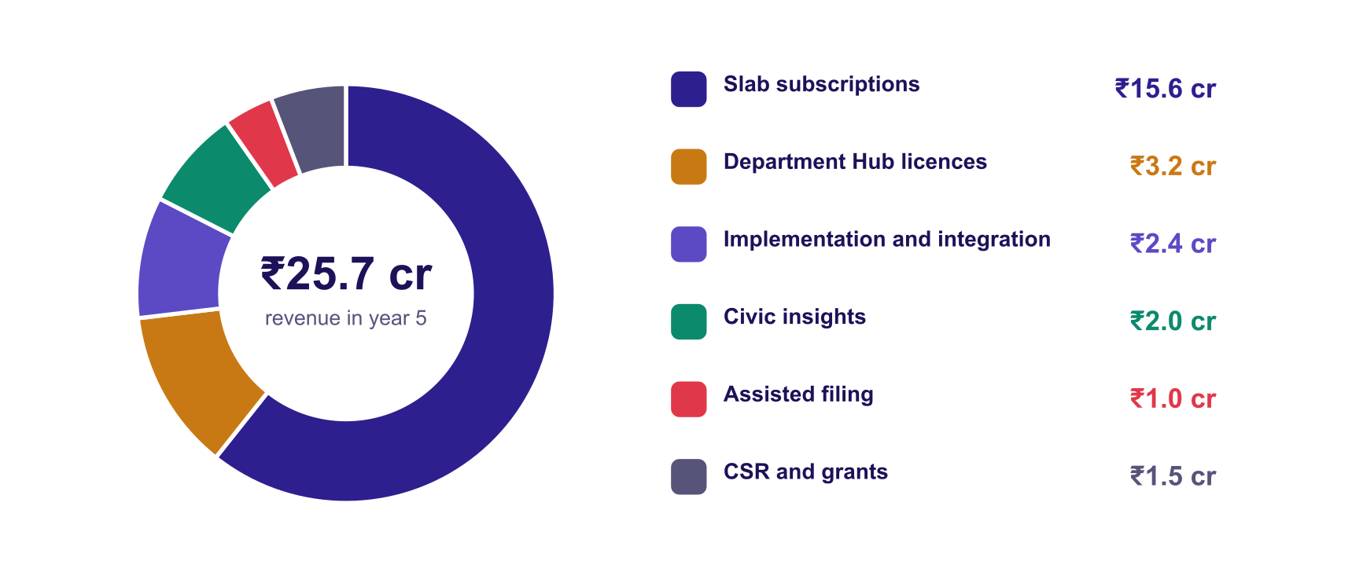

The price card: by the population of the jurisdiction
Exhibit 12 Public price card (illustrative; to be published openly)
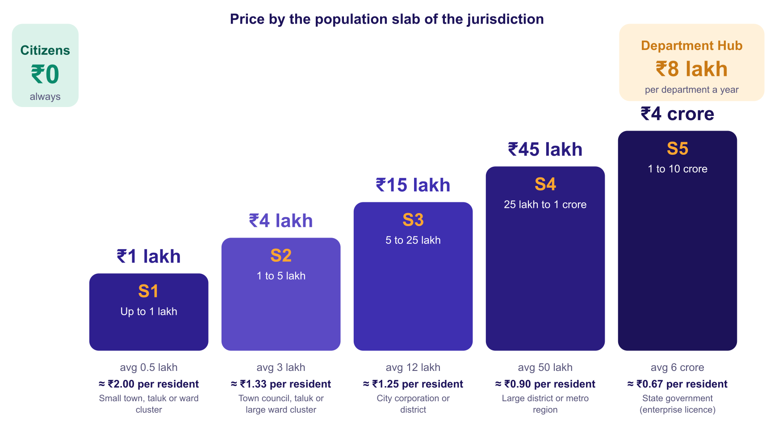
Source: team pricing proposal [A2]. The last column is price divided by the average population of the slab, shown only to compare with per-resident pricing: it falls from about ₹2 to under ₹1 as the population served rises. Karnataka's projected population is 6.82 crore [S2], so a state-slab licence of ₹4 crore is about ₹0.59 per resident.

A worked example: how Karnataka would be priced
Karnataka has 31 districts [S3], 227 taluks [P6] and a projected 6.82 crore residents [S2]. An average district has about 22 lakh residents, which is slab S3; an average taluk has about 3 lakh, which is slab S2. A buyer can start at its own size and widen later; buying once at state level is cheapest per resident.
Exhibit 13 Three ways to cover the whole state (illustrative, ₹ crore a year)
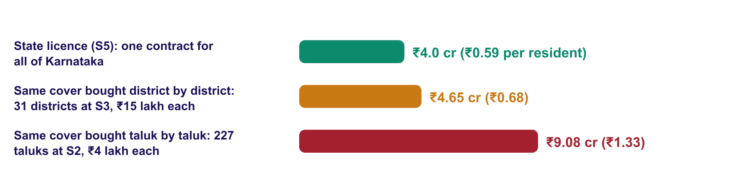
Source: team arithmetic from the price card [A2], with S2, S3 and P6. Illustrative: the state licence is a negotiated enterprise licence, and actual contracts will differ.
Exhibit 14 How a jurisdiction is placed in a slab
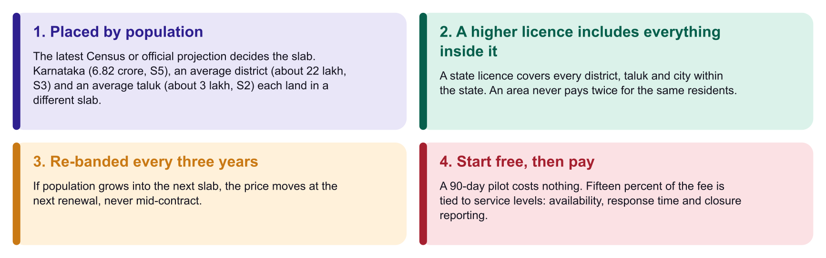
So what
The slab lets a taluk begin with a ₹4 lakh pilot-to-paid step and a state commit to ₹4 crore, with no one paying twice for the same residents. Pricing by population also keeps the offer simple: a buyer can read the card and know the fee without a negotiation about volumes.

Why price by slab and not per resident
- Simple to buy. A fixed annual price per jurisdiction fits how government budgets and the Government e-Marketplace work, with no usage metering.
- Fair across sizes. A small taluk pays a small fixed fee; a state pays more, but less per resident.
- Predictable for the buyer. The fee does not rise when citizens report more, so officials are not discouraged from encouraging use.
- Citizens stay out of the revenue model. No fees, no advertising, no sale of personal data.

The price is below the value it creates (test by slab)
Exhibit 15 Measured value versus price, by slab, at maturity (1.5 percent of residents reporting a year)
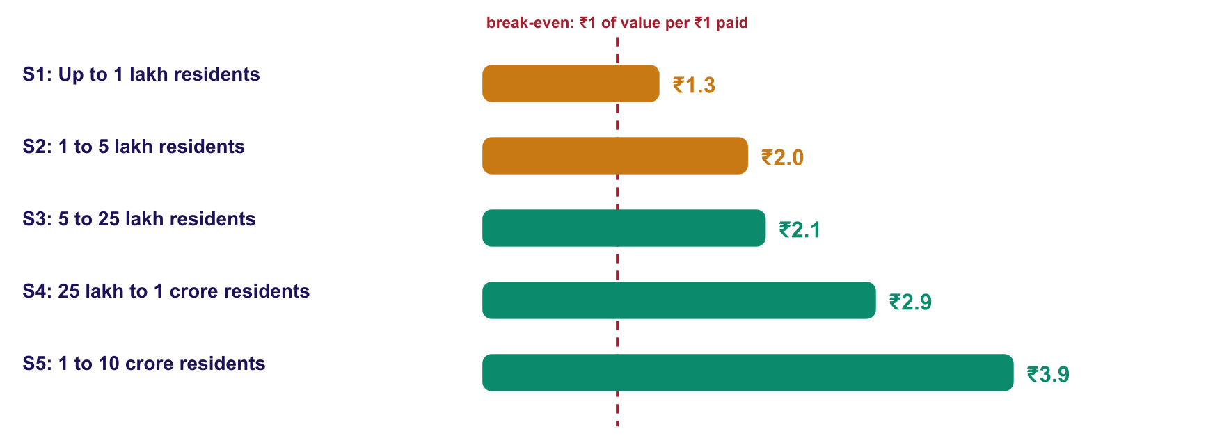
Source: model assumptions: 1.5 percent of residents report a year [A4]; ₹175 of measured value per report [A5]. Both are validated in the pilot.

Pricing principles
- Citizens are never the product. No fees, no advertising and no sale of personal data, ever.
- Pay for performance. 15 percent of each government fee is tied to service levels (availability, response times, closure reporting).
- Transparent. The price card is public. Multi-year terms and joint rollouts across offices earn discounts.
- Start free, prove, then pay. A 90-day pilot with a joint review removes procurement risk for the first buyer.
- Procurement-ready. Listing on the Government e-Marketplace; recognised startups can use relaxations on prior experience and turnover under the General Financial Rules [S18].

Unit economics of one S3 contract (a city or district of about 12 lakh residents)
Exhibit 16 Steady state, ₹ lakh a year
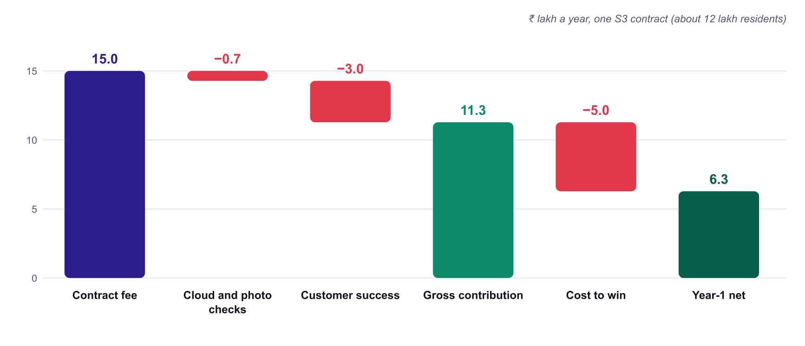
Source: team model [A2, A4, A6, A9].

5. Go-to-market
Land with one office that can say yes, prove value in 90 days, then expand across offices, departments and levels of government.

Land and expand
Exhibit 17 The expansion ladder inside one geography
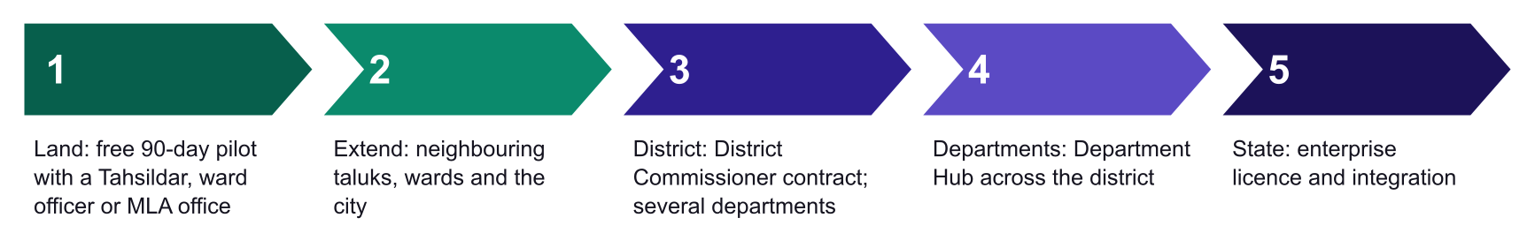
Source: team go-to-market plan [A1].

Channels
- Direct to government. Solution leads working with district and city administrations and with state e-governance bodies.
- Government e-Marketplace and startup procurement. A listed product and a public price card; relaxation of prior experience and turnover for recognised startups [S18].
- Elected representatives as sponsors. MLA and MP offices champion a rollout; their area view is included in the contract.
- Common Service Centres and gram panchayats. 'Voice Mitra' helpers bring citizens without smartphones into the system; the 2.69 lakh gram panchayats [S5] are the last mile.
- Civil-society and resident associations. Outreach and trust, supported by CSR.
- Technology partners. Bhashini for language [S11]; the national e-governance bodies for standards; government-empanelled cloud where required.

What each buyer needs to hear
Buyer | The message
Ward officer, Tahsildar | One queue for your area, with the photo and place, and a way to show what you fixed.
District Commissioner | See all departments' problems in one view; assign across departments; know what is stuck.
Line department head | Receive only your problems, with evidence; transfer what is not yours with a reason; share status with others.
MLA, MP | A live and fair picture of your constituency, ranked by share fixed, not volume.
State secretariat, central ministry | Comparable data across districts; connectors to existing grievance systems; no replacement of your portal.
Everyone | Free 90-day pilot; officials see only their own area; citizens' identities are never exposed; part of the fee is tied to service levels.

6. Financial outlook and funding need
Base case: operating surplus from year 3, ₹25.7 crore revenue in year 5, and a funding need of about ₹2.3 crore driven by government payment cycles.
Exhibit 18 Contracts in force by population slab (average over the year)
Contracts | Year 1 | Year 2 | Year 3 | Year 4 | Year 5
S1: Up to 1 lakh residents | 0 | 4 | 12 | 30 | 60
S2: 1 to 5 lakh residents | 0 | 2 | 8 | 20 | 40
S3: 5 to 25 lakh residents | 0 | 1 | 4 | 10 | 18
S4: 25 lakh to 1 crore residents | 0 | 0 | 1 | 3 | 6
S5: 1 to 10 crore residents | 0 | 0 | 0.5 | 1 | 2
Department hubs | 0 | 0 | 4 | 15 | 40
Residents covered (crore) | 0.1 | 0.2 | 4.3 | 9.5 | 18.7
Source: team plan [A1, A3]. Year 1 is the free pilot. Half a state contract in year 3 reflects a mid-year start. Karnataka has 31 districts [S3] and 224 assembly constituencies [S4], so the district and city counts are a small share of the state.
Exhibit 19 Subscription revenue by population slab (₹ crore)
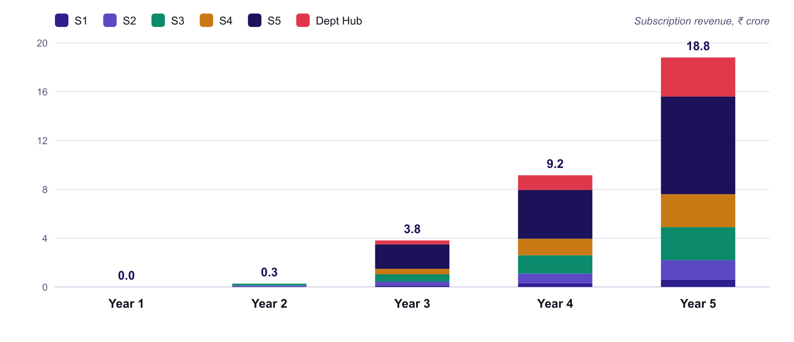
Exhibit 20 Five-year plan, base case (₹ crore)
 | Year 1 | Year 2 | Year 3 | Year 4 | Year 5
Revenue | 0.8 | 1.3 | 6.5 | 13.2 | 25.7
Slab subscriptions (S1 to S5) | 0.0 | 0.3 | 3.5 | 8.0 | 15.6
Department Hub licences | 0.0 | 0.0 | 0.3 | 1.2 | 3.2
Implementation and integration | 0.0 | 0.1 | 0.9 | 1.3 | 2.4
Civic insights | 0.0 | 0.0 | 0.2 | 0.8 | 2.0
Assisted filing | 0.0 | 0.0 | 0.1 | 0.4 | 1.0
CSR and grants | 0.8 | 1.0 | 1.5 | 1.5 | 1.5
Costs | 0.7 | 2.5 | 6.1 | 11.0 | 18.7
Team | 0.5 | 1.8 | 3.8 | 6.5 | 10.5
Cloud, photo checks, messaging | 0.0 | 0.0 | 0.2 | 0.5 | 1.1
Customer success and delivery | 0.0 | 0.1 | 0.9 | 2.1 | 4.2
Sales, field and outreach | 0.2 | 0.4 | 0.8 | 1.3 | 1.9
Legal, audit, other | 0.1 | 0.3 | 0.4 | 0.6 | 0.9
Operating surplus | 0.1 | (1.2) | 0.4 | 2.2 | 7.1
Cumulative cash after payment delays | 0.1 | (1.2) | (2.3) | (2.2) | 0.9
Source: team model, assumptions in Appendix A [A1 to A10]. Brackets denote negatives. Year 1 is the free pilot year; revenue is grants. Receivables assume a 120-day government payment cycle [A8].
Exhibit 21 Revenue, costs and cumulative cash by year (₹ crore)
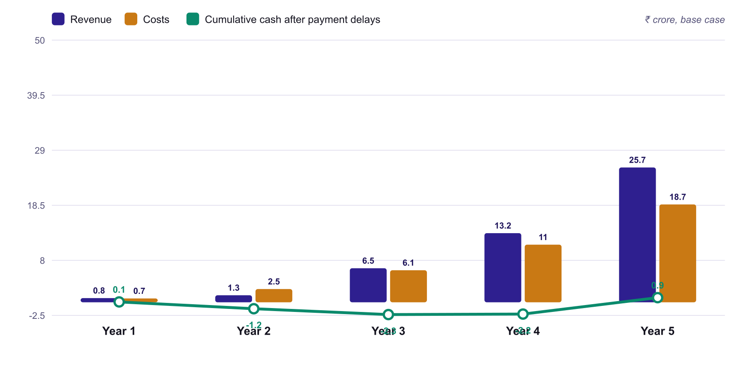

Three scenarios
Exhibit 22 Scenario comparison: revenue by year (₹ crore)
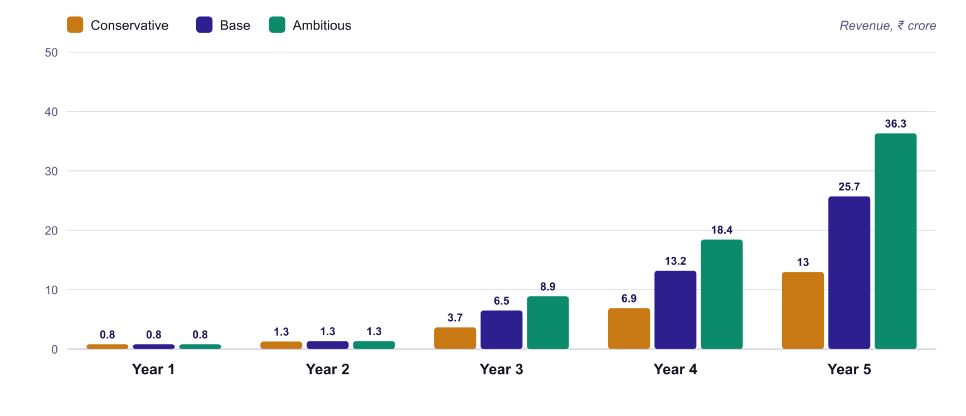
Exhibit 23 Scenario comparison: year 5 and cash need
 | Conservative | Base | Ambitious
Contracts relative to plan, from year 3 | 50 percent | 100 percent | 150 percent
Prices relative to plan | 80 percent | 100 percent | 100 percent
Residents covered, year 5 (crore) | 9.3 | 18.7 | 28.0
Revenue, year 5 (₹ crore) | 13.0 | 25.7 | 36.3
Operating surplus, year 5 (₹ crore) | 2.1 | 7.1 | 15.0
Peak cumulative cash need (₹ crore) | 2.5 | 2.3 | 1.3
Cost base | Hiring slowed by about a third from year 3 | Plan | Plan
Source: team model [A1 to A10]. In the conservative case the cost base is flexed down; without that the business would not break even.

What drives the shape of the curve
- People are the cost. Cloud and photo checks are about ₹4 per report [A6]; the plan is dominated by team and delivery cost, which we control.
- Government pays slowly. A 120-day cycle [A8] turns a profit into a cash deficit while the company grows, so funding need exceeds the accounting loss.
- Margins improve with scale. A state licence serves many residents at one fixed fee and a small marginal cost.
Funding need
The growth plan above has a peak cumulative cash need of about ₹2.3 crore (base) to ₹2.5 crore (conservative). That is not what we are asking for now. We ask for ₹10 lakh to run a six-month proof (section 14). The growth capital is raised only if the proof passes its gate, from first paid contracts, CSR, grants and follow-on investors. Year 1 of this plan is the full-scale version of that proof.

7. Impact
Measured value of about ₹49.0 crore a year by year 5 from time saved alone: about ₹2.3 of value for every ₹1 governments pay.

A simple, conservative value model
We count only what we can defend: the time citizens save and the time officials and departments save. We do not count the value of faster repairs, avoided accidents, reduced water loss or better planning. We will measure those in the pilot.
Exhibit 24 Value per report (assumptions to validate)
Item | ₹ per report | Basis and validation
Citizen time saved (no travel, no repeat visits, no chasing) | 100 | About 1.5 hours of citizen time. Validate with a time-and-motion study and official wage data in the pilot [A5].
Official and department time saved (routing, duplicate triage, status calls, transfers) | 75 | About 15 minutes of official time per report. Validate in the pilot [A5].
Measured value per report | 175 | Excludes faster repairs and downstream benefits.
Source: team assumptions [A5].
Exhibit 25 Measured value versus what governments pay (base case, ₹ crore)
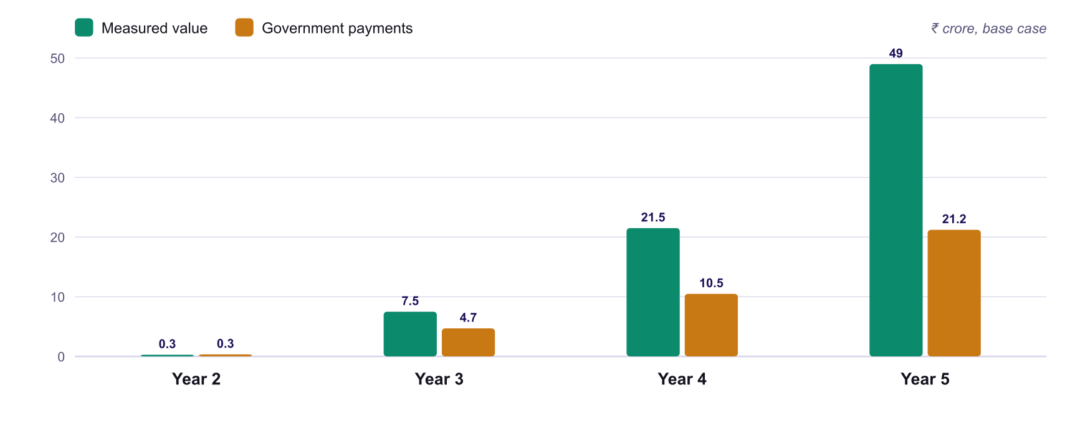
Source: team model [A1 to A5]. In years 2 and 3 adoption is still building, so payments are close to or above measured value; from year 4 value exceeds payments.

Governance outcomes
Outcome | How Prajadhwani delivers it
Transparency | Public report cards, map and feed make the state of civic services visible [P6].
Accountability | Every ticket has an area owner and an assigned worker; the history records who changed what and when; the leaderboard shows the share fixed [P3, P6].
Coordination | One record across officer, department, MLA and MP; Department Hub (planned) for joint resolution.
Responsiveness | Emergencies and hotspots are surfaced; bulk assignment [P6].
Participation | 'Me too' and comments; citizens confirm fixes [P3, P6].
Evidence-based planning | Structured, geotagged, clustered data across districts, taluks and constituencies; AI briefings and PDF reports [P6].
Inclusion | Voice in 10 languages [P2]; assisted filing for citizens without smartphones (planned).
Privacy and trust | Anonymised public layer; consent-based photos with versioned terms; area-scoped access [P4].

How we will know: the scorecard
Exhibit 26 Impact scorecard for the pilot and beyond
Metric | Why it matters | Pilot target (to set with partner) [A11]
Median time to acknowledgement by an official | Responsiveness | Within 2 days
Share of reports assigned to a named worker within 3 days | Ownership | At least 60 percent
Share of fixed reports confirmed by the citizen; reopen rate | True closure | Tracked and published
Share of reports filed in a language other than English | Inclusion | At least half in the pilot area
Share of cross-department problems resolved on a joint ticket | Coordination | Baseline in the first 60 days
Citizen satisfaction (in-app) | Trust | Baseline set in the first 30 days
Context for targets: the central grievance system's average disposal time fell to 13 days in August 2026 [S8]; our pilot targets acknowledgement in 2 days and measure confirmed closure, which the national system does not report.

8. How governance changes: from paper to digital to proactive
Adoption moves the whole chain from letters, registers and meetings to one shared digital record, and moves governance from periodic and opaque to live and public.
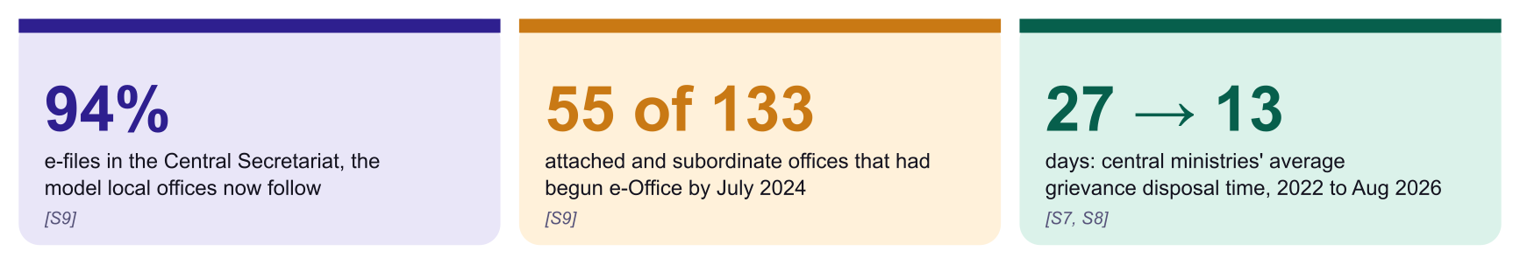
Context: digital systems are already shortening disposal and replacing paper files at the centre. Prajadhwani brings the same shift to the local, civic layer where problems are actually fixed.
Exhibit 27 The life of one civic complaint: before and after
Before: paper and phone (typical process, to be mapped with the pilot partner) [A14]
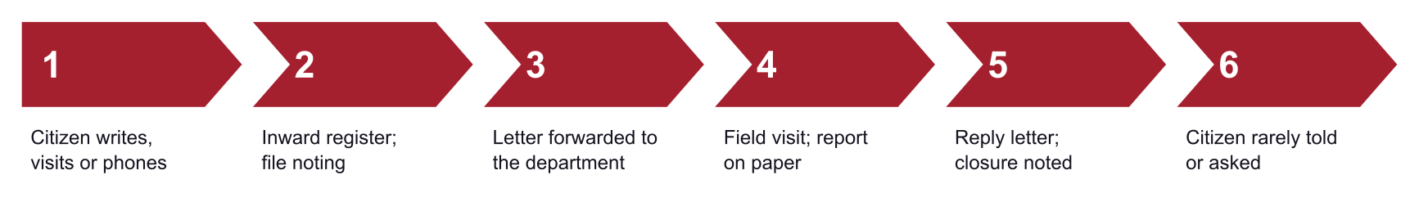

After: one shared digital record [P3, P6]
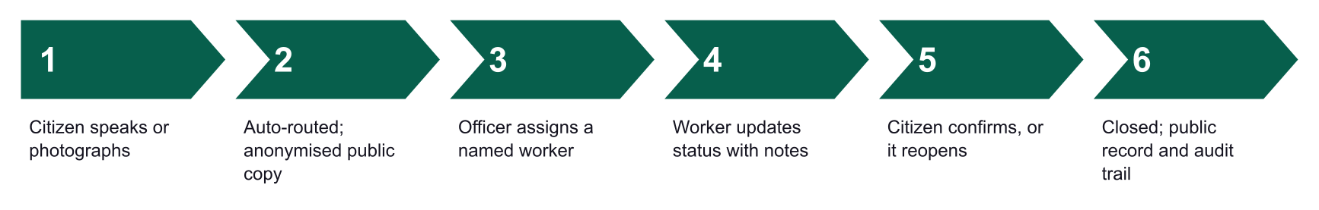
Exhibit 28 What changes at each level of administration
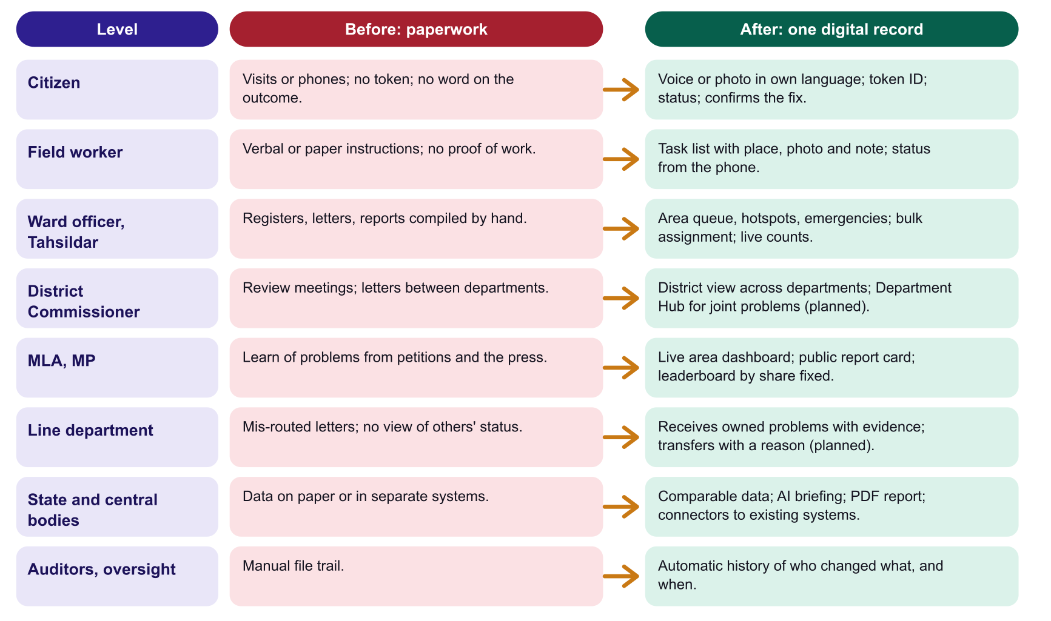
Exhibit 29 Reporting: from paperwork to digital
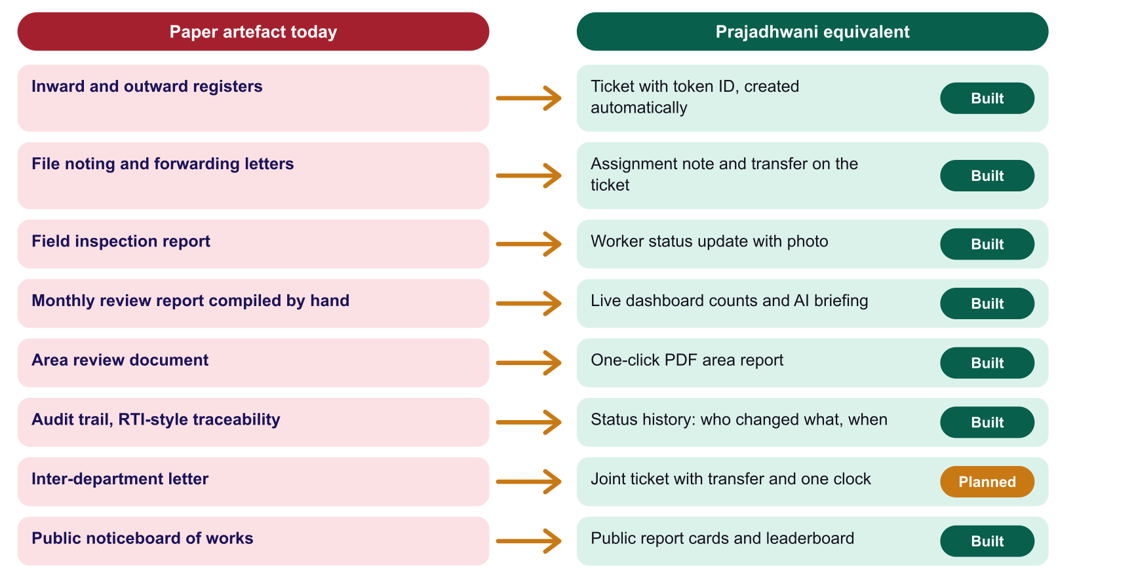
Exhibit 30 Five shifts in how governance works
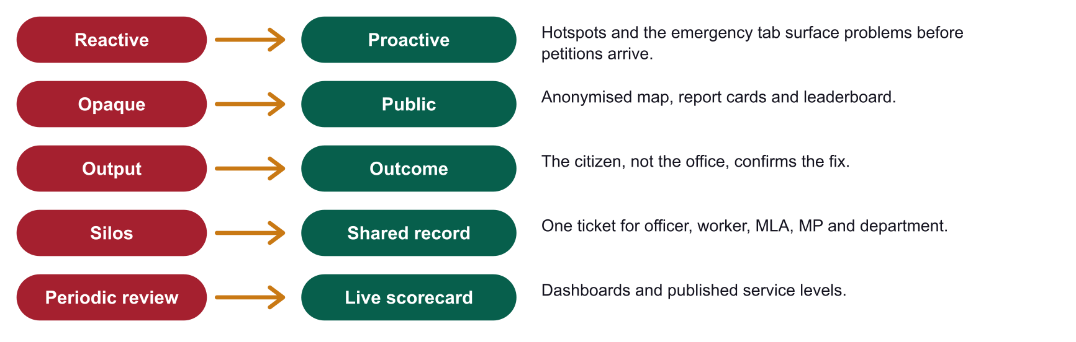

Where governance is heading: five stages
Governments everywhere are moving along the same path. Most local civic work in India still sits at stage 1 or 2: a paper file or a department's own portal [A14]. Prajadhwani's contribution is stage 3, one shared record for each problem. It is also the base for stages 4 and 5, because a connected or proactive administration needs a clean shared record to start from.
Exhibit 31 Five stages of governance maturity
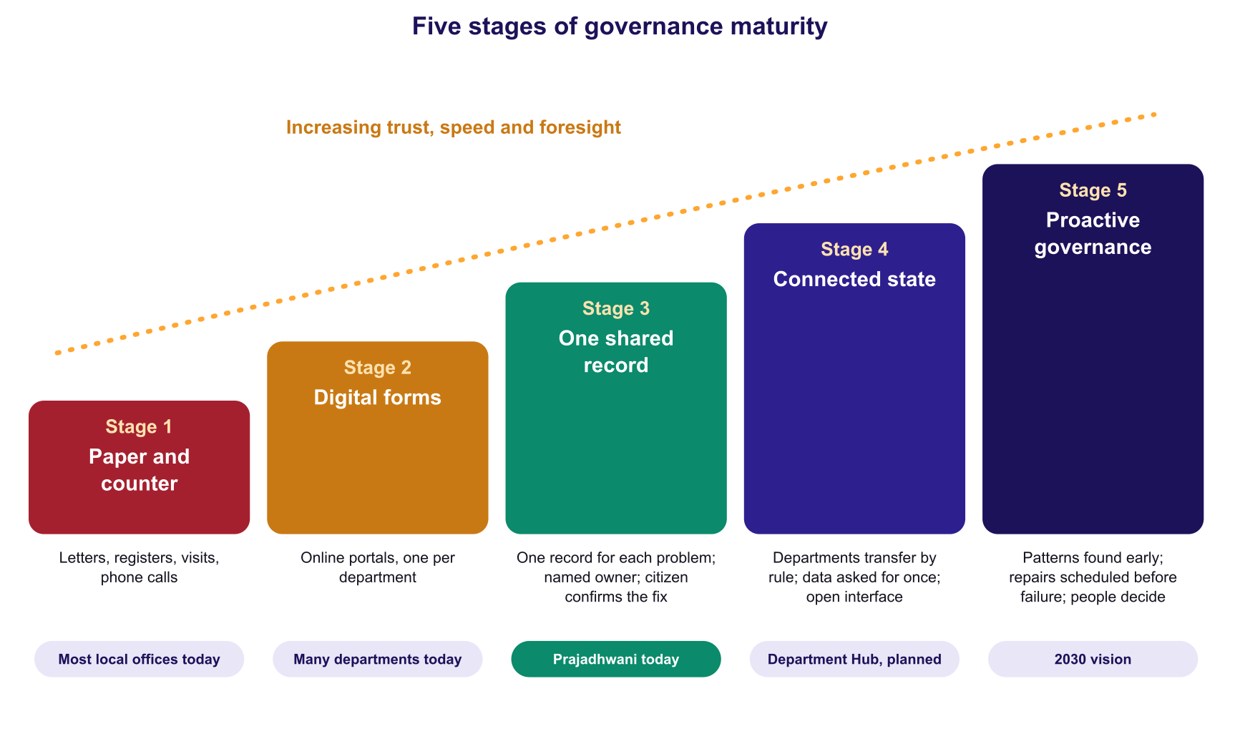

What Europe and China show
Two very different systems point to one lesson. Citizens do not want to learn which office owns a problem, and administrations perform better when each case has one owner, one clock and one record.
Exhibit 32 Three reference points: Estonia, the European Union and China
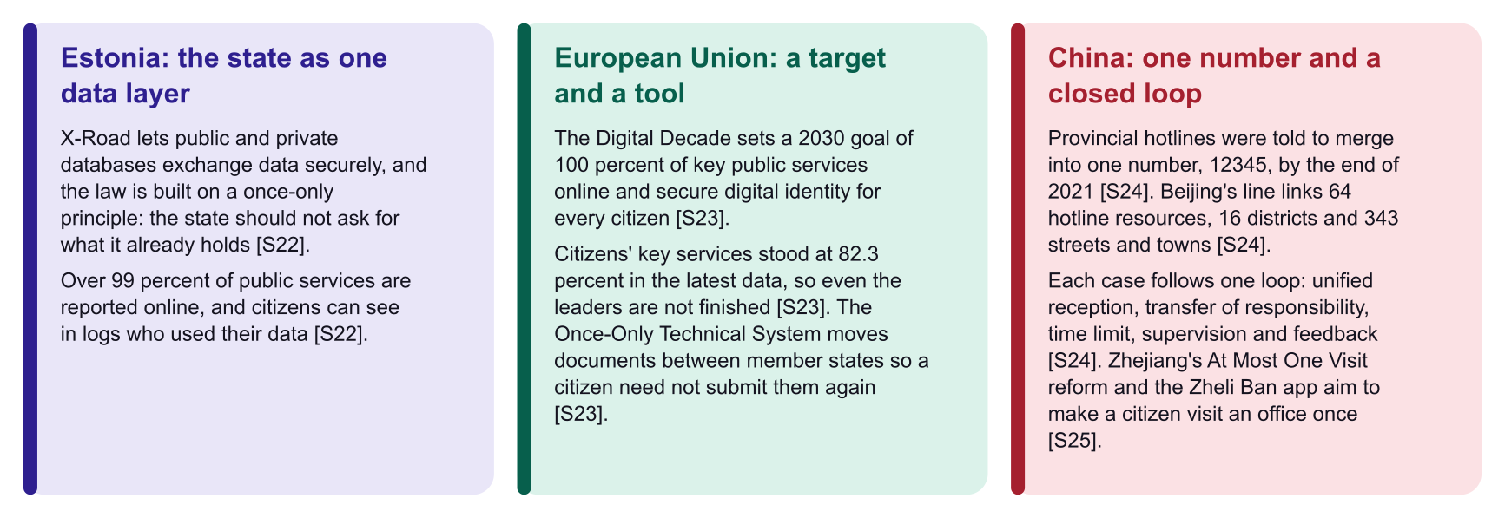
Sources: [S22], [S23], [S24], [S25]. The Estonian figure is as reported by the e-Estonia programme and service counts vary by source. EU progress figures should be checked against the latest State of the Digital Decade report. Chinese performance figures come from official or state-affiliated media and have not been independently verified.
Exhibit 33 What we adopt, and where we differ
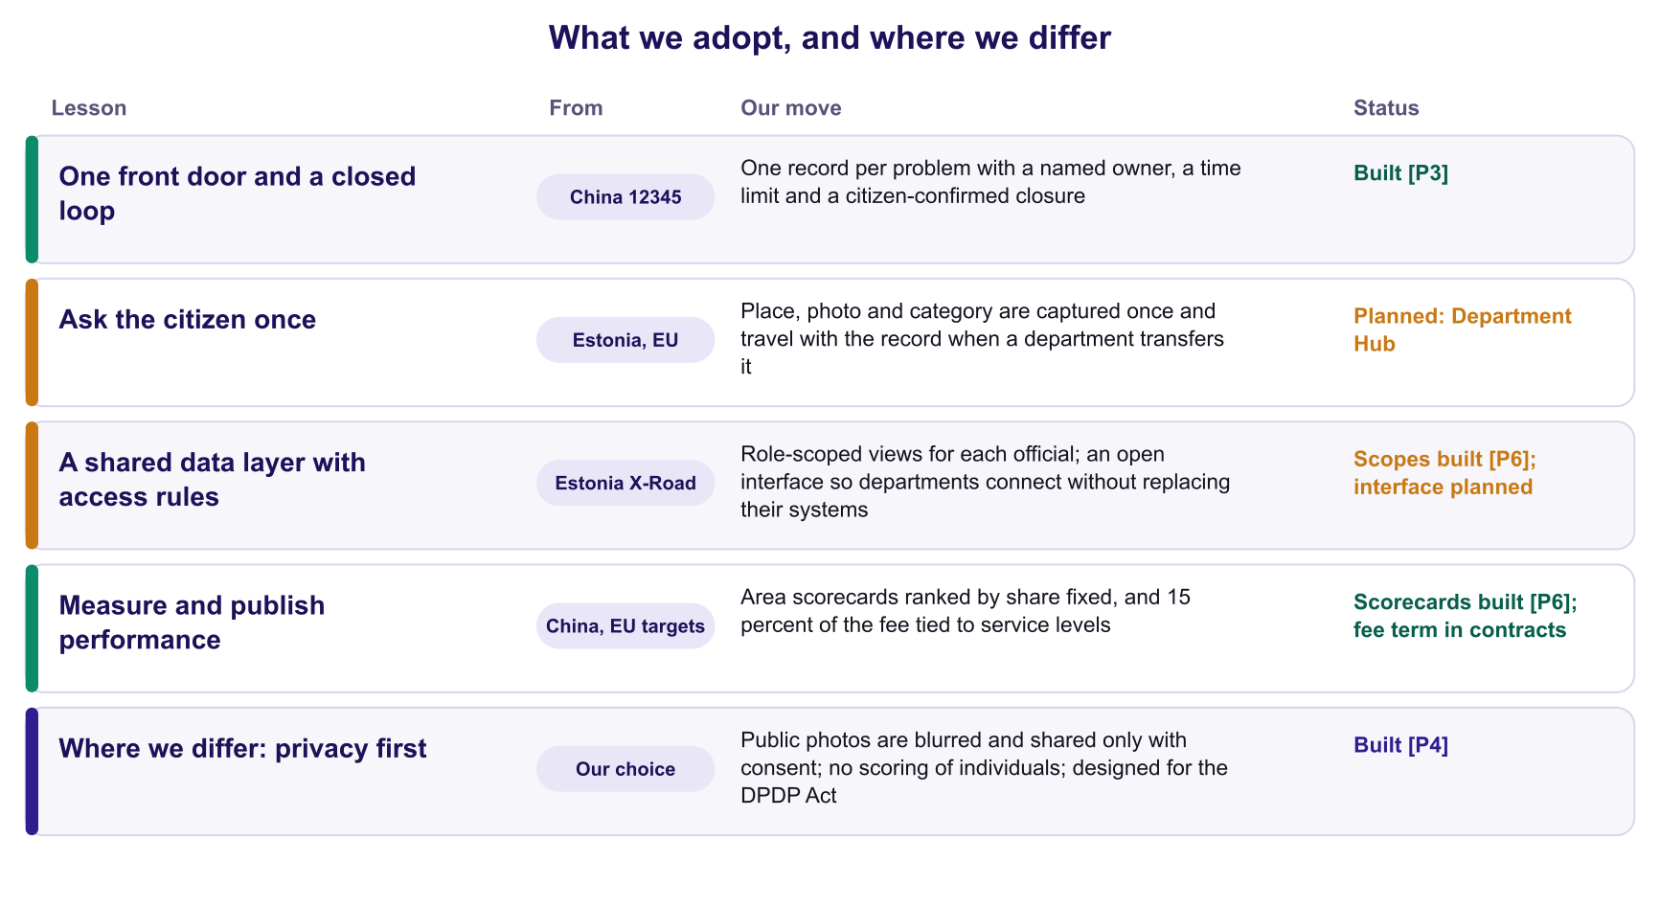
We adopt the discipline, not the architecture, of any one country. India's federal structure, the constitutional right to privacy and the DPDP Act [S16] mean Prajadhwani must work across many independent departments, leave each in control of its own systems, and keep citizens' identity private. The closed loop of China's 12345 hotline and the once-only principle of Estonia and the EU are the ideas worth borrowing; centralised scoring of individuals is not.

Governance in 2030: from reactive to proactive
Exhibit 34 Today, next and the 2030 vision
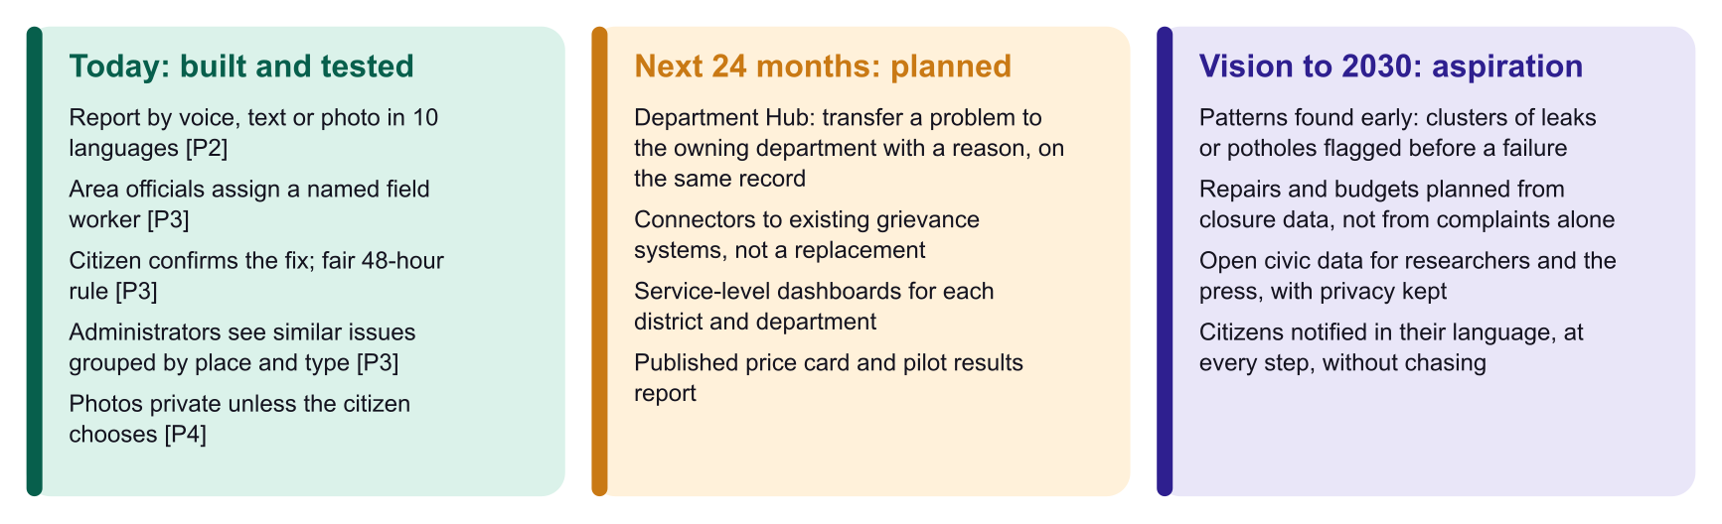
Each column builds on the one before. Nothing in the 2030 column is built. It is a direction, shown separately so that no one mistakes vision for product.
So what
The biggest saving is not speed alone. It is that every actor works from one record, so ownership, evidence and outcome are visible to everyone who needs them.

9. Digital India alignment and the public-rail strategy
Prajadhwani turns Digital India's three vision areas into a working civic service: infrastructure as a utility, governance on demand, and empowerment of citizens.
Exhibit 35 Shared rails at national scale, and the one that is missing
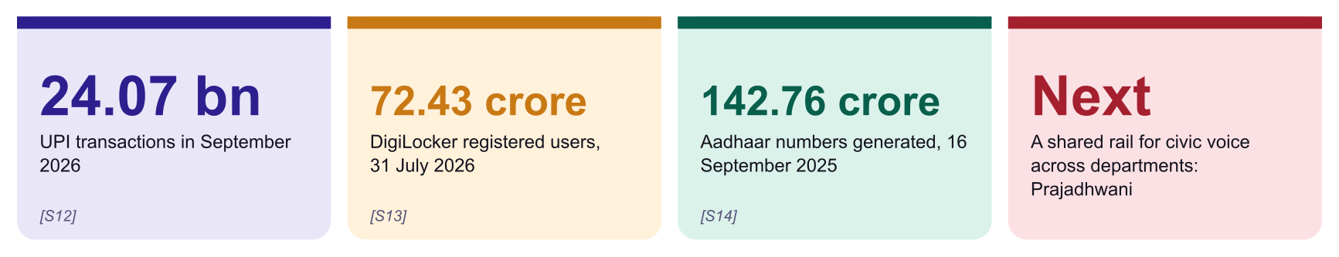
Sources: NPCI data via press [S12]; Parliament reply on DigiLocker [S13]; UIDAI [S14].
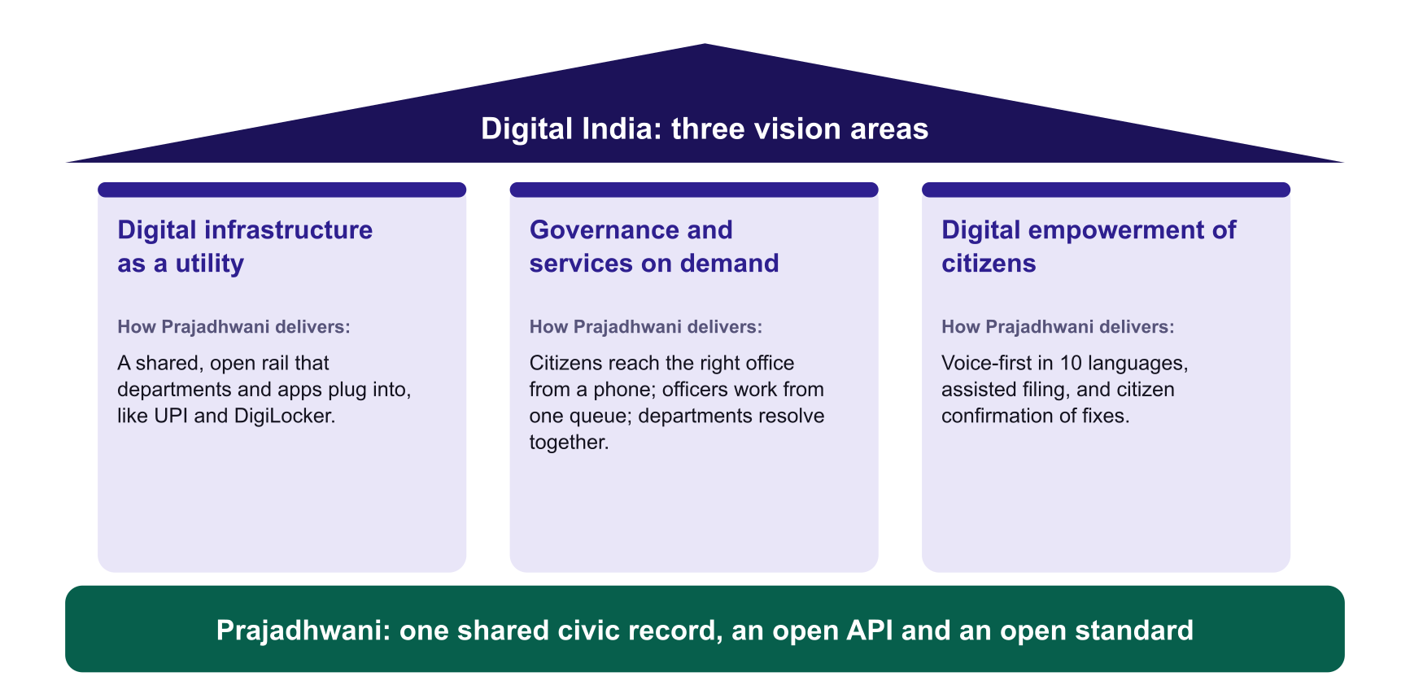
Exhibit 36 Alignment with Digital India and national priorities
National priority | How Prajadhwani contributes
Digital infrastructure as a core utility (Digital India vision area 1) | A shared, open rail that departments and apps plug into, in the spirit of UPI and DigiLocker [S10, S12, S13].
Governance and services on demand (vision area 2) | Citizens reach the right office from a phone; officers work from one queue; departments resolve together; status is visible [S10, P6].
Digital empowerment of citizens (vision area 3) | Voice-first in 10 languages, assisted filing, and citizen confirmation of fixes [S10, P2].
Bhashini | Uses Bhashini for speech recognition, translation and language detection, a live public-service use of the platform [S11, P2].
Digital Personal Data Protection Act and Rules | Recorded consent for public photos with a versioned terms record; purpose limitation; anonymised public layer; role-scoped access [S16, P4].
Government e-Marketplace and startup procurement | Public price card; relaxation of prior experience and turnover for recognised startups [S18].
e-Office and paperless government | Extends the paper-to-digital shift from the secretariat to the local, civic layer [S9].
Common Service Centres and gram panchayats | 'Voice Mitra' assisted filing; the last mile of about 2.69 lakh gram panchayats [S5].

From product to public rail: three layers
Exhibit 37 The path from an app to a rail
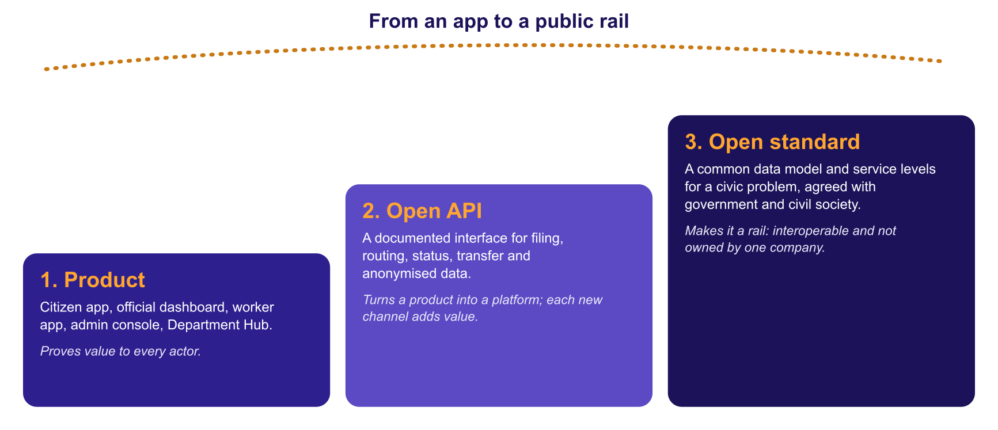

Governing the rail
Public rails earn trust through governance as much as technology. We propose to separate the operating company from the open standard: the company runs the service and sells subscriptions, while a non-profit foundation with government, civil-society and academic members holds the open standard, the data-protection charter and the leaderboard method.
The vision
A citizen in any village or ward speaks one sentence in their own language. It reaches the right officer, department and worker, is fixed, and returns to the citizen to confirm.
Every grievance channel in the country, whether a state helpline, a city app or a national portal, speaks to the same rail, so no one has to start again.

10. Expansion roadmap
Expand in layers: depth in Karnataka first, then neighbouring language-fit states, then the rest, adding departments and channels as we go.
Exhibit 38 Phased roadmap
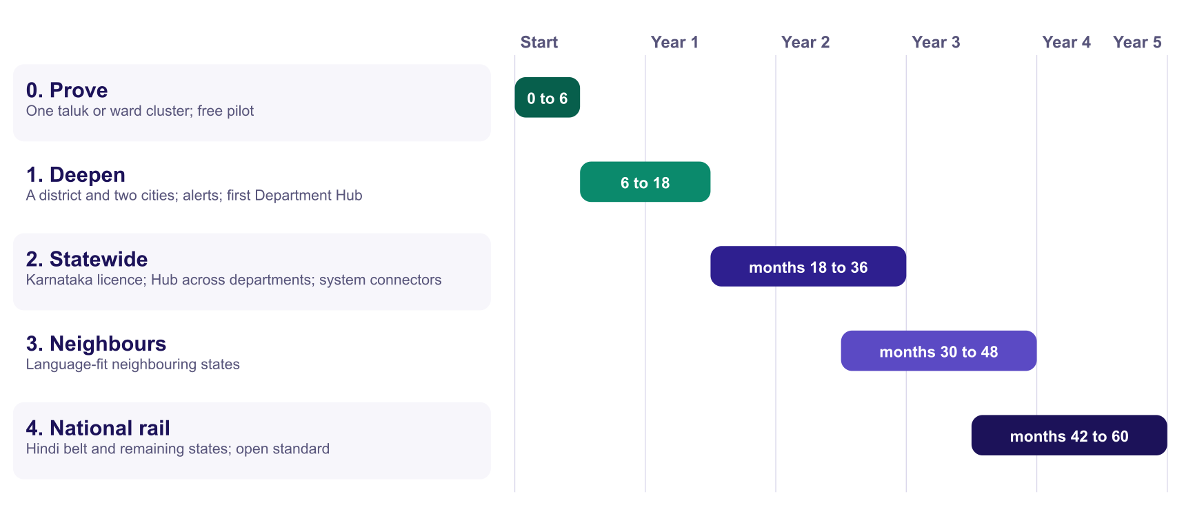

Choosing the next states
Exhibit 39 State prioritisation (team judgement, to be validated) [A13]
State | Languages already supported in the app [P2] | Why in this wave
Karnataka | Kannada, English | Home state: area data, 224 assembly and 28 Lok Sabha constituencies [S4], 31 districts [S3] already loaded [P6]. Population about 6.82 crore [S2].
Maharashtra | Marathi, Hindi, English | Language supported; neighbouring state.
Tamil Nadu | Tamil, English | Language supported; neighbouring state.
Telangana, Andhra Pradesh | Telugu, Hindi, English | Language supported; neighbouring states.
Kerala | Malayalam, English | Language supported; neighbouring state.
Gujarat, West Bengal, Punjab | Gujarati, Bengali, Punjabi, Hindi, English | Languages supported; second wave of expansion.
Hindi-belt states | Hindi, English | Hindi supported; state by state, after the open API is in place.
Source: languages from the product [P2]; sequencing is team judgement [A13]. State populations other than Karnataka are deliberately not quoted here, because we have not yet verified them against official sources.

What changes when we enter a new state
- Reference data: areas, boundaries, representatives and the directory of offices (the main work).
- Language quality review by native speakers.
- Integration with the state's existing grievance system.
- Department Hub set-up: the state's department list and owners.
- Local partners for outreach and assisted filing.
- No new product build: area, language and routing are configuration.

Capability expansion
- More channels: WhatsApp, IVR and kiosks for citizens who do not use the app.
- More languages: More Indian languages as Bhashini coverage grows [S11].
- Deeper service: Deadlines and escalation, official replies visible to citizens, department scorecards, links into existing grievance systems.
- More uses of the rail: Emergency alerts, scheme-delivery feedback and public-works progress tracking.

11. Operating model, platform governance and team
A lean team, a clear governance charter and independent oversight make the platform safe to hold public trust.

Team and hiring plan
Exhibit 40 Team by phase [A7]
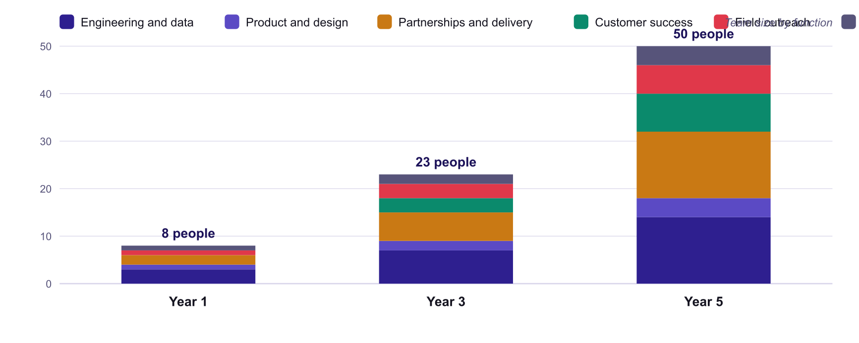
Source: team plan, consistent with the team cost line in the financial plan [A7].

Platform governance
Principle | How it is enforced
Purpose limitation and data minimisation | Only data needed to route and fix a report is collected; the public layer carries an allow-listed set of fields, audited regularly [P4].
Consent and control | Photos are private by default; public only after the citizen accepts versioned privacy terms; withdrawal deletes the public copy [P4].
Least-privilege access | Officials see only their own area; field workers see only tickets assigned to them; every status change records who and when [P3].
Transparency of method | The leaderboard ranks share fixed, not volume; vacant seats are not ranked; trial data is never counted [P6].
No invented facts | Official contacts come only from a verified directory; AI never generates them [P6].
Abuse and safety | Comment moderation, rate limits, safe-search check on every public photo [P4].
Independent oversight | An advisory board with government, civil-society, academic and citizen members reviews privacy, fairness and performance quarterly.
Security | Independent security audit before real data is held; role-based rules validated [P3]; data stored in India on government-empanelled cloud where required.

Service levels we publish
- Platform availability and response times, reported monthly.
- Share of reports acknowledged by an official within 2 days, per area.
- Share of fixed reports confirmed by citizens, and the reopen rate, per area.
- Time to remove abusive content and to withdraw a public photo.

12. Risks and how we manage them
The largest risks are institutional rather than technical: procurement, adoption and political sensitivity.
Exhibit 41 Risk register [A16]
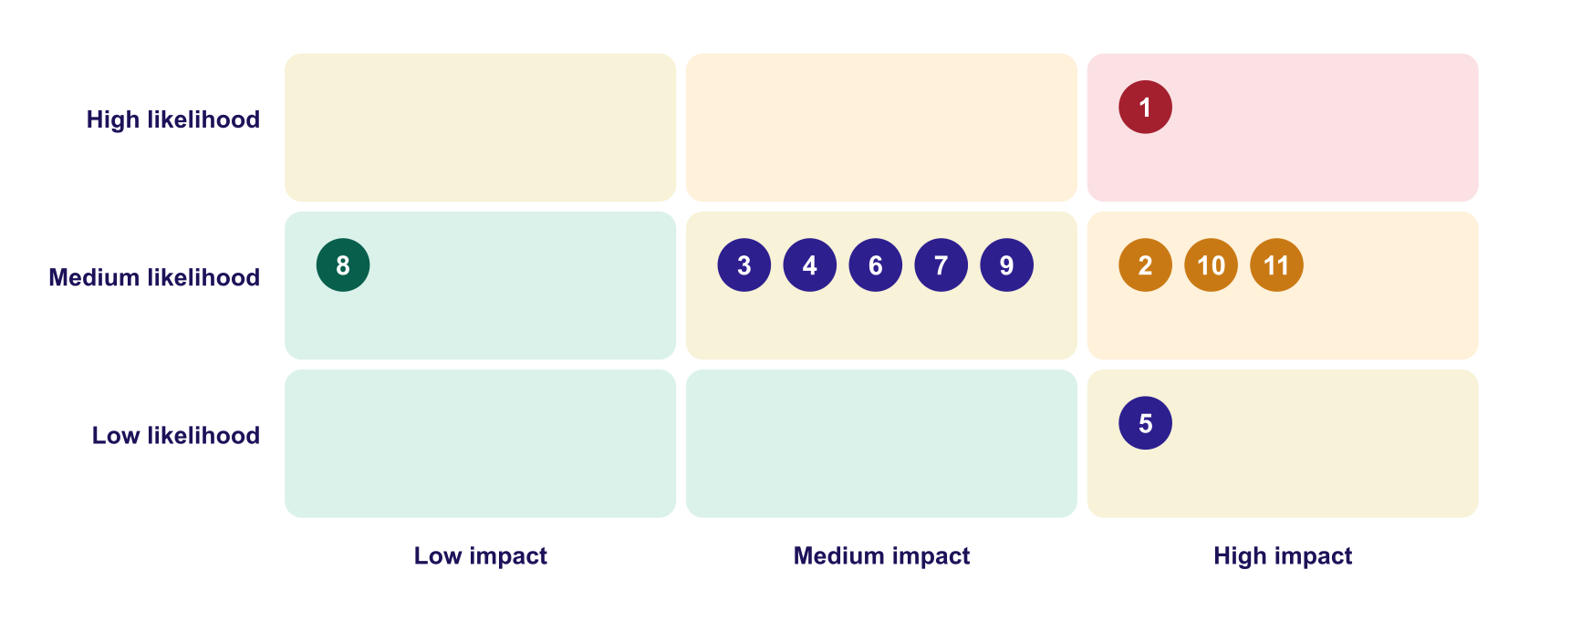
Risk | Likelihood | Impact | Mitigation
1. Slow government procurement and late payment | High | High | Free 90-day pilot; GeM listing and startup relaxations [S18]; public price card; 120-day receivables in the plan [A8]; CSR as a buffer.
2. Officials and departments do not adopt | Medium | High | Area-scoped, simple queue; training; elected-representative sponsorship; adoption metrics in the joint review.
3. Departments resist a shared record | Medium | Medium | Start with one willing department; show time saved; transfer with a reason, not blame; District Commissioner sponsorship.
4. Political sensitivity of the leaderboard | Medium | Medium | Rank on share fixed, not volume; publish the method; never rank vacant seats; start opt-in if needed [P6].
5. Privacy incident or misuse of photos | Low | High | Private by default; consent and versioned terms; blur and EXIF removal; safe-search; least privilege [P4]; security audit; breach plan.
6. Language quality errors | Medium | Medium | Native-speaker review; citizen can edit text; fall-back providers [P2].
7. Dependence on third-party services (Bhashini, cloud) | Medium | Medium | Fall-back providers already built [P2]; data portability; production quota; multi-region plan.
8. Spam and abuse | Medium | Low | Moderation, rate limits, reporting.
9. A government-built alternative | Medium | Medium | Position as an open rail that integrates with national and state systems [S7, S17]; offer to be adopted as the standard.
10. Trust gap among citizens | Medium | High | Publish the scorecard; citizen confirmation; visible fixes; start where a partner is committed.
11. Funding and key-person risk | Medium | High | Document everything; a small ₹10 lakh first stage limits exposure; growth capital only after a stage gate; phased hiring; cost flex as in the conservative case.
Source: team assessment [A16].

13. The next 24 months and the 100-day plan
We are ready to start the pilot within days of a partner signing.

The 100-day plan
Exhibit 42 From signature to joint review
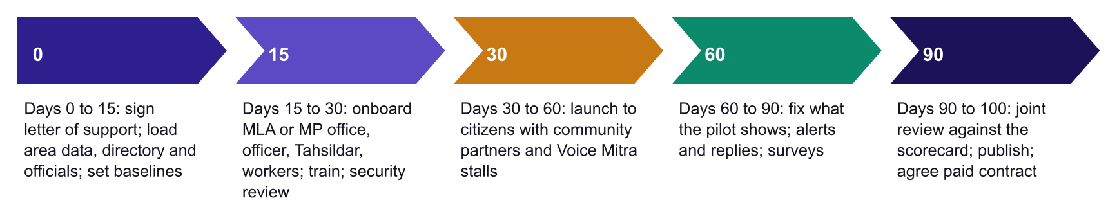

Milestones
Exhibit 43 24-month milestones
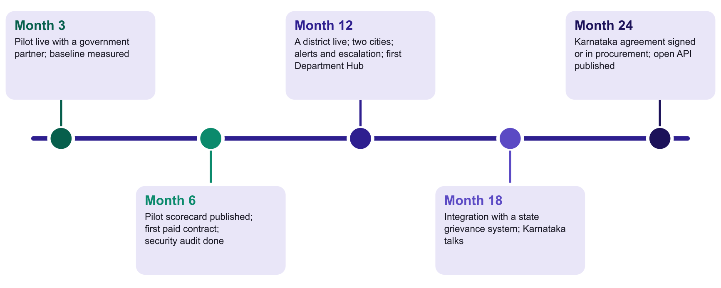

14. The ask: ₹10 lakh and what it delivers
We ask for ₹10 lakh and one pilot partner. It buys a six-month, real-world proof in one area. It does not buy the whole plan, and we say so.
Exhibit 44 What we need
Support | Why | Size
Pilot partner in government | A named taluk or ward cluster of about 3 lakh residents (an S2 jurisdiction), its officials, one MLA office and two or three departments. | Letter of support or MoU
Seed grant | To run the six-month proof in this report. Budget on the next page [A17]. | ₹10 lakh in total; challenge grant of ₹[__] lakh towards this
Bhashini production access | A production quota and technical contact for the pilot [S11]. | Access
Privacy and legal review | Terms, privacy notice and data-sharing agreement under the Digital Personal Data Protection Act and Rules [S16]. A scoped review is funded; a pro bono extension is welcome. | ₹1 lakh, funded
Security review | A scoped review of the callable functions, database and storage rules before real citizen data is held. A full audit is a Stage 1 item. | ₹1 lakh, funded; full audit ₹2 to 3 lakh later
Mentoring and introductions | Government partnerships, public procurement, civic-tech product and policy. | Mentors

What ₹10 lakh realistically does
Exhibit 45 Use of the ₹10 lakh over six months
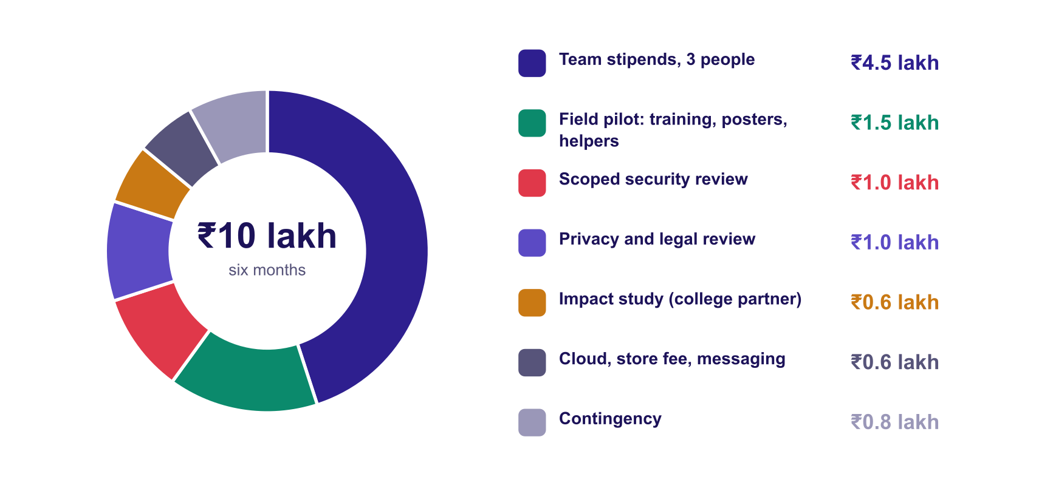
Source: team plan [A17]. Stipends assume ₹25,000 a month for three people. Cloud is mostly within free quotas (photo checks are free for the first 1,000 a month); the line covers overage, the Android store fee, a domain and messaging.
Exhibit 46 What gets done in six months
Deliverable | Detail | How it is checked
A live pilot in one area | One taluk or ward cluster of about 3 lakh residents, its officials, one MLA office and 10 to 15 field workers across two or three departments. Departments are coordinated by manual transfer until the Department Hub exists. | Area officials sign in and use the live system
Real citizen reports | At least 500 reports in the four live months. At the plan's 0.8 percent of residents a year [A4] the area would file about 2,400 a year, so this is a modest target. | Counted from the system, not estimated
The closed loop proven | 90 percent of reports assigned to a named worker within 24 hours; 60 percent or more confirmed fixed by the citizen. | System records; pilot partner signs off
Measured value | A time-and-motion study on 100 reports, with a college partner, replaces the ₹175 assumption [A5] with a measured figure. | Study report
Privacy and security cleared | Scoped security review; privacy notice, terms and data-sharing agreement reviewed. | Reviewer letters
A pilot report and a first contract | A public pilot report, and a paid S2 contract (₹4 lakh a year [A2]) or a letter of intent. One such contract equals 40 percent of this ask. | Signed document

Exhibit 47 Six months, month by month
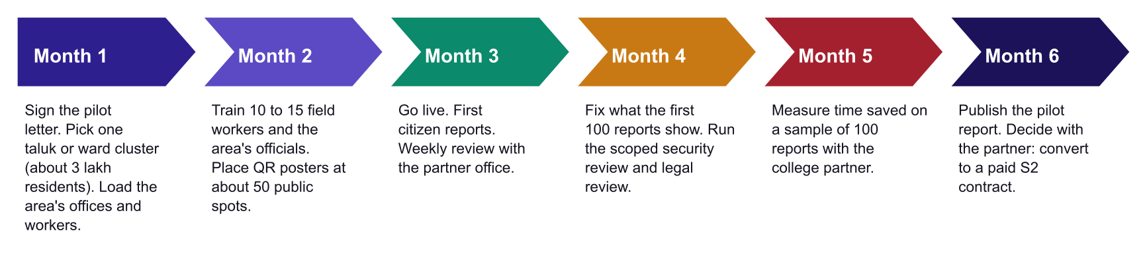

What ₹10 lakh does not do
- No Department Hub. It is built after the first contract, because it needs two or three departments to test it with.
- No second district or state. One area, done well, is the proof.
- No full-time salaries. The team works on stipends. That is right for six months and not sustainable beyond them, which is why the gate matters.
- No large marketing or full audit. A full security audit (₹2 to 3 lakh) and any paid outreach wait for Stage 1.
- No guarantee of a government contract. Procurement is slow [A8]. The gate asks for a contract or a letter of intent, not payment received.

From ₹10 lakh to growth: a stage gate
Exhibit 48 What ₹10 lakh buys and what it unlocks
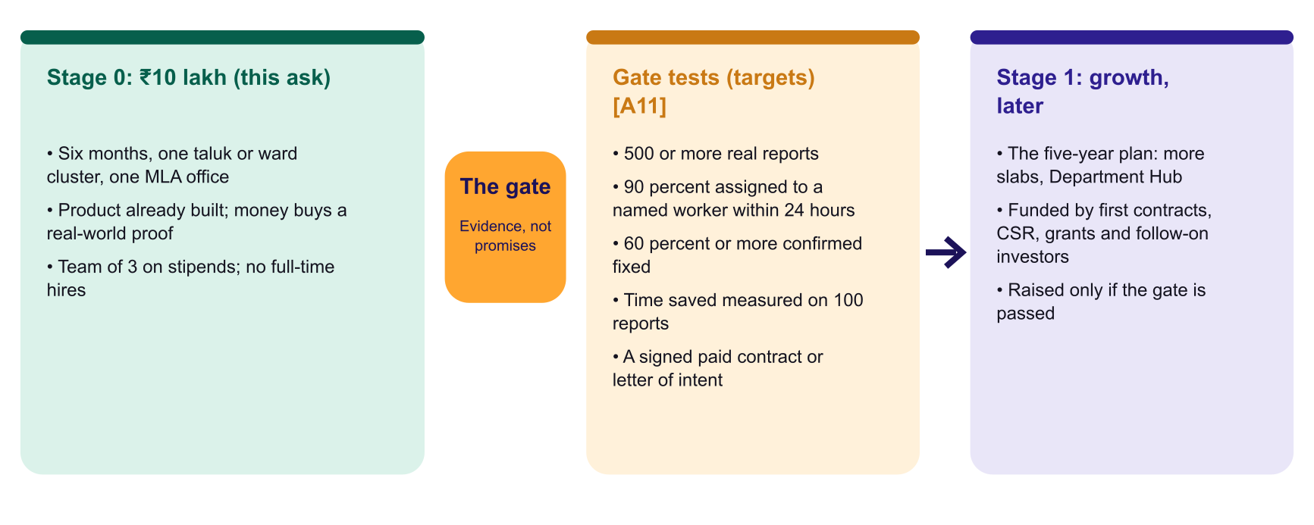
The five-year plan in section 6 has a peak cash need of about ₹2.3 crore in its base case [A8]. That is a growth plan, not this ask. We raise it only after the gate, from first paid contracts, CSR, grants and follow-on investors. If the gate is not passed, the exposure is limited to ₹10 lakh and six months, and we publish what we learned.
Why Prajadhwani should win in Business and Governance
A real business. Clear buyers at every level, a public price card by population slab, positive unit economics and a plan that survives a conservative case.
A real governance gain. One record for the whole administration; transparency, accountability, coordination, inclusion and citizen-confirmed closure, with privacy built in.
Already built and tested. Funding goes into a pilot and a business, not a prototype [P1 to P5].
A Digital India fit. Built on Bhashini, aligned with the DPDP Act, sold through GeM, and designed to become an open public rail [S10, S11, S16, S18].
Free for citizens, always. The citizen is never the customer and never the product.
Honest about risk. We show the conservative case, the payment-cycle cash gap and what we have not yet proven.

Appendix A: Assumptions
All financial and impact figures come from one transparent model. Change any assumption and the report's figures change with it. Each is a team assumption [A#]; the validation plan is in Appendix C.
Assumption | Value (base case)
Contracts in force by slab, years 1 to 5 [A1] | S1: 0, 4, 12, 30, 60; S2: 0, 2, 8, 20, 40; S3: 0, 1, 4, 10, 18; S4: 0, 0, 1, 3, 6; S5: 0, 0, 0.5, 1, 2
Slab prices (₹ lakh a year) [A2] | S1: 1; S2: 4; S3: 15; S4: 45; S5: 400
Department Hubs in force, years 1 to 5; price [A3] | 0, 0, 4, 15, 40; ₹8 lakh each
Reports per resident per year, years 1 to 5 [A4] | 0.008, 0.008, 0.01, 0.013, 0.015
Value per report [A5] | ₹175 (citizen time 100, official time 75)
Cost per report [A6] | ₹4 (empanelled cloud, photo checks, messaging, redundancy)
Team cost, years 1 to 5 (₹ crore) [A7] | 0.48, 1.8, 3.8, 6.5, 10.5
Government payment cycle [A8] | 120 days
Implementation fee; customer success cost [A9] | 25 percent of new annual contract value; 20 percent of subscription and implementation revenue
Insights, assisted filing, CSR (₹ crore) [A10] | Insights 0, 0, 0.2, 0.8, 2; assisted filing 0, 0, 0.1, 0.4, 1; CSR 0.8, 1, 1.5, 1.5, 1.5
Sales, field, outreach (₹ crore); legal, audit, other (₹ crore) [A7] | 0.15, 0.4, 0.8, 1.3, 1.9; 0.1, 0.25, 0.4, 0.6, 0.9
Average population per slab (lakh) | S1: 0.5; S2: 3; S3: 12; S4: 50; S5: 600

Appendix B: Scenario detail

Conservative case (₹ crore)
 | Year 1 | Year 2 | Year 3 | Year 4 | Year 5
Revenue | 0.8 | 1.3 | 3.7 | 6.9 | 13.0
Costs | 0.7 | 2.5 | 3.7 | 6.5 | 10.9
Operating surplus | 0.1 | (1.2) | (0.1) | 0.3 | 2.1
Cumulative cash after payment delays | 0.1 | (1.3) | (1.9) | (2.5) | (2.2)
Residents covered (crore) | 0.1 | 0.2 | 2.1 | 4.7 | 9.3
Reports (lakh) | 0.1 | 0.2 | 2.1 | 6.1 | 14.0
Measured value | 0.1 | 0.3 | 3.7 | 10.7 | 24.5

Ambitious case (₹ crore)
 | Year 1 | Year 2 | Year 3 | Year 4 | Year 5
Revenue | 0.8 | 1.3 | 8.9 | 18.4 | 36.3
Costs | 0.7 | 2.5 | 6.7 | 12.3 | 21.3
Operating surplus | 0.1 | (1.2) | 2.2 | 6.1 | 15.0
Cumulative cash after payment delays | 0.1 | (1.2) | (1.3) | 1.8 | 11.1
Residents covered (crore) | 0.1 | 0.2 | 6.4 | 14.2 | 28.0
Reports (lakh) | 0.1 | 0.2 | 6.4 | 18.4 | 42.0
Measured value | 0.1 | 0.3 | 11.2 | 32.2 | 73.5

Appendix C: Evidence register
Every tag in the report maps to a row below. Public sources (S) can be checked at the link given; product evidence (P) can be re-run from the repository or the live system; assumptions (A) are ours, with the way we will test them.
ID | Claim | Type | Source, test or validation plan
S1 | India's population is about 1.45 billion (2024). | Public source | UN World Population Prospects 2024, via press: https://www.dtnext.in/news/world/indias-population-to-peak-in-early-2060s-to-17-billion-before-declining-un-794557
S2 | Karnataka's projected population is about 6.82 crore (1 July 2024). | Public source | National Commission on Population technical-group projection, via https://statisticstimes.com/demographics/india/karnataka-population.php. Verify with the latest official release.
S3 | Karnataka has 31 districts. | Public source | https://en.wikipedia.org/wiki/List_of_districts_of_Karnataka. One source also lists 236 sub-districts; the app uses 227 taluks from KGIS data [P6].
S4 | Karnataka has 224 assembly constituencies and 28 Lok Sabha constituencies. | Public source | https://en.wikipedia.org/wiki/List_of_constituencies_of_the_Karnataka_Legislative_Assembly (cites Election Commission of India reports). Verify at eci.gov.in.
S5 | India has 2,68,603 gram panchayats and traditional local bodies (March 2025); an earlier reply gave 2,69,073 (December 2023). | Public source | Rajya Sabha replies: https://community.data.gov.in/?p=119279 and https://rsdebate.nic.in/bitstream/123456789/746172/1/PQ_262_06122023_U408_p327_p327.pdf
S6 | India had about 4,657 urban local bodies (2017). | Public source (dated) | A 2017 count; the current Ministry of Housing and Urban Affairs figure should replace it before submission.
S7 | The national grievance system (CPGRAMS) recorded 18,19,104 grievances in 2022; central ministries disposed about 11.3 lakh and states and UTs about 4.4 lakh; central average disposal time fell from 32 days (2021) to 27 days (2022). | Public source | CPGRAMS Annual Report 2022: https://www.indianbureaucracy.com/dr-jitendra-singh-releases-the-annual-report-of-cpgrams-for-the-year-2022/ and https://theprint.in/india/cpgrams-report-shows-steady-progress-in-resolving-citizen-complaints/2263447
S8 | Central ministries' average grievance disposal time was 16 days (April 2025), 15 days (October 2025) and 13 days (August 2026). | Public source (press reports of DARPG monthly reports) | https://www.constructionworld.in/amp/resources-company-news/over-125-000-grievances-resolved-by-ministries-in-april/73797 ; https://www.constructionworld.in/amp/policy-updates-and-economic-news/darpg-report-shows-faster-grievance-redress-in-october-2025/81414 ; https://newsonair.gov.in/central-ministries-redress-2-42-lakh-grievances-in-august-average-disposal-time-13-days/
S9 | In the Central Secretariat, 37 lakh files (94 percent) were handled as e-files and 95 percent of receipts as e-receipts; 133 attached, subordinate and autonomous offices were identified for e-Office in 2024 and 55 had initiated implementation by late July 2024. | Public source | https://www.thestatesman.com/india/digital-push-37-lakh-govt-files-being-handled-as-e-files-says-dopt-1503319544.html ; PIB: https://pib.gov.in/PressReleasePage.aspx?PRID=2038050
S10 | Digital India (launched 1 July 2015) is centred on three vision areas: digital infrastructure as a utility, governance and services on demand, and digital empowerment of citizens. | Public source | https://digitalindia.gov.in/vision-vision-areas/
S11 | Bhashini, a MeitY mission under the National Language Translation Mission, targets all 22 scheduled languages; one account reports technologies covering 20-plus languages with 350-plus AI models. | Public source | https://ldcil.org/bhashini ; https://blogs.iiit.ac.in/genesis-of-bhashini/. Coverage varies by language; check the Bhashini portal.
S12 | UPI processed 24.07 billion transactions in September 2026. | Public source (press, NPCI data) | https://startuptalky.com/india-upi-transactions-september-2026/
S13 | DigiLocker had more than 72.43 crore registered users as of 31 July 2026. | Public source (Parliament reply, press) | https://ianslive.in/digilocker-reaches-more-than-7243-crore-registered-users-umang-at-over-1166-crore-users--20260812153558
S14 | 142.76 crore Aadhaar numbers were generated as of 16 September 2025. | Public source | UIDAI: https://uidai.gov.in/hi/about-uidai
S15 | India had 1,092.79 million internet subscribers at the end of March 2026. | Public source | TRAI press release 32 of 2026: https://www.trai.gov.in/sites/default/files/2026-03/PR_No.32of2026.pdf
S16 | The Digital Personal Data Protection Rules, 2025 were notified on 13 November 2025 with a phased rollout over 18 months. | Public source | https://www.tribuneindia.com/news/business/government-notifies-dpdp-rules-to-empower-citizens-protect-privacy ; https://www.storyboard18.com/digital/breaking-govt-notifies-final-dpdp-rules-sets-staggered-rollout-with-key-obligations-for-data-fiduciaries-84201.htm
S17 | Karnataka's Janaspandana (iPGRS) offers a portal, app and the 1902 helpline, and escalates a grievance to a higher officer if the citizen is not satisfied. | Public source (secondary) | https://indiacustomercare.com/karnataka-integrated-public-grievance-redressal-system-ipgrs ; https://negd.gov.in/isl/Directory/statedata/418. Confirm on the official portal.
S18 | Recognised startups can be relieved of prior-experience and prior-turnover conditions in public procurement (General Financial Rules 2017, Rule 173(i)). | Public source | https://www.startupindia.gov.in/content/sih/en/public_procurement.html. Relaxation depends on the tender; check the bid.
S22 | Estonia's X-Road is open-source software for secure data exchange between public and private databases, and the country's e-government is built on a once-only principle. Over 99 percent of public services are reported online; counts of e-services vary from about 1,000 to over 3,000 by source and year. | Public source (e-Estonia programme, press) | https://e-estonia.com/solutions/interoperability-services/x-road/ ; https://www2.computerworld.co.nz/article/662057/how-estonia-set-global-benchmark-e-government/
S23 | The EU Digital Decade sets 2030 targets of 100 percent of key public services online and secure digital identity for citizens; the Once-Only Technical System lets documents move between member states; citizens' access to key online services was 82.3 percent in a recent monitoring summary. | Public source (European Commission, press summary) | https://commission.europa.eu/strategy-and-policy/priorities-2019-2024/europe-fit-digital-age/europes-digital-decade-digital-targets-2030_en ; https://identityweek.net/state-of-the-digital-decade-report-monitors-progress-towards-goals-for-2030-including-eid. Check the latest State of the Digital Decade report.
S24 | China's State Council set a goal to merge provincial government service hotlines into one number, 12345, by the end of 2021; Beijing's line was reported to integrate 64 hotline resources across 16 districts and 343 streets and towns; local descriptions give a closed loop of unified reception, transfer of responsibility, time limit, supervision and feedback. | Public source (official and state-affiliated media, press release) | https://english.www.gov.cn/news/pressbriefings/202101/08/content_WS5ff7abd0c6d0f725769436ff.html ; https://chinaservicesinfo.com/s/202006/29/WS5f0f1a28498ed1e2f3407a7e/hechi-launches-citizen-service-hotline.html ; Beijing figures: https://kyodonewsprwire.jp/release/202310271830. Performance figures are not independently verified.
S25 | Zhejiang province launched the 'At Most One Visit' reform in February 2017 so that a citizen need visit an office only once, and the Zheli Ban app was reported to offer more than 100 services. | Public source (state-affiliated media) | https://subsites.chinadaily.com.cn/ezhejiang/2017-06/14/c_107108_3.htm ; https://archive.opengovasia.com/2017/10/27/zhejiang-province-in-china-piloting-at-most-one-visit-scheme-for-streamlined-government-service-delivery/. Reporting notes that most procedures then still needed more than one visit.
S21 | India has 28 states and 8 Union Territories. | Public source | https://en.wikipedia.org/wiki/States_and_union_territories_of_India
P1 | A working product is live on the web and as an Android build distributed to testers. | Product evidence | Web: https://code-for-community-e2cf2.web.app. Android: Firebase App Distribution. Code: branch feature/username-auth-free-maps-bbmp-wards (workflow commit 9cb3d32; later photo-privacy and navigation changes are deployed, commit pending).
P2 | Speech recognition, language detection and translation verified live for all 10 app languages with Bhashini; fall-back providers built. | Product evidence | functions/src/scripts/verifyBhashini.ts, run live on 29 October 2026 (10 of 10 passed).
P3 | Worker creation, assignment, status changes, citizen confirmation, reopening, the 48-hour rule, role limits and admin issue groups work end to end. | Product evidence | npm run verify:workflow: 32 of 32 checks; live end-to-end run against the deployed backend on 2 November 2026: 20 of 20 (test data removed). Code: functions/src/work/, functions/src/officials/adminIssues.ts.
P4 | Photos are private by default; public only after versioned consent; face and plate blur and whole-photo blur; officials, assigned workers and admins can open the original; withdrawal deletes the public copy. | Product evidence | npm run verify:photo: 16 of 16 checks; live run with Cloud Vision enabled on 3 November 2026: 18 of 18 (test data removed). Code: functions/src/public/publishPhoto.ts, photoPrivacy.ts.
P5 | 64 automated app tests pass. | Product evidence | flutter test (including tests for the report flow, photo-visibility picker, fix-confirmation card and navigation).
P6 | Built today: voice, text and photo reporting; suggested office from a verified directory of 26 offices; public report cards and a feed; leaderboard over a roster of 224 MLAs and 28 MPs; six-tab official dashboard; AI briefing and PDF report; area data for 227 taluks. | Product evidence | Repository: lib/, functions/src/ (agents/departmentSeed.ts, data/ka_mla_roster.json as of 25 October 2026, assets/geo/karnataka_taluks.json).
A1 | Number of paid contracts by population slab and year. | Team assumption | Validate with the pilot partner's referrals, letters of intent from 3 to 5 offices, and sales-cycle data.
A2 | Slab prices (₹1 lakh to ₹4 crore a year). | Team assumption | Price-test with 3 to 5 buyers; compare with comparable government software contracts; confirm GeM catalogue terms.
A3 | Department Hub price (₹8 lakh a year), the number of hubs (4, 15, 40), 30 departments per state and 50 central departments. | Team assumption | Check the state secretariat's department list and the central ministry list; pilot the hub with two departments; interview department heads.
A4 | Reports per resident a year (0.8 to 1.5 percent). | Team assumption | Measure adoption in the pilot. Context: the national system recorded 18.19 lakh grievances in 2022 [S7], a different and narrower scope, so it is not a comparator.
A5 | Value per report of ₹175 (₹100 citizen time, ₹75 official time). | Team assumption | Time-and-motion study of citizen and official time in the pilot, priced at official wage data.
A6 | Cost per report of about ₹4. | Team assumption | Compare with actual cloud, photo-check and messaging bills in the pilot; check the cloud price list.
A7 | Team size and cost, sales and outreach, legal and audit costs. | Team assumption | Hiring plan reviewed quarterly against market salary data.
A8 | A 120-day government payment cycle. | Team assumption | Ask pilot partners and GeM sellers for actual payment times.
A9 | Implementation fee of 25 percent; customer-success cost of 20 percent; cost to win a contract. | Team assumption | Track actual onboarding effort in the pilot.
A10 | Insights, assisted filing and CSR revenue. | Team assumption | Letters of intent from CSR funders; pilot assisted-filing stalls.
A11 | Pilot scorecard targets. | Team assumption | Agree targets with the pilot partner in the first 30 days.
A12 | Count and price used to size the Karnataka and national department-hub pool. | Team assumption | Replace with the official department lists.
A13 | State sequencing for expansion. | Team judgement | Review with Bhashini language coverage and state government interest.
A14 | The description of the paper-and-phone process and the actors' needs. | Team description | Process mapping and interviews with each role in the pilot partner's area.
A15 | Competitor comparison by category. | Team assessment | Structured review of named products in the pilot's first 60 days.
A17 | The ₹10 lakh Stage 0 budget: stipends of ₹25,000 a month for three people for six months; field, review, study and cloud costs; and the gate targets. | Team assumption | Obtain two quotes each for the security and legal reviews; confirm stipend norms with the challenge organiser; agree gate targets with the pilot partner in the first 30 days [A11].
A16 | Risk likelihood and impact ratings. | Team assessment | Reviewed quarterly with the advisory board.

Appendix D: Glossary
Term | Meaning
Bhashini | The Government of India's language platform for speech recognition, translation and language detection.
CPGRAMS | The Centralised Public Grievance Redress and Monitoring System, the national grievance portal.
CSC | Common Service Centre: a local access point for digital government services.
Department Hub | A planned licence for state and central departments to transfer and jointly resolve problems on one shared ticket.
DPDP Act | The Digital Personal Data Protection Act, 2023, and its Rules, 2025.
e-Office | The government's electronic file and receipt system that replaces paper files.
GeM | Government e-Marketplace, the public procurement portal.
DPI | Digital public infrastructure: shared rails such as UPI, Aadhaar and DigiLocker.
Population slab | A band of population (for example 5 to 25 lakh) that sets a jurisdiction's annual price.
Stage gate | A set of tests the pilot must pass before growth funding is raised.
Once-only principle | The rule that the state should not ask a citizen for information it already holds.
Voice Mitra | A trained local helper who assists citizens to file a report by voice.
Token ID | The receipt code each report receives; it carries no personal information.

