**Titan-Infrastructure.**

**Below is the high-level Titan Global Infrastructure diagram.**

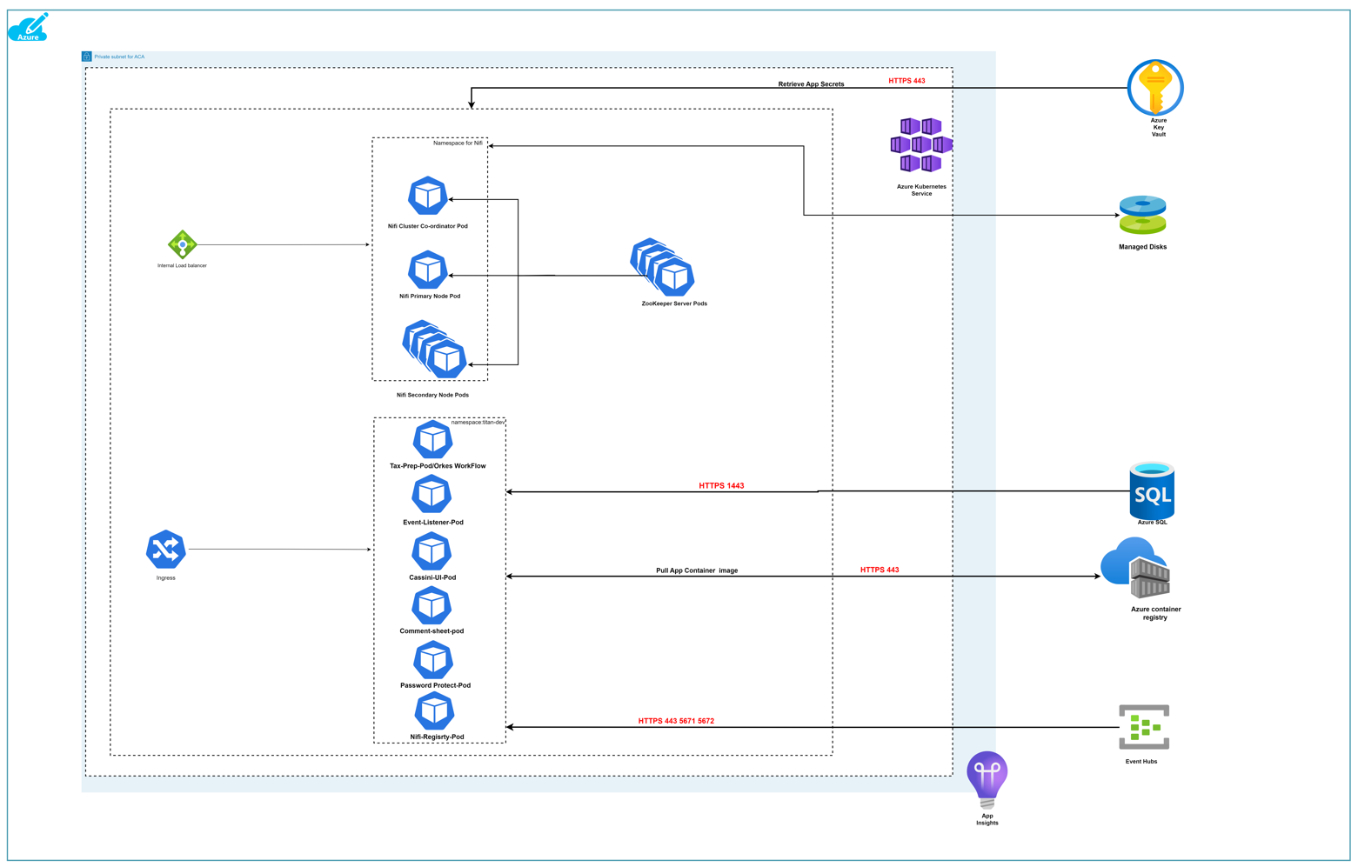

**List of resources.**

1. AKS
2. Azure SQL
3. Azure Container Registry
4. Event Hubs.
5. Azure key Vault.
6. Ingress
7. Azure Internal Load balancer.
8. Managed disk.

**AKS Details:**

|  |  |  |  |  |
| --- | --- | --- | --- | --- |
| **NAME** | **RESOURCE GROUP** | **LOCATION** | **SUBSCRIPTION** | **ENV** |
| ZWETITNKSD001 | vzi-we-np-rg-titn-d001 | West Europe | VZI-GX-NP-SUB049 | Dev |
| ZWETITNKSQ001 | vzi-we-np-rg-titn-q002 | West Europe | VZI-GX-NP-SUB049 | QA |
| ZWETITNKSP001 | vzi-we-pr-rg-titn-p002 | West Europe | VZI-GX-PR-SUB049 | PROD |

**Describing each service.**

**AKS: Azure Kubernetes service.**

Kubernetes is an open-source orchestration system that facilitates the deployment and scaling of containerized workloads. Despite its popularity and widespread use, manually deploying and maintaining a Kubernetes cluster is still not an easy task. Microsoft’s Azure Kubernetes Service (AKS) helps engineers manage Kubernetes clusters. With AKS, the operational tasks of managing Kubernetes environments become easier.

**Kubernetes Capabilities:**

**Some of the main Kubernetes capabilities include:**

**Service Discovery**

Kubernetes-hosted workloads can be automatically discoverable and exposed through DNS or IP addresses, making it easier for other workloads to find those services and initiate communication.

**Load Balancing**

With workloads abstracted as Services, Kubernetes can offer basic load-balancing capabilities between multiple replicas of the same workload.

**Storage Orchestration**

Kubernetes makes it easier to mount a storage system and make it available to your container for persisting data. Kubernetes can integrate with a node’s local storage and with remote, cloud-hosted volumes**.**

**Workload Deployment.**

Kubernetes-hosted workloads are described declaratively, and the Kubernetes engine takes care of the actual deployment by ensuring all required dependencies are present. By leveraging concepts like Deployments, workloads can be easily declared—including their rollout and rollback strategies.

**Bin Packing**

Kubernetes lets you specify the number of resources (requests and limits) each workload replica can use. This allows computing resources to be better utilized, preventing wasted resources and protecting against workloads consuming the resources of other workloads.

**Self-Healing**

Leveraging liveness, readiness, and startup probes, Kubernetes ensures services are healthy and capable of receiving traffic, restarting them when necessary**.**

**Azure SQL: (zwetitnsqd001)**

Microsoft Azure SQL Database is a relational database-as-a-service that is reliable and secure, and it gives high performance without having to worry about any infrastructure.

It supports relational, JSON, XML, and spatial data structures.  
Microsoft Azure SQL Database has three deployment options:

* Single database
* Elastic pool
* Managed instances

**Azure Container Registry:**

Which is used to store all docker images, here we are using to push and pull images.

We are consuming all application images in AKS.

**Event Hubs:**

|  |  |  |  |  |  |
| --- | --- | --- | --- | --- | --- |
| **NAME** | **TIER** | **RESOURCE GROUP** | **SUBSCRIPTION** | **LOCATION** | **ENV** |
| ZWETITNEHD001 | Standard | VZI-GX-NP-SUB049 | VZI-GX-NP-SUB049 | West Europe | DEV |
| ZWETITNEHQ001 | Standard | VZI-GX-NP-SUB049 | VZI-GX-NP-SUB049 | West Europe | QA |
| ZWETITNEHS001 | Standard | VZI-GX-NP-SUB049 | VZI-GX-NP-SUB049 | West Europe | Stage |
| ZWETITNEHP001 | Standard | VZI-GX-PR-SUB049 | VZI-GX-PR-SUB049 | West Europe | Prod |
| **ZWETITNEHP002** | **Standard** | **VZI-WE-PR-RG-TITN-P001** | **VZI-GX-PR-SUB049** | **West Europe** | **Prod** |

Which is used to manage all application events at different workflow levels, Below are the 10 eventhub namespaces which are used by titan application.

* compensationcomplete
* delivertaxreturn
* efileconsentreceived
* preparetaxreturn
* questionnairemilestonemoved
* taxcreatereturn
* taxdeliverreturn
* taxprepartion
* taxquestionnairesubmit
* taxquestionnairetracking

**Azure key Vault:**

Azure keyvault is used to place all sensitive data like password and token’s etc.

|  |  |  |  |  |
| --- | --- | --- | --- | --- |
| **NAME** | **TIER** | **LOCATION** | **SUBSCRIPTION** | **ENV** |
| ZWETITNEHD001 | Standard | West Europe | VZI-GX-NP-SUB049 | Dev |
| ZWETITNEHS001 | Standard | West Europe | VZI-GX-NP-SUB049 | Stage |
| ZWETITNEHQ001 | Standard | West Europe | VZI-GX-NP-SUB049 | QA |
| ZWETITNEHP001 | Standard | West Europe | VZI-GX-NP-SUB049 | Prod |
| [**ZWEDTSB1KVP049**](https://portal.azure.com/#@vialtopartners.onmicrosoft.com/resource/subscriptions/140192c8-1278-4edf-bab2-2641f586e314/resourceGroups/VZI-WE-PR-RG-DTSB-P002/providers/Microsoft.KeyVault/vaults/ZWEDTSB1KVP049) | **Standard** | **West Europe** | **VZI-GX-PR-SUB049** | **Prod** |
| **ZWEDTSB1KVN049** | **Standard** | **West Europe** | **VZI-GX-PR-SUB049** | **QA** |

**Ingress:**

**Ingress which is used to route traffic to particular pods based on domain or path.**

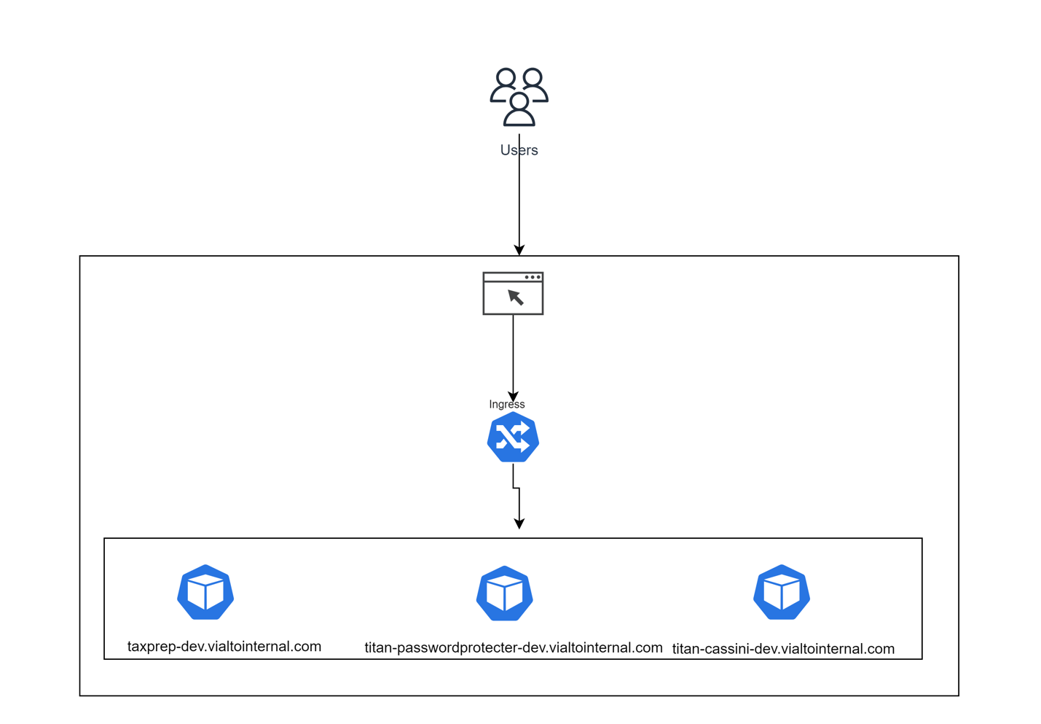

**Azure Internal Load Balancer:**

Azure load balancer is used for route traffic to nifi cluster.

**Managed disk:**

Managed disk is the dependency part for nifi cluster, which is used to store the state of the nifi reop’s state.

**Titan Service Endpoints.**

[**http://titan-nifiregistry-dev.vialtointernal.com/**](http://titan-nifiregistry-qa.vialtointernal.com/)

[**http://titan-nifiregistry-qa.vialtointernal.com/**](http://titan-nifiregistry-qa.vialtointernal.com/)

[**https://titan-cassini-dev.vialtointernal.com/**](https://titan-cassini-dev.vialtointernal.com/)

[**https://titan-cassini-qa.vialtointernal.com/**](https://titan-cassini-qa.vialtointernal.com/)

[**http://titan-dev-nifi.vialtointernal.com/**](http://titan-dev-nifi.vialtointernal.com/)

[**http://titan-qa-nifi.vialtointernal.com/**](http://titan-qa-nifi.vialtointernal.com/)

[**https://titan-passwordprotecter-dev.vialtointernal.com**](https://titan-passwordprotecter-dev.vialtointernal.com)

[**https://titan-passwordprotecter-qa.vialtointernal.com**](https://titan-passwordprotecter-dev.vialtointernal.com)

[**https://taxprep-dev.vialtointernal.com/**](https://taxprep-dev.vialtointernal.com/)

[**https://taxprep-qa.vialtointernal.com/**](https://taxprep-qa.vialtointernal.com/)

[**https://titan-commentsheet-dev.vialtointernal.com**](https://titan-commentsheet-dev.vialtointernal.com)

[**https://titan-commentsheet-qa.vialtointernal.com**](https://titan-commentsheet-dev.vialtointernal.com)