LAPTOP REQUEST CATALOG ITEM

# LAPTOP REQUEST CATALOG ITEM

### Problem Statement:

Employees in the organization need a quick and efficient way to request laptops for work. The current process is manual and prone to delays, with no dynamic form behavior to guide users or ensure accurate data collection. To address this, a Service Catalog item needs to be created, allowing users to easily request a laptop, with dynamic fields, clear instructions, and additional functionality like resetting the form if needed. The solution should also ensure all changes are tracked for governance and deployment.

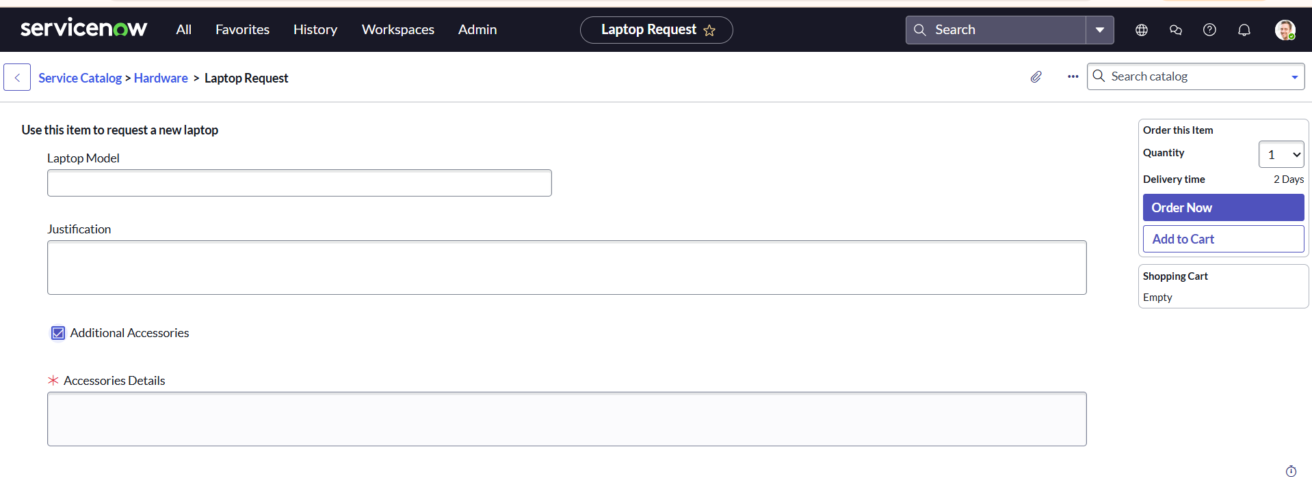output:-

## Project Overview

The *Laptop Request* catalog item in ServiceNow is designed to streamline the process of requesting laptops for employees within an organization. Instead of relying on manual communication or emails, users can submit a structured request directly through the Service Catalog.

The catalog item provides employees with a simple and user-friendly interface where they can specify their laptop requirements such as model type, operating system, accessories, or additional software. Once submitted, the request is automatically routed through predeﬁned workﬂows, including approvals and task assignments for the IT fulﬁllment team.

The purpose of this catalog item is to:

* **Improve eﬃciency** by reducing manual effort in handling laptop requests.
* **Enhance user experience** with a guided and transparent request submission process.
* **Ensure compliance** with organizational policies by enforcing approval ﬂows.
* **Provide tracking and visibility** to both requesters and approvers throughout the request lifecycle.

Ultimately, this project supports automation and standardization of IT asset requests, ensuring that employees receive the right devices quickly while IT maintains control and governance

## Business Requirement / Objective

Modern organizations rely heavily on laptops as essential tools for daily operations. Traditionally, employees requested laptops through emails, phone calls, or in-person communication with the IT team, which often led to delays, lack of tracking, and inconsistent approvals. This manual process also made it diﬃcult for IT to manage inventory, ensure compliance, and maintain service quality.

The *Laptop Request* catalog item in ServiceNow addresses these challenges by providing a

**centralized, automated, and standardized process** for requesting laptops.

#### Objectives of the project:

* **Streamline request handling** by enabling employees to raise laptop requests directly through the Service Catalog.
* **Standardize information collection** using predeﬁned variables (such as laptop type,

conﬁguration, and accessories).

* **Automate approval workﬂows** so that requests are reviewed and authorized by managers before fulﬁllment.
* **Enhance visibility and transparency** by allowing both requesters and approvers to track

the status of requests in real time.

* **Improve IT eﬃciency** by generating fulﬁllment tasks automatically for the IT team.
* **Ensure compliance** with organizational policies regarding asset allocation and cost management.

This project ensures that the organization delivers laptops to employees in a timely, consistent, and controlled manner while reducing manual effort and improving user satisfaction.

## Scope

The scope of this project deﬁnes what is covered under the *Laptop Request* catalog item and what falls outside its boundaries.

### In-Scope

* Creation of a **Service Catalog Item** for Laptop Requests in ServiceNow.
* Conﬁguration of **variables** to capture requester details and laptop requirements (e.g., laptop model, operating system, accessories, justiﬁcation).
* Use of **Flow Designer / Workﬂow** to automate the approval and fulﬁllment process.
* Implementation of **manager approval** before request fulﬁllment.
* Automatic generation of **fulﬁllment tasks** for the IT support team to process the request.
* **Notiﬁcations** for requester, approver, and fulﬁllment team (e.g., submission conﬁrmation, approval/rejection, completion).
* **Access control** to ensure only eligible users can submit requests.
* **Request tracking** via ServiceNow portal for end users.

### Out-of-Scope

* Procurement of new laptops from external vendors (only internal stock is considered).
* Integration with third-party asset management or procurement systems.
* Automation of hardware delivery logistics outside the ServiceNow platform.
* Management of non-laptop assets (desktops, mobile devices, peripherals).
* Handling of software license requests (separate catalog items handle software).

1. Design / Implementation Details
   1. updateset

### Step 1: Create an Update Set

Before starting the conﬁguration of the *Laptop Request* catalog item, an **Update Set** is created to capture all the customizations. This ensures that the work can be moved across environments (e.g., from development to test or production).

#### Steps to create an Update Set:

* + 1. Log in to **ServiceNow** with the appropriate role (admin/developer).
    2. In the left navigation pane, click on **All** and search for **Update Sets**.
    3. Under **System Update Sets**, select **Local Update Sets**.
    4. Click on **New** to create a new update set.
    5. Enter the following details:
       - **Name**: Laptop Request
       - (Other ﬁelds such as Description can be ﬁlled as needed).
    6. Click **Submit**.
    7. Once created, open the update set record and click **Make Current**.

By making the update set current, all further conﬁgurations (catalog item, variables, workﬂows, etc.) will automatically be captured in this update set.

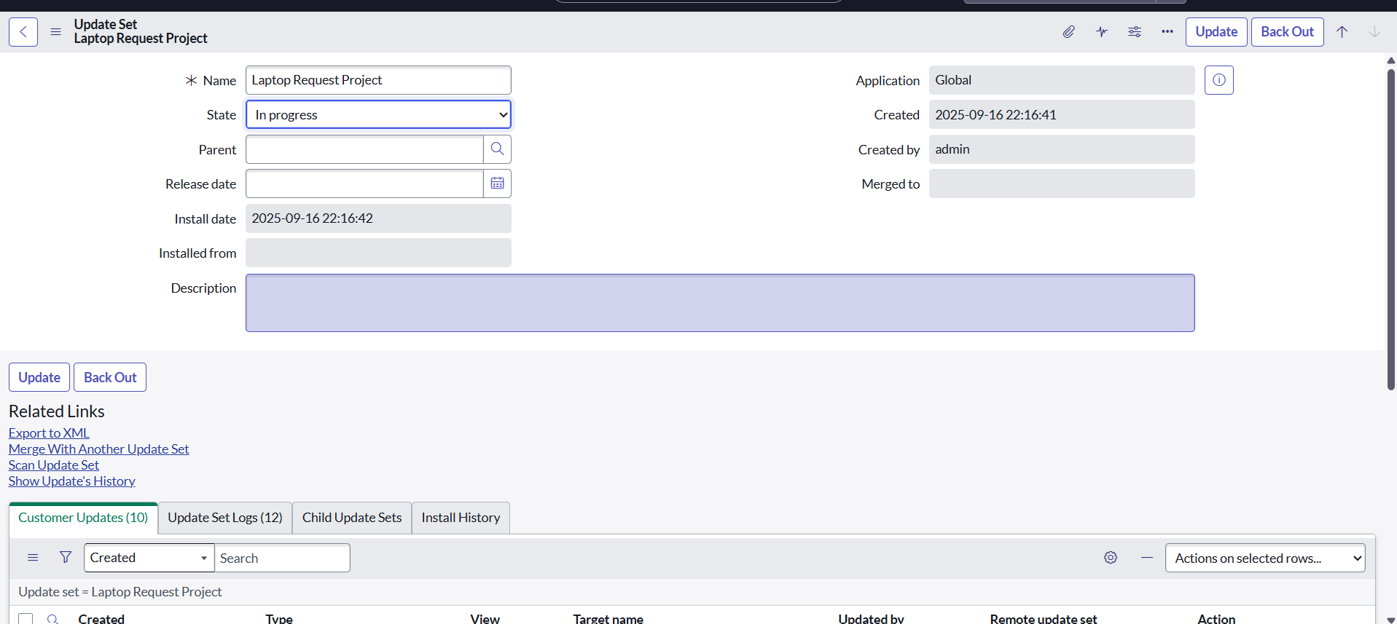

# Service Catalog Item

## Step 1: Create Service Catalog Item

After setting up the update set, the next step is to create a new **Catalog Item** for the laptop request. This item will be available in the Service Catalog for end users to submit their requests.

#### Steps to create the Catalog Item:

* + 1. Log in to **ServiceNow**.
    2. In the left navigation pane, click on **All** and search for **Service Catalog**.
    3. Under **Catalog Deﬁnitions**, select **Maintain Items**.
    4. Click on **New** to create a new catalog item.
    5. Fill in the following details:
       - **Name**: Laptop Request
       - **Catalog**: Service Catalog
       - **Category**: Hardware
       - **Short Description**: Use this item to request a new laptop
    6. Click on **Save** to create the item.

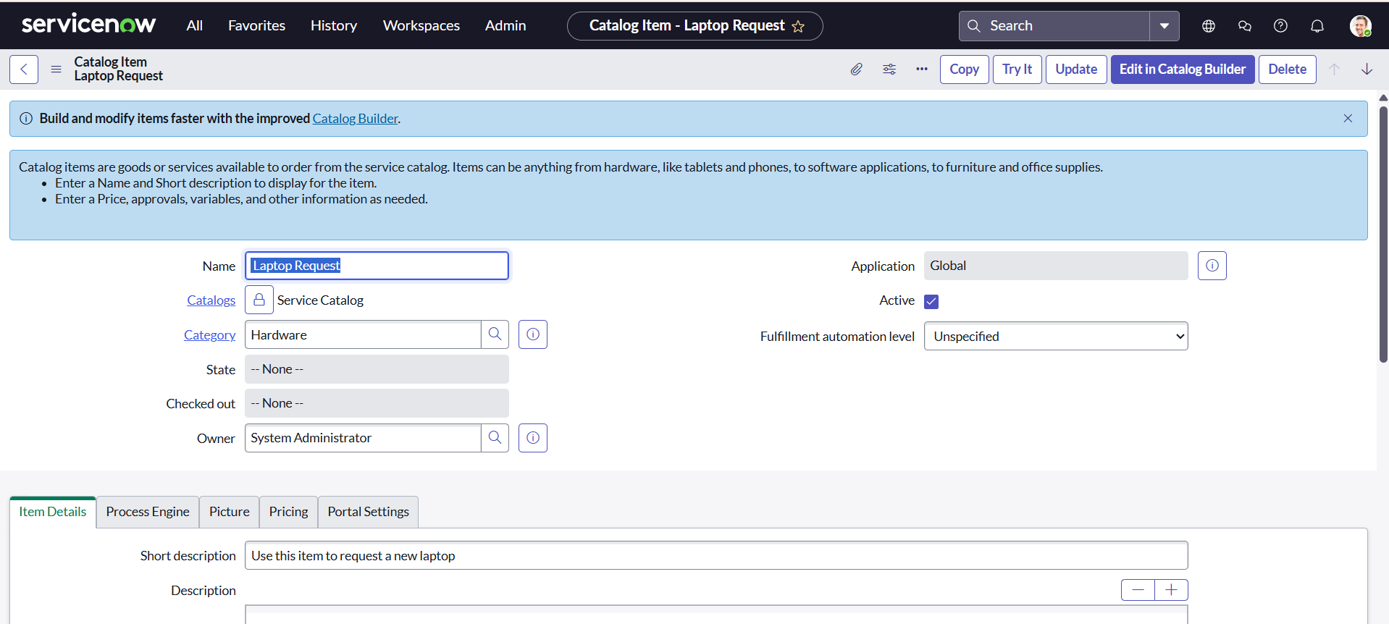

## Step 3: Add Variables to Catalog Item

Once the catalog item (*Laptop Request*) is created, the next step is to deﬁne **variables**. Variables capture user input when submitting the request and help the IT team understand the requirements clearly.

**Steps to Add Variables:**

### Step 2: Create Variables

1. Open the newly created **Laptop Request** catalog item.
2. Scroll down to the **Variables** related list.
3. Click **New** to create a new variable.
4. Enter the following details for each variable:

#### Variable 1: Laptop Model

* + Type: *Single Line Text*
  + Name: laptop_model
  + Order: 100
  + Click **Submit**.

#### Variable 2: Justiﬁcation

* + Type: *Multi Line Text*
  + Name: justiﬁcation
  + Order: 200
  + Click **Submit**.

#### Variable 3: Additional Accessories

* + Type: *Checkbox*
  + Name: additional_accessories
  + Order: 300
  + Click **Submit**.

#### Variable 4: Accessories Details

* + Type: *Multi Line Text*
  + Name: accessories_details
  + Order: 400
  + Click **Submit**.

### Step 3: Save the Catalog Item

* After all variables have been added, they are automatically linked to the *Laptop Request*

catalog item.

* Finally, click **Save** on the catalog item form to conﬁrm the changes.

These variables ensure that the requester provides all the necessary details (laptop speciﬁcations, justiﬁcation, and accessories requirements) while submitting a request.

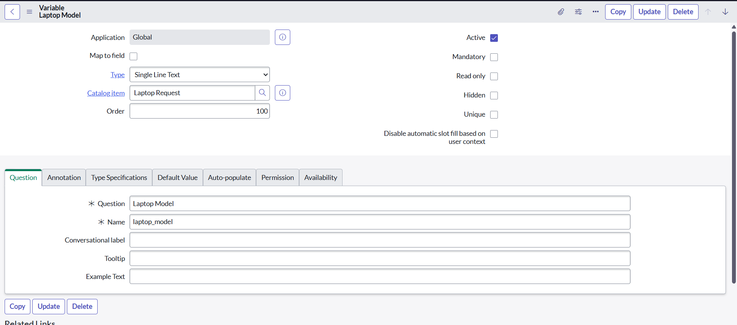

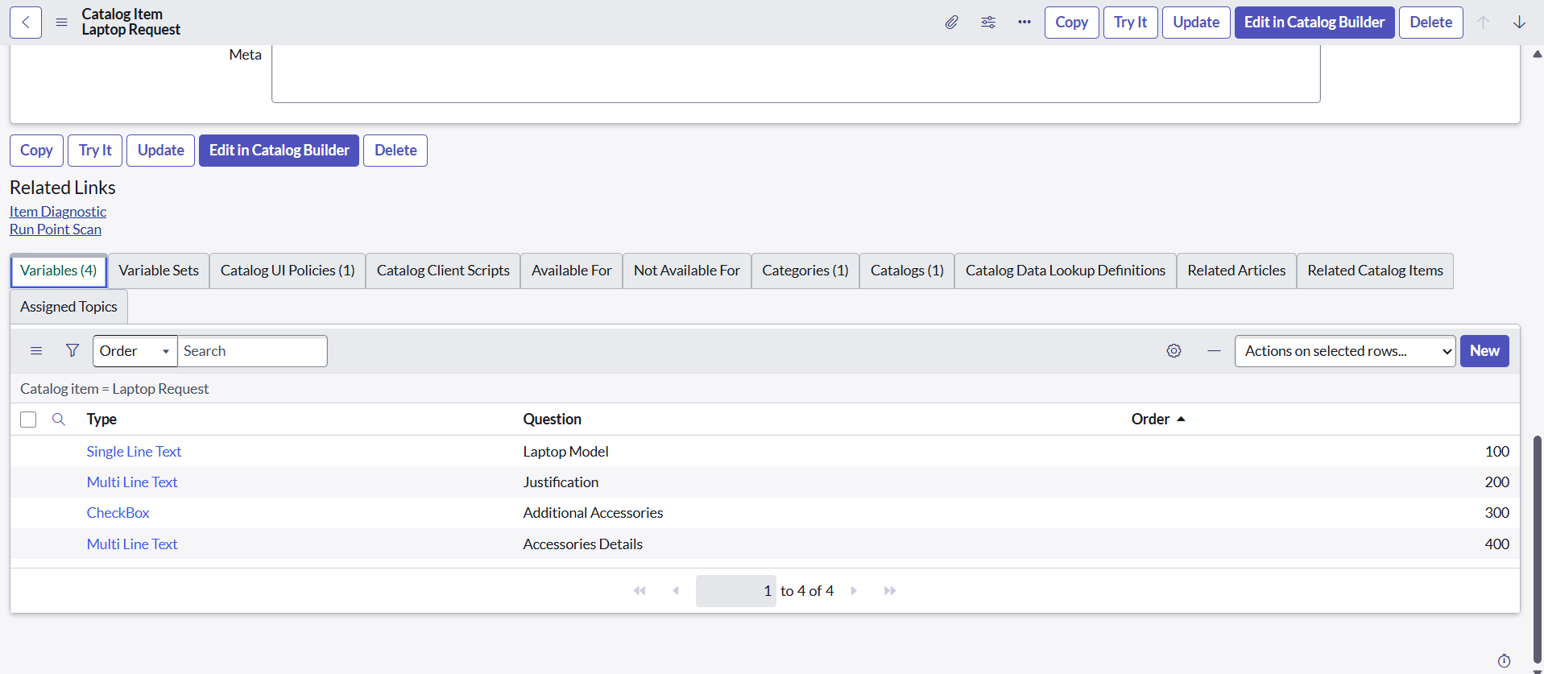

# UI Policy

## Step 1: Create Catalog UI Policies

Catalog UI Policies are used to dynamically control the behavior of variables (e.g., making them visible, mandatory, or read-only) based on conditions. For the *Laptop Request* catalog item, a UI policy is created to ensure that when a user selects **Additional Accessories**, they must provide details in the **Accessories Details** ﬁeld.

#### Steps to Create a Catalog UI Policy:

* 1. In the left navigation pane, click **All** and search for **Service Catalog**.
  2. Under **Catalog Deﬁnitions**, select **Maintain Items**.
  3. Search for the previously created item: **Laptop Request**.
  4. Open the *Laptop Request* catalog item record.
  5. Scroll down to the **Catalog UI Policies** related list and click **New**.
  6. Fill in the details:
     + **Short Description**: Show Accessories Details
     + **Catalog Conditions** (When to Apply):
       - Field: additional_accessories
       - Operator: is
       - Value: true
  7. Click **Save** (do not click Submit yet).

### Step 2: Conﬁgure Catalog UI Policy Actions

1. Scroll down to the **Catalog UI Policy Actions** related list.
2. Click **New** to add an action.
3. Fill in the details:
   * **Variable Name**: accessories_details
   * **Order**: 100
   * **Mandatory**: True
   * **Visible**: True
4. Click **Save**.
5. Return to the Catalog UI Policy form and click **Save** again to conﬁrm the policy.

#### Result:

When the requester selects the **Additional Accessories** checkbox, the **Accessories Details** ﬁeld will automatically become visible and mandatory. If unchecked, the ﬁeld will remain hidden.

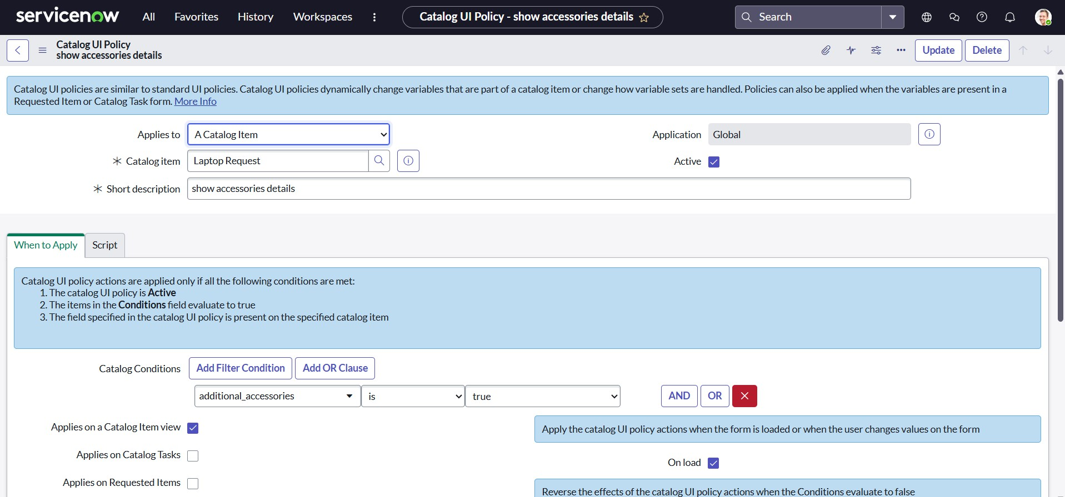

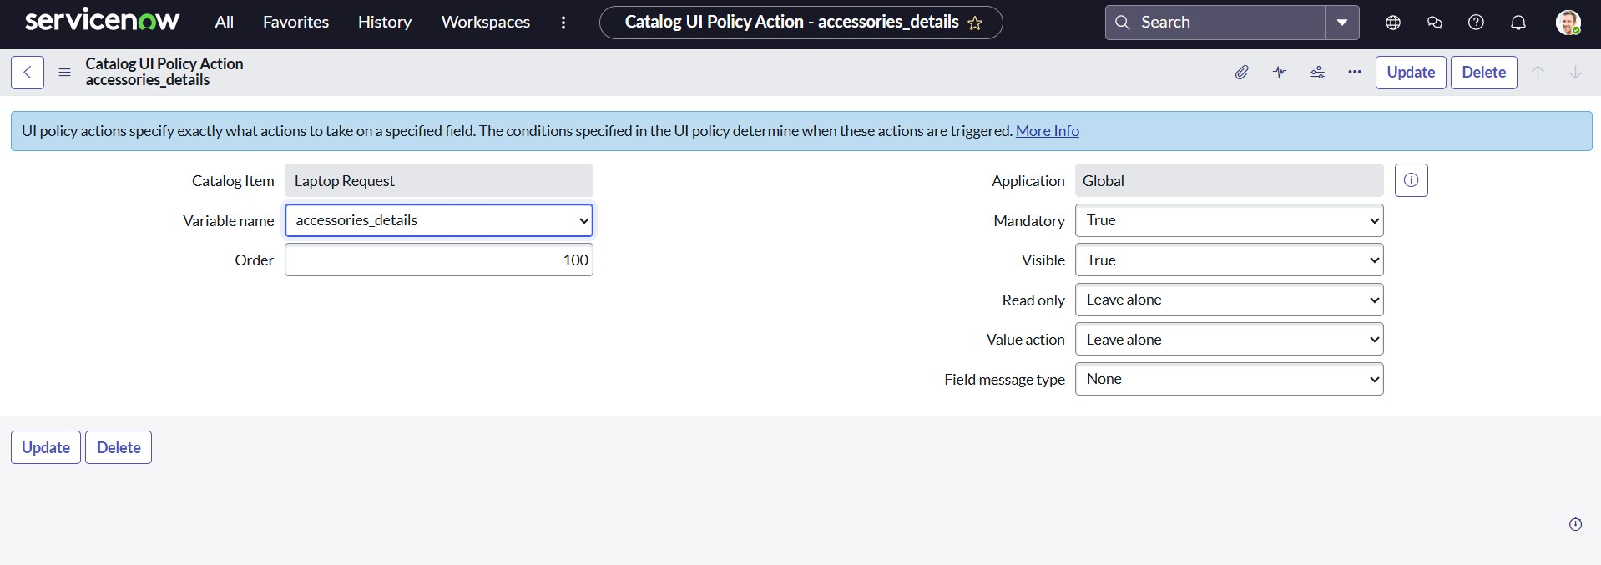

# UI Action

## Step 1: Create UI Action

UI Actions in ServiceNow are used to add custom buttons, links, or context menu items to forms and lists. For the *Laptop Request* catalog item, a UI Action is created to allow users to **reset the form**, clearing all entered values.

#### Steps to Create a UI Action:

* 1. In the left navigation pane, click **All** and search for **UI Actions**.
  2. Under **System Deﬁnition**, select **UI Actions**.
  3. Click on **New** to create a new UI Action.
  4. Fill in the following details:
     + **Table**: Shopping Cart (sc_cart)
     + **Order**: 100
     + **Action Name**: Reset form
     + **Client**: Checked
  5. In the **Script** ﬁeld, enter the following client-side script:
  6. function resetForm() {

g_form.clearForm(); // Clears all ﬁelds in the form alert("The form has been reset.");

}

* 1. Click **Save** to create the UI Action.

#### Result:

A **Reset Form** button will now be available on the Shopping Cart form. When clicked, it clears all

entered values and alerts the user that the form has been reset.

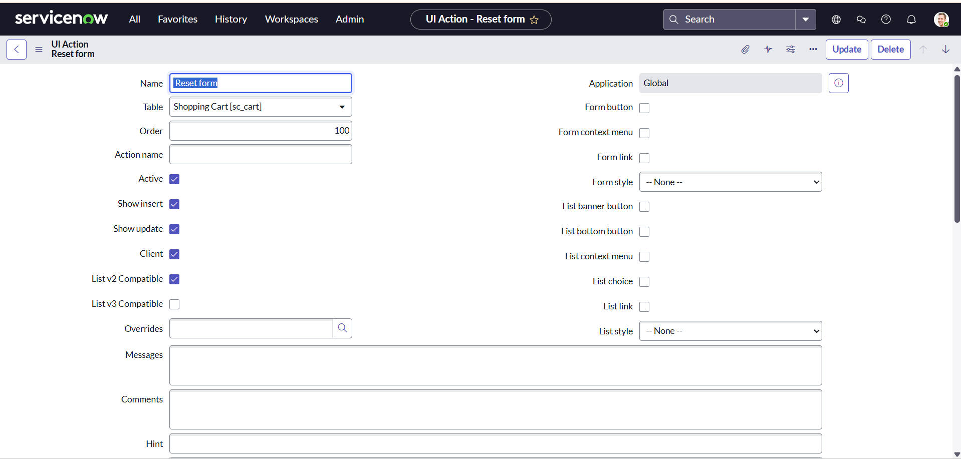

# Export Update set

## Step 1: Exporting Changes to Another Instance

Once all conﬁgurations (catalog item, variables, UI policies, and UI actions) are completed in the development instance, the changes must be exported to another instance (e.g., Test or Production). This is done using **Update Sets**.

#### Steps to Export Update Set:

* 1. In the left navigation pane, click **All** and search for **Update Sets**.
  2. Select **Local Update Sets**.
  3. Open the update set created earlier: **Laptop Request Project**.
  4. Change the **State** of the update set to Complete.
  5. Scroll down to the **Updates** related list tab to verify all captured updates (catalog item, variables, UI policies, UI actions, etc.).
  6. From the header, click **Export to XML**.
  7. The system will generate and download an **XML ﬁle** containing all the changes made under this update set.

This XML ﬁle can then be imported into another ServiceNow instance to migrate the *Laptop Request* project conﬁgurations.

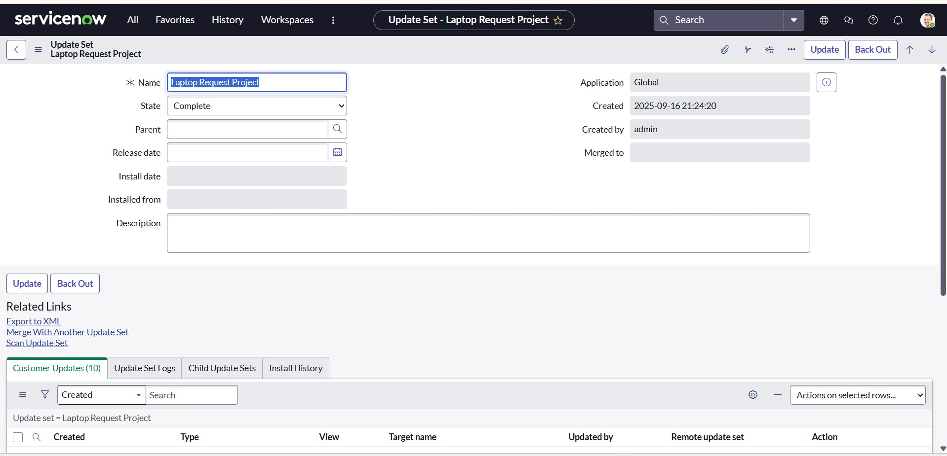

# Login to another Instance

## Step 1: Retrieving the Update Set

After exporting the update set from the development instance, the next step is to import it into another instance (e.g., Test, UAT, or Production). This ensures that all conﬁgurations are replicated in the target instance.

#### Steps to Retrieve and Commit the Update Set:

* 1. Open the target ServiceNow instance (recommended: use an incognito/private window).
  2. Log in with the appropriate credentials.
  3. In the left navigation pane, click **All** and search for **Update Sets**.
  4. Under **System Update Sets**, select **Retrieved Update Sets**.
  5. On the Retrieved Update Sets list view, scroll down and click **Import Update Set from XML**.
  6. Upload the previously downloaded XML ﬁle of the update set (*Laptop Request Project*).
  7. Click **Upload**. The update set is now available in the list of retrieved update sets.
  8. Open the retrieved update set record (**Laptop Request Project**).
  9. Click on **Preview Update Set** to validate changes and check for errors or collisions.
  10. If the preview is successful, click **Commit Update Set** to apply the changes in this instance.
  11. Verify the **Updates** related list tab to conﬁrm all conﬁgurations (catalog item, variables, UI policies, UI actions, etc.) have been migrated.

#### Result:

After committing the update set, the *Laptop Request Project* catalog item and all related conﬁgurations are now available in the new instance, ensuring consistency across environments.

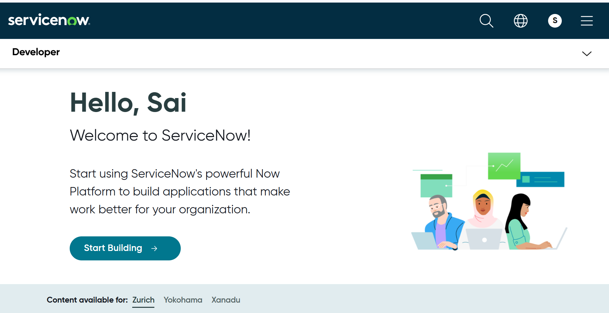

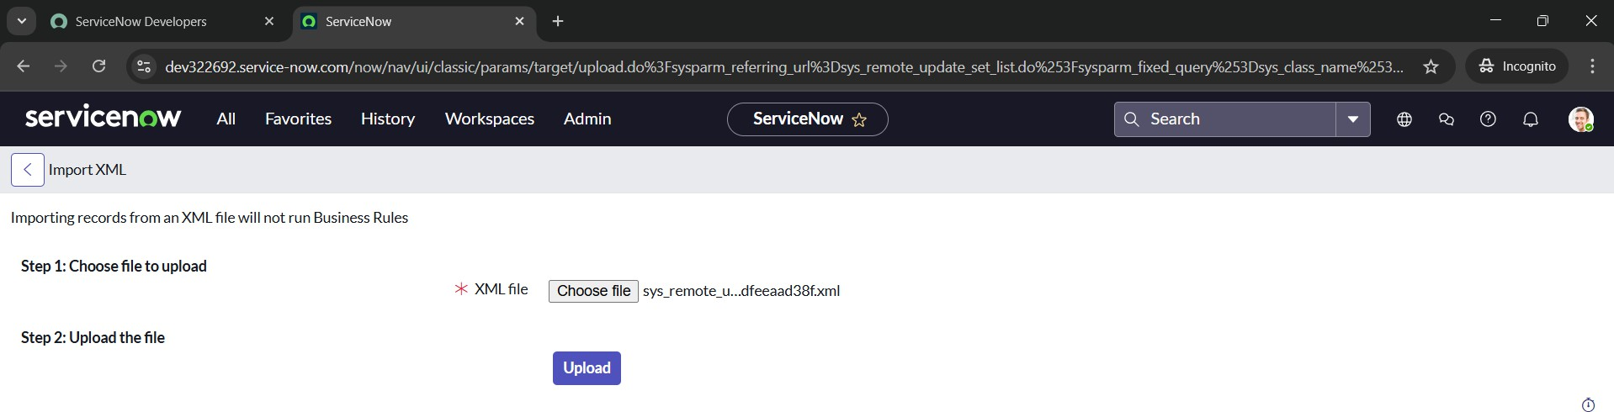

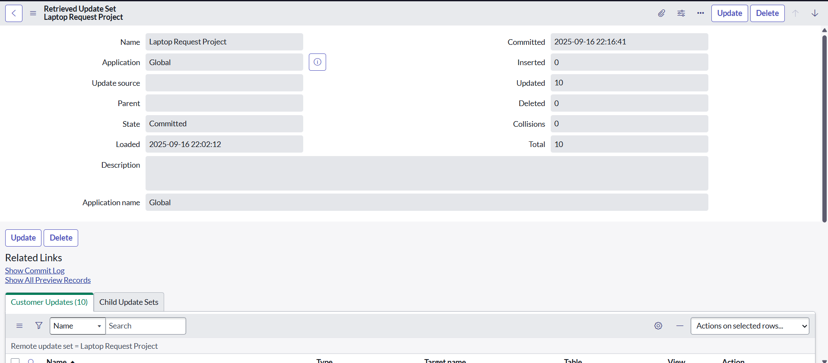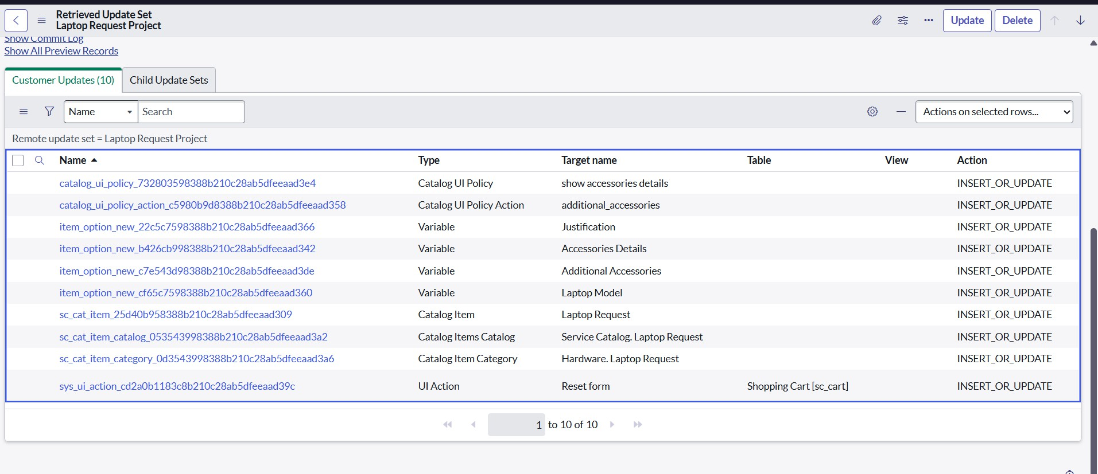

# Testing

## Step 1: Testing the Catalog Item

After migrating the update set to the target instance, the *Laptop Request* catalog item must be tested to ensure all conﬁgurations work as expected.

#### Steps to Test the Catalog Item:

* 1. In the target ServiceNow instance, search for **Service Catalog** in the application navigator.
  2. Select **Catalog** under *Service Catalog*.
  3. Open the **Hardware** category.
  4. Locate and open the catalog item **Laptop Request**.
  5. Verify that the form displays the deﬁned variables:
     + **Laptop Model**
     + **Justiﬁcation**
     + **Additional Accessories**
  6. Test the **UI Policy functionality**:
     + By default, only three variables are visible.
     + When the **Additional Accessories** checkbox is selected, the ﬁeld **Accessories Details** should appear.
     + The **Accessories Details** ﬁeld should also be **mandatory** when visible.

#### Result:

The test conﬁrms that the catalog item behaves as expected. The *Laptop Request* item captures the necessary information, dynamically displays the **Accessories Details** ﬁeld when required, and enforces mandatory input.

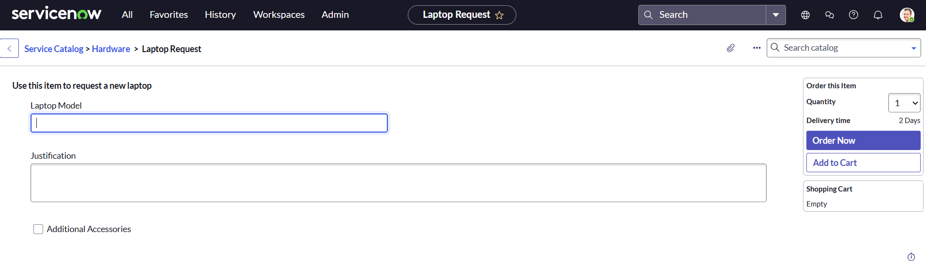

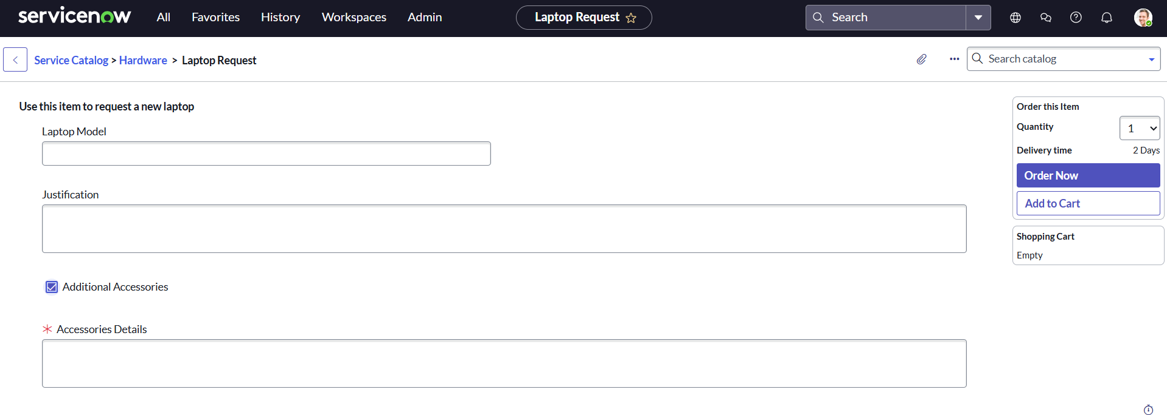

## Conclusion

The *Laptop Request Catalog Item* project successfully streamlines the process of requesting laptops within the organization by leveraging ServiceNow’s Service Catalog capabilities. By creating a dynamic and automated catalog item, the project provides employees with an intuitive, user-friendly interface that minimizes errors, reduces manual effort, and improves overall eﬃciency.

The implementation of variables, UI policies, UI actions, and automated workﬂows ensures that requests are captured accurately, routed for necessary approvals, and fulﬁlled in a timely manner. Additionally, the migration of conﬁgurations through update sets demonstrates how ServiceNow supports smooth transitions between development, test, and production environments.

This project clearly highlights how ServiceNow can replace manual, error-prone processes with standardized, automated, and user-centric solutions. It not only improves service delivery and IT governance but also enhances employee satisfaction by offering a modern and transparent request experience.