An Internet Protocol address is a numerical label assigned to each device connected to a computer network that uses the Internet Protocol for communication

Protocol version 4 is the fourth version of the Internet Protocol. It is one of the core protocols of standards-based internetworking methods in the Internet, and was the first version deployed for production in the ARPANET in 1983

Internet Protocol version 6 is the most recent version of the Internet Protocol, the communications protocol that provides an identification and location system for computers on networks and routes traffic across the Internet.

TCP/IP is short for **Transmission Control Protocol**/Internet Protocol. TCP/IP is the suite of communications protocols used to connect hosts on the Internet. TCP/IP uses several protocols, the two main ones being TCP and IP.

User Datagram Protocol (**UDP**) is part of the Internet Protocol suite used by programs running on different computers on a network. **UDP** is used to send short messages called datagrams but overall, it is an unreliable, connectionless protocol.

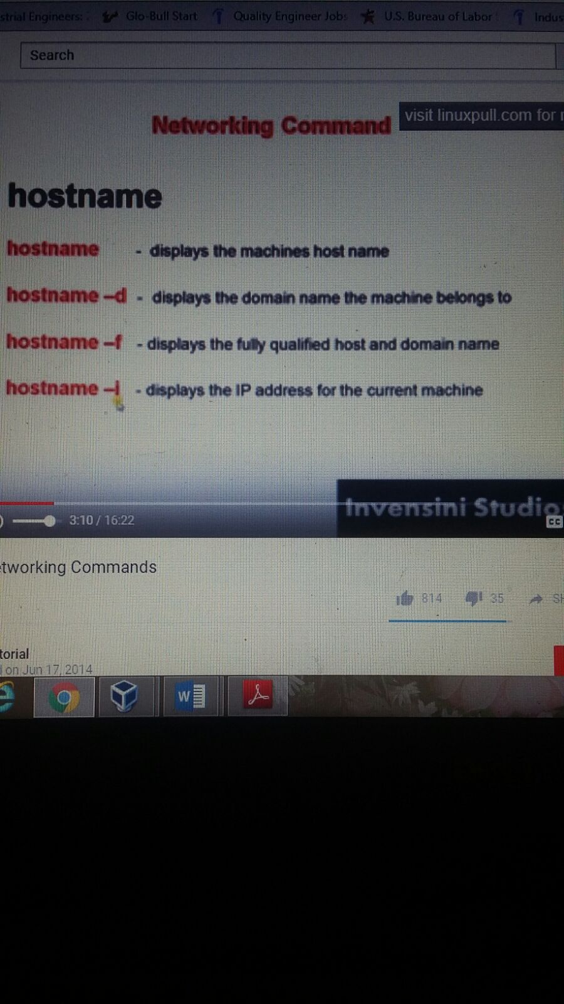

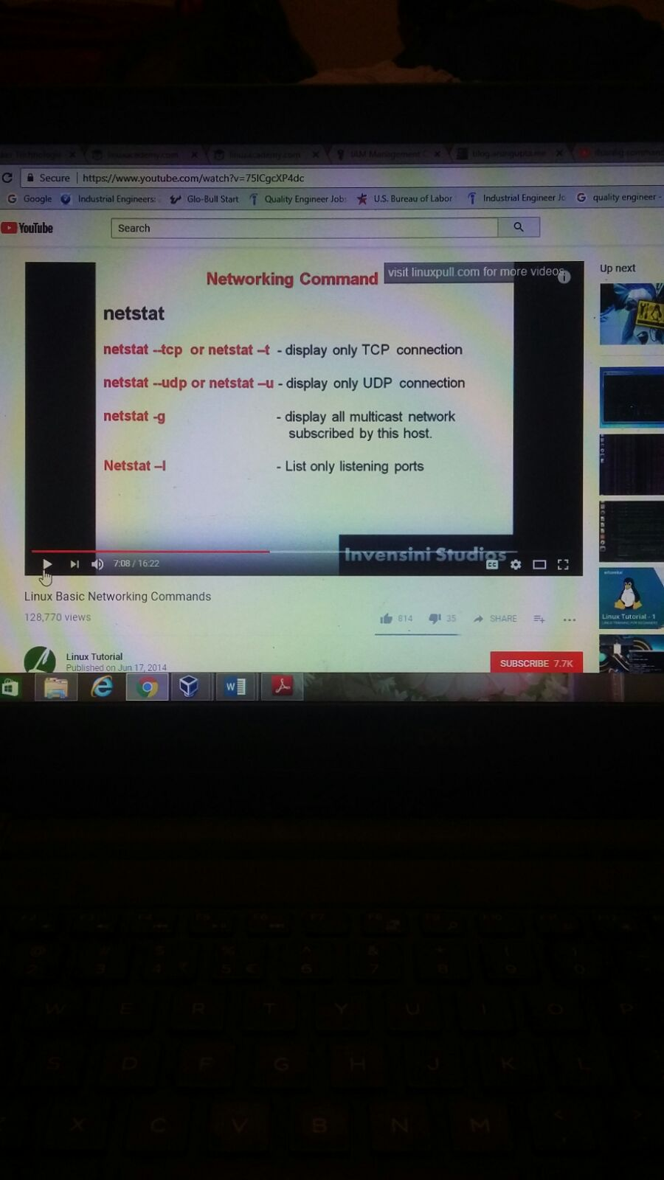

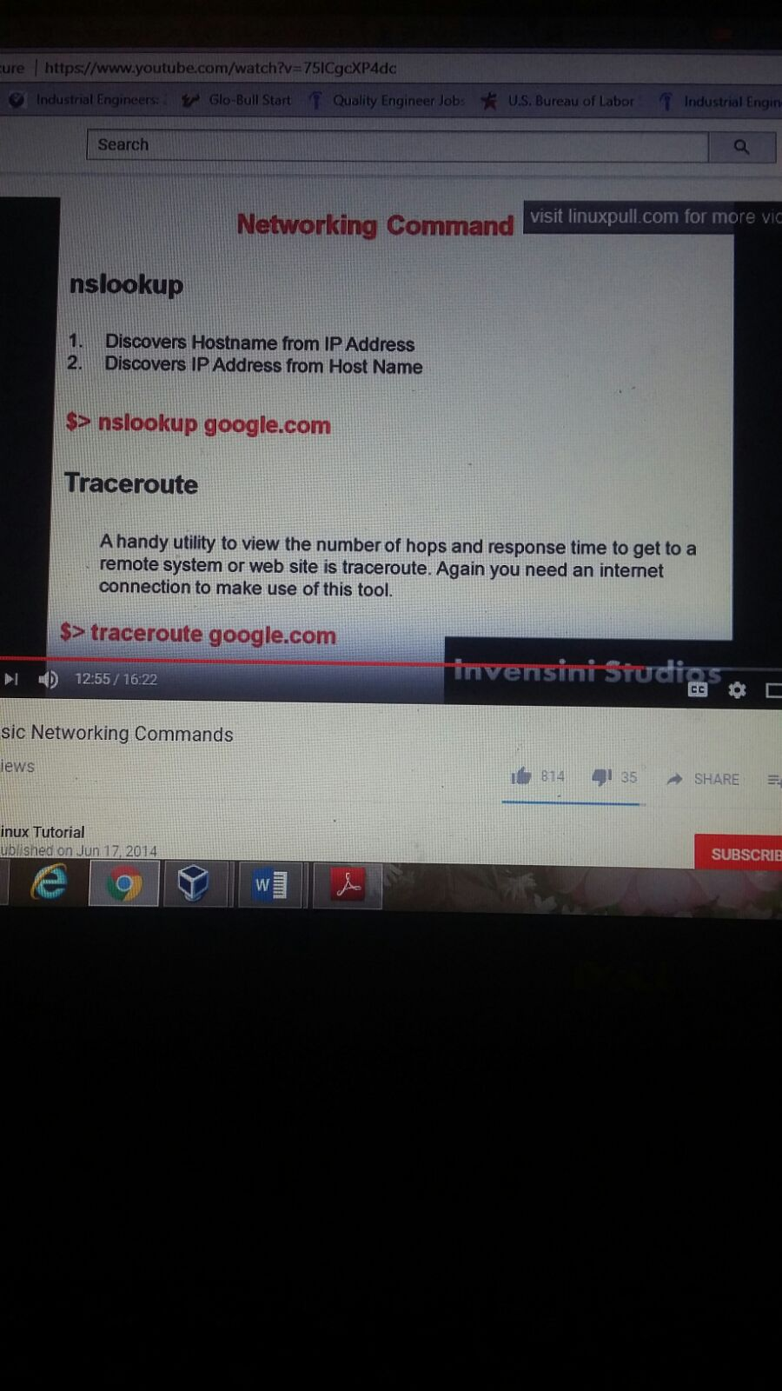

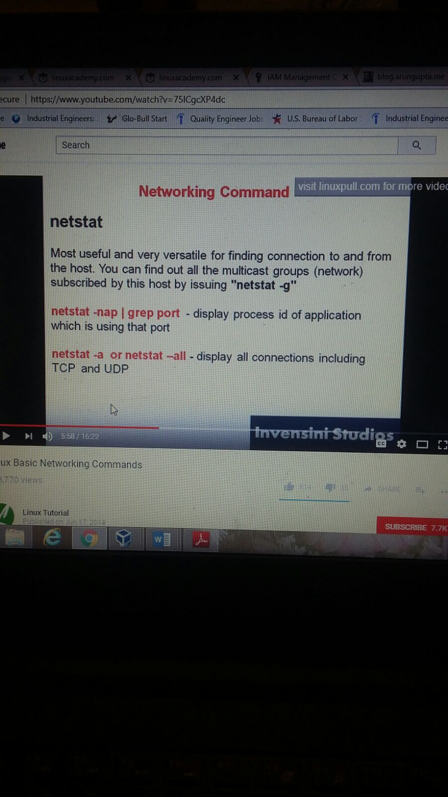

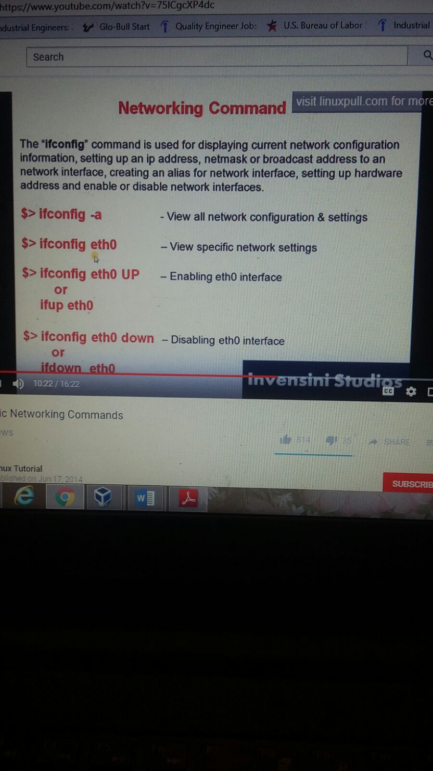

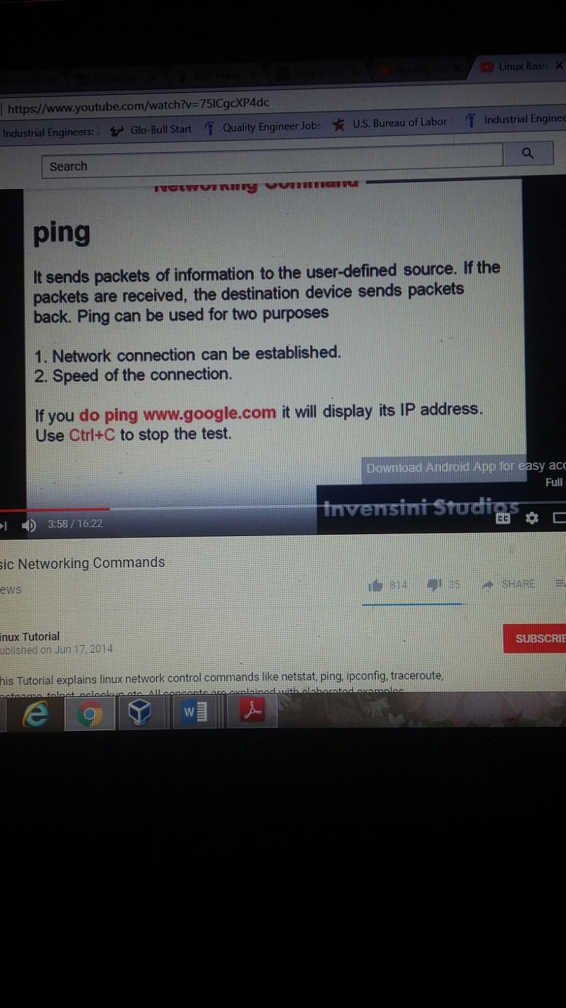

DIG Command (Domain Information Groper) gives Record, CNAME, MX Record. This is used for DNS troubleshooting

$ dig ww.google.com

HOST command

Host command is used to find name to IP name in IPv4 or IPv6 and also DNSrecords

$ host www.google.com

ARP ommand – Address Resolution Protocol is used view/add ontents to ARP tables

$ arp -e

$nmap ipaddress

To find the available ports in the ip address

Ifconfig

The first para right below the command line is the active interface. Towards the left you can see the name of the interface

Ip, subnetmask,gateway, dns all in diagrams

ssh username@ipaddress to secure a connection with that computer