JUSTIFICATION OF TITLE - 50 marks

**ANALYSIS OF THE WATER QUALITY MONITORING**

**SYSTEM**

How we are able to analysis? Is there any data storage types to analysis ??

How we are monitoring all the paramaters that affects water quality??

For what purpose we are monitoring WATER QUALITY??

what are the paramaters that affects water quality???

Scientists measure a variety of properties to determine water quality. These include temperature, acidity (pH), dissolved solids (specific conductance), particulate matter (turbidity), dissolved oxygen, hardness and suspended sediment. Each reveals something different about the health of a water body.

The result of a single measurement, however, is actually less important than monitoring changes over time. For example, if you measure the pH of the creek behind your house and find that it is 5.5, you might think it is acidic. But a pH of 5.5 might be “normal” for that creek. If the pH or the turbidity of your creek begins to change, however, something may be happening (probably upstream) that is affecting water quality. Taking routine measurements at scheduled intervals allows you to monitor overall changes in water quality.

**The following water properties are important in determining water quality:**

* **Temperature:** Water temperature is important to fish and aquatic plants. Temperature can affect the level of oxygen, as well as the ability of organisms to resist certain pollutants. See: [Water Temperature](http://www.michiganseagrant.org/lessons/lessons/earth-science/water-quality-what-makes-water-healthy/weather-and-water-temperature/" \o "Weather and Water Temperature)
* **Acidity – pH:** The measurement of pH is a measure of the amount of hydrogen ions (H+) present in a substance such as water. Knowing the amount of hydrogen in a substance allows us to judge whether it is acidic, neutral, or basic. See: [Measuring pH](http://www.michiganseagrant.org/lessons/lessons/earth-science/water-quality-what-makes-water-healthy/measuring-ph/" \o "Measuring pH)
* **Dissolved Oxygen:** A small amount of oxygen, about ten molecules of oxygen per million molecules of water, is dissolved in water. Fish and microscopic organisms need dissolved oxygen to survive. See: [Oxygen and Carbon Dioxide](http://www.michiganseagrant.org/lessons/lessons/earth-science/water-quality-what-makes-water-healthy/oxygen-and-carbon-dioxide/" \o "Oxygen and Carbon Dioxide)
* **Turbidity:** Turbidity makes the water cloudy or opaque. Turbidity is the amount of particulate matter (such as clay, silt, plankton, or microscopic organisms) suspended in water. See: [Water Clarity](http://www.michiganseagrant.org/lessons/lessons/earth-science/water-quality-what-makes-water-healthy/water-clarity/" \o "Water Clarity)
* **Specific Conductance:** Specific conductance measures the capacity of water to conduct an electrical current. It depends on the amount of dissolved solids, such as salt, in the water.
* **Hardness:** The amount of dissolved calcium and magnesium in water determines its “hardness.” Water hardness varies throughout the United States.
* **Suspended Sediment:** Suspended sediment is the amount of soil circulating in water. The amount depends in part on the speed of the water flow. Fast-flowing water can pick up and hold, or suspend, more soil than calm water

Just by measuring Acidity-pH (with PH Sensor ) and turbidity (with turbidity sensor) how can we justify Water quality??

Where is temperature sensor???

[we can’t full fledgely say

**“ANALYSIS OF THE WATER QUALITY MONITORING**

**SYSTEM”**

With out measuring all the paramaters.]

Existing System :

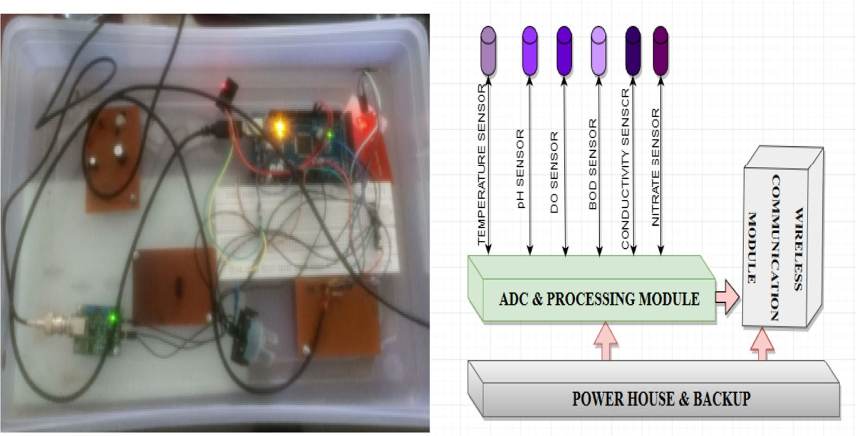

<https://youtu.be/yc4Dphzx_C8>

USED IOT WEB PAGES+SENSORS+PHP CODE+MYSQL DATA BASE+SMS ALERT+EMAIL ALERT

?????

How to over come the existing system

???

What is majour improvement in Proposed system ???