1.Brief Discussion of the Firm or Organization Sponsoring the Internship

1.1 General Information
The organization’s name, precise location, and workforce figures are withheld in this paper at its request; it is referred to throughout as “the Organization.” The Organization is a regional retail bank operating primarily in a metropolitan area of the United States, with a branch network that extends into surrounding communities. It offers the standard range of consumer and commercial banking products: checking and savings accounts, consumer and business loans, credit cards, and, increasingly, digital account access. Three business units make up its operations — the retail branch network, a back-office operations group, and a technology division. The internship described in this paper was based in the technology division.
The Organization began as a single community bank and grew into its current regional footprint through a series of acquisitions of smaller community banks, supplemented by organic growth in its existing markets. That acquisition history still shows up in the technology environment: several legacy systems inherited from earlier mergers coexist alongside newer platforms, which is part of why modernization projects such as the one described in this paper carry real weight internally.
The Organization’s stated vision is to be a trusted bank for the communities it serves by pairing strong in-branch service with digital banking that is both safe and easy to use. Its mission centers on providing reliable, secure, and convenient financial services to customers regardless of their comfort with technology. That mission was not abstract during the internship — it showed up directly in product requirements. Error messages, for example, had to be understandable to a customer with no banking or technical background, not just accurate to a developer. When my team rewrote a raw database error into a plain-language explanation of why a transfer had failed, that was the mission being applied to a single line of text.
The Organization’s most significant recent achievement is the one this paper focuses on: replacing a largely manual, branch-dependent account-servicing process with a browser- and app-based Digital Banking Platform (DBP). Before DBP, checking a balance, transferring funds, or confirming interest posted to an account typically required a branch visit and manual reconciliation by staff. That model was slow, inconsistent from branch to branch, and increasingly out of step with customer expectations shaped by other digital financial services. DBP was the Organization’s answer to that gap, and it was the project I worked on for the full length of my internship.

1.2 Organizational Structure
The technology division follows a conventional hierarchical structure for a community-bank IT organization. A Chief Information Officer (CIO) sits at the top, with an IT Director for Digital Banking reporting directly to the CIO and overseeing the DBP program specifically. Three managers report to the IT Director: an Engineering Manager, a QA Manager, and a DevOps/Infrastructure Lead, each responsible for a distinct functional area of the program. Within Engineering, a Backend Team Lead and a Front-End Team Lead each oversee a small group of developers. My internship sat on the backend side of the Engineering team, reporting to the Backend Team Lead, as shown in Figure 1.
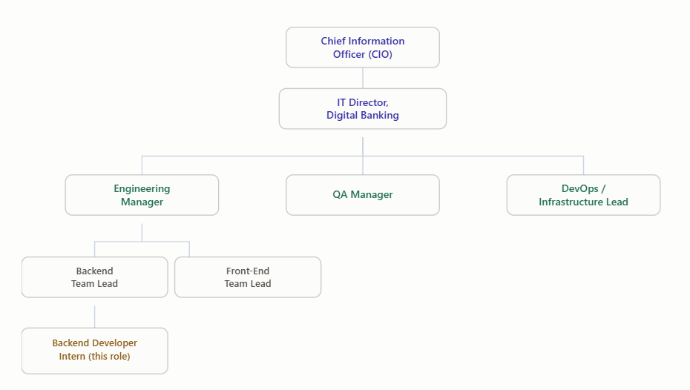
Figure 1: Organizational structure of the technology division hosting the internship.
In practice, this structure determined how fast a decision could move. Questions confined to my own code — how to structure a repository method, which exception type to throw for a given edge case — were usually settled within the team, either by the Backend Team Lead or a senior peer, in a matter of minutes. Anything that touched the API contract shared with the front-end team, or that had budget or timeline implications, moved more slowly and deliberately through the Engineering Manager, since a fast decision at that level could affect teams well outside my own.

2. Information Security Infrastructure
The description below covers the security controls and technology categories used on the Digital Banking Platform, based on publicly available industry practice and my own observations during the internship. Specific vendor and product names are omitted at the Organization’s request; categories such as “commercial web application firewall” or “SIEM platform” are used instead. That level of generalization is common in financial services, where publishing exact security configurations can itself create risk.
Network infrastructure is segmented into separate zones by application tier — a public-facing DMZ, an application tier, and a restricted data tier. Traffic between zones passes through commercial web application firewalls and network access control lists before it reaches the banking application servers. All traffic between the client, the API layer, and internal services is encrypted in transit using TLS, and sensitive customer data — account numbers, balances, and other personally identifiable information — is encrypted at rest in the database tier. The effect of this zone-based design is that compromising one layer does not automatically expose the layers behind it; an attacker who breached the DMZ would still need to defeat separate controls at the application tier before reaching customer data.
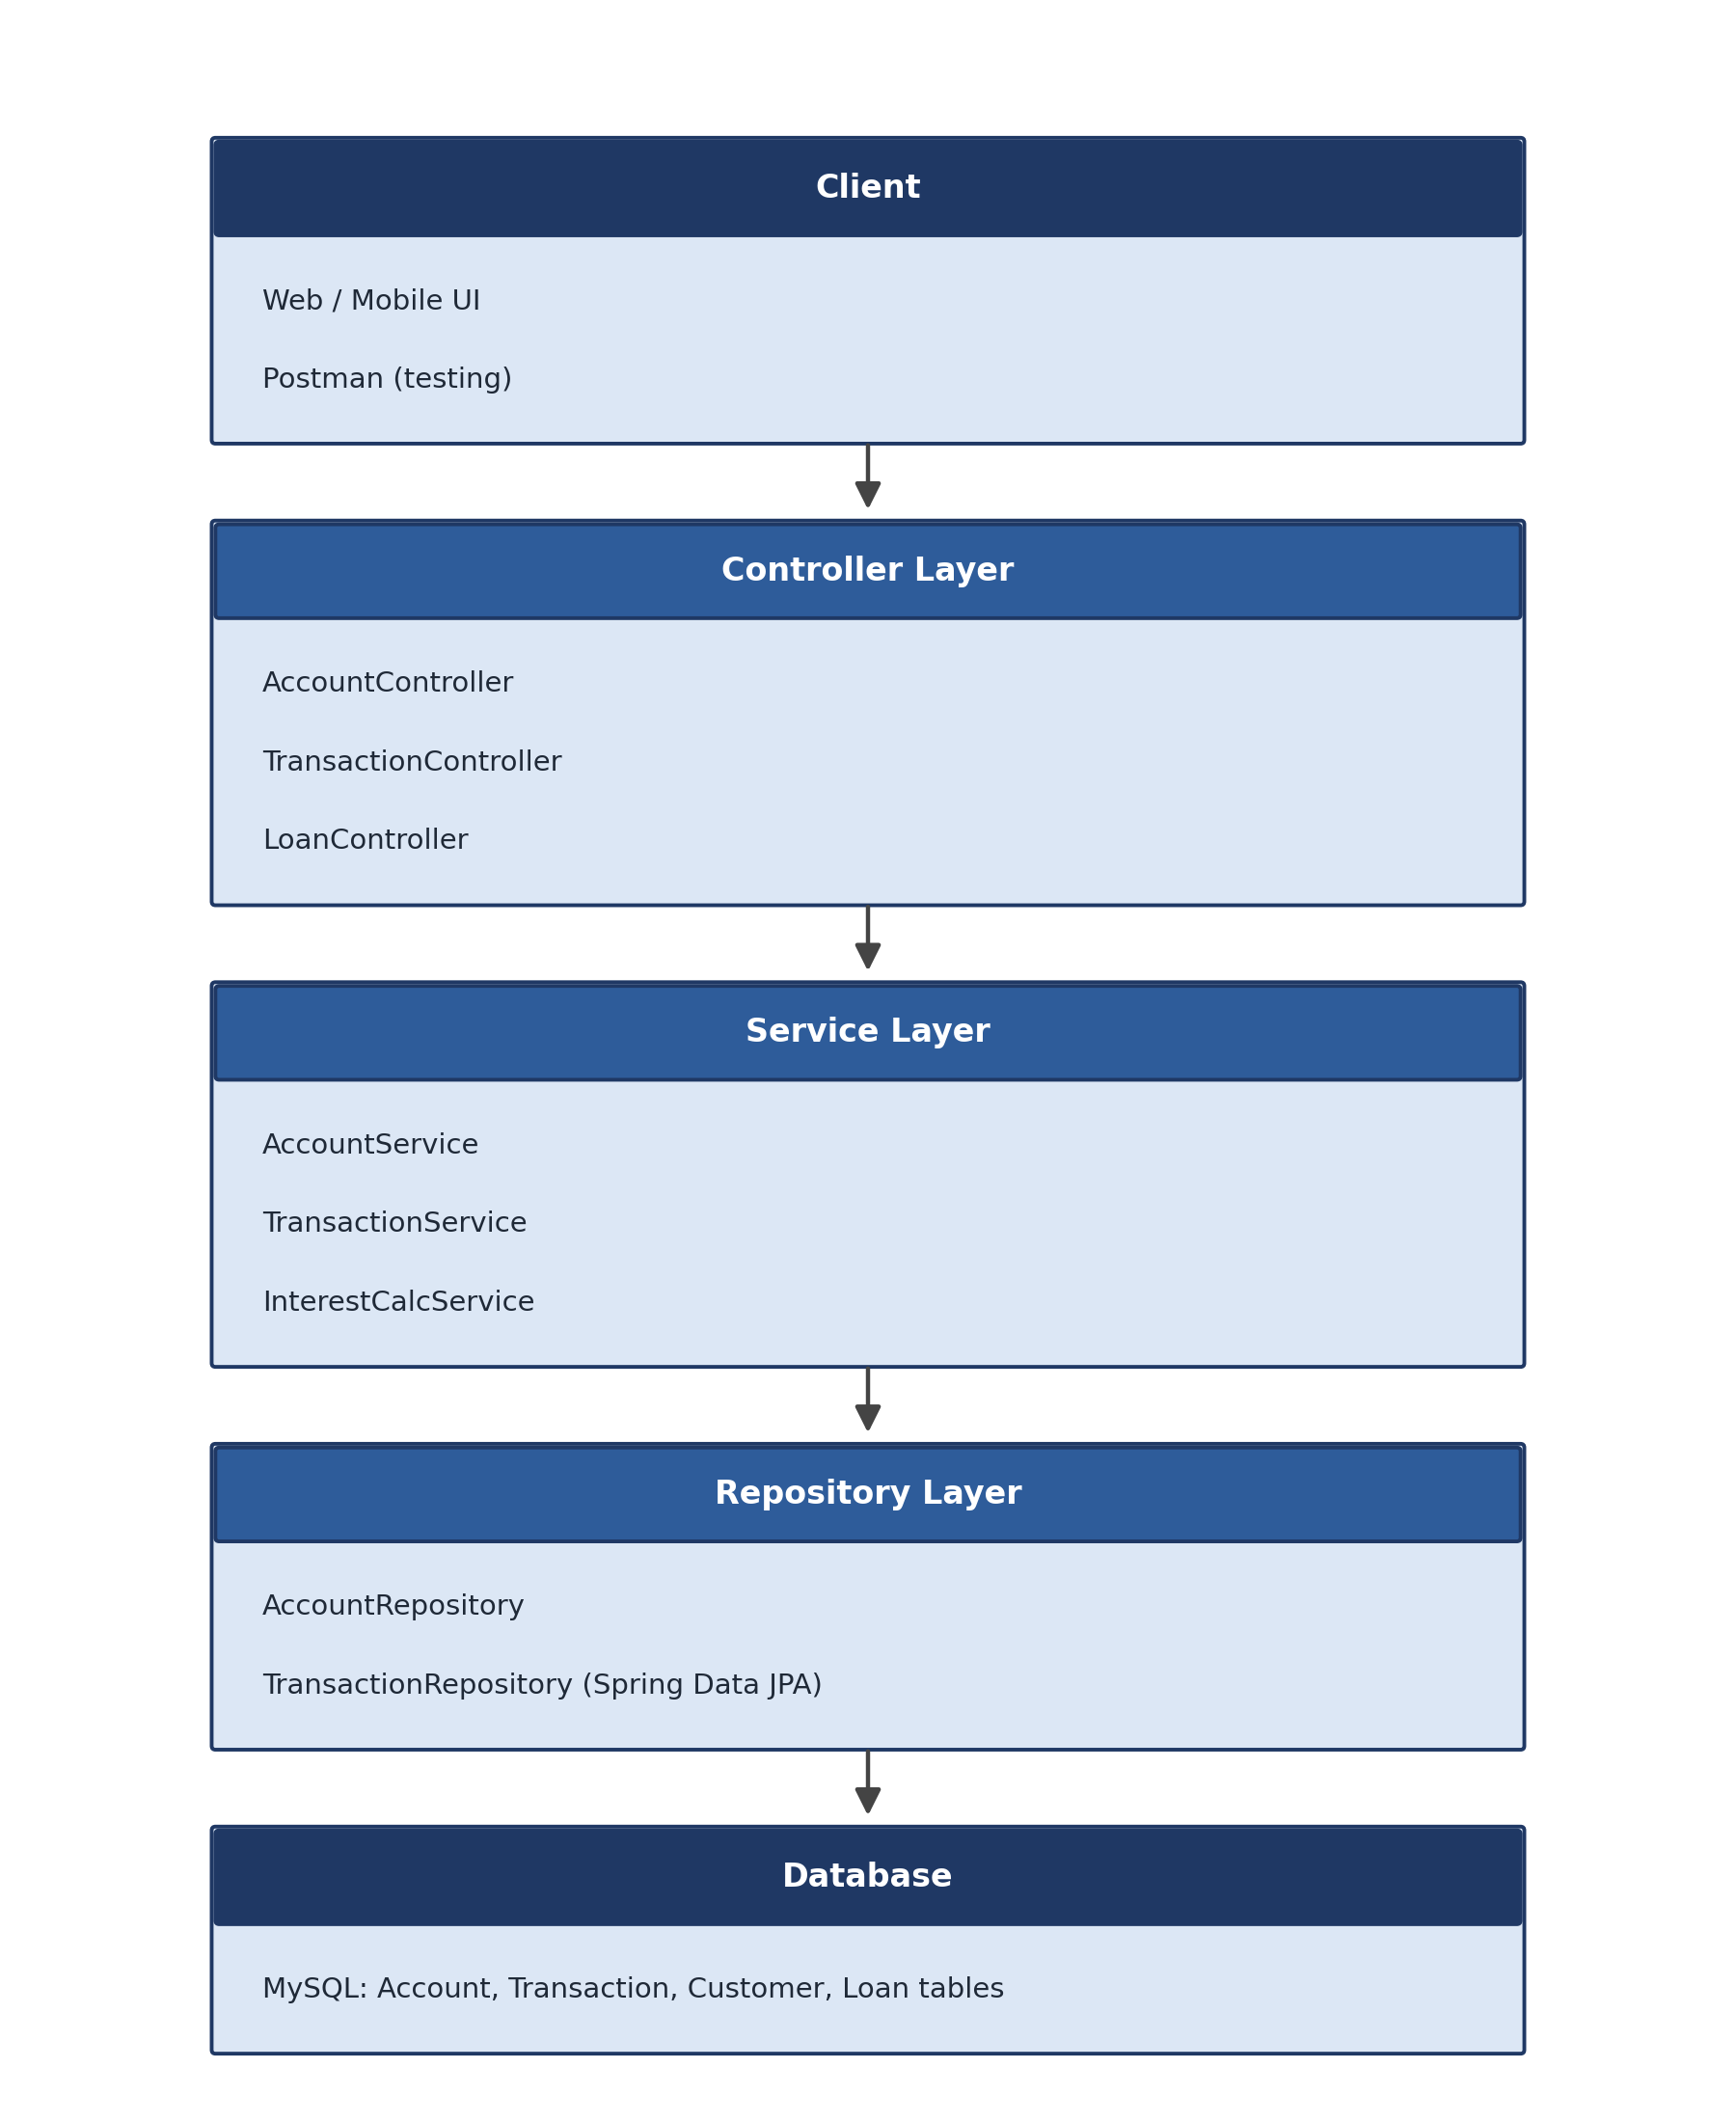
Figure 2: Layered application architecture used on the Digital Banking Platform.
Authentication and authorization on DBP are handled by Spring Security using role-based access control, with distinct roles for customers, tellers, and administrators. Scoping those roles correctly was a recurring part of my work: for every new endpoint, the team had to confirm which roles had a legitimate business reason to call it, since an overly broad permission could let an ordinary customer session reach an operation meant only for administrators. Passwords are never stored in plain text or with reversible encryption; they are hashed with a salted, one-way algorithm. Administrative actions with financial consequences, such as reversing a transaction, require an elevated role and are logged with enough detail — acting user, timestamp, affected account — to reconstruct the sequence of events later if a transaction is disputed.
Application and infrastructure logs feed into a central logging and monitoring platform that flags anomalies and supports periodic vulnerability scanning of externally facing systems. The Organization’s security program is built around applicable regulatory requirements, including PCI DSS for cardholder data, along with standard expectations for data retention, auditability, and incident response. Those requirements were concrete during development, not abstract: they determined, for instance, which fields could appear in an application log and how long certain records had to be kept. One conversation that stuck with me involved whether a partially masked account number was safe to log for debugging purposes — a colleague pointed out that combining a masked account number with a timestamp and session ID in the same log line could still be enough, in aggregate, to identify a specific customer. That reframed how I thought about log data generally: the risk is often in the combination of fields, not any single field in isolation.
Most SIEM and cloud infrastructure tooling used by the Organization is third-party. The core banking application itself — the Java/Spring Boot services built during this internship — is developed, supported, and operated entirely in-house by the Engineering team, with no external vendor to escalate defects to. That distinction mattered day to day: if the transfer service failed at two in the morning, an internal on-call engineer handled it, which is part of why the team held code quality, test coverage, and rollback readiness to a high standard for anything touching the core banking application.

3. Detailed Description of My Work

3.1 Schedule
The internship ran from September 1, 2025 through July 29, 2026, structured across three academic-term phases totaling approximately 45 weeks of work: Phase 1 (September–December 2025), Phase 2 (January–April 2026), and Phase 3 (May–July 2026, in progress at the time of writing). Work was organized into two-week Agile sprints, sixteen of which are reflected in the tables below, bracketed by an onboarding period at the start and deployment, monitoring, and hand-off activities at the end. The tables below summarize each week’s focus and key activities.

3.1.1 Phase 1: September 1, 2025 – December 12, 2025

3.1.2 Phase 2: January 14, 2026 – April 24, 2026

3.1.3 Phase 3: May 13, 2026 – July 29, 2026
Week | Focus | Activities / Accomplishments
Sep 01, 25 – Sep 05, 25 | Onboarding & Orientation | Company/team orientation, environment setup (IntelliJ, Git, Maven), codebase walkthrough, security and compliance training.
Sep 08, 25 – Sep 12, 25 | Project Set-Up | Reviewed existing architecture; set up Spring Boot project scaffolding; attended first sprint planning session.
Sep 15, 25 – Sep 19, 25 | Database Schema Design (Sprint 1) | Began designing relational schemas for customers, accounts, transactions, cards, and loans.
Sep 22, 25 – Sep 26, 25 | Database Schema Design, cont. | Finalized keys, indexes, and constraints; peer-reviewed schema with Technical Lead; sprint demo and retrospective.
Sep 29, 25 – Oct 03, 25 | Customer Module (Sprint 2) | Implemented customer registration and authentication endpoints; began role-based access control work.
Oct 06, 25 – Oct 10, 25 | Customer Module, cont. | Completed authentication/authorization logic; unit tests for customer service layer; sprint review and retrospective.
Oct 13, 25 – Oct 17, 25 | Account Management (Sprint 3) | Built account CRUD endpoints and balance look-up services; peer code reviews; daily stand-ups.
Oct 20, 25 – Oct 24, 25 | Account Management, cont. | Finished account module integration tests; coordinated with front-end team on API contracts.
Oct 27, 25 – Oct 31, 25 | Card Management (Sprint 4) | Designed card entity and linked-account relationships; implemented card issuance and status endpoints.
Nov 03, 25 – Nov 07, 25 | Card Management, cont. | Added card activation/lock endpoints and validation rules; sprint demo to stakeholders.
Nov 10, 25 – Nov 14, 25 | Fund Transfer (Sprint 5) | Designed and implemented the fund-transfer workflow, including transactional balance updates and concurrency safeguards.
Nov 17, 25 – Nov 21, 25 | Fund Transfer, cont. | Hardened transfer logic against edge cases (concurrent debits); resolved a merge conflict; sprint demo to stakeholders.
Nov 24, 25 – Nov 28, 25 | Fund Transfer Hardening (Sprint 6) | Added additional concurrency tests and rollback handling for partially failed transfers.
Dec 01, 25 – Dec 05, 25 | Fund Transfer Hardening, cont. | Load-tested the transfer endpoint against simulated concurrent requests; refined locking strategy.
Dec 08, 25 – Dec 12, 25 | Loan Tracking & Interest (Sprint 7) | Implemented loan tracking and automated interest-calculation endpoints; began testing across modules.
Table 1a: Week-by-week internship schedule – Phase 1.
Week | Focus | Activities / Accomplishments
Jan 14, 26 – Jan 16, 26 | Loan Tracking & Interest, cont. | Finalized interest-posting audit records; coordinated with QA on loan-module test cases.
Jan 19, 26 – Jan 23, 26 | Notifications & Alerts (Sprint 8) | Designed and built endpoints for transfer-confirmation and low-balance notification events.
Jan 26, 26 – Jan 30, 26 | Notifications & Alerts, cont. | Integrated notification triggers with the account and transfer services; wrote unit tests for alert logic.
Feb 02, 26 – Feb 06, 26 | Reporting & Dashboards (Sprint 9) | Built reporting-dashboard endpoints; ran full integration test suite; supported QA in test case design.
Feb 09, 26 – Feb 13, 26 | Reporting & Dashboards, cont. | Added filtering and export options to reporting endpoints; reviewed output with branch operations staff.
Feb 16, 26 – Feb 20, 26 | Cross-Module Integration (Sprint 10) | Ran end-to-end integration tests spanning customer, account, transfer, card, and loan modules.
Feb 23, 26 – Feb 27, 26 | Cross-Module Integration, cont. | Resolved integration defects surfaced by end-to-end tests; updated automated regression suite.
Mar 02, 26 – Mar 06, 26 | Performance Tuning (Sprint 11) | Profiled slow endpoints; introduced caching for frequently read, rarely changed account data.
Mar 09, 26 – Mar 13, 26 | Performance Tuning, cont. | Tuned database indexes and query plans based on profiling results; re-ran load tests.
Mar 16, 26 – Mar 20, 26 | Security Hardening (Sprint 12) | Reviewed role-based access control coverage across all endpoints; closed gaps identified in the review.
Mar 23, 26 – Mar 27, 26 | Security Hardening, cont. | Supported an internal penetration test exercise; remediated findings related to input validation.
Mar 30, 26 – Apr 03, 26 | Mobile API Enhancements (Sprint 13) | Adjusted API response payloads to better support the mobile client team’s data needs.
Apr 06, 26 – Apr 10, 26 | Mobile API Enhancements, cont. | Added pagination and lightweight response modes for mobile; coordinated versioning with the front-end team.
Apr 13, 26 – Apr 17, 26 | Accessibility & Messaging (Sprint 14) | Rewrote technical error messages into plain-language, customer-facing text across the API surface.
Apr 20, 26 – Apr 24, 26 | Accessibility & Messaging, cont. | Reviewed updated messaging with branch operations staff; incorporated feedback into final wording.
Table 1b: Week-by-week internship schedule – Phase 2.
Week | Focus | Activities / Accomplishments
May 13, 26 – May 15, 26 | UAT Preparation (Sprint 15) | Prepared UAT test scripts and sample data sets; supported QA in scenario design.
May 18, 26 – May 22, 26 | UAT Preparation, cont. | Triaged pre-UAT defects; finalized release notes and known-issues list for stakeholders.
May 25, 26 – May 29, 26 | UAT Execution (Sprint 16) | Supported User Acceptance Testing sessions; resolved bugs identified during UAT.
Jun 01, 26 – Jun 05, 26 | UAT Execution, cont. | Completed final round of UAT defect fixes; obtained stakeholder sign-off for production release.
Jun 08, 26 – Jun 12, 26 | Production Deployment | Supported production deployment through the CI/CD pipeline; monitored initial post-release performance.
Jun 15, 26 – Jun 19, 26 | Post-Release Monitoring | Tracked system logs and performance metrics post-launch; addressed minor data mapping and integration discrepancies.
Jun 22, 26 – Jun 26, 26 | Technical Debt & Refactoring | Refactored legacy code in the application layer; optimized database queries identified during initial live usage.
Jun 29, 26 – Jul 03, 26 | Backlog Enhancements | Began implementing low-priority backlog features deferred from the main release, such as advanced reporting filters.
Jul 06, 26 – Jul 10, 26 (in progress) | Backlog Enhancements, cont. | Finalize and merge backlog features; update automated test coverage for the new enhancements.
Jul 13, 26 – Jul 17, 26 (upcoming) | System Documentation | Draft operational runbooks; update internal wikis, architecture diagrams, and API schemas.
Jul 20, 26 – Jul 24, 26 (upcoming) | Knowledge Hand-off | Conduct codebase walkthroughs with the core team; finalize module documentation and internal transition plans.
Jul 27, 26 – Jul 29, 26 (upcoming) | Final Presentation & Wrap-up | Deliver final project showcase to leadership and stakeholders; complete final offboarding procedures.
Table 1c: Week-by-week internship schedule – Phase 3.

3.2 Description of the Projects

3.2.1 Type and Length of Each Project, and My Role in Each Project
The internship centered on a single continuous project: the Digital Banking Platform (DBP), a Java/Spring Boot application that lets customers view account balances, transfer funds, and review loan information without visiting a branch. The project ran the full length of the internship and was organized into sixteen two-week Agile sprints across the three phases described in Section 3.1, each ending in an incremental release demoed to stakeholders for feedback. That cadence gave me repeated, low-stakes opportunities to get feedback on both functionality and code quality, which shaped how I approached the next sprint’s work. Early demos were nerve-wracking because I was essentially hoping nothing broke while someone clicked through a live screen; by the later sprints, I trusted the automated test suite enough to spend the demo discussing trade-offs and upcoming work instead.
As the Java Backend Developer on a team that also included a Technical Lead, two front-end developers, and a QA engineer, I was primarily responsible for the Account Management, Fund Transfer, and Interest Calculation modules. The Technical Lead retained final say over architectural decisions, but I had real latitude to propose implementation approaches and defend them in code review rather than simply implementing instructions handed down to me. Figure 2 shows the Agile/SDLC cycle used to structure the project.
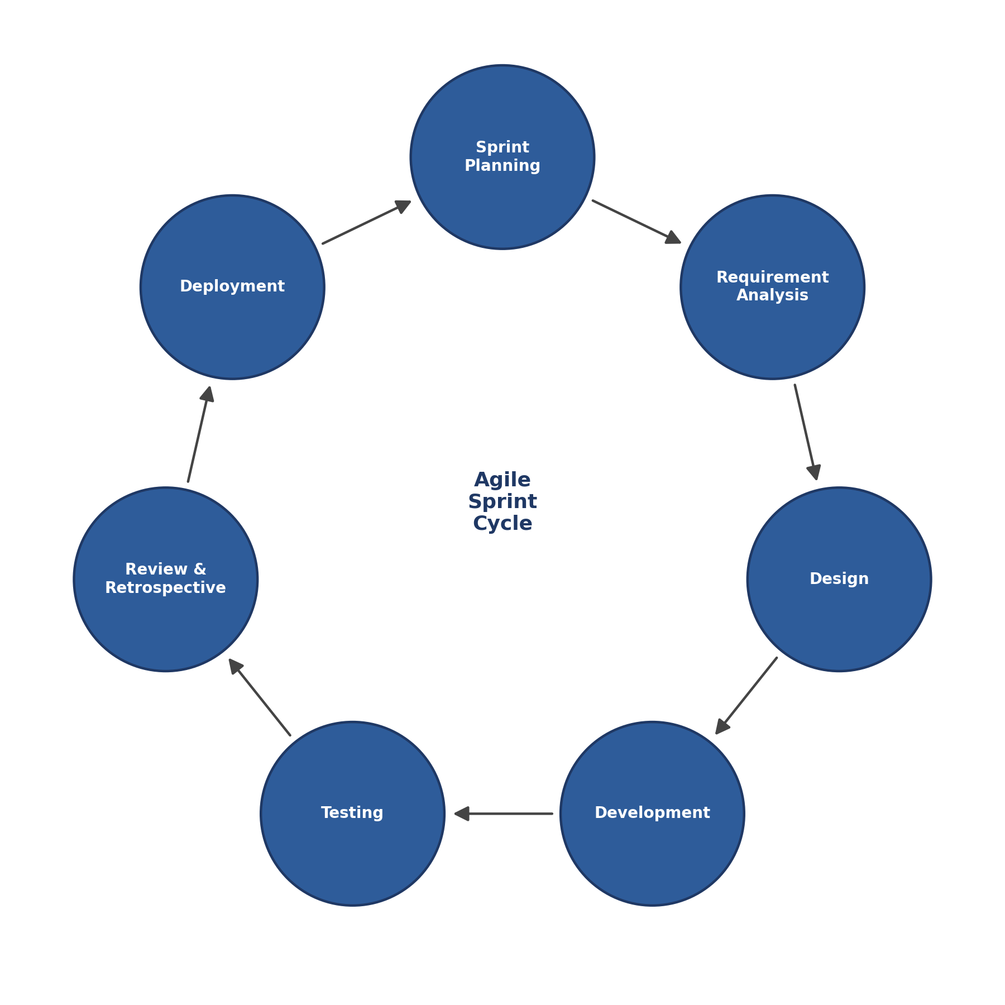
Figure 2: SDLC / Agile methodology cycle used for sprint planning.
One part of that cycle I underestimated at first was the sprint retrospective. My instinct, coming from a more academic background, was to treat it as a chance to identify who was responsible when something went wrong. Watching how the Technical Lead ran these meetings taught me a different habit — frame every issue as a question about the process (why did this bug get past code review?) rather than the person (who approved it?). That reframing noticeably increased how willing the team was to surface its own mistakes early.

3.2.2 Scope, Task, Problem Statement, Cause and Effects, Constraints, and Deliverables
Problem statement: Before DBP, account servicing at the Organization was largely manual. Confirming a balance, processing a transfer, or posting interest required a branch visit and back-office reconciliation. That produced slow, inconsistent service and frequent opportunities for manual error, and it limited how well the Organization could scale as its customer base grew.
Cause and effect: The root cause was the absence of a secure, self-service digital channel. The effect was that every balance inquiry, transfer, or interest posting consumed branch staff time and carried manual-entry risk — a cost that grew with transaction volume. Framed that way, DBP was less a new feature than a structural fix to a bottleneck that scaled poorly with the Organization’s own growth.
Scope and tasks: My scope covered the backend services for customer account management, fund transfers, and loan/interest tracking — the underlying MySQL schema, the REST APIs consumed by the front-end team, and the automated test suite for that logic. These three areas were interdependent enough (a transfer touches the same account rows a balance inquiry reads; an interest posting is itself a specialized account update) that I could not treat them as fully independent, even though they were tracked as separate backlog items. Concretely, this involved designing relational tables for customers, accounts, transactions, cards, and loans with appropriate keys and indexes; building RESTful endpoints with Spring Boot, Spring Data JPA, and Spring Security; implementing the fund-transfer workflow with transactional guarantees so a transfer could never leave the system in an inconsistent state, including safeguards against two near-simultaneous debits to the same account; and writing unit and integration tests with JUnit and Mockito, validated manually with Postman before handoff to the front-end team. That manual verification step caught more than one mismatch between documented and actual endpoint behavior before it became a front-end integration problem.
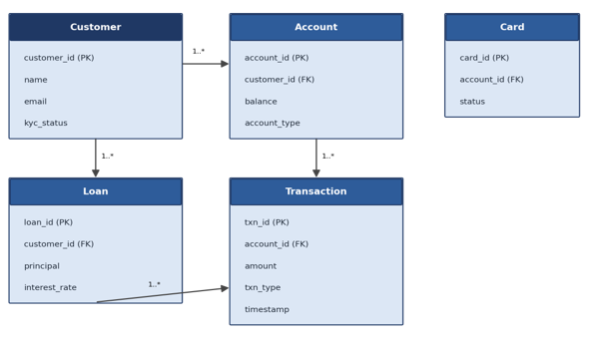
Figure 3: Banking database entity-relationship diagram covering customer, account, transaction, card, and loan entities.
Constraints: Sprints were fixed at two weeks, and several constraints shaped every design decision within them — the API contract with the front-end team had to remain stable so both teams could work in parallel; money movement had to be correct even under concurrent transactions; and every system touching customer financial data had to meet the Organization’s security and auditability standards. These constraints occasionally pulled in different directions. When designing the interest-calculation job, for example, the fastest approach would have overwritten each account’s balance in place; instead I generated and stored an explicit interest-posting record on every run, trading a small amount of processing time for a complete, reconstructable audit history.
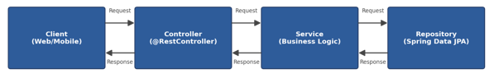
Figure 4: REST API request/response flow for the account module.
Deliverables: By the close of Phase 2, the backend provided operationally complete, tested REST APIs for customer registration and authentication; account creation, update, closure, and balance look-up; fund transfer and withdrawal processing with transactional integrity; and automated interest calculation for loans — all backed by a normalized MySQL schema, covered by unit and integration tests, and promoted through the Organization’s Jenkins CI/CD pipeline across Development, SIT, UAT, and Production environments (Figure 5). Each environment promotion required passing an automated test gate, so a build that failed in SIT never reached UAT, which measurably reduced the number of defects that reached real customers.
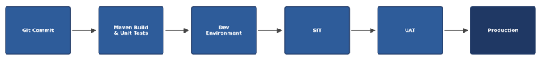
Figure 5: CI/CD deployment pipeline used to promote builds across environments.
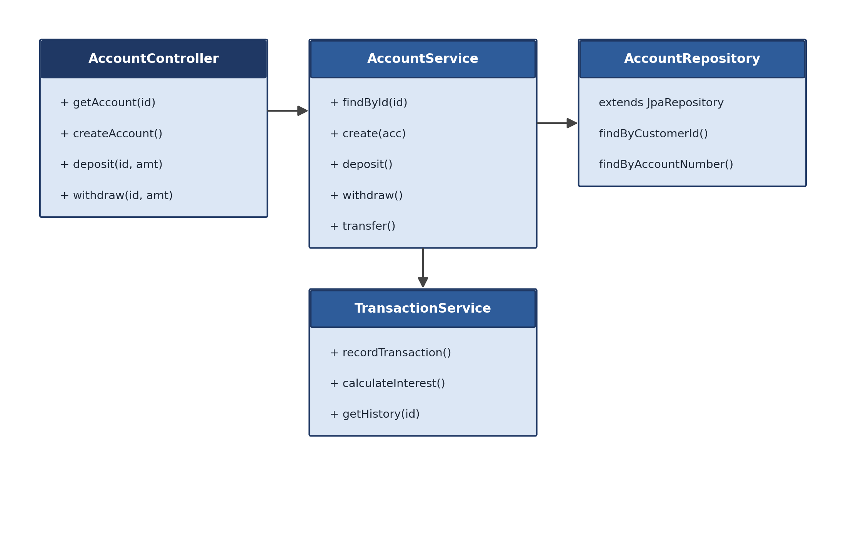
Figure 6: Account module class diagram showing the controller, service, and repository relationship.

4. Course(s) That Helped in the Internship
The three courses below, taken as part of the MSIA program, most directly shaped my ability to succeed in this internship.

IA 643 – Database Application Security and Auditing
How it was useful: This course taught me how to secure a database for a financial application — protecting customer data, minimizing unauthorized access, and applying the principle of least privilege. Its coverage of input validation and parameterized queries directly shaped how I wrote both repository and service-layer code to defend against SQL injection, and I returned to those concepts often when reviewing other interns’ pull requests.
How it might be improved: A lab component built around a modern ORM (Spring Data JPA, for example) rather than raw SQL alone would help, since most production code I saw accessed the database through an ORM. That would let students practice spotting the same security pitfalls within the abstraction layer they are actually likely to encounter on the job, including the specific failure mode of an ORM silently generating an inefficient or unsafe query underneath a seemingly harmless method call.

IA 559 – Information Systems in Today’s World
How it was useful: This course built my ability to translate a business or operational problem into a technical design, and to evaluate a system not just on whether it works but on whether it improves the process it was built to support. That habit — asking whether a change actually makes the underlying process better, not just whether it can be built — mattered directly when designing the fund-transfer confirmation screen: the technically simplest option was an instant, silent transfer, but branch staff pointed out that customers accustomed to a teller confirming a transfer would find that unsettling rather than convenient. We added an explicit confirmation step instead.
How it might be improved: A case study on modernizing legacy financial systems into digital ones — similar to the DBP transformation — would help future students see in advance how a manual, paper-based process gets decomposed into discrete digital requirements, a skill I mostly had to build through trial and error in my first few weeks.

IA 560 – Project Management
How it was useful: SMART goals and Gantt-chart planning were directly useful for estimating backlogs and planning sprints, and the course gave me a working vocabulary for discussing scope, risk, and trade-offs with the Technical Lead — useful when a stakeholder once questioned why a seemingly small new transaction category would take an entire sprint, and I could walk through its downstream effects on reporting, interest calculation, and the existing test suite instead of just asserting the estimate.
How it might be improved: A short unit comparing Agile/Scrum ceremonies against traditional waterfall planning — particularly how a backlog evolves mid-project rather than being fixed at the start — would prepare students better for the Agile environments most companies actually use.
Foundational coursework in object-oriented design (encapsulation, inheritance, interface design) also contributed, though it was completed prior to the program and does not carry a program course number. It gave me the vocabulary to plan entity and service class structures that could be extended later without a rewrite — most visibly when I was able to add a new loan product type by extending an existing class hierarchy rather than reworking the account and transaction classes that already existed.

5. Overall Impression of the Internship Experience

5.1 Internship Contribution to the Organization
The modules I built or co-built — account management, fund transfer, and loan/interest tracking — became load-bearing parts of DBP rather than isolated practice exercises. The transactional safeguards I implemented around fund transfers directly prevented a class of bug (inconsistent balances from near-simultaneous debits) that QA specifically tested for and that would have been expensive to discover in production. My work also gave the front-end team a stable, documented API surface to build against, which let their work proceed in parallel with backend development rather than waiting on it — shortening the time between when a feature was designed and when it was demonstrable to stakeholders.
There was a smaller, harder-to-measure benefit as well. Being new to the codebase and the domain meant I asked questions that more experienced team members had stopped asking — why a particular validation rule existed at all, for example. More than once, that kind of question surfaced an assumption that had quietly gone stale as the business evolved, and fixing it became a small but genuine improvement to the system.

5.2 Internship Contribution to Self-Improvement
Early in the internship, I was slow to become productive with the team’s Spring Boot conventions because exception handling and logging patterns were not well documented. I solved that by reading recently merged pull requests and asking questions while pairing rather than guessing — an approach I now treat as the default for any unfamiliar codebase, since a project’s recent commit history is often more reliable than an out-of-date wiki page.
One incident stands out as a genuine turning point. I changed an API field name without telling the front-end team, which broke the transfer confirmation screen for a short period. That taught me, more effectively than any lecture could have, that an API contract is a shared agreement, not something I could modify unilaterally. Afterward, I made a habit of versioning and documenting endpoint changes before merging them, and of flagging even minor field renames in the team’s shared channel before opening a pull request.
I also grew substantially in how I reasoned about concurrency and data integrity. Before this internship, I wrote code that looked correct without considering what happens when two operations compete for the same data. By the end of the internship, checking for that had become automatic — reviewing a pull request without asking “what happens if this runs twice at once” started to feel incomplete. That shift showed up concretely in my test suites: later tests deliberately simulated two near-simultaneous calls to the same transfer endpoint for the same account, a scenario that looks fine in a demo and only surfaces as a defect under real production load.

6. Discuss How You Achieved the Learning Outcomes Submitted as Part of Your Internship Proposal
The Student Learning Outcomes (SLOs) below are the ones submitted in my Internship Proposal. Reviewing them now, at the end of the internship, they map cleanly onto the growth described in Sections 3 and 5, even though I was not consciously tracking them against this list while the work was underway.

SLO 1: Apply knowledge gained from academic studies to solving real-life problems related to Information Systems.
I designed and implemented two production components of DBP — the fund transfer and interest calculation modules — directly applying database design, secure coding, and object-oriented design principles from coursework. Database design is the clearest example of the shift from theory to constraint: in coursework, a normalized schema is evaluated against a rubric; on DBP, the same decisions were evaluated against how a query performed under real transaction volume and whether a future loan product could be added without a disruptive migration.

SLO 2: Communicate professionally and effectively as part of a team performing technical work.
I participated daily in stand-ups, sprint planning, and retrospectives; coordinated with the front-end team on API contracts; and worked with QA to design test plans, as described in Sections 3 and 5. The clearest lesson was that surfacing a blocker early was worth far more than working through it silently — a blocker mentioned on a Tuesday could often be resolved in five minutes, while the same blocker left unmentioned until Friday could cost the team a full day of sprint time.

SLO 3: Evaluate and implement security and data integrity controls in application development.
I worked directly with transactional safeguards for fund transfers, role-based access control for administrative functions, and secure coding practices, as described in Sections 2 and 3. Implementing role-based access control in particular gave me a concrete sense of what “least privilege” means in practice — for every new endpoint, asking exactly which roles genuinely needed access, rather than granting a broader role because it happened to already have access to something related.

SLO 4: Reflect critically on professional growth and identify areas for continued development.
This outcome is addressed most directly in Section 5.2, particularly the API-contract incident and the shift in how I reasoned about concurrency. Both examples follow the same pattern: making a mistake once, understanding specifically why it happened, and building a durable habit that prevented it from recurring.
Taken together, these four outcomes describe more than a checklist to me now — they describe specific habits: defending a design decision to a skeptical reviewer, surfacing a blocker before it becomes a crisis, treating security as a default rather than an add-on, and converting a single mistake into a lasting process improvement. If I were advising a student about to start a similar internship, I would tell them to treat every question a reviewer, a QA engineer, or an operations employee asks about their work as useful information rather than criticism — nearly every lesson in this paper started with someone else asking a question I had not thought to ask myself first.

References
[1] Spring Boot Reference Documentation. https://docs.spring.io/spring-boot/
[2] Spring Data JPA Reference. https://spring.io/projects/spring-data-jpa
[3] Oracle Java Documentation. https://docs.oracle.com/en/java/
[4] JUnit 5 User Guide. https://junit.org/junit5/docs/current/user-guide/
[5] Mockito Documentation. https://site.mockito.org/
[6] MySQL Reference Manual. https://dev.mysql.com/doc/
[7] Postman Learning Center. https://learning.postman.com/
[8] Atlassian Jira Documentation. https://www.atlassian.com/software/jira/features
[9] Git Documentation. https://git-scm.com/doc
[10] Jenkins User Documentation. https://www.jenkins.io/doc/

