Broadband high-quality airy beams via lossy acoustic gradient-index metasurfaces

**Ming Xia1, Xin Zhang2,a), Fugen Wu2,b), Licheng Wang2, Yuechang Liu3 , Zhuohao Chen2 and Yuanwei Yao2**

1School of materials and energy, Guangdong University of Technology, Guangzhou 510006, China

2School of Physics and Optoelectronic Engineering, Guangdong University of Technology, Guangzhou 510006, China

3School of Information Engineering, Guangdong University of Technology, Guangzhou 510006, China

a)E-mail: [xinxintwinkle@163.com](mailto:xinxintwinkle@163.com)

b)E-mail: [wufg@gdut.edu.cn](mailto:wufg@gdut.edu.cn)

Abstract

In this study, we show that fine manipulation of sound wave can be achieved through lossy acoustic gradient-index metasurfaces by utilizing the energy losses. This work, provides a practical route for achieving independent and arbitrary modulation of amplitude and phase of sound. We demonstrate this mechanism by producing broadband high-quality airy beams. Furthermore we realize the multifocal focusing based on this lossy acoustic gradient-index metasurfaces. Our findings increase the freedom and flexibility of the control of sound transmission.

Keywords: acoustic gradient-index metasurface, loss, airy beam, multifocal focusing

1. Introduction

In recent years, the appearance and development of acoustic metasurfaces have brought new freedom and great possibility to control sound wave1-10. In the traditional view, the inherent attenuation has always been considered to have an adverse effect on acoustic manipulation. Therefore, in the design of many acoustic metasurfaces, we usually want the inherent attenuation to be as small as possible so as to ignore it. Losses, however, are ubiquitous in the process of acoustic wave propagation due to thermal and viscous boundary layers and dissipative losses. Although lossless metasurfaces have been well studied and they have shown extraordinary ability in manipulating reflected and transmitted waves11-22, lossy metasurfaces are far from being studied.

As is well-known, Airy beams have become a subject of tremendous interest in recent years on account of their non-diffracting, self-accelerating, and self-healing characteristics23-27,36. Acoustic Airy beams have also received much attention because of their potential applications in particle trapping and manipulation, medical ultrasound, ultrasonic imaging, and acoustic focusing28-35. Previously, to generate acoustic Airy beams, various groups have proposed different designs. For example, Gao et al. used a zero-index medium to generate Airy beams37 and Bar-Ziv et al. demonstrated the acoustic Airy beams by using a tailored acoustic phase mask to provide the required phase profile38. Lately, due to the advantage of sub-wavelength thickness, the method using the acoustic metasurfaces to realize the Airy beams has been proposed31. However, people change the phase and amplitude of the sound mainly through the method of adjusting the internal structure of the metasurfaces to generate airy beams which is extremely complicated.

Recently, Li proposed that tunable asymmetric transmission can be realized by deliberately introducing loss in an acoustic metasurface7. This work inspired us. In this study, we demonstrate that independent and arbitrary modulation of amplitude and phase of sound can be realized by intentionally introducing energy loss in an acoustic gradient-index metasurface(GIM). This method provides a new route for fine manipulation of sound bearing the advantages of simple design, low-cost fabrication, and high efficiency. And the structure can be manipulated in a broad frequency bandwidth. We employ the lossy GIM to realize the high-quality Airy beams. To demonstrate this mechanism based on this lossy GIM, we furthermore realize the multifocal focusing.

2. The structure and parameters

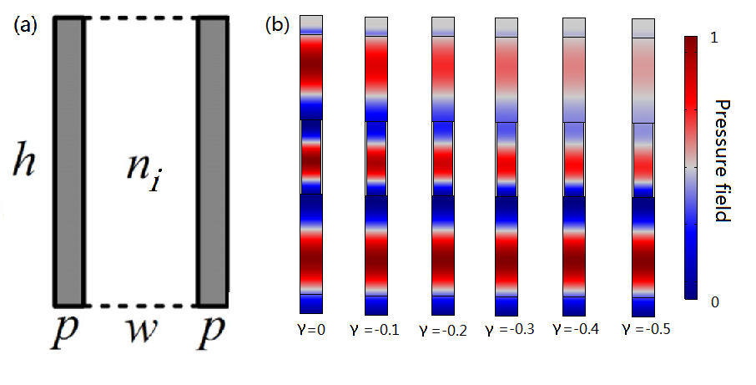

Fig.1. The structure and parameters. (a) schematic diagram of the unit cell of the lossy acoustic gradient-index metasurface with the refractive index *ni =s+*γ*j*. (b) simulated pressure field passed through the six unit cells of the metasurface at normal incidence with same *s*=1.6 and different γ from -0.5 to 0.

The unit cell of the lossy GIM is illustrated in Fig.1 (a). It is immersed in air. The width and the height of each slit is *w* and *h* separately, and the separation between two neighboring slits is *p*. The unit cell is filled with a material that has refractive index *ni*. To the unit cell the corresponding phase change is given by *φ =k0niL*, where *k0* is the sound wave vector of the air respectively and *L* is the propagation distance which is equal to *h* in this metasurface design. It can be seen from the phase formula that by adjusting the sound refractive index of the filling material *ni* the phase delay of sound wave can effectively be manipulated. Here we introduce an isotropic loss in the metasurface unit cells such that the refractive index *ni =s+*γ*j* with loss factor γ7. *s* is the real part of the refractive index and γ is the imaginary part of the refractive index. We set *h*=0.004m, *w*=0.1cm, *p*=0.0125cm, and the working frequency is set at 53125Hz. So the wavelength of sound wave λ0 in the air is 0.0064m, and we could get *h*=0.625λ0。The structure is a sub-wavelength structure. When we keep the real part of the refractive index unchanged and change the imaginary part of the refractive index, we can see from Fig.1 (b) that the phase of the sound wave is basically unchanged while the amplitude is changed. At the same time, we can observe that the smaller the imaginary part of the refractive index is, the more attenuation of the sound wave will be. When the imaginary part is 0, there is almost no attenuation, and when the imaginary part is 0.5, there is almost complete attenuation. In addition, we have made the whole system meet the conditions of impedance matching in the all simulation.

When we manipulate both the real and imaginary parts of the refractive index, a completely independent and arbitrary manipulation of refraction amplitude and phase could get. A completely independent and arbitrary manipulation means that the amplitude and phase of refraction should be related to only one parameter of refractive index. Fig.2(a),(b) presents the correlation of amplitude A and phase ϕ to *s* and γ from which we can observe that the real part of the refractive index only have effect on the phase of the acoustic wave and the imaginary part of the refractive index only have effect on the amplitude. The results clearly demonstrate the independent and arbitrary tuning of A and ϕ within the ranges of [0, 1] and [0, 2π] with *s* from 0.8 to 2.4 and γ from -0.5 to 0. In this project, our designed lossy GIM benefits from the availability of all possible combinations of refraction amplitude and phase by tuning two separate parameters of refractive index (*s* and γ) that induce a controlled loss dependent on this two parameters. Such a significant feature of independent control of refraction amplitude and phase enables a complete manipulation of sound.

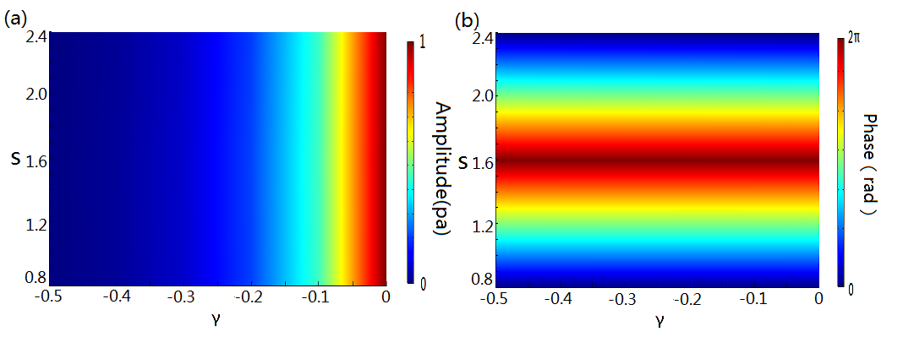

Fig.2. (a), (b) The refraction amplitude and phase shift to the parameters *s* and γ for a unit cell which reveal that the refraction amplitude and phase are controlled by only one parameter, respectively. The simulations are carried out by the finite element solver in commercial software COMSOL MultiphysicsTM5.0.

**3. High-quality Airy beam.**

There, we employ a lossy acoustic GIM to generate an Airy beam based on the independent and arbitrary modulation of amplitude and phase of sound. Here, we numerically show that via lossy GIM, Airy beam can be stably generated without complex optimization process. We consider a planar acoustic Airy wave propagating along the *y*-axis, the acoustic source of which can be described as31

*Φ(x)=2Ai(bx)eax,* (1)

where *Ai(bx)=∫cos(t3/3+bxt)dt* is the Airy function, *x* corresponds to the transverse coordinate along the lossy GIM surface, *b* is the transverse scale, and the decay factor *a* is a positive value to ensure containment of the infinite Airy tail at *x=-∞*23,24. Here, the decay factor is *a*=0.004, and the transverse scale is *b*=2. Fig.3 (a), (b) shows the refraction amplitude and phase profiles at the surface of the lossy GIM (along the *x* direction) for generating the Airy beam. The spatial distribution of pressure amplitude profile follows the Airy function as shown in Fig. 3a, with the corresponding phase profile displayed in Fig.3 (b). We can get the desired lossy GIM based on the relationship between the phase and amplitude of the sound wave and the real and imaginary parts of the refractive index. Fig.3 (c) provide the simulated pressure fields of the Airy beams produced by the lossy GIM, where it is apparent that the Airy beam formed by GIM has a high quality. It is composed of 80 discrete units with different refractive index.

To quantitatively assess the quality of the Airy beam, we also plot in Fig. 3 (d) the distribution of amplitude along the white lines in Fig.3 (c), which is 0.007m away from the sample metasurface. The result shows that the Airy beam formed by the lossy GIM has a high quality. Fig.4 shows that the lossy GIM works well in a large frequency range of 50-60 kHz, hence, generates a broadband Airy-like beams.

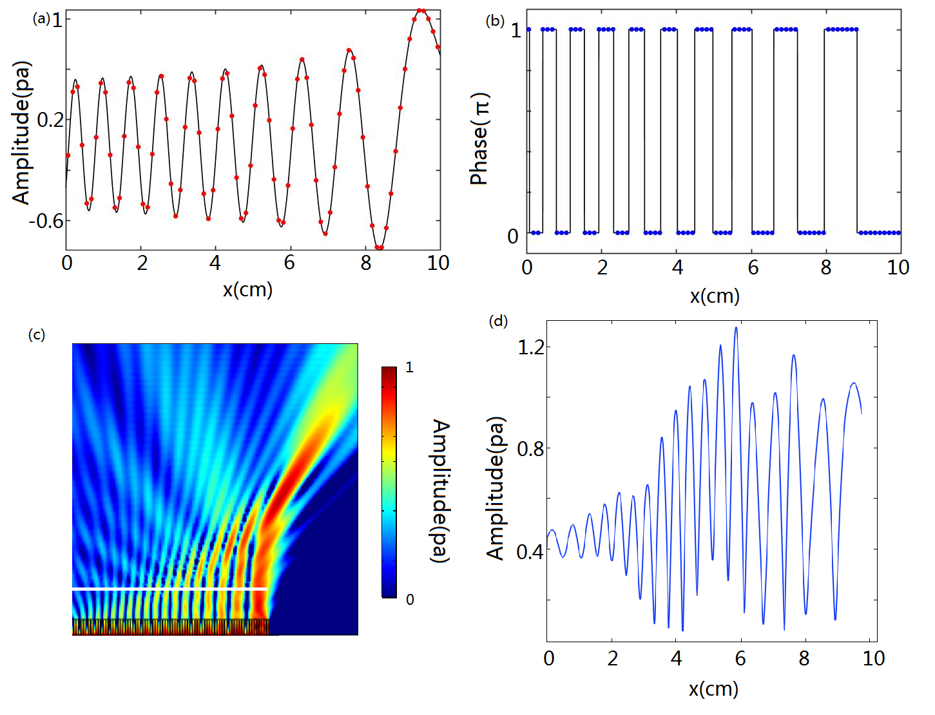

Fig.3. High-quality Airy beam. (a),(b) The refraction amplitude profile and the phase profile on the surface of the lossy GIM (along the *x* direction) required for generating a high-quality airy beam.The lossy GIM consists of 80 discrete units. (c) Simulated pressure field of the airy beams produced by the lossy GIM. (d)The distribution of acoustic amplitude along the white lines in (c).

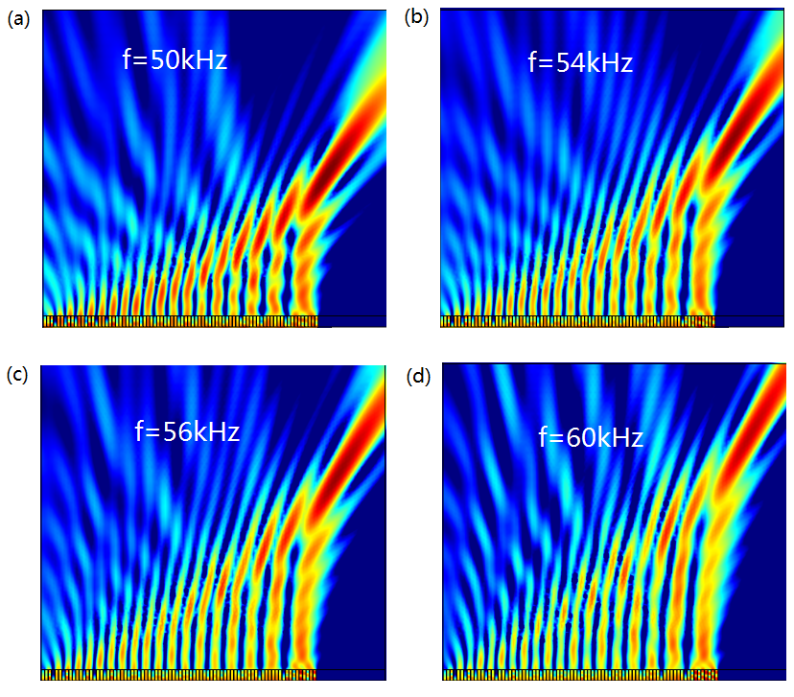

Fig.4. High-quality Airy beam. Acoustic intensity distributions of Airy-like beams generated by the lossy GIM at frequencies of 50,54,56,60 kHz.

**4. Multifocal focusing.**

In addition, we employ a lossy acoustic GIM to generate Multifocal focusing of sound wave which can make the sound energy/sound signal only spread to one or several specific positions. Fig.5 (a) is the schematic diagram of a cylindrical wave focusing at arbitrary focal points. Here, we show a point source wave

,(*y≤-h*) (2)

from an acoustic source at (*x*0,*y*0) transmits through the metasurface which has the phase-shift distribution of 1(x) and a local amplitude distribution of T1(x), consequently focusing on four points at (*x*1,*y*1), (*x*2,*y*2), (*x*3,*y*3) and (*x*4,*y*4). The transmitted field satisfies

, (*y≥0*) (3)

The phase shift and transmissivity due to the metasurface should satisfy

(4)

(5)

Fig.5 (b),(c) show the phase-shift distribution and transmissivity distribution for the lossy GIM by setting (*x*0,*y*0)=(0,-5)cm,(*x*1,*y*1)=(-3.75,6)cm,(*x*2,*y*2)=(-1.25,6)cm,(*x*3,*y*3)=(3.75,6)cm,(*x*1,*y*1)=(1.25,6)cm respectively. We can get the desired lossy GIM based on the relationship between the phase and amplitude of the sound wave and the real and imaginary parts of the refractive index. According to Fig.5 (b) and 5 (c), the lossy LAM that can realize multi-focal focusing as shown in Fig.5 (a) can be constructed. The metasurface is composed of 80 units with different refractive indices. Fig.5 (d) shows the simulated energy-field distributions of the multi-focal focusing when a cylindrical incident wave of frequency 53125 Hz hits the metasurface. It is found that the cylindrical wave can be focused at focal points by the lossy GIM. It's the same as seen in the Airy-like beam that the lossy GIM works well in a large frequency range of 50-60 kHz, therefore, generates a broadband Multifocal focusing.

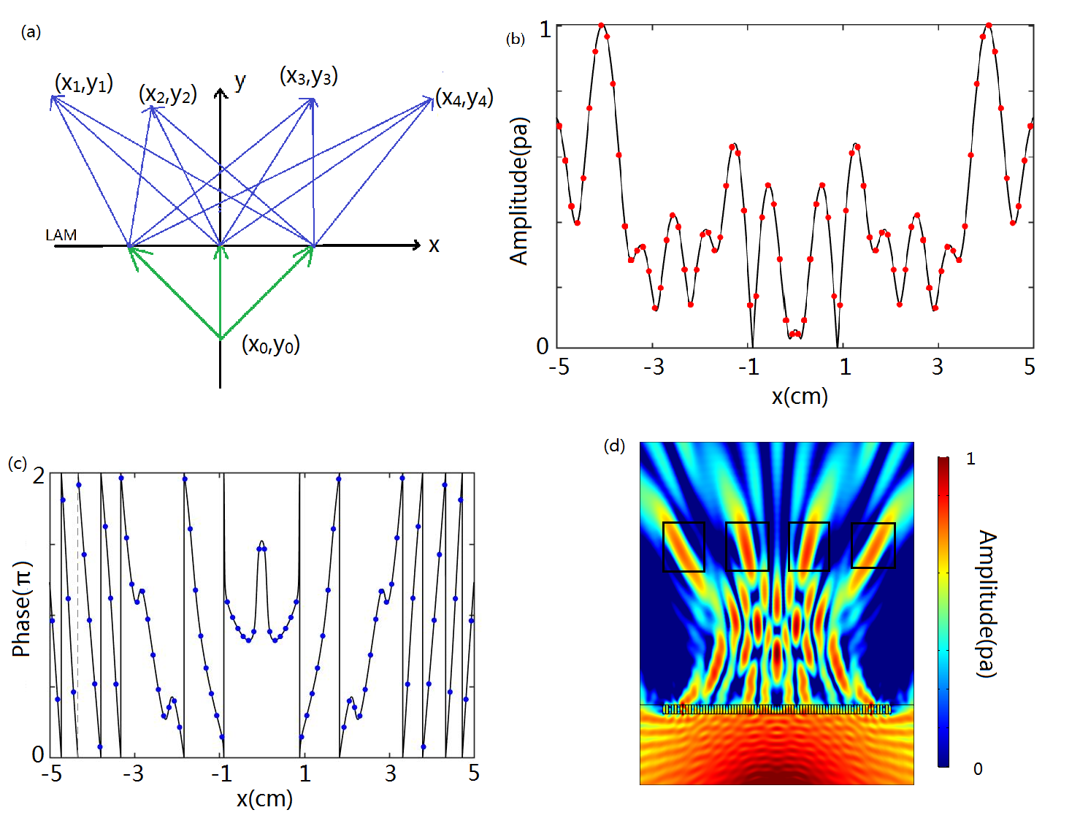

Fig.5 Multifocal focusing. (a) Schematic diagram of a cylindrical wave focusing at the arbitrary focal points. (b), (c) The refraction phase profile and the refraction amplitude profile on the surface of the lossy GIM(along the *x* direction) required for achieving multifocal focusing. (d) The simulated pressure field distribution of the multifocal focusing.

There is a simple method to realize the lossy GIM by using existing natural materials. Basically, we can use the composites of noble gases to realize the real part of the refractive index *ni*and the acoustic impedance matching. About the imaginary part of the refractive index, the viscosity coefficient of gas increases with the increase of temperature. Therefore, we can adjust the viscosity coefficient of the gas by adjusting the temperature, so as to increase the damping of sound wave when it propagates in the gas. Moreover, we know that the sound velocity of gas is not sensitive to temperature within a certain temperature range, so the temperature does not have a large influence on the refractive index of the gas and we could ignore the temperature influence. Consequently, such a lossy GIM could be manufactured.

**5. Conclusion**

In summary, we have shown that by engineering the energy loss in acoustic metasurface, our proposed lossy GIM can achieve the fine control of acoustic waves, by independently and arbitrarily modulating both amplitude and phase of acoustic waves in a static and precise manner. To exhibit the powerful ability of lossy GIM in wave manipulation, we report the realization of high-quality airy beam and furthermore we realize the multifocal focusing bearing advantages of simple design, low-cost fabrication, broadband and high efficiency. Our findings increase the freedom and flexibility of the control of sound transmission.

Acknowledgements

This work was supported by the National Natural Science Foundation of China (Grant Nos. 11374066 and 11374068).

References

1. Liu Z, Zhang X, Mao Y, Zhu Y Y, Yang Z, Chan C. T, and Sheng P 2000 *Science* **289** 1734
2. Fang N, Xi D, Xu J, Ambati M, Srituravanich W, Sun C, and Zhang X 2006 *Nat.Mater* **5** 452
3. Yang Z, Mei J, Yang M, Chan N H, and Sheng P 2008 *Phys. Rev. Lett.* **101**204301
4. Cummer S A, Christensen J, and Alu A 2016 *Nat. Rev. Mater.* **1** 16001.
5. Ma G and Sheng P 2016 *Sci. Adv.* **2** e1501595
6. Huang T Y, Shen C, and Jing Y 2016 *J. Acoust. Soc. Am.* **139** 3240
7. Li Y, Chen S 2017 *Phys. Rev. Lett.* **119** 035501
8. Ju F F, Tian Y, Cheng Y, and Liu X J 2018 *Appl. Phys. Lett.* **1** 5032263
9. Zhu Y F, Hu J, Fan X D, Yang J, Liang B, Zhu X F & Cheng J C 2018 *Nat. Commun.* **9** 1632
10. Tian Y, Wei Q, Cheng Y and Liu X J 2017 *Appl. Phys. Lett.* **110** 191901
11. Ma G and Sheng P 2016 *Sci. Adv.* **2** e1501595
12. Yu N, Genevet P, M. A. Kats, F. Aieta, J. P. Tetienne, F.Capasso, and Z. Gaburro 2011 *Science* **334** 333
13. Yu N and Capasso F 2014 *Nat. Mater.* **13** 139
14. Li Y, Liang B, Gu Z M, Zou X Y, and Cheng J C 2013 *Sci.Rep*. **3** 2546
15. Li Y, Jiang X, Li R Q, Liang B, Zou X Y, Yin L L, and Cheng J C 2014 *Phys. Rev. Applied* **2** 064002
16. Xie Y, Wang W, Chen H, A. Konneker, B. I. Popa, andS. A. Cummer 2014 *Nat. Commun.* **5** 5553
17. Tang K, Qiu C, Ke M, Lu J, Ye Y, and Liu Z 2014 *Sci. Rep.* **4** 6517
18. Mei J and Wu Y 2014 *New J. Phys.* **16** 123007
19. Li Y, Jiang X, Liang B, Cheng J C, and Zhang L K 2015 *Phys. Rev. Applied* **4** 024003
20. Jiang X, Li Y, Liang B, Cheng J C, and Zhang L 2016 *Phys.Rev. Lett.* **117** 034301
21. A. Marzo, S. A. Seah, B. W. Drinkwater, D. R. Sahoo, B. Long, and S.Subramanian 2015 *Nat. Commun*. **6** 8661
22. Y. Hertzberg and G. Navon 2011 *Med. Phys.* **38** 6407
23. G. A. Siviloglou, J. Broky, A. Dogariu, and D. N. Christodoulides 2007 *Phys.Rev. Lett.* **99** 213901
24. G. A. Siviloglou and D. N. Christodoulides 2007 *Opt. Lett.* **32** 979–981
25. J. Broky, G. A. Siviloglou, A. Dogariu, and D. N. Christodoulides 2008 *Opt.Express* **16** 12880–12891
26. A. Minovich, A. E. Klein, N. Janunts, T. Pertsch, D. N. Neshev, and Y. S.Kivshar 2011 *Phys. Rev. Lett.* **107** 116802
27. Tang X M, Li L, Li T, Wang Q J, Zhang X J, Zhu S N, and Zhu Y Y 2013 *Opt. Lett.* **38** 1733–1735
28. Zhang P, Li T C, Zhu J, Zhu X F, Yang S, Wang Y, Yin X B, and Zhang X 2014 *Nat. Commun.* **5** 4316
29. Mitri F G 2016 *J. Appl. Phys.* **120** 104901
30. U. Bar-Ziv, A. Postan, and M. Segev 2015 *Phys. Rev. B* **92** 100301
31. Chen D C, Zhu X F, Wei Q, Wu D J, and Liu X J 2018 *J. Appl. Phys.* **1** 5010705
32. Zhai S, Chen H, Ding C and Zhao X 2013 *J. Phys. D: Appl. Phys.* **46** 475105
33. Ding C L and Zhao X P 2011 *J. Phys. D: Appl. Phys.* **44** 215402
34. Zhang X, Huang D, Wu F G and Liu Z Y 2008 *J. Phys. D: Appl. Phys.* **41** 155110
35. Li J F, Zhou X M, Huang G L and Hu G K 2016 *Smart Mater. Struct.* **25** 045013
36. Hao W M, Deng M, Chen S Q and Chen L 2019 *Phys. Rev. Applied* **11** 054012
37. Gao H, Gu Z M, Liang B, Zou X Y, Yang J and Cheng J C 2016 *Appl. Phys. Lett.* **108** 073501
38. Bar-Ziv U, Postan A and Segev M 2015 *Phys. Rev. B* **92** 100301