**One dimension PT-Symmetric local resonance acoustic structure**

**Abstract**

In this study, we show that asymmetric wave propagation phenomenon could achieve in the subwavelength by exerting balance gain and loss in the local resonance acoustic system to form PT-symmetric structure. This founding show a new way to manipulate acoustic wave in the subwavelength frequency domain.

**I. INTRODUCTION**

Since Bender et al proposed that Non-Hermitian quantum system could have real specturm if it invariants under a combined parity P and time-reversal T operation which calls PT-Symmetric [1], optical and acoustic areas also began relevant research and found many interseting phenomenons, like the coherent perfect absorption [4], nontrivial anisotropic-transmission resonances [5-7], unidirectional perfect absorption [8], etc.

Phononic crystals (PCs) is an artificial periodic structure that can manipulate acoustic wave efficently compares to natural material. The distint property of PCs is the band gap in its dispersion relation which means the corresponded frequency acoustic wave couldn’t propagate in it. In 2000, Liu et al. published the concept of resonance PCs for the first time in 《Science》[2] , this new type of PCs can produce a very low frequency band gap in a small size (the lattice size is much smaller than the elastic wave wavelength corresponding to the band gap frequency), which greatly breaks through the limitations of traditional PCs.

The structure of PCs proposed by Liu et al is consisted of hard core material and

coating with elastically soft material, such a structure could be simpled as a mass-spring model under the one-dimensional (1D) condition. Zhao et al has exploited this method to analogy this structure to SSH model then researched the relevant topology property of it [3].

In this letter, we combine the PT-symmetric with local resonance phononic

crystal and find asymmetric propagation in the subwavelength domain.

**II. SPRING-MASS MODEL ANALYZE**

The basic structure is shown in FIG. 1. (a), it is called mass-in-mass monatomic chain. According to the appendix A in Ref [3], we could deduce the dispersion relation of this structure as below

(1)   
where denotes the effective mass of unit cell, is the local resoance frequency, a is the lattice constant, q is the Bloch wave number. The dispersion relation curve of Eq. (1) in the Irreducible Brillouin Zone (IBZ) has shown in FIG. 1. (b) with .

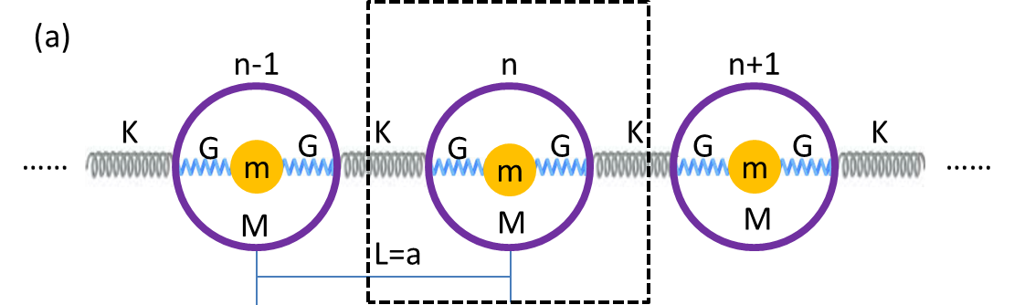

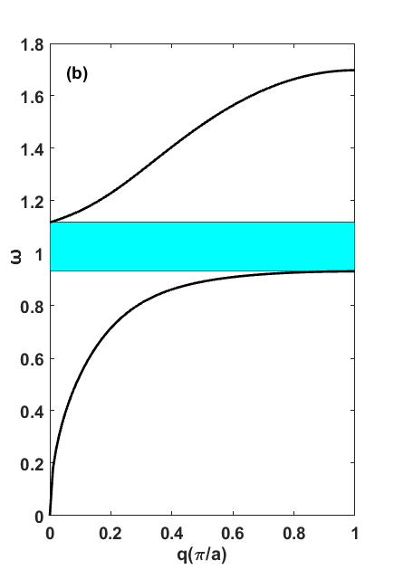

FIG. 1. (a) mass-in-mass monatomic chain model, K is the spring constant between each unit cell, G is the spring constant between core and coating, m is the mass of core, M is the mass of coating and lattice constant ; (b) dispersion relation curve with with , , cyan area corresponds to local resonance band gap.

Then concern about supercell that consists of two unit cells but other parameters remain invariant, and the band structure is deduced by folding FIG.1.(b) simply as shown in FIG.2.(b) because the IBZ of FIG.1.(a) is the half of FIG.1.(a).

In this fundamental , we exert loss and gain factor to the spring constant G, i.e., to satisfy the condition of PT-Symmetric. FIG.3.(a) and FIG.3.(b) are corresponding PT-Symmetric structure and dispersion relation diagram respectively, where FIG.3.(b) is the case of .

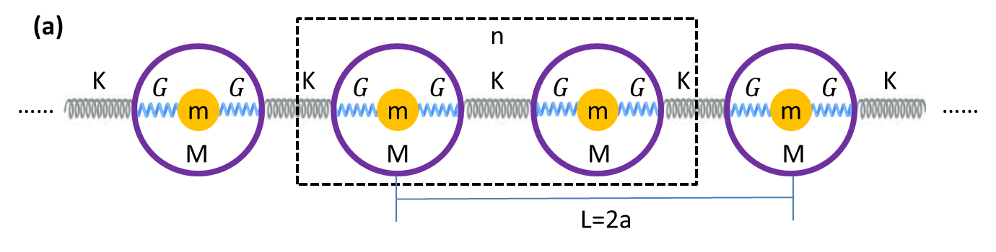

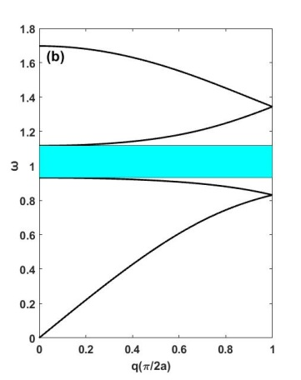

FIG. 2. (a) two unit cells in FIG.1.(a) consist of one supercell structure; (b) dispersion relation of supercell structure, it could be deduced by folding FIG.1.(b) and the cycan area local resonance band gap is the same.

Compare with FIG.2.(b), degeneracy appears in the dispersion relation curve clearly when we exert the loss and gain factor, and the local resonance band gap (cycan area) becomes more narrow. The dispersion relation curve evolute from non-degeneracy to degeneracy means phase transition from PT-exact phase to PT -broken phase and the point between these two phases is called exception point[9]. The magenta points A and B signed in the figure are two exception points.

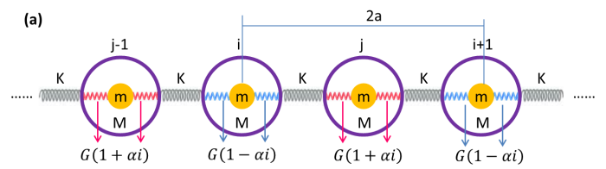

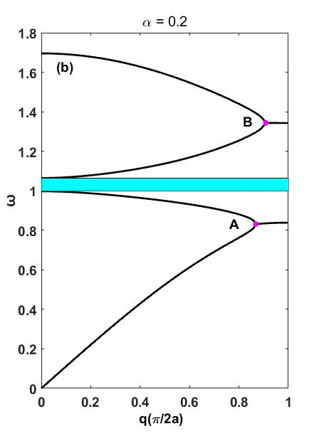

FIG.3. (a) The structure introduces loss and gain to spring constant G alternatively that satisfies PT-Symmetric; (b) Dispersion relation curve of the structure in (a) when , points A and B are two exception points which are the demarcation of degeneracy area and non-degeneracy area.

In additon, if increase the value of further more, local resonance band gap would becomes more narrow and disappears completely finally then produces a new exception point. The degeneracy woluld also be enhanced as becomes bigger and bigger in this process. FIG.4.(a) to FIG.4.(c) show the evolution of dispersion relation curve as increases from 0.21 ~ 0.23 with steps of 0.01.

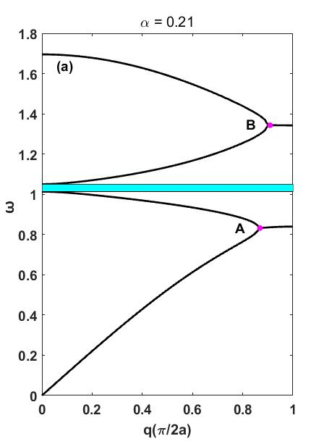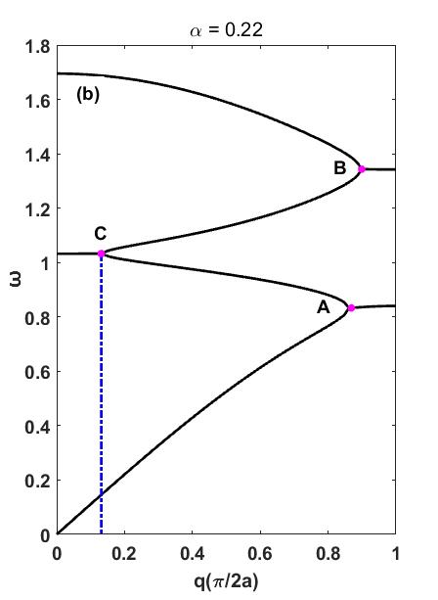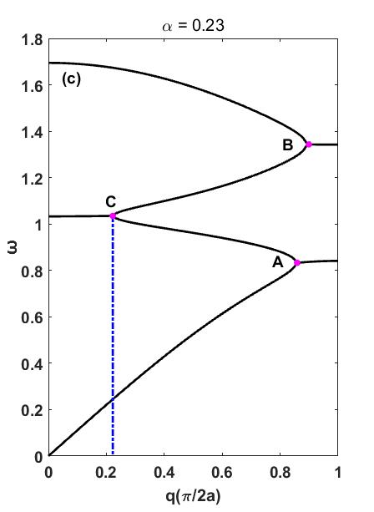

FIG.4. (a) The dispersion relation curve when , we can see that the local resonance band gap hardly ever close; (b)The dispersion relation curve when , this time local resonance has closed and produced a new exception point C; (c) The dispersion relation curve when , compare with (b), the degeneracy futher enhances, we could conclude this from the x axis value of point c.

In general, many exotic phenomens would appear near the exception point[10-15],

here we use a pratical structure and simulate with commercial fem soft-ware comsol multiphysics to carry out futher research and find that asymmetric propagation would happen near the exception point A.

**III. SIMULATION ANALYZE**

Analog to the unit cell of model in FIG.3.(a), we use a pratice structure consists of an expoxy core (mass density , first lame constant , and the second lame constant ) coated by soft rubber mass density ( , first lame constant , and the second lame constant ) and they are immersed in water background (mass density , longitudinal wave velocity c = 1490 m/s). We exert imaginary part on the lame constant and to mimic exert imaginary part to spring constant G in FIG.3.(a). Assume the width of this structure is , then the height will be 0.5L, diameter of each cylinder is where the thickness of soft rubber is and the diameter of expoxy core is .

We compute the dispersion relation curve where the condition of periodic boundary exerts on left and right boundary and the condition of continuity boundary exerts on up and down boundary, relevant results have been plotted in FIG.5.(b) ~ (e) correspond to the changes from 0~0.4 with steps of 0.1 which have similar trendency with the numberical computation results in previous figure . So use this structure as the equivalence of previous model is rational.

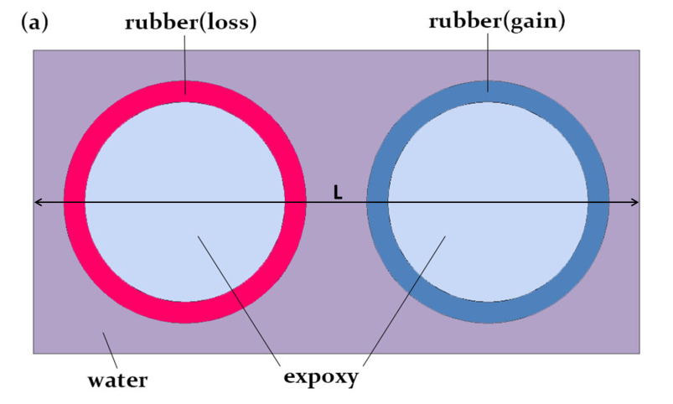

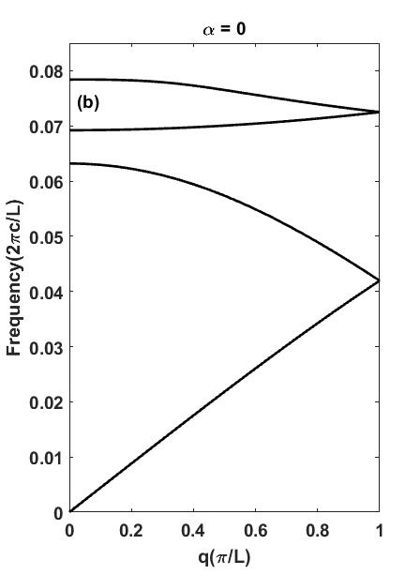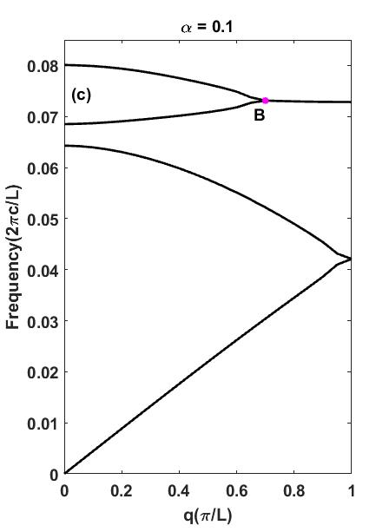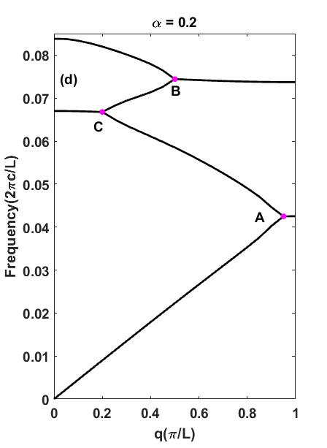

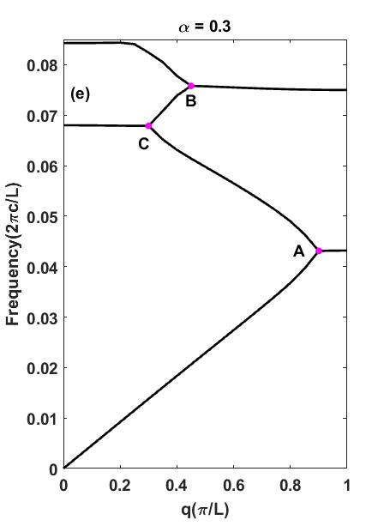

FIG.5. (a) The unit cell of structure we concern in article, expoxy core in the left is coated with loss soft rubber whose first lame constant has positive imaginary part and counterpart in the right has negative imaginary part .ie. ; (b) Dispersion relation curve without any loss and gain; (c) Dispersion relation curve with , one exception point in the diagram so the degeneracy begins to appear; (d) Dispersion relation with , in this situation ,we could see three exception points; (e) Dispersion relation with , degeneracy further enhances, the total evaluation process is the same as numberical computation results show in FIG.2.

Then we concern about an array of six unite cells with the and compute its transmission spectrum, near the exception point A, two high reflection coefficients appear corresponds to left- and right-incidence situation respectively. These two situtions both holds for extremed low reflection coefficient from other side, and this is the necessary condition of asymmetric propagation case[7].



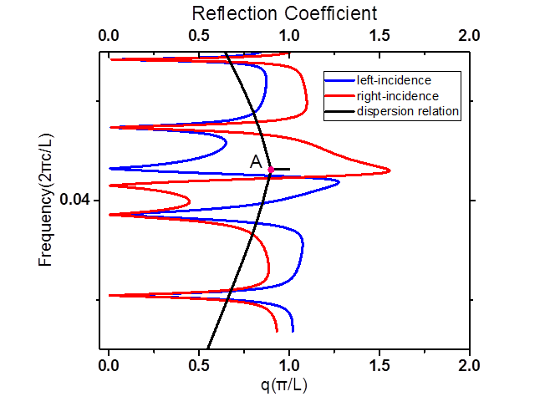

**(b)**

FIG.6. (a) The structure of super-cell which is consisted of six unite cells; (b) reflection coefficient curve for the situation of left-incidence and right-incidence (blue and red), and the dispersion relation curve (black), magenta square marks out the asymmetric propagation part of two reflection coefficient curves.

In order to observe the phenomenon more clear, the spatial distribution of scatter acoustic pressure in two corresponded frequency points (about 3092Hz and 3220Hz) also have been plotted in FIG.7. As we can see, at frequency 3092 Hz, spatial distribution of scatter acoustic pressure is almost 0 in the incidence area when the wave propagates from right to left, and but it is not 0 when wave propagates from left to right. While at frequency 3220 Hz, the situation is oppsite.

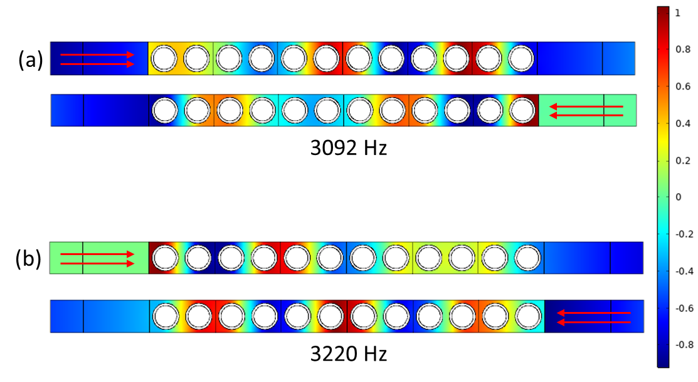

FIG.7. (a) The scatter acoustic pressure field contribution in the frequency 3092 Hz, above is left-incidence, below is right-incidence; (b) same situation except the frequency of wave is 3220 Hz.

In addition, these two frequencies are near the exception point A in FIG.5.(d) belong to subwavelength domain because they are even lower than local resonance frequency domain is shown in FIG.5.(a) and FIG.5.(b). So we have achieve asymmetric propagation in low frequency domain.

**IV. CONCLUSION**

In summary, we first studied the spring-mass unit cell model with balance gain and loss to form PT-symmetric and found the expection point in its dispersion relation curve, then we achieved wave asymmetric propagation in subwavelength domain by using a super cell which consists of six unit cells. This means the potential for the fabrication of novel functional devices in low frequency domain, such as acoustic diode and perfect sensor.

**References**

1. C. M. Bender and S. Boettcher, Real Spectra in Non-Hermitian Hamiltonians Having PT Symmetry, Phys.Rev. Lett. 80, 5243 (1998).
2. Liu Z, Zhang X, Mao Y, Zhu Y Y, Yang Z, Chan C. T, and Sheng P 2000 Science 289 1734
3. ,Topological interface modes in local resonant acoustic systems
4. Y. D. Chong, L. Ge, and A. D. Stone, PT-Symmetry Breaking and Laser-Absorber Modes in Optical Scattering Systems, Phys. Rev. Lett. 106, 093902 (2011).
5. R. Fleury, D. Sounas, and A. Alu, Parity-time symmetry in acoustics: Theory, devices and potential applications, IEEE J. Sel. Top. Quantum Electron. 22, 5000809 (2016).
6. A. Guo, G. J. Salamo, D. Duchesne, R. Morandotti, M. Volatier-Ravat, V. Aimez, G. A. Siviloglou, and D. N. Christodoulides, Observation of PT-Symmetry Breaking in Complex Optical Potentials, Phys. Rev. Lett. 103, 093902 (2009).
7. X. Zhu, H. Ramezani, C. Shi, J. Zhu, and X. Zhang, PTSymmetric Acoustics, Phys. Rev. X 4, 031042 (2014).
8. H. Ramezani, Y. Wang, E. Yablonovitch, X.Zhang, Unidirectional Perfect Absorber, IEEE Journal of Selected Topics in Quantum Electronics, 22, 5 (2016).
9. Coalescence of exceptional points and phase diagrams for one-dimensional PT-symmetric photonic crystals
10. Exceptional Contours and Band Structure Design in Parity-Time Symmetric Photonic Crystals
11. C. Shi, M. Dubois, Y. Chen, L. Cheng, H. Ramezani, Y.Wang, and X. Zhang, Accessing the exceptional points of parity-time symmetric acoustics, Nat.Commun. 7, 11110(2016).
12. Topological edge modes with PT symmetry in a quasiperiodic structure
13. C. Huang, F. Ye, and X. Chen, Phys. Rev. A 90, 043833 (2014).
14. Non-Hermitian Acoustic Metamaterials: the role of Exceptional Points in sound Absorption
15. Bound states in one-dimensional acoustic parity-time-symmetric lattices for perfect sensing