Algorithm1:

* Serves the requests based on the First come first serve.
* It generates a random number of requests to from and to destinations.
* Uses those requests to calculate the time.
* Here is the screenshot of the output
* 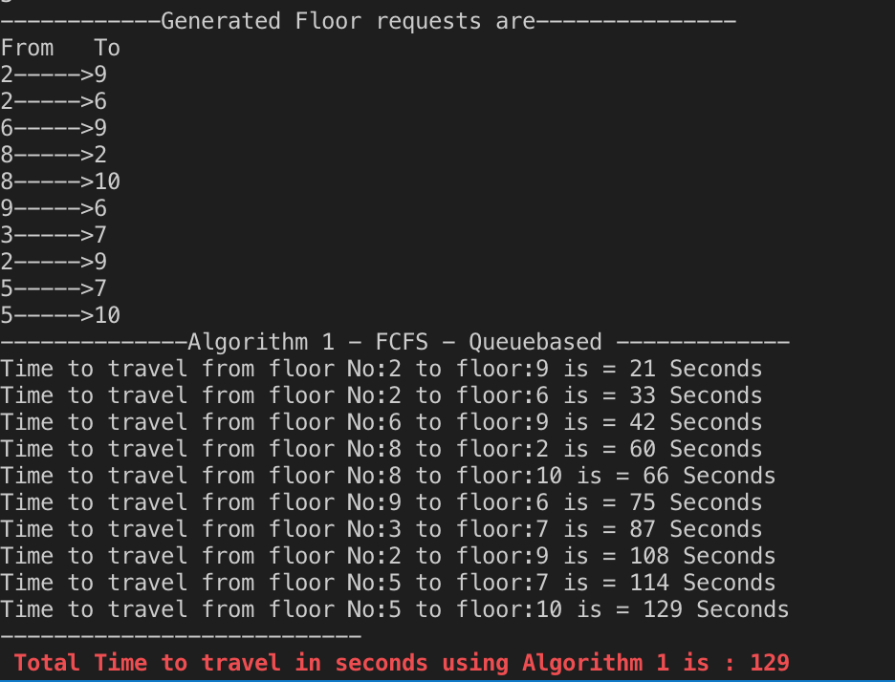

Algorithm2:

* In Algorithm 2, the requests are being served based on the more number of requests from particular floor.
* Therefore, it checks which floor has more requests and stores those destinations in an array and sends them to particular destination.
* Times are logged into time2 array.
* Here is the sceenshot.
* 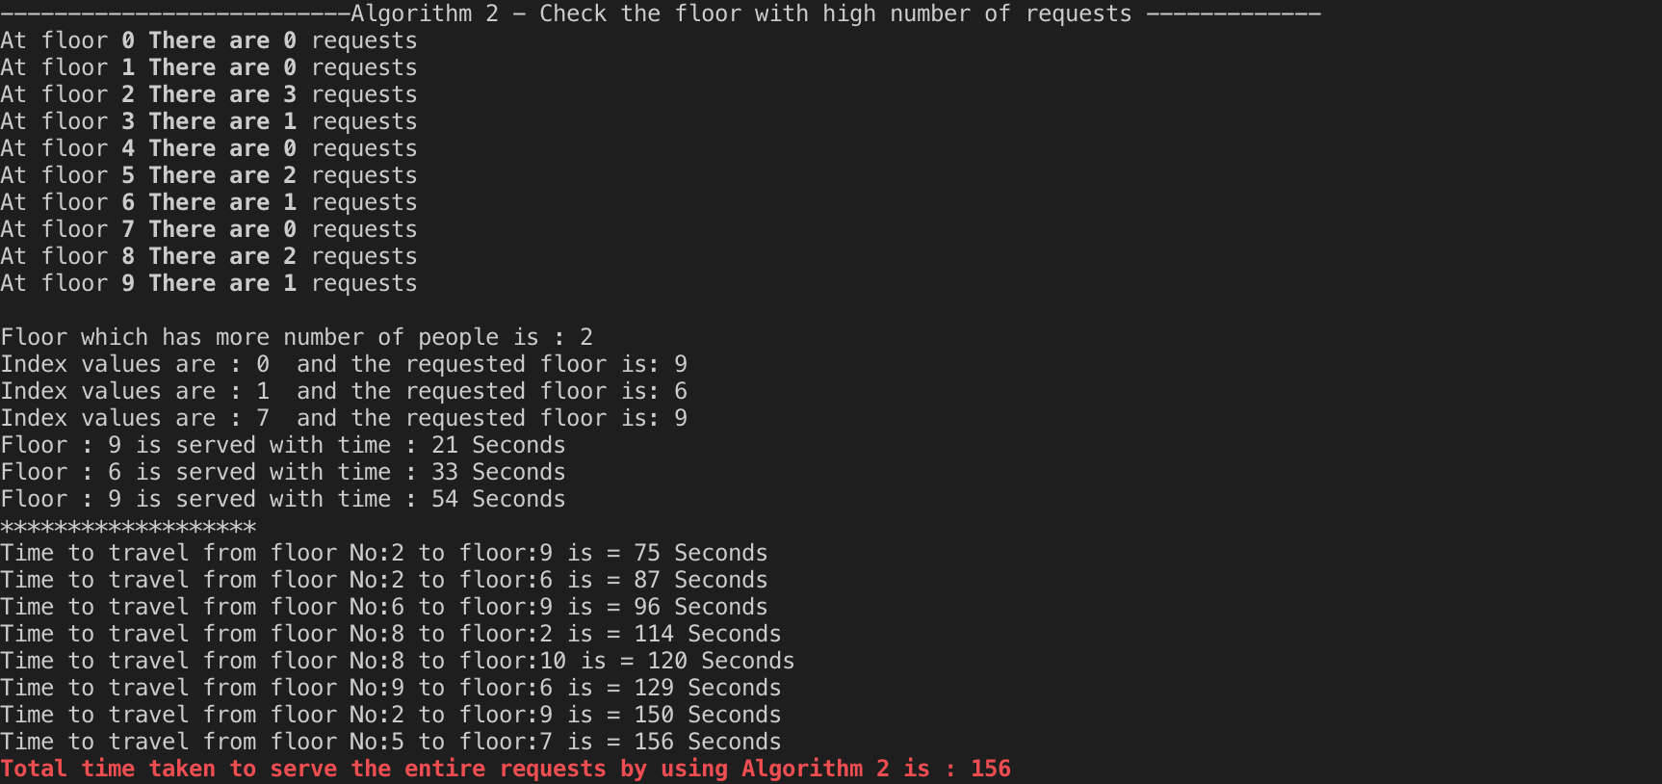

**Algorithm 3:**

* This is the extension of the algorithm 2.
* Here, it sorts the destinations based on the distance to travel and serves them
* Rest of the algorithm is similar where the requests that are already served will be skipped and others will be served.
* The previous array values with index values are stored into the other array to make changes.
* Time is calculated and logged into time3 array
* Here is the screenshot of output.
* 