**Homework #3**

1. **(20 pts) Assess the impact of the hash table size.** Set the hash table to a fixed value (**m**, see below). Set the size of your hash table (***m***) to 1 million, 10 million, 30 million, and 60 million elements.

For each of your 4 hash table sizes, how many collisions did you observe while populating the hash?

* + 1. For the hash size 1000000 - 99000001 collisions
    2. For the hash size 50000000 - 64405364 collisions
    3. For the hash size 100000000 – 51588542 collisions
    4. 4. For the hash size 200000000 – 41393877 collisions.

For each of your 4 hash table sizes, how long did it take you to populate the hash table? Do the timing results make sense (provide big O notation)? Explain.

* + 1. The time taken for the hash size 1000000 - 99.2899 seconds
    2. The time taken for the hash size 50000000 - 97.9511 seconds
    3. The time taken for the hash size 100000000 - 100.613 seconds
    4. The time taken for the hash size 200000000 - 100.509 seconds

For all the hash table sizes, the time taken is almost similar, so the big-O notation would be **O(N)** which is linear time complexity.

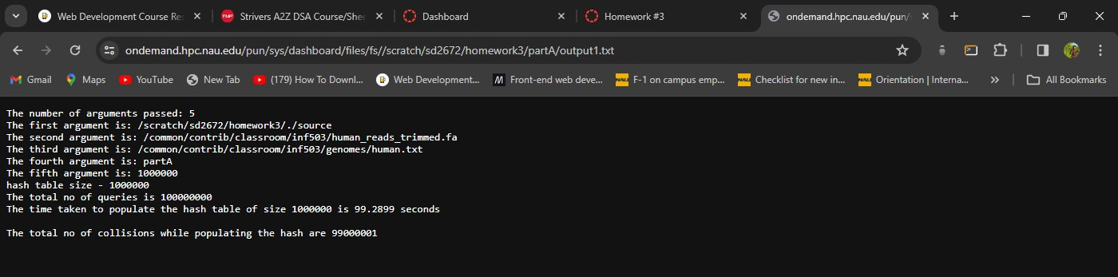

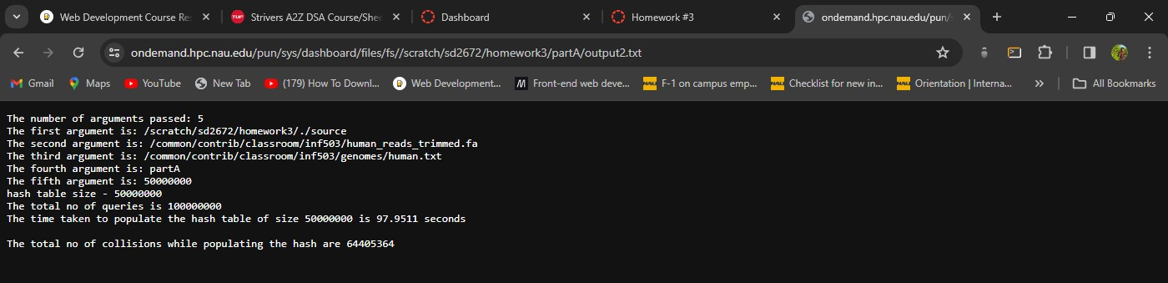

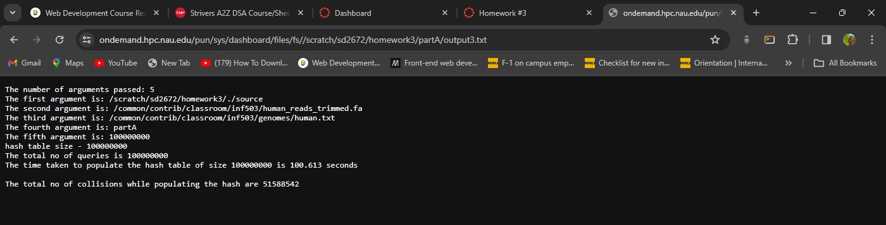

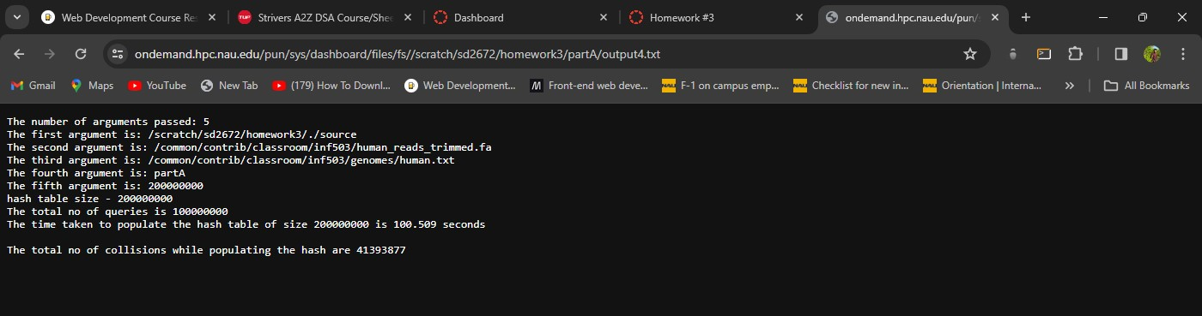

**B. (20 pts) Searching speed**: Set the hash table size to 60 million. Populate the hash table with the sequence fragments from the *query dataset*. Read the entire *subject dataset* into a single, concatenated character array (same way you did it in HW#1). Implement a search function which would search for 16character fragments of the subject sequence within the Queries_HT object. Iterate through all 16character long fragments of the *subject dataset*, searching for each one in the *query dataset*.

• How long did it take to search for every possible 16-character long fragment of the *subject dataset* within the *query dataset*?

3146.31 seconds

* + - How many such fragments did you find?

848542709

* + - Print the first 10 fragments of the *subject dataset* that you found within the Query_HT.

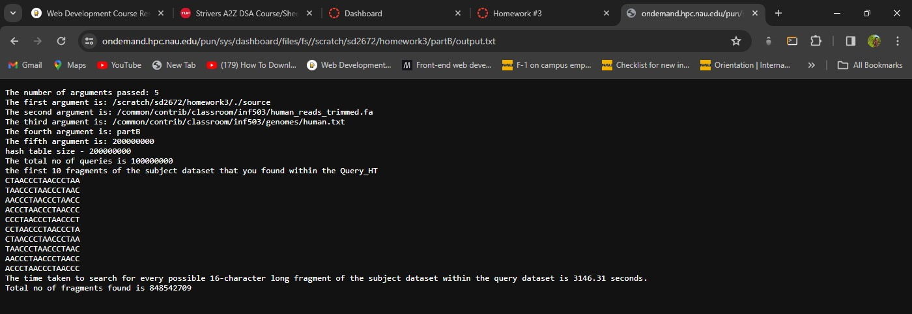

**Steps of execution:**

* + - Created total of three files main.cpp, header_definitions.cpp and header.h
    - Header.h file contains all the header files that are used in the program
    - The main.cpp contains the main function and all the function calls required to get desired output
    - Header_definition.cpp file contains all the function definitions which are declared in the header

file

* + - Created a make file to run the code
    - Uploaded all the above files to a directory on monsoon
    - There I have opened terminal and entered the command “make” then source executable file is generated next we need to run the source file with file path and the part of execution.
    - The command for execution of part A is

./source /common/contrib/classroom/inf503/human_reads_trimmed.fa

/common/contrib/classroom/inf503/genomes/human.txt partA (hashsize)

* + - The command for execution of part B is

./source /common/contrib/classroom/inf503/human_reads_trimmed.fa

/common/contrib/classroom/inf503/genomes/human.txt partB (hashsize)