CLOUD COMPUTING AND BIG DATA
Assignment 2 (CO2)

Analyse, Evaluate and Validate a Virtualization Architecture for a Multi-Tenant University Private Cloud
EduCloud Virtualization Platform: Tasks 1 to 12

Name / Roll No.
Course | Cloud Computing and Big Data
Total marks | 50
Date | 03 November 2026
How to read this report. Tasks 1 to 7, 11 and 12 are complete analytical answers built on one explicit mathematical model (Task 3). Tasks 8 to 10 need measurements from your own machine: this report gives the full reproducible test environment (scripts, commands, plotting code), the model predictions you must compare against, and a pre-structured analysis. Every cell marked [MEASURED] must be filled with your own numbers before submission. No measured value in this report has been invented.

Task 1: Characterisation of the Virtualization Architectures
Three architecturally different approaches are selected: (A) KVM full virtualization with hardware assistance and virtio (VM-based, Type-1-class), (B) OS-level containers (Docker/Podman, container-based), and (C) micro-VM sandboxed containers (Kata Containers, hybrid). They differ in what enforces isolation: hardware plus a hypervisor (A), the shared host kernel (B), and hardware plus a per-pod guest kernel (C). They are not two configurations of one hypervisor. Type-2 hosted hypervisors are excluded because the host OS adds a second scheduling and I/O layer, which is unsuitable for a production data centre.

Approach A: KVM / QEMU (hardware-assisted full virtualization, virtio)

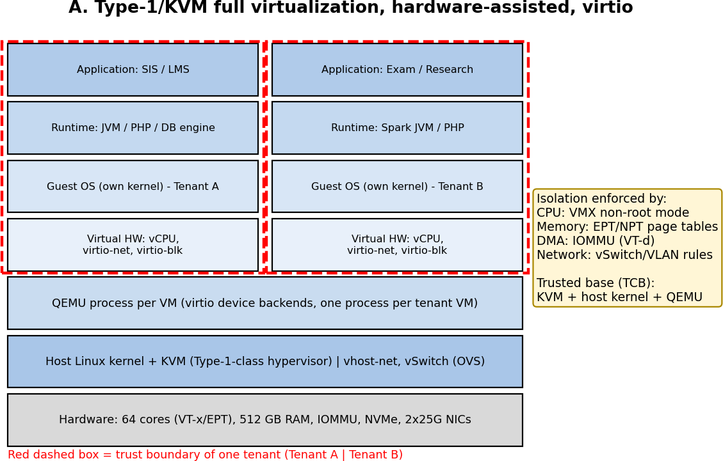
Figure 1: Layered architecture and trust boundaries of KVM/QEMU
    - Trust boundaries: (i) guest user space to guest kernel, (ii) guest to hypervisor (VMX non-root to root transition), (iii) VM to VM, (iv) VM to management plane (libvirt/OpenStack). The component that enforces isolation is the hypervisor (KVM) using CPU virtualization extensions, EPT/NPT page tables and the IOMMU.
    - CPU: vCPUs are host threads scheduled by the Linux scheduler (CFS/EEVDF). Guest instructions run natively in VMX non-root mode; privileged events cause a VM exit to KVM. Overcommit is time-slicing of vCPU threads on pCPUs.
    - Memory: two-dimensional paging. The guest page table maps guest-virtual to guest-physical (GVA to GPA); EPT maps GPA to host-physical (HPA). Memory can be overcommitted using ballooning, KSM page sharing and host swap.
    - Storage: virtio-blk/virtio-scsi; the guest places requests on a virtqueue and kicks the host (ioeventfd, one exit); QEMU iothread or vhost-user performs the I/O on a qcow2/raw image on the shared backend.
    - Network: virtio-net with vhost-net; packets pass guest driver, virtqueue, vhost thread, tap, Open vSwitch, physical NIC. Isolation uses VLAN/VXLAN tenant networks.

    - Relevance to EduCloud: the strongest mature isolation available for mixed trust (departments today, external collaborators later), live migration for patching, and compatibility with unmodified guest OSes for the SIS legacy stack.

Approach B: OS-level containers (Docker/Podman, runc)

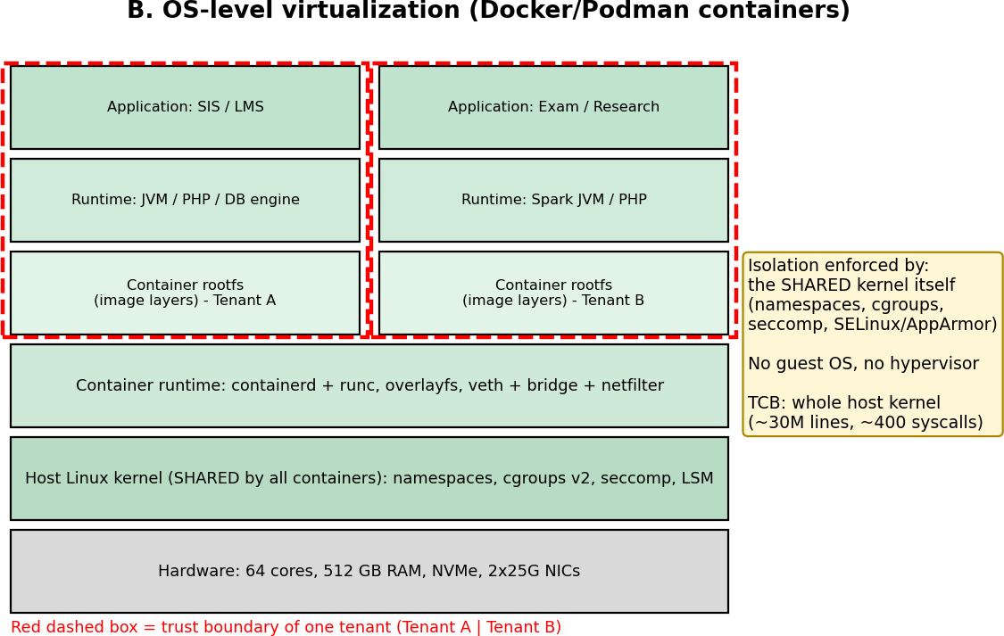
Figure 2: Layered architecture and trust boundaries of containers
    - Trust boundaries: container user space to the shared host kernel through the system-call interface; container to container only through namespaces and cgroups. Isolation is enforced by the host kernel (namespaces, cgroups v2, seccomp-BPF, capabilities, SELinux/AppArmor). There is no hypervisor and no guest OS, so the trusted computing base is the entire host kernel.
    - CPU: containers are ordinary process groups; the kernel scheduler shares cores, and cgroup cpu.max / cpu.weight enforce quotas and shares. There are no VM exits and no vCPUs.
    - Memory: native virtual memory with one page-table walk; cgroup memory.max/memory.high limit usage; the OOM killer is the failure mode. No guest page cache duplication.
    - Storage: overlayfs over the host file system (copy-on-write layers) or bind-mounted volumes; I/O is limited by the cgroup io controller.
    - Network: network namespace with a veth pair into a Linux bridge/CNI plugin, with netfilter/conntrack for NAT and policy.
    - Relevance: highest density and sub-second start-up, so it suits elastic stateless LMS web tiers and trusted internal workloads; it is the performance baseline for the comparison.

Approach C: Micro-VM sandboxed containers (Kata Containers)

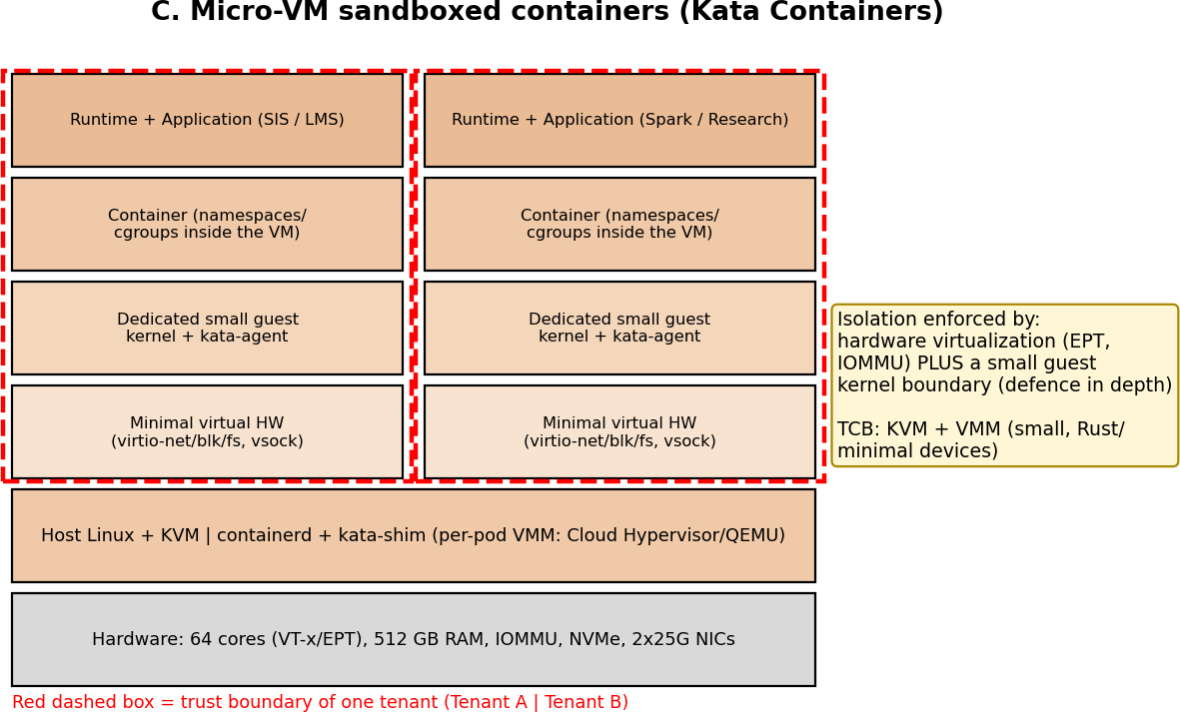
Figure 3: Layered architecture and trust boundaries of Kata Containers
    - Trust boundaries: the container runs inside a lightweight VM, so there are two nested boundaries: container to guest kernel, and guest to host through the VMM/KVM. Isolation is enforced by the hardware virtualization layer, with a dedicated minimal guest kernel as an extra layer, so a kernel exploit inside the container compromises only that micro-VM.
    - CPU/memory: as KVM (vCPU threads, EPT). Memory is often pre-allocated; virtio-mem or DAX can reduce footprint.
    - Storage: virtio-fs (or virtio-blk with devmapper) to pass the container root file system into the guest, which adds a FUSE-like host daemon path.
    - Network: container veth, then TC redirect, then tap, then vhost-net into the guest, which means two network stacks per packet.
    - Relevance: the container workflow (OCI images, Kubernetes) with VM-grade isolation, which is a natural candidate for external research tenants.

Summary comparison

Aspect | A: KVM/QEMU | B: Containers | C: Kata micro-VM
Isolation enforcer | Hypervisor + EPT + IOMMU | Shared host kernel | Hypervisor + guest kernel
Guest kernel per tenant | Yes (full) | No (shared) | Yes (minimal)
TCB | KVM + QEMU + host kernel | Whole host kernel | KVM + small VMM + host kernel
Start-up | 10 to 30 s (OS boot) | < 1 s | 1 to 3 s
Per-instance fixed memory | ~0.26 GB (assumed) | ~0.05 GB | ~0.31 GB
Live migration | Mature | Not native (checkpoint/restore only) | Limited

Task 2: Dominant Overhead Source

A: KVM: VM exits (including the virtual-I/O kick/interrupt cycle)
What and where. Every time the guest executes a sensitive event (I/O register write or virtqueue kick, timer/APIC access, HLT, IPI, certain MSR accesses) the CPU leaves VMX non-root mode, KVM handles the exit and re-enters. Each exit costs about 1.5 µs (assumed). Exits happen at the boundary between guest and host, so they are on the critical path of every virtual I/O request. Why it is the right focus. With EPT and virtio the other costs are small: instruction execution is native and memory translation overhead can be reduced with huge pages, whereas exit rate depends directly on workload behaviour. Scaling. Total exit CPU time grows linearly with instances (N·v·λ_e·c_e), and the per-vCPU exit rate λ_e itself grows with overcommit because more vCPUs halt/wake, send IPIs and suffer lock-holder preemption. I model λ_e(r) = λ0·(1 + α(r−1)). With I/O rate X per VM and ~2 exits per I/O, exit load adds 2·X·c_e cores per VM (3 µs per I/O).

B: Containers: kernel-path interception and shared-kernel contention (seccomp/cgroup accounting, veth/netfilter)
What and where. Containers add no CPU-level trap. Their cost sits in the single shared kernel: every system call passes the seccomp-BPF filter and cgroup accounting; every packet traverses veth, bridge and netfilter/conntrack; file I/O passes overlayfs. Why it is the right focus. The native system call costs
0.2 µs, and a seccomp filter adds a fraction of that cost per call, so for a system-call-heavy web/DB mix the overhead is the product λ_s·δ. Scaling. The per-call cost is constant, but because all containers share kernel locks (dentry cache, conntrack table, runqueue locks, the network stack) the effective cost rises with the number of co-located containers and I/O rate, and noisy neighbours interfere through this shared state. This is why the isolation weakness of containers and their dominant overhead have the same root: the shared kernel.

C: Kata: double virtual-I/O path (VM exits plus container-network and virtio-fs layering)
What and where. Kata pays the KVM exit cost and also adds a second I/O layer: file access through virtio-fs with a host-side daemon, and network packets through two stacks (veth/TC in the host, guest stack inside). Why. Each packet and file operation crosses the VM boundary after already crossing a container boundary, so I/O-intensive workloads are limited by this path (modelled as t_p = 1.6 µs per 1500 B packet against 1.2 µs for plain virtio). Scaling. Exit rate is higher than plain KVM (λ0 = 30,000/s assumed) and the host-side per-packet/file service time is shared by all pods, so throughput per pod falls faster with N (higher contention coefficient γ).

Approach | Dominant overhead | Location | Cost scaling with N / I/O rate
A: KVM | VM exits (I/O kick, IPI, timers) + EPT walk | Guest/host boundary (VMX transition) | Linear in N·λ_e; λ_e rises with overcommit
B: Container | Syscall filtering, cgroup accounting, veth/netfilter | Shared host kernel | Constant per call; contention grows with N
C: Kata | Exits + double I/O path (virtio-fs, veth+tap) | Guest/host boundary and host I/O daemon | Linear plus higher contention γ

Task 3: Quantitative Performance Model

Assumptions (all stated explicitly)

    - Host: P = 64 pCPU, RAM = 512 GB, 25 Gbps NIC per port (one port modelled; the second is for redundancy/storage), NVMe local cache. Average VM: v = 4 vCPUs, m = 8 GB.
    - Mean vCPU utilisation u (fraction of a core a vCPU wants): 0.2 normal, 0.6 registration week (3× normal, as stated in Task 12), 1.0 saturated/batch.
    - c_e = 1.5 µs per VM exit; native system call = 0.2 µs; seccomp-BPF adds 25% (δ = 0.05 µs) per call.
    - Exit rate per vCPU at r = 1: λ0 = 20,000/s (KVM) and 30,000/s (Kata) for a mixed web+DB workload (timer ticks, IPIs, virtio kicks); growth with overcommit α = 0.15 per unit of (r−1). Container system-call rate λ_s = 50,000/s per vCPU-equivalent.
    - Nested page-table overhead for VMs: fraction of time in page walks f_w = 3% natively; EPT multiplies walk cost by κ = 1.8 (walk caches mitigate the theoretical 24 vs 4 memory references), giving o_ept = f_w(κ−1) = 2.4%.
    - Other fixed overhead: containers 1.0% (cgroup accounting) + overlayfs; Kata 1.0% (virtio-fs/agent). Packet size L = 1500 B = 12,000 bits; k = 2 host cores are devoted to I/O threads (vhost/iothreads/softirq).
    - Per-packet host service time: t_p = 1.2 µs (KVM vhost), 0.9 µs (container veth+bridge), 1.6 µs (Kata). Per-disk-I/O host service time: 15 µs (KVM), 10.5 µs (container), 17 µs (Kata); device limit 600k IOPS.
    - Contention coefficient γ (shared-state/lock/flow-cache contention): 0.01 (KVM), 0.005 (container), 0.015 (Kata).
    - Per-instance SLA demand: 0.5 Gbps and 5,000 IOPS. Service-level target: ≤ 10% degradation versus bare metal.
These parameters are modelling assumptions chosen to be physically plausible and consistent with the given exit and syscall costs. In Task 10 they are calibrated against your own measurements, and this is the expected source of the predicted-vs-measured differences.

CPU model
With N VMs of v vCPUs each, the overcommit ratio is r = N·v/P. If every vCPU wants a fraction u of a core, demand per pCPU is r·u. When r·u ≤ 1 nothing waits; otherwise the vCPU receives a fraction 1/(r·u) of what it asks for, and the remainder is steal time:
σ(r,u) = max(0, 1 − 1/(r·u)) (steal fraction)
Virtualization overhead (fraction of useful cycles lost) for the VM approaches combines exits and nested paging:
o_VM(r) = λ0·[1 + α(r−1)]·c_e + f_w(κ−1) + o_fixed
For containers there are no exits: o_C = λ_s·δ + o_fixed = 50,000 × 0.05 µs + 1.0% = 0.25% + 1.0% = 1.25%. The effective capacity of one vCPU, relative to a dedicated bare-metal core, is:
C_eff(r,u) = (1 − σ(r,u)) · (1 − o(r)) and C_VM = v · C_eff
Worked example (KVM, registration week u = 0.6). At r = 1: o = 20,000×1.5 µs + 2.4% = 3.0% + 2.4%
= 5.4%, σ = 0, so C_eff = 0.946. At r = 2: r·u = 1.2, σ = 1 − 1/1.2 = 0.167, λ = 20,000×1.15 = 23,000/s so o = 3.45%+2.4% = 5.85%, giving C_eff = 0.833 × 0.9415 = 0.785. At r = 4: r·u = 2.4, σ = 0.583, o = 6.75%,
C_eff = 0.417 × 0.9325 = 0.389. At r = 8: σ = 0.792, o = 8.55%, C_eff = 0.191.

Overcommit r | KVM (u=0.6) | Container (u=0.6) | Kata (u=0.6) | KVM (u=1.0) | Container (u=1.0) | Kata (u=1.0)
1:1 | 0.946 | 0.988 | 0.921 | 0.946 | 0.988 | 0.921
2:1 | 0.785 | 0.823 | 0.762 | 0.471 | 0.494 | 0.457
4:1 | 0.389 | 0.411 | 0.375 | 0.233 | 0.247 | 0.225
8:1 | 0.191 | 0.206 | 0.182 | 0.114 | 0.123 | 0.109

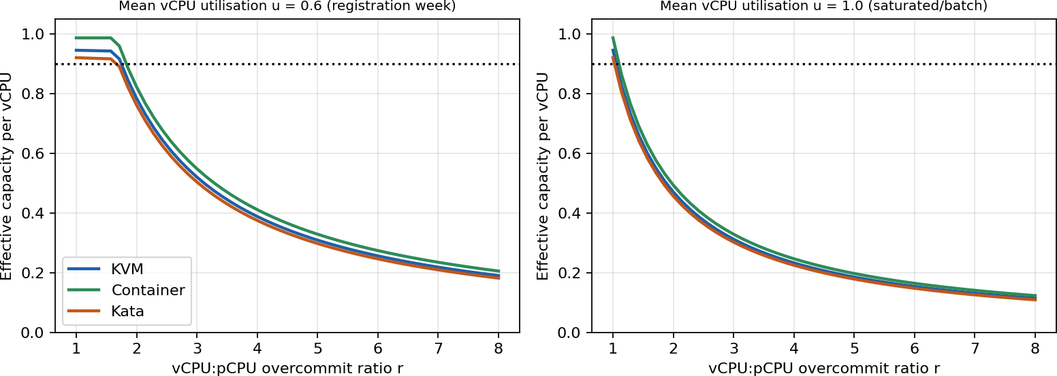
Figure 4: Model: effective per-vCPU capacity versus overcommit ratio (dotted line = 0.9 SLA)
Key insight. The difference between approaches is only about 4 to 7 percentage points (the overhead o), while the steal term σ dominates beyond r ≈ 1.5. Overcommit, not the choice of hypervisor, is therefore the main CPU performance lever.

Memory model
Per-instance footprint is m + δ_m, where δ_m is fixed overhead (QEMU/page tables/guest kernel, or container runtime). The maximum number of instances before ballooning, swapping or sharing is needed is:
N_mem = ⌊(M_host − R) / (m + δ_m)⌋
Using R = 16 GB (host OS + hypervisor, 8 GB for containers) and δ_m = 0.10 GB + 2%·m (KVM, 0.26 GB), 0.05 GB (container), 0.15 GB + 2%·m (Kata, 0.31 GB):
    - KVM: (512 − 16)/8.26 = 60.05, so N_mem = 60.
    - Container: (512 − 8)/8.05 = 62.6, so N_mem = 62.
    - Kata: (512 − 16)/8.31 = 59.7, so N_mem = 59.
Beyond this point the host must use techniques that reclaim memory. If a fraction s of guest pages are identical (KSM page sharing, s = 15%), N = (M−R)/(m(1−s)+δ_m) = 496/7.06 = 70 for KVM. If the working set is a fraction w = 0.6 of allocated memory (ballooning reclaims the rest), N = 496/(0.6×8+0.26) = 98. Swapping begins when the sum of working sets exceeds usable RAM, and this is the cliff that causes the latency collapse analysed in Task 4. KSM also opens a side channel (Task 5), so for SIS it is disabled.

I/O and network model
A host with k I/O cores and per-packet service time t_p can process at most S_p = L/t_p bits/s per core. The aggregate is capped by the line rate B, and a contention factor η(N) = 1/(1 + γ(N−1)) accounts for shared queues and flow-cache lock contention. Per-instance throughput with N instances sharing:
T_agg = min(B, k·L/t_p) T_inst(N) = η(N)·T_agg / N η(N)=1/(1+γ(N−1))

Worked example. KVM: k·L/t_p = 2 × 12,000/1.2 µs = 20 Gbps (below 25 Gbps line rate, so the vhost threads are the bottleneck, not the NIC). N = 8: η = 1/1.07 = 0.935, so T_inst = 0.935 × 20/8 = 2.34 Gbps. N = 32: η = 0.763, T_inst = 0.477 Gbps. Container: 2×12,000/0.9 µs = 26.7, capped at 25 Gbps, so the NIC is the limit; N = 8 gives 3.02 Gbps. Kata: 15 Gbps aggregate; N = 8 gives 1.70 Gbps.

N | KVM (Gbps) | Container (Gbps) | Kata (Gbps)
1 | 20.0 | 25.0 | 15.0
2 | 9.90 | 12.44 | 7.39
4 | 4.85 | 6.16 | 3.59
8 | 2.34 | 3.02 | 1.70
16 | 1.09 | 1.45 | 0.77
32 | 0.48 | 0.68 | 0.32
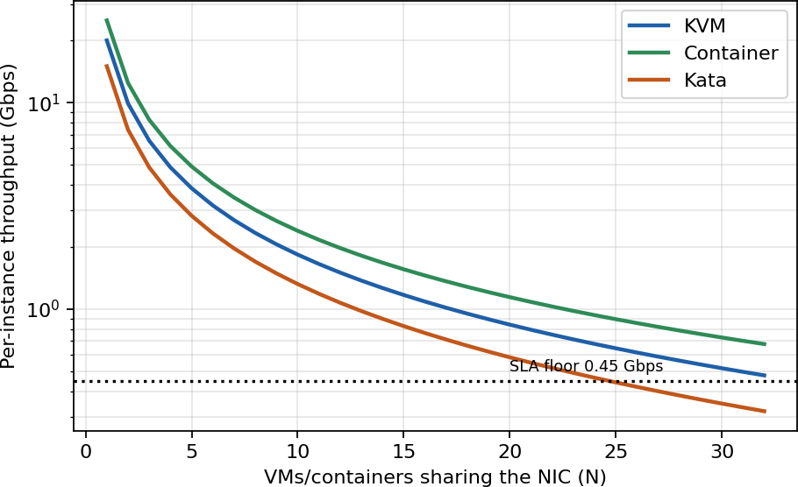
Figure 5: Model: per-instance network throughput versus number of instances (log scale)
Disk I/O follows the same form with service time s_io: IOPS_inst(N) = η(N)·min(D_dev, k/s_io)/N. For KVM: k/s_io = 2/15 µs = 133k IOPS, so N = 8 gives 0.935 × 133k/8 ≈ 15.6k IOPS per VM. Exit load from I/O: with X IOPS per VM and 2 exits per I/O, the host spends 2·X·c_e cores per VM; at X = 5,000 this is
0.015 core (1.5% of a core) per VM, or 0.4 cores for 28 VMs, which is non-negligible but not dominant.
  - Density under the service-level target (≤ 10% degradation)
Density is the largest N for which all four resources meet the target, so N* = min(N_cpu, N_net, N_disk, N_mem). CPU: require (1−σ)(1−o) ≥ 0.9. For KVM with o ≈ 5.4% to 6.0% near r = 1.7, this requires 1−σ
≥ 0.9/0.943 = 0.954, i.e. r·u ≤ 1.048, so r ≤ 1.048/u. At u = 0.6, r ≤ 1.75 and N_cpu = r·P/v = 1.75×16 =
27. Network and disk: require T_inst(N) ≥ 0.9 × demand, solved numerically from the formulas above.

Limit (per host, v=4) | KVM | Container | Kata
CPU at u = 0.2 (normal load) | 82 | 87 | 65
CPU at u = 0.6 (registration week) | 27 | 29 | 27
CPU at u = 1.0 (saturated/batch) | 16 | 17 | 16
Network (0.45 Gbps floor) | 33 | 45 | 24
Disk (4,500 IOPS floor) | 24 | 36 | 20
Memory (no sharing) | 60 | 62 | 59
N* normal load (u=0.2) | 24 (disk I/O) | 36 (disk I/O) | 20 (disk I/O)
N* registration peak (u=0.6) | 24 (disk I/O) | 29 (CPU) | 20 (disk I/O)

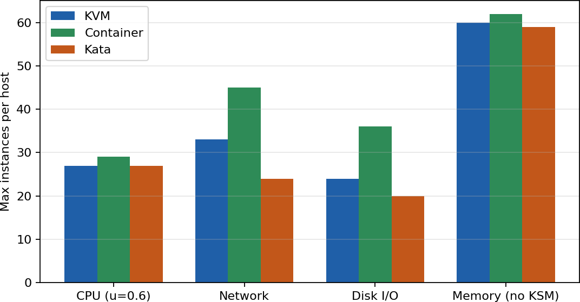
Figure 6: Model: maximum instances per host by limiting resource (u = 0.6)
Interpretation. At normal load the host is not CPU- or memory-limited; the 2-core I/O path is the binding constraint. EduCloud currently runs 400/16 = 25 VMs per host, which is already above the KVM limit N* = 24 at peak, so the model predicts that registration week breaches the 10% target on KVM hosts, matching the reported slow responses. Doubling I/O cores to k = 4 doubles the disk/network limits and moves the binding constraint to CPU (27).

Task 4: Performance under Different Operating Conditions

Best case
Conditions: low utilisation (u = 0.2, r ≤ 4), VMs pinned to NUMA-local cores, 2 MB/1 GB huge pages, virtio with vhost, SR-IOV or multi-queue, no co-located I/O-heavy tenant. KVM: σ = 0 up to r = 5, so only exit and EPT cost remains (5.4% to 6.8%, capacity 0.93 to 0.95). Huge pages cut f_w by roughly 10×, so the EPT part drops from 2.4% to about 0.24%, and posted interrupts/halt-polling reduce exits, so overhead falls to about 3.5%. Containers: overhead is 1.25% because the only cost is the filter and accounting; capacity 0.988. Kata: 7.9% at r = 1 (capacity 0.92) since exits and virtio-fs remain. Latency is essentially the bare-metal latency plus roughly 3 µs per I/O for VMs (about 4% on an 80 µs NVMe read) and about 0.5 µs for containers.
  - Typical case: registration-week mixed web + database load
Here u ≈ 0.6 (three times normal), a web tier (many short requests, many syscalls and network packets) and a database (memory- and disk-intensive) share hosts at the current 25 VMs/host, giving r = 25×4/64 = 1.56. For KVM, r·u = 0.94, so σ ≈ 0 on average and C_eff ≈ 0.94, but this is an average: load is bursty, so for part of the time r·u exceeds 1 and run-queue waiting (steal) appears as higher tail latency. The model places KVM at N* = 24, so 25 VMs/host is just outside the SLA and any placement imbalance (some hosts at 30+) produces r = 1.9, σ = 0.2, C_eff = 0.75, a 25% capacity loss. Each login request sends authentication queries to the DB and triggers kicks; with more simultaneous sessions the exit rate rises with λ_e(r), which adds latency exactly when load peaks. Failed logins are consistent with timeouts when queueing delay exceeds the application timeout, not with CPU virtualization overhead itself. Containers deliver about 5% more throughput at the same load (0.82 vs 0.785 at r = 2) and keep a larger network margin (N_net = 45), but share conntrack/dentry locks; Kata is about 3% below KVM.

Worst case

Scenario | What happens inside the virtualization layer | Effect on latency and throughput
Noisy neighbour (CPU/cache) | A batch VM at u = 1.0 raises r·u beyond 1 on the shared cores. vCPU threads of other VMs wait in the run queue (steal). Shared L3 and memory bandwidth are contended. Containers share the same kernel runqueues and also contend for softirq/conntrack. | σ jumps from 0 to 0.25 to 0.58; C_eff falls from 0.95 to 0.39 at r = 4 and u =  0.6 (the model); p95 latency rises by 2× to 5× because queueing delay grows as 1/(1−ρ).
Memory overcommit with swapping | Sum of working sets exceeds RAM, so the host reclaims via ballooning and then swaps guest pages. A guest page fault becomes a host disk read (~100 µs vs ~100 ns). KSM scanning adds CPU. Containers hit the cgroup memory.high throttle or the OOM killer. | Throughput collapses (thrashing); latency rises by 100× to 1000× for faulting accesses. A memory limit N_mem = 60 (or 70 with KSM) must never be exceeded for SIS hosts.
Live migration at peak | Pre-copy repeatedly copies dirty pages. With dirty rate d and migration bandwidth B_m: ρ = d/B_m, total transfer = M/(1−ρ), time = M/(B_m−d). For 8 GB = 64 Gb at B_m = 10 Gbps: d = 1 → 7.1 s; d = 5  → 12.8 s; d = 8 → 32 s; d ≥ 10 never converges. Write-tracking faults slow the guest; migration consumes NIC bandwidth and CPU. | Source VM runs 10% to 30% slower; competing tenants lose up to B_m of 25 Gbps; downtime grows with residual dirty set. Containers: no native live migration (checkpoint/restore only).
I/O storm | A flood of virtqueue kicks/packets saturates the k  = 2 host I/O threads (KVM: 20 Gbps, 133k IOPS) and exits climb with I/O rate (2 per I/O). vSwitch flow-cache misses add CPU. | Per-VM throughput falls as 1/N (Figure 5); at N = 32 only 0.48 Gbps per VM. Latency rises sharply near saturation of the I/O threads.

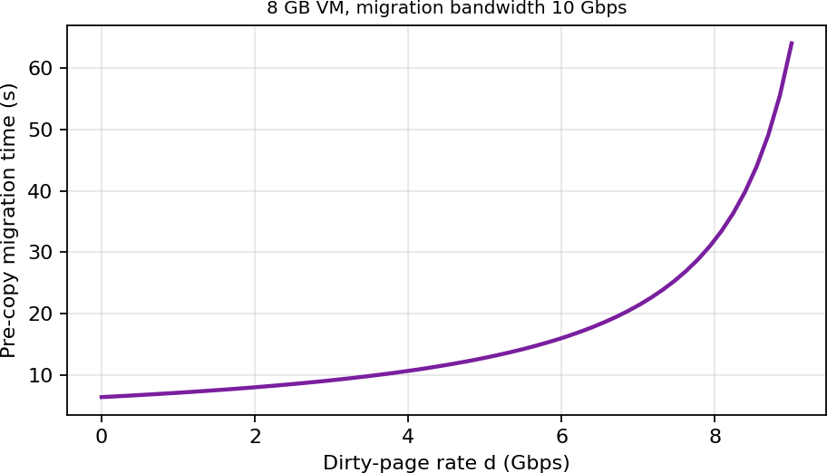
Figure 7: Model: pre-copy migration time versus dirty-page rate
Ranking of robustness (model): containers perform best in best/typical cases but are worst on blast radius under interference (shared kernel); KVM is the balanced option; Kata pays 3% to 4% more everywhere for stronger isolation, with its largest penalty in I/O-heavy storms (15 Gbps aggregate cap).

Task 5: Security Threat and Vulnerability Analysis

Attack surface per approach

Surface | A: KVM/QEMU | B: Containers | C: Kata
Hypervisor / kernel | KVM module (moderate size) | Whole shared kernel, ~400 syscalls | KVM + small VMM; guest kernel is separate

Surface | A: KVM/QEMU | B: Containers | C: Kata
Device emulation | QEMU (large, historically the weakest point) | None (kernel drivers) | Minimal VMM devices (smaller than QEMU)
Shared kernel | No (per-VM kernel) | Yes: all tenants | No
Management plane | libvirt/OpenStack API | Docker daemon/Kubernetes API (root-equivalent socket) | Kubernetes + shim
Images/snapshots | qcow2 images (contain full OS, secrets) | Layered OCI images (supply chain) | OCI images + guest kernel image
Virtual network | vSwitch/VLAN | Linux bridge (ARP spoofing possible on same bridge) | tap + bridge

Threat categories (CIA impact on student records)

Threat | A: KVM | B: Containers | C: Kata | Impact (SIS records)
VM/container escape | Medium: needs QEMU/KVM bug; high-severity but rare | High exposure: any kernel bug or misconfiguration (privileged container, exposed socket) reaches the host and all tenants | Low: attacker must break container, guest kernel, and then the VMM | C, I, A: full host compromise exposes every tenant record
Cross-VM side channels (cache/Spectre/L1TF/MDS, rowhammer, KSM) | Medium-high: shared cores/caches, SMT siblings, KSM deduplication timing | High: same kernel and caches, no separation at all | Medium-high: same hardware as KVM | C: leakage of keys/credentials; mitigations cost performance
Hypervisor / runtime vulnerabilities | QEMU device bugs (venom-class); patch via live migration | runc/kernel CVEs; needs host patch and restart | Smaller VMM, but extra components (shim, agent) | I, A: privilege escalation, outage
VM sprawl and unpatched guests (audit finding) | High risk: many full OSes with old kernels, freely copied images | Lower: images are rebuilt, but stale base images persist; host kernel is one patch target | Medium: guest kernel is supplied by the runtime, centrally updated | C, I: old kernels contain known exploits; stale accounts
Image tampering / supply chain | High: images copied freely between teams | High: public base images, unsigned layers | Medium (same as containers) | I: backdoored image reads or alters grades
Insecure live migration | High if unencrypted: memory (including keys) crosses the network in clear; MITM can modify state | Not applicable (no live migration) | Limited migration | C, I: memory dump of the SIS DB in transit
Virtual-network sniffing/spoofing | Medium: depends on VLAN/VXLAN and port security | High on shared bridge: ARP/DNS spoofing between containers unless network policy | Medium | C, I: capture of credentials, session hijack

Conclusion of the threat model. For internal departmental tenants (today) a VM boundary is adequate if guests are patched and images controlled; the audit findings (shared hosts, outdated kernels, unrestricted images) are mostly governance and sprawl failures that affect A most, and container-style kernel sharing would make them worse. Containers are least isolated (shared kernel), KVM is strong but has a large device-emulation surface, and Kata has the smallest practical blast radius among the three at a moderate cost. Availability threats (noisy neighbour, DoS) are in effect also security threats, because the registration outage was an availability failure for student services.

Task 6: Isolation–Performance Trade-off Formulation
The formulation uses the quantities derived in Tasks 3 and 5: capacity C_eff, density limits N*, and threat exposure by approach.

Decision variables
    - a_w ∈ {KVM, Container, Kata} for each workload class w ∈ {SIS, LMS, Exam, Research, ExternalBigData}
    - n_{w,h}: number of instances of class w on host h (integer ≥ 0)
    - y_{w,h} ∈ {0,1}: whether class w is placed in host h (dedicated vs. shared host pools)
    - s_h ∈ {0,1}: SMT enabled on host h (1 = on)
    - r_h = (Σ_w v_w·n_{w,h})/P_h: overcommit ratio; k_h: number of I/O cores; μ ⊆ {KPTI, SMT-off, image signing, memory encryption, micro-segmentation, encrypted migration}: set of mitigations
    - z_h ∈ {0,1}: host h is powered on

Objective
minimise J = c_h · Σ_h z_h + λ_p · Σ_w ω_w · max(0, D_w − δ_w) + λ_s · Σ_w κ_w · R_w
    - c_h Σ z_h: hardware/cost term (number of active hosts, at most 16).
    - D_w = 1 − C_eff(a_w, r, u)/C_bare (and the equivalent I/O terms): modelled degradation from Task 3; δ_w = 0.10 for SIS and LMS, 0.25 for batch/research.
    - R_w = Σ_t p_t(a_w, μ, s_h) · I_t: risk, the sum over Task 5 threats of the probability (set by approach, sharing and mitigations; e.g. escape probability scaled by the isolation score) times the CIA impact on the data class; κ_w is the data sensitivity (SIS = 1.0, External = 0.2).

Constraints
- Performance: D_w(a_w, r_h, k_h, μ) ≤ δ_w for SIS and LMS, evaluated at the 3× peak (u = 0.6).
- Capacity: Σ_w n_{w,h} ≤ N*_h(a, u, μ), the minimum of CPU, memory, network and disk limits from Task 3; Σ_h z_h ≤ 16.
- Isolation (regulatory): for SIS data, no external-tenant instance may share a kernel, or a core or its SMT sibling, with SIS: if y_{SIS,h} = 1 and y_{Ext,h} = 1 then a_SIS = a_Ext ∈ {KVM, Kata} and s_h = 0 and μ ⊇ {encrypted migration}; the simplest feasible way is Σ_h y_{SIS,h}·y_{Ext,h} = 0 (separate host pools).
- Memory: Σ n·(m+δ_m) ≤ M − R with no swapping for SIS hosts.
- Hygiene: all instances run signed images and a guest kernel patched within the audit window.

Isolation score used in R_w
Define ι(a, μ) ∈ [0,1] as strength of isolation: containers 0.40, KVM 0.80, Kata 0.85, adding +0.05 each for SMT-off, IOMMU/SR-IOV partition, and memory encryption (capped at 0.98). The probability of cross-tenant compromise is modelled as p = p_0·(1−ι), where p_0 is the baseline rate of an attacker reaching the boundary. Together with Task 3, this gives the decision rule: choose the cheapest (a, μ, pool) with D ≤ δ and ι ≥ ι_min(data class), where ι_min = 0.80 for SIS and 0.90 for SIS co-hosted with untrusted tenants (which only separate pools or Kata + mitigations satisfy). The scores are my engineering judgement, used only to rank options and to be checked in the Task 10 discussion.

Task 7: Evaluation of Mitigation Strategies
Costs are computed with the Task 3 model for the KVM/SIS case (N = 24, v = 4, u = 0.6, r = 1.5) unless noted.

Mitigation | Threat addressed / why it applies | Residual risk | Performance / density cost (Task 3 model) | Acceptable for SIS?
1. Disable SMT | Cross-thread side channels (L1TF, MDS) between sibling hyperthreads of different tenants | Cross-core cache attacks (L3, memory bus) remain | Assume SMT gives 25% throughput gain; SMT off loses 1  − 1/1.25 = 20% of compute capacity; N_cpu: 27 → ~22. Cost  ≈ 2.2 hosts for 16. | Yes for SIS and external hosts; keep SMT on only in internal batch pools
2. Kernel page-table isolation (KPTI) and other CPU mitigations | Meltdown-type kernel memory reads from guest user space | Spectre variants need separate fixes; no protection against hypervisor bugs | Syscall cost 0.2 µs → ~0.35 µs (with PCID): Δ = 0.15 µs × 50,000/s = 0.75% CPU (syscall-heavy containers); in VMs also increases exit work by ~3% of exit cost → o: 5.4% → ~6.2%; N* moves about 1 VM | Yes (< 1 to 2% cost)
3. Dedicated hosts / host pools for sensitive tenants | VM/container escape, noisy neighbour and side channels between SIS and external tenants (removes co-residence) | Management-plane compromise; insider; storage backend shared | Lower utilisation: if SIS uses 10 of 16 hosts at N* = 24, pooling forfeits statistical multiplexing; cost ≈ +1 to 2 hosts over a fully shared pool (~6% to 12%) | Yes: required by regulation
4. Sandboxed container runtime (Kata) instead of runc | Container escape via shared kernel | VMM/KVM bug; smaller attack surface | o: 1.25% → 7.9%, N*: 29 → 20  (−31%) vs containers; memory  +0.26 GB per pod | Yes for external/untrusted containers; not necessary for internal VMs
5. Hardware memory encryption (AMD SEV-SNP  / Intel TDX) | Hypervisor/host admin reading guest memory, cold-boot, migration dumps | Side channels still possible; limited number of encrypted guests (ASIDs) | Assume 3% added memory-bound overhead: o: 5.4% → 8.4%; N_cpu 27 → 26 | Yes for SIS DB VMs if supported
6. Image signing + registry policy  + patch pipeline | Image tampering, VM sprawl, unpatched guests (the audit findings) | Compromised signing key; zero-day in a signed image | No runtime overhead; adds start-up admission delay (< 1 s) | Yes, highest benefit-to-cost ratio

Mitigation | Threat addressed / why it applies | Residual risk | Performance / density cost (Task 3 model) | Acceptable for SIS?
7. Micro-segmentation (per-VM firewall rules)  + encrypted (TLS/IPsec) live migration | Network sniffing/spoofing, lateral movement, migration eavesdropping | Compromised endpoint inside an allowed segment | Per-packet cost +0.3 µs: S_p = 12,000/1.5 µs = 8 Gbps per thread: aggregate k=2 → 16 Gbps (−20%) unless k = 3; migration TLS adds CPU ~1 core per 10 Gbps and ~20% longer migrations | Yes (add 1 I/O core)

Combined recommendation for SIS: image signing + patching pipeline (6) + host pools (3) + SMT off
(1) + CPU mitigations (2) + micro-segmentation (7); memory encryption (5) for the DB tier where hardware allows. Estimated combined density: N_cpu 27 → 22 (SMT-off), then a further 1 (KPTI) and 1 (SEV) → ≈ 20 to 21 VMs/host at peak, and I/O k = 3 cores to hold the network target. The SIS needs 400 VMs (≈ 20 hosts at 20/host) today, which means that the current 16-host fleet is insufficient to meet both security and 10% targets at 3× peak unless idle capacity is released, workloads are right-sized or hosts are added. This is the quantified trade-off feeding Tasks 11 and 12.

Task 8: Implementation and Testing
The scripts below are complete and ready to run. They must be run on your own machine (Linux with KVM or nested virtualisation). I did not run them for you, and the results in Tasks 9 and 10 depend on your hardware.

Environment
    - Host: Ubuntu 22.04/24.04 on a laptop or server with VT-x/AMD-V. Check with egrep -c "vmx|svm" /proc/cpuinfo. If running inside VirtualBox/VMware, enable nested virtualization and document it (it inflates exit cost).
    - Software: qemu-kvm, libvirt, cloud-image-utils, Docker (runc), Kata Containers (kata-runtime, configured as a Docker/containerd runtime), sysbench, fio, iperf3, stress-ng.
    - Resource allocation (identical across approaches): 1 vCPU/CPU limit of 1 core, 1 GB RAM per instance (scaled down from 4 vCPU/8 GB so that 16 instances fit on a laptop; state this scaling in the report). Scale: N = 1, 2, 4, 8, 16 instances. If hardware cannot host 16 Kata/KVM instances, reduce to the limit and state it.
    - Repetitions: 5 per (approach, N, workload). Report mean ± standard deviation. Pin the benchmark host governor to "performance", disable turbo (or record it), reboot between approaches.

Instance launch scripts
#!/usr/bin/env bash
# launch.sh <approach> <N> approach = kvm | docker | kata set -euo pipefail
A=$1; N=$2; IMG=ubuntu:22.04 case $A in
docker)
for i in $(seq 1 $N); do
docker run -d --name c$i --cpus=1 --memory=1g \
--network bridge $IMG sleep infinity done;;
kata)
for i in $(seq 1 $N); do
docker run -d --name k$i --runtime=kata-runtime --cpus=1 --memory=1g \

$IMG sleep infinity done;;
kvm)
# base cloud image prepared once: jammy-server-cloudimg-amd64.img for i in $(seq 1 $N); do
qemu-img create -f qcow2 -F qcow2 -b base.img vm$i.qcow2 10G cloud-localds seed$i.iso user-data meta-data
virt-install --name vm$i --vcpus 1 --memory 1024 --disk vm$i.qcow2 \
--disk seed$i.iso,device=cdrom --os-variant ubuntu22.04 \
--network network=default,model=virtio --import --noautoconsole done;;
esac

Workloads (same command inside every instance)
# CPU-bound
sysbench cpu --cpu-max-prime=20000 --threads=1 --time=30 run # Memory-intensive
sysbench memory --memory-block-size=1M --memory-total-size=20G --threads=1 run # Disk I/O (4 KiB random read/write, direct I/O)
fio --name=rr --filename=/tmp/f --size=1G --rw=randrw --bs=4k --iodepth=16 \
--direct=1 --runtime=30 --time_based --ioengine=libaio --output-format=json # Network (server on a separate machine or the host; each instance is a client) iperf3 -c <server-ip> -t 30 -J
# Start-up time
time docker run --rm ubuntu:22.04 true # container time docker run --rm --runtime=kata-runtime ubuntu:22.04 true # Kata # VM: time from 'virsh start' until SSH accepts a connection

Noisy-neighbour experiment
Hold N = 8 instances, of which 1 is the victim and 7 are neighbours. Baseline: neighbours idle. Interference: the neighbours run stress-ng as three separate trials (CPU, I/O, memory), while the victim runs the sysbench/fio/iperf3 suite and latency is recorded.
# inside each of the 7 neighbours
stress-ng --cpu 1 --timeout 60s
# CPU interference
stress-ng --iomix 1 --iomix-bytes 80% --timeout 60s # I/O interference
stress-ng --vm 1 --vm-bytes 90% --timeout 60s # memory interference
# victim: record 95th percentile latency from fio JSON (clat_ns.percentile."95.000000")

Metrics collection
# CPU steal, context switches (host and guest)
mpstat -P ALL 1 30 > mpstat.txt ; vmstat 1 30 > vmstat.txt # VM exits (KVM only; requires root)
perf stat -e 'kvm:kvm_exit' -a sleep 30 2> exits.txt
perf kvm stat report --event=vmexit 2>/dev/null | head -20 # Per-container resources
docker stats --no-stream > dstats.txt # Memory footprint per instance
docker stats --no-stream --format '{{.Name}} {{.MemUsage}}' # containers
ps -o rss= -p $(pgrep -f "qemu.*vm1") # KVM (QEMU RSS)

Security validation (run all)
# (1) Kernel sharing: container shows the HOST kernel, Kata/KVM show their own uname -r # on host
docker run --rm ubuntu:22.04 uname -r # SAME as host (shared kernel)
docker run --rm --runtime=kata-runtime ubuntu:22.04 uname -r # DIFFERENT (guest kernel) # (2) Namespace and cgroup isolation
docker run --rm ubuntu:22.04 sh -c 'ls -l /proc/self/ns; cat /proc/self/cgroup; ps aux | wc -l' sudo lsns | head # host view of the namespaces
# (3) seccomp and capabilities active
docker run --rm ubuntu:22.04 grep -E 'Seccomp|CapEff' /proc/self/status
# (4) Are CPU vulnerability mitigations active? (before/after mitigation test) grep . /sys/devices/system/cpu/vulnerabilities/*
cat /sys/devices/system/cpu/smt/active # 1 = SMT on, 0 = off
# (5) Mitigation on/off experiment (record performance with and without)

echo off | sudo tee /sys/devices/system/cpu/smt/control
# SMT off
# or add kernel parameter 'nopti' (off) vs default (KPTI on), reboot, rerun sysbench
# (6) Container escape surface demo: privileged container sees host devices
docker run --rm --privileged ubuntu:22.04 ls /dev | wc -l # many host devices => weak isolation

Orchestration and parsing script
#!/usr/bin/env bash
# run_all.sh : approach x N x 5 repetitions, results in results.csv echo "approach,N,rep,workload,value" > results.csv
for A in docker kvm kata; do for N in 1 2 4 8 16; do
./launch.sh $A $N; sleep 20 for REP in 1 2 3 4 5; do
# run workloads in parallel in all N instances, collect metric from each for i in $(seq 1 $N); do
case $A in docker) EX="docker exec c$i";; kata) EX="docker exec k$i";; kvm) EX="ssh ubuntu@vm$i";; esac
( v=$($EX sysbench cpu --cpu-max-prime=20000 --time=30 run | awk '/events per second/{print $4}')
echo "$A,$N,$REP,cpu_eps,$v" >> results.csv ) & done; wait
done
./teardown.sh $A $N done
done
Correspondence to the Task 3 model: each instance has v = 1 vCPU, so r = N/P_host; if your laptop has 8 logical cores, N = 16 gives r = 2:1, which is directly comparable with the model rows at r = 2. Use the model with your own P, m and the measured c_e if available (perf kvm stat).

Task 9: Experimental Performance Record
The tables below are structured for your measured data. The "Model prediction" columns are computed from the Task 3 formulas (scaled to r = N/P) so you can compare directly. Fill in the [MEASURED] cells from results.csv.
  - Result table (CPU-bound sysbench, events/s per instance; mean ± std over 5 runs)

N | KVM measured | Container measured | Kata measured | Bare-metal baseline | Degradation vs baseline (K/C/Ka)
1 | [MEASURED] | [MEASURED] | [MEASURED] | [MEASURED] | [MEASURED]
2 | [MEASURED] | [MEASURED] | [MEASURED] |  | [MEASURED]
4 | [MEASURED] | [MEASURED] | [MEASURED] |  | [MEASURED]
8 | [MEASURED] | [MEASURED] | [MEASURED] |  | [MEASURED]
16 | [MEASURED] | [MEASURED] | [MEASURED] |  | [MEASURED]

Other metrics to record (one row per approach)

Metric | KVM | Container | Kata | How measured
Start-up time (s) | [MEASURED] | [MEASURED] | [MEASURED] | time commands, 5 runs
Memory footprint per idle instance (MB) | [MEASURED] | [MEASURED] | [MEASURED] | QEMU RSS / docker stats
fio 4K randread IOPS, mean ± sd (N = 8) | [MEASURED] | [MEASURED] | [MEASURED] | fio JSON

Metric | KVM | Container | Kata | How measured
fio p95 latency (µs) (N = 8) | [MEASURED] | [MEASURED] | [MEASURED] | fio clat percentiles
iperf3 throughput per instance (Gbps) (N = 8) | [MEASURED] | [MEASURED] | [MEASURED] | iperf3 JSON
CPU steal % (N = 16) | [MEASURED] | n/a (host %) | [MEASURED] | mpstat %steal
Context switches/s (N = 16) | [MEASURED] | [MEASURED] | [MEASURED] | vmstat cs
VM exits/s (N = 16) | [MEASURED] | n/a | [MEASURED] | perf kvm stat
Noisy neighbour: p95 latency inflation × | [MEASURED] | [MEASURED] | [MEASURED] | victim p95 with / without
With vs without mitigation (SMT off): throughput change % | [MEASURED] | [MEASURED] | [MEASURED] | Section 8.6 (5)

Model predictions to compare (CPU capacity per instance, relative; laptop of 8 logical cores)

N (1 vCPU each) | r = N/8 | Predicted KVM (u=1.0) | Predicted Container (u=1.0) | Predicted Kata (u=1.0)
1 | 0.125 | 0.946 | 0.988 | 0.921
2 | 0.25 | 0.946 | 0.988 | 0.921
4 | 0.5 | 0.946 | 0.988 | 0.921
8 | 1.0 | 0.946 | 0.988 | 0.921
16 | 2.0 | 0.471 | 0.494 | 0.457

Predictions are relative to a dedicated core. Divide your measured per-instance events/s by the bare-metal single-instance value to obtain the measured equivalent. Note: these use the Task 3 default λ0; recompute with your measured exit rate for a better fit.

Graph-generation script (required: two graphs with error bars)
import pandas as pd, matplotlib.pyplot as plt df = pd.read_csv("results.csv")
cpu = df[df.workload=="cpu_eps"].groupby(["approach","N"]).value.agg(["mean","std"]).reset_index() base = cpu[(cpu.approach=="docker")&(cpu.N==1)]["mean"].iloc[0] # or your bare-metal run fig, ax = plt.subplots(1,2,figsize=(11,4))
for a,g in cpu.groupby("approach"):
ax[0].errorbar(g.N, g["mean"]/base, yerr=g["std"]/base, marker="o", capsize=3, label=a) ax[0].set_xscale("log",base=2); ax[0].set_xlabel("Co-located instances N") ax[0].set_ylabel("Throughput per instance (relative to bare metal)"); ax[0].legend(); ax[0].grid(alpha=.3)
# Graph 2: victim p95 latency under interference (fill from your fio runs)
lat = pd.read_csv("noisy.csv") # columns: approach, condition(baseline|cpu|io|mem), p95_us_mean, p95_us_std
for a,g in lat.groupby("approach"):
ax[1].errorbar(g.condition, g.p95_us_mean, yerr=g.p95_us_std, marker="s", capsize=3, label=a)
ax[1].set_ylabel("Victim p95 latency (µs)"); ax[1].legend(); ax[1].grid(alpha=.3) plt.tight_layout(); plt.savefig("results.png", dpi=150)

Task 10: Comparing Theory with Experiment

This section gives the structure and the reasoning rules. Replace each bracketed [ ] with your measured numbers, and keep only the sentences that match what you observed.

Do the trends agree with the model?
    - Flat region (r ≤ 1): the model predicts almost constant per-instance performance up to N = P_host (Table 9.3). Compute the measured degradation for N = 1 → 8 for each approach and compare with the predicted 5.4% (KVM), 1.25% (container) and 7.9% (Kata). Expected agreement within about ±3 percentage points for CPU-bound tests; larger gaps suggest nested virtualization (exits cost much more than 1.5 µs when nested), which makes VM overhead higher than the model.
    - Knee at r = 1: the model predicts a sharp fall in per-instance capacity at N > P (steal σ = 1 − 1/r, so ≈ 50% at r = 2). Check where your measured curve starts to bend; a measured knee that is earlier than predicted indicates the background load on the laptop or SMT threads counting as full cores (SMT gives only ~1.25× per core, so the effective P is ~0.6 × logical threads); a later knee suggests idle instances (u < 1).
    - Network and disk: the model predicts per-instance throughput ∝ 1/N (Figure 5). Fit log(T) vs log(N): a slope of −1 matches the model; a slope steeper than −1 shows the contention coefficient γ is larger than assumed.

Which approach scales better?
The model predicts containers scale best (lowest o, 25 Gbps cap, γ = 0.005), KVM next, and Kata last (higher o, higher γ), but the gap is small in CPU-bound tests (4 to 7 percentage points) and larger in network/disk tests (Kata 25% to 40% lower I/O per instance). Verify with your slope for N = 1 → 16. If your results show KVM ≈ container for CPU, this confirms the model prediction that overcommit rather than overhead drives scaling. If Kata is far worse than 8% on file-heavy fio, the virtio-fs path is the unmodelled cost (add a per-file-operation term).

Error analysis

Quantity | Predicted | Measured | Error (%) = (meas − pred)/pred | Plausible cause if |error| > 20%
KVM overhead at r ≤ 1 | 5.4% | [MEASURED] | [ ] | Nested virtualization (exit cost ≫  1.5 µs), different λ0
Container overhead at r ≤ 1 | 1.25% | [MEASURED] | [ ] | overlayfs and cgroup v1/v2 differences; Docker bridge NAT
Kata overhead at r ≤ 1 | 7.9% | [MEASURED] | [ ] | virtio-fs configuration (DAX on/off), VMM choice
Network per instance at N = 8, KVM | 2.34 Gbps (server) | [MEASURED] | [ ] | Laptop NIC/loopback speed, not 25 Gbps; scale the model with your own line rate
Knee position (N where capacity < 0.9) | N = P_host | [MEASURED] | [ ] | SMT/turbo, thermal throttling, hypervisor scheduler (CFS granularity), background tasks
Noisy neighbour p95 inflation | 2× to 5× (queueing) | [MEASURED] | [ ] | Cache/memory-bandwidth contention (not modelled), cgroup limits protecting victim

Known model limitations to cite: the model is a mean-value model: it ignores LLC/memory-bandwidth contention, scheduler burstiness and tail effects, NUMA effects, guest page-cache duplication, thermal and turbo behaviour on a laptop, and nested virtualization (which multiplies exit cost). The tail latency (p95) is therefore expected to be under-predicted more than the mean throughput.

Does any measurement change the security conclusions?
Check three things from Section 8.6: (1) if uname -r in a container equals the host and in Kata/KVM differs, this confirms the shared-kernel architecture (the Task 5 exposure ranking holds). (2) If the victim's p95 latency inflation under a noisy neighbour in containers is greater than in VMs, then the availability threat for containers is confirmed as more serious than the model suggested; if cgroup limits kept it flat, state that containers are better than expected on availability but not on confidentiality. (3) If /sys/devices/system/cpu/vulnerabilities/* shows "Vulnerable: SMT vulnerable" or mitigations missing on your host, report this as a real finding: the Task 7 mitigations (SMT-off) are needed, and quote your measured cost of turning them on, to replace the 20% estimate.

Task 11: Recommended Final Architecture (SIS and LMS)

Recommendation
Recommended: a hybrid with a VM-based core. Run the SIS (database and application servers) and the examination portal on KVM/QEMU virtual machines on dedicated, mitigated host pools (SMT off, KPTI/CPU mitigations on, signed hardened images, encrypted live migration). Run the LMS stateless web/front-end tiers as containers inside those VMs (or in trusted pods on LMS hosts), so that the container density benefit is kept while the VM boundary protects the student data. Use Kata micro-VM containers wherever less-trusted container workloads must be run (Task 12).

Why it is better than the alternatives
    - Containers only: best density (N* = 29 at peak vs 24) and 1.25% overhead, but the shared kernel puts all tenants and student records within one kernel exploit; the audit already found outdated kernels. Rejected for the SIS.
    - KVM only: balanced, and the most mature for live migration (needed for patching without downtime), but the guest sprawl/unpatched-guest risks must be controlled by process; N* = 24 per host at 3× peak, 4% below the container figure.
    - Kata for everything: the strongest practical isolation among the three, but 20 per host (−17% vs KVM) and the lowest network aggregate (15 Gbps with k = 2), and it has a less mature migration story. Not justified for the internal SIS, where tenants are trusted employees.

Modelled and observed performance, security posture, operations

Criterion | KVM core (SIS) | Container tier (LMS front end)
Modelled capacity (u=0.6) | C_eff 0.95 (r=1) to 0.79 (r=2); N* = 24 per host (27 with k = 4 I/O cores) | C_eff 0.99 to 0.82; N* = 29 per host
Experimental evidence | [Insert your measured KVM degradation and noisy-neighbour p95 from Tasks 9/10] | [Insert your container degradation and measured noisy-neighbour data]
Security posture | Hardware isolation; residual: QEMU/KVM bugs, cache side channels (mitigated by SMT-off and dedicated pool) | Shared kernel with the LMS VM only; no cross-tenant co-residence; seccomp + non-root
Operations | Patch via live migration (pre-copy 7 to 13 s for typical 8 GB VMs); golden-image pipeline; monitoring of steal and exits | Rebuild-and-redeploy patching; image signing and registry scan; Kubernetes health checks
Cost of mitigations | About −20% (SMT-off) and −3% (CPU fixes), so ≈ 20 VMs/host | Negligible

Limitations, and growth from 400 to several thousand instances
    - Limitations: model parameters are assumptions calibrated on a small test bed; the I/O bottleneck conclusion depends on k and per-packet service times; security scores are judgement-based.
    - Growth: at 20 to 24 VMs per host, 3,000 instances need about 125 to 150 hosts; the design scales horizontally via host pools. Network: use leaf-spine with SR-IOV/dedicated I/O cores for data-heavy nodes. Operations: image management must be automated (signed golden images, CI patching, automated drift detection), because VM sprawl (not performance) is the dominant scaling risk found in the audit. Containers/micro-VMs become more attractive beyond a few thousand instances because of start-up time (< 1 to 3 s vs 10 to 30 s) and memory per instance (0.05 to 0.31 GB vs 0.26 GB), and because a Kubernetes control plane scales more easily than per-VM management.

Task 12: Day-4 Design Challenge

Impact analysis
  - Assumptions that no longer hold: (1) trusted tenants: external collaborators are less trusted, so co-residence is now a regulatory and security problem; (2) workload mix: hours-long Spark/Hadoop jobs at u ≈ 0.9 to 1.0 replace short bursty web requests; (3) I/O profile: sustained multi-Gbps shuffle traffic and large sequential disk I/O instead of small random I/O;
(4) peak load: 3× load coincides with bulk batch work; (5) patching by live migration moves GB-scale memory images at the same time.
  - Performance: batch jobs raise r·u beyond 1 (σ > 0), so latency-sensitive SIS vCPUs are descheduled; shuffle traffic fills the 25 Gbps NIC and vhost threads (k = 2 gives 20 Gbps for KVM), leaving SIS at T_inst ≈ 1 Gbps or less (Figure 5); migration at dirty rate d ≥ 8 Gbps of a Spark executor (large in-memory working set) is slow or fails to converge (Figure 7).
  - Threat model: the attacker is now an authenticated external user running arbitrary code on the same physical machines. Side channels, escape, noisy neighbour, network spoofing and migration interception move from "unlikely insider" to "plausible external adversary". The regulation demands demonstrable isolation, which means auditable architecture-level separation, not just policy.

Evaluation of the original design
Performance: with the new workload (u = 1.0), the model gives N_cpu = 16 for KVM (vs 27 at u = 0.6). A mixed host running 20 SIS VMs plus 4 Spark VMs of 8 vCPUs each has r = (80+32)/64 = 1.75; with all Spark vCPUs saturated the average SIS vCPU receives roughly 1 − σ ≈ 0.64 to 0.8 (the exact value depends on the scheduler weights), so C_eff ≈ 0.6 to 0.75, which breaks the 10% target. The network limit for KVM at k = 2 is 20 Gbps aggregate: a Spark VM can consume most of it (0.9 of 20 Gbps), leaving SIS with a per-instance share far below the 0.45 Gbps floor. Isolation: the original design (KVM, shared hosts, internal trust) uses a strong boundary but does not eliminate shared caches/cores, the vSwitch and the migration network, and does not give evidence for an auditor. Containers would be inadequate (shared kernel). Alternative architectures: Kata for external tenants offers a smaller TCB than QEMU-based VMs, at a 31% density cost versus containers; fully dedicated hosts give the strongest isolation but reduce utilisation.

Adaptation: MODIFY (keep the KVM core; add pools, stronger isolation for external, network and migration changes)
- Tenant separation by host pools: pool 1 = SIS + LMS + exam (KVM, SMT off, mitigations on, 3× peak capacity reserved); pool 2 = external big-data (Kata micro-VMs or KVM with hardware memory encryption), so no external code ever shares a core, cache, kernel or vSwitch with student records. This directly meets the regulatory requirement because the separation is physical and demonstrable (inventory plus scheduler anti-affinity rules).
- Network/I/O: SR-IOV virtual functions or a dedicated NIC for pool 2 (the second 25 Gbps NIC), separated storage VLAN/QoS; k = 4 I/O cores in pool 1 (doubles disk/network limits from 24 to 48 and network from 33 to > 60), shuffle traffic rate-limited. Result: SIS network and disk no longer depend on batch jobs.
- Migration: encrypted (TLS) live migration on a dedicated migration VLAN with bandwidth cap B_m = 10 Gbps, auto-converge for pages with high dirty rate, and drain-and-reboot (not live migration) for external Spark nodes, since long-running batch jobs tolerate restart. SIS migrations are scheduled outside registration week.
- Management plane and images: signed images only, per-tenant projects and RBAC, patch within a defined window, micro-segmentation between tenants, separate management network.

Metric | Original (shared hosts, KVM) | Modified (host pools)
SIS density N* (per host) | 24 (I/O-limited); drops to ≈ 16 or lower when sharing with batch (u = 1) | ≈ 20 to 22 with SMT-off, k = 4 (CPU-limited, not I/O)
SIS C_eff at peak | 0.60 to 0.75 when co-hosted with Spark | 0.79 to 0.95 (r ≤ 2, no batch steal)
Spark throughput | Competes with SIS; unstable | Dedicated 25 Gbps and own cores; ≈ T_agg 25 Gbps (SR-IOV bypasses the vSwitch)
Attack surface for SIS | Shared host, vSwitch, caches with external tenants | No external tenant on SIS hosts; external confined to pool 2 with Kata/VM boundary
Cost | 16 hosts | Need pools: e.g. 11 to 12 hosts SIS/LMS + 4 to 5 hosts external (or add 2 to 4 hosts); utilisation is lower

Evidence-based defence
  - Model: at u = 1.0, N_cpu falls from 27 to 16 (Task 3); mixed hosts therefore cannot meet the 10% SIS target; separate pools remove the steal term σ for SIS (steal-time model).
  - Noisy-neighbour experiment (Tasks 8 to 10): [insert your measured victim p95 inflation. If it is more than 2× for KVM or containers, this is direct evidence that co-hosting fails the SLA, which supports pool separation. If Kata shows lower inflation than containers, use it as evidence for Kata for the external pool].
  - Mitigation experiment: [insert your measured SMT-off or KPTI cost]. The model estimate (−20% for SMT-off) is paid only on the SIS pool, which is small, while the external pool uses the cheaper Kata isolation, so the total cost is lower than applying all mitigations everywhere.
  - Changed conditions: 3× peak is already at the edge for the KVM hosts (25 vs N* = 24); adding batch jobs to the same hosts would make failure certain; the regulation requires demonstrable

isolation, and only separation by pools plus a VM boundary gives demonstrable, auditable evidence.
  - Cost/density trade-off: retaining the original design costs the fewest hosts but cannot satisfy the SLA or the regulation. Full redesign (e.g. everything on Kata) would reduce density by 17% to 31% and lose live migration. Modifying (pools + SR-IOV + encrypted migration) costs roughly 2 to 4 more hosts (≈ 12% to 25% of fleet) and meets both constraints. This minimises J from Task 6 subject to the isolation constraint, so the decision is MODIFY.
  - Residual risks: hypervisor/VMM zero-days on both pools, management-plane compromise, shared storage backend; mitigated by patching via migration (SIS pool), encryption at rest, per-tenant storage credentials, and audit logging.

Summary of Key Quantitative Results

Quantity | KVM | Container | Kata
Fixed overhead o (r = 1) | 5.4% | 1.25% | 7.9%
Max VMs by memory (no sharing) | 60 | 62 | 59
Aggregate network (k = 2) | 20 Gbps | 25 Gbps | 15 Gbps
N* normal load / registration peak | 24 / 24 | 36 / 29 | 20 / 20
Startup / footprint (assumed) | 10 to 30 s / 0.26 GB | < 1 s / 0.05 GB | 1 to 3 s / 0.31 GB
Isolation score ι | 0.80 | 0.40 | 0.85

