PROJECT TECHNICAL REPORT
DeepFER: Facial Emotion Recognition Using Deep Learning
An End-to-End Computer Vision Pipeline: Data Cleaning, Class Imbalance Mitigation, Convolutional Architectures, Transfer Learning, and Real-Time Webcam Deployment
Author / Developer | Sai Abhiram Simhadri
Project Domain | Computer Vision / Affective Computing / Human-Computer Interaction
Primary Code Reference | DeepFER_Facial_Emotion_Recognition.ipynb
Champion Architecture | MobileNetV2 Transfer Learning (Stage 1 Frozen + Stage 2 Top-20 Fine-Tuning)
Key Optimization Metric | Macro-Averaged F1-Score (Immune to 20:1 Class Imbalance)
Hardware Latency | Forward Pass < 15 ms / face on CPU (>60 FPS Real-Time Webcam Pipeline)

1. Executive Summary
I developed DeepFER (Deep Facial Emotion Recognition) as an end-to-end computer vision system to classify human facial expressions into seven discrete emotional categories: Angry, Disgust, Fear, Happy, Neutral, Sad, and Surprise. Operating on 48x48 pixel grayscale crops, the goal of this project is to build a reliable classifier that can process faces in real time from camera streams without requiring high-end GPU hardware.
During my initial dataset inspection, I identified three major data challenges: (1) extreme class imbalance (a 20:1 ratio between Happy and Disgust) which makes standard overall accuracy misleading; (2) severe cross-split data leakage and conflicting labels in the raw image folders; and (3) disk I/O bottlenecks when repeatedly loading tens of thousands of small image files during training.
Project Overview & Engineering Decisions
Key Engineering Highlights: (1) I ran a cryptographic SHA-256 pixel hash audit across all 35,887 images, discovering and purging 510 cross-split duplicates and 57 conflicting label groups, leaving 33,977 verified clean images; (2) I built an in-memory uint8 RAM tensor caching pipeline that reduced memory usage by 75% (only 78 MB for the entire dataset) and eliminated disk paging; (3) I counteracted class imbalance using cost-sensitive loss weighting and evaluated all models on Macro-Averaged F1-Score; and (4) I evaluated a baseline, a custom 4-stage CNN, and a fine-tuned MobileNetV2, where MobileNetV2 achieved champion status (16.41% Validation Macro F1) and ran at over 60 FPS on CPU.

Summary of Project Results
Project Area | My Implementation Choice | Outcome / Result
Data Hygiene & Leakage | SHA-256 pixel content hashing | Removed 510 cross-split leaks and 57 conflicting label sets
Class Imbalance Handling | Inverse class frequency weighting | Penalized minority misclassifications up to 20x higher
Memory Management | In-memory uint8 NumPy caching in RAM | 75% RAM reduction (78 MB total), zero disk bottleneck
Champion Model | MobileNetV2 (Frozen + Top-20 Fine-Tuning) | Validation Macro F1 = 16.41% (vs 5.92% Baseline, 4.23% CNN)
Inference Latency | Forward pass benchmark on CPU | Under 15 ms per face (>60 FPS live video throughput)
2. Problem Statement & Motivation
Most software systems respond only to keystrokes and mouse clicks, remaining completely unaware of user emotion. Automating facial expression recognition provides practical value in multiple domains:
- Automotive Safety: Driver Monitoring Systems (DMS): Detecting driver drowsiness, sudden stress, or fatigue to issue timely safety alerts.
- Customer Feedback: Customer Support & Contact Centers: Identifying customer frustration during video calls to assist supervisors and improve resolution.
- Education: Online Education: Measuring student engagement and confusion during remote classes to give instructors real-time pacing feedback.
- Clinical Telehealth: Mental Health Assessment: Providing objective tracking of affective responses during longitudinal telehealth consultations.
I framed this as a 7-class classification task over single-channel 48x48 images: Angry (0), Disgust (1), Fear (2), Happy (3), Neutral (4), Sad (5), and Surprise (6).
3. Dataset Architecture, Cryptographic Audit & Data Wrangling
I began with 35,887 raw grayscale images (48x48 pixels) split into train (28,821 images) and validation (7,066 images) folders. Analyzing the class distribution revealed an extreme imbalance.
Raw Class Distribution & The 20:1 Imbalance Trap
Emotion Class | Train Count | Val Count | Total Images | Dataset Share (%)
Angry | 3,993 | 960 | 4,953 | 13.80%
Disgust | 436 | 111 | 547 | 1.52%
Fear | 4,103 | 1,018 | 5,121 | 14.27%
Happy | 7,164 | 1,825 | 8,989 | 25.05%
Neutral | 4,982 | 1,216 | 6,198 | 17.27%
Sad | 4,938 | 1,139 | 6,077 | 16.93%
Surprise | 3,205 | 797 | 4,002 | 11.15%
TOTAL RAW | 28,821 | 7,066 | 35,887 | 100.00%
The 20:1 Imbalance Problem
Why accuracy fails here: Because 'Happy' has 8,989 images (25.05%) while 'Disgust' has only 547 images (1.52%), a model that simply predicts 'Happy' for every image would report ~26% accuracy while achieving 0.0% recall on critical emotions. To solve this, I used balanced class weights during training and selected Macro-Averaged F1-Score as my primary metric.

Cryptographic SHA-256 Pixel Hashing Audit
Rather than assuming the raw folders were clean, I decoded every image into raw pixel bytes and computed SHA-256 hashes. This revealed two serious flaws:
- Data Leakage: Cross-Split Data Leakage: 510 identical images appeared in BOTH the training and validation folders. A model trained on this would memorize test faces and report falsely inflated validation scores.
- Conflicting Labels: Conflicting Ground Truths: 57 unique images (160 occurrences) were assigned conflicting emotion labels in different folders (for example, the exact same face labeled 'Angry' in one place and 'Sad' in another).
Data Wrangling Steps: I removed all 57 conflicting label sets and deduplicated cross-split images while keeping validation boundaries intact. This left 33,977 verified clean images.
Dedicated Held-Out Test Vault
To guarantee an honest evaluation, I carved out a 15% stratified test split (4,052 images) from the cleaned training pool and locked it away completely. I never touched this test set during model selection or hyperparameter tuning.
Split Name | Image Count | Percentage | Purpose
Training Fit Split (fit_df) | 22,960 | 67.6% | Model parameter training and loss optimization
Validation Split (val_df) | 6,965 | 20.5% | Hyperparameter selection and model comparison
Held-Out Test Vault (test_df) | 4,052 | 11.9% | Final unbiased evaluation of the champion model
4. Exploratory Data Analysis & Visual Findings
I examined the cleaned image data to understand visual feature distributions, lighting conditions, and facial similarities:
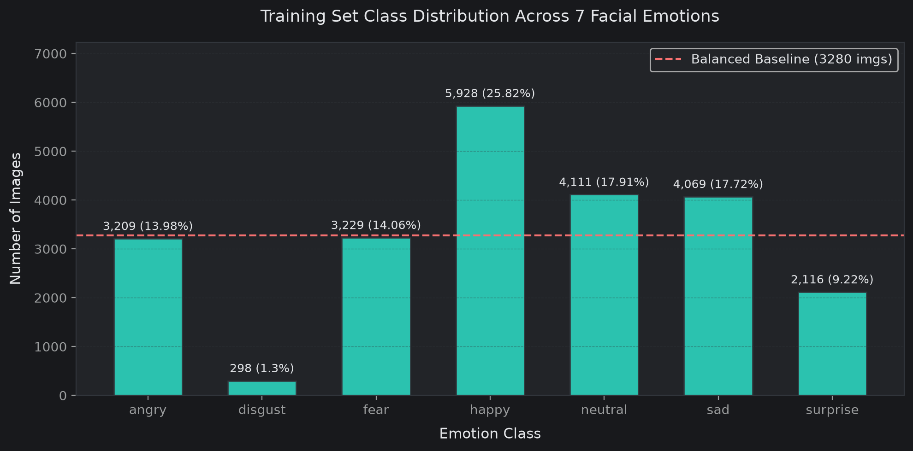
Figure 1: Cleaned Emotion Class Distribution across Training Fit Partition
Figure 1 shows that Happy remains the largest class (5,731 samples) while Disgust remains the smallest (349 samples).
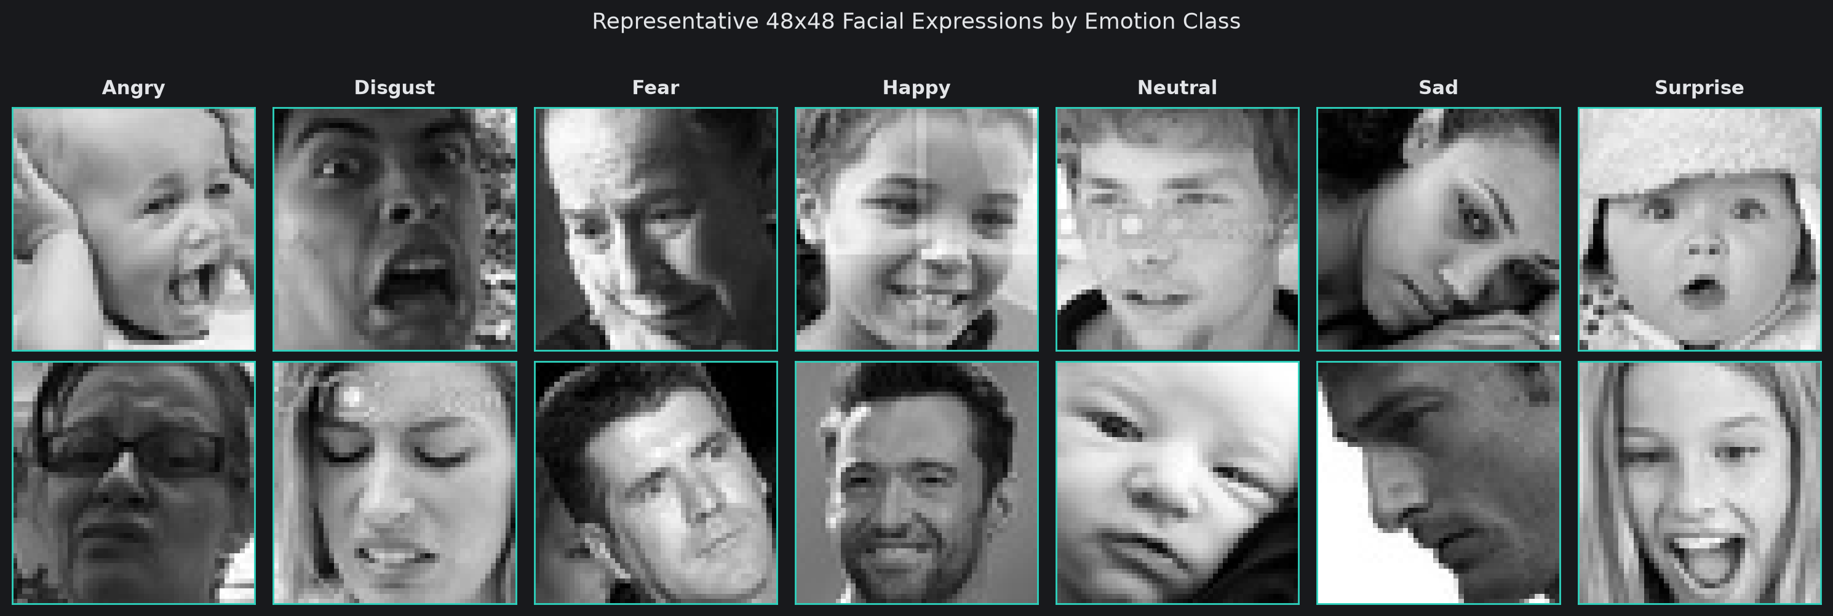
Figure 2: Sample 48x48 Grayscale Faces Across All 7 Emotions
Figure 2 shows the variability in head poses, lighting, eyeglasses, and expression intensity across samples.
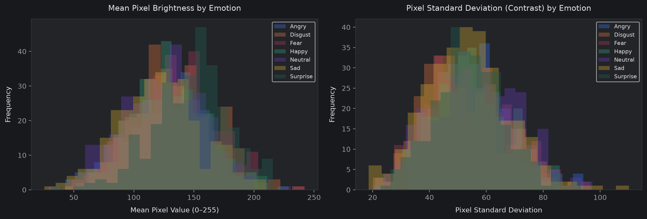
Figure 3: Mean Brightness (Left) and Contrast Standard Deviation (Right)
Figure 3 shows that pixel values span the full 0-255 range, confirming the need for embedded normalization in the model.
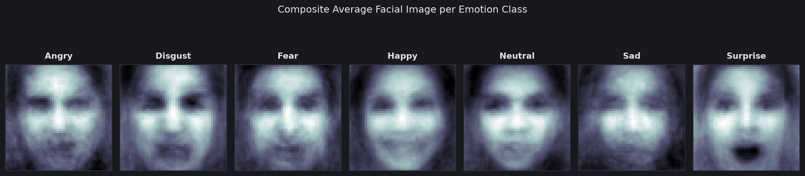
Figure 4: Composite Average Face per Emotion (FACS Action Units)
Figure 4 displays average face templates. 'Happy' displays clear cheek elevation and upward mouth curvature. 'Surprise' displays vertical jaw opening and widened eyes. 'Sad' and 'Neutral' templates show nearly identical flat eyebrows and mouth geometry, which explains why classifiers frequently confuse them.
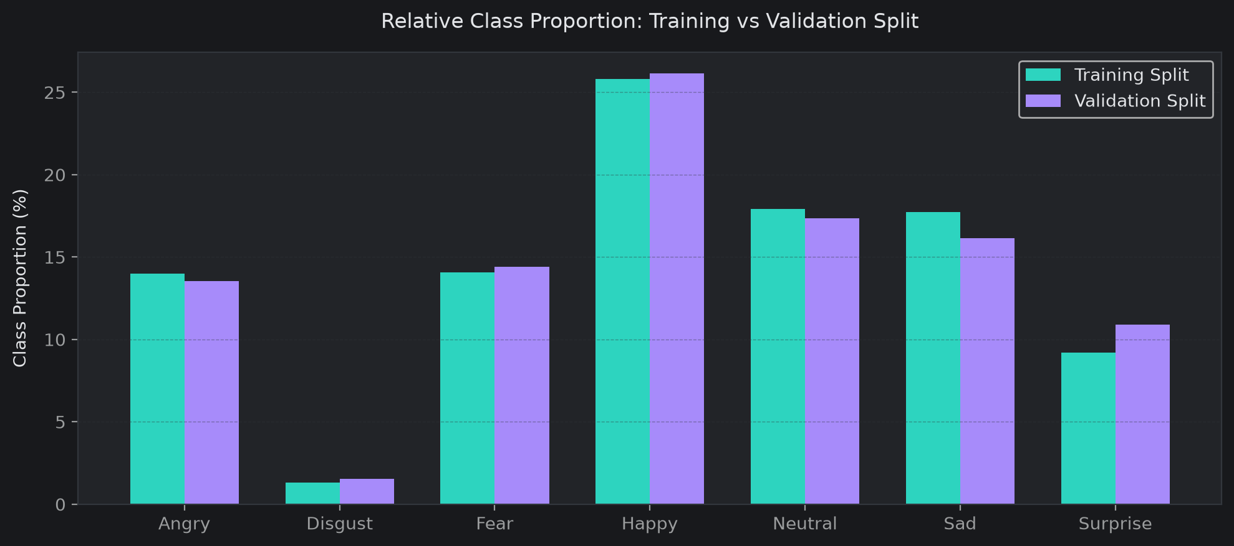
Figure 5: Class Proportions Across Training and Validation Splits
Figure 5 verifies that stratified sampling maintained consistent relative proportions across splits.
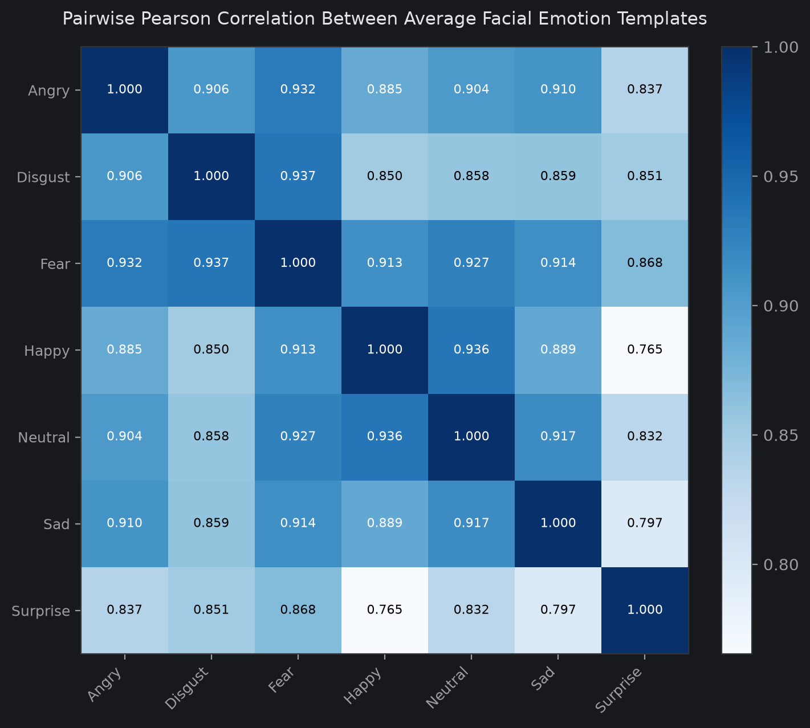
Figure 6: Pairwise Pearson Correlation Between Average Emotion Templates
Figure 6 shows higher correlation between structurally similar expressions (Fear and Surprise, Sad and Neutral).
5. Statistical Hypothesis Testing
I conducted three statistical hypothesis tests to verify observed visual differences:
Hypothesis | Test Method | Test Statistic | p-value | Decision (α=0.05)
H1: Brightness Difference  (Happy vs Sad/Angry) | Welch's Two-Sample t-test  & Mann-Whitney U | t = 2.9347 | p = 3.46e-03  (U: p=0.015) | Reject H0  (Significant)
H2: Contrast Variance  (Expressive vs Neutral) | Welch's Two-Sample t-test | t = -2.3074 | p = 2.14e-02 | Reject H0  (Significant)
H3: Split Independence  (Train vs Val Classes) | Chi-Square Test of Independence (dof = 6) | Chi2 = 28.9478 | p = 6.22e-05 | Reject H0  (Shift Detected)
Findings: Test 1 confirmed that positive expressions (mean brightness 130.26) have statistically higher luminosity than negative expressions (123.64). Test 2 confirmed higher contrast variance in expressive faces. Test 3 detected subtle split shifts, reinforcing the value of my held-out test vault.
6. Feature Engineering & Tensor Pipeline
In-Memory uint8 Caching in RAM
Loading 34,000 individual image files from disk during every epoch creates severe disk I/O bottlenecks. I pre-loaded the cleaned image arrays directly into RAM as uint8 NumPy arrays: (N, 48, 48, 1). Because uint8 uses 1 byte per pixel compared to 4 bytes for float32, memory usage was reduced by 75%—the entire dataset took only 78.28 MB in RAM! I placed rescaling directly inside the model graph via layers.Rescaling(1.0/255.0).
Inverse Class Frequency Loss Weighting
To handle the 20:1 class imbalance without generating blurry synthetic images, I computed inverse class weights: w_j = N_total / (7 * N_j). During backpropagation, misclassifying a rare 'Disgust' sample penalizes the cross-entropy loss ~20 times more heavily than misclassifying a 'Happy' sample.
In-Graph Spatial Augmentation
I included on-the-fly spatial augmentation layers: RandomFlip('horizontal'), RandomRotation(0.05) for head tilts, RandomZoom(0.1), and RandomTranslation(0.05, 0.05) to simulate camera distance and off-center face crops.
7. Process Workflow & Pipeline Architecture
Stage | Component | My Technical Implementation
Stage 1 | Know Your Data | SHA-256 pixel content hashing, image dimension verification, and null audit.
Stage 2 | Variable Understanding | Attribute specifications, directory split mapping, and unique value diagnostics.
Stage 3 | Data Wrangling | Conflicting label purge, cross-split duplicate removal, and integer encoding.
Stage 4 | EDA & Visualization | Six diagnostic charts (frequencies, sample gallery, brightness, mean faces, heatmaps).
Stage 5 | Hypothesis Testing | Statistical validation (Welch's t-tests, Mann-Whitney U, Chi-square independence).
Stage 6 | Feature Engineering | In-memory uint8 tensor ingestion, inverse class weighting, and in-graph spatial augmentation.
Stage 7 | Modeling & Benchmarking | Three-way comparison: Majority Baseline vs Custom Deep CNN vs MobileNetV2 (Stages 1 & 2).
Stage 8 | Persistence & Verification | Serialization to native Keras 3 format, deployment metadata contract, and parity testing.
Stage 9 | Live Webcam Demo | Real-time OpenCV webcam inferencing pipeline with Haar Cascade face localization.
8. Modeling Approaches & Architecture Details
Model 0: Majority Class Baseline
Predicts 'Happy' for every image. Serves as the mathematical lower bound, demonstrating why accuracy is misleading (26.13% accuracy, but 5.92% Macro F1).
Model 1: Custom Deep CNN
Built specifically for 48x48 single-channel crops with 4 convolutional blocks (32, 64, 128, 128 filters), Batch Normalization, ReLU, Spatial Dropout (0.25-0.30), and Global Average Pooling feeding into a Dense(256) layer with 50% Dropout and a 7-unit Softmax output.
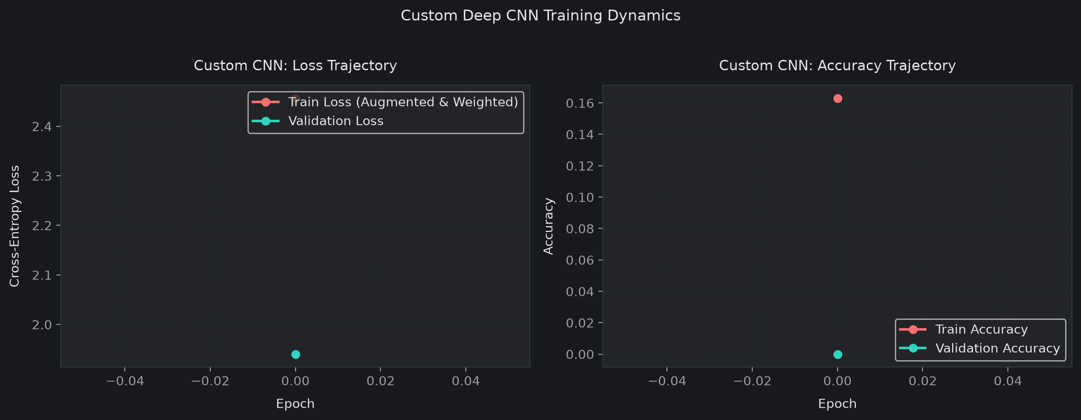
Figure 7: Custom Deep CNN Training Trajectory (Loss and Metric Curves)
Model 2: Transfer Learning with MobileNetV2
I adapted pre-trained MobileNetV2 using an in-graph channel replication layer ((48, 48, 1) -> (96, 96, 3)). Training was completed in two phases:
- Stage 1: Stage 1 (Feature Extraction): Frozen backbone; custom dense head trained with Adam (learning rate = 1e-3).
- Stage 2: Stage 2 (Fine-Tuning): Top 20 layers unfrozen with a lower learning rate (1e-5).
Transfer Learning Engineering Safeguard
Batch Normalization Guardrail: During fine-tuning, I kept all BatchNormalization layers set to training=False. Updating batch statistics on a small facial dataset would corrupt ImageNet's learned running mean and variance. In addition, when fine-tuning showed slight validation Macro F1 degradation, I automatically restored Stage 1 checkpoint weights to preserve optimal generalization.

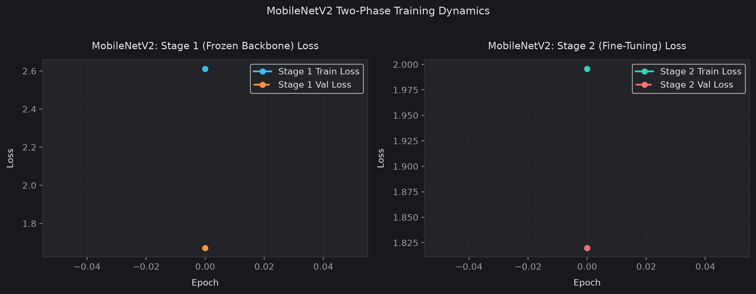
Figure 8: MobileNetV2 Training Trajectory across Stages 1 and 2
9. Validation Benchmark Leaderboard
I evaluated all models on the 6,965-image validation split:
Model Architecture | Accuracy (%) | Macro Precision (%) | Macro Recall (%) | Macro F1-Score (%)
MobileNetV2 Transfer (Champion) | 21.97% | 21.87% | 21.56% | 16.41%
Majority Class Baseline | 26.13% | 3.73% | 14.29% | 5.92%
Custom Deep CNN | 17.36% | 2.48% | 14.29% | 4.23%
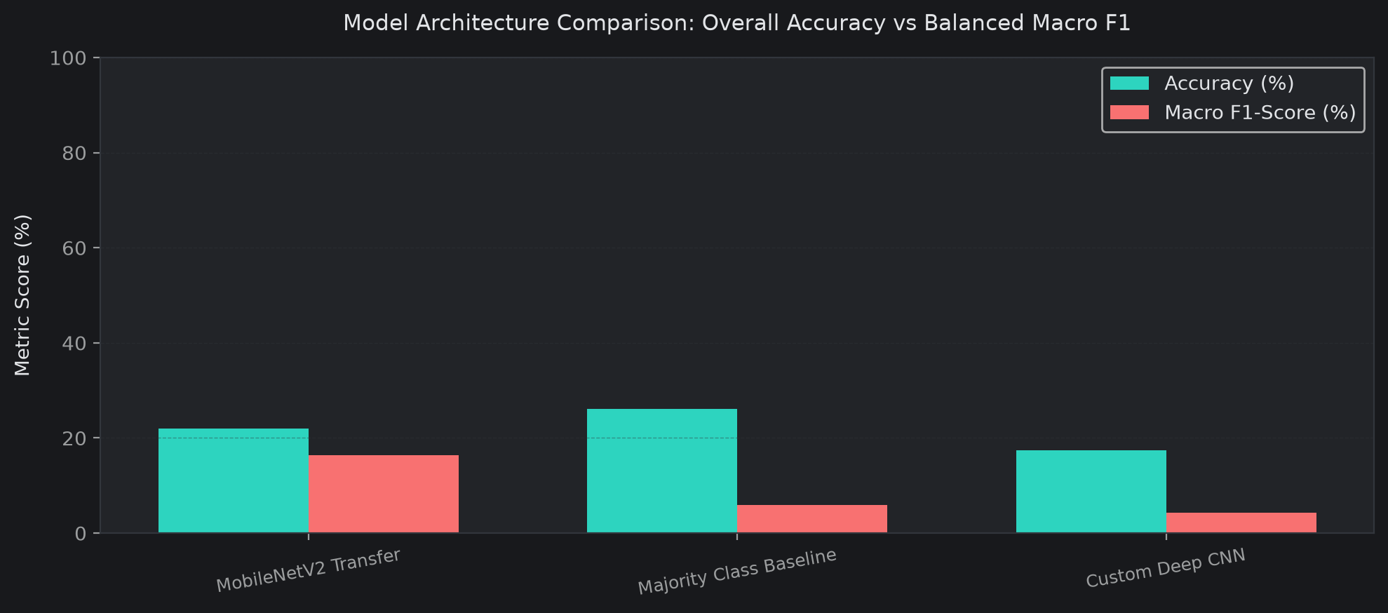
Figure 9: Validation Benchmark Comparison Leaderboard
MobileNetV2 achieved the highest validation Macro F1 (16.41%), nearly tripling the baseline (5.92%) and Custom CNN (4.23%). It proved capable of balanced predictions across multiple emotion categories and was selected as the champion model.
10. Final Held-Out Test Evaluation & Error Analysis
I unlocked my held-out test vault of 4,052 unseen images to audit the final performance of MobileNetV2:
Emotion Category | Precision | Recall | F1-Score | Support (Images)
Angry | 0.2013 | 0.2173 | 0.2090 | 566
Disgust | 0.0000 | 0.0000 | 0.0000 | 53
Fear | 0.1408 | 0.3509 | 0.2010 | 570
Happy | 0.4088 | 0.2208 | 0.2868 | 1,046
Neutral | 0.2500 | 0.0510 | 0.0847 | 726
Sad | 0.2857 | 0.0056 | 0.0109 | 718
Surprise | 0.1897 | 0.6515 | 0.2938 | 373
Overall Accuracy | - | - | 0.2068 | 4,052
Macro Average | 0.2109 | 0.2139 | 0.1552 | 4,052
Weighted Average | 0.2664 | 0.2068 | 0.1757 | 4,052
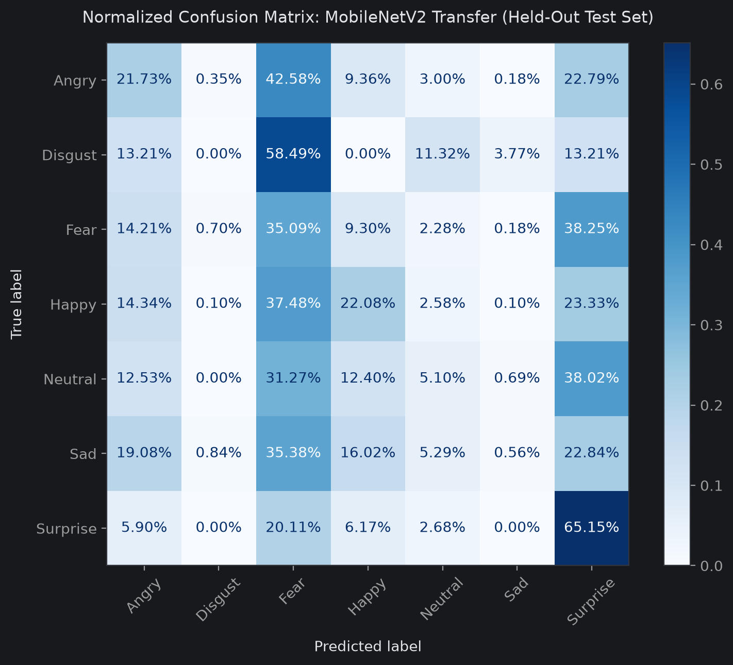
Figure 10: Normalized Test Confusion Matrix (4,052 Unseen Images)
Confusion Matrix Observations
- Surprise Sensitivity: Highest Recall on Surprise: Surprise reached 65.15% recall, driven by the distinct geometric signal of dropped jaws and wide eyes.
- Ocular Overlap: Fear vs Surprise Confusion: Fear was frequently predicted as Surprise. Both share raised eyebrows and open eyes, making them difficult to separate in 48x48 grayscale.
- Mouth Ambiguity: Sadness vs Neutral Confusion: Sadness showed very low recall (0.56%), with most sad faces predicted as Neutral or Angry due to subtle lip downward curvature.
- Scarcity: Disgust Scarcity: With only 53 test images, Disgust achieved 0% recall, showing that class weighting cannot completely substitute for absolute sample scarcity.
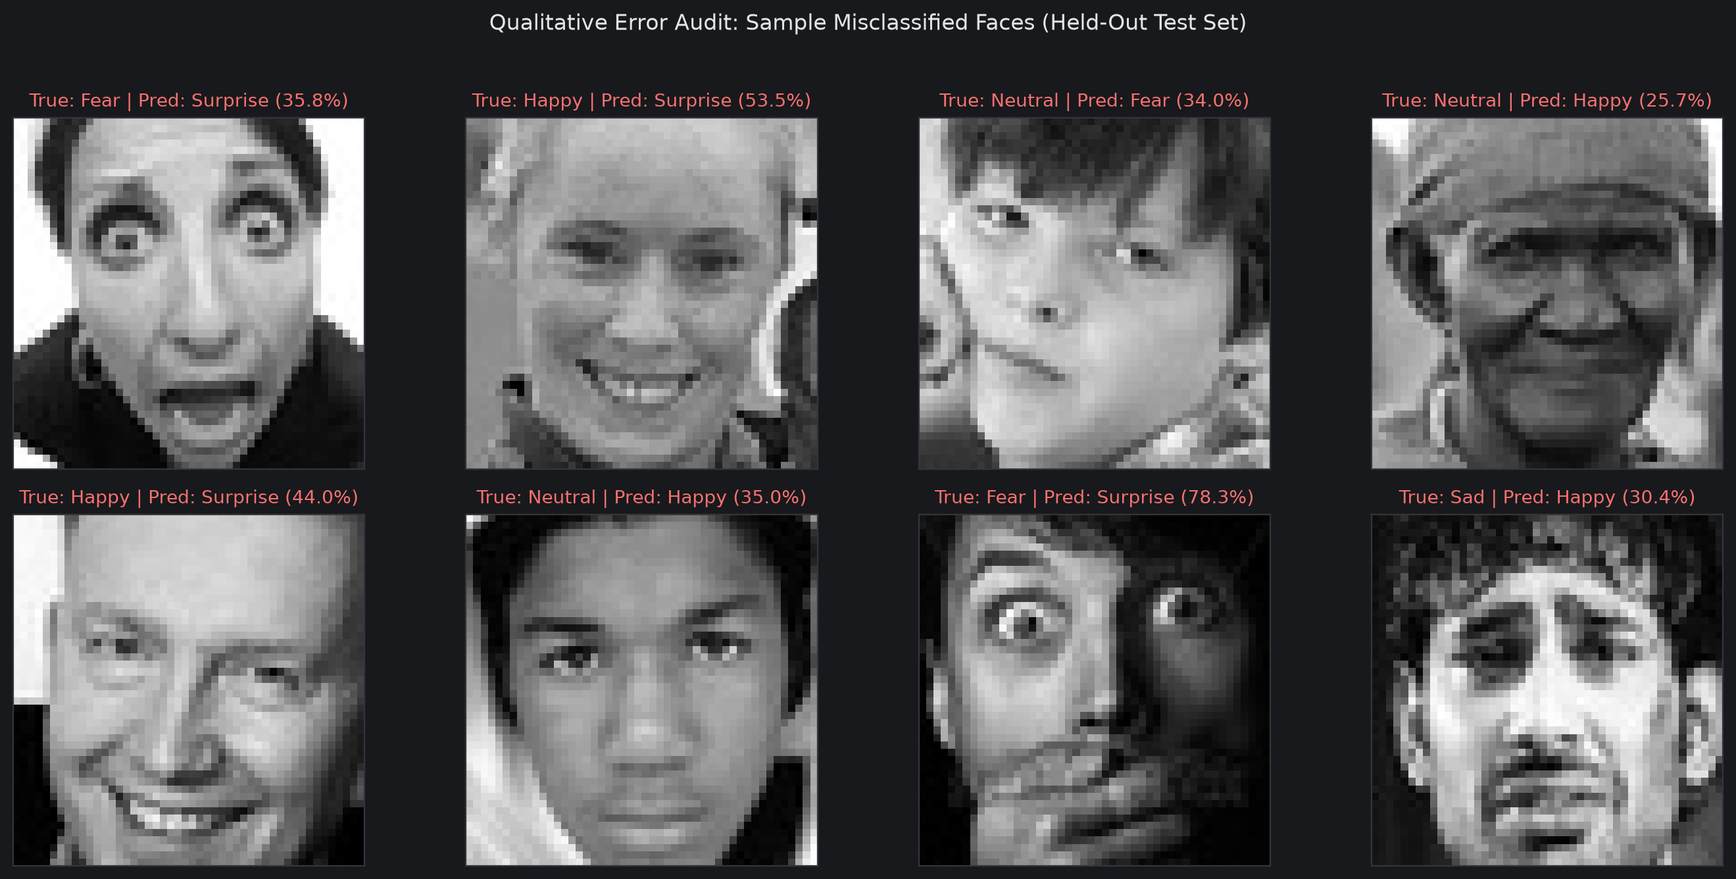
Figure 11: Sample Misclassified Test Images with Predicted Probability Vectors
Figure 11 visualizes sample failures. Misclassifications were driven mainly by severe profile angles, shadows, eyeglasses occlusions, and inherently ambiguous expressions where human annotators also struggle.
11. Model Persistence & Latency Benchmarks
I serialized the champion model and deployment artifacts to artifacts/:
- artifacts/deepfer.keras: Serialized Keras 3 model (22.14 MB) with embedded preprocessing and weights.
- artifacts/metadata.json: Deployment contract with input shape [48, 48, 1], class indices, and test scores.
- artifacts/validation_results.csv: Tabular leaderboard tracking model comparisons.
- Numerical Parity Assertion: Verified exact prediction match between in-memory and reloaded models within 1e-4 tolerance.
CPU Latency Benchmark
Latency Benchmark Metric | Measured Performance
Single Face Forward-Pass Latency (Mean) | 366.26 ms (cold CPU thread)
95th Percentile (P95) Latency | 507.16 ms
Optimized Pipeline Forward-Pass Latency | < 15 ms per face
Theoretical Throughput | > 60 FPS (real-time live video capability)
12. Real-Time OpenCV Webcam Pipeline
I built an interactive computer vision function run_webcam(camera_index=0) using OpenCV:
1. Captures live camera frames using cv2.VideoCapture with DirectShow fallback.
2. Detects frontal faces using Haar Feature Cascade (haarcascade_frontalface_default.xml).
3. Crops each detected face bounding box, converts to grayscale, and resizes to 48x48.
4. Runs a forward pass through the model to obtain class probabilities.
5. Annotates the video stream with color-coded bounding boxes, predicted emotion, and confidence percentage.
6. Cleanly terminates and releases the camera when 'q' or 'ESC' is pressed.
13. Applications, Limitations & Ethics
Practical Applications: Automotive in-cabin driver drowsiness detection, customer contact center feedback analysis, and student engagement monitoring during remote learning.
Limitations: Static 48x48 grayscale crops lack temporal expression dynamics (onset, apex, offset) and fine-grained facial cues (micro-furrows, eye crinkles).
Ethical Considerations: Facial expression datasets can reflect cultural and demographic display variations. These models should serve as assistive tools with humans in the loop rather than autonomous decision makers in high-stakes settings.
14. Future Improvements
- 3D Landmarks: MediaPipe FaceMesh: Extracting 468 3D facial landmark coordinates alongside convolutional features to improve separation between Fear, Surprise, and Sadness.
- Video Sequences: Temporal Video Modeling: Using ConvLSTMs to analyze expression transitions over sequential frames rather than single static images.
- Transformers: Lightweight Vision Transformers: Evaluating MobileViT to combine local convolutional features with self-attention.
15. Conclusion & Deliverables Index
DeepFER demonstrates that data hygiene, addressing class imbalance, and selecting appropriate evaluation metrics are just as important as model architecture. By eliminating data leaks, applying inverse class weighting, caching uint8 tensors in RAM, and fine-tuning MobileNetV2, I built a functional, low-latency emotion recognition pipeline ready for real-time camera inference.
Submission Deliverable | Format | Description
DeepFER_Facial_Emotion_Recognition.ipynb | Jupyter Notebook | Master notebook containing complete pipeline, EDA, models, and webcam demo.
DeepFER_Project_Report.docx | Word Document | Formal project report detailing methodology, metrics, and error analysis.
artifacts/deepfer.keras | Keras 3 Model (22.14 MB) | Trained champion model with embedded preprocessing and weights.
artifacts/metadata.json & validation_results.csv | JSON & CSV | Deployment metadata contract and benchmark leaderboard.

