Q1) Print the storeid and number of orders for the store

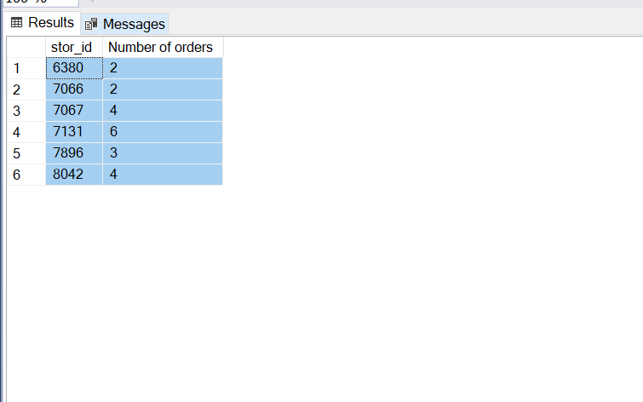

Q2) print the number of orders for every title

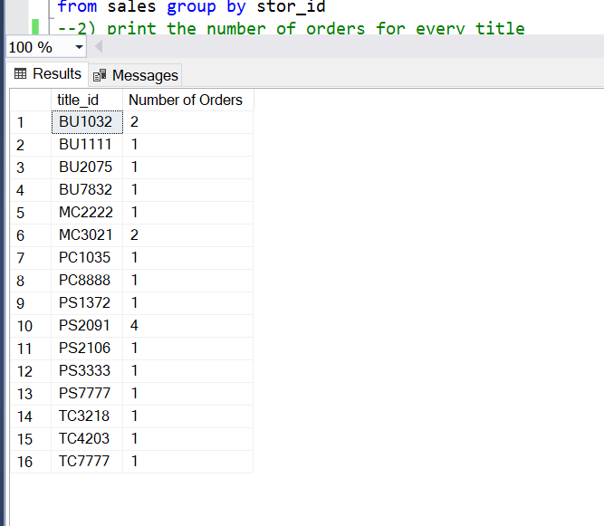

Q3) print the publisher name and book name

Ans)

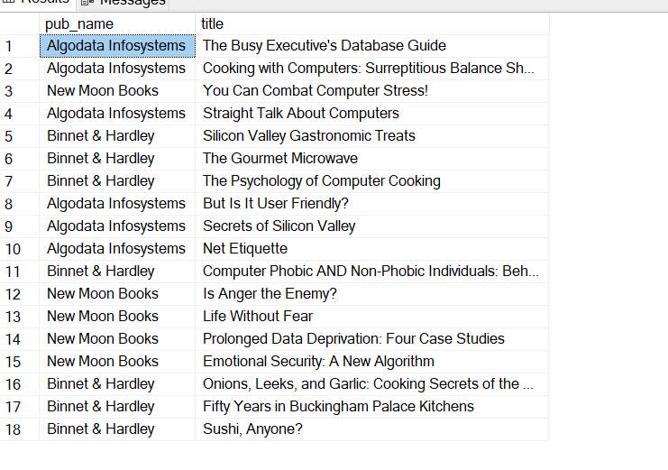

Q4) Print the author full name for al the authors

Ans)

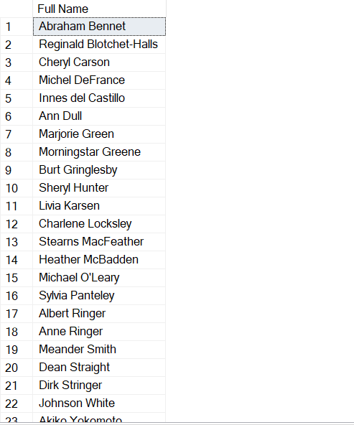

Q5) Print the price or every book with tax (price+price\*12.36/100)

Ans)

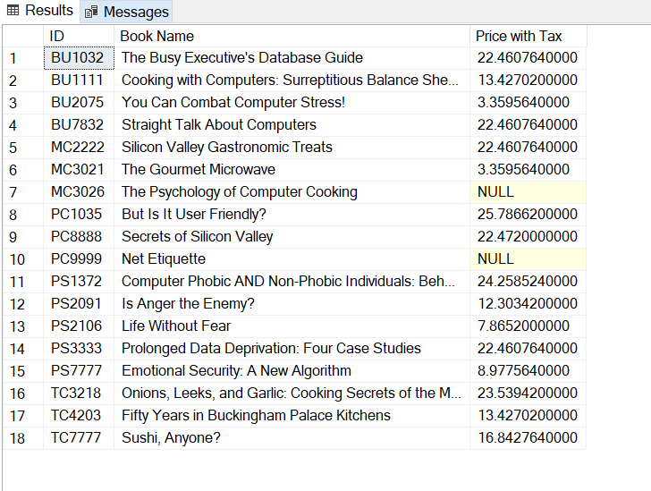

Q6) Print the author name, title name

ANS)

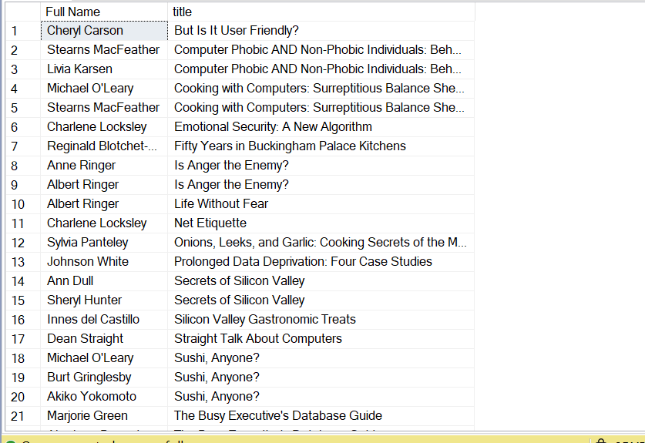

Q7) print the author name, title name and the publisher name

ANS)

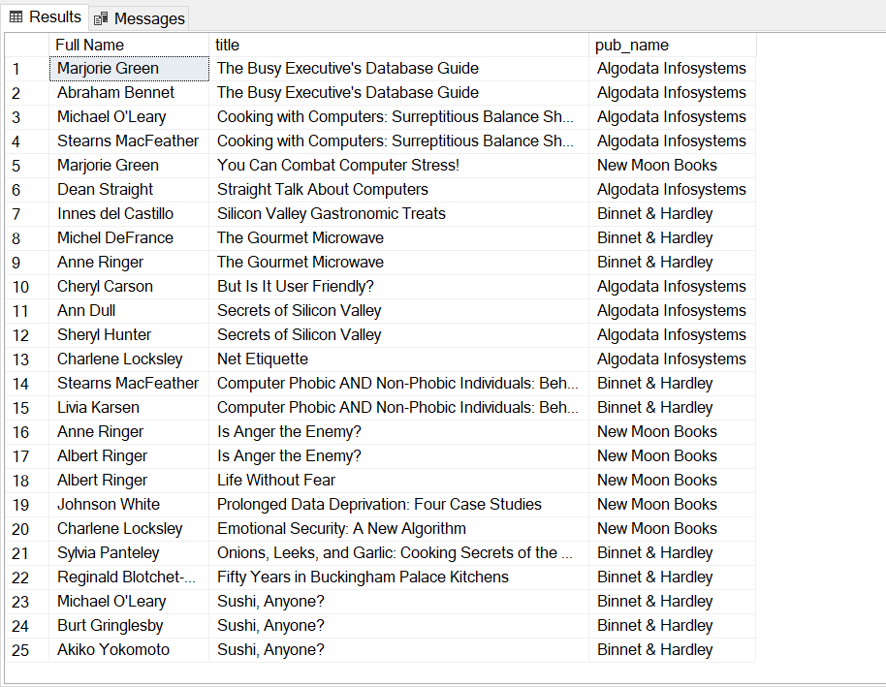

Q8) Print the average price of books pulished by every publisher

ANS)

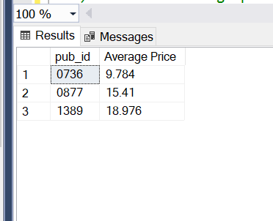

Q9) print the books published by 'Marjorie'

ANS)

Q10) Print the order numbers of books published by 'New Moon Books'

ANS)

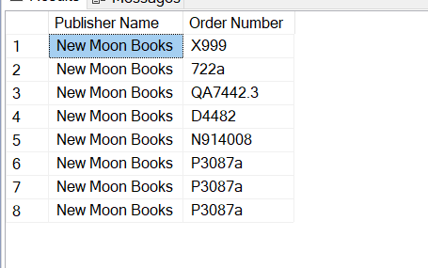

Q11) Print the number of orders for every publisher

ANS)

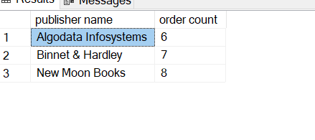

Q12) print the order number , book name, quantity, price and the total price for all orders

ANS)

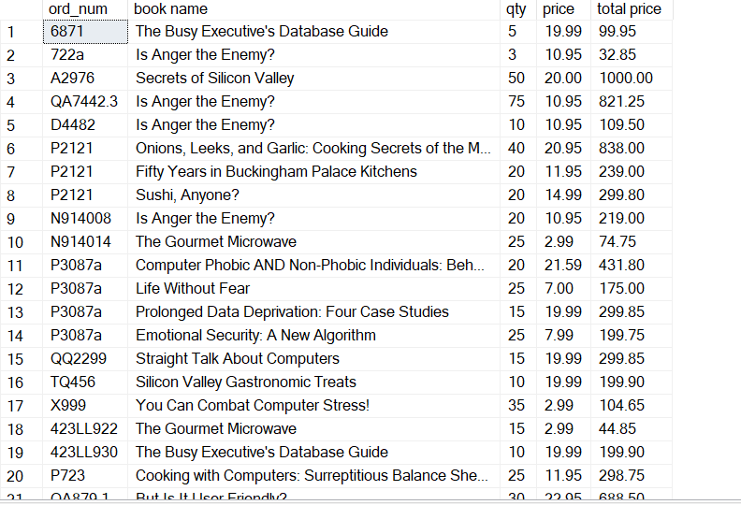

Q13) print he total order quantity for every book

ANS)

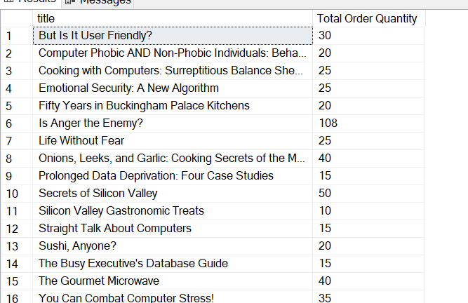

Q14) print the total ordervalue for every book

ANS)

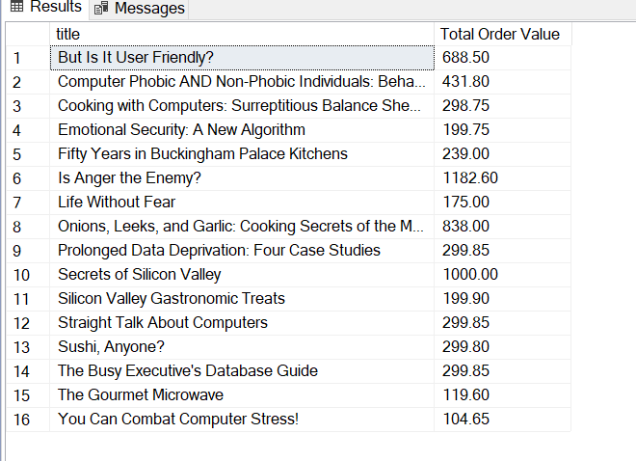

Q15) print the orders that are for the books published by the publisher for which 'Paolo' works for

ANS)

