Q1) Create a stored procedure that will take the author firstname and print all the books polished by him with the publisher's name

Ans)

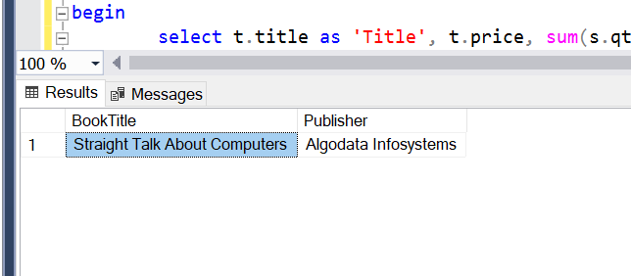

Q2) Create a sp that will take the employee's firstname and print all the titles sold by him/her, price, *quantity and the cost.*

Ans)

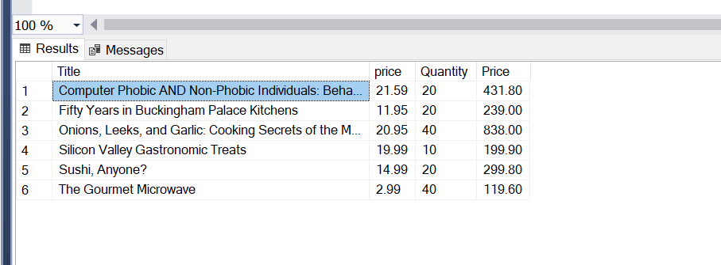

Q3) Create a query that will print all names from authors and employees

Ans)

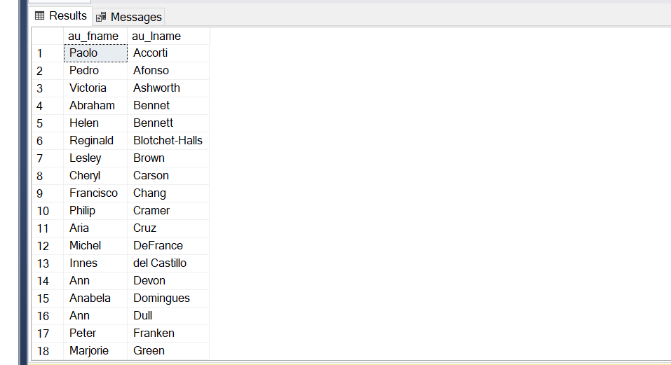

Q4) Create a query that will fetch the data from sales,titles, publisher and authors table to print title name,Publisher's name, author's full name with quantity ordered and price for the order for all orders, print first 5 orders after sorting them based on the price of order

Ans)

