1. Cow and bull -leetcode question(https://leetcode.com/problems/bulls-and-cows/description/)

Sol)

Code :

class Solution {

public:

    string getHint(string s, string g) {

        int n = s.size() ,cows = 0 ,bulls= 0;

        unordered_map<char,int> m;

        for(int i = 0 ;i<n;i++)m[s[i]]+=1;

        for(auto it : m) cout<<it.first<<" "<<it.second;

        cout<<endl;

        for(int i =0 ;i<n;i++){

            if(s[i] == g[i] && m[g[i]] > 0 ){ bulls++; m[s[i]]-=1;}

        }

        for(int i =0 ;i<n;i++){

            if(s[i] != g[i] && m[g[i]] > 0 ){

                cows++;

                m[g[i]]-=1;

            }

        }

        string ans = to_string(bulls)+"A" +to_string(cows)+"B";

        return ans;

    }

};

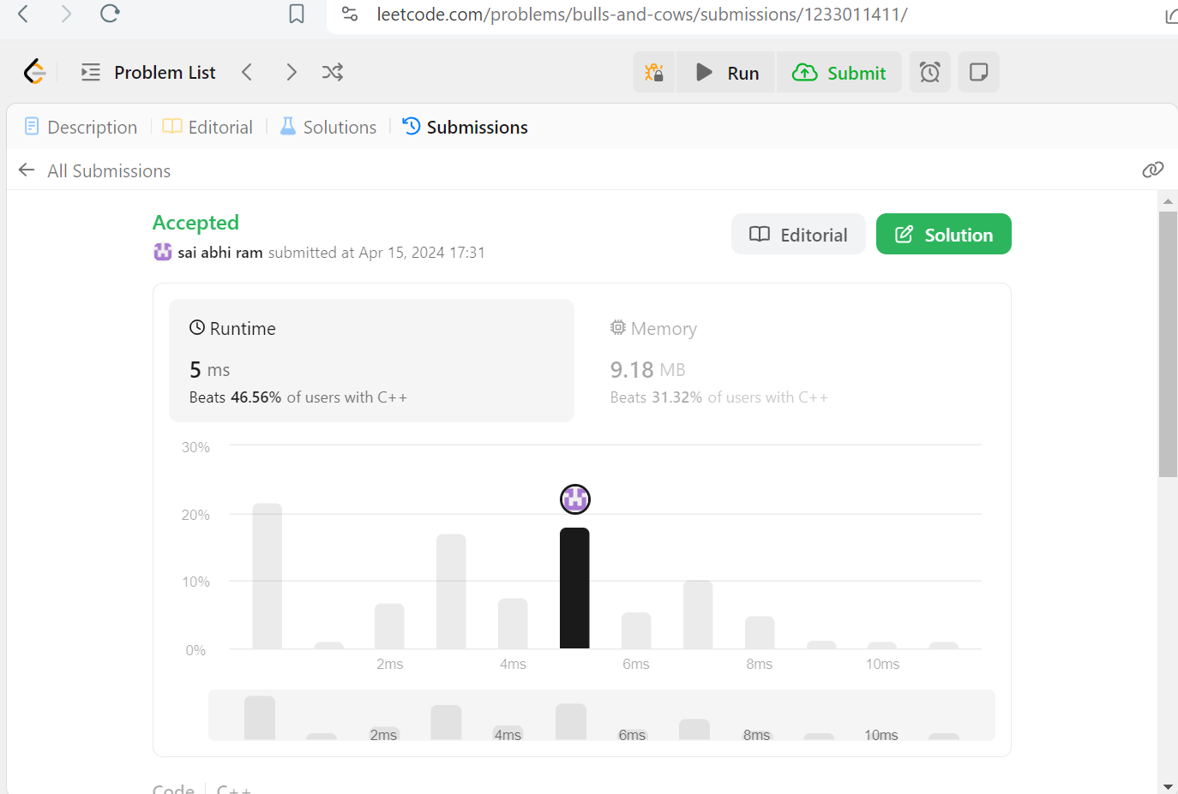

1. Update And delete options task

Sol) **Add Employee :**

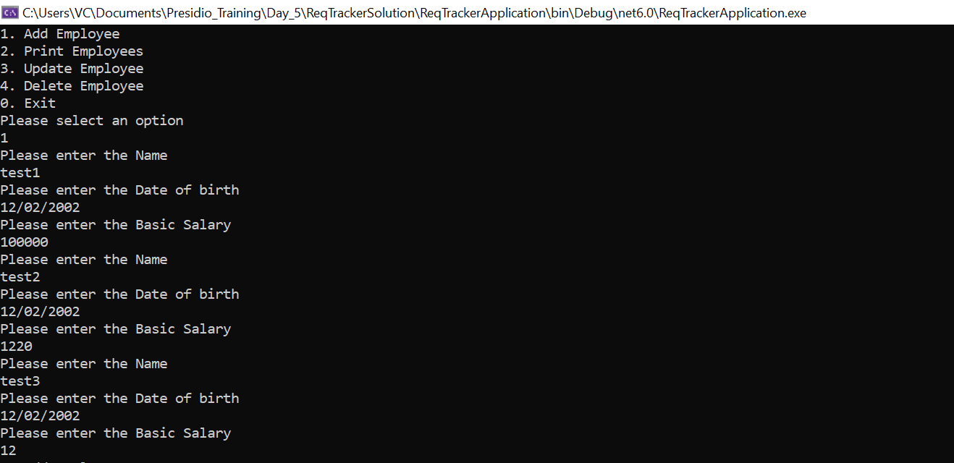

**Print Employees:**

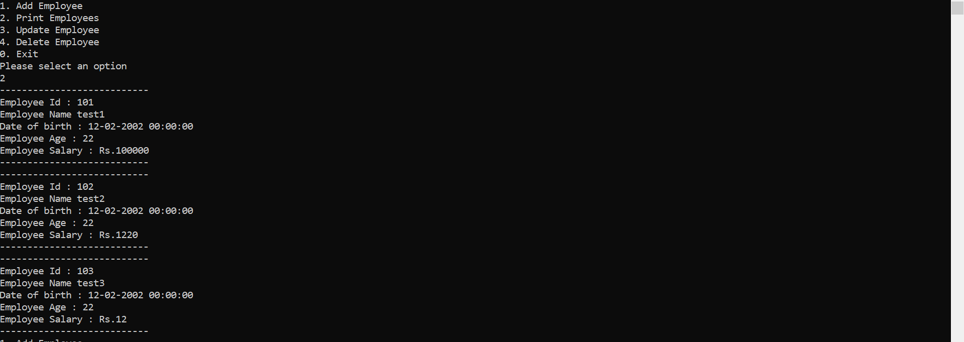

**Update Employee:** 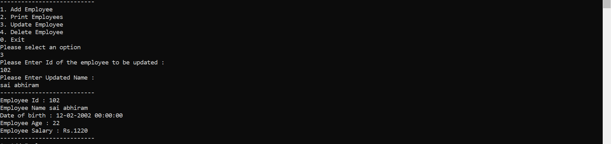

**Delete Employee :**

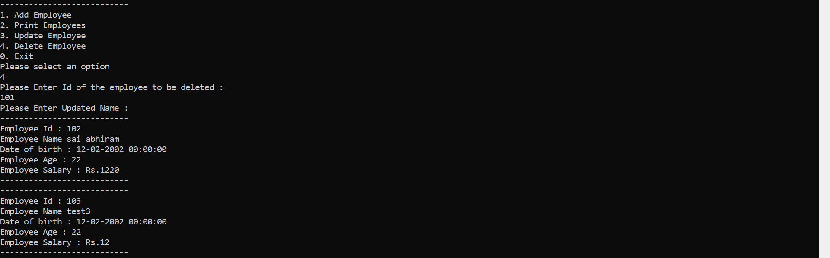

1. Cow and bull game

**Sol )**

**Code :**

namespace CowBullApplication

{

internal class Program

{

string HandlingStringInput()

{

string str = string.Empty;

do

{

str = Console.ReadLine();

if (string.IsNullOrWhiteSpace(str) || str?.Length !=4)

Console.WriteLine("Please Enter a valid string \n");

} while (string.IsNullOrWhiteSpace(str) || str.Length != 4);

return str;

}

int[] CountOfCowsAndBulls(string str, string main)

{

int[] cowandbull = new int[2];

char[] temp = (main.ToCharArray());

for (int i = 0; i < 4; i++)

{

if (str[i] == main[i]) {cowandbull[0]++ ; temp[i] = '#'; continue; }

int index = Array.IndexOf(temp, str[i]);

if (index > 0)

{

temp[index] = '#';

cowandbull[1]++;

}

}

return cowandbull;

}

void CowAndBullGame()

{

Console.WriteLine("Please Enter Main Word : ");

string main = HandlingStringInput(),str;

do

{

Console.WriteLine("Please Enter the Guess Word: ");

str = HandlingStringInput();

int[] CowAndBull = CountOfCowsAndBulls(str, main);

if (CowAndBull[0] != 4)

Console.WriteLine($"Cow : {CowAndBull[0]} , Bull : {CowAndBull[1]}");

else

{

Console.WriteLine("Congrate You Won");

break;

}

} while (str != "-1" );

return;

}

static void Main(string[] args)

{

Program program = new Program();

program.CowAndBullGame();

}

}

}

Output:

