Workbook 7.4
From the Java Bootcamp Resources, launch Workbook 7.4.
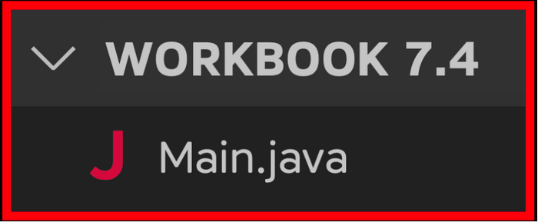
Task 1
Inside the Person class, add a copy constructor.
Task 2
Your code contains a Person object.
- Person person = new Person("Rayan Slim", "Canadian", "01/01/1111", 5);
That person's twin is also flying with Java airlines. Use this code to test your copy constructor.
- Person twin = new Person(person); // creates a copy of the first object.
- twin.setName("Jad Slim"); // updates name field of the second object.
- twin.setSeatNumber(3); // updates the seat number of the second object.
Print the other person's fields as well.
- System.out.println("Name: " + twin.getName() + "\n" +
- "Nationality: " + twin.getNationality() + "\n" +
- "Date of Birth: " + twin.getDateOfBirth() + "\n" +
- "Seat Number: " + twin.getSeatNumber() + "\n");
- Name: Rayan Slim
- Nationality: Canadian
- Date of Birth: 01/01/1111
- Seat Number: 10

- Name: Jad Slim
- Nationality: Canadian
- Date of Birth: 01/0﻿1﻿/1﻿1﻿11
- Seat Number: 3
Visualizing the Runtime
After you solve this workbook, I still recommend watching the video solution on Udemy.

It will show you how to visualize the runtime using Visual Studio Code.

