Workbook 6.13
From the Java Bootcamp Resources, open Workbook 6.13.
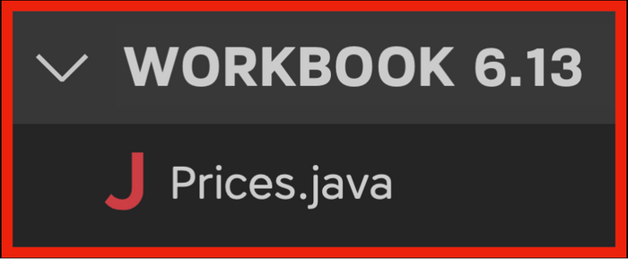
Task 1
Create a 2D array of double values that can hold 3 rows and 5 elements per row.
Task 2
Populate your 2D array with values from the following table:
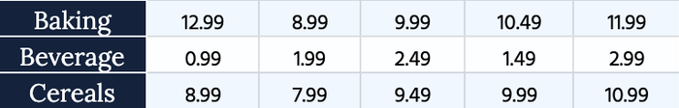
For the sake of exercise, do it the long way (indexing elements one by one).
- prices[x][x] = 12.99
- prices[x][x] = 8.99
- //....
Task 3
Print the prices of each row using this format:
- System.out.println("Baking: " + prices[0][0] + " " + prices[0][1] + " "...);
Result
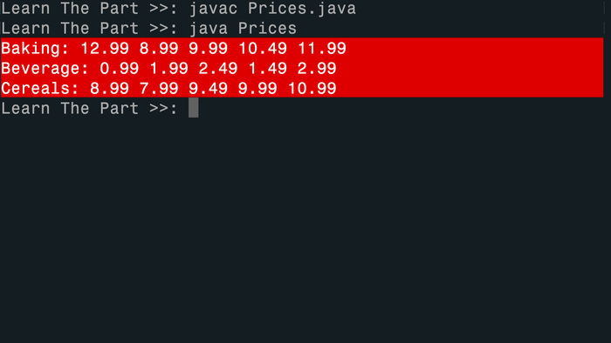
Task 4
Define the array in a single line.
- double[][] prices = {
- {12.99, 8.99, 9.99, 10.49, 11.99},
- {0.99, 1.99, 2.49, 1.49, 2.99},
- {8.99, 7.99, 9.49, 9.99, 10.99}
- };
Visualizing the Runtime
After you solve this workbook, I still recommend watching the video solution on Udemy.

It will show you how to visualize the runtime using Visual Studio Code.

